Narrative:
I’m Alison. I’m building my blog. At the moment, I only have a few things that I’d like to share with my friends. First, why did I choose to do coding this summer? Second, I’d like to let you know my work and education background. Third, I’m happy to share the basic facts about my current family. Since I may have a lot more to share in the future, I need to add a form for submitting more posts in the future.

Schema drawing
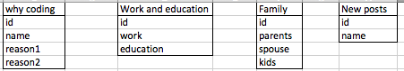

Kanban board
