**PUBLIC HEALTH PRACTICE**

**Web Application to Investigate Butler County Overdose Death Data**

Alison C. Tuiyott1,*; Bri Clements1, 2; A. John Bailer, PhD1; Lisa K. Mannix, MD3; Jennifer F. Bailer, RN, MS4

1Department of Statistics, Miami University, Oxford, OH 45056

2Columbus Collaboratory, 1375 Perry St, Columbus, OH 43201

3Butler County Coroner’s Office, Government Services Center, 315 High Street, Suite 650, Hamilton, OH 45011

4Butler County General Health District, 301 S. 3rd Street, Hamilton, OH 45011

\***Corresponding Author:** Alison Tuiyott ● (513)-265-7079 ● tuiyotac@miamioh.edu

# ABSTRACT

**Background:** Drug overdose deaths, specifically opioid-related ones, are a public health crisis in the United States with high incidence observed in many Midwestern states, including Ohio. Butler County, Ohio has the third highest opioid-related death rate in the state. Information on overdose deaths is collected by the county coroner and can serve as a data source for analysis of this public health concern. Given this access, stakeholders can investigate trends in their community and for their idiosyncratic interest.

**Methods:** A web application was developed, using the R Shiny package, to visualize and explore the characteristics of all overdose deaths in Butler County between 2013 and 2018. Demographics of the decedents, drugs found in the decedents’ postmortem toxicology analyses, annual trends in overdose deaths and the location of these cases can be examined.

**Results:** The web application provides a graphical user interface that allows for a user to request specific analyses and summaries. Examples of questions that can be explored using this application include: 1) Who is dying from opioid overdoses? 2) What drugs, including opioids, are found in overdose deaths? 3) Has the number of opioid involved deaths increased in a specific community over time?

**Conclusions:** This application empowers both the public and the local policymakers to investigate the impact of overdose deaths on their communities. Understanding characteristics of the epidemic is an important first step to addressing this problem. The expansion of this application to include other counties in Ohio could be truly beneficial to communities that need it.

**Key Words:** Epidemic, Ohio, Opioid, Overdose Death, R Shiny Application

# INTRODUCTION

In the United States, more than 47,000 people died from an opioid-involved overdose, including prescription and illicit opioids in 2017.1 Opioids include heroin, fentanyl and prescription drugs such as oxycodone. To put that number into perspective, roughly 37,000 people died of a fatal motor vehicle crash that same year.2 Ohio had the second highest rate of opioid-related drug overdose deaths in the United States in 2017; 39.2 deaths per 100,000 people (or persons) in Ohio vs. 14.6 deaths per 100,000 people (or persons) in the U.S.3 Ohio also had the second highest rate of drug overdose deaths, in general, in 2017 in the United States; 46.3 deaths per 100,000 people (or persons) in Ohio vs. 21.7 deaths per 100,000 people (or persons) in the U.S.4 Butler County, Ohio has the third highest overdose death rate in the state with 43 deaths per 100,000 people (or persons).5

A web application displaying various interactive data visualizations regarding overdose deaths was created to spread awareness of the issue and educate the community of Butler County. Stakeholder access to these data and to summaries of these data can be provided on the Internet. Given this access, stakeholders can investigate patterns in trends in their community and for their idiosyncratic interest. This article describes that application with hopes of empowering the public to use it to query and explore a critical public health issue in their community.

The interactive application provides an accessible way to see and understand trends, outliers and patterns in the Butler County overdose data through various views. Users can explore the demographics (gender/sex, race/ethnicity and age) of the decedents and specific drugs (e.g. heroin, fentanyl, carfentanil) detected by postmortem toxicology analyses. For the purposes of this application, gender was used synonymously with sex. Likewise, race was also used synonymously with ethnicity in this application. Users can also analyze annual trends of categories of drugs (e.g. opioids, fentanyl analogs, stimulants) found in decedents. The application also provides insight on location information including: a map of Butler County displaying the location of each overdose incident, annual trends of overdose incidents by city/township and the types of places the overdose incidents and deaths occurred (e.g. home, motel).

The goal of the application is to provide a framework to answer basic questions about the epidemic at a local level. For example, who is dying from opioid overdoses? What drugs, including opioids, are found in overdose deaths? Has the number of opioid involved deaths increased in a certain community over time? This article delves into the process of using such an application to answer these kinds of questions.

# METHODS

**Data Source**

Overdose mortality data were collected by the Butler County Coroner’s Office. According to the Ohio Revised Code Title III Chapter 313, all records in the coroner's office that are public records are open to inspection by the public, and any person may receive a copy of any such record or part of it upon demand in writing, accompanied by payment of a record retrieval and copying fee. This section of the code goes on to list records that are not public records, which include: preliminary autopsy and investigative notes and findings, photographs of the decedent, suicide notes, medical and psychiatric notes, confidential law enforcement investigatory records, and laboratory reports of physical evidence. Similar to the disclaimer on the Ohio Department of Health (ODH) website, we state that the data in this web application are to support on-going activities such as surveillance, investigations, assessments, and evaluations. The developers of this application specifically disclaim responsibility for any analyses, interpretations or conclusions.

**Setting**

Butler County is located in the southwest corner of Ohio, with Indiana on the west. The major cities in the county include Middletown and Hamilton. Almost a third of the population of Butler County residents live in either Hamilton or Middletown. The cities of Hamilton and Middletown have lower median household incomes than Butler County and the entire state of Ohio. These cities also have twice the percentage of people in poverty within these cities compared to the county percentages and statewide percentages. The race/ethnicity compositions of the cities are similar to Butler County and Ohio, in general. The percent of people with a bachelor's degree or higher in Hamilton and Middletown are lower than the county and state percentages. Supplemental Table 1 provides a more detailed comparison of the demographics of Middletown, Hamilton, Butler County and Ohio.6

**Community, participant characteristics, recruitment**

The coroner’s office investigates when any person dies as a result of criminal or other violent means: by casualty, by suicide, or in any suspicious or unusual manner.7 This includes all suspected overdose deaths that occur in the county. Deaths that were investigated by the coroner’s office and had drug toxicity listed as a cause of death and manner was ruled accidental were identified as overdose deaths and used in this analysis. The term “toxicity” is used consistently by this coroner to identify cause of death in these cases. The Ohio Department of Health (ODH) would classify the cause of death as “poisoning” and apply an ICD-10 code. Suicide and undetermined manners of death were not included in these data. Data used in this application were provided by the coroner’s office and already classified as overdose deaths according to the criteria defined above. These data contain information on opioid and non-opioid drugs detected in postmortem toxicology analyses. Data from 2013 to 2018 were included in the application.

**Procedures/program description**

The application was developed to give community members and decision makers access to public health issues in Butler County. The application, using the Shiny package8 in the R9 software system, was developed in the RStudio IDE.10 The RStudio IDE, R software and all of the packages utilized for data cleaning and visualization are free open source technologies. The Shiny server (dataviz.miamioh.edu) hosting this application uses a paid license on a virtual server that is provided by the Department of Statistics at Miami University. This Shiny server also hosts other applications that can be accessed through a main Gallery page. Google Analytics was installed on the main Gallery page, however, these were not installed on the individual application. If we were able to restart this process, we would make sure to include analytics to be able to track the demand of this application. In addition to the obvious benefit of cost, an advantage to open source software is the abundance of online tutorials. Links to a few online tutorials for the software used in the creation of this application are provided in the Appendix. Also included in the Appendix is a flow diagram to clarify the procedure to create the application.

The application originated as a client project for the coroner in a data visualization course. Later, two students continued to enhance this web application and launched the application on a Shiny server hosted at Miami University (dataviz.miamioh.edu) on April 25, 2018. Finally, the application was enhanced, updated and relaunched on May 1, 2019.

To illustrate the features and controls of this application, we demonstrate how a user of this application would address questions such as: who is dying from opioid overdoses? What drugs, including opioids, are found in of overdose deaths? Has the number of opioid involved deaths increased in a specific community over time?

**Measures/outcomes**

Demographic data available in the database included: date of birth, date of death, age, gender/sex and race/ethnicity. Location information, such as place (e.g. home, motel), city/township and address of an overdose incident, as well the place, city/township and address of the actual death were provided. Postmortem analysis of blood and urine were performed to determine drugs present in the decedent at the time of death. Data from 2013 to 2018 included up to three or four drugs detected in each decedent. For deaths occurring between June 2016 and August 2018, information was also collected on fentanyl analogs, a new and potentially more dangerous category of opioids.

**Statistical analysis**

Bar graphs and segmented bar graphs were used to represent the number of times a specific drug was traced in a decedent. As more than one drug could be detected during testing, decedents could be counted in multiple bars within the ‘Number of times drug traced’ graph. Bar graphs were also used to represent the number of overdose deaths in a specific city and a specific place, such as a home or motel. Line graphs were used to visualize the number of drugs or categories of drugs traced over time, along with the frequency of overdose deaths in cities and townships. Maps were used to illustrate the specific locations of overdose deaths.

# RESULTS

The web application can be accessed at http://dataviz.miamioh.edu/Butler_County_Overdose_Deaths/. The landing page describes the contributors to the application and the years of data included in the application.

On the left sidebar, there are four options. The landing page is **Home**. The **How to Use the App** tab provides instructions to use and explore the application, with notes of a few details specific to these data. The **Drugs Found in Overdose Decedent** tab is a dropdown menu with three options: **Demographics**, **Annual Trends** and **Annual Category Trends**.

By selecting the **Demographics** tab, the application displays a bar graph of the most frequent number of times a drug was traced in a decedent. A screenshot of this bar graph can be observed in Figure 1. The three boxes above the segmented-bar graph are used to specify gender/sex, age and race/ethnicity of the decedent to be displayed.

Figure 1: Segmented bar graph that illustrates the number of times each drug was detected in white male and female decedents between the ages of 31 and 60 years from 2013 to 2018.

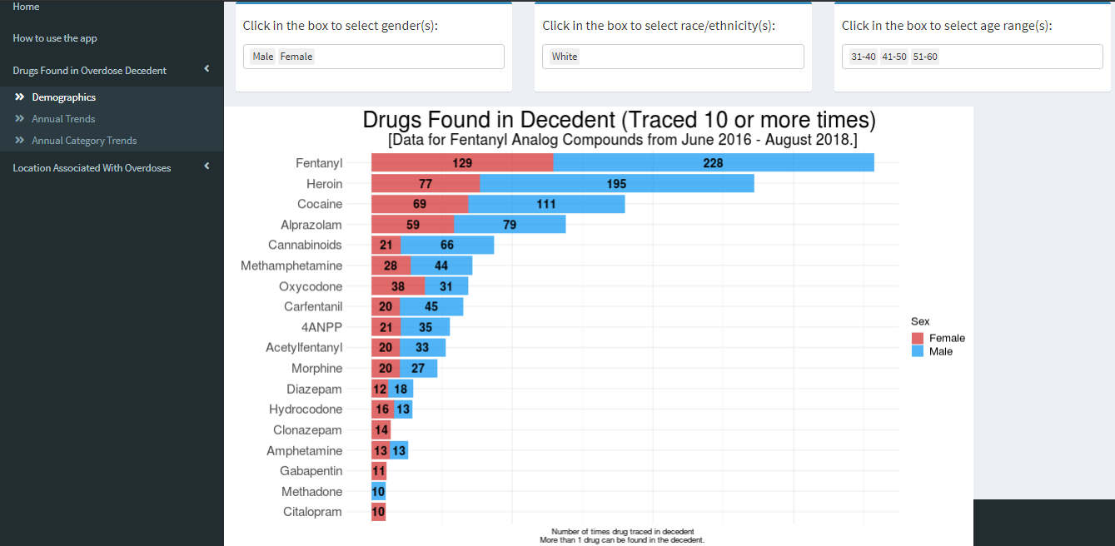

Figure 1 can be used to explore the demographics of who is dying (restricted here to ages 31-60 and white decedents) in the opioid epidemic in Butler County during 2013-2018 and from what drugs. Fentanyl and heroin were the two most common drugs traced in drug overdose deaths in this age-race group during this time. In addition, of the top 12 drugs traced in decedents, more were traced in males than females.

The second tab, **Annual Trends**, shows a line graph that describes the patterns and trends of the number of times a drug was found in a decedent over time. A screenshot of this line graph can be observed in Figure 2. The selection box above the graph can be used to specify the drugs to be highlighted.

Figure 2: Line graph showing the number of times each drug was found in overdose decedents from 2013 to 2018.

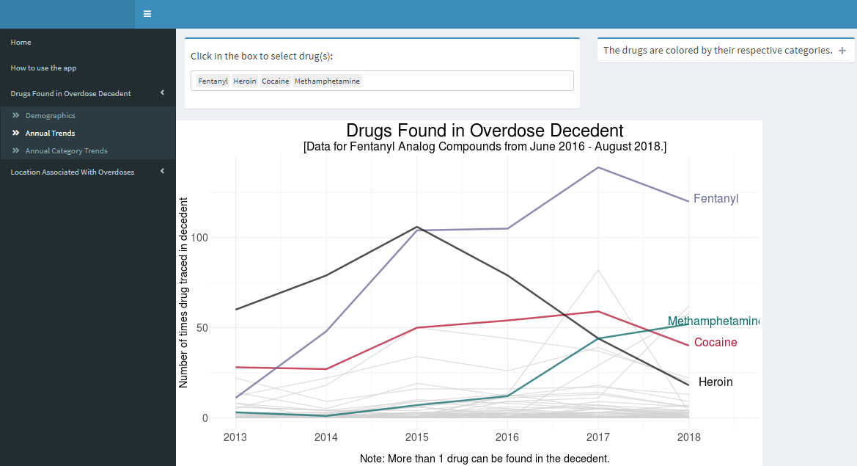

Figure 2 displays the trends in which drugs, including opioids, are found in overdose deaths. Fentanyl and methamphetamine have increased rapidly since 2014 and remain some of the most common drugs traced in decedents. Other drugs like heroin have had rapid declines in the number of times traced since 2015. Other drugs are displayed as light grey connected segments but will change color once the drug associated with that particular segment is selected.

The third tab, **Annual Category Trends**, produces a line graph that describes the number of times a drug category was found in a decedent over time. This value was calculated by utilizing the individual drug data used in Figure 2 and sums the ‘Number of times drug traced’ for each drug category. This display is similar to Figure 2; however, Figure 2 displays individual drugs. Drug categories combine similar drugs into a category to provide ease and clarity on the type of drugs playing large roles in this epidemic. This line graph helps easily identify patterns and trends in the categories of drugs in the epidemic.

The **Location Associated with Overdoses** tab is a dropdown menu with three options: **Address of Overdose Incidents**, **Trends by Cities & Townships**, and **Location of Incident vs Death**. By selecting the **Address of Overdose Incidents** tab, the application displays a map of the address where the presumed overdose incident happened (e.g. drug was used at this location) with an animation to show the addresses change over time, see Figure 3 below. The darker points represent a higher frequency. Lighter points represent a lower frequency, however, we cannot be certain that it represents a single death. The slider above the map can be used to select a particular year or an animation over the years 2013 to 2018.

Figure 3: Map showing the location of overdose incidents in 2018

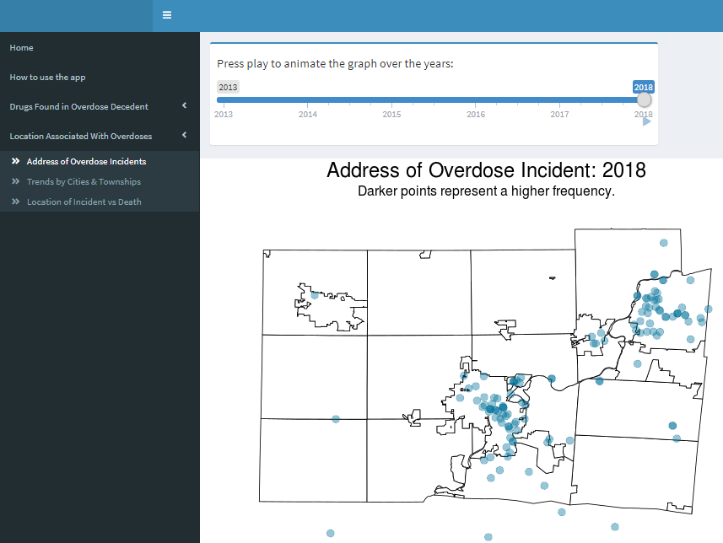

Using Figure 3, the concentration of location of overdose incidents can be viewed. In the application there is an animation option that allows users to observe the concentrations change throughout the 2013 to 2018 time period. According to this figure, the largest concentration of overdose incidents occurred in the urban areas, but there are several in the rural areas as well. The occurrence of overdose deaths is a not uniquely an urban problem. A line graph similar to Figure 2 was used to display the **Trends by Cities & Townships** (figure not shown).

The last tab, **Location of Incident vs Death**, contains two different bar graphs controlled by a dropdown that can be changed to view the overdose incident or death data. The location of the presumed incident is the location of overdose, which may not be the same as the location of death. The first bar graph on the left hand side illustrates the number of overdoses in each location of incidents/deaths within each city or township. The second bar graph illustrates the number of overdoses within each place of overdose incidents/deaths faceted by city or township selected. Examples of place of death include home, vehicle, or motel. A screenshot of this visualization can be observed in Figure 4. The input boxes above the graphical displays allow for the selection of the location of the incident and the city/township where the incident occurred.

Figure 4: Bar graph that illustrates the total number of overdoses from 2013 to 2018 by location of incident/death and place of overdoses by city/township

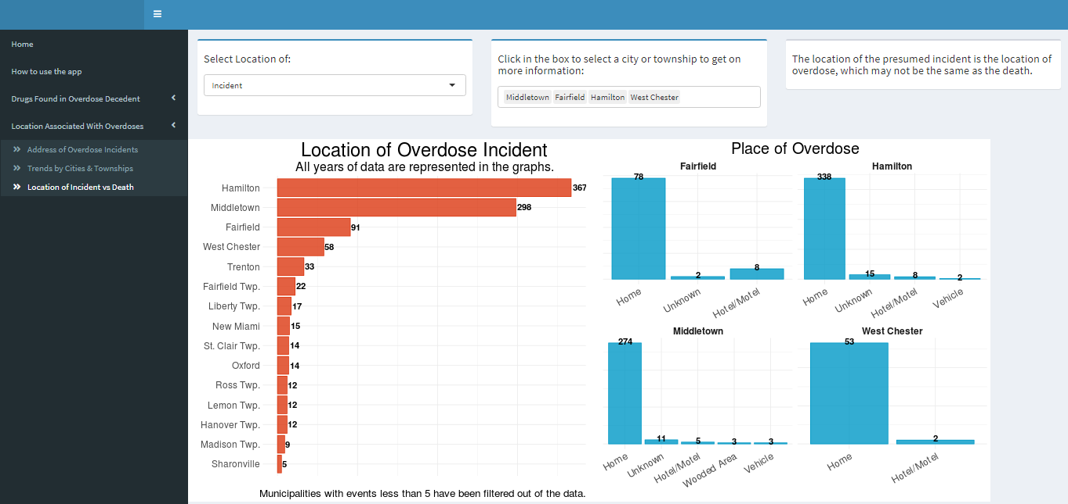

Using Figure 4, we can see that most of the overdose incidents in the top four cities or townships–Hamilton, Middletown, Fairfield and West Chester—occurred in a home.

# DISCUSSION

This application was developed with the intent of providing public access to information regarding overdoses in Butler County. More specifically, the purpose of this application was to provide the ability to look at specific drugs or drug categories over time and explore community locations of interest. For example, as stated in the Results section, drugs like heroin have had rapid declines in the number of times detected in decedents since 2015. What could this mean? Policy changes might have contributed to this decline, but the number of times fentanyl has been traced has not decreased over time. Why is that? Also, why are more males dying from the opioid epidemic? Although we may not have answers to these questions, we realize the benefits of collaborative efforts from the public health subject matter experts and the data gathering and developing experts to gather necessary insights.

Although all drugs detected in overdose victims are presented, communities are most interested in the impact of opioid-related deaths. This information is available as public record from the coroner’s office. That being said, this tool allows the public to access that information to answer specific questions. One of the challenges in developing and updating this application is the data cleaning process. The raw data provided are variable and require custom data processing for use in this application. This mandates that every update to the application be manual. This proves to be especially challenging if this application were expanded to other counties in Ohio, since there is no standard reporting format among all coroners.

The data set used in this application was provided by the coroner’s office. These data were initially intended for internal use only, but then later developed into the public application it is now. Ideally, data can be structured and formatted for ease of use in an application and for ease of updating in an application. For example, future data sets could use ICD10 codes, however, this would require adjusting the data set from previous years to be able to connect them.

Limitations of these data are that it only contains reported overdose deaths in a single county and that the decedent had to have their postmortem specimens available for toxicology analysis. The data set used in this tool from the toxicology report only includes three to four substances with the largest quantities found in the decedent. It is important to be mindful that the data set only includes overdose deaths, while excluding nonfatal drug overdoses. In addition, the presumed location of the incident cannot always be verified if there is no evidence of drug use or eyewitness reports of the use. Another limitation is the lack of historical context. If data were available for years prior to 2013, the application would provide more historic context to these epidemic concerns. The application can be expanded as more recent data become available, although data processing and reformatting is required for this.

There are many ways to improve the application in the future. First, by creating a standardized data collection system both within counties and across counties, the data cleaning and preprocessing could be automated, leading to a simple updating procedure of the application when new data become available. This could lead to real time displays of the data set within the application, rather than seeing data from the previous year. This could lead to different views as well, such as displaying these data by months, rather than over an entire year. It would also allow for offices such as the coroner to make decisions sooner when there are unusual trends observed in the data set. There is also room to enrich this application with external data, such as data regarding nonfatal drug overdoses, if data could be found at the city/township or zip code level. An additional major improvement would be expanding outside Butler County. By standardizing how every coroner collects their data, we could potentially expand to the entire state and address the epidemic directly. Also, adding to the tool when certain interventions were put in place would allow for stakeholders to directly see how policy and regulations are affecting the trends. We note that Ohio provides a dashboard for “Emergency Department Visits for Suspected Drug Overdose Among Ohio Residents Ages 11 Years and Older” (https://odh.ohio.gov/wps/portal/gov/odh/know-our-programs/violence-injury-prevention-program/Suspected-OD-Dashboard). This site provides some demographic information for overdose cases encountered in emergency department visits; however, this does not capture the granularity of detail about drugs found in overdose decedents nor the detail of locations of cases in a county.

Other counties can implement applications such as this. The key to success when developing this application was close collaboration on a team that included the coroner, county health officials and data scientists. Rapid prototyping of the application was needed to get feedback to improve the presentation of these data and the functioning of the application.

# IMPLICATION FOR PUBLIC HEALTH

The application developed and the results reported above have implications for public health practice and policymakers in Ohio. In addition to raising awareness about overdose deaths, this application allows the public to explore pertinent questions regarding this crucial matter. The policymakers in Ohio can use this information to make data driven decisions when passing new policy and addressing issues. For example, the amount of the opioid reversing drug, Naloxone (Narcan), available to first responders in a community can be increased or decreased based on the presence of opioids in that specific community. Once a community is aware of the number and type of overdoses, implemented policies or interventions may be able to reduce the number of overdose deaths over time. Knowing the place that most overdoses occur could identify areas where treatment resources could be made readily available. This application provides a way to understand the problem so subsequent actions can be taken to begin alleviating the problem.

# ACKNOWLEDGEMENTS

The Butler County Overdose Deaths application was initially created as a part of a data visualization class, enhanced in a senior independent study and finally updated in a senior capstone class. We particularly acknowledge the contributions of: Katherine Shockey, Rachel Lewis, Lulu Liu, and Martin Schneider. We also thank Brad Koby for his support in maintaining the server and software packages and licenses. Finally, we would like to thank the anonymous reviewers and editor for suggestions that improved this manuscript.

# REFERENCES

# National Institute on Drug Abuse. (2019, January 22). National Institute on Drug Abuse: Opioid Overdose Crisis. Retrieved from https://www.drugabuse.gov/drugs-abuse/opioids/opioid-overdose-crisis.

1. Insurance Institute for Highway Safety. (2018, December). Fatality Facts 2017: State by state. Retrieved from https://www.iihs.org/topics/fatality-statistics/detail/state-by-state#fatal-crash-totals.
2. National Institute on Drug Abuse. (2019, March 30). National Institute on Drug Abuse: Ohio Opioid Summary. Retrieved from https://www.drugabuse.gov/opioid-summaries-by-state/ohio-opioid-summary.
3. Centers for Disease Control and Prevention. (2019, June 27). Drug Overdose Deaths. Retrieved from https://www.cdc.gov/drugoverdose/data/statedeaths.html.
4. University of Wisconsin Population Health Institute. (2019). County Health Rankings and Roadmaps. Drug overdose deaths. Retrieved from https://www.countyhealthrankings.org/app/ohio/2017/measure/factors/138/data?sort=desc-3.
5. U.S. Census Bureau QuickFacts: Middletown city, Ohio; Hamilton city, Ohio; Butler County, Ohio; Ohio. (2019, September 10). Retrieved from https://www.census.gov/quickfacts/fact/table/middletowncityohio,hamiltoncityohio,butlercountyohio,OH/PST045218.
6. LAW Writer® Ohio Laws and Rules: 313.12 Notice to coroner of violent, suspicious, unusual or sudden death. (2004, January 30). Retrieved from http://codes.ohio.gov/orc/313.12.
7. Winston Chang and Barbara Borges Ribeiro (2018). shinydashboard: Create Dashboards with 'Shiny'. R package version 0.7.1. https://CRAN.R-project.org/package=shinydashboard
8. R Core Team (2018). R: A language and environment for statistical computing. R Foundation for Statistical Computing, Vienna, Austria. https://www.R-project.org/.
9. RStudio Team (2015). RStudio: Integrated Development for R. RStudio, Inc., Boston, MA http://www.rstudio.com/.
10. Garrett Grolemund, Hadley Wickham (2011). Dates and Times Made Easy with lubridate. Journal of Statistical Software, 40(3), 1-25. URL http://www.jstatsoft.org/v40/i03/.
11. D. Kahle and H. Wickham. ggmap: Spatial Visualization with ggplot2. The R Journal, 5(1), 144-161. URL http://journal.r-project.org/archive/2013-1/kahle-wickham.pdf.
12. Baptiste Auguie (2017). gridExtra: Miscellaneous Functions for "Grid" Graphics. R package version 2.3. https://CRAN.R-project.org/package=gridExtra.
13. Hadley Wickham, Romain François, Lionel Henry and Kirill Müller (2019). dplyr: A Grammar of Data Manipulation. R package version 0.8.0.1. https://CRAN.R-project.org/package=dplyr.
14. H. Wickham. ggplot2: Elegant Graphics for Data Analysis. Springer-Verlag New York, 2016.
15. Ohio Public Health Information Warehouse - Public: Disclaimer. (n.d.). Retrieved from http://publicapps.odh.ohio.gov/EDW/Site/Disclaimer

# Supplementary File

The data cleaning files and the code for the application can be found at https://github.com/alisontuiyott/OpioidOverdose. The process to create the application can be followed using the steps outlined in the graphic below.

A Shiny tutorial can be found at https://shiny.rstudio.com/tutorial/. An RStudio tutorial can be found at https://rstudio.cloud/learn/primers. R for Data Science, is a helpful online textbook to learn about R. It can be found at https://r4ds.had.co.nz/" https://r4ds.had.co.nz/.

Table 1: Demographic characteristics of residents in Ohio

|  |  |  |  |  |
| --- | --- | --- | --- | --- |
|  | Middletown, OH | Hamilton, OH | Butler County, OH | Ohio |
| Population Estimates, July 1, 2018 | 48,861 | 62,174 | 382,378 | 11,689,442 |
| White alone, percent | 81.1% | 84.9% | 84.6% | 81.9% |
| Black or African American alone, percent | 11.8% | 9.6% | 8.9% | 13.0% |
| Hispanic or Latino, percent | 5.6% | 5.5% | 4.9% | 3.9% |
| Two or More Races, percent | 4.2% | 2.9% | 2.4% | 2.3% |
| Bachelor's degree or higher, percent of persons age 25 years, 2013-2017 | 17.1% | 15.6% | 29.6% | 27.2% |
| Persons without health insurance, under age 65 years, percent | 11.9% | 11.9% | 6.9% | 7.7% |
| Median household income (in 2017 dollars), 2013-2017 | $39,116 | $42,360 | $62,188 | $52,407 |
| Persons in poverty, percent | 24.1% | 20.2% | 10.7% | 13.9% |