**Web Application to Investigate Butler County Overdose Death Data**

Alison Tuiyott1,*; Bri Clements1,2; A. John Bailer, PhD1; Lisa Mannix, M.D.3

1Department of Statistics, Miami University, Oxford, OH

2Columbus Collaboratory, 1375 Perry St, Columbus, OH 4320

3Butler County Coroner, Hamilton, OH

\***Corresponding Author:** Alison Tuiyott ● (513)-265-7079 ● tuiyotac@miamioh.edu

# ABSTRACT

**Background:** Drug overdose deaths, particularly opioid-related deaths, are a public health crisis in the United States particularly in many of the Midwestern states. Ohio has been dramatically impacted with Butler County being the country having the third highest rate. Information on overdose deaths is collected by the county coroner and can serve as a data source for the web application.

**Methods:** A web application was developed in the R Shiny package to explore the characteristics of all overdose deaths in Butler County 2013-2018. Demographics of the decedents can be examined, trends in deaths over time can be evaluated and the spatial location of these cases can be mapped.

**Results:** The use of the web app is used address three questions to illustrate its use: what are the types of people dying from the opioid epidemic; what other drugs are found in many overdose deaths; and has the number of opioid involved deaths increased in my community over time?

**Conclusions:**

**Key Words:** Epidemic, Ohio, Opioid, Overdose Death, R Shiny Application

# INTRODUCTION

In the United States, 1999-2017, almost 400,000 people died from an overdose involving any opioid, including prescription and illicit opioids.1 In 2016, Ohio had the second highest rate of drug overdose deaths among all 50 states.2 Out of 88 counties in Ohio, Butler County had the third largest rate of drug overdose deaths, 60 deaths per 100,000 population.3 This article describes the data visualization application designed to provide public access to this crucial information about Butler County. This interactive application empowers the public to be researchers to analyze the overdose deaths data for Butler County, Ohio. By providing access to summaries of this data, the Butler County community and other communities can be more knowledgeable of this epidemic and can increase the awareness about the epidemic.

This interactive application provides data visualization that are summaries of the Butler County overdose data. Here, data visualization tools provide an accessible way to see and understand trends, outliers, and patterns in data.4 Users can explore the demographics (gender, race/ethnicity, and age range) associated with the type of drug found in the decedent. Users can also analyze annual trends in types of drugs and categories of drugs found in decedents. The application also contains spatial/location information: a map of Butler County displaying the relative address of each overdose incident, annual trends of overdose incidents by city or township, and the types of places the overdose incidents occurred.

The goal of the application is to provide a framework to answer basic questions that someone might have about the epidemic at a local level. For example, what are the types of people dying from the opioid epidemic? What other drugs are found in many overdose deaths? Has the number of opioid involved deaths increased in my community over time? This article delves into the process of using such an application that can answer these kinds of questions.

# METHODS

**Setting:**

The data was collected in Butler County, Ohio. Butler County is located in the southwest corner of Ohio, bordering Indiana on the west side. Butler County is home to approximately 375,000 people.5 The major cities include Hamilton, Middletown, West Chester, Fairfield, Oxford, Trenton, and Monroe. The average household income is approximately $57,000.5 This is similar to the average household income for the entire country. The Butler County population is 85% White, 9% Black, 5% Hispanic or Latino, and 4% Asian.6 Approximately 90% of the population has a high school education or higher.6 Approximately 7% percent of the population under 65 years old is without health insurance.6

**Community, participant characteristics, recruitment:**

The data from the decedents with an overdose listed as a cause of death were used in the application. The coroner’s office investigates any suspicious deaths in the county. Overdose deaths are part of this data. The data in the application was from 2013 to 2018.

**Procedures/program description:**

The application was developed to provide access to public health issues. The Shiny package (ref) in the R7 (ref) software system was developed in the RStudio IDE (ref). The features and controls of this application are illustrated by answering using the app to answer: who are the overdose victims? What drugs are found in the overdose deaths? Has the number of opioid involved deaths increased over time?

**Measures/outcomes:**

For each decedent, we have demographic information: date of birth, date of death, age, gender, and race/ethnicity. We also have location information: place and address of incident, city/township/county of incident, place and address of death, city/township/county of death, and cause of death. Drug information found in the decedent were determined by toxicology assays of blood and urine. Early data included the top three drugs detected in each decedent. More recent data provided by the coroner included more details pertaining to the tracing of fentanyl analogs.

**Statistical analysis:**

Bar graphs and segmented bar graphs were used to represent the number of times a specific drug was traced in a decedent. They were also used to represent the number of overdose deaths located in a specific city and a specific place. Line graphs were used to visualize amount drugs or categories of drugs traced over time. They were also used visualize the frequency of overdose deaths in a city or township. Maps were used to illustrate the clusters of the location of overdose deaths.

# RESULTS (5 in-text figures)

The web application can be accessed at http://dataviz.miamioh.edu/Butler_County_Overdose_Deaths/. This is the landing page that describes the contributors to the application and the years of data included in the application. Upon entering the application, on the left sidebar, there are four options: Home, How to use the app, Drugs Found in Overdose Decedent, and Location Associated with Overdose Decedent. The landing page is Home. The ‘How to use the app’ tab describes how users can explore the application and notes a few details including that the data used in the application is only data from the overdose deaths in Butler County. The ‘Drugs Found in Overdose Decedent’ tab is a drop down menu with three options: Demographics, Annual Trends, and Annual Category Trends.

By selecting the ‘Demographics’ tab, the application displays a bar graph of the most frequent number of times a drug was traced in a decedent. A screenshot of this bar graph can be observed in **Figure 1** below.

**Figure 1: Segmented bar graph that illustrates the number of times each drug was traced in male and female decedents 31-60 years old.**

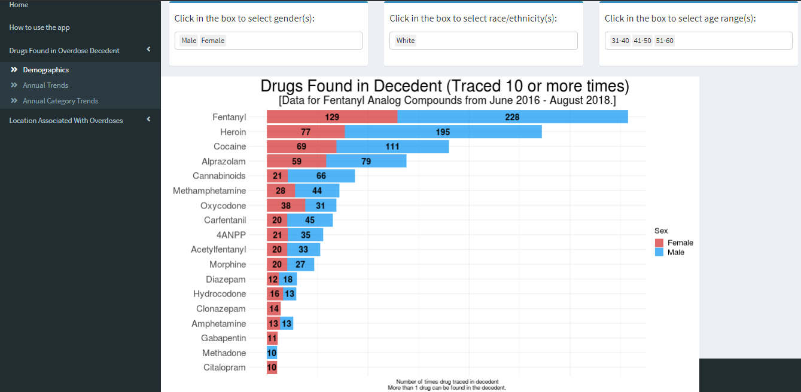

Using **Figure 1**, we can answer the first question posed in the introduction: what are the types of people dying from the opioid epidemic? Fentanyl and Heroin were the two most commonly encountered drugs found in drug overdose deaths during this time. In addition, we see more males than females in the top 12 drugs found.

The second tab, ‘Annual Trends’, shows a line graph that describes the patterns and trends in the number of times a drug was found in a decedent over time. A screenshot of this line graph can be observed in **Figure 2** below.

**Figure 2: Line graph showing the number of times each drug was found in overdose victims over time.**

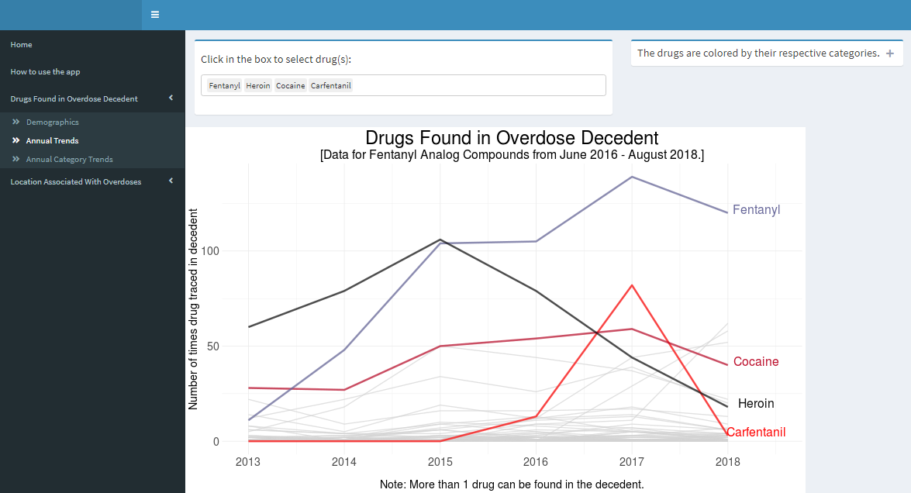

Using **Figure 2**, we can answer the second question posed in the introduction: what other drugs are involved in many overdose deaths? According to this figure, fentanyl has increased rapidly since 2014 and remains the drug traced the most in decedents. Other drugs like heroin and carfentanil have had quick declines in the number of times traced since 2015 and 2017, respectively. What could this mean? Policy changes might have contributed to this decline, but fentanyl has not decreased.

The third tab, ‘Annual Category Trends’, shows a line graph that describes the number of times a drug category was found in a decedent over time. Drug categories combine similar drugs into a category to provide ease and clarity on the type of drugs playing large roles in this epidemic. This line graph helps easily identify patterns and trends in the categories of drugs in the epidemic.

The ‘Location Associated with Overdose Decedent’ tab is a drop down menu with three options: Address of Overdose Incidents, Trends by Cities & Townships, and Location of Incident vs Death. By selecting the ‘Address of Overdose Incidents tab, the application displays a map of the addresses of the overdose incidents with an animation to show the addresses change over time. The ‘Trends by Cities & Townships’ tab shows a line graph with the number of overdose incidents over time, colored by city or township. A screenshot of this line graph can be observed in **Figure 3** below.

**Figure 3: Line graph showing the number of overdose incidents over time by city/township.**

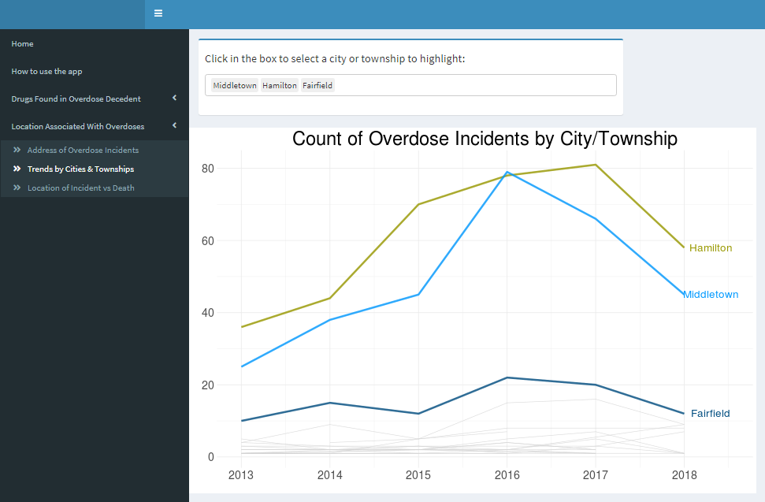

Using **Figure 3**, we can answer the third question: has the number of opioid involved deaths increased in my community over time? According to this figure, the most number of overdose incidents are from Hamilton, Middletown, and Fairfield. In 2016, Middletown had the most overdose incidents. What happened in 2016 in Middletown? How did the community turn it around and bring down the number of overdose incidents?

The last tab, ‘Location of Incident vs Death’, contains two different bar graphs controlled by a drop down that can be changed to view the incident or death data. The first bar graph illustrates the number of overdoses in each location of incidents/deaths within each city or township. The second bar graph illustrates the number of overdoses within each place of overdose incidents/deaths faceted by city or township selected. A screenshot of these graphs can be observed in **Figure 4** below.

**Figure 4: Bar graph that illustrates the number of overdoses by location of incident/death and place of overdoses by city/township.**

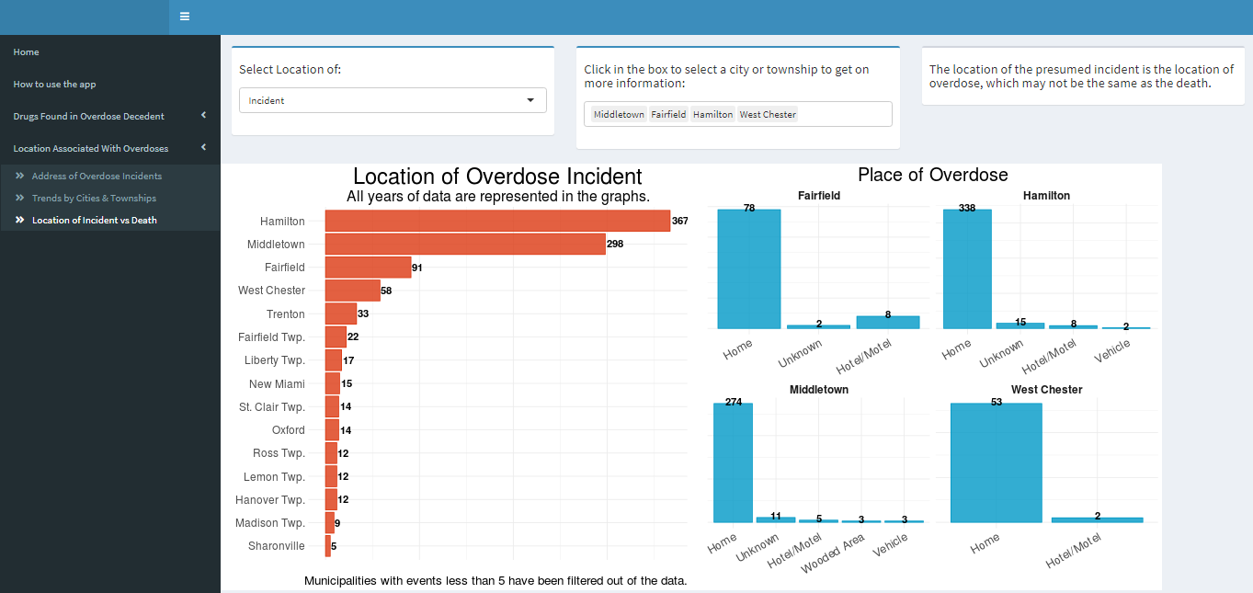

Using **Figure 4**, we can see that most of the overdose incidents occurred in the home, regardless of city or township. We also can see that West Chester, Trenton and Fairfield Township are the three cities following the top three in the county for number of overdose incidents. What can this information do to help raise awareness?

# DISCUSSION

**Need feedback from people who benefit from the application.**

This application was developed with the intent of …

One of the challenges in developing and updating this application was the data cleaning process. The raw data needed to be processed for use in this application and this mandates every update to the application to be manual.

If data were available for years before 2013, the application would provide more of a longer historic context to some of these epidemic concerns. The application could be expanded to include most recent data or even to other counties in Ohio.

# IMPLICATION FOR PUBLIC HEALTH

The application developed and the results reported above have implications for public health practice and policymakers in Ohio. The public is now able to explore questions pertaining to their curiosities by being able to access this information. The policymakers in Ohio can use this information to address the amount of Narcan police officers should carry on them. This application enables the public to make data driven solutions to local policy.

# Acknowledgements

The Butler County Overdose Deaths application was initially created as a part of a data visualization class, enhanced in an undergraduate senior independent study and finally updated in an undergraduate senior capstone class. We particularly acknowledge the contributions of Katherine Shockey, Rachel Lewis, and Lulu Liu.

# References

# Understanding the Epidemic | Drug Overdose | CDC Injury Center. (2018, December 19). Retrieved from https://www.cdc.gov/drugoverdose/epidemic/index.html

# Drug Overdose Deaths | Drug Overdose | CDC Injury Center. (2019, June 27). Retrieved from https://www.cdc.gov/drugoverdose/data/statedeaths.html

# Rankings. (2019). Retrieved from https://www.countyhealthrankings.org/app/ohio/2019/measure/factors/138/data?sort=desc-3

# Data visualization beginner's guide: a definition, examples, and learning resources. (2019). Retrieved from https://www.tableau.com/learn/articles/data-visualization

1. Where is Butler County, Ohio? (2016, June 30). Retrieved September 29, 2019, from https://www.worldatlas.com/na/us/oh/c-butler-county-ohio.html.
2. U.S. Census Bureau QuickFacts: Butler County, Ohio; Ohio. (n.d.). Retrieved from https://www.census.gov/quickfacts/fact/table/butlercountyohio,OH/BZA010216
3. R Core Team (2018). R: A language and environment for statistical computing. R Foundation for Statistical Computing, Vienna, Austria. <https://www.R-project.org/>
4. Winston Chang, Joe Cheng, JJ Allaire, Yihui Xie and Jonathan McPherson (2018). shiny: Web Application Framework for R. R package version 1.2.0. <https://CRAN.R-project.org/package=shiny>
5. Baptiste Auguie (2017). gridExtra: Miscellaneous Functions for "Grid" Graphics. R package version 2.3. <https://CRAN.R-project.org/package=gridExtra>
6. Hadley Wickham, Romain François, Lionel Henry and Kirill Müller (2019). dplyr: A Grammar of Data Manipulation. R package version 0.8.0.1. <https://CRAN.R-project.org/package=dplyr>
7. H. Wickham. ggplot2: Elegant Graphics for Data Analysis. Springer-Verlag New York, 2016.
8. Winston Chang, (2014). extrafont: Tools for using fonts. R package version 0.17. <https://CRAN.R-project.org/package=extrafont>
9. D. Kahle and H. Wickham. ggmap: Spatial Visualization with ggplot2. The R Journal, 5(1), 144-161. URL <http://journal.r-project.org/archive/2013-1/kahle-wickham.pdf>
10. Winston Chang and Barbara Borges Ribeiro (2018). shinydashboard: Create Dashboards with 'Shiny'. R package version 0.7.1. <https://CRAN.R-project.org/package=shinydashboard>
11. Garrett Grolemund, Hadley Wickham (2011). Dates and Times Made Easy with lubridate. Journal of Statistical Software, 40(3), 1-25. URL <http://www.jstatsoft.org/v40/i03/>.

# APPENDIX