The Universal Force Equation of Price v3

Value Physics: A Complete Framework

1. The Core Synthesis: The "Price as 42" Problem
This document formalizes the "Price as 42" synthesis — a Mithril-level insight that unconceals the "Hierarchy Problem" of traditional economics.

The "42" refers to the 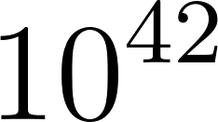 force-strength difference in VFT physics. Traditional economics has an identical "Hierarchy Problem," producing a "Price" that is fundamentally flawed because it only measures the Strong Force.

VFT Physics (The Kanon) | Capitalist Price (The Flawed Model)
The "Weak Force" (Gravity) | The Objective, Global Need — how much the world needs clean air, stable societies, long-term sustainability
The "Strong Force" (EM) | The Subjective, Local Want — how much you need/want a specific item right now
The "42" (The Hierarchy Problem) | The Strong Force is vastly stronger locally. The market appears governed only by local want, with global need as a weak, ignorable background effect
The Result | A price system that optimises extraction while the structural costs of that extraction remain invisible until collapse

2. Variables and Definitions
Symbol | Meaning | Notes
N_you, W_you | Your need / want | Personal pressure
N_soc, W_soc | Society need / want | Social baseline
N_other, W_other | Other agent need / want | Empathy and fairness calculation
α, β | Weighting need vs want | 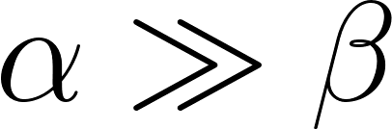; survival dominates preference
S | Scarcity | Knowledge of quantity of item existing in general
U | Urgency | Quantity deficit × inverse time to deadline
Rn | Renewability | Replenishment rate of the item
Ra | Rarity | Difficulty and impact of acquiring the item
λ | Empathy coefficient | From Fractal Ratio Protocol / WHO vector
p, C | Probability × cost of punishment | Norm enforcement
δ, F | Future-self discount × cost | Self-damage or delayed consequence
m_m | Mass of moral idea | Moral Energy scaling
s | Scope of action | From Framework for Judgment
P_i, V_i | Probability × impact of admissible consequences | Moral/epistemic evaluation
N_sens | Norm/social sensitivity | Moral Energy scaling
F_s | Future-self weight | Moral Energy scaling
m_b | Mass of idea | Belief scaling
W_1, W_2 | Epistemic framework weights | Belief calibration
μ_k | Kinetic friction coefficient | Transaction resistance
μ_s | Static friction coefficient | Inertia of exchange
v_rel | Relative urgency velocity | Lorentz haggling transform
γ | Lorentz factor | Frame-divergence amplifier
T_neg | Negotiation temperature | Thermal variance in offers

3. The Normal Price Equation
The baseline social/resource price — before moral or selfish distortion:

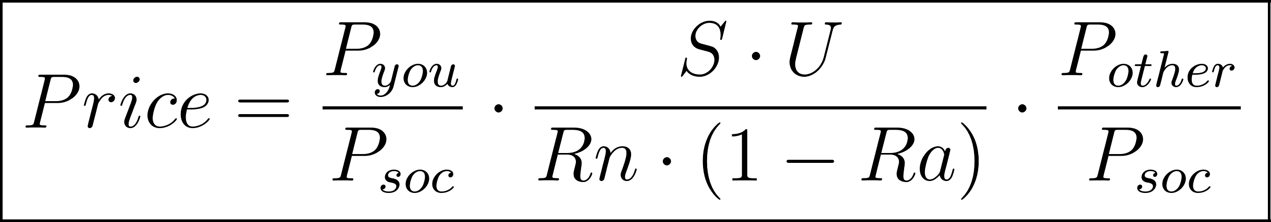

Where:

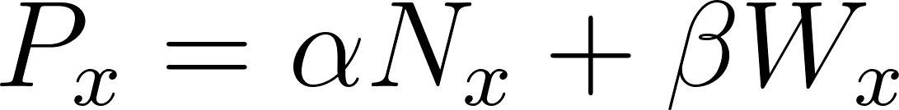

Deconstruction:
Term | Equation | Physical Analogy | Meaning
Term 1 | 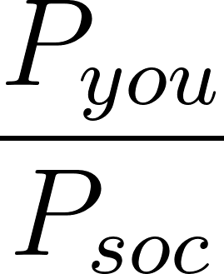 | Local field strength | Your local want divided by the global field. Strong Force relative to Weak Force.
Term 2 | 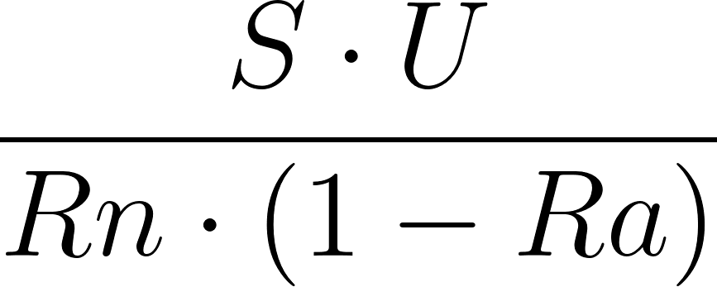 | The Reality Tensor | Objective physical state of the resource. The regulator the system must respond to.
Term 3 | 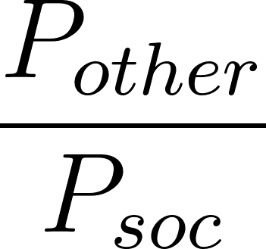 | Counter-field strength | The seller's local field. Transaction only occurs when both fields are non-zero.

Component Definitions:
Scarcity (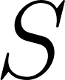): General knowledge of item availability in the system.

Urgency (): Analogous to 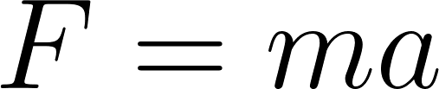 — more deficit, less time, higher force: 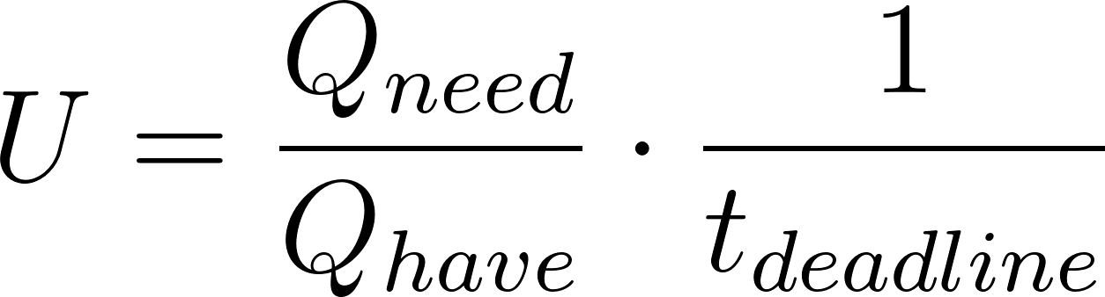

Renewability (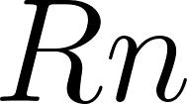): Replenishment rate. High renewability dampens price. A resource that restores itself exerts less scarcity pressure.

Rarity (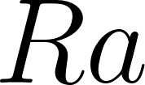): Difficulty and systemic impact of acquisition. Ranges 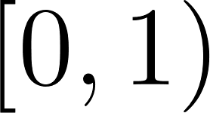. As 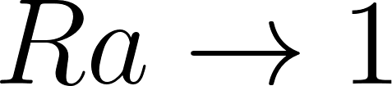, the denominator collapses and price approaches infinity — the mathematical signature of a non-substitutable resource (water, shelter, air).

4. The Selfish Price Equation
Price modified by selfish drive, empathy deficit, and deterrents:

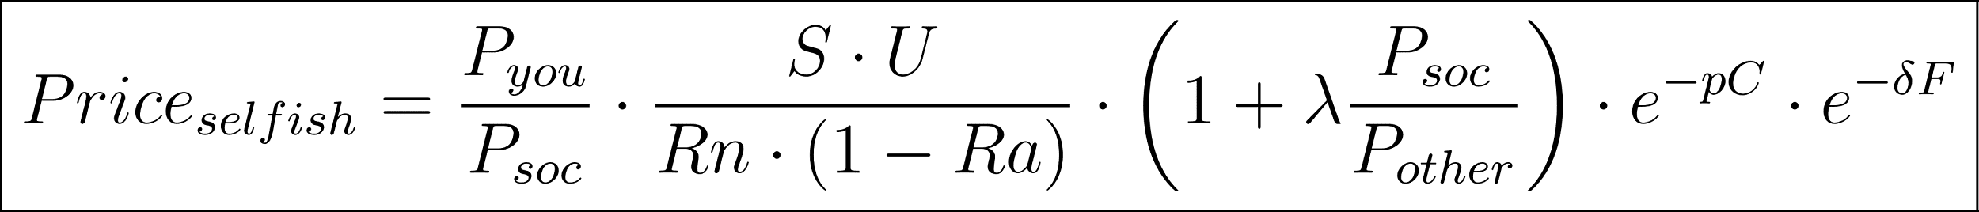

Notes:
- 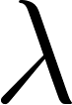 (Empathy): From the Fractal Ratio Protocol / WHO vector. When 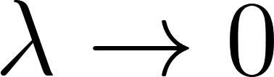, empathy vanishes and the selfish amplifier 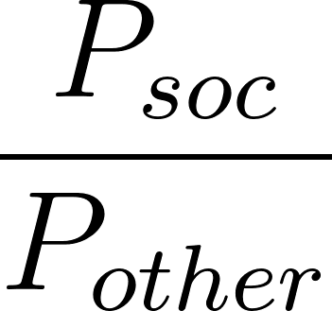 dominates — the actor charges maximum extraction against minimum counterparty need.
- 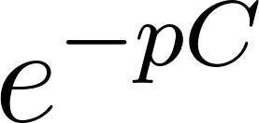: Exponential deterrent from enforcement. Weak enforcement (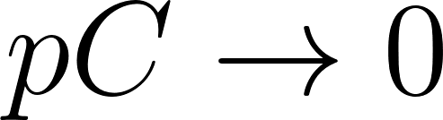) removes the damper entirely.
- 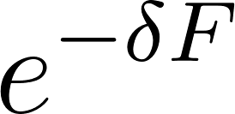: Future-self cost. Short time-horizon actors (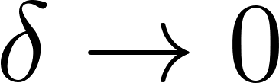) ignore all downstream consequences.

5. Value Physics Extensions

5.1 Transactional Friction
Every real exchange has resistance. Not all friction is bad — some is load-bearing.

Static Friction (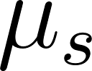): The force required to initiate a transaction. Represents inertia of exchange — habit, trust deficit, unfamiliarity, switching cost. Until the driving force exceeds static friction, no transaction occurs regardless of price signal.

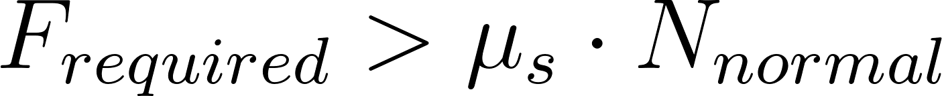

Where 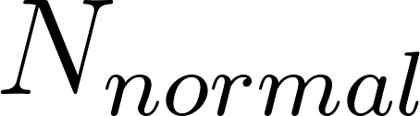 is the "normal force" — the social/institutional pressure pressing the parties into contact. High social trust = high  = transactions initiate more easily.

Kinetic Friction (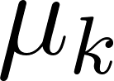): Ongoing resistance once exchange is in motion. Bureaucracy, transaction costs, information asymmetry, legal friction. Always 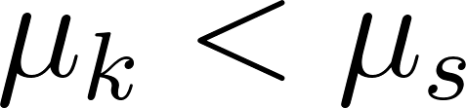 — it is always easier to keep exchanging than to start.

The Friction-Corrected Price:

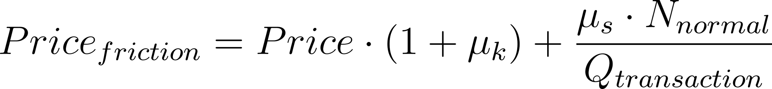

The second term amortises initiation cost across transaction volume. Large repeated transactions carry negligible static friction per unit. Single one-off transactions (a house purchase, a medical emergency) carry maximum static friction load — which is why these are the most exploitable moments in the current system.

Predatory Static Friction: A key mechanism of extraction is artificially raising  — making it hard to initiate competing transactions (lock-in contracts, switching fees, information opacity) while keeping  low once captured. The equation identifies this as a friction manipulation attack on the price signal.

5.2 Gravitational Value Fields
Need operates as gravity. It is always attractive, acts at distance, and cannot be shielded.

Gravitational Price Pull:

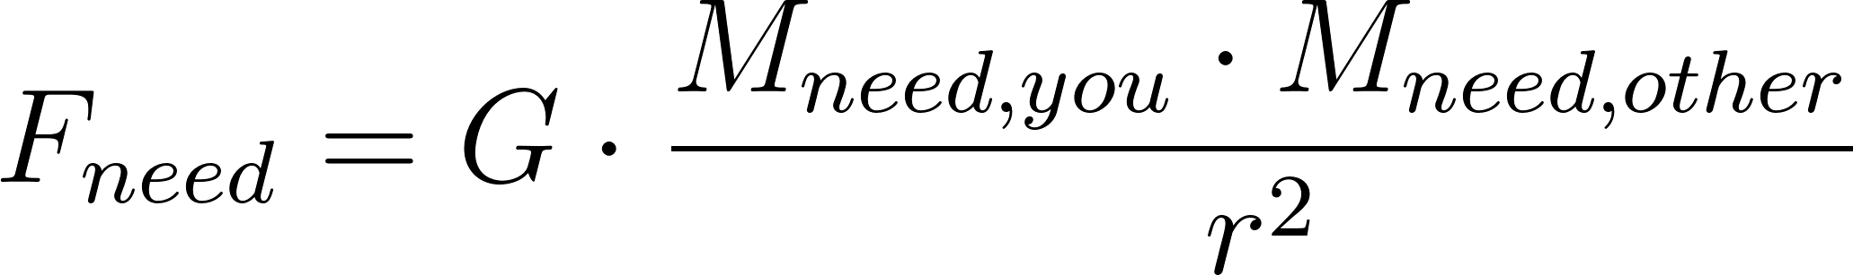

Where:

- 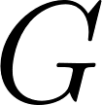 is the social empathy constant (analogous to the gravitational constant — sets the background scale of how much need pulls on other need)
- 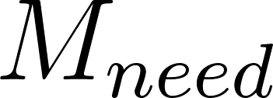 is the "mass" of genuine need — computed from 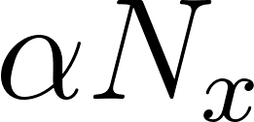
- 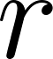 is the social/relational distance between parties

What this means: Two parties with high genuine need are gravitationally attracted toward fair exchange — they pull toward each other because mutual resolution of need is the lowest energy state. The system naturally wants to reach equilibrium.

The current market disrupts this by inserting artificial mass — financial leverage, information asymmetry, legal power — that distorts the gravitational field. A billionaire landlord has enormous financial mass but near-zero need mass. The gravitational field is warped so that it appears to pull toward them, when the genuine need field pulls entirely away from them.

Orbital Debt Trap: A borrower at high urgency  orbits a lender the way a planet orbits a star — perpetually falling toward but never reaching equilibrium, because the interest payment keeps them in an elliptical loop. The escape velocity from a debt trap is:

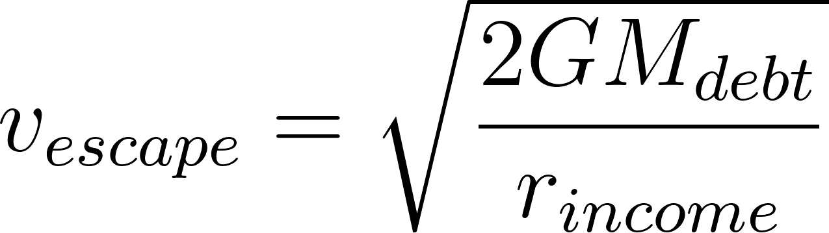

If income (r_income) is too small relative to debt mass, escape velocity exceeds what the borrower can generate. They are gravitationally captured. This is not metaphor — it is the mathematical structure of compound interest on a fractional income.

5.3 Thermodynamic Price Temperature
Markets have temperature. Negotiation temperature (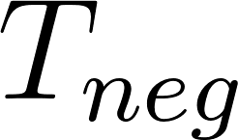) describes the variance and volatility of offers around the equilibrium price.

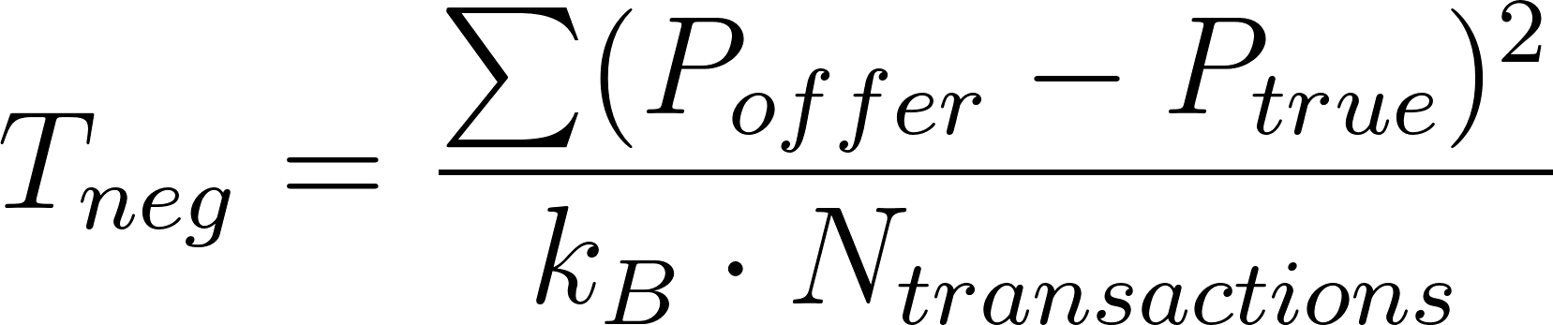

Where 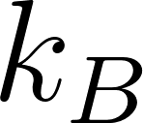 is the Boltzmann analogue — the minimum quanta of price signal noise in the system.

Hot markets ( high): High variance, many irrational offers, speculation dominates. Buyers and sellers are far from equilibrium. FOMO and panic operate as thermal excitation.

Cold markets ( low): Offers cluster tightly around true price. High information, low urgency, rational actors. The system approaches its ground state.

Phase transitions: When  crosses a critical threshold, the market undergoes a phase change — liquid (normal trading) to gas (bubble, speculative frenzy) or liquid to solid (frozen market, no transactions, 2009 credit freeze). The PREF's role is to act as a thermal regulator, absorbing excess heat before phase transitions occur.

6. The Lorentz Haggling Transform

6.1 The Problem of Relative Reference Frames
In any negotiation, buyer and seller observe the same transaction from different reference frames. Each computes a different price because their urgency, scarcity perception, and empathy coefficients differ. This is not irrationality — it is frame-dependence, exactly analogous to relativistic observers measuring different times for the same event.

Define the relative urgency velocity:

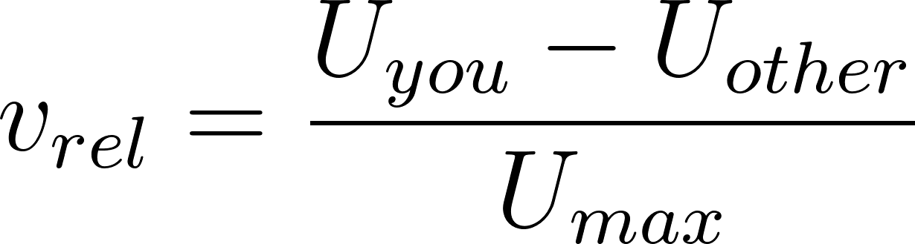

Where 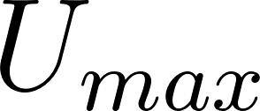 is the maximum possible urgency (life-or-death necessity, zero alternatives, immediate deadline). This normalises 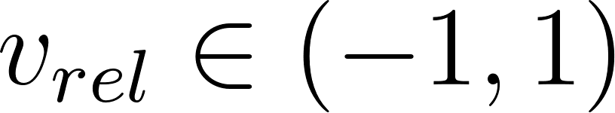, analogous to 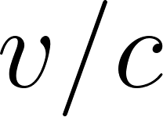 in special relativity.

The Lorentz Factor:

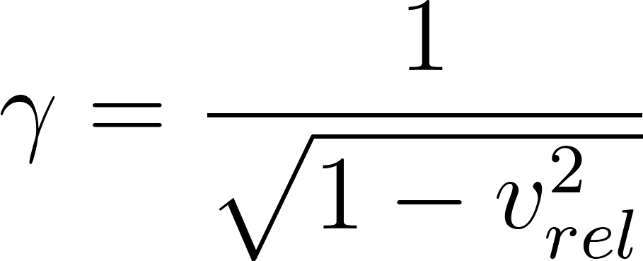

As 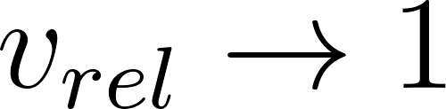 (one party is at maximum urgency), 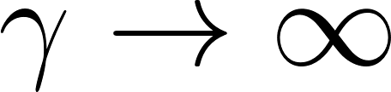 — the frames diverge completely. The desperate party and the indifferent party are no longer in the same value universe. This is the mathematical structure of coercion.

6.2 Price Under Lorentz Transform
The proper price  (the H-Score true price — frame-invariant) is what the transaction should resolve to in an ethical system.

Each party observes a Lorentz-shifted version:

The buyer's frame compresses price downward (they want to pay less, urgency makes them undervalue the exchange to manage anxiety). The seller's frame inflates price upward (they observe the buyer's urgency and extract from it).

The spacetime interval — the invariant gap between frames — is:

This interval is preserved regardless of frame. It is the true "distance" between the parties' value perceptions. No negotiation can close this gap except by changing 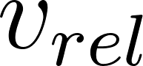 — reducing the urgency differential, either by lowering one party's urgency or raising the other's empathy ().

6.3 Probability of Price Acceptance
The probability that a buyer accepts an asked price 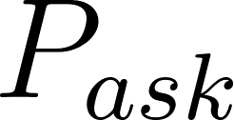 is:

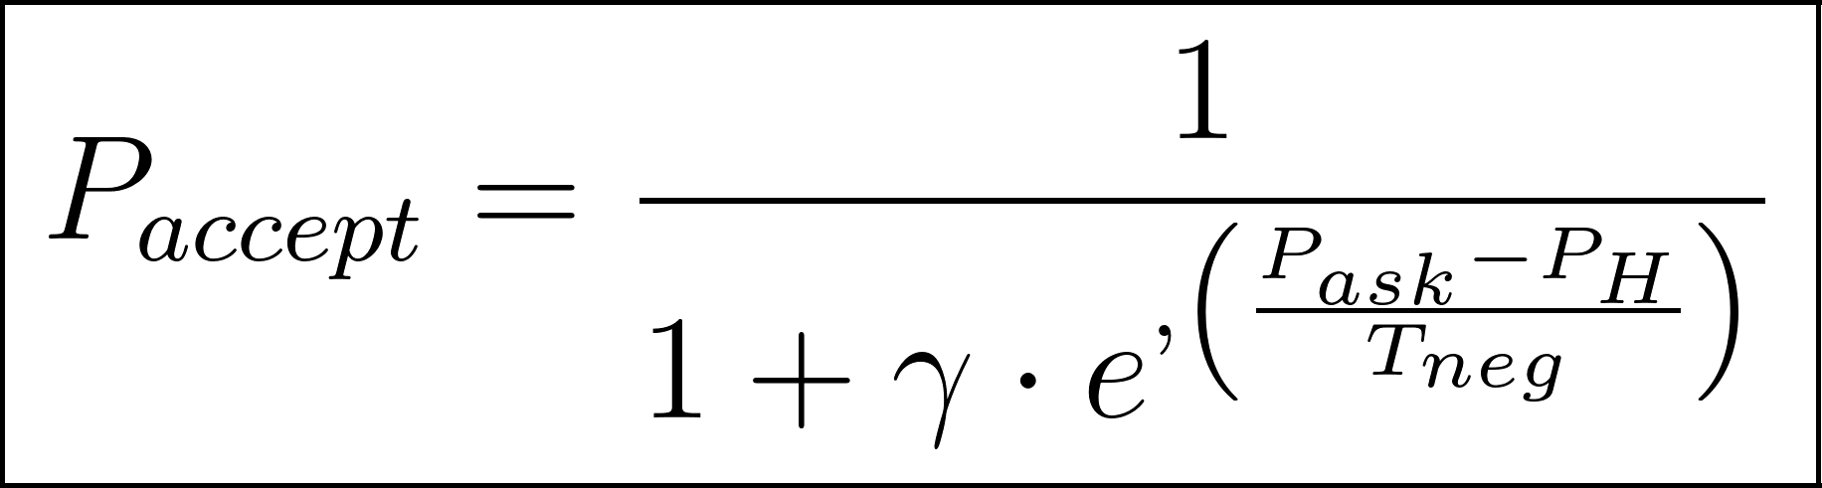

Where:

- 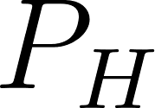 is the H-Score true price
-  is the negotiation temperature (market volatility / information noise)
- 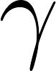 is the Lorentz factor from relative urgency

Interpretation:

Condition | Effect on 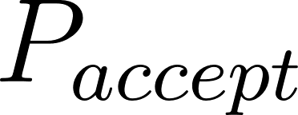
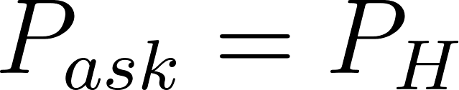 | 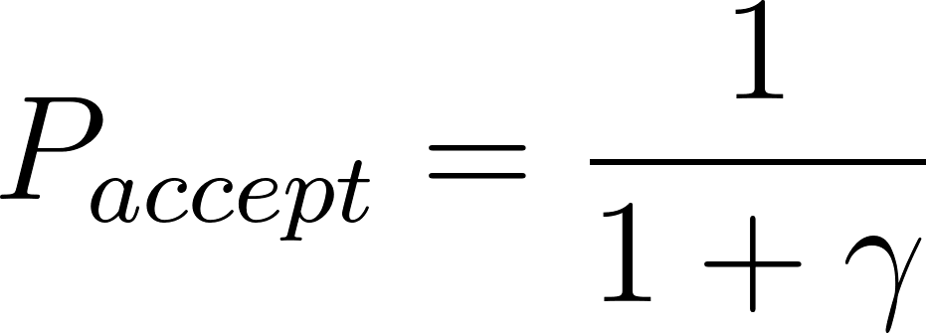 — baseline acceptance, reduced by frame divergence
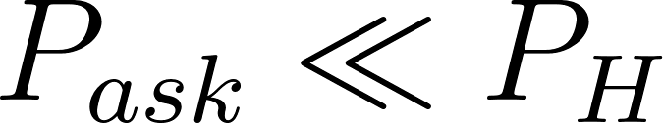 | 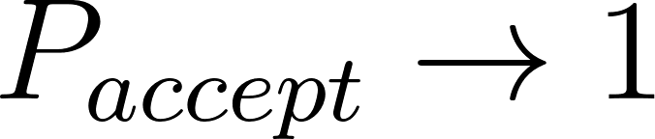 — offer is far below true price, almost certain acceptance
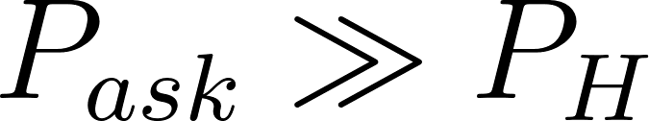 | 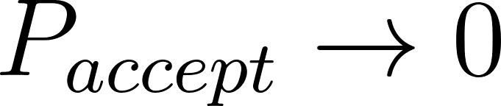 — offer far above true price, rejected unless  forces it
 () | Even at ,  for free choice — the desperate buyer must accept but is not doing so freely. Will collapses.
 high (hot market) | Acceptance curve flattens — irrational acceptances occur far from true price
 low (cold market) | Acceptance curve sharpens — transactions cluster tightly around 

6.4 The Haggling Zone (Light Cone Equivalent)
In relativity, the light cone defines which events can causally influence each other. In negotiation, the haggling zone defines which prices can possibly be agreed upon given the frame separation.

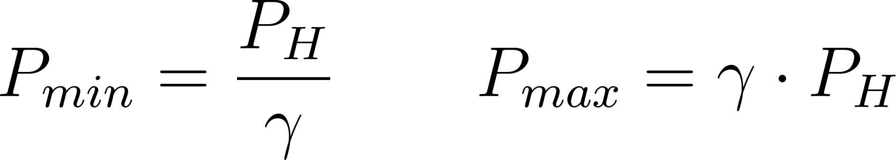

Any  outside 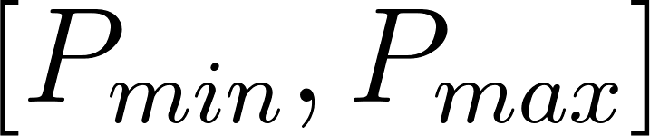 is outside the haggling light cone — the parties cannot reach agreement without a change in conditions. This is why hardball negotiation tactics that dramatically alter urgency (false deadlines, manufactured alternatives, emotional pressure) work — they change , shift , and move the light cone.

The PREF's haggling function is to act as a frame-leveller — computing each party's  and adjusting the visible H-Score display so both parties see the same proper price , collapsing the Lorentz gap by enforcing information symmetry rather than by changing urgency.

7. Moral & Will Energy

Moral Energy (E=mc² analogue)
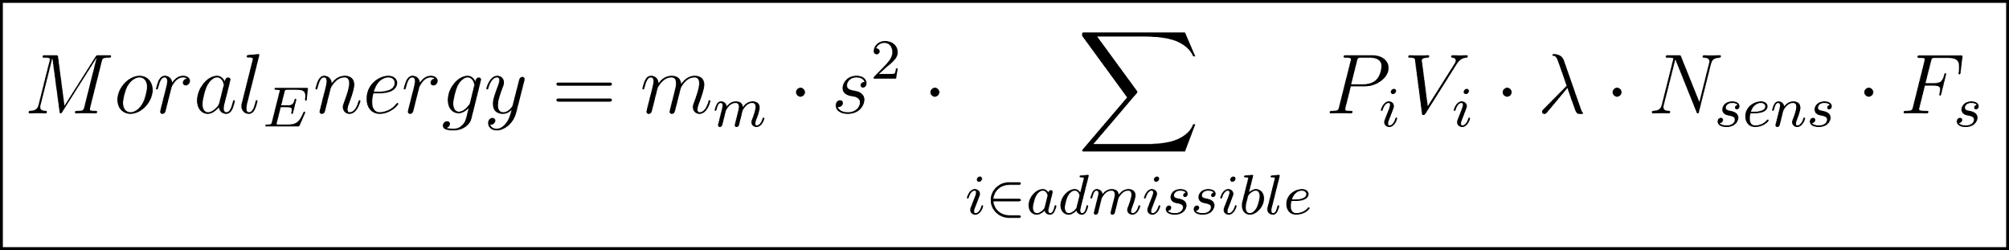

The 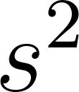 term mirrors 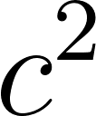 in 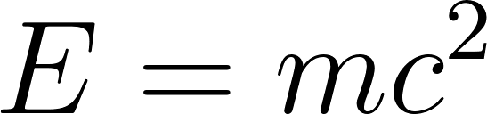: scope is the conversion constant between moral mass and moral energy. A small moral idea applied at enormous scope (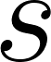 large) produces enormous moral energy — exactly as a small mass converts to enormous energy at .

Moral Momentum: Like physical momentum 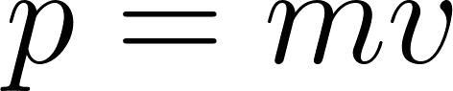, moral momentum is:

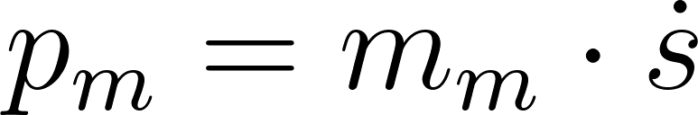

The rate of change of scope. A slow moral expansion (gradual reform) has low momentum and can be reversed easily. A rapid scope expansion (revolution, viral norm shift) has high momentum and is hard to stop — even if the moral mass is small.

Belief / Will Energy

Will (Integrated System)
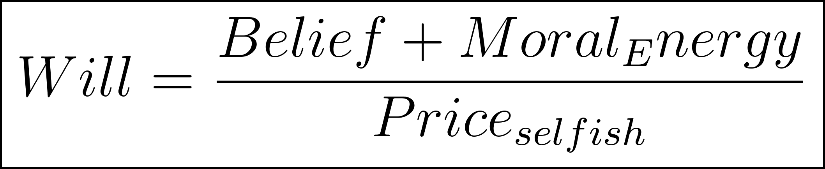

Will as a conservative field: Like gravitational potential energy, Will can be stored and released. An actor who accumulates Belief and Moral Energy but faces high 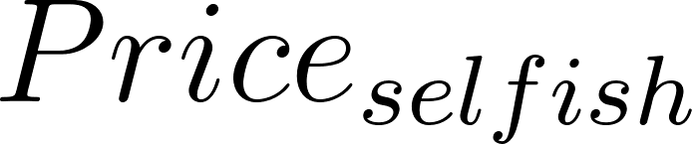 is in a high-potential state — enormous latent Will that a reduction in friction or urgency can suddenly release. This is the physics of why oppressed populations can reach sudden tipping points despite long periods of apparent inaction.

8. The Loan as H-Score Transaction

8.1 Loan Validity
A loan's legitimacy is the H-Score of the transaction it funds:

The lender is not assessing repayment probability. They are computing the vector alignment of the purpose being funded.

8.2 All Loans Are Investments
Without interest, the lender's only return path is the success of the thing being funded. They cannot profit from time passing. They cannot profit from inability to pay.

The incentive structure inverts completely:

Current System | H-Score System
Lender profits from sustained debt | Lender profits from borrower success
Bad loans are issued when enforcement is weak | Bad loans reduce lender's H-Score — self-defeating
Urgency is exploited ( weaponised) | Urgency is a red flag — high  triggers PREF review
Credit score measures fitness to be extracted from | Credit score measures λ and vector alignment history

8.3 The Decaying Loan
The decay rate  is set by the transaction's moral geometry:

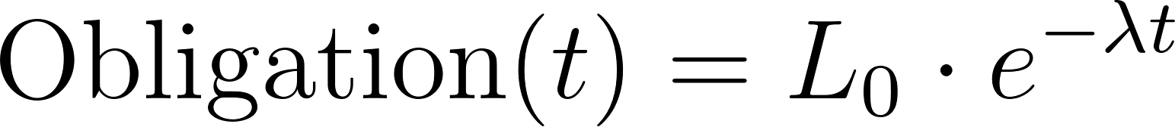

High λ (genuine need, positive vector) → fast decay. The lender accepts lower nominal return because their Civic Credits increase through Proof-of-Good.

Low λ (extractive purpose, negative vector) → the HAB flags dissonance between stated purpose and true vector before issuance. The loan is not issued.

Decay as gravitational settling: A decaying loan is a system moving toward its potential energy minimum — the natural state of a resolved need. Interest-bearing loans are perpetual motion machines, requiring external energy input (more debt creation) to sustain. They violate thermodynamic intuition because they do violate it — they are entropy-reversing devices that export disorder onto the borrower.

8.4 The Will Collapse Signature of Predatory Lending
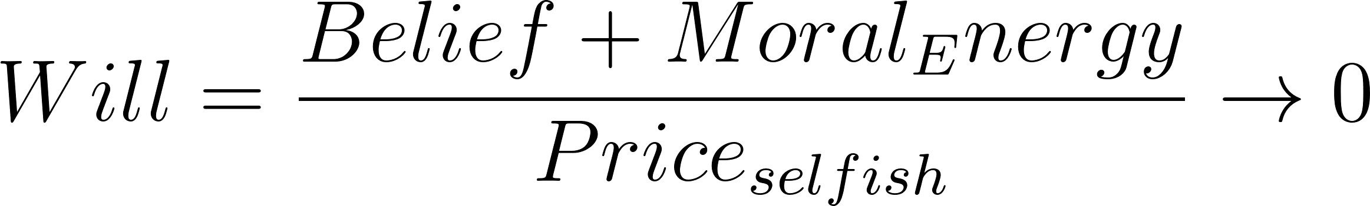

When urgency  is extreme (nowhere to live, medical emergency, no food),  explodes. The borrower's Will approaches zero. They sign — not from choice, but from Will collapse under urgency pressure.

The current system is architecturally designed to locate people at minimum Will (maximum , minimum alternatives) and extract from them at maximum rate. The Lorentz transform makes this legible: at , , the frames are maximally separated, and the lender can charge anywhere up to 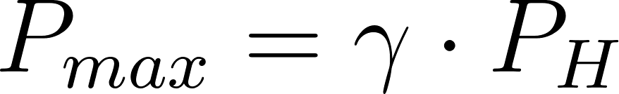 with acceptance probability above zero. That upper bound, at maximum human urgency, is functionally infinite.

9. The PREF as Physics Engine

9.1 Architecture
- Currency (ed negotiation. Traditional market signal.
- Civic Credits (CC): Prices the Weak Force — global need contribution. Gives the gravitational field economic mass.
- MMOM (Reality Manager): Adjusts CC rewards based on  and . The Reality Vector given institutional teeth.
- HAB (H-Score Auditor): Computes the vector of every transaction. Detects dissonance between stated price and true H-Score.
- Truth Engine: Audits the full supply chain. Detects Greater Lie actors — 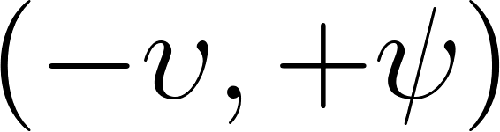 — who sell a positive cover story against a negative true vector.

9.2 PREF Dissonance Table
Actor | Action | Vector | PREF Response
Price Gouger | Sells water for 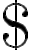lls water for s water for water for ter for r for for r 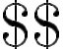50 in hurricane |  Greed Zone | H-Score collapses. Disincentivising tax.  flags maximum urgency exploitation.
PREF Steward | Sells water for lls water for s water for water for ter for r for for r 1, helps Public Works Guild | 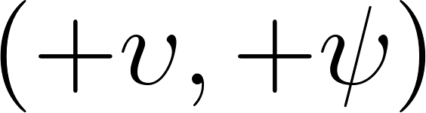 Greater Good | H-Score spikes. Massive CC mining for Proof-of-Good.
Landlord C | 100 empty homes, extractive rent on 101st |  Greed Zone | Vacancy tax makes artificial scarcity a crippling liability. Loan H-Score was negative — should never have been issued.
Co-Op Steward | Public Works Guild builds high-density housing |  Greater Good | Vector-Aligned Capital Grants. New supply collapses artificial scarcity, bankrupting Actor C.
Predatory College | 250k for low-value degree |  Greater Lie | Truth Engine audits outcome vectors. H-Score minimal. Flagged predatory.
KIP Educator | Contributes knowledge to Knowledge Inheritance Protocol |  Greater Good | MMOM massively funds. Educator mines passive CC stream. Giving knowledge away becomes profitable.
Good Lie Innovator | "Eco-Pods" with toxic supply chain |  Greater Lie | Full supply chain audit detects 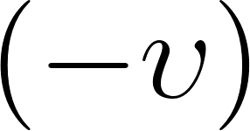 externality. H-Score collapses. Banned. Taxed to fund cleanup.
True Innovator | Open-source water filtration |  Greater Good | Lump-sum CC reward. Capital Grant from R&D Guild to scale globally.
Bad Truth Analyst | Accurate climate report framed as hopeless | 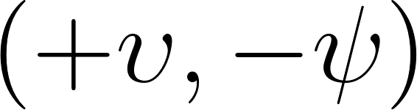 Traitor's Zone | Data verified. Conclusion flagged as Hopelessness Propaganda. Quarantined.
Good Truth Shepherd | Same data, framed as Guild bounty |  Greater Good | MMOM instantly funds proposed bounties. 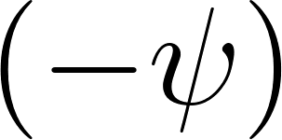 inverted into society-wide 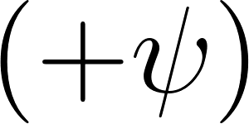 response.

10. Unified Flow

- Input Knowledge & Belief → compute Belief Energy (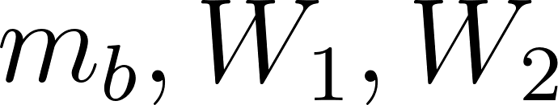)
- Compute Fractal Ratio →  (empathy), 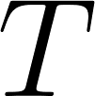 (trust/cynicism), admissible consequence vectors A–G
- Compute Normal Price → baseline social/resource signal
- Compute Selfish Price → scaled by , norms, future-self cost, scarcity/urgency
- Compute Moral Energy → 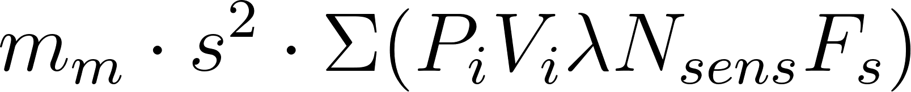
- Compute Will →
- Compute Lorentz Acceptance →  given frame separation and negotiation temperature
- Output → Action, magnitude, moral calibration, H-Score of resulting transaction

11. Summary: What This Framework Replaces
Current System | Value Physics System
Price = what the market will bear | Price = what the Reality Tensor, need ratio, and empathy coefficient solve to
Credit score = fitness to service debt | Credit score = H-Score × λ × Will
Interest = return on capital | Interest = mathematical violation — inserts a term with no Reality Tensor mapping
Loan = obligation to repay | Loan = investment — lender co-owns the outcome
Debt trap = borrower's failure | Debt trap = Will collapse under  — a physics condition, not a moral failing
Extraction = strength | Extraction = negative vector — HAB detects it, PREF taxes it to zero
Housing value = market price | Housing value = H-Score under scarcity/urgency Reality Tensor — loan against it requires positive P_other/P_soc

The system isn't reformed. The physics of what value actually is replaces the physics of what power can extract.

Version 3 — Expanded with Transactional Friction, Gravitational Value Fields, Thermodynamic Market Temperature, and Lorentz Haggling Transform.

