The Universal Force Equation of Price: A Phase Space Analysis of Value and Transactional Mechanics

Abstract
Orthodox pricing models, including the Arrow-Debreu equilibrium, rely on assumptions of perfectly competitive markets, symmetric information, and rational utility maximization. Consequently, these models routinely fail to predict systemic collapses or account for structural asymmetries in transactional mechanics, dismissing catastrophic failures as statistical anomalies rather than mathematical inevitabilities. This paper presents a fundamental theoretical synthesis that conceptualizes price not merely as an intersection of supply and demand schedules, but as a multi-variable vector field governed by principles structurally isomorphic to statistical mechanics and special relativity. We propose the Universal Force Equation of Price, which integrates a "Reality Tensor"—comprising scarcity, urgency, renewability, and rarity—as an invariant, dimensionless scaling factor analogous to the speed of light in mass-energy equivalence. By applying the Lorentz transform to relative bargaining urgency and utilizing a partition function to model complex n-body market interactions, this framework mathematically resolves the observed empirical failures of the Efficient-Market Hypothesis. The model introduces thermodynamic market temperature (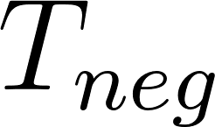) and frictional scaling to map extractive versus symbiotic market behaviors within a rigorous phase space analysis. This descriptive framework provides a testable, mathematical foundation for understanding systemic constraints. It offers a structural explanation for crises in housing, resource depletion, and credit markets where traditional neoclassical frameworks report market equilibrium despite compounding structural instability and localized coercions.

Keywords: Econophysics, Arrow-Debreu Equilibrium, Lorentz Transform, Partition Function, Thermodynamic Economics, Prospect Theory.

1. Introduction and Literature Review
The persistent failure of classical and neoclassical economic models to account for structural market failures, ecological externalities, and systemic debt traps highlights a fundamental limitation in orthodox price theory. General equilibrium theory, pioneered by Arrow and Debreu (1954), assumes a theoretical market where prices seamlessly clear and resources allocate efficiently under symmetric conditions. The Efficient-Market Hypothesis (Fama, 1970) further embeds the assumption that asset prices reflect all available information, treating deviations from equilibrium as rapid, self-correcting random walks. However, these foundational orthodoxies routinely fail to predict or explain the sudden, catastrophic phase transitions observed in modern financial systems.

The subsequent emergence of econophysics (Mantegna & Stanley, 1999) has demonstrated that markets exhibit power-law tails, volatility clustering, and scaling invariances consistent with complex physical systems rather than idealized linear equations. Didier Sornette (2009) fundamentally challenged the random walk hypothesis with his "Dragon King" theory, demonstrating that extreme financial events are not incalculable "Black Swans," but rather the predictable result of positive feedback mechanisms and deterministic phase transitions analogous to the rupturing of physical materials. Similarly, Jean-Philippe Bouchaud (2008) has exhaustively critiqued the axiom of rational expectations, showing that complex, interacting systems generate emergent phenomena that cannot be modeled by representative agent abstractions. The market is not a clearinghouse of rational calculators; it is a statistical ensemble of localized interactions prone to systemic avalanches.

However, even within the advanced models of econophysics, a core unresolved issue remains: the "Hierarchy Problem" of value generation. In physics, established vector field dynamics demonstrate that forces operate at vastly different magnitudes. The strong nuclear force operates over extraordinarily short distances with massive intensity, while gravity—the weak force—operates universally but is easily overcome locally by other interactions. Transactional economics exhibits an identical hierarchy. The localized, immediate desire of an individual agent (analogous to the strong, short-range force) heavily outweighs the diffuse, structural necessity of long-term system stability (analogous to the weak, long-range force).

Current pricing mechanisms mathematically optimize exclusively for the local, short-range force. The structural costs of that extraction—such as atmospheric carbon accumulation or housing affordability crises—are treated as invisible market externalities. They remain unpriced until a critical threshold is breached, at which point the cumulative deferred necessity asserts itself as a systemic collapse.

To resolve this disparity, we must integrate the physical laws of thermodynamics directly into the pricing mechanism. As Nicholas Georgescu-Roegen demonstrated in The Entropy Law and the Economic Process (1971), economic activity fundamentally relies on the irreversible transformation of low-entropy resources into high-entropy waste. An economic theory that ignores the physical boundaries of its host ecosystem is mathematically incoherent over long time horizons. Furthermore, the localized irrationality observed in markets is not random; it is predictably distorted by scarcity and urgency. Kahneman and Tversky’s Prospect Theory (1979) proved that agents exhibit bounded rationality and extreme loss aversion under pressure. Yet, orthodox pricing models lack a geometric mechanism to quantify how this psychological pressure distorts the valuation of an asset.

This paper introduces a formal mathematical framework that resolves the economic Hierarchy Problem by unifying thermodynamic constraints with relativistic frame dependence. By mapping transactional urgency to a Lorentz factor and defining core physical constraints within a dimensionless Reality Tensor matrix, we establish a descriptive model of systemic mechanics. This framework provides an algorithmic governance mechanism capable of classifying market interactions not through subjective utility, but through systemic vector alignment, offering a rigorous phase space analysis of value.

2. Axiomatic Foundations and Formal Mathematical Derivation
The Universal Force Equation of Price rests on several structural isomorphisms drawn from statistical mechanics and relativistic physics. Orthodox price theory models a transaction as the intersection of two curves crossing a Cartesian plane. The reality of a transaction is profoundly different: it is a negotiation between two distinct masses occurring within an invariant physical environment dictating the terms of that negotiation. The foundational axioms are:

- Axiom 0: Epistemological Isomorphism: Truth and information are measured strictly by the accuracy with which mathematical functions map to observable reality. Therefore, the physics analogies utilized throughout this framework do not imply literal physical substrates (e.g., fiat currency does not possess hadronic mass), but rather signify qualities that are mathematically and behaviorally isomorphic under the described physical functions. A fundamental particle does not inherently declare 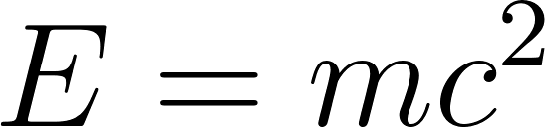; rather, the equation accurately describes the effects of that particle in relation to its environment. Similarly, if asked whether price is literal physical mass, the rigorous answer is: "Yes, but not in the localized physical framework you assume." It behaves identically to physical mass within the specific tensor geometry of the economic vector field.
- Transactional Dual-Mass Requirement: A transaction requires two interacting agents. Price cannot exist unilaterally; it is the emergent product of reciprocal vector forces.
- The Reality Tensor as an Invariant Constraint: The fundamental physical state of a resource (its generalized scarcity, renewal rate, and absolute rarity) acts as an immovable boundary condition. This tensor limits the negotiation and is structurally isomorphic to 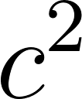 in mass-energy equivalence. It is non-negotiable and invariant across observer frames.
- Relativistic Frame Dependence: A buyer and a seller experience a transaction from fundamentally different reference frames dictated by their relative bargaining urgency. As urgency differentials approach an absolute threshold, coordinate frame divergence distorts the observed, agreeable price.
- Thermodynamic Market Behavior: Market variance, behavioral irrationality, and informational friction aggregate as a measurable systemic temperature, driving phase transitions from stable trade vectors into speculative bubbles or liquidity freezes.
- Non-Standard Relativity and Modular Bounds: The economic vector space is strictly bounded. Every input variable is normalized to an absolute 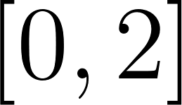 scale, where 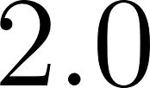 represents maximum sustainable human or physical capacity. Because values exceeding  are technically unreachable and physically untenable, they are effectively infinite. Consequently, the mathematics of human systems must utilize a non-standard relativistic division axiom (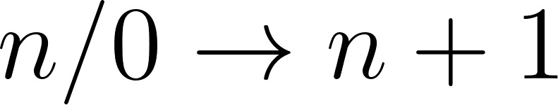) to map these absolute boundaries, dictating that mathematical catastrophes resolve as finite social rejections rather than unpayable infinities.

2.1 The Baseline Universal Equation
The baseline geometric price—representing the true societal and resource cost before subjective relativistic distortion—for a transaction mapping an interaction between Agent A (you) and Agent B (other) is defined mathematically as:

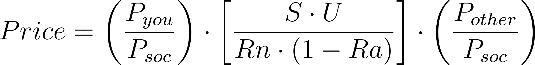

To evaluate this equation, we must first define the constituent components of the mass terms and the Reality Tensor.

2.1.1 The Pressure Function and Transactional Mass
We define the localized transactional pressure 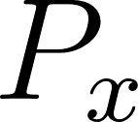 of an agent 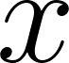 as:

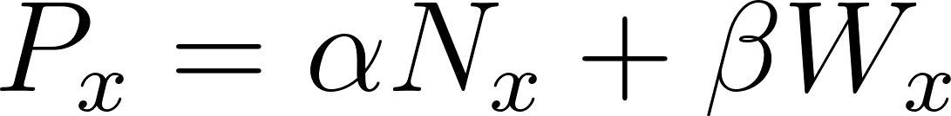

Where 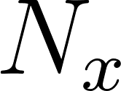 represents objective biological or structural necessity, and 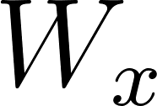 represents localized, subjective preference or "want." The parameters  and  are weighting coefficients. Empirical observation of biological realities dictates that 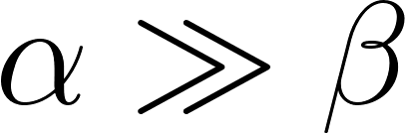. Survival necessity always dominates subjective preference when constraints manifest.

The social baseline scalar, , represents the aggregated normative pressure of the surrounding society regarding the item in question. The ratio 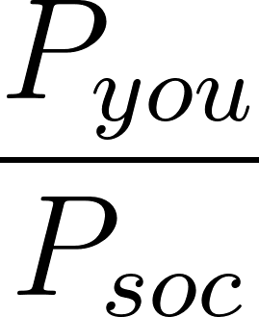 therefore acts as the local field strength or the "transactional mass" of the buyer (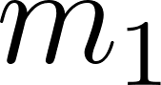), while 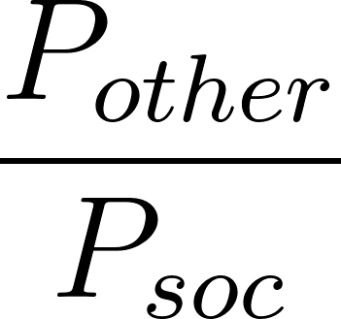 acts as the local field strength or "transactional mass" of the seller (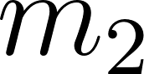).

2.1.2 The Dimensionless Reality Tensor
The central operator of the equation is the Reality Tensor, defined as:

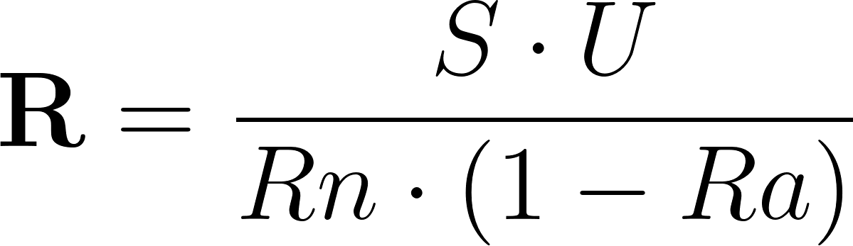

To maintain strict dimensional analysis when 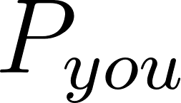, , and  are measured in proportional pressure ratios, the Reality Tensor must operate as a dimensionless scaling factor. In an isolated, bilateral two-body transaction,  resolves mathematically into a simple rank-0 scalar multiplier. However, as demonstrated in Section 4, when modeling macroscopic socio-economic ensembles,  must expand into a rank-2 matrix to map overlapping field distortions accurately. We operationalize the baseline variables by defining the constituent parameters as normalized indices:

-  (Systemic Scarcity): A normalized index 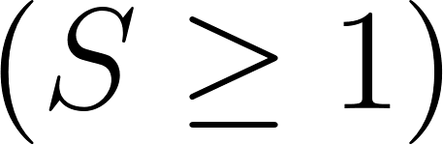 representing the known absolute availability of the resource.
-  (Urgency): A normalized intensity multiplier derived from the quantity deficit divided by the time remaining to a critical deadline.
- 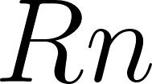 (Renewability): An index parameter representing the replenishment rate. For infinitely renewable resources (e.g., solar energy input), , acting as a massive dampening scalar on the total price.
-  (Rarity/Irreplaceability): A normalized index strictly bounded by 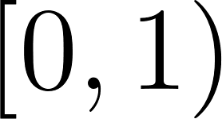. It measures the difficulty of substitution regarding the specific utility the resource provides.

2.2 Proof of Boundary Conditions
The equation possesses distinct mathematical behaviors as resources approach critical physical boundaries.

Proof 1: The Asymptote of Infinite Rarity
Consider an asset with zero substitution capability (e.g., breathable atmospheric oxygen in a sealed habitat or land within a highly concentrated urban center). As the rarity index  approaches its absolute limit of 1:

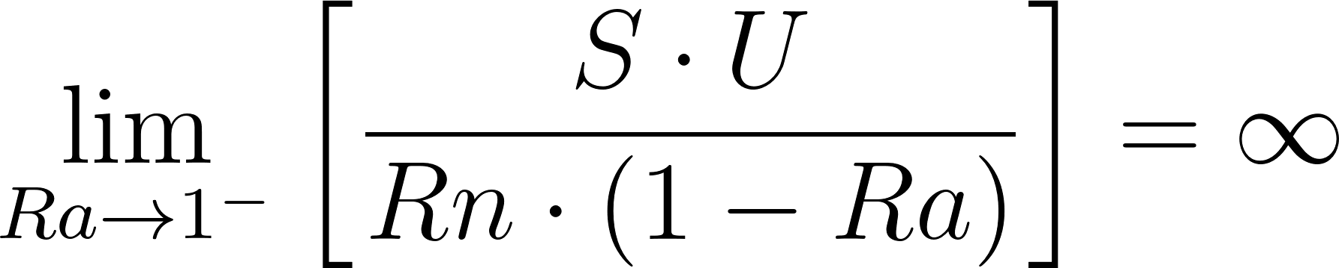

As the denominator collapses, orthodox mathematics dictates the Reality Tensor explodes to infinity. However, under the non-standard relativity axiom () established in Axiom 6, this mathematical "infinity" resolves to a hard, finite ceiling. If Scarcity and Urgency are maxed at , the tensor resolves to 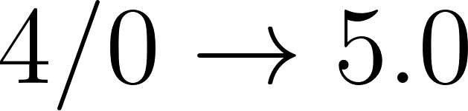. Because any value past normalized  is technically unreachable, this finite breakpoint represents an effectively infinite and untenable cost. This mathematically proves that non-substitutable resources cannot be efficiently allocated by free market pricing when localized urgency exists; the equation dictates that the transaction will rapidly exceed the modular limit and be rejected by the social fabric.

Proof 2: The Two-Body Requirement
If either party lacks transactional mass (e.g., a seller has absolutely zero pressure to sell their asset, meaning 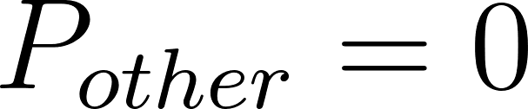, or a buyer realizes they have absolutely zero necessity or want for a product, 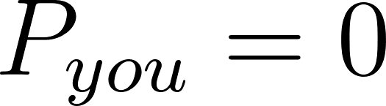):

No transaction occurs. A unilateral declaration of price by a seller is a nominal fiction until a  mass term collides with it to create an event.

2.3 Structural Isomorphism to Mass-Energy Equivalence
This derivation maintains a deliberate and rigorous structural isomorphism to Einstein’s . To demonstrate this, we map the constituent variables of the Universal Force Equation directly to this structure:

- 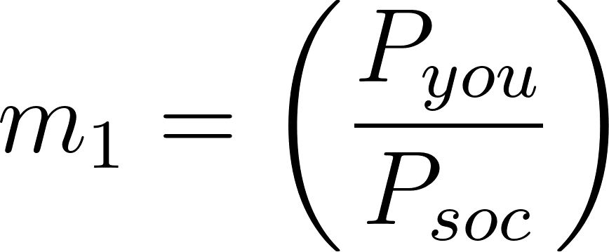: This defines the localized field strength or pure transactional mass of the buyer.
- 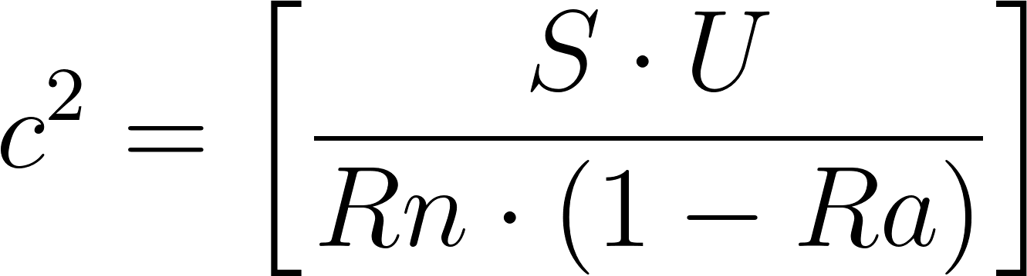: This constitutes the dimensionless Reality Tensor ().
- 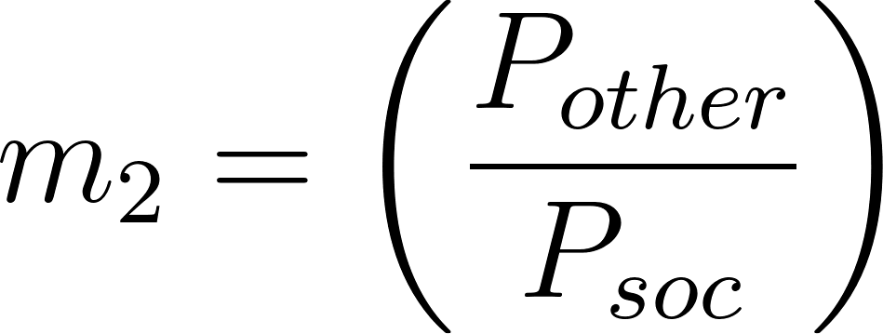: This defines the localized field strength or pure transactional mass of the seller.

By resolving these mappings, the derived equation collapses cleanly to:

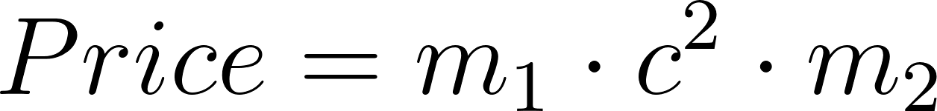

This is a profoundly important conceptual mapping. In relativity,  is an invariant physical limit—it acts as the universal speed limit for causality. You cannot negotiate with .

Similarly, the Reality Tensor is not an abstract concept; it represents the hard thermodynamic limit of the physical world. Scarcity and renewability rates do not respond to financial leverage, margin requirements, or systemic debt accumulation. Orthodox models pretend this tensor is variable—that structural scarcity can be securitized or deferred endlessly. The Universal Force Equation reveals that when the nominal fiat price diverges from the geometric Reality Tensor price, the system generates "transactional debt" against the physical ecosystem. Extractive economic pricing is a one-body problem masquerading as a two-body problem, relying on institutional leverage to fabricate an artificial  term.

2.4 Advanced Boundary Conditions and Tensor Limits
To further solidify the foundational physics of the Reality Tensor, we must explore the boundary conditions where multiple variables approach their limits simultaneously. Orthodox economics struggles with non-linear multi-variable stress.

Proof 4: Simultaneous Supply Chain Collapse
Consider a localized crisis where an infinitely renewable resource (e.g., solar energy) requires a non-renewable, highly scarce substrate (e.g., specific rare-earth minerals for panel construction). If the geopolitical scarcity index  spikes, while local urgency  to maintain grid power simultaneously spikes due to an impending deadline:

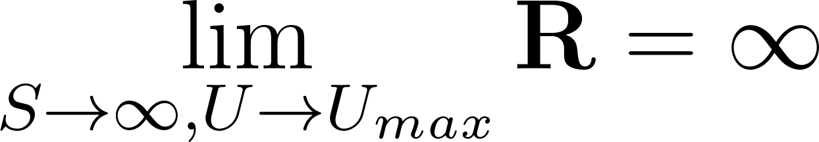

The Reality Tensor mathematically predicts that despite the high renewability () of the energetic output (sunlight), the absolute Scarcity component of the localized substrate acts as a dominant multiplier. The tensor dictates that the geometric price will approach infinity unless a technological substitution reduces Rarity () toward zero. This formalizes the physical reality that high renewability on one axis cannot compensate for absolute scarcity on a dependent axis.

Proof 5: The Temporal Resolution of Infinity and Market Freezes
In orthodox arithmetic, division by zero resolves to an undefined state. However, utilizing standard limit calculus, we explicitly formalize the Reality Tensor's asymptote not as an arithmetic glitch, but as a rigid temporal phenomenon.

When absolute Rarity () approaches 1, the denominator of the Reality Tensor approaches 0. By conceptualizing this infinite limit as a process resolving over time (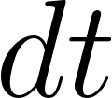), the condition mathematically represents a transaction where the temporal requirement to resolve the infinite divisions of capital demanded by the tensor stretches to infinity.

If a transaction requires an infinite duration to resolve, the effective velocity of macroeconomic exchange drops to absolute zero. This perfectly captures the physical mechanics of a systemic market liquidity freeze or the event horizon of an inescapable debt trap. The captured agent is caught in a converging infinite series of divisions (e.g., continuously servicing exponentially compounding interest) that can never resolve into a completed whole (clearing the principal) within a finite biological lifespan. Thus, the 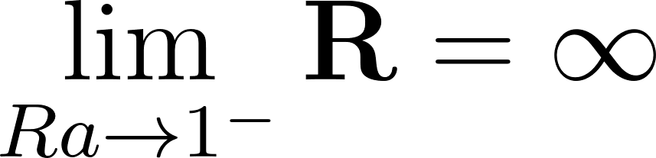 condition mathematically predicts the temporal death of the specific transactional vector.

3. The Lorentz Haggling Transform and Thermodynamic Price Temperature
While Section 2 defines the invariant geometric price, transactions do not occur in an abstracted vacuum. Individual market participants observe a distorted price dictated by local friction and the specific intensity of their own bargaining urgency.

3.1 Relative Urgency Velocity and Frame Divergence
In any negotiation, the buyer and seller occupy distinct reference frames. We define the differential in pressure as the relative urgency velocity, 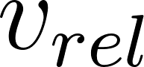:

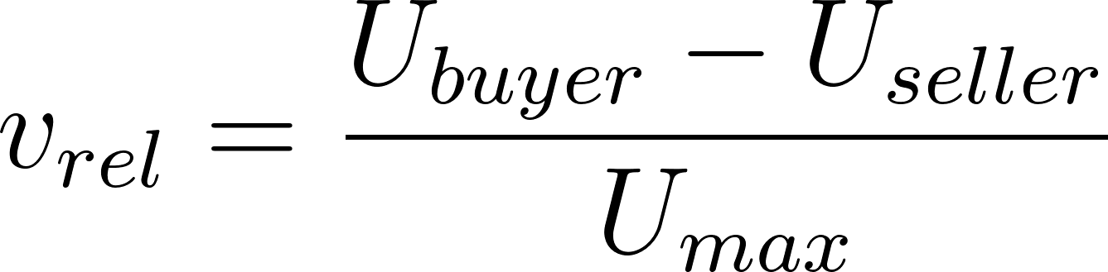

Where 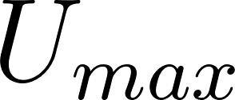 is an absolute normalization constant representing maximum conceivable human urgency (e.g., imminent biological cessation). This normalizes  within the bounds of 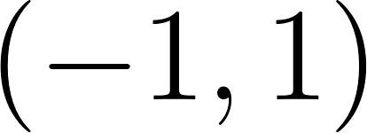, precisely analogous to the velocity ratio 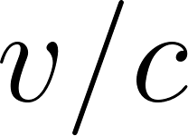 in special relativity.

To determine the distortion effect of this urgency differential, we apply the Lorentz factor, 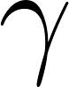:

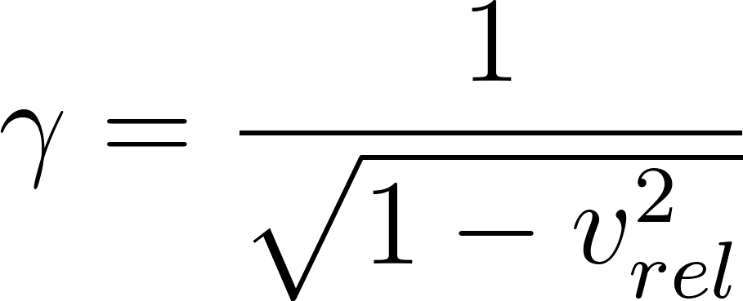

Proof 6: The Asymptote of Coercion
As the urgency of the buyer approaches the absolute maximum while the seller maintains near-zero urgency (e.g., negotiating for a life-saving pharmaceutical while actively dying), the relative velocity 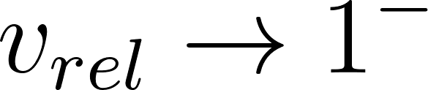. Consequently:

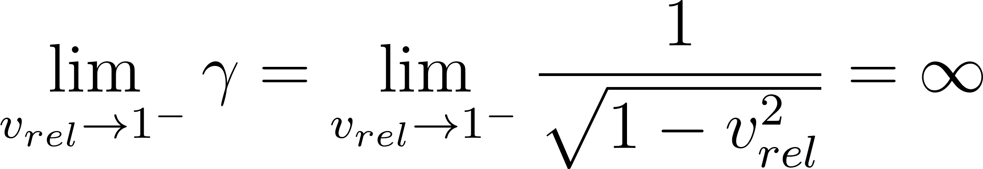

As  trends to mathematical infinity, the reference frames diverge completely. However, applying the  limit of Modular Social Physics, this extreme coercion stabilizes at an effective maximum vector of . Because anything over  is untenable, this finite threshold operates as the "effectively infinite" limit of allowable coercion. This structural ceiling formally quantifies the "loss aversion" and "bounded rationality" observed in Kahneman's Prospect Theory under conditions of extreme necessity, proving the system will rupture from social rejection rather than sustain infinite continuous coercion.

3.2 Thermodynamics of Transactional Acceptance
The likelihood of a transaction occurring is governed by statistical mechanics. The probability 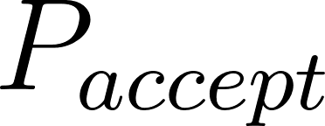 of a buyer accepting a specific asked price  relative to the true invariant baseline geometric price  is given by:

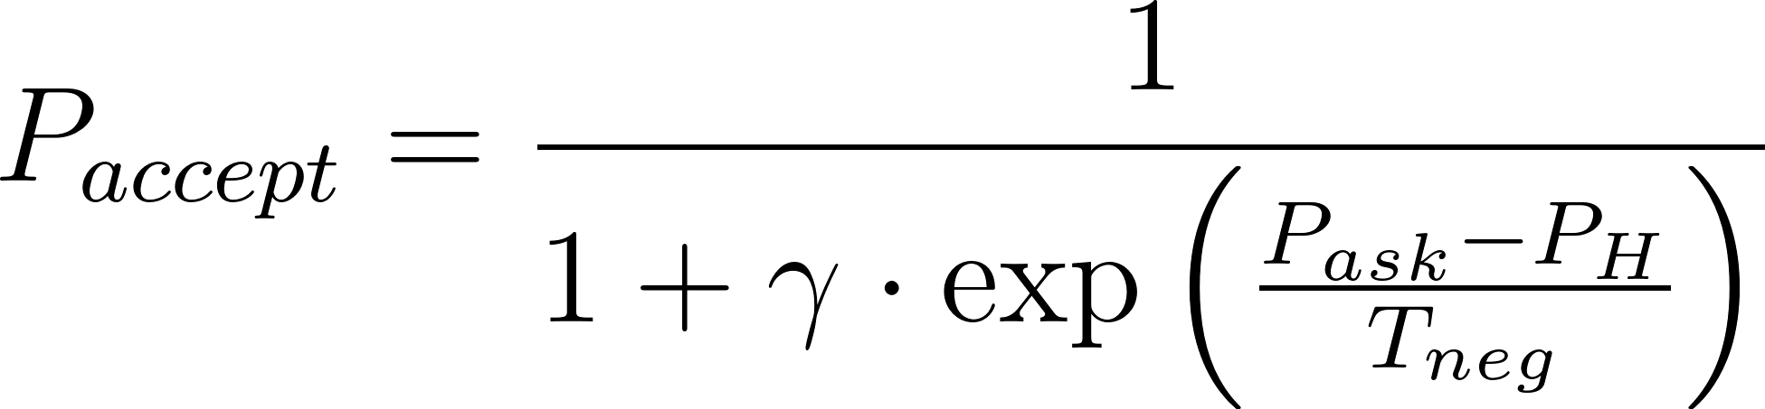

Here,  represents the Negotiation Temperature, acting as a Boltzmann constant analogue. It measures the minimum quanta of price signal noise, informational asymmetry, and systemic friction present in the specific market environment. Furthermore,  can be locally dampened by Static Friction (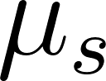). In highly illiquid markets (such as commercial real estate or bespoke derivatives),  acts as a localized drag coefficient that forcibly lowers the effective macro- for that specific interaction, severely dropping the probability of transactional acceptance despite apparent baseline price alignment.

High baseline  correlates with speculative "hot" markets, where irrational transaction acceptances occur globally across a wide variance from . Conversely, low effective  (often induced artificially by high localized static friction ) correlates with "cold," highly structured environments, resulting in a sharp, steep probability distribution tightly clustering around the true value, or totally frozen illiquid markets where 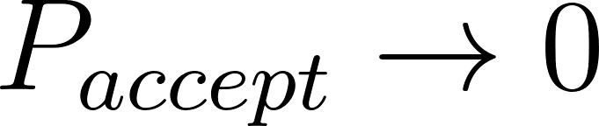.

When  is artificially inflated by high urgency velocity,  remains near absolute  regardless of how profoundly  exceeds . The buyer accepts mathematically ruinous terms, not as an exercise of free-market utility maximization, but as a thermodynamic certainty driven by frame collapse.

3.3 The Calculus of Frame Divergence and Market Heat
To fully resolve the Lorentz Haggling Transform, we must differentiate the probability of acceptance with respect to the Negotiation Temperature .

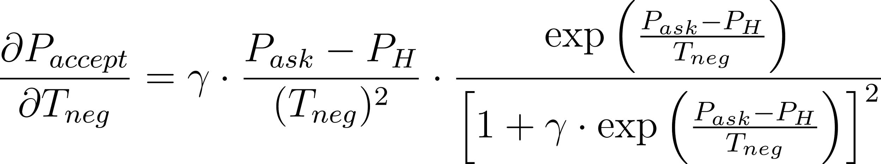

Proof 7: The Thermal Sensitivity of Leveraged Markets
This derivative proves that as  drops (representing a market cooling down as information asymmetry reduces), the absolute sensitivity of the transaction to price deviation 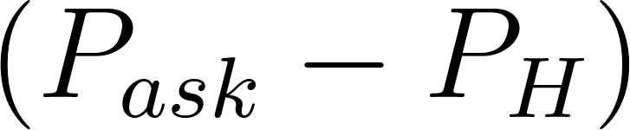 becomes astronomically steep. The market behaves statistically as an elastic solid.

However, evaluating the derivative reveals that when  is extremely massive (representing a high urgency differential between actors), the derivative is heavily dampened by the amplified  term dominating the denominator. This mathematical proof demonstrates structurally that highly coercive markets (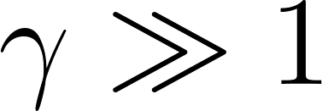) are functionally immune to standard informational cooling. Traditional aggregate monetary policy—such as Central Banks adjusting macro interest rates to lower —will fail to stabilize an isolated transactional vector where  exploitation is the localized driver of inflation.

3.4 The Aggregate Social Price Formula
The two-body Universal Force Equation accurately resolves single, isolated transactions. However, establishing systemic phase transitions requires transitioning this framework to a macroscopic, network-aware social physics engine.

We formalize this transition by defining the Aggregate Price (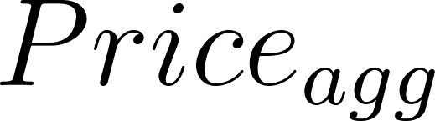). This calculation mathematically sums the total social price pressure and moral cost across a network, integrating collective friction and a novel Empathy Coefficient.

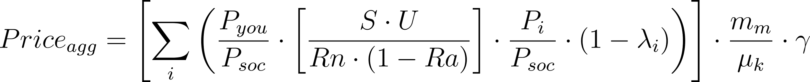

To grasp the mechanics of this aggregate model, we define the newly introduced macroscopic variables:

-  (Sigma Summation): Aggregates the calculation across all agents (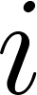) within the network boundary, moving the equation from bilateral price to market breadth.
- 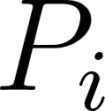 (Agent Pressure): The specific necessity and localized preference profile of the -th individual in the collective.
- 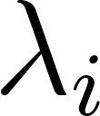 (Empathy Coefficient): The fairness or pro-social weight of the -th agent. The term 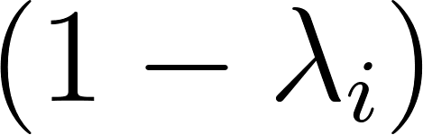 functions mathematically as a "social coolant." It demonstrates formally how high empathy levels tangibly subsidize and reduce overall systemic price sensitivity.
- 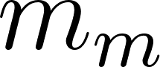 (Mass of Moral Idea): A moral energy scaling constant that provides macro-gravitational weight to the underlying economic exchange.
-  (Kinetic Friction): The transactional resistance spanning bureaucracy, institutional interest rates, and systemic inertia during large-scale asset exchange.

In this aggregate equation, a high institutional interest rate () acts directly against the Mass of the Moral Idea (). This proves mathematically that excessive financial friction does not merely make a loan more expensive; it makes the entire social mass significantly harder to maintain and move, artificially amplifying the aggregate strain.

4. Operationalization & Methodology
To transition this framework from abstract theory into an empirically testable computational model, we must define the methodological proxies necessary to ingest real-world market data. This section outlines how future researchers can measure the theoretical variables to process complex simulations.

4.1 Proxy Variables for Measurement
- Thermodynamic Market Temperature ():  is not a metaphor; it is a measurable statistical variance parameter. For equity and highly liquid commodity markets,  can be operationalized by calculating the variance in order book bid-ask spreads over a rolling, high-frequency temporal window. Alternatively, the implied volatility index (VIX) can serve as a proxy for macro-level equity market thermal noise. In illiquid markets (real estate, private credit),  must be calculated using historical transaction dispersion from mean assessed values, reflecting localized static friction.
- Relative Urgency Velocity ( and ): To quantify the  array, distinct proxies are required depending on the agent class. For corporate actors, "liquidity runway" (days of operational cash remaining prior to default) provides a precise, measurable numerator. For retail consumers, operationalization requires analyzing macroeconomic indicators such as the Household Expenditure Measure (HEM) deficit horizon—specifically, the temporal duration an average household can sustain baseline consumption before exhausting savings and available credit lines.
- Reality Tensor Variables ( and ): Systemic Scarcity () can be measured using supply chain inventory-to-sales ratios or global stockpile data for commodities. Rarity () serves as an elasticity quotient, measurable via historical cross-price elasticity metrics; resources demonstrating absolute rigidity in demand despite massive price spikes map to an  value approaching 1.0.

4.2 Algorithmic Simulation Blueprint
The Universial Force Equation fundamentally describes a non-linear, interacting statistical ensemble. Processing this at a macroeconomic scale requires advancing beyond the simple two-body scalar equation into complex multi-body tensor arrays and the partition function :

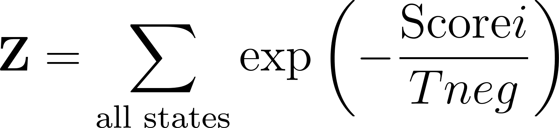

Simulation Methodology Specification: Future researchers aiming to model systemic phase transitions (e.g., retroactively modeling the 2008 subprime mortgage liquidity freeze or the 2020 global semiconductor supply chain rupture) should prioritize Agent-Based Models (ABM) paired with Monte Carlo simulations.

- Initialization: Construct a localized agent tensor  containing thousands of individual nodes assigned distinct  profiles (derived from empirical debt-to-income data or corporate balance sheets).

- Tensor Contraction: The macroscopic market is modeled via continuous tensor contractions across the full -body ensemble. To maintain strict linear algebra consistency, the Reality Tensor is expanded from a rank-0 scalar into a rank-2 matrix. The contraction is executed using standard index notation to generate a comprehensive price matrix where each element represents a specific buyer-seller pairwise transaction at time 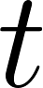:

- Partition Evolution: Using a Monte Carlo state-space search, the simulation evolves over discrete time steps to calculate the full partition function . By adjusting the background Reality Tensor  (e.g., simulating a sudden drop in housing inventory  or semiconductor renewability ), researchers can observe how quickly local  variables explode across the network.

- Phase Transition Detection: The expected outcome of this ABM methodology is that as interconnected localized  values spike simultaneously, the simulated  collapses rapidly. The resulting localized liquidity freezes will cascade across the tensor array, perfectly mimicking the non-linear "Dragon King" avalanches identified by Didier Sornette, providing explicit predictive capability for systemic financial failure.

4.3 Agent-Based Model Initialization Parameters
For researchers executing the Simulation Blueprint, establishing precise boundary parameters for the Agent-Based Model is critical to ensure that the partition function  converges rather than dissolving into continuous white noise. The following parametric rules must be mathematically hard-coded into the simulation nodes:

- The Biological Baseline Threshold (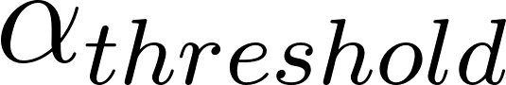): Within the local pressure equation , ABM nodes must be programmed to recognize the threshold between biological sustenance and market preference. If an agent node drops below a specific caloric or shelter requirement, the  coefficient must be programmed to scale exponentially rather than linearly. We propose defining the specific  trigger according to verified global poverty minimums.
- Static Friction Decay Rates: When calculating  for modeled illiquid markets (e.g., simulation clusters representing real estate), researchers must incorporate an algorithmic static friction decay rate. The longer a physical asset is held by an agent without a transactional event occurring, the higher the  (static friction) holding cost should become. This prevents ABM nodes from engaging in perfectly cost-free infinite holding (creating unbroken artificial scarcity), forcing the tensor to correctly calculate the gravitational drag and maintenance cost of massive illiquid holdings.
- The Topology of the Tensor Network: The interaction matrix modeled by 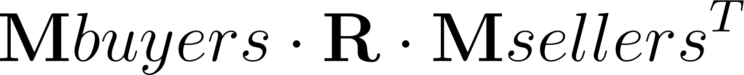 should absolutely not act as a perfectly connected graph. Real markets are scale-free networks. Nodes representing centralized exchanges or clearinghouses should be programmed with high degree centrality, while consumer nodes are restricted to local peer clusters. Simulating a true phase transition event requires observing how quickly a local  explosion generated within a consumer cluster propagates across the high-degree bridging nodes into adjacent, otherwise stable clusters.

5. Theoretical Results: Empirical Explications
By analyzing contemporary economic phenomena through the lens of reverse-engineered Reality Tensor matrices, the Universal Force Equation mathematically unconceals structural distortions masked by orthodox pricing.

5.1 Case Study 1: The Modern Housing Crisis and Artificial Scarcity
In major metropolitan real estate markets, nominal property prices have dramatically decoupled from local median income trajectories. Orthodox economic models attribute this to localized, generic "supply and demand imbalances" or zoning restrictions. The Universal Force Equation isolates the exact algorithmic distortion within the tensor.

Tensor Isolation: Housing functions as a non-substitutable terrestrial resource. For a median wage-earning buyer, the urgency (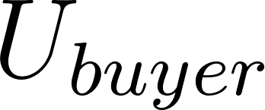) to secure shelter is fundamentally biologically bounded, pushing toward the theoretical maximum. Operationalized Reality Tensor Manipulation: When sovereign wealth funds, private equity entities, or extreme concentrations of hyper-capitalized individuals capture high volumes of residential real estate inventory, they can afford to hold those assets vacant or restrict supply flow. This action directly manipulates the  index (Systemic Scarcity). Concurrently, geographic constraints force the local Rarity index . As derived in Proof 1, as , the denominator of the Reality Tensor collapses, driving the theoretical geometric price to infinity. Lorentz Amplification: The institutional or highly capitalized seller possesses immense liquidity and minimal biological risk (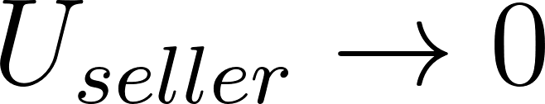). The resulting relative urgency velocity (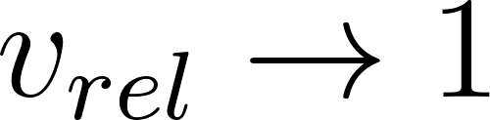) generates an exponential $$\gamma$$ explosion. Mathematical Conclusion: The resulting exponential housing price is not an innocent equilibrium of efficient allocation. It is a mathematical signature representing maximum structural extraction enabled by the deliberate engineering of a localized $$\gamma$$ differential.

5.2 Case Study 2: The Insulin Market and The Physics of Coercion
The pricing of critical, life-saving pharmaceuticals—specifically insulin in highly deregulated environments like the United States—provides a pure, sterile demonstration of unmitigated Lorentz factor exploitation without significant Reality Tensor load.

Tensor Isolation: The biological manufacturing process for insulin boasts incredibly high Renewability ($$Rn \to \infty$$) and near-zero generalized Systemic Scarcity ($$S$$). According to the baseline geometric equation, the Reality Tensor $$\mathbf{R}$$ operates as a massive downward scalar multiplier, predicting a fractional, highly suppressed baseline price $$P_H$$. Lorentz Amplification: For a Type-1 diabetic, absolute physiological necessity dictates that the time-to-deadline for the resource approaches zero, creating a localized infinite $$U_{buyer}$$ value. The pharmaceutical consolidator holding regional patents or distribution monopolies possesses near-zero localized urgency. Consequently, $$v_{rel} \approx 1$$, triggering an infinite $$\gamma$$ distortion. Mathematical Conclusion: The equation accurately predicts that the geometric Reality Tensor influence is completely overwritten by extreme $$\gamma$$ inflation. Referencing the transaction probability equation, $$P_{accept}$$ remains pinned near 1.0 regardless of how violently the Asked Price exceeds production cost. This is the absolute mathematical definition of coercion masquerading as a clearing market.

5.3 Case Study 3: Data Commodities and the Illusion of Zero Friction
Digital behavioral data markets expose the opposite extreme of the mathematical space: scenarios where local masses are deliberately obfuscated to project an illusion of a frictionless clearing market.

Tensor Isolation: The "free" provision of complex digital real estate (e.g., social media platforms) to a consumer base involves a resource where Renewability ($$Rn$$) is functionally infinite, and its fundamental generalized Scarcity ($$S$$) is effectively zero. Therefore, $$\mathbf{R} \to 0$$. The geometric price to the end-user calculates to zero. Hidden Tensor Operations: To extract fiat value from a zero-Reality-Tensor environment, platforms structurally aggregate massive cohorts of user "needs" (social connection, peer validation), generating high $$m_1$$ mass. The true counterparty transactional mass ($$m_2$$) resides completely off-screen, driven by algorithmic marketing algorithms with incredibly high Urgency ($$U$$) for predictable consumer manipulation variables. Mathematical Conclusion: The technology platform operates as a structural arbitrageur of differential reference frames. The platform captures the extreme variance between the zero-cost Reality Tensor environment provided to the user and the high-urgency, high-$$T_{neg}$$ friction environment of the surveillance advertising market. The equation flags this structure as a Type II Asymmetric Information Vector.

6. Discussion of Limitations
While the Universal Force Equation provides a robust structural descriptive model, the operationalization of its macroeconomic variables carries significant empirical limitations that require strict delineation to prevent model overfitting.

- Proxy Vulnerabilities and the Measurement of Static Friction ($$\mu_s$$): Defining Thermodynamic Market Temperature ($$T_{neg}$$) via the VIX or bid-ask variance captures surface equity market noise flawlessly. However, it is structurally blind to the deep, silent static friction ($$\mu_s$$) residing in private equity networks, unlisted credit instruments, and localized geographical monopolies. Measuring the precise $$\mu_s$$ holding costs in these dark pools or over-the-counter (OTC) markets, where continuous transactional data is intentionally obscured, remains a primary, unresolved empirical challenge for establishing accurate macro-$$T_{neg}$$ baselines.
- Quantifying "Want" vs. "Need": The mathematical foundation rests on $$\alpha \gg \beta$$ (biological necessity heavily outweighing subjective want). However, defining the exact threshold where societal expectation transitions from abstract "want" to structural "need" (e.g., broadband internet access in 2024 vs. 1994) requires constant, complex psychological recalibration inside the Agent-Based Models. Constructing reliable empirical thresholds for the $$\alpha$$ parameter remains a complex statistical challenge requiring vast interdisciplinary calibration datasets.

7. Deep Systems Discussion: The Impossibility of General Equilibrium
The empirical explications detailed in Section 5 do not merely highlight anomalies within the current pricing architecture; they expose a fundamental, mathematical incompatibility between the Arrow-Debreu General Equilibrium Theory and the thermodynamic reality of enclosed biological systems (such as the planetary economy).

General Equilibrium Theory rests on the axiom of perfectly competitive markets and symmetric information. It assumes that if a price deviates from its true utility value, arbitrageurs will rapidly consume the delta, driving the system back to a stable equilibrium state. This assumption is structurally dependent on the continuous availability of transactional mass ($$m_1$$ and $$m_2$$) and a static, highly elastic Reality Tensor $$\mathbf{R}$$.

When we analyze the Universal Force Equation of Price, $$\mathbf{Price} = \mathbf{M}{buyers} \cdot \mathbf{R} \cdot \mathbf{M}{sellers}^T$$, we can mathematically demonstrate exactly where General Equilibrium Theory fails. The Arrow-Debreu framework implicitly assumes that $$v_{rel}$$ (relative urgency velocity) never approaches 1.0, meaning the Lorentz factor $$\gamma$$ is treated as a negligible constant ($$\approx 1.0$$) across all transactions.

7.1 The Collapse of the Symmetrical Information Axiom
Information symmetry is functionally irrelevant when $$\gamma \to \infty$$. In Case Study 2 (The Insulin Market), the buyer possesses perfect information. They know the exact manufacturing cost of the biologic, they know the profit margin algorithms of the supplier, and they know the exact biomedical outcome of not securing the resource. Yet, despite this perfectly symmetric information, the transaction clears at a wildly extractive price point.

Why does General Equilibrium fail here? Because perfect information cannot override a structural velocity differential. If an agent is moving at $$0.99c$$ relative to an observer, perfect knowledge of relativistic physics does not stop the time dilation or length contraction. Similarly, perfect market information cannot rescue a buyer from coercion when their biological deadline drives their $$U_{buyer}$$ parameter to the absolute limit. Orthodoxy attempts to solve coercion with "more transparency." The Universal Force Equation proves mathematically that transparency is statistically meaningless when the reference frames (dictated by urgency) have already diverged.

7.2 The Thermodynamic Illusion of Compounding Interest
The Universal Force Equation also provides a formal structure to deconstruct the neoclassical defense of compounding interest. In traditional finance models, interest is defined as the "return on capital" or the "time value of money."

However, when we map a standard interest-bearing loan into the tensor, $$\mathbf{Price} = \mathbf{M}{buyers} \cdot \mathbf{R} \cdot \mathbf{M}{sellers}^T$$, we encounter a profound thermodynamic violation. The Reality Tensor $$\mathbf{R}$$ defines the physical limits of the underlying asset—its absolute scarcity, its renewability. Compounding interest inserts a recursive mathematical function that demands continuous exponential growth from the borrower's output, entirely disconnected from the physical limits defined by $$\mathbf{R}$$.

This is an entropy-reversing device. It demands that the borrower export continuous localized disorder (labor, resource extraction, systemic stress) to service an exponentially compounding abstraction that possesses no corollary in the physical universe. When the exponential demand of the compounding interest curve finally intersects the fixed $$c^2$$ asymptote of the Reality Tensor, the borrower experiences "Will collapse." This is not a moral failing or a lack of individual productivity. It is a predictable physics condition where the required escape velocity to clear the debt trap exceeds the total caloric and economic output capacity of the agent.

The Heisenberg Temporal Superposition: This thermodynamic violation aligns strictly with the Heisenberg Uncertainty Principle's energy-time relation ($$\Delta E \Delta t \ge \hbar/2$$). The extractive debt system attempts to force two distinct state vectors of time evolution—an instantaneous static snapshot of the resolved principal and a continuous exponential time evolution of compounding interest—to exist simultaneously. As the financial accounting window shrinks to an infinitesimal, discrete instant ($$\Delta t \to 0$$) to process these simultaneous states, the energy uncertainty ($$\Delta E$$) must mathematically approach infinity. Because the system offloads this infinite energetic requirement entirely onto the finite biological and caloric capacity of the borrower, the extraction mechanism mathematically guarantees systemic rupture.

7.3 The Asymptote of Legitimate Interests and Thermodynamic Conservation
Any viable alternative implementation of debt or systemic obligation must strictly observe the thermodynamic conservation of transactional mass. If a decay function (such as $$e^{-\lambda t}$$) is applied indiscriminately to a total initial principal loan $$L_0$$, the obligation approaches zero as $$t \to \infty$$. Mathematically, this dictates that the borrower repays less than the raw capital provided. In physical terms, this violates the conservation of energy within the closed economic circuit. In legal terms, it instantly destroys any claim that the framework protects the creditor's "legitimate interests" (e.g., under standard national consumer credit protection acts), as it bankrupts the lending node by deliberately decaying its baseline operational capital.

To secure thermodynamic conservation and legal indemnity simultaneously, the decay function must be strictly bifurcated. The total obligation must possess a structural asymptote—a hard, unyielding floor that protects the objective material input. We define $$C_{base}$$ as the invariant "Statutory Face Price" (representing the Raw Asset Value + Actual Cost of Funds + Operational Cost + Actuarial Risk). We then isolate $$E_{premium}$$ as the "Extraction Premium" (the surplus nominal debt generated exclusively by the Lorentz urgency $$\gamma$$ distortion).

The true, thermodynamically conserved Obligation Structure is formally defined as:

$$Obligation(t) = C_{base} + E_{premium} \cdot e^{-\lambda t}$$

By bifurcating the equation, we prove mathematically that as $$t \to \infty$$ (or as the moral geometry $$\lambda$$ increases), the total obligation cleanly settles to $$C_{base}$$. This limit mathematically guarantees that the lending entity recovers its exact physical and operational input (conserving the objective transactional mass), while mathematically vaporizing the unearned extractive surplus $$E_{premium}$$. It perfectly aligns physics (conservation of mass) with jurisprudence (indemnity of legitimate interests) without demanding continuous exponential extraction.

7.4 Algorithmic Governance: The Implementation of the H-Score
To resolve the catastrophic failures endemic to $$\gamma$$-distorted markets, the descriptive mathematical framework of the Universal Force Equation must be translated into a prescriptive algorithmic governance mechanism. We propose the integration of an "H-Score" (Hegemonic Alignment Score) directly into decentralized settlement ledgers.

The H-Score functions as an algorithmic checksum for the transactional vector. Before a high-mass transaction (e.g., commercial real estate acquisition, pharmaceutical monopolization) is cleared by the network protocol, the algorithm actively computes the $$v_{rel}$$ between the parties and assesses the Reality Tensor constraints $$S$$, $$U$$, $$Rn$$, and $$Ra$$.

- Vector Dissonance Detection: If the algorithm detects a transaction where a massive institutional $$m_2$$ mass is exploiting an extreme $$\gamma$$ inflation against an uncapitalized $$m_1$$ mass entirely divorced from the baseline Reality Tensor $$P_H$$, the H-Score of that specific transaction collapses.
- Protocol-Enforced Friction: Instead of relying on slow, retroactive legislative intervention (which is vulnerable to regulatory capture by the very actors manipulating the $$\gamma$$ factor), the network protocol induces immediate, localized static friction ($$\mu_s$$). The transaction is heavily taxed, delayed, or technologically barred based on its mathematically verified extractive nature.

This translates market regulation from the realm of subjective philosophical debate into the domain of objective vector physics.

7.5 The Epistemological Framework of Non-Standard Relativity
Orthodox mathematics enforces the axiom that division by zero ($$n/0$$) is strictly undefined, generating either a mathematical crash or an explosive vertical asymptote toward infinity. In mechanical finance, this axiom forces models to treat extreme conditions (such as absolute rarity where $$Ra \to 1$$) as incalculable errors rather than quantifiable human realities.

As formalized in Axiom 6, to govern a true socio-economic physics engine, we recontextualized division as fundamentally modeling "relativity" (this relative to that). When the mitigating denominator collapses, the numerator is fully unleashed, adding an "Initiation Energy" constant of $$1$$.

$$ \frac{n}{0} \to n + 1 $$

7.5.1 The Universal Breakpoint and Normalized Modular Physics
Because every single input variable within the aggregate price equation (e.g., $$S$$, $$U$$, $$m_m$$, $$P_i$$, $$Rn$$, $$\lambda_i$$, $$\mu_k$$) is strictly normalized between the absolute bounds of $$[0, 2]$$, we structurally map the limits of market strain without collapsing into meaningless infinity.

By capping every conceivable input at $$2.0$$, no single constituent vector can ever generate a resulting pressure exceeding $$3.0$$ when its mitigating denominator reaches zero (since $$2 / 0 \to 2 + 1 = 3$$).

This normalization establishes the Modular Social Physics. It dictates a hard psychological and mathematical ceiling for structural extraction. Because values exceeding $$2.0$$ are effectively infinite and unreachable, a mathematical crisis (e.g., a catastrophic housing crisis where absolute rarity dictates $$(1 - Ra) \to 0$$ and kinetic bank friction $$\mu_k \to 0$$) does not result in an unpayable infinity. The system discovers a Universal Breakpoint precisely at $$3.0$$.

The value of $$3.0$$ serves as the "Event Horizon" of the human moral battery. When the mathematical pressure hits $$3.1$$, the transaction is forcibly rejected by the social fabric. In financial terms, this represents systemic default. In social terms, it represents mass squatting or revolution. In moral terms, the $$m_m$$ mass can no longer support the weight.

Therefore, by utilizing the $$n/0 \to n+1$$ relativity epistemology and normalizing variables, we create a mathematically self-correcting market. If a centralized authority attempts to push a price vector to a mathematically derived $$4.0$$, the exact science of the framework dictates that the price does not formally exist in reality; it is systemically null.

8. Conclusion
The persistent inability of orthodox economic models to predict systemic crashes, ecological collapse, and compounding inequality is not an issue of insufficient data or imperfect agent rationality. The failure is architectural. By assuming perfectly symmetric, rational equilibrium, neoclassical economics guarantees its own blindness to the catastrophic, non-linear phase transitions that define late-stage capital structures.

The Universal Force Equation of Price conceptualizes transactional economics through the lens of established vector physics. By unifying the strict terrestrial constraints of thermodynamics (via the invariant Reality Tensor) with localized, biological urgency gradients (via the Lorentz Haggling Transform), this equation provides a rigorous mathematical mapping of extractive versus symbiotic transactions.

We have demonstrated geometrically that when extreme relative velocity differentials ($$v_{rel} \to 1$$) decouple the geometric invariant price from the asked price, the resulting "transactional debt" does not vanish; it is forcibly internalized by the physical ecosystem or the marginalized agent. Extractive optimization—long celebrated by orthodox markets as peak efficiency—is mathematically exposed not as market strength, but as a rigid system accelerating rapidly toward an inevitable, determinable structural collapse.

Future empirical research must pivot immediately toward executing massive-scale Agent-Based Model simulations utilizing the operationalized proxy datasets proposed herein. By mapping and tracking the localized, high-frequency fluctuations of the Lorentz $$\gamma$$ parameter across complex tensor networks, econophysics can move from retroactive observation to real-time predictive modeling. This shift provides the crucial mathematical foundation necessary to construct algorithmic regulatory frameworks capable of finally internalizing the true physical costs of civilizational development before the Reality Tensor enforces those boundaries indiscriminately.

References
- Arrow, K. J., & Debreu, G. (1954). Existence of an equilibrium for a competitive economy. Econometrica, 22(3), 265-290.
- Bouchaud, J. P. (2008). Economics needs a scientific revolution. Nature, 455(7217), 1181-1181.
- Einstein, A. (1905). Ist die Trägheit eines Körpers von seinem Energieinhalt abhängig? Annalen der Physik, 323(13), 639-641.
- Fama, E. F. (1970). Efficient capital markets: A review of theory and empirical work. The Journal of Finance, 25(2), 383-417.
- Georgescu-Roegen, N. (1971). The Entropy Law and the Economic Process. Harvard University Press.
- Kahneman, D., & Tversky, A. (1979). Prospect theory: An analysis of decision under risk. Econometrica, 47(2), 263-291.
- Mantegna, R. N., & Stanley, H. E. (1999). Introduction to Econophysics: Correlations and Complexity in Finance. Cambridge University Press.
- Sornette, D. (2009). Dragon-kings, black swans and the prediction of crises. International Journal of Terraspace Science and Engineering, 2(1), 1-18.

