

Project Report - 2120

Course Work 02 – E-Commerce Website



February 15, 2021

MOHAMAD IKBAL ALISSA, LUCAS CHASE ANDERSON-DAYE

MA3182(M00714688)/LA756(M00937379)

Project Description

In this project we were tasked with creating an e-commerce website. To re-cap on the progress report, we establish we would be selling cars and then proceeded to develop the front end of the site.

For the final project report, we were tasked with adding functionality to site. The site had to be able to…

* have some sort of **shopping functionality**.
* have **surfing mechanics** such as searching and sorting.
* have customer **registration**.
* have customer **tracking** and **recommendation**.
* have a functioning content management system **(CMS)**.
* have **AJAX** code that can request content and add functionality to certain parts of the site such as the CMS, registration and login.
* have a place to **store data**.

We also had to provide a **dump** of the site’s current **database**.

Front End Screenshots Are Provided at the end of the report:

**Customer Pages**

* Home
* Customer Registration & Login,
* Cart

**Content Management System**

* Admin
* View Products
* Add Products
* Edit Products
* View Customer Orders

Our Project Description

In conclusion we believe that we have a achieved the general aim of the project and are very proud of the result. We have learned a lot about databases and how AJAX can be used to communicate information between the client and server. Here is what we believed we have achieved over the progress of making this website.

Shopping functionality

* Users are able to add products of interest from the shopping page to a basket.
* They are then able to take these items through a checkout process where they are asked to confirm if they like the items.

Search for products

* Customers can search for products of interest using a search bar.
* They are also able to sort products in the following ways.
* High – Low
* Low – High
* A – Z
* Z – A

Customers can login and register while Admins can only login, they can only be registered through the database directly.

Customer tracking and recommendation

* The website can log what customers search.
* It then uses these logged keywords to produce recommendations.

CMS

* Staff login works and gives feedback.
* All products that are available to customers can be viewed through the CMS.
* Products can be added to the database through the CMS.
* Products cannot be edited once added to the database.
* However, products can be removed to the database using CMS.
* We can view and delete customer orders using the CMS.

AJAX

* We have used simple AJAX. It is used to generate responses to customer and administrative actions.
* We believe we have used more sophisticated AJAX for website functionality such as the login, registration and communicating with the mongo database.

Security, Privacy and Legal Issues

**Security Issues**

When building a website, it is important to protect companies from various issues that may breach security, privacy and legality Issues. It is important to do so because organisations do not ever want to lose the reputation that they may have gained due to the negative impacts of these issues that may arise.

When talking about securityit is important to know where potential threats are coming from so that we can think of ways in which a system can be exploited.

The first of the few security threats that I would like to discuss our **average cyber-criminals**.Average Cyber-Criminals are always looking for personal data like credit card details, identity information, email-addresses and data. This is because they usually want to use it for their own personal goals such as identity theft, sending spam mail, extortion or even holding data for Ransome.

The second is **Activists/Terrorists** who always do things for a political acknowledgement or to arise certain issues. They may use more annoying tactics such as denying a websites service with a DDOS attack.

The final is different **Governments** which to our knowledge does not happen a lot but is still a potential threat as they have done loads of things in the past such as steal intellectual property, spying on individuals and cyber-warring.

Now that we have thought of these threats it is important to know how they actually threaten your system. To list some of these **methods**, we could say…

* Ransomware
* Adware
* Spyware
* Bots
* Bugs
* Viruses
* Worms
* Trojan Horses
* Rootkits
* Physical Attacks (Going into a company’s business destroying/stealing data and social engineering)

When making **our website** we were not asked to think of such complicated matters. However, we would like to discuss some of the small ways that we did manage to protect the system and also what we think would counteract some of the more complicated methods that potential threats such as the ones discussed would use.

The methods that we used include

* Database Stored Password
* Database Stored Username and E-mail
* Employee Permissions (CMS)
* Customer Permissions (Shopping, Log-In and Checkout)

**Privacy Issues**

When talking about people privacy it is important to know that it is a sensitive topic this is because some **people care a lot** about their privacy for personal reasons while **others are quite carefree** and share data not caring what could be being done with it. In the eyes of the **law** the British police stated in 1984 that people “don’t need privacy if you have nothing to hide.”

Now that we know how different people perceive their personal data it is important to list methods to **not share** anything at all.

* Do not create any website accounts.
* Don’t buy online.
* Don’t create an E-mail.
* Don’t create social- media.
* Using A VPN.
* Using web browsers such as Tor.
* Making payments with crypto currency.

It is also Important to know how to **protect** **users** that do these things. You can do things like…

* Make users agree to the use of cookies or any session storage.
* Make them agree to a privacy policy.
* Store little customer data.
* Make sure to manage your own collected information whether its employee or customer data. You could also hire a trusted external company to manage data.
* Integrate modern techniques such as face recognition.

When making **our website** we added a privacy policy. Here is a link to the privacy that we have included at the end of the document in case it could not be accessed.

[Privacy Policy for CarScApe: Car Selling Association (privacypolicies.com)](https://www.privacypolicies.com/live/42880436-f392-4d72-9d6a-c44415c12635)

**Legal Issues**

To talk about legal issues, we first need to point them out. The first is theft of sensitive data will most likely happen, so it is important you **prepare for the worst,** so it doesn’t become the worst because the penalty for any legal issues arising is severe. When preparing for the worst make sure that you have talked your **company’s legal liability** in multiple situations.

Other legal issues that can arise include…

* publishing of illegal content on your site.
* third-party workers, such as your database operator, sharing content with the government.

Consequences of a **person’s personal data** **being lost** include…

* Identity Theft.
* Loss of Privacy.
* Impact on Personal (offline) life.

Consequences for a **company losing a person’s personal** data include…

* Loss of reputation.
* Loss of customers.
* Being fined for up to £500, 000.

**Front End Screenshots**

Home page featuring the products:

:

Customer Login & Signup:

Customer would have to sign up in order to log in and purshase products

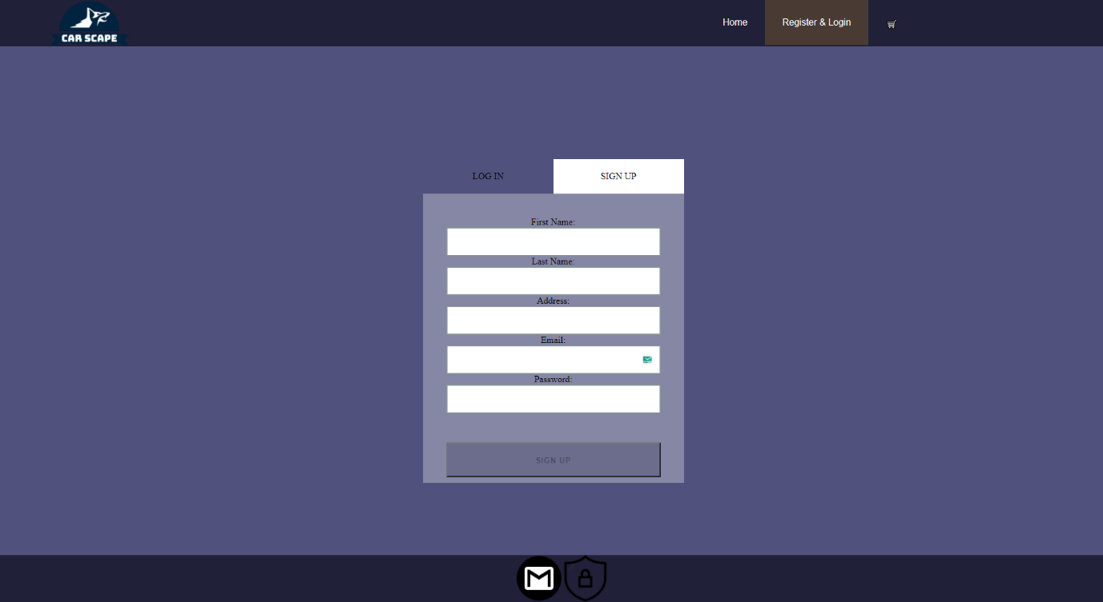

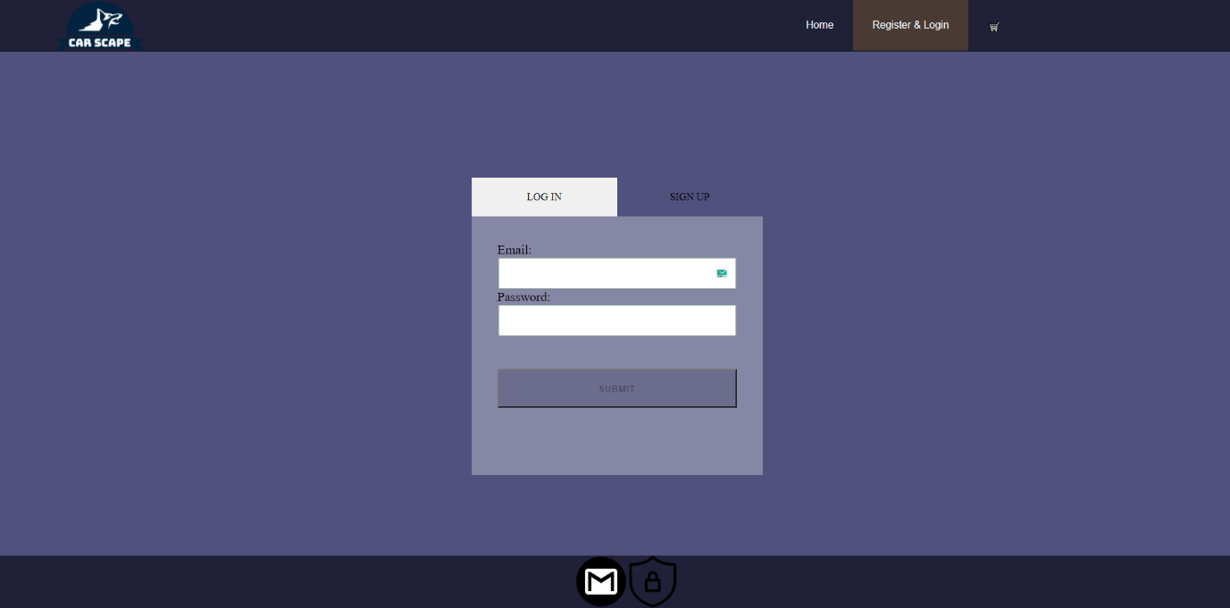

Cart:

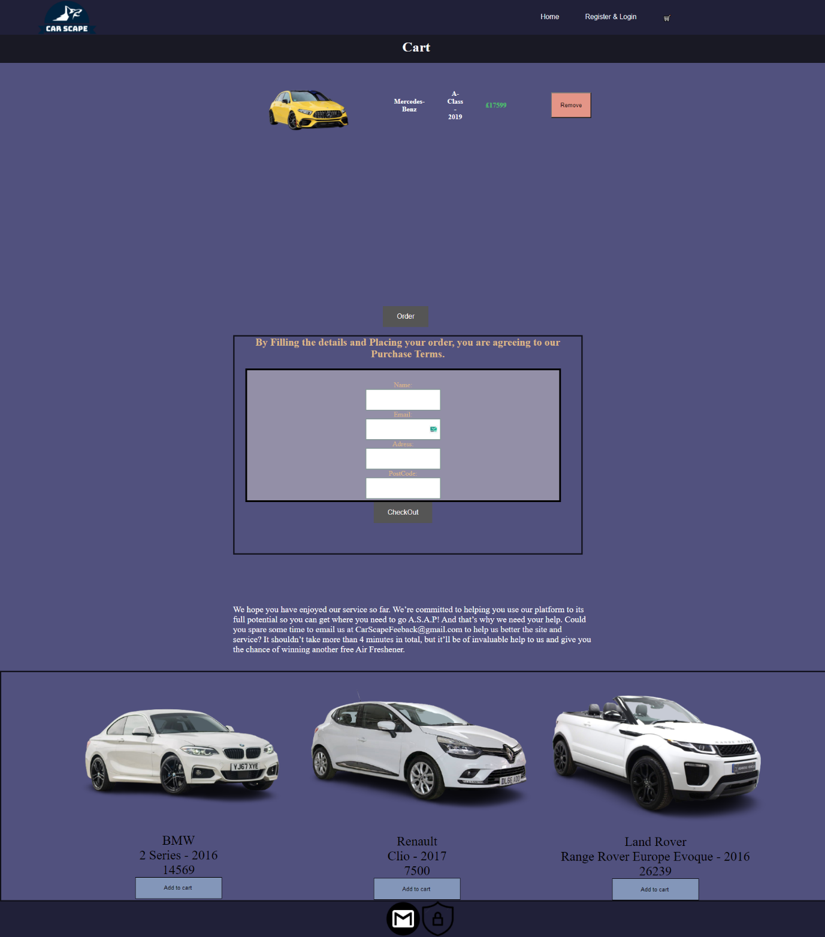

Admin Login: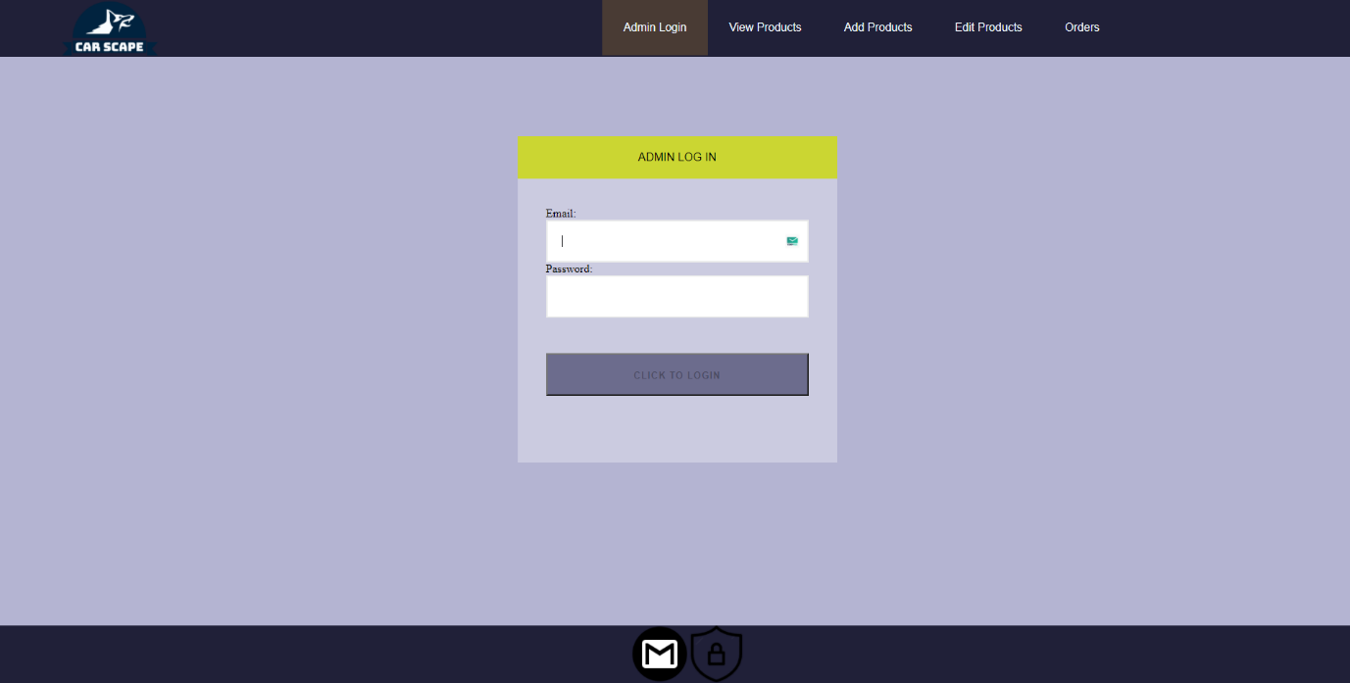

View Products: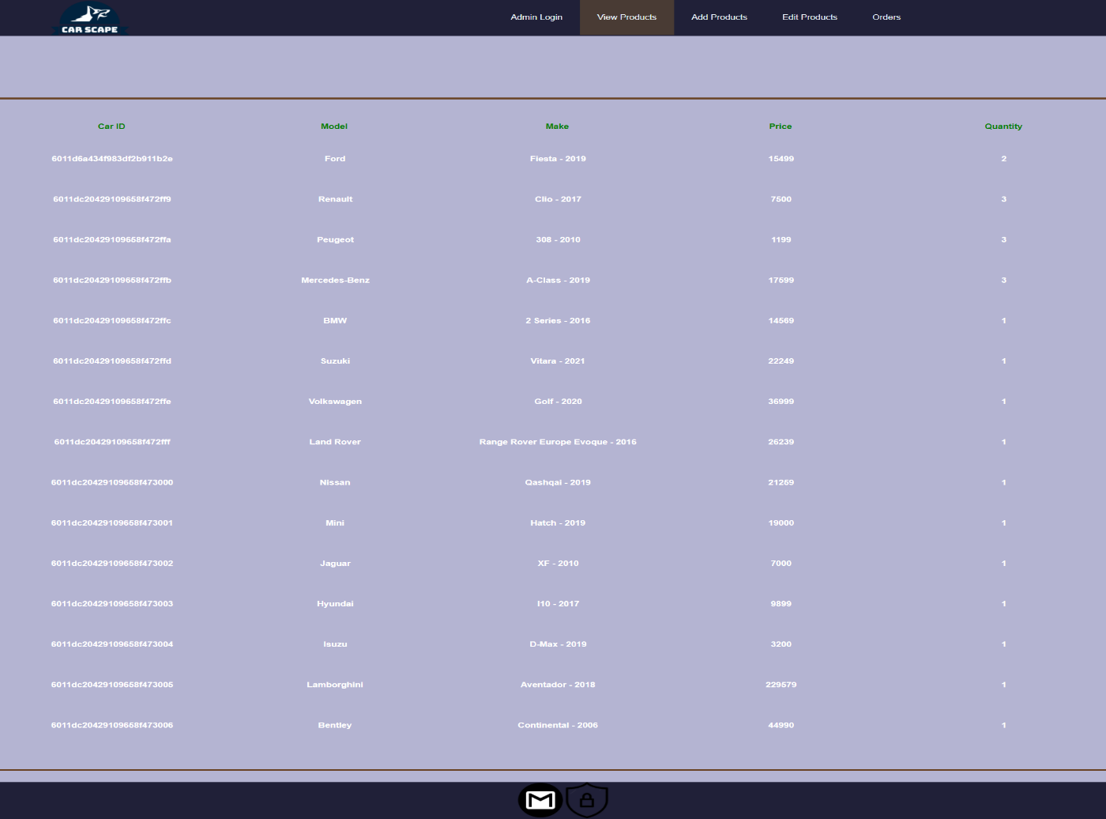

Add product: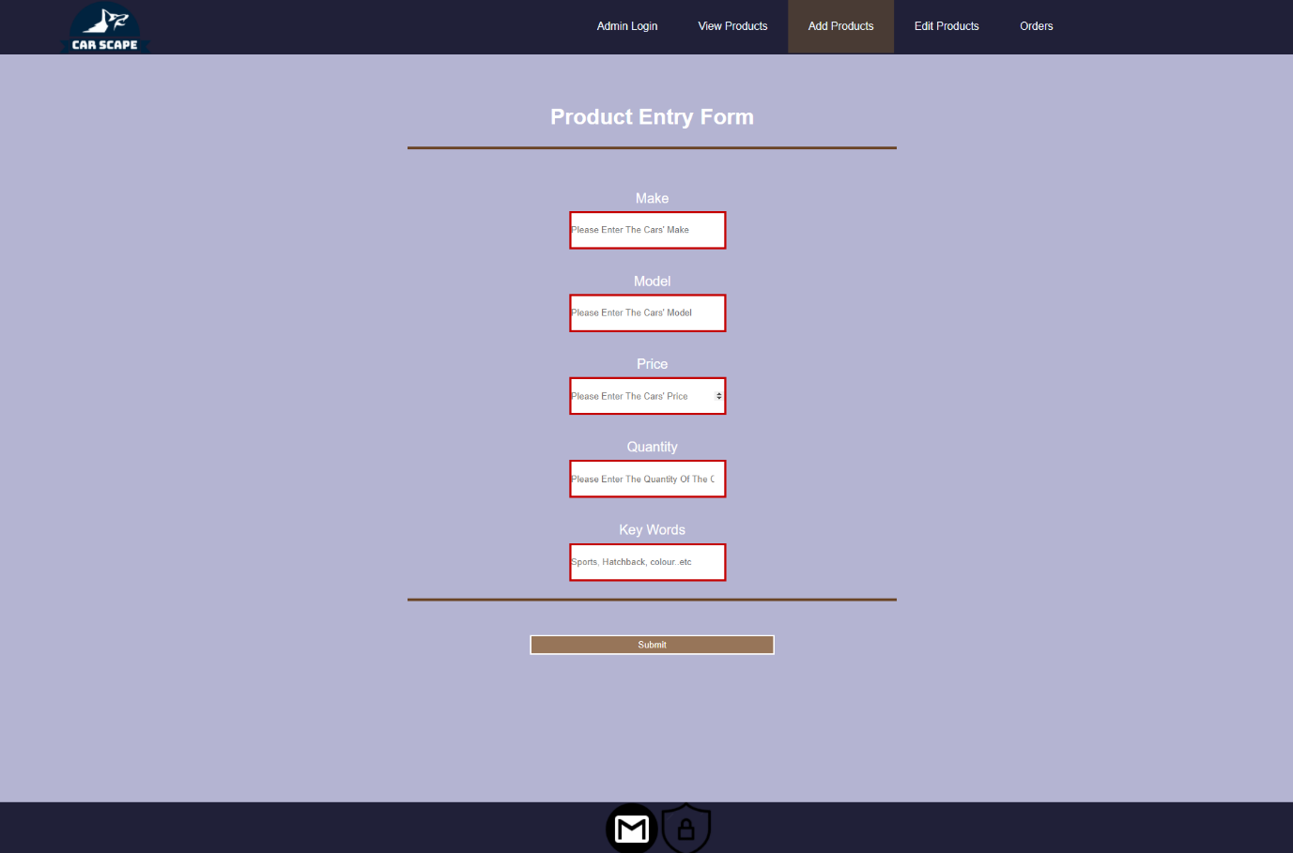

Edit product: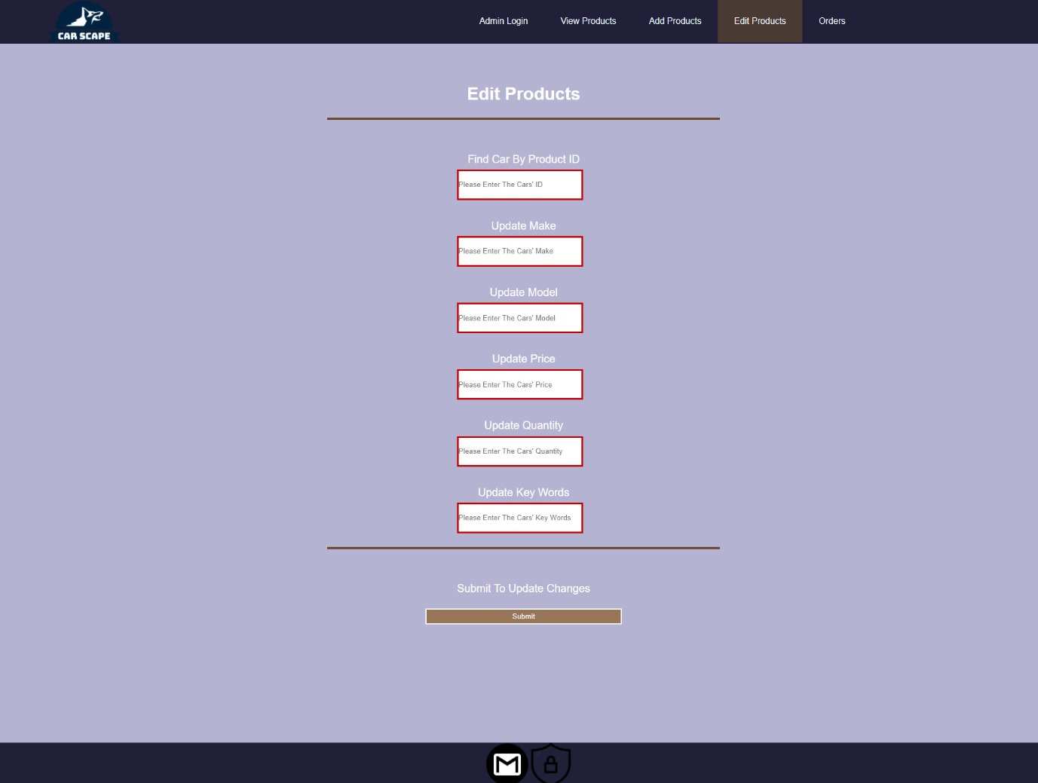

Show and remove Orders: 