COFFEE MARKET RESEARCH · DEMAND SIDE
Coffee demand: a learning guide
Who drinks the coffee, who flinches at the price, who keeps producing — how the market works, what the official data say for 2005–2026, and how to read every chart in the companion PowerPoint deck.
September 2026 · volumes: USDA PSD and ICO · prices: IMF and ICO to Aug-2026 · national data: ABIC, IBGE, BLS, World Bank
The answers in one page
Demand growth: world consumption rose from 125.2m to 173.9m 60-kg bags between 2005/06 and 2025/26 (+1.7% a year, about +2.4m bags every year). It fell in only 6 of 20 years. USDA forecasts a record 179.7m for 2026/27.
Faster than supply? not over 20 years (production +2.1%/yr), but yes in 2020/21–2025/26: demand +1.4%/yr vs supply +0.3%/yr, so world stocks fell 17.3m bags to 20.1m (12% of a year's use) and prices hit records.
Biggest consumers: Europe (EU-27+UK 46.2m bags) and the US (26.6m), then Brazil (22.3m). Growth now comes from producing countries and new importers (China, Turkey, the Gulf).
Why it grows: about 68% is population, 32% more coffee per person — rising incomes and cities in Asia, café chains and cheap instant coffee.
Marginal buyers: Europe, the US and Canada are inelastic; China, Vietnam, Turkey and the Gulf keep growing whatever the price; Japan, Algeria, Russia and — only at extreme retail inflation — Brazil cut back.
Switching: roasters add robusta when arabica trades at ≥1.8× robusta and move back when the ratio falls below ~1.5×; structurally robusta rose from 40% to 47% of world output.
Marginal producers: Brazil, Vietnam, Ethiopia, Uganda and India produce through price lows; Honduras, Peru, El Salvador and Colombia cut; Guatemala, Nicaragua, Costa Rica, Côte d'Ivoire decline even at record prices; high prices bring a record crop 3–4 years later.

Contents
Right-click here and choose 'Update Field' to build the table of contents.

How to use this guide
The PowerPoint deck gives the story in charts. This guide explains the mechanics behind each chart, defines every concept a trader needs (elasticity, marginal buyer, stocks-to-use, arbitrage…), shows the full data tables and documents where every number comes from. Read section 1 first if the concepts are new; sections 2–6 follow the deck; section 7 explains the data sources and how to refresh them.
- Deck ↔ guide: each chapter here matches a section of the deck (01 Global picture, 02 Segments & drivers, 03 Marginal buyers, 04 Marginal producers, 05 Tracker).
- Numbers: every number is computed by scripts/analysis.py from the files in research/coffee-demand/data. Nothing is typed by hand.
- Units: volumes in millions of 60-kg bags of green coffee equivalent; prices in US cents per pound unless stated.

1. The basics you need

1.1 Units, years and the two statistical agencies
- A bag = 60 kg of green (unroasted) coffee. 1 million bags ≈ 60,000 tonnes. Roasted and instant coffee are converted back to 'green bean equivalent'.
- Marketing year (USDA) follows each country's harvest: Brazil July–June, Vietnam and Colombia October–September, Indonesia April–March. Importing countries use October–September. The world total adds up these local years.
- Coffee year (ICO) is always October–September for every country, so ICO and USDA totals never match exactly.
- USDA FAS PSD (Production, Supply & Distribution) gives a full balance sheet for ~90 countries every year since 1960: production (arabica/robusta), imports, exports, domestic consumption (roast & ground vs soluble) and stocks. It is the backbone of this analysis.
- ICO (International Coffee Organization) publishes the official indicator prices, monthly exports by coffee type and its own world balance (which in 2026 switched to 'apparent consumption' and was revised heavily — do not splice old and new ICO series).

1.2 Arabica, robusta and the price indicators
Arabica (Coffea arabica) grows at altitude, is milder and more expensive; robusta (Coffea canephora, called conilon in Brazil) grows in hot lowlands, is more bitter, has more caffeine and costs less. Robusta dominates instant (soluble) coffee and many espresso blends.
Table 1. Price indicators used in this guide
Indicator | What it is | Used here as
ICO Other Milds | Washed arabicas from Central America, Peru, India etc., New York ex-dock | 'Arabica' price
ICO Robustas | Vietnam, Uganda, Indonesia, Côte d'Ivoire robustas, New York | 'Robusta' price
ICO Composite (I-CIP) | Weighted average of the four ICO groups | headline level only
ICE 'KC' (New York) | Arabica futures; the trading benchmark | context
ICE 'RC' (London) | Robusta futures, US$ per tonne | context
Green price (own) | 0.6 × Arabica + 0.4 × Robusta — roughly the world consumption mix | price in elasticity work
Ratio / arbitrage | Arabica ÷ Robusta (or Arabica − Robusta in c/lb) | switching signal

1.3 Demand, consumption and stocks
Nobody counts cups. For an importing country, USDA estimates consumption as imports minus re-exports, adjusted for changes in stocks — i.e. disappearance. That is why consumption in the EU or the US can jump ±5–10% in one year: roasters and traders build or run down inventories. Always read trends on 3-year averages. For producing countries, national surveys are used (for Brazil, ABIC's industry panel).
Stocks-to-use = ending stocks ÷ annual consumption. It measures the buffer against a bad crop. In this dataset it ranged from 31% (2014/15) down to 12% (2025/26). The lower it is, the more violently prices react to weather.

1.4 Growth maths
- Year-on-year (y/y) = value this year ÷ value last year − 1.
- CAGR (compound annual growth rate) = (end ÷ start)^(1/years) − 1. 125.2 → 173.9 over 20 years = +1.66% a year.
- 3-year average smooths inventory noise: e.g. average 2023/24–2025/26 vs average 2017/18–2019/20 compares 'during the spike' with 'before it'.
- Growth decomposition consumption = population × consumption per person, so ln(growth) = ln(population growth) + ln(per-capita growth).

1.5 Elasticity — the key idea
Price elasticity of demand = % change in quantity ÷ % change in price. An elasticity of −0.1 means a 10% price rise cuts volumes by 1%. Between 0 and −1 demand is inelastic (spending rises when prices rise); below −1 it is elastic.
- Coffee demand is inelastic because the green bean is a small part of what the drinker pays: in a café cup it is a few percent, on the supermarket shelf roughly a third to a half. A doubling of green prices raises shelf prices by far less, and later.
- Habit and caffeine make coffee a staple for regular drinkers; cheaper substitutes (instant, robusta blends, own-label) exist inside the category, so people trade down rather than stop.
- Cross-price elasticity (arabica vs robusta) is where the action is: roasters change blends when the price ratio moves.
- Income elasticity (response to income) is high in emerging markets and near zero in mature ones.

1.6 Marginal buyer and marginal producer
The marginal buyer is the last buyer who drops out when the price rises — the one whose reaction balances the market. The marginal producer is the highest-cost supplier who stops (or starts) producing as the price falls (or rises). In coffee both are small groups: most demand does not react to price in the short run and most supply cannot react for 2–4 years (new trees take that long to bear), so the price has to move a lot to find the few who can adjust.

2. The global picture, 2005–2026

2.1 World demand, year by year
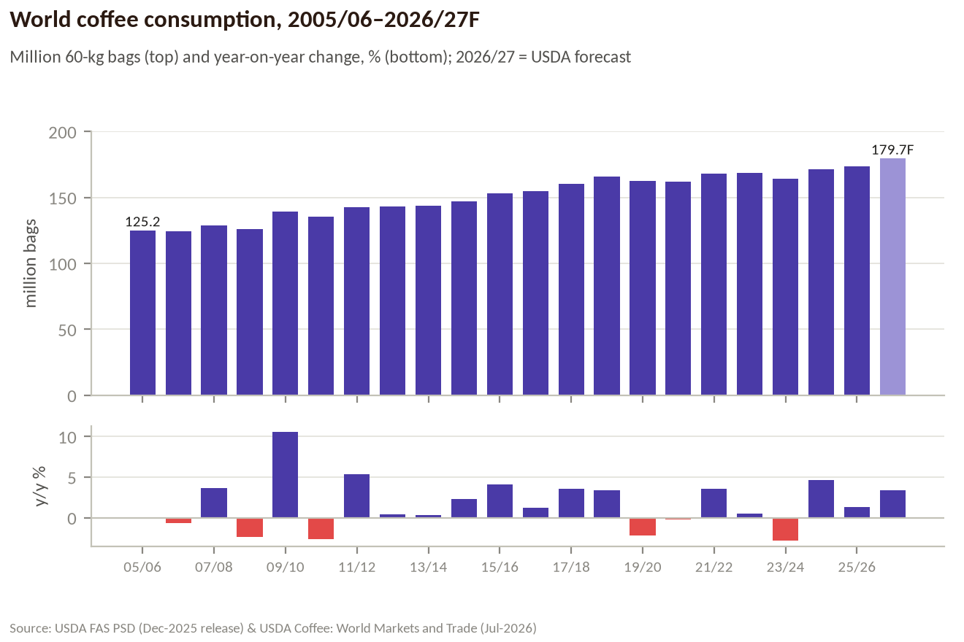
Figure 1. World coffee consumption and its year-on-year change (USDA).
World consumption rose by 48.7m bags in 20 years. The year-on-year changes are small and mostly positive: the standard deviation of annual growth is 3.3% (production: 6.0%). The 6 down years (2006/07, 2008/09, 2010/11, 2019/20, 2020/21, 2023/24) are explained by inventory swings in importing countries (2006/07, 2008/09, 2010/11, 2023/24) and COVID (2019/20–2020/21). The +10.6% in 2009/10 is the mirror image of low stock-building the year before, not a sudden jump in drinking.
Table 2. World balance, million bags (USDA PSD Dec-2025 release; 2026/27 = USDA Jul-2026 forecast)
Year | Production | Consumption | Cons. y/y | Prod. y/y | End stocks | Stocks/use
2005/06 | 117.9 | 125.2 |  |  | 32.6 | 26.0%
2006/07 | 134.0 | 124.4 | −0.6% | +13.7% | 35.7 | 28.7%
2007/08 | 124.4 | 128.9 | +3.7% | −7.2% | 31.4 | 24.4%
2008/09 | 136.8 | 125.9 | −2.4% | +9.9% | 39.6 | 31.5%
2009/10 | 129.8 | 139.2 | +10.6% | −5.1% | 28.8 | 20.7%
2010/11 | 141.4 | 135.5 | −2.6% | +9.0% | 28.6 | 21.1%
2011/12 | 144.8 | 142.8 | +5.4% | +2.4% | 25.7 | 18.0%
2012/13 | 158.0 | 143.4 | +0.4% | +9.1% | 35.4 | 24.7%
2013/14 | 160.1 | 143.9 | +0.3% | +1.3% | 41.2 | 28.6%
2014/15 | 153.8 | 147.2 | +2.3% | −3.9% | 43.1 | 29.3%
2015/16 | 152.4 | 153.2 | +4.1% | −0.9% | 35.0 | 22.8%
2016/17 | 161.1 | 155.1 | +1.3% | +5.7% | 36.5 | 23.5%
2017/18 | 159.8 | 160.6 | +3.6% | −0.8% | 32.0 | 19.9%
2018/19 | 175.9 | 166.0 | +3.3% | +10.0% | 36.9 | 22.3%
2019/20 | 169.0 | 162.4 | −2.2% | −3.9% | 35.8 | 22.1%
2020/21 | 176.5 | 162.1 | −0.2% | +4.4% | 37.5 | 23.1%
2021/22 | 165.0 | 167.9 | +3.6% | −6.5% | 31.9 | 19.0%
2022/23 | 164.4 | 168.8 | +0.5% | −0.4% | 26.9 | 16.0%
2023/24 | 169.3 | 164.0 | −2.8% | +3.0% | 23.1 | 14.1%
2024/25 | 175.3 | 171.6 | +4.6% | +3.5% | 21.3 | 12.4%
2025/26 | 178.8 | 173.9 | +1.3% | +2.0% | 20.1 | 11.6%
2026/27F | 189.7 | 179.7 | +3.4% | +6.0% | 26.3 | 14.6%

Note on 2026/27: USDA's July-2026 report forecasts consumption at 179.7m (+3.6% vs its revised 2025/26) and stocks rebuilding by 1.9m bags to 26.3m. Its revised 2025/26 figures were not published in the text we could access, so 2025/26 is shown in the December-2025 version; the stock rebuild should be read from USDA's +1.9m, not from the table's difference.

2.2 Is demand growing faster than supply?
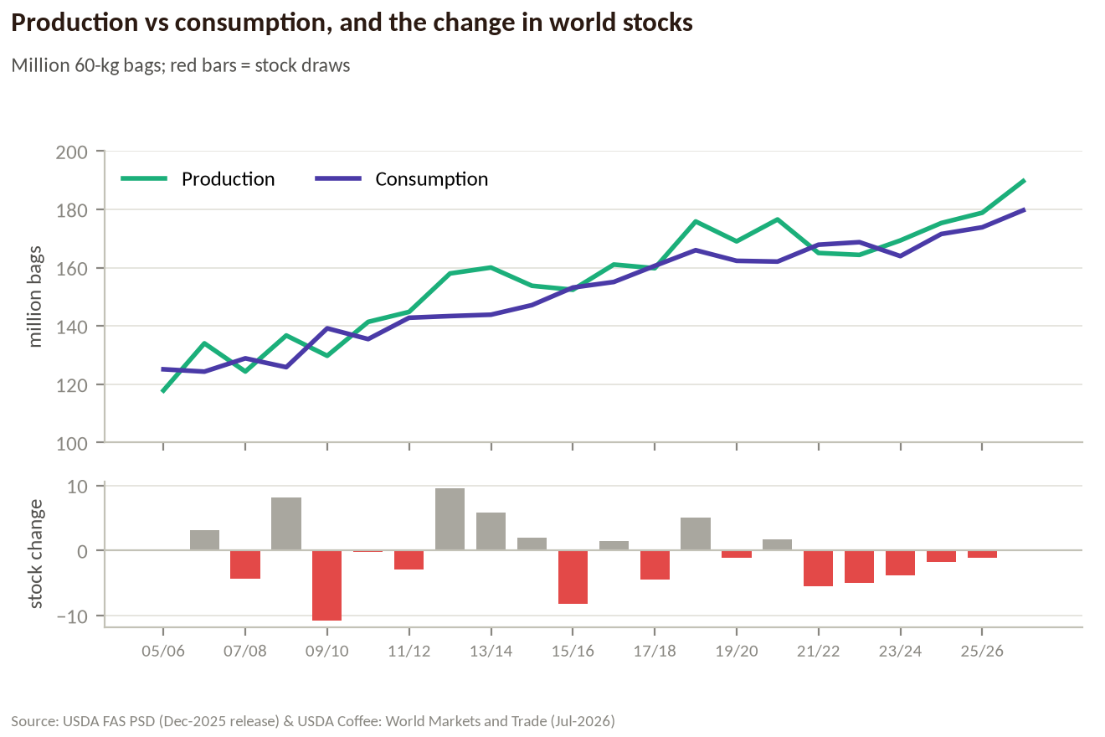
Figure 2. World production vs consumption, and the change in world ending stocks (USDA).
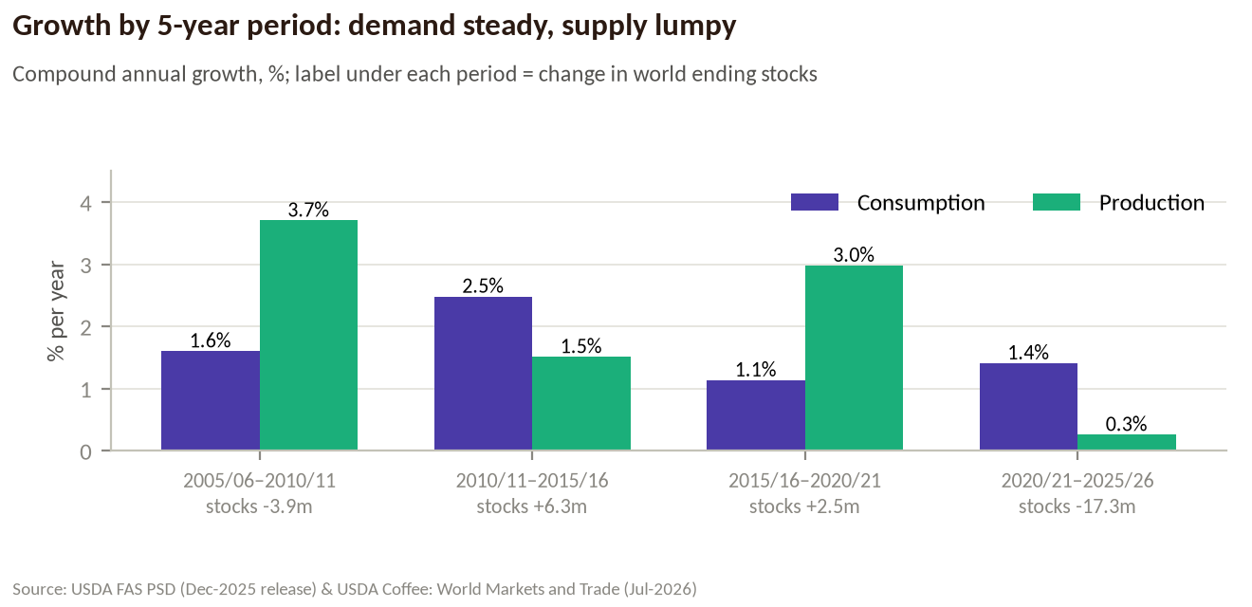
Figure 3. Compound annual growth by 5-year period; stock change under each period.
The honest answer depends on the window:
- 20 years: no. Production grew 2.1% a year vs 1.7% for consumption. Part of that is the starting point: 2005/06 was a small Brazilian crop.
- 2010/11–2015/16 and 2020/21–2025/26: yes. Demand grew 2.5% and 1.4% a year while supply grew 1.5% and 0.3%. In the second period stocks fell 17.3m bags.
- The price follows the stock cycle, not the demand trend. Demand growth sits in a narrow 1.1–2.5% band in every period; supply growth ranges from 0.3% to 3.7%.

2.3 Stocks and prices
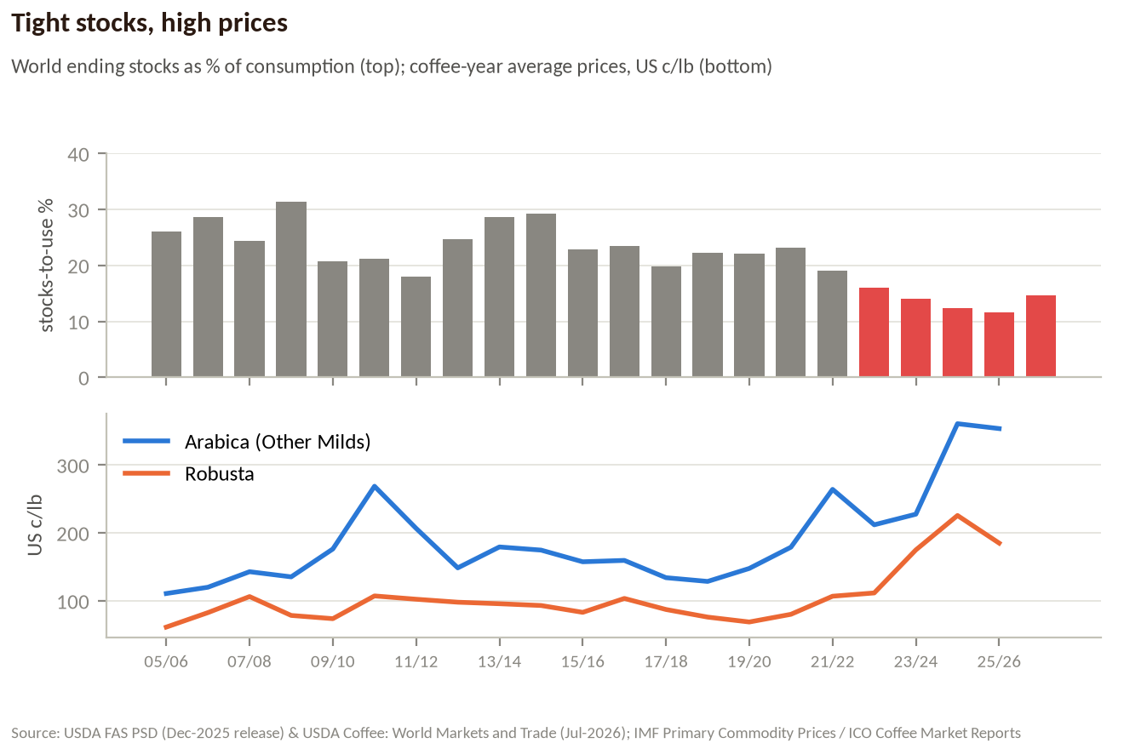
Figure 4. Stocks-to-use (top) and coffee-year average prices (bottom).
Stocks peaked at 43.1m bags in 2014/15 and fell to 20.1m by 2025/26. Arabica averaged 129 c/lb in coffee year 2018/19 and 361 c/lb in 2024/25; robusta went from 76 to 226 c/lb. From 2022/23 stocks-to-use sat below 16% for the first time in the series, and prices broke out to records: with no buffer, every weather scare had to be rationed by price.

2.4 Who consumes the most, and how
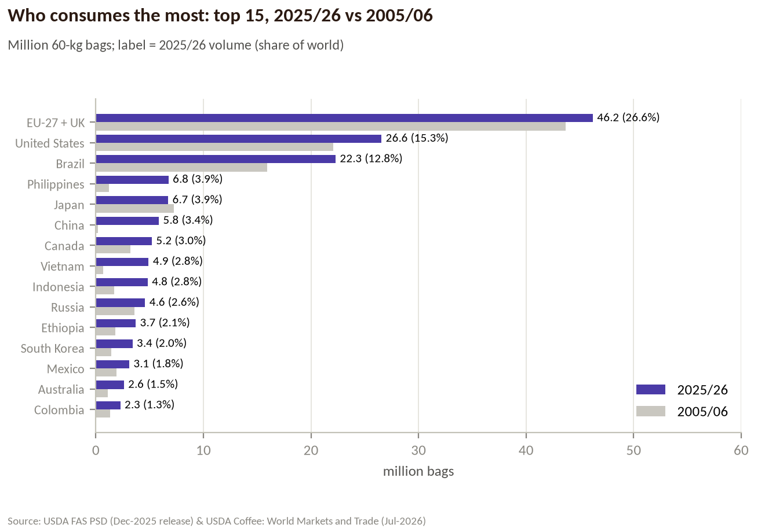
Figure 5. Top 15 consumers, 2025/26 vs 2005/06 (USDA).
Table 3. Consumption by country, million bags (USDA)
Country | 2005/06 | 2015/16 | 2020/21 | 2025/26 | Share | CAGR 05→25 | Group
EU-27 + UK | 43.7 | 44.1 | 44.2 | 46.2 | 26.6% | +0.3% | Traditional importers
United States | 22.1 | 25.1 | 25.9 | 26.6 | 15.3% | +0.9% | Traditional importers
Brazil | 15.9 | 20.9 | 22.3 | 22.3 | 12.8% | +1.7% | Producing countries
Philippines | 1.2 | 6.2 | 6.6 | 6.8 | 3.9% | +9.0% | Producing countries
Japan | 7.3 | 8.1 | 7.4 | 6.7 | 3.9% | −0.4% | Traditional importers
China | 0.2 | 2.5 | 4.5 | 5.8 | 3.4% | +18.4% | Emerging importers
Canada | 3.2 | 4.5 | 5.0 | 5.2 | 3.0% | +2.4% | Traditional importers
Vietnam | 0.7 | 2.6 | 2.7 | 4.9 | 2.8% | +10.5% | Producing countries
Indonesia | 1.7 | 3.2 | 4.5 | 4.8 | 2.8% | +5.4% | Producing countries
Russia | 3.6 | 4.4 | 4.2 | 4.6 | 2.6% | +1.2% | Emerging importers
Ethiopia | 1.8 | 3.1 | 3.0 | 3.7 | 2.1% | +3.6% | Producing countries
South Korea | 1.5 | 2.5 | 3.0 | 3.4 | 2.0% | +4.3% | Emerging importers
Mexico | 1.9 | 2.3 | 2.6 | 3.1 | 1.8% | +2.5% | Producing countries
Australia | 1.1 | 1.8 | 2.1 | 2.6 | 1.5% | +4.3% | Traditional importers
Colombia | 1.3 | 1.4 | 2.1 | 2.3 | 1.3% | +2.8% | Producing countries
Algeria | 2.1 | 2.3 | 2.2 | 2.0 | 1.2% | −0.1% | Emerging importers
Turkey | 0.2 | 0.7 | 1.2 | 1.8 | 1.0% | +11.5% | Emerging importers
Saudi Arabia | 0.5 | 0.8 | 1.2 | 1.5 | 0.9% | +5.2% | Emerging importers
India | 1.4 | 1.2 | 1.2 | 1.4 | 0.8% | 0.0% | Producing countries
Switzerland | 0.9 | 1.1 | 1.2 | 1.3 | 0.7% | +1.9% | Traditional importers
Ukraine | 1.6 | 1.0 | 1.2 | 1.2 | 0.7% | −1.6% | Emerging importers
Morocco | 0.5 | 0.7 | 0.9 | 1.1 | 0.6% | +3.5% | Emerging importers
Egypt | 0.1 | 0.5 | 0.4 | 1.0 | 0.6% | +13.5% | Emerging importers
Jordan | 0.2 | 0.6 | 0.8 | 0.9 | 0.5% | +8.7% | Emerging importers
Thailand | 0.5 | 0.6 | 0.7 | 0.9 | 0.5% | +3.2% | Producing countries

How people drink differs by market. USDA splits each country's consumption into roast & ground and soluble (instant). Europe, the US and Brazil drink more than 90% roast & ground (filter, espresso, capsules, cafés). Instant dominates in the Philippines and is a third of use in China, Indonesia and Vietnam (Table 4). Brazil buys 73–78% of its coffee through retail for home brewing (ABIC, 2025).
Table 4. Instant coffee's share of consumption by country, 2025/26 (USDA; several countries, e.g. Korea and Turkey, report no split)
Country | Consumption 2025/26, m bags | of which instant (soluble)
Philippines | 6.75 | 91%
Thailand | 0.93 | 76%
India | 1.36 | 70%
Mexico | 3.10 | 58%
Canada | 5.20 | 35%
China | 5.85 | 32%
Indonesia | 4.81 | 32%
Vietnam | 4.90 | 31%
Colombia | 2.27 | 27%
Australia | 2.60 | 23%
Ukraine | 1.18 | 21%
Russia | 4.58 | 9%
EU-27 + UK | 46.20 | 8%
Japan | 6.72 | 7%
United States | 26.55 | 6%
Brazil | 22.28 | 4%

Table 5. Inside Europe: consumption by member state, million bags (ICO importing-country data, calendar years; latest public year 2019)
EU country | 2005 | 2019
Germany | 8.66 | 8.67
France | 4.79 | 6.19
Italy | 5.55 | 5.47
Spain | 3.01 | 3.25
Poland | 2.27 | 2.50
Netherlands | 1.93 | 2.03
Sweden | 1.17 | 1.77
Finland | 1.10 | 1.35
Belgium | 1.16 | 1.19
Austria | 0.77 | 1.17
Greece | 0.87 | 1.14
Romania | 0.86 | 1.11
Portugal | 0.74 | 0.93

2.5 Where the growth came from
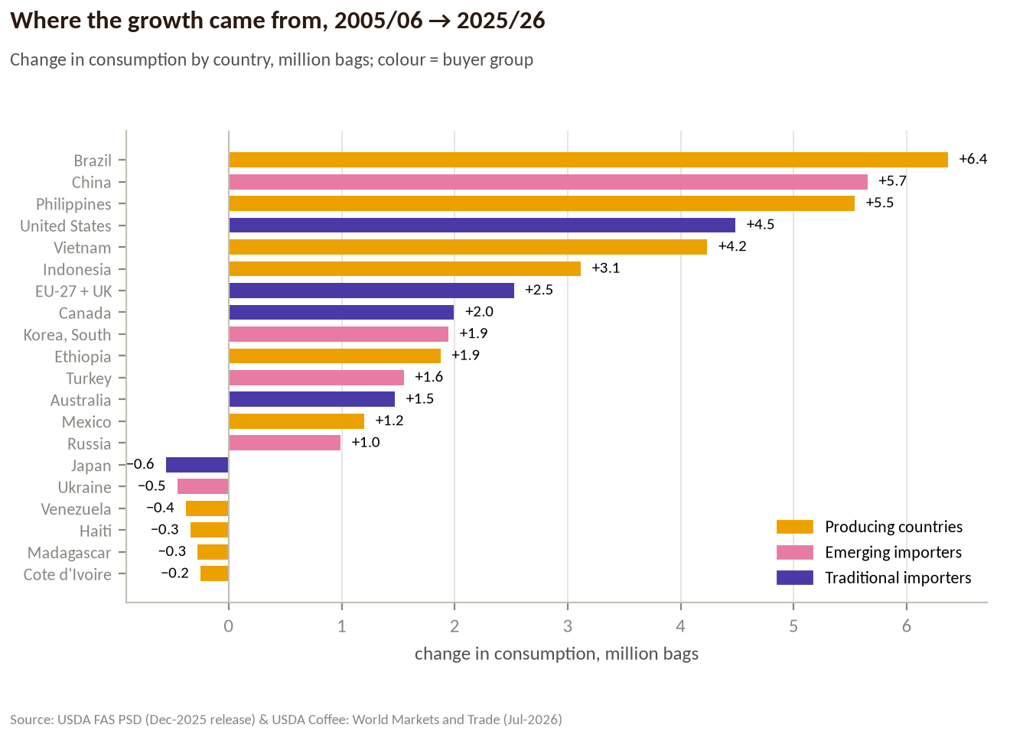
Figure 6. Change in consumption by country, 2005/06 → 2025/26, coloured by buyer group.
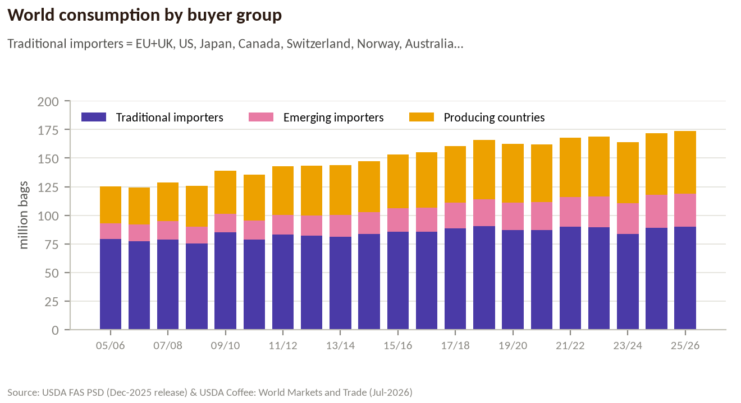
Figure 7. World consumption by buyer group.
Of the 48.7m extra bags, producing countries added 22.9m (47%), emerging importers 15.1m (31%) and traditional importers 10.7m (22%). Traditional importers' share of world use fell from 63% to 52%.
Trading implication: as Brazil, Vietnam, Indonesia and Ethiopia drink more of their own crops, less is left to export. Producing countries now consume about 55m bags a year.

2.6 Why demand grows: people, income and habit
Between 2005/06 and 2024/25 world consumption rose 37.1%. World population rose 23.8% (6.58bn → 8.14bn) and consumption per person rose 10.7% (1.14 → 1.26 kg). On a log basis population explains ~68% of the growth and per-capita gains ~32%.
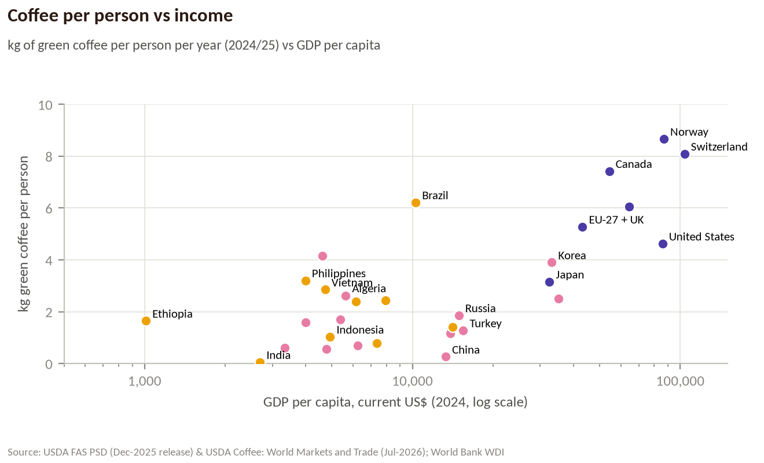
Figure 8. Consumption per person vs GDP per capita (log scale).
Per-capita use climbs with income until roughly 4–9 kg a year (Nordics, Switzerland, Canada, Brazil, Europe, the US). China (0.26 kg), India (0.05 kg) and Indonesia (1.0 kg) are far below — that is the long-run runway. China's GDP per head multiplied by 7.5 since 2005 and its urban population share rose from 42.5% to 65.5% (World Bank); its coffee use multiplied almost thirty-fold.

3. Demand segments and drivers
The brief asked which type of demand grew: personal (at home), coffee shops, retailers, roasters. Official statistics do not split coffee by channel, so the guide uses three official segmentations and one set of proxies:
- By buyer group (USDA, every country): traditional importers, emerging importers, producing countries — section 2.5.
- By format (USDA): roast & ground vs soluble (instant) — below.
- By channel (national data): Brazil's ABIC measures retail (at-home) at 73–78% of domestic volume in 2025.
- Proxies for cafés (company filings): store counts of the big chains.

3.1 Formats: instant is the fastest-growing
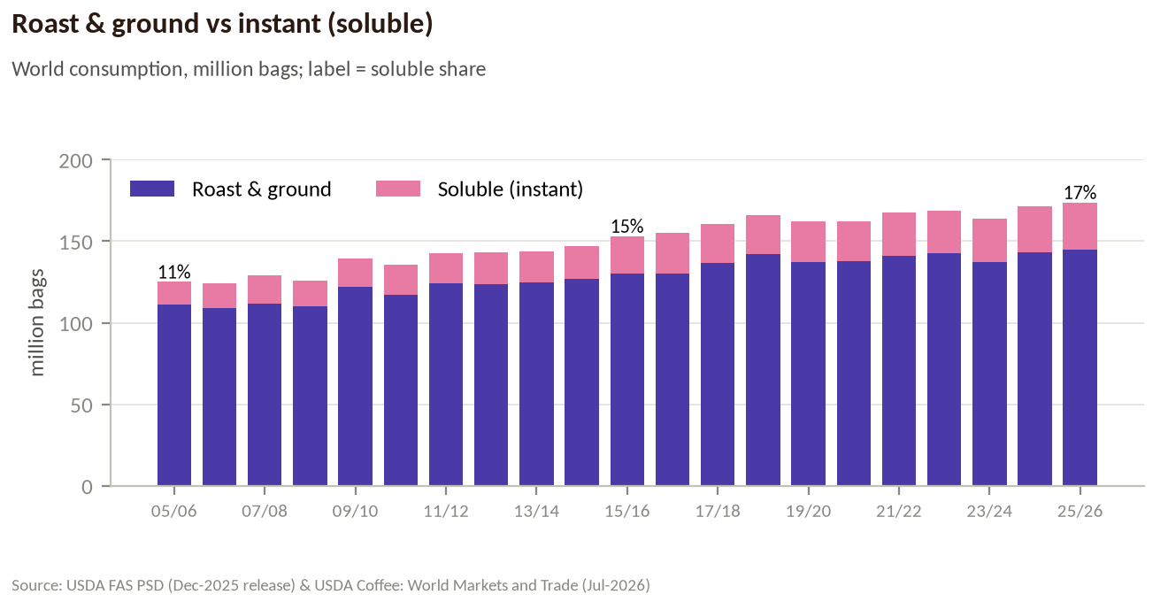
Figure 9. World consumption: roast & ground vs soluble (USDA).
Soluble consumption rose from 14.1m to 29.1m bags (+3.7% a year) against +1.3% a year for roast & ground; its share went from 11% to 17%. Instant is the entry format in new markets and the cheapest cup when prices rise — and it is mostly robusta. Capsules and pods show up in trade statistics as roasted coffee: world roast & ground exports rose from 1.6m to 6.7m bags; Switzerland, home of Nespresso's roasting, exported 1.9m bags of roasted coffee in 2025/26.

3.2 Coffee shops
Table 6. Starbucks stores at fiscal year-end (Form 10-K; years not captured are omitted)
Fiscal year | Starbucks total | of which China | of which US
FY2005 | 10,241
FY2006 | 12,440
FY2010 | 16,858
FY2014 | 21,366
FY2015 | 23,043
FY2016 | 25,085
FY2017 | 27,339
FY2018 | 29,324
FY2019 | 31,256
FY2020 | 32,660 | 4,706 | 15,337
FY2021 | 33,833 | 5,360 | 15,450
FY2022 | 35,711 |  | 15,878
FY2023 | 38,038 | 6,806 | 16,352
FY2024 | 40,199 | 7,596 | 16,941
FY2025 | 40,990 | 8,011 | 16,864

Starbucks grew from 10,241 stores (FY2005) to 40,990 (FY2025), ×4.0. Since FY2020 its China store count grew 70% while the US grew 10%. Luckin Coffee reported 22,340 stores at the end of 2024 (20-F, as quoted in a secondary source) — about three times Starbucks China. Cafés matter less for volume than for habit: they recruit new, young, urban drinkers who then also buy coffee for home.

3.3 Roasters and blends
Roasters are the buyers who actually face green-coffee prices, and they have three levers: raise shelf prices, change the blend (more robusta/conilon, cheaper origins), or run down inventories. ABIC reports that in 2021–2025 Brazilian green-coffee costs rose 201% (conilon) and 212% (arabica) while retail prices rose 116% — roasters absorbed part of the shock and changed blends. The ICO attributed part of the fall in arabica exports in 2022/23 to 'substitution towards the Robustas' and to consuming countries running down stocks.

4. Marginal buyers: who reacts to price

4.1 The price shock
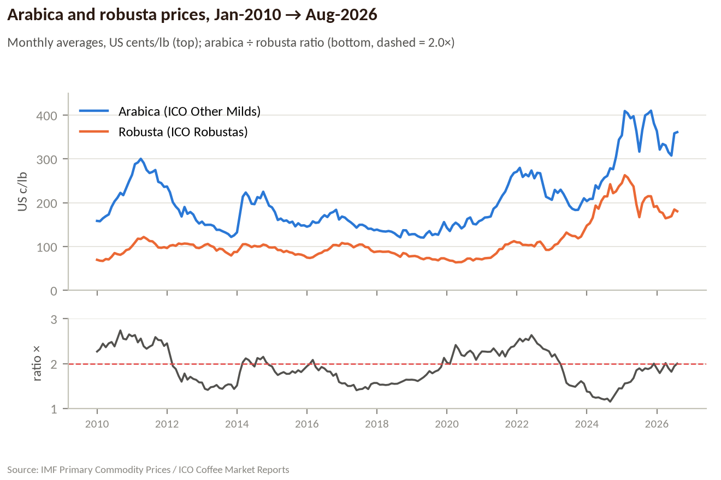
Figure 10. Monthly arabica and robusta prices and their ratio, Jan-2010 → Aug-2026.
Table 7. Coffee-year average prices, US c/lb (Oct–Sep; IMF to Sep-2025, ICO after)
Coffee year | Arabica | Robusta | Ratio | Green price | y/y | months
2005/06 | 111 | 61 | 1.80 | 91 | +7% | 12
2006/07 | 120 | 83 | 1.45 | 105 | +15% | 12
2007/08 | 143 | 106 | 1.34 | 128 | +22% | 12
2008/09 | 135 | 79 | 1.72 | 113 | −12% | 12
2009/10 | 176 | 74 | 2.39 | 135 | +20% | 12
2010/11 | 269 | 107 | 2.50 | 204 | +51% | 12
2011/12 | 207 | 102 | 2.02 | 165 | −19% | 12
2012/13 | 149 | 98 | 1.52 | 128 | −22% | 12
2013/14 | 179 | 96 | 1.87 | 146 | +14% | 12
2014/15 | 175 | 93 | 1.87 | 142 | −3% | 12
2015/16 | 158 | 83 | 1.89 | 128 | −10% | 12
2016/17 | 160 | 104 | 1.54 | 137 | +7% | 12
2017/18 | 134 | 87 | 1.54 | 115 | −16% | 12
2018/19 | 129 | 76 | 1.69 | 108 | −7% | 12
2019/20 | 148 | 69 | 2.14 | 116 | +8% | 12
2020/21 | 179 | 80 | 2.23 | 140 | +20% | 12
2021/22 | 264 | 107 | 2.47 | 201 | +44% | 12
2022/23 | 212 | 112 | 1.90 | 172 | −15% | 12
2023/24 | 228 | 175 | 1.30 | 207 | +20% | 12
2024/25 | 361 | 226 | 1.60 | 307 | +48% | 12
2025/26 | 354 | 185 | 1.91 | 286 | −7% | 11

Green prices averaged 113 c/lb in 2017/18–2019/20 and 266 c/lb in 2023/24–2025/26: +136%. That is the 'experiment' used below to see who cut consumption.

4.2 Three kinds of buyer
Each of the 30 largest consuming countries is classified by the change in its 3-year average consumption through the spike (2023/24–2025/26 vs 2017/18–2019/20). Rules: keep growing = above +10%; inelastic = between −5% and +10%; cut back = below −5% or a documented price-driven break (Brazil). Venezuela is excluded (economic collapse, not coffee prices).
Table 8. Keep growing (22% of world use)
Country | Δ 3-yr avg | 2025/26 m bags | CAGR 15→20 | CAGR 20→25 | down years 21–25
China | +90% | 5.8 | +12.5% | +5.5% | 1
Iran | +83% | 0.9 | +7.6% | +16.2% | 1
Turkey | +56% | 1.8 | +10.4% | +8.5% | 2
Vietnam | +52% | 4.9 | +0.7% | +12.5% | 0
Saudi Arabia | +47% | 1.5 | +8.9% | +4.6% | 2
Taiwan | +27% | 0.8 | +4.3% | +4.9% | 1
Australia | +26% | 2.6 | +2.9% | +4.8% | 3
Colombia | +24% | 2.3 | +8.0% | +1.8% | 1
Mexico | +24% | 3.1 | +2.2% | +3.7% | 0
Thailand | +24% | 0.9 | +3.2% | +7.3% | 1
Morocco | +22% | 1.1 | +5.6% | +3.8% | 1
South Korea | +20% | 3.4 | +4.0% | +2.6% | 1
Egypt | +19% | 1.0 | −5.3% | +20.1% | 2
Ethiopia | +14% | 3.7 | −0.7% | +4.3% | 0
Indonesia | +13% | 4.8 | +7.0% | +1.6% | 1

Table 9. Inelastic (52% of world use)
Country | Δ 3-yr avg | 2025/26 m bags | CAGR 15→20 | CAGR 20→25 | down years 21–25
EU-27 + UK | 0% | 46.2 | +0.1% | +0.9% | 1
United States | −3% | 26.6 | +0.7% | +0.5% | 2
Philippines | +4% | 6.8 | +1.2% | +0.5% | 2
Canada | +6% | 5.2 | +1.9% | +0.8% | 2
India | +8% | 1.4 | −1.1% | +2.9% | 1
Switzerland | +10% | 1.3 | +1.5% | +2.0% | 2
Ukraine | −5% | 1.2 | +4.9% | −1.0% | 2
Jordan | +9% | 0.9 | +7.8% | +2.4% | 3
Argentina | +1% | 0.8 | +1.3% | +1.5% | 2
Norway | 0% | 0.8 | +0.8% | −0.1% | 2

Table 10. Cut back (21% of world use)
Country | Δ 3-yr avg | 2025/26 m bags | CAGR 15→20 | CAGR 20→25 | down years 21–25
Japan | −15% | 6.7 | −1.8% | −1.8% | 3
Algeria | −9% | 2.0 | −0.7% | −1.8% | 3
Serbia | −7% | 0.8 | +3.2% | −2.1% | 3
Russia | −5% | 4.6 | −1.1% | +1.9% | 1
Brazil | −3% | 22.3 | +1.3% | 0.0% | 2

Why the US is 'inelastic' but Brazil 'cuts back' at the same −3%
USDA's US consumption fell 7.8% in 2022/23 and 4.4% in 2023/24 — then rose 11.4% in 2024/25. That pattern is inventory (destocking, then restocking), not drinkers quitting.
Brazil's fall is measured directly by the roasters' association (ABIC): −2.3% in 2025, −3.9% per person, at a time when retail ground-coffee prices were up ~80% year on year, followed by a +2.3% rebound in January–August 2026 as prices fell.

4.3 The nine country cards (deck section 03)
Table 11. Consumption of the nine card countries, million bags (USDA)
Country | 15/16 | 16/17 | 17/18 | 18/19 | 19/20 | 20/21 | 21/22 | 22/23 | 23/24 | 24/25 | 25/26
China | 2.5 | 2.3 | 2.7 | 2.9 | 3.7 | 4.5 | 4.9 | 5.3 | 5.8 | 6.1 | 5.8
Vietnam | 2.6 | 2.8 | 2.9 | 2.9 | 3.1 | 2.7 | 3.2 | 3.2 | 3.9 | 4.8 | 4.9
Turkey | 0.7 | 1.0 | 0.9 | 1.2 | 1.2 | 1.2 | 1.3 | 1.6 | 1.5 | 1.8 | 1.8
EU-27+UK | 44.1 | 43.3 | 45.7 | 46.0 | 44.1 | 44.2 | 45.9 | 48.5 | 43.8 | 45.7 | 46.2
United States | 25.1 | 25.5 | 25.6 | 27.2 | 26.0 | 25.9 | 26.7 | 24.6 | 23.5 | 26.2 | 26.6
Canada | 4.5 | 4.5 | 4.8 | 4.9 | 4.8 | 5.0 | 5.3 | 5.1 | 5.0 | 5.1 | 5.2
Japan | 8.1 | 8.2 | 8.2 | 7.9 | 7.6 | 7.4 | 7.2 | 6.9 | 7.0 | 6.5 | 6.7
Brazil | 20.9 | 21.6 | 22.4 | 23.2 | 23.0 | 22.3 | 22.3 | 22.4 | 22.2 | 22.0 | 22.3
Algeria | 2.3 | 2.2 | 2.3 | 2.3 | 2.0 | 2.2 | 2.1 | 2.0 | 1.9 | 2.0 | 2.0

Table 12. Year-on-year change, % — compare with the green-price change in Table 'Coffee-year average prices'
Country | 16/17 | 17/18 | 18/19 | 19/20 | 20/21 | 21/22 | 22/23 | 23/24 | 24/25 | 25/26
China | −5.7 | +15.8 | +7.4 | +27.1 | +20.9 | +9.8 | +7.3 | +9.2 | +6.2 | −4.5
Vietnam | +5.3 | +4.0 | +2.1 | +5.4 | −12.3 | +17.6 | 0.0 | +21.9 | +23.1 | +2.1
Turkey | +35.2 | −9.9 | +39.3 | +0.8 | −4.1 | +10.3 | +23.7 | −2.8 | +17.8 | −3.8
EU-27+UK | −1.8 | +5.5 | +0.6 | −4.1 | +0.4 | +3.7 | +5.7 | −9.6 | +4.3 | +1.1
United States | +1.7 | +0.2 | +6.3 | −4.1 | −0.5 | +3.0 | −7.8 | −4.4 | +11.4 | +1.3
Canada | +0.1 | +4.4 | +2.8 | −1.1 | +3.4 | +6.7 | −4.1 | −2.5 | +2.6 | +1.8
Japan | +1.9 | +0.3 | −4.1 | −3.6 | −3.4 | −2.0 | −4.5 | +1.6 | −6.7 | +2.9
Brazil | +3.7 | +3.7 | +3.5 | −0.9 | −3.1 | +0.3 | +0.5 | −1.3 | −0.9 | +1.4
Algeria | −5.0 | +4.3 | +1.7 | −12.8 | +9.8 | −6.7 | −1.9 | −4.9 | +5.1 | 0.0

4.4 Measured elasticities
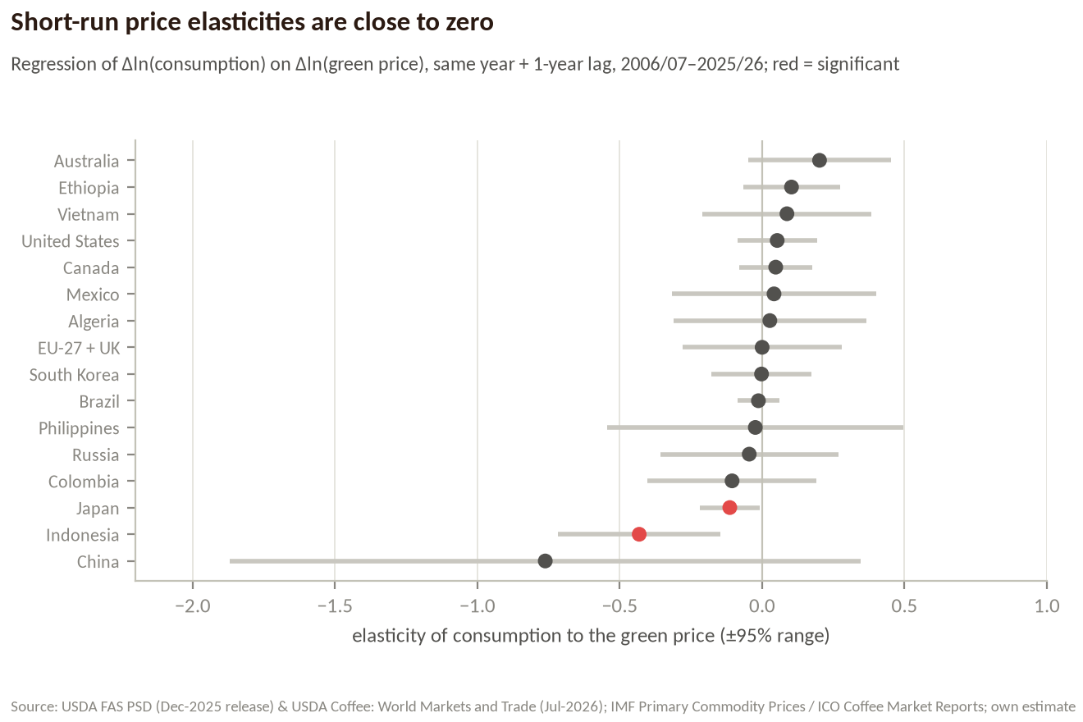
Figure 11. Estimated short-run price elasticities with 95% ranges.
Table 13. Elasticity of consumption to the green price, 2006/07–2025/26
Country | same year | 1-yr lag | total | 95% range | significant < 0
EU-27 + UK | −0.06 | +0.06 | 0.00 | ±0.28
United States | +0.06 | 0.00 | +0.05 | ±0.14
Brazil | −0.02 | +0.01 | −0.01 | ±0.07
Philippines | −0.12 | +0.10 | −0.02 | ±0.52
Japan | −0.07 | −0.05 | −0.11 | ±0.10 | yes
China | −0.20 | −0.56 | −0.76 | ±1.11
Canada | +0.10 | −0.05 | +0.05 | ±0.13
Vietnam | +0.09 | −0.01 | +0.09 | ±0.30
Indonesia | −0.37 | −0.06 | −0.43 | ±0.29 | yes
Russia | +0.12 | −0.17 | −0.05 | ±0.31
Ethiopia | +0.05 | +0.05 | +0.10 | ±0.17
South Korea | +0.13 | −0.13 | 0.00 | ±0.18
Mexico | +0.13 | −0.09 | +0.04 | ±0.36
Australia | +0.12 | +0.08 | +0.20 | ±0.25
Colombia | −0.08 | −0.02 | −0.11 | ±0.30
Algeria | −0.07 | +0.10 | +0.03 | ±0.34

Method: for each country, the annual log-change in consumption is regressed on the log-change in the green price in the same coffee year and the year before (20 observations). The sum of the two coefficients is the short-run elasticity. The estimates are small and mostly insignificant — coffee demand barely responds to green prices within two years. Japan and Indonesia are the clear exceptions. Because shelf prices move less than green prices, the elasticity with respect to the retail price is roughly 2–3 times larger (Brazil: about −0.03 to −0.05).

4.5 Why consumers barely react: retail pass-through
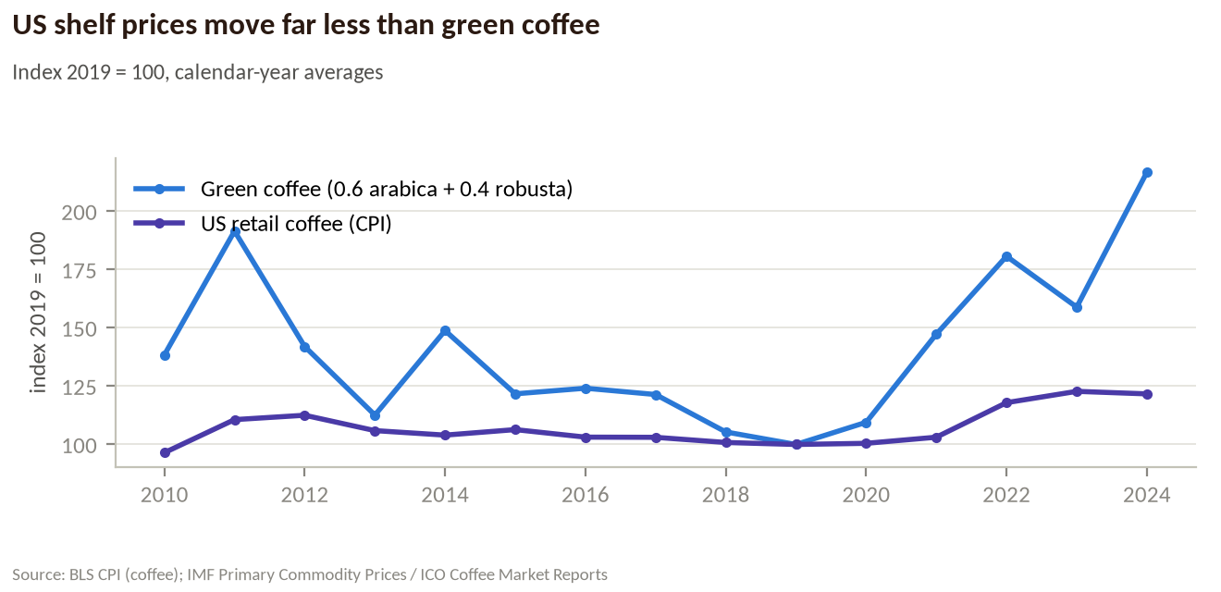
Figure 12. US retail coffee prices (CPI) vs green coffee, index 2019 = 100.
From 2019 to 2024 green coffee rose 117% while the US consumer price index for coffee rose 22%. The shock reached US shelves about a year later: +13% y/y in June 2025, +18% in January 2026, +10% in July 2026. Brazil passes costs through faster and further: ground-coffee prices rose 50% in 2021, 40% in 2024 and 36% in 2025, then fell 15% between December 2025 and August 2026.

4.6 Brazil: where demand cracks
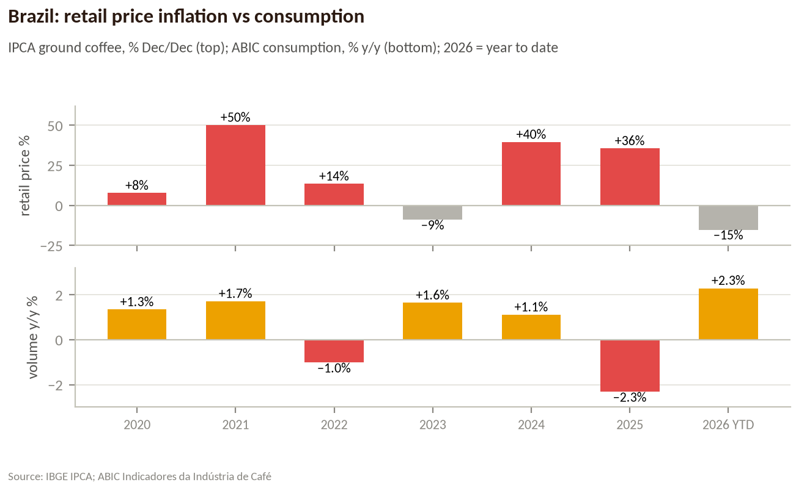
Figure 13. Brazil: retail ground-coffee inflation vs consumption growth.
Table 14. Brazil domestic consumption (ABIC). Method change in 2018 excludes unregistered firms (earlier years ~2m bags higher); 2016 not captured
Year (Nov–Oct) | ABIC consumption, m bags | Published growth
2005 | 15.53 | –
2006 | 16.33 | +5.1%
2007 | 17.10 | +4.7%
2008 | 17.66 | +3.2%
2009 | 18.39 | –
2010 | 19.13 | –
2011 | 19.72 | +3.1%
2012 | 20.33 | –
2013 | 20.08 | −1.2%
2014 | 20.33 | +1.2%
2015 | 20.51 | +0.9%
2016 | – | –
2017 | 21.99 | +3.6%
2018 | 21.00 | +4.8%
2019 | 20.90 | –
2020 | 21.20 | +1.3%
2021 | 21.50 | +1.7%
2022 | 21.30 | −1.0%
2023 | 21.67 | +1.6%
2024 | 21.92 | +1.1%
2025 | 21.41 | −2.3%

Brazil is the best-documented case of a price-sensitive buyer. Retail inflation of +50% (2021) and +40% (2024) was absorbed with volumes still growing (+1.7%, +1.1%). Only when 12-month ground-coffee inflation hit ~+78–82% (March–May 2025) did volumes break: monthly retail volumes fell 15.96% y/y in April 2025 and the year closed at −2.31% (21.41m bags), −3.88% per person. With retail prices falling in 2026, volumes recovered (+2.29% in January–August, +4.65% in May–August). One per cent of Brazilian demand is about 0.2m bags — enough to move Brazil's export surplus.

4.7 At what price increase does demand fall?
Table 15. All consumption declines of 3% or more, 2015/16–2025/26, 30 largest markets
Market | Year | Cons. y/y | Green price same yr | Green price prior yr | Level c/lb | Reading
Turkey | 2025/26 | −3.8% | −7% | +48% | 286 | Price-driven, 1-year lag
China | 2025/26 | −4.5% | −7% | +48% | 286 | Price-driven, 1-year lag
Australia | 2025/26 | −5.1% | −7% | +48% | 286 | Price-driven, 1-year lag
Egypt | 2025/26 | −14.9% | −7% | +48% | 286 | Price-driven, 1-year lag
Colombia | 2024/25 | −3.4% | +48% | +20% | 307 | Reversed next year (+5.6%): inventory swing
Philippines | 2024/25 | −6.1% | +48% | +20% | 307 | Reversed next year (+9.0%): inventory swing
Japan | 2024/25 | −6.7% | +48% | +20% | 307 | Structural decline, deepened by price
United States | 2023/24 | −4.4% | +20% | −15% | 207 | Reversed next year (+11.4%): inventory swing
Algeria | 2023/24 | −4.9% | +20% | −15% | 207 | Reversed next year (+5.1%): inventory swing
Switzerland | 2023/24 | −5.7% | +20% | −15% | 207 | Reversed next year (+11.1%): inventory swing
EU-27 + UK | 2023/24 | −9.6% | +20% | −15% | 207 | Reversed next year (+4.3%): inventory swing
Egypt | 2023/24 | −27.8% | +20% | −15% | 207 | Reversed next year (+80.8%): inventory swing
Canada | 2022/23 | −4.1% | −15% | +44% | 172 | Price-driven, 1-year lag
Japan | 2022/23 | −4.5% | −15% | +44% | 172 | Structural decline, deepened by price
South Korea | 2022/23 | −6.8% | −15% | +44% | 172 | Reversed next year (+5.5%): inventory swing
Australia | 2022/23 | −7.4% | −15% | +44% | 172 | Price-driven, 1-year lag
United States | 2022/23 | −7.8% | −15% | +44% | 172 | Price-driven, 1-year lag
Philippines | 2022/23 | −10.1% | −15% | +44% | 172 | Price-driven, 1-year lag
Ukraine | 2022/23 | −16.2% | −15% | +44% | 172 | Price-driven, 1-year lag
Morocco | 2022/23 | −18.7% | −15% | +44% | 172 | Price-driven, 1-year lag
Saudi Arabia | 2021/22 | −5.0% | +44% | +20% | 201 | Reversed next year (+21.1%): inventory swing
Algeria | 2021/22 | −6.7% | +44% | +20% | 201 | Price-driven (same year)
India | 2021/22 | −25.8% | +44% | +20% | 201 | Price-driven (same year)
Brazil | 2020/21 | −3.1% | +20% | +8% | 140 | Price-driven (same year)
Japan | 2020/21 | −3.4% | +20% | +8% | 140 | Structural decline, deepened by price
Turkey | 2020/21 | −4.1% | +20% | +8% | 140 | Reversed next year (+10.3%): inventory swing
Ethiopia | 2020/21 | −4.5% | +20% | +8% | 140 | Reversed next year (+12.1%): inventory swing
Indonesia | 2020/21 | −9.2% | +20% | +8% | 140 | Reversed next year (+6.7%): inventory swing
Russia | 2020/21 | −9.9% | +20% | +8% | 140 | Price-driven (same year)
Vietnam | 2020/21 | −12.3% | +20% | +8% | 140 | Reversed next year (+17.6%): inventory swing
Egypt | 2020/21 | −46.7% | +20% | +8% | 140 | Price-driven (same year)
Japan | 2019/20 | −3.6% | +8% | −7% | 116 | Structural decline, deepened by price
Australia | 2019/20 | −3.9% | +8% | −7% | 116 | Reversed next year (+4.8%): inventory swing
United States | 2019/20 | −4.1% | +8% | −7% | 116 | Not price-driven
EU-27 + UK | 2019/20 | −4.1% | +8% | −7% | 116 | Not price-driven
India | 2019/20 | −6.4% | +8% | −7% | 116 | Not price-driven
Russia | 2019/20 | −6.5% | +8% | −7% | 116 | Not price-driven
Colombia | 2019/20 | −7.8% | +8% | −7% | 116 | Reversed next year (+17.2%): inventory swing
Egypt | 2019/20 | −9.1% | +8% | −7% | 116 | Not price-driven
Algeria | 2019/20 | −12.8% | +8% | −7% | 116 | Reversed next year (+9.8%): inventory swing
Morocco | 2019/20 | −16.0% | +8% | −7% | 116 | Reversed next year (+23.9%): inventory swing
Japan | 2018/19 | −4.1% | −7% | −16% | 108 | Structural decline, deepened by price
Philippines | 2018/19 | −6.5% | −7% | −16% | 108 | Not price-driven
Switzerland | 2018/19 | −6.5% | −7% | −16% | 108 | Not price-driven
Russia | 2017/18 | −5.8% | −16% | +7% | 115 | Reversed next year (+10.8%): inventory swing
Philippines | 2017/18 | −6.4% | −16% | +7% | 115 | Not price-driven
Turkey | 2017/18 | −9.9% | −16% | +7% | 115 | Reversed next year (+39.3%): inventory swing
Australia | 2016/17 | −3.1% | +7% | −10% | 137 | Reversed next year (+9.8%): inventory swing
India | 2016/17 | −4.0% | +7% | −10% | 137 | Not price-driven
Algeria | 2016/17 | −5.0% | +7% | −10% | 137 | Reversed next year (+4.3%): inventory swing
China | 2016/17 | −5.7% | +7% | −10% | 137 | Reversed next year (+15.8%): inventory swing
Mexico | 2016/17 | −11.5% | +7% | −10% | 137 | Reversed next year (+11.6%): inventory swing

Reading the table: declines that reverse the next year are inventory swings (2023/24 in the US, Switzerland, Algeria). The declines that stick came one year after a big jump in green prices — 2022/23 after +44% (Canada), 2025/26 after +48% (Turkey, China, Australia, Egypt) — and in Japan, whose structural decline deepened when prices rose. Rule of thumb: demand only cracks when prices have risen by 40–50% on top of an already high level, and it cracks with a lag of about a year.

4.8 Bean switching
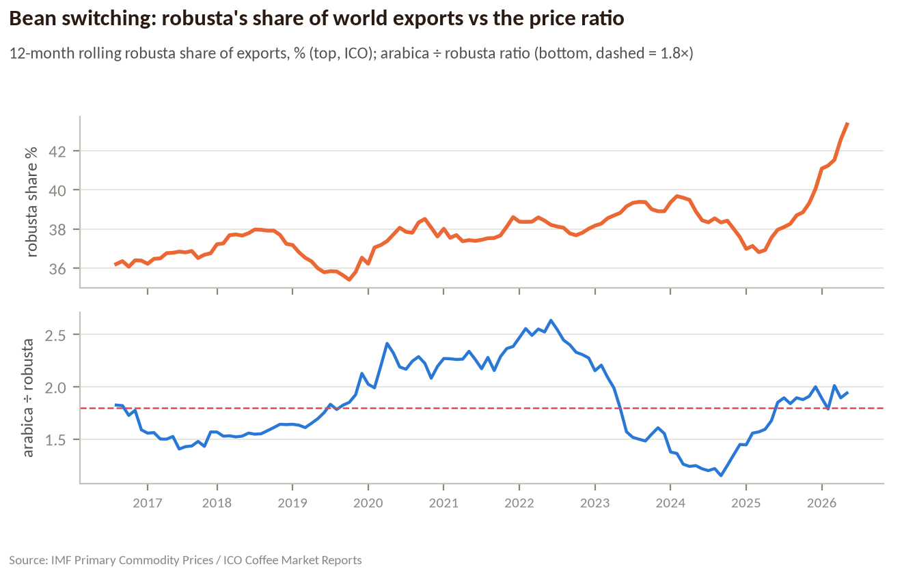
Figure 14. Robusta share of world exports (12-month rolling) vs the arabica/robusta ratio.
Table 16. Switching test on ICO monthly exports, Aug-2016 → Jul-2026
Arabica ÷ robusta at month t | Change in robusta export share over the next 12 months | months
below 1.5× | 0.0 pp | 21
1.5–1.8× | +0.3 pp | 37
1.8–2.2× | +1.0 pp | 19
above 2.2× | +0.4 pp | 28

Table 17. World exports by type, million bags (sum of ICO monthly reports; *2025/26 = 8 months)
Coffee year | World exports | Arabicas | Robustas | Robusta share | Price ratio
2015/16 | 109.3 | 69.5 | 39.7 | 36.4% | 1.89
2016/17 | 117.9 | 74.9 | 43.1 | 36.5% | 1.54
2017/18* | 111.7 | 69.0 | 42.7 | 38.2% | 1.54
2018/19 | 127.3 | 81.9 | 45.3 | 35.6% | 1.69
2019/20 | 123.7 | 76.3 | 47.4 | 38.3% | 2.14
2020/21 | 125.3 | 78.3 | 47.0 | 37.5% | 2.23
2021/22 | 129.3 | 80.4 | 48.8 | 37.8% | 2.47
2022/23 | 121.8 | 73.8 | 48.0 | 39.4% | 1.90
2023/24 | 136.7 | 84.3 | 52.4 | 38.3% | 1.30
2024/25 | 138.3 | 84.8 | 53.5 | 38.7% | 1.60
2025/26* | 92.5 | 50.8 | 41.6 | 45.0% | 1.91

Switching is measurable but second-order. When arabica trades at 1.8× robusta or more, robusta gains roughly 0.4–1.0 percentage points of the export market over the next year; below 1.5× it gains nothing. The biggest moves in the share are supply-driven: Brazil's big arabica crop in 2018/19 pushed the robusta share down to 35.6%; the record conilon crop and short arabica crop in 2025/26 pushed it to ~45%. Structurally, though, the world is moving to robusta: 40% of production in 2005/06, 47% in 2025/26. The switchers are blend roasters, instant makers and Brazil's own industry — not individual drinkers.
Summary — who is the marginal buyer?
When prices rise, the volume that disappears is small (about 1–2m bags of ~174m) and comes from Japan, North Africa (Algeria), Russia/Eastern Europe and, at extreme retail inflation, Brazil.
Growth buyers (China, Vietnam, Turkey, the Gulf, Korea, Mexico) keep adding ~1m bags a year even at record prices — a floor under demand.
The larger adjustment is the bean mix: roasters buy more robusta when arabica costs ≥1.8× robusta and less when the ratio falls towards 1.5×.

5. Marginal producers

5.1 Supply by origin
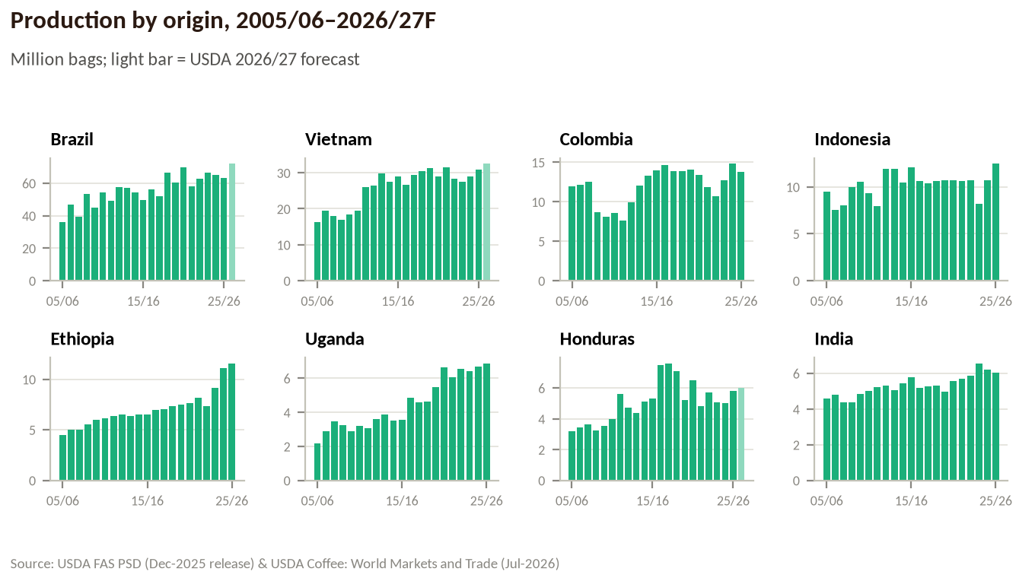
Figure 15. Production by origin (USDA).
Table 18. Production by origin, million bags, and price responses (USDA)
Origin | 05/06 | 15/16 | 20/21 | 25/26 | 26/27F | Rob. | CAGR | After low | Boom | Type
Brazil | 36.1 | 49.4 | 69.9 | 63.0 | 71.9 | 40% | +2.2% | +8% | +2% | Produce regardless
Vietnam | 16.3 | 28.9 | 29.0 | 30.8 | 32.5 | 96% | +2.8% | +6% | −6% | Produce regardless
Colombia | 12.0 | 14.0 | 13.4 | 13.8 | – | 0% | +0.7% | −7% | −1% | Cut when low
Indonesia | 9.4 | 12.1 | 10.7 | 12.4 | – | 88% | +1.0% | +1% | −2% | Produce regardless
Ethiopia | 4.5 | 6.5 | 7.6 | 11.6 | – | 0% | +4.3% | +9% | +26% | Produce regardless
Uganda | 2.2 | 3.5 | 6.6 | 6.9 | – | 85% | +4.8% | +29% | +10% | Produce regardless
India | 4.6 | 5.8 | 5.6 | 6.0 | – | 78% | +1.5% | +3% | +14% | Produce regardless
Honduras | 3.2 | 5.3 | 6.5 | 5.8 | 6.0 | 0% | +2.7% | −26% | −2% | Cut when low
Peru | 2.4 | 3.5 | 3.4 | 4.2 | – | 0% | +0.7% | −12% | 0% | Cut when low
Mexico | 4.2 | 2.3 | 3.5 | 3.9 | – | 9% | −0.4% | +1% | +4% | Produce regardless
Guatemala | 3.7 | 3.3 | 3.9 | 3.5 | – | 4% | −0.6% | 0% | −9% | Decline regardless
Nicaragua | 1.7 | 2.1 | 2.6 | 2.6 | – | 6% | +3.0% | −1% | −8% | Decline regardless
China | 0.4 | 1.9 | 1.9 | 1.9 | – | 0% | +8.2% | −1% | −3% | Produce regardless
Malaysia | 0.7 | 2.2 | 2.0 | 1.5 | – | 100% | +3.3% | −6% | −21% | Decline regardless
Tanzania | 0.6 | 1.1 | 1.1 | 1.4 | – | 48% | +2.4% | +4% | +14% | Produce regardless
Cote d'Ivoire | 2.1 | 1.6 | 0.9 | 1.3 | – | 100% | −3.2% | −13% | −15% | Decline regardless
Costa Rica | 1.8 | 1.6 | 1.5 | 1.2 | – | 0% | −2.0% | +2% | −15% | Decline regardless
Papua New Guinea | 1.3 | 0.8 | 0.7 | 0.9 | – | 5% | −0.5% | −20% | +19% | Expand when high
Thailand | 1.0 | 0.7 | 0.6 | 0.9 | – | 100% | −0.3% | −9% | +25% | Expand when high
Kenya | 0.8 | 0.8 | 0.7 | 0.8 | – | 0% | +0.5% | −5% | +12% | Expand when high
Venezuela | 0.8 | 0.5 | 0.5 | 0.5 | – | 0% | −2.5% | −9% | −2% | Cut when low
El Salvador | 1.4 | 0.6 | 0.5 | 0.5 | – | 0% | −4.8% | −14% | −4% | Cut when low

5.2 The response map and the four producer types
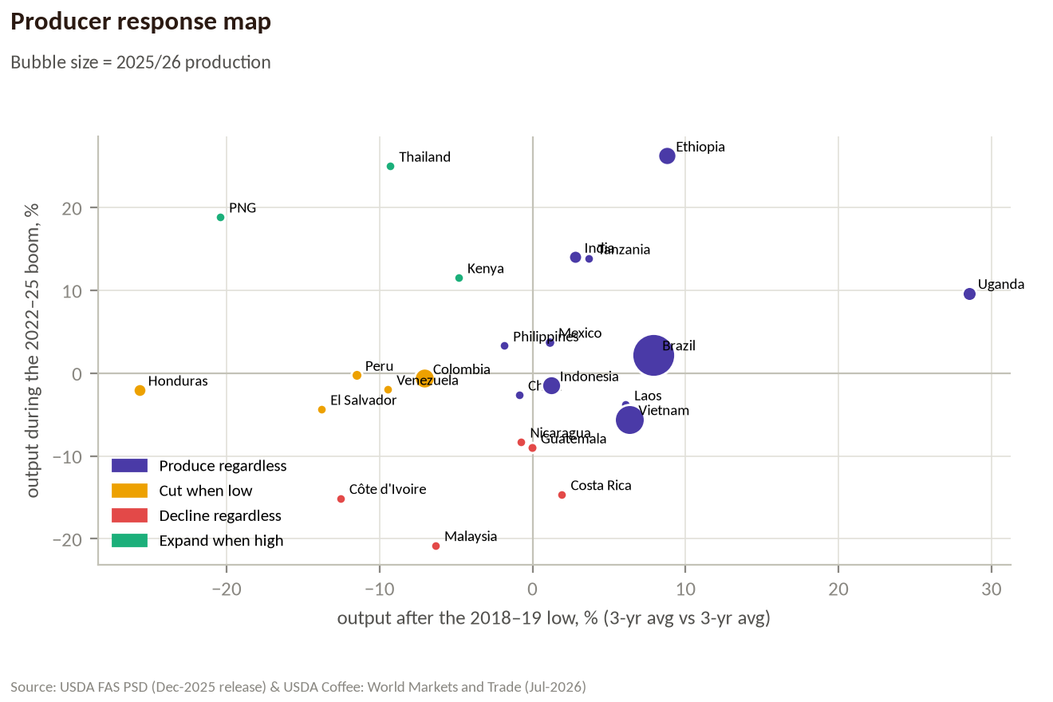
Figure 16. Output after the 2018–19 price low (x) vs during the 2022–25 boom (y).
- Produce no matter what — Brazil, Vietnam, Indonesia, Ethiopia, Uganda, India. They kept producing through arabica at ~137 c/lb and robusta at ~77 c/lb (2017/18–2019/20): scale and mechanisation (Brazil), very high yields (Vietnam), low cash costs and family labour (Ethiopia, Uganda).
- Cut when prices are low — Honduras (−26%), El Salvador (−14%), Peru (−12%), Colombia (−7%). Arabica averaged 137 c/lb, 17% below 2014–16, for two to three years; high labour costs per bag, leaf rust, fertiliser cuts and migration did the rest. Honduras never got back to its 2016–18 peak even in the boom.
- Decline even at high prices — Guatemala, Nicaragua, Costa Rica, Côte d'Ivoire, Malaysia (and Cameroon): output fell further in 2022–25 while arabica was above 200 c/lb. Land goes to other crops (cocoa, rubber, durian), housing and tourism; trees and farmers are old.
- Expand when prices are high — Papua New Guinea, Thailand, Kenya bounce back quickly; Brazil's conilon and Vietnam and Uganda expand with a lag. The result is USDA's record 2026/27 crop of 189.7m bags (+10.8m).
Why the response is slow and asymmetric: a coffee tree needs 3–4 years to bear, so supply cannot react quickly to high prices, while low prices cut output at the high-cost margin within 1–2 years (less fertiliser, fewer pickers, abandoned plots). Cost-of-production surveys (CONAB, FNC, ICO) are not included in this version; the thresholds above are inferred from observed output.

6. Country tracker
Table 19. Consumption tracker, 30 largest markets (USDA; CAGR by period)
Country | 2025/26 | Share | 05→15 | 15→20 | 20→25 | Spike Δ | y/y 25/26 | Trend
EU-27 + UK | 46.2 | 26.6% | +0.1% | +0.1% | +0.9% | 0% | +1.1% | → steady
United States | 26.6 | 15.3% | +1.3% | +0.7% | +0.5% | −3% | +1.3% | → steady
Brazil | 22.3 | 12.8% | +2.7% | +1.3% | 0.0% | −3% | +1.4% | ↓ cutting
Philippines | 6.8 | 3.9% | +17.8% | +1.2% | +0.5% | +4% | +9.0% | → steady
Japan | 6.7 | 3.9% | +1.0% | −1.8% | −1.8% | −15% | +2.9% | ↓ cutting
China | 5.8 | 3.4% | +28.8% | +12.5% | +5.5% | +90% | −4.5% | ↑ growing
Canada | 5.2 | 3.0% | +3.6% | +1.9% | +0.8% | +6% | +1.8% | → steady
Vietnam | 4.9 | 2.8% | +14.7% | +0.7% | +12.5% | +52% | +2.1% | ↑ growing
Indonesia | 4.8 | 2.8% | +6.5% | +7.0% | +1.6% | +13% | −1.3% | ↑ growing
Russia | 4.6 | 2.6% | +2.1% | −1.1% | +1.9% | −5% | +2.8% | ↓ cutting
Ethiopia | 3.7 | 2.1% | +5.5% | −0.7% | +4.3% | +14% | +2.1% | ↑ growing
South Korea | 3.4 | 2.0% | +5.4% | +4.0% | +2.6% | +20% | +1.0% | ↑ growing
Mexico | 3.1 | 1.8% | +2.0% | +2.2% | +3.7% | +24% | 0.0% | ↑ growing
Australia | 2.6 | 1.5% | +4.7% | +2.9% | +4.8% | +26% | −5.1% | ↑ growing
Colombia | 2.3 | 1.3% | +0.8% | +8.0% | +1.8% | +24% | +5.6% | ↑ growing
Algeria | 2.0 | 1.2% | +1.1% | −0.7% | −1.8% | −9% | 0.0% | ↓ cutting
Turkey | 1.8 | 1.0% | +13.5% | +10.4% | +8.5% | +56% | −3.8% | ↑ growing
Saudi Arabia | 1.5 | 0.9% | +3.7% | +8.9% | +4.6% | +47% | +1.7% | ↑ growing
India | 1.4 | 0.8% | −0.9% | −1.1% | +2.9% | +8% | +4.6% | → steady
Switzerland | 1.3 | 0.7% | +2.0% | +1.5% | +2.0% | +10% | +7.0% | → steady
Ukraine | 1.2 | 0.7% | −5.1% | +4.9% | −1.0% | −5% | +9.8% | → steady
Morocco | 1.1 | 0.6% | +2.4% | +5.6% | +3.8% | +22% | +5.5% | ↑ growing
Egypt | 1.0 | 0.6% | +20.7% | −5.3% | +20.1% | +19% | −14.9% | ↑ growing
Jordan | 0.9 | 0.5% | +12.4% | +7.8% | +2.4% | +9% | +18.7% | → steady
Thailand | 0.9 | 0.5% | +1.3% | +3.2% | +7.3% | +24% | −0.5% | ↑ growing
Iran | 0.9 | 0.5% | – | +7.6% | +16.2% | +83% | +5.3% | ↑ growing
Argentina | 0.8 | 0.5% | +1.1% | +1.3% | +1.5% | +1% | −3.5% | → steady
Taiwan | 0.8 | 0.5% | +11.8% | +4.3% | +4.9% | +27% | +2.4% | ↑ growing
Norway | 0.8 | 0.5% | +1.2% | +0.8% | −0.1% | 0% | +0.6% | → steady
Serbia | 0.8 | 0.4% | +1.4% | +3.2% | −2.1% | −7% | +11.1% | ↓ cutting

What to watch
- Demand baseline: +2.4m bags a year; USDA 2026/27F 179.7m; ICO sees 2025/26 at 180.6m (−0.8%, lower US demand).
- Stocks-to-use: the spike happened below ~16%; USDA's 2026/27 figure is 14.6% — still tight.
- Arbitrage: ratio 2.0× in Aug-2026; above ~1.8× roasters add robusta, below ~1.5× they return to arabica.
- Marginal buyers: Brazil retail inflation (IPCA café moído), Japan's demand, North African and Russian imports give the first signs of demand loss.
- Producer response: record 2026/27 crop from Brazil, Vietnam and East Africa; Central America will add little.

7. Data, sources and methodology
The research environment blocked direct downloads from the statistical agencies (usda.gov, ico.org, worldbank.org, eurostat, census, comtrade) and capped web searches. Official files were therefore obtained from public mirrors of the original downloads and every mirror was cross-checked against independent official figures before use:
Table 20. Provenance of every dataset
Dataset | How it was obtained | Validation
USDA PSD coffee (all countries, 1960–2025/26, Dec-2025 release) | Official bulk file psd_coffee_csv.zip downloaded 21-Jun-2026 by the public project andenick/Foodberg (PROVENANCE.md) | 98.2% of 84,170 values identical to a second, independent copy of the Jun-2024 release (differences = normal revisions); world totals equal USDA's Dec-2025 report (178.8 / 173.9 / 20.1m bags)
USDA Coffee: World Markets and Trade, Jul-2026 | Web search of the report and trade press | 2026/27 figures cross-checked in two or more sources
IMF Primary Commodity Prices (PCOFFOTM, PCOFFROB) | IMF source file external-data.xls (Mar-2026) in datasets/commodity-prices | Annual averages match the World Bank Pink Sheet to within 0.5%
ICO Coffee Market Reports (prices, exports by group) | Report tables parsed by the public project BMR-Com/coffee-analytics | 22 of 22 monthly values found independently by web search match exactly; months with parse errors were dropped
ABIC, IBGE IPCA, BLS CPI | Web search of ABIC/Agência Brasil releases; public copies of IBGE/BLS series | ABIC figures from two or more articles
World Bank population & GDP per capita | WDI bulk files (public copies) | Standard WDI series
Starbucks store counts | Form 10-K via web search | High-confidence rows only

Limitations
- USDA consumption is disappearance: year-to-year changes in importing countries include inventory movements.
- Channel data (home vs café) exist only for Brazil; café chains are a proxy elsewhere.
- Import-origin data (Eurostat Comext, US Census, UN Comtrade) were not pulled; the refresh script downloads them.
- Cost-of-production surveys are not included; producer price thresholds are inferred from behaviour.
- USDA's July-2026 revisions to 2025/26 were available only for world production and trade, not for every country.

How to refresh everything from the official files
- python research/coffee-demand/scripts/fetch_official_data.py — downloads USDA PSD, World Bank Pink Sheet, IMF, FRED, US Census, UN Comtrade and Eurostat files and logs URL, time and SHA-256 in data/source_files/MANIFEST.csv
- python research/coffee-demand/scripts/analysis.py — rebuilds data/clean/*.csv and output/metrics.json
- python research/coffee-demand/scripts/build_deck.py and build_doc.py — regenerate the PowerPoint and this guide

Official homes of the data
- USDA FAS PSD Online — https://apps.fas.usda.gov/psdonline/app/index.html#/app/downloads
- USDA Coffee: World Markets and Trade — https://www.fas.usda.gov/data/commodities/coffee
- ICO Coffee Market Reports — https://www.ico.org (e.g. https://www.ico.org/documents/cy2025-26/cmr-0826-e.pdf)
- IMF Primary Commodity Prices — https://www.imf.org/en/Research/commodity-prices
- World Bank Pink Sheet — https://www.worldbank.org/en/research/commodity-markets
- ABIC — https://www.abic.com.br/estatisticas/indicadores-da-industria/
- IBGE IPCA — https://sidra.ibge.gov.br · BLS CPI — https://www.bls.gov/cpi/
- World Bank WDI — https://data.worldbank.org

Appendix A. Consumption by country, every year (USDA, million bags)
Table 21. Consumption 2005/06–2015/16
Country | 05/06 | 06/07 | 07/08 | 08/09 | 09/10 | 10/11 | 11/12 | 12/13 | 13/14 | 14/15 | 15/16
EU-27+UK | 43.7 | 41.3 | 43.0 | 39.1 | 49.1 | 41.4 | 45.2 | 43.3 | 41.5 | 43.9 | 44.1
United States | 22.1 | 21.8 | 21.8 | 21.8 | 21.4 | 22.4 | 22.9 | 23.0 | 23.8 | 23.6 | 25.1
Brazil | 15.9 | 16.7 | 17.4 | 18.0 | 18.8 | 19.4 | 20.0 | 20.1 | 20.2 | 20.4 | 20.9
Philippines | 1.2 | 1.4 | 1.3 | 1.7 | 2.2 | 2.8 | 3.7 | 4.4 | 3.6 | 4.2 | 6.2
Japan | 7.3 | 7.4 | 7.0 | 7.0 | 6.9 | 7.0 | 7.0 | 7.6 | 7.8 | 7.9 | 8.1
China | 0.2 | 0.3 | 0.2 | 0.3 | 1.1 | 1.1 | 1.1 | 1.7 | 2.3 | 2.4 | 2.5
Canada | 3.2 | 3.6 | 3.9 | 3.7 | 4.1 | 4.2 | 4.2 | 4.2 | 4.6 | 4.5 | 4.5
Vietnam | 0.7 | 0.8 | 0.8 | 0.9 | 1.2 | 1.3 | 1.7 | 1.8 | 2.0 | 2.2 | 2.6
Indonesia | 1.7 | 1.8 | 1.7 | 1.9 | 1.9 | 1.6 | 2.1 | 2.8 | 2.5 | 2.9 | 3.2
Russia | 3.6 | 4.2 | 4.3 | 3.3 | 3.9 | 4.4 | 3.9 | 4.1 | 4.2 | 4.0 | 4.4
Ethiopia | 1.8 | 2.0 | 2.3 | 2.5 | 2.8 | 2.9 | 3.0 | 3.1 | 3.1 | 3.0 | 3.1
S. Korea | 1.5 | 1.4 | 1.6 | 1.7 | 1.7 | 1.9 | 1.8 | 1.8 | 2.2 | 2.3 | 2.5
Mexico | 1.9 | 1.8 | 2.3 | 2.4 | 2.5 | 2.6 | 2.3 | 2.2 | 2.7 | 2.3 | 2.3
Australia | 1.1 | 1.1 | 1.2 | 1.3 | 1.4 | 1.4 | 1.6 | 1.7 | 1.6 | 1.8 | 1.8
Colombia | 1.3 | 1.1 | 1.1 | 1.1 | 1.2 | 1.1 | 1.3 | 1.2 | 1.3 | 1.4 | 1.4
Algeria | 2.1 | 1.8 | 2.0 | 2.1 | 2.1 | 1.8 | 2.3 | 1.9 | 2.3 | 2.2 | 2.3
Turkey | 0.2 | 0.2 | 0.2 | 0.3 | 0.3 | 0.3 | 0.4 | 0.5 | 0.5 | 0.7 | 0.7
Saudi Arabia | 0.5 | 0.6 | 0.6 | 0.6 | 0.6 | 0.6 | 0.7 | 0.6 | 0.7 | 0.8 | 0.8
India | 1.4 | 1.1 | 1.3 | 1.2 | 1.2 | 1.2 | 1.2 | 1.1 | 1.2 | 1.2 | 1.2
Switzerland | 0.9 | 0.9 | 1.0 | 1.1 | 1.1 | 1.1 | 1.1 | 1.1 | 1.0 | 1.1 | 1.1
World | 125.2 | 124.4 | 128.9 | 125.9 | 139.2 | 135.5 | 142.8 | 143.4 | 143.9 | 147.2 | 153.2

Table 22. Consumption 2016/17–2025/26
Country | 16/17 | 17/18 | 18/19 | 19/20 | 20/21 | 21/22 | 22/23 | 23/24 | 24/25 | 25/26
EU-27+UK | 43.3 | 45.7 | 46.0 | 44.1 | 44.2 | 45.9 | 48.5 | 43.8 | 45.7 | 46.2
United States | 25.5 | 25.6 | 27.2 | 26.0 | 25.9 | 26.7 | 24.6 | 23.5 | 26.2 | 26.6
Brazil | 21.6 | 22.4 | 23.2 | 23.0 | 22.3 | 22.3 | 22.4 | 22.2 | 22.0 | 22.3
Philippines | 7.0 | 6.5 | 6.1 | 6.1 | 6.6 | 7.2 | 6.5 | 6.6 | 6.2 | 6.8
Japan | 8.2 | 8.2 | 7.9 | 7.6 | 7.4 | 7.2 | 6.9 | 7.0 | 6.5 | 6.7
China | 2.3 | 2.7 | 2.9 | 3.7 | 4.5 | 4.9 | 5.3 | 5.8 | 6.1 | 5.8
Canada | 4.5 | 4.8 | 4.9 | 4.8 | 5.0 | 5.3 | 5.1 | 5.0 | 5.1 | 5.2
Vietnam | 2.8 | 2.9 | 2.9 | 3.1 | 2.7 | 3.2 | 3.2 | 3.9 | 4.8 | 4.9
Indonesia | 3.2 | 3.6 | 4.3 | 4.9 | 4.5 | 4.8 | 4.8 | 4.8 | 4.9 | 4.8
Russia | 4.7 | 4.5 | 4.9 | 4.6 | 4.2 | 4.1 | 4.2 | 4.2 | 4.5 | 4.6
Ethiopia | 3.1 | 3.1 | 3.2 | 3.1 | 3.0 | 3.4 | 3.4 | 3.5 | 3.6 | 3.7
S. Korea | 2.7 | 2.6 | 2.8 | 3.0 | 3.0 | 3.4 | 3.2 | 3.4 | 3.4 | 3.4
Mexico | 2.1 | 2.3 | 2.6 | 2.6 | 2.6 | 2.9 | 3.0 | 3.1 | 3.1 | 3.1
Australia | 1.7 | 1.9 | 2.0 | 2.0 | 2.1 | 2.3 | 2.1 | 2.1 | 2.7 | 2.6
Colombia | 1.4 | 1.6 | 1.9 | 1.8 | 2.1 | 2.1 | 2.1 | 2.2 | 2.1 | 2.3
Algeria | 2.2 | 2.3 | 2.3 | 2.0 | 2.2 | 2.1 | 2.0 | 1.9 | 2.0 | 2.0
Turkey | 1.0 | 0.9 | 1.2 | 1.2 | 1.2 | 1.3 | 1.6 | 1.5 | 1.8 | 1.8
Saudi Arabia | 0.8 | 0.9 | 1.0 | 1.0 | 1.2 | 1.1 | 1.4 | 1.4 | 1.5 | 1.5
India | 1.2 | 1.2 | 1.2 | 1.2 | 1.2 | 0.9 | 0.9 | 1.2 | 1.3 | 1.4
Switzerland | 1.1 | 1.2 | 1.1 | 1.1 | 1.2 | 1.2 | 1.2 | 1.1 | 1.2 | 1.3
World | 155.1 | 160.6 | 166.0 | 162.4 | 162.1 | 167.9 | 168.8 | 164.0 | 171.6 | 173.9

Appendix B. Production by origin, every year (USDA, million bags)
Table 23. Production 2005/06–2015/16
Origin | 05/06 | 06/07 | 07/08 | 08/09 | 09/10 | 10/11 | 11/12 | 12/13 | 13/14 | 14/15 | 15/16
Brazil | 36.1 | 46.7 | 39.1 | 53.3 | 44.8 | 54.5 | 49.2 | 57.6 | 57.2 | 54.3 | 49.4
Vietnam | 16.3 | 19.5 | 18.0 | 17.0 | 18.5 | 19.4 | 26.0 | 26.5 | 29.8 | 27.4 | 28.9
Colombia | 12.0 | 12.2 | 12.5 | 8.7 | 8.1 | 8.5 | 7.7 | 9.9 | 12.1 | 13.3 | 14.0
Indonesia | 9.4 | 7.5 | 8.0 | 10.0 | 10.5 | 9.3 | 8.0 | 11.9 | 11.9 | 10.5 | 12.1
Ethiopia | 4.5 | 5.0 | 5.0 | 5.5 | 6.0 | 6.1 | 6.3 | 6.5 | 6.3 | 6.5 | 6.5
Uganda | 2.2 | 2.9 | 3.5 | 3.3 | 2.9 | 3.2 | 3.1 | 3.6 | 3.9 | 3.5 | 3.5
India | 4.6 | 4.8 | 4.4 | 4.4 | 4.8 | 5.0 | 5.2 | 5.3 | 5.1 | 5.4 | 5.8
Honduras | 3.2 | 3.5 | 3.6 | 3.2 | 3.5 | 4.0 | 5.6 | 4.7 | 4.4 | 5.1 | 5.3
Peru | 2.4 | 4.4 | 2.8 | 4.0 | 3.3 | 4.1 | 5.2 | 4.3 | 4.2 | 2.9 | 3.5
Mexico | 4.2 | 4.5 | 4.3 | 4.5 | 4.2 | 4.0 | 4.3 | 4.7 | 4.0 | 3.2 | 2.3
Guatemala | 3.7 | 4.0 | 4.1 | 4.0 | 4.0 | 4.0 | 4.4 | 4.0 | 3.5 | 3.2 | 3.3
Nicaragua | 1.7 | 1.3 | 1.9 | 1.6 | 1.9 | 1.7 | 2.1 | 1.9 | 2.0 | 2.1 | 2.1
China | 0.4 | 0.4 | 0.4 | 0.6 | 1.2 | 0.8 | 1.1 | 1.5 | 1.9 | 2.1 | 1.9
Malaysia | 0.7 | 0.5 | 0.8 | 1.0 | 1.0 | 1.1 | 1.4 | 1.4 | 1.5 | 2.1 | 2.2
Tanzania | 0.6 | 0.9 | 0.7 | 1.1 | 0.6 | 1.1 | 0.6 | 1.2 | 0.8 | 1.1 | 1.1
Cote d'Ivoire | 2.1 | 2.4 | 2.1 | 1.9 | 2.4 | 1.6 | 1.6 | 1.8 | 1.7 | 1.4 | 1.6
Costa Rica | 1.8 | 1.8 | 1.9 | 1.6 | 1.5 | 1.6 | 1.8 | 1.7 | 1.4 | 1.4 | 1.6
PNG | 1.3 | 0.8 | 1.0 | 1.0 | 1.1 | 0.9 | 1.4 | 0.8 | 0.9 | 0.8 | 0.8
Thailand | 1.0 | 0.8 | 0.9 | 0.8 | 0.9 | 1.0 | 1.0 | 1.0 | 1.0 | 1.0 | 0.7
Kenya | 0.8 | 0.9 | 0.8 | 0.9 | 0.9 | 0.7 | 0.8 | 0.7 | 0.8 | 0.8 | 0.8
World | 117.9 | 134.0 | 124.4 | 136.8 | 129.8 | 141.4 | 144.8 | 158.0 | 160.1 | 153.8 | 152.4

Table 24. Production 2016/17–2025/26
Origin | 16/17 | 17/18 | 18/19 | 19/20 | 20/21 | 21/22 | 22/23 | 23/24 | 24/25 | 25/26
Brazil | 56.1 | 52.1 | 66.5 | 60.5 | 69.9 | 58.1 | 62.6 | 66.3 | 65.0 | 63.0
Vietnam | 26.7 | 29.3 | 30.4 | 31.3 | 29.0 | 31.6 | 28.3 | 27.6 | 29.0 | 30.8
Colombia | 14.6 | 13.8 | 13.9 | 14.1 | 13.4 | 11.8 | 10.7 | 12.8 | 14.8 | 13.8
Indonesia | 10.6 | 10.4 | 10.6 | 10.7 | 10.7 | 10.6 | 10.7 | 8.2 | 10.7 | 12.4
Ethiopia | 6.9 | 7.1 | 7.3 | 7.5 | 7.6 | 8.2 | 7.3 | 9.1 | 11.1 | 11.6
Uganda | 4.9 | 4.6 | 4.7 | 5.5 | 6.6 | 6.0 | 6.6 | 6.4 | 6.7 | 6.9
India | 5.2 | 5.3 | 5.3 | 5.0 | 5.6 | 5.7 | 5.9 | 6.6 | 6.2 | 6.0
Honduras | 7.5 | 7.6 | 7.1 | 5.2 | 6.5 | 4.8 | 5.7 | 5.0 | 5.0 | 5.8
Peru | 4.2 | 4.4 | 4.4 | 3.9 | 3.4 | 4.2 | 3.5 | 3.9 | 3.7 | 4.2
Mexico | 3.3 | 4.0 | 3.5 | 3.7 | 3.5 | 3.7 | 3.5 | 3.9 | 3.9 | 3.9
Guatemala | 3.6 | 3.8 | 3.8 | 3.6 | 3.9 | 3.5 | 3.3 | 3.5 | 3.2 | 3.5
Nicaragua | 2.6 | 2.7 | 3.0 | 2.8 | 2.6 | 2.8 | 2.6 | 2.3 | 2.6 | 2.6
China | 1.9 | 1.9 | 1.9 | 2.0 | 1.9 | 1.8 | 1.8 | 1.8 | 1.9 | 1.9
Malaysia | 2.1 | 2.1 | 2.1 | 1.9 | 2.0 | 2.0 | 2.0 | 1.3 | 1.4 | 1.5
Tanzania | 1.1 | 1.1 | 1.2 | 1.2 | 1.1 | 1.2 | 1.2 | 1.4 | 1.4 | 1.4
Cote d'Ivoire | 1.1 | 1.2 | 2.0 | 1.8 | 0.9 | 1.1 | 1.0 | 1.3 | 0.7 | 1.3
Costa Rica | 1.3 | 1.5 | 1.2 | 1.5 | 1.5 | 1.2 | 1.1 | 1.2 | 1.3 | 1.2
PNG | 1.1 | 0.8 | 1.0 | 0.8 | 0.7 | 0.8 | 0.9 | 1.0 | 0.8 | 0.9
Thailand | 0.8 | 0.7 | 0.7 | 0.7 | 0.6 | 0.7 | 0.7 | 0.8 | 0.9 | 0.9
Kenya | 0.8 | 0.7 | 0.8 | 0.8 | 0.7 | 0.9 | 0.8 | 0.8 | 1.0 | 0.8
World | 161.1 | 159.8 | 175.9 | 169.0 | 176.5 | 165.0 | 164.4 | 169.3 | 175.3 | 178.8

Appendix C. Glossary
Term | Meaning
Arbitrage | Price difference (or ratio) between arabica and robusta; drives blend switching
Bag | 60 kg of green coffee
CAGR | Compound annual growth rate
Coffee year | October–September (ICO)
Conilon | Brazilian name for robusta (Coffea canephora)
Disappearance | Imports − re-exports ± stock change: USDA's measure of consumption in importing countries
Elasticity (price) | % change in quantity ÷ % change in price
Green coffee | Unroasted beans, the traded commodity
I-CIP | ICO Composite Indicator Price
Marginal buyer / producer | The buyer or producer whose reaction to price balances the market
Marketing year | USDA's local crop year, e.g. Brazil July–June
Pass-through | How much and how fast a change in green prices reaches shelf prices
R&G | Roast & ground coffee (includes capsules)
Soluble | Instant coffee
Stocks-to-use | Ending stocks ÷ consumption

