ASSIGNMENT 4

Alissa Trujillo

April 16, 2022

# Markdown Basics

## Favorite Foods

1. Sushi
2. Guacamole
3. Tacos

## Images

image

## Add a Quote

“Treat yo’ self!”

— Donna Meagle

## Add an Equation

$f\left(x\right)=\frac{1}{2}x^{3}$

## Add a Footnote

[1]Footnotes are fun!

## Add Citations

* R for Everyone Lander (2014)
* Discovering Statistics Using R Field, Miles, and Field (2012)

# Inline Code

## NY Times COVID-19 Data

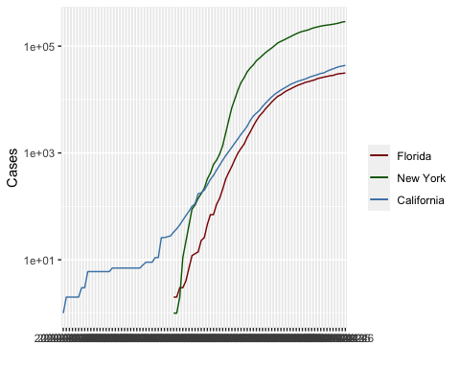

## R4DS Height vs Earnings

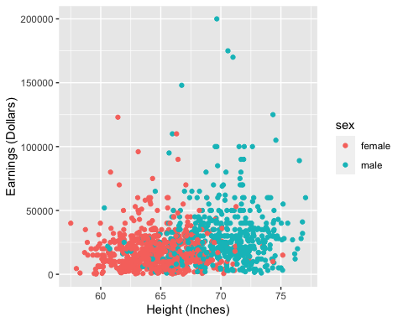

# Tables

## Knitr Table with Kable

One Ring to Rule Them All

| name | race | in_fellowship | ring_bearer | age |
| --- | --- | --- | --- | --- |
| Aragon | Men | TRUE | FALSE | 88 |
| Bilbo | Hobbit | FALSE | TRUE | 129 |
| Frodo | Hobbit | TRUE | TRUE | 51 |
| Galadriel | Elf | FALSE | FALSE | 7000 |
| Sam | Hobbit | TRUE | TRUE | 36 |
| Gandalf | Maia | TRUE | TRUE | 2019 |
| Legolas | Elf | TRUE | FALSE | 2931 |
| Sauron | Maia | FALSE | TRUE | 7052 |
| Gollum | Hobbit | FALSE | TRUE | 589 |

## Pandoc Table

##   
## --------------------------------------------------------------  
## Name Race Is Fellowship? Is Ring Bearer? Age   
## ----------- -------- ---------------- ----------------- ------  
## Aragon Men TRUE FALSE 88   
##   
## Bilbo Hobbit FALSE TRUE 129   
##   
## Frodo Hobbit TRUE TRUE 51   
##   
## Galadriel Elf FALSE FALSE 7000   
##   
## Sam Hobbit TRUE TRUE 36   
##   
## Gandalf Maia TRUE TRUE 2019   
##   
## Legolas Elf TRUE FALSE 2931   
##   
## Sauron Maia FALSE TRUE 7052   
##   
## Gollum Hobbit FALSE TRUE 589   
## --------------------------------------------------------------

# References

Field, A., J. Miles, and Z. Field. 2012. *Discovering Statistics Using r*. SAGE Publications. <https://books.google.com/books?id=wd2K2zC3swIC>.

Lander, J. P. 2014. *R for Everyone: Advanced Analytics and Graphics*. Addison-Wesley Data and Analytics Series. Addison-Wesley. <https://books.google.com/books?id=3eBVAgAAQBAJ>.

1. Footnotes are fun!