Client/Server operations under SCAN 4.3

Introduction
“Client/Server operations” is an industry term which refers to data exchange through network. Many approaches can be used for such exchange. SCAN 4.3 uses TCP to transfer information between 2 systems in LAN. Each system can act as server or as a client, not as both. SCAN 4.3 supports only one client per server. That means if some client is already connected to server, other clients can’t pull data from that station.

The following types of information are sent between systems:
- Commands (or control codes);
- Files (e.g. AST setup files);
- Data (e.g. EEG and event codes stream, EDF header).
Commands are used to synchronize operations between 2 systems, like starting acquisition or impedance measurement on server will send correspondent command to client and it will act the same way. Both, server and client can send commands to opposite side.

AST files are sent automatically from server to client to make sure that client will expect the same number of channels with same names as server is acquiring. Stream of EEG data is sent by server to client as soon as acquisition or impedance measurement starts.

All types of information are transmitted as packets structured according to format described in section “Packet structures…” User can use that information to write client side. Directory “NetReader” has example code to create such clients on C, C++ and Java. Clients written on C and Java can run on Windows or Unix-based systems.

Some terms
TCP is abbreviation for Transmission Control Protocol.
LAN stands for Local Area Network.
SCAN system what sends EEG data is referred as a server.
SCAN system which receives data is referred as a client.
IP address is a machine name, such as “ftp.microsoft.com”, or a dotted number, such as “128.56.22.8”

Starting ACQUIRE as a Server

Start ACQUIRE on server computer. Main program window will open:
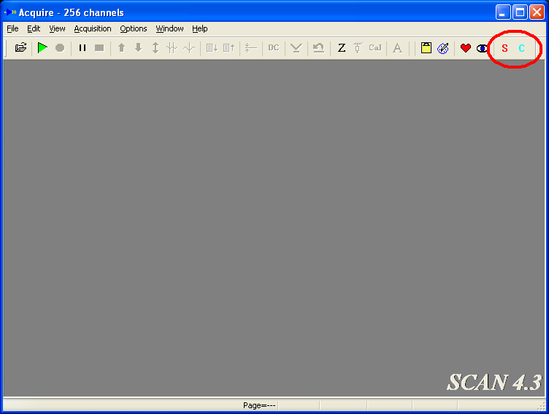
Two rightmost buttons from main toolbar, red circled, are related to client/server operations. Press S(erver) button to activate the following dialog:
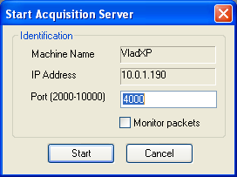
It identifies the computer by Machine Name and IP address. In that dialog you can specify TCP number port which will be used to exchange information. You can use default value 4000, or set any in range 2000-10000. Just make sure that both sides (server and client) are using same port number. The last setting – checkbox “Monitor packets” – allows you to see some statistics while EEG data streaming. Press “Start” button to start server. Status bar will show:
Any time you want to stop running server, press again S(erver) button which will bring the dialog:
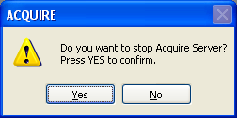
Press Yes button to confirm. The status bar will show:

Starting ACQUIRE as a Client

Now start ACQUIRE on client computer. At that time press C(lient) button to activate the following dialog:
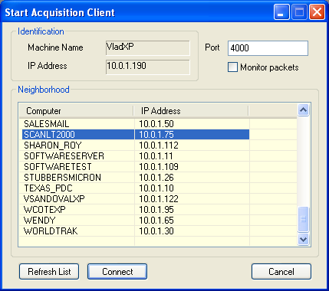
Along with identification information, port number and “Monitor packets” check box, the dialog shows you the network neighborhood as list of computer names and correspondent IP addresses. If you were connected to some server previously, then the same computer will be selected from the list. Select computer you want connect to and press Connect button.

If you were connected successfully, then status bar reads as:
It identifies server’s IP address and port used. The server toolbar also updates and shows IP address of connected client.
Important notes:
- Looking in network for other computers may take some time (several seconds), that delays the appearance “Start Acquisition Client” dialog on your screen.
- Before client can connect to some computer, you need to start Server there first. If server isn’t started, then client is failed to connect and the warning is shown:
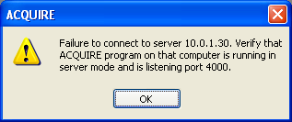
- If a system enters in client mode, then usage of the local amplifier will be disabled. That means, if you press button, then program will not acquire data from the local amplifier, but will wait for data stream from server.
- You can connect to server even after it starts acquisition.
- If server stops or exits, then client status bar will show “Server was stopped”.

Any time you want to disconnect client from server, press C(lient) button again, the warning will appear:
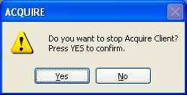
Press Yes to confirm.

If you exit from program on either side, the transmission will be stop automatically. That means, there is no really a need to stop server or client explicitly, if you are not planning to switch servers or clients during the same working session.

Sending data from server to client

This is the easiest part of SCAN 4.3 client/server operations. On server side do everything as you usually do to run EEG/EP recording: select some AST file, modify it, and then start acquisition (or impedance measurement). Immediately, the same registration will appear on client computer screen. You can start recording (saving data to hard drive) on either or both systems. If you switch to impedance measurement on server computer, client will switch to impedance screen as well.

If you enabled “Monitor packets”, then status bar will show simple statistics on data transfer. For example, client program may show something like:
This message is interpreted as “So far received 1.81 mega-bytes of data, current speed of transmission is 80.0 kilo-bytes per second”. Status on server system may look like:
That is interpreted as “So far sent 2.68 M, current transmission speed is 81.5 K per second”. This status message is updated every second. As network is shared by many PCs in your LAN, the current speed can slightly fluctuate over a time.

This monitoring tool can be used to evaluate the maximum sampling rate for acquisition on this client/server configuration. The current speed of transmission should be close to the EEG data stream output (per second), which is equal to:
(EEG number of channels + 1 event channel)*(Sampling rate)*(2 bytes),
where “2 bytes” means 16-bit data are sent.

For example, if you are recording 40 EEG channels at 1000 Hz sampling rate, then you have the following EEG data stream output:
(40+1)*1000*2=82000 bytes=80.07 K/second

This value is close to speeds shown above for client and server side. If transmission speed starts to decline from expected EEG data stream output, then it indicates that your network can’t handle such acquisition speed. Client will draw EEG in step-wise manner as well to indicate problems with the network bandwidth.

You may decrease (or even shut down) all other network traffic by switching off other workstations in your LAN. Or you can build the separate dedicated LAN to connect directly ACQUIRE server and client. The last method guaranties the highest throughput; in that case the maximum acquisition rate closely depends on type of LAN connection you use. For example, 10Base-T connection provides the transfer speed as 10 Mbps, that means for 40 channels recording you can reach acquisition rate close to:
15000 Hz = (10*1024*1024/(8*(40+1)*2))

Packet structures and command set

Who should read this section? This section is intended for users who want to write their own client program to pull data online from running ACQUIRE server. ACQUIRE program uses stream sockets (neither datagram nor raw sockets) to guarantee data delivery in proper order. Refer to Windows Socket Specification or books on TCP for more information on this socket type and socket programming.

Packet structure All information sent between client and server is organized as packets. Each packet consists of 12-byte header and optional body. The header structure is the following:
typedef struct {
char m_chId[4]; // ID string, no trailing ‘\0’
WORD m_wCode; // Code
WORD m_wRequest; // Request
DWORD m_dwSize; // Body size (in bytes)
} PacketHeader;
If body size field is 0, then no body is sent. Otherwise, the receiving socket should read the specified number of bytes and process them according to meaning of the header’s ID string, Code and Request fields.

Byte ordering Different machine architectures store data using different byte orders. For example, Intel-based machines store data in the reverse order of Macintosh (Motorola) machines. Intel’s byte order, called “little-Endian,” is also the reverse of the network standard “big-Endian” order. The following table explains these terms:

Byte ordering | Meaning
Big-Endian | The most significant byte is on the left end of a word.
Little-Endian | The most significant byte is on the right end of a word.

ACQUIRE always sends the packet header translated to “big-Endian”(network) notation. But the content of data and file packets (as proprietary information) is always sent in native Intel “little-Endian” format. This means that ACQUIRE performs the following operations on packet’s header:
void PacketHeader::Convert(BOOL bSending)
{
if (bSending) {
// Convert from host byte order to network byte order
// (Little-Endian to Big-Endian) while sending
m_wCode = htons (m_wCode);
m_wRequest = htons (m_wRequest);
m_dwSize = htonl (m_dwSize);
} else {
// Convert from network byte order to host byte order
// (Big-Endian to Little-Endian) while receiving
m_wCode = ntohs (m_wCode);
m_wRequest = ntohs (m_wRequest);
m_dwSize = ntohl (m_dwSize);
}
}
Command set. Header ID string consist of 4 upper case letters, without trailing ‘\0’. It can be one of the following:
“CTRL” - control code
“FILE” - file packet
“DATA” - data packet
This ID specifies what kind of information is sent in other fields and in optional body. The following table summarizes the possible combinations:
Packet ID string | Code |  | Request |  | Body size
Packet ID string | Value | Meaning | Value | Description | Body size
“CTRL” | 1 | General Control Code | 1 | Request for Version | 0
“CTRL” | 1 | General Control Code | 2 | Closing Up Connection | 0
“CTRL” | 2 | Server Control Code | 1 | Start Acquisition | 0
“CTRL” | 2 | Server Control Code | 2 | Stop Acquisition | 0
“CTRL” | 2 | Server Control Code | 3 | Start Impedance | 0
“CTRL” | 2 | Server Control Code | 4 | Change Setup | 0
“CTRL” | 2 | Server Control Code | 5 | DC Correction | 0
“CTRL” | 3 | Client Control Code | 1 | Request for EDF Header | 0
“CTRL” | 3 | Client Control Code | 2 | Request for AST Setup File | 0
“CTRL” | 3 | Client Control Code | 3 | Request to Start Sending Data | 0
“CTRL” | 3 | Client Control Code | 4 | Request to Stop Sending Data | 0
“FILE” | 1 | Setup file | 1 | Neuroscan AST Format | ≠ 0
“DATA” | 1 | Information | 1 | Version Information | ≠ 0
“DATA” | 1 | Information | 2 | Standard EDF Header | ≠ 0
“DATA” |  |  | 3 | Basic Header | ≠ 0
“DATA” | 2 | EEG data | 1 | Neuroscan 16-bit Raw Data | ≠ 0
“DATA” | 2 | EEG data | 2 | Neuroscan 32-bit Raw Data | ≠ 0

Server side sends general and server control codes, file and data packets. Client side should send only general and client control codes and be able to process (or simply drop) incoming file and data packets.
The formats for “Version Information”, “EDF Header” and “Neuroscan 16-bit Raw Data” packets are presented in “acq_client.c” source code, included in “NetReader” directory.

Important note. As ACQUIRE uses some other codes and requests internally, avoid the usage of numbers not presented in the table.

Program examples

Standard client operations Normally, client program first connects to ACQUIRE server; second, it requests for configuration info and processes it; third, it asks for EEG data and then is receiving them for further processing/display/storage; and, finally, it disconnects from ACQUIRE server. The following are basic client actions:
- Connect to ACQUIRE server through TCP socket.
- Send “Request for EDF Header”.
- Read “DATA” packet with EDF Header and process it to extract electrodes information.
- Send “Request to Start Sending Data”.
- Read incoming “DATA” packets with 16/32-bit EEG data with further processing, displaying and storage.
- Send “Request to Stop Sending Data”.
- Send “Closing Up Connection”.
- Disconnect from ACQUIRE server by closing up the client TCP socket.
See example code “acq_client.c” for such client implementation.

“Minimum” client operations The basic sequence can be reduced. If you manually set the number of channels on client side, then you may skip steps 2 and 3. Exiting the client program will also close all sockets, so you may also trim out steps 6-8. Finally, the minimum sequence of operations is:
- Connect to ACQUIRE server through TCP socket.
- Send “Request to Start Sending Data”.
- Read incoming “DATA” packets with 16/32 EEG data, process and display them.
- Exit from client program (to automatically disconnect from ACQUIRE server).
See sample code “acq_client_min.c” for implementation of “minimum” client.

“NetReader” directory contains for the following program examples:
Name of file or project | Description | Language | Location  (relative to SCAN4.3) | Platforms
acq_client_min.c | Minimum code for console ACQUIRE client | C | NetReader | Windows  UNIX
Acq_client.c | Console-type ACQUIRE client with storage data to EDF file format | C | NetReader | Windows  UNIX
AcqClient | Dialog-based ACQUIRE client with EEG display and storage | C++  MFC | NetReader\AcqClient | Windows
JavaClient | Console-type ACQUIRE client with storage data to file | Java | NetReader\JavaClient | Windows  UNIX

