MSc Software Development

CSC7051 Programming 2

Practical 2

**Exercise 1**

Write a class CalendarMonth with a constructor that accepts two integers and a boolean. The first integer represents a month of the year, 1 to 12. The second integer, in the range 1 to 7, represents the day of the week on which the first day of the month falls. The Boolean indicates if the year is a leap year. The class should display on the screen a calendar for the month. For example setting the month to 2 (February), the start day to 2 (Monday) and leap year to false would result in the display..



Create ad hoc test cases (main method within the class) to test several of month , day combinations.

**Exercise 2**

Suppose we wish to encrypt a string, that is, scramble it so that it is unreadable except to those who know the decryption method and the decryption key. We use a simple method dating from the days of Julius Caesar, known as the Caesar cipher. The person performing encryption chooses an encryption key; here the key is a number between 1 and 10 that indicates the shift to be used in encrypting each letter. For example, if the key is 3, we replace A with a D etc.

In Java the char primitive type is represented as a single 16-bit Unicode.

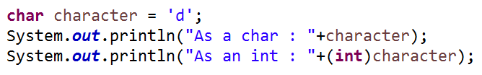

So the above would output …



It is possible to treat the char as a number and perform addition and subtraction operations. For example ..

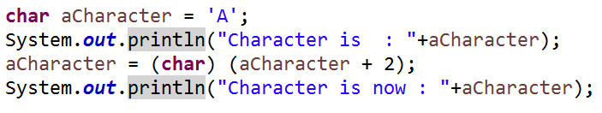

would output:



Develop a java class *CaesarCipher* with two methods, *encrypt* and *decrypt*. Both accept as arguments a string to be encrypted/decrypted and the encryption/decryption key (limited 1 -10). Return the appropriate encrypted/decrypted string from the methods.





For exampling calling the encryption method with “**Aidan**” and key value 3 would return “**Dlgdq**”.

Calling the decryption method with “Lcxc” and key value 6 would return “Java”.

**Code breaker …**

You have received the following encrypted string but not the key. Can you decrypt it….? Hint the key is between 1 and 10 but try and automate the decryption process (e.g. use a loop)

Jfy%Xqjju%Of{f%Wjujfy%2%gj%knwxy%yt%jrfnq%ymfy%yt%Fnifs%yt%|ns

**Exercise 3**

Command line arguments may be passed to a main method when a program runs. Write a program that examines command line arguments with allowable values 0,1,2,3,4,5,6,7,8,9. The program should then convert each argument into an element of an Integer (wrapper class) array.

Hint Integer wrapper class will take a valid string as a constructor argument.

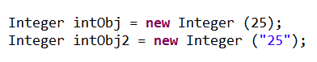

Then sort the values (ascending) and output to screen.

If there are no arguments passed the program should output an error message to the user. Any invalid values passed in with the command line arguments should also result in an error message to the user.

To run a program with command arguments in Eclipse..

Select the program,P2Co Right click > Run As > Run Configurations >

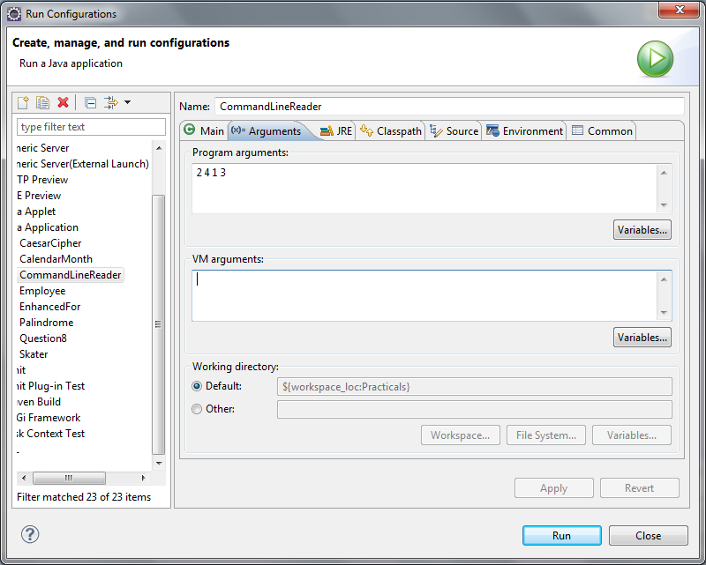

**Optional** : run it from a command line i.e. DOS window (on Window machines)  
  
Go to the root folder of the project (if created in Eclipse it will be the **bin** folder… eg

**C:\Users\amcgowan\Dropbox\qub\13-14\Programming 2 - CSC7051\ws\Practicals\bin>**

Then enter :

**java P2.CommandLineReader 3 4 6 1 8 9 2**

Command line arguments (treated by the program as Strings)

Java executable (remember to have the path set)

Package and class name