Lab 3 Report

Priscilla Burity, Oscar Linares, Alissa Stover

Due: 4/14/2020

# Introduction

Our key research questions for this report are: **Which policies are most promising in reducing crime rate: those that target punishing crimes (criminal justice policy) or reducing the need to commit crimes (economic policy)? What is the influence of contextual factors (e.g., characteristics of a population) on these relationships?**

We have a cross-section of data on crime statistics and indicators that can influence crime rates for a selection of counties in North Carolina. Most of the data are from 1987, except for some demographic variables derived from the 1980 Census. These indicators include local statistics on the performance of the criminal justice system and economc variables that a county administrator can act upon (directly or indirectly). Our task is to examine the data to help a political campaign understand the determinants of crime and generate policy suggestions that are applicable to local government and as such we focus primarily on these actionable variables.

We also include a range of contextual variables that help to control the estimated impact of these policies for local characteristics that could influence crime and the efficacy of these policies. In contrast to our variables of main focus, these are generally not actionable for a local government (for example, demographic and geographic indicators). We produced a model robust to these, that can help guide policy decisions and help reduce crime across these counties.

These data were limited in two major ways: (1) they only have one year of cross-sectional data and (2) the economic variables were limited in terms of policy analysis due to omitted variables and lack of variation across the state. Issue (1) limits the causal claims we can make, since we cannot use time to observe how different policies could lead to different outcomes. In addition, having data from one year alone means that the context of that specific year is a factor throughout. For example, unusual events within and beyond North Carolina during this year could have biased the data in various ways. One specific event that could have affected both crime and economic variables was the Black Monday crash in October of that year (<https://en.wikipedia.org/wiki/Black_Monday_(1987)>). Issue (2) made it difficult to isolate different economic policies. For example, unemployment levels would be expected to have an effect on crime (e.g., people are more likely to commit theft if they lack income). You also cannot compare different policies if there is not enough variation (e.g., if you want to measure the effect of different minimum wages, you must have different ones to compare) and North Carolina was largely similar across the state on policies like minimum wage and tax levels in the 1980s. Nevertheless, economic policy is known to have an impact on crime and so we made our best effort to address this in our models.

We found that acting on crime deterrants within the criminal justice system (like arrests and convictions) is important when it comes to preventing crime. In fact, for a 10% rise in the probability of arrests and convictions individually, the negative impact on crime rate hovers between 5-7% for arrests and between 4-5% for convictions.

Even though we could not find much support for the importance of economic policy variables to prevent crimes, this could be due to the lack of a good measure of this kind of policy available in the data. Either way, we believe that improving living conditions locally should not detract from efforts on the criminal justice system front. Targeting economic development policies that can bring higher wages and improve the quality of life in a region is likely important to deter crime as well, even though we did not have a robust test of this here.

## Actionable Variables

### Criminal Justice Policy

These variables describe things we could affect with policy around the criminal justice system. Many of these policies are used as deterrants of crime, with the assumption being that people inherently understand that these punishments exist and as such will be less likely to commit crimes (in order to avoid the punishment).

Please note that the 3 variables below are dubbed “probabilities”. However, this is a misnomer as these variables are truly ratios (e.g., the ratio of arrests to crimes reported). We interpret these as measures of the assertiveness of the criminal justice system in a county. Ideally, we would want to strike a balance between arresting enough people to prevent criminal activity, and not arresting so many as to abuse the populace.

*Probability of arrest*

If we find that the assertiveness of arrest is associated with crime rate (with higher punishment associated with lower crime), we may consider stricter policies around police practice that encourage more arrests.

* prbarr: number of convictions for every crime reported

*Probability of conviction*

If we find that the assertiveness of conviction is associated with crime rate (with higher conviction rates associated with lower crime), we may consider stricter policies around court practices so that more arrests lead to convictions.

* prbconv: number of convictions for every arrest made

*Probability of sentencing*

If we find that the assertiveness of sentencing is associated with crime rate (with higher sentencing rates associted with lower crime), we may consider stricter policies around judicial practices so that more convictions lead to sentencing. However, whether or not a given conviction carries a prison sentence depends on the severity of the crime. Counties with more severe crime would see elevated numbers for this variable (and vice versa).

This variable may be more limited in its explanatory power than arrests and convictions and will not be a prime candidate for our model.

* prbpris: number of prison sentences for every conviction

*Severity of punishment*

If we find that the severity of punishment is associated with crime rate (with greater severity associated with lower crime), we may consider stricter policies around judicial practices so that people receive more severe punishments if sentenced with a crime. Similarly to conviction rate, the length of someone’s sentence depends on the severity of the crime. Counties with more severe crime would see elevated numbers for this variable (and vice versa).

This variable may also be more limited in its explanatory power than arrests and convictions and will not be a prime candidate for our model.

* avgsen: average sentence in days

*Number of police officers per capita*

The number of police officers per capita (measured by the variable polpc) is a very intuitive example of crime deterrant, as it in theory increases the likelyhood of being caught in the act of the crime and is also a measure of the capacity of the State to enforce the law.

As our job is to advise a policy maker, it’s very important that we feel safe about the causal interpretation of our findings. After all, the idea is to propose policies with a significant impact on people’s lives. Thus, for statistical rigor, we need to make sure that causal effects go one way (that we have reason to believe that our independent variables have causal effects on our dependent variables, and not the reverse).

The cross-section of data available to us are limited in this respect, as they do not allow us to link police presence to crime rates with a causal interpretation. This is because one can expect the counties with larger crime rates in a year *t* would consider necessary to have a larger number of police officers on the streets in year *t*, which can imply a positive correlation between presence of police and crime rates that couldn’t be read as police presence leading to *higher* crime rates. In fact, an increase in crime could result in an increase in the number of police officers *and* an increase in police officers could result in a decrease in crime.

Thus, in this exercise we opted not to include police per capita as a candidate policy variable or covariate.

### Economic Policy

These variables describe things we could affect with economic policy and speak to wages for different sectors. For example, if increased wages are found to be related significantly to crime, our candidate could consider strategies such as raising the minimum wage in an attempt to lower crime. However, given that North Carolina did not have a wide range of minimum wage policies at this time (or even at present day), it is questionable how much we can test such policies with these data. We do not have enough of a range in the real-life policy we are trying to examine for this to be a good test.

As this is our best proxy for wage policy available in the dataset and given the importance of the economy in crime and human behavior more generally, we will attempt to use these to operationalize this type of policy change. Making inferences about economic policies from the relationships we measure between these and other variables will naturally be limited by the fact that these are a flawed operationalization of variation in wage policy. Omitting these could introduce a bias that would affect the other relationships we measure (for example, one could imagine that being very tough on crime would not serve as much of a deterrant if people are not able to make a living wage and are desperate to get by). We do not have data from other localities that could allow us to better measure wage policy changes. So, we strike a balance between these issues by including these variables as covariates to test the robustness of other relationships, but being cautious about drawing any strong conclusions from them.

* wcon: weekly wage, construction
* wtuc: weekly wage, transportation, utilities, communication
* wtrd: weekly wage, wholesale and retail trade
* wfir: weekly wge, finance, insurance, real estate
* wser: weekly wge, services
* wmfg: weekly wge, manufacturing
* wsta: weekly wge, state employees
* wloc: weekly wge, local government employees

The following federal wage variable will be grouped with other wages in much of our analyses for easier comparison in terms of data quality, however it is not related to minimum wage policy but rather to cost of living. Federal employee wages are controlled by the federal government (as opposed to local politicians such as our candidate) and are adjusted by cost of living in a locality (<https://www.opm.gov/policy-data-oversight/pay-leave/salaries-wages/fact-sheets/>); thus, this variable could also be used as a marker of cost of living in a county. If we find a relationship between federal wages and crime, one could predict that changing the economic development of a region may affect crime. However, this variable is confounded by the types of federal workers in an area, since federal wages are determined by a grade system that is tied to the nature of the position and time in position. A specific effort that could affect both of these - bringing more economic development and the right types of high-earning federal employees - would be to attract federal jobs to the area that have higher wages.

Policy recommendations that could be made from this variable are further limited by the fact that cost of living calculations depend to a large extent on the cost of goods. One could imagine a county that had the characteristics we would like to operationalize with this variable: relatively high cost of living, accompanied by broader economic development in the area so that many people can partake in this wealth (e.g., a strong school system, museums, and other community investments). A strong community such as this would likely see lower crime rates - less people would be in a position where they needed to commit crimes to get what they needed. However, this variable alone cannot help us differentiate this type of community compared to others that see a high cost of living without such community investment, where only some wealthy people can enjoy the prosperity and afford the more expensive goods around them. A community that sees this level of inequality may expect to see more crime, as those who are in need would find more reason to take from those who have more than they need.

Similar to our comments above, this variable is not a good proxy for what we would ideally like to measure (the economic prosperity of a region and how much of the populace can partake in it - which could be influenced by economic development initiatives like investing in businesses large and small). However, we imagine that omitting this variable could introduce a bias in other relationships we find.

Thus, we find it is important to attempt to measure the relationship between federal wages and crime to test the robustness of other variables, but we will not attempt to make any causal interpretation about these relationships.

* wfed: weekly wge, federal employees

The following variable represents tax revenue per capita, but does not differentiate between different revenue streams (taxes on income, sales, property, or businesses). It also doesn’t help us understand how governments use this revenue (are they corrupt and profiting? or are they reinvesting into the community for schools and other public works?). It also reflects overall wealth in a county. Holding tax rate constant, counties with more wealth will have more tax revenue and vice versa. Holding wealth constant, changing the tax rate would change the tax revenue per capita. A better measure of tax policy would be the actual tax rates in each county, for different entitites. Since the impact of policy on this variable is confounded by the overall wealth in a county and the specific tax policy variations are hidden, the causal relationship would be difficult to interpret. Plus, many taxes are set at the state and federal level; the level of variation at the county-level may be limited for a small state like North Carolina. However, similar to wfed, this variable would be related to overall economic development and may be a helpful covariate in testing and teasing out other relationships in the data.

* taxpc: tax revenue per capita

## Contextual Variables

Since we are aiming to produce policy recommendations, the following variables may be helpful in our analysis but are not actionable. They describe county characteristics that provide important information about how policies could work across different county contexts.

### Types of Crime

Does the type of crime affect the impact of crime policy? For example, if an area has mostly petty crimes, one would imagine that some of the punishment could be more discrete than arresting people - you could handle this with fines, for example. The consequences are real, but less visible and thus perhaps less of a deterrant. This could change the relationship between our crime policy variables like number of arrests per crime (an area with less face-to-face crimes would see less arrests). It could also affect overall number of crimes (if localities are punishing the crimes they can with arrests, but don’t have many of those face-to-face crimes to punish, the punishments would not be as visible and so people would have less of a clear deterrant - so they might end up committing a lot of petty crimes).

* mix: offense mix: face-to-face/other

### Demographics

The following variables describe different aspects of the people that reside in these counties.

*Urban/rural dwellers*

Higher density areas would see more interaction between people, which could drive up the number of crimes (more opportunity). It could also drive up the amount of punishment and actual measurement of crime - it might be easier to get away with things if less people are around to catch you.

* density: people per square mile

*Minority status*

It is well known that people of minority status (compared to whites) are more likely to be involved in the criminal justice system and as such this is a key covariate in our analysis.

* pctmin80: percent minority, 1980

*Gender & Age*

Young males are more likely to enter the criminal justice system so this is another demographic variable that we would expect to see related to crime.

* pctymle: percent young male, 1980

### Geography

The following variables identify which region of the state each county is in, with the assumption that counties cluster geographically in terms of their culture and other characteristics we are not explicitly measuring. Western North Carolina is along the Appalachian mountains and seems qualitatively different from much of the rest of the state. For example, it has much fewer universities compared to the rest of the state (you can see this through a quick Google Maps search). Thus, we will lean towards using west over the other geographical variables (especially since urban could be highly related to density).

* west: =1 if in western N.C.
* central: =1 if in central N.C.
* urban: =1 if in SMSA

# A Model Building Process

## Data Cleaning & Exploratory Data Analysis

# import libraries   
library(tidyverse) # for data import, manipulation, viz  
library(corrplot) # for correlation matix  
library(stargazer) # visualize model fit  
library(skimr) # generate summary statistics  
library(car) # statistics   
library(lmtest) # linear modeling  
library(olsrr) # evaluating OLS regression   
library(sandwich) # correcting heteroskedasticity violation  
library(grid) # to arrange ggplot figures into a grid   
library(gridExtra) # to arrange ggplot figures into a grid

# import data  
data <- read_csv("crime_v2.csv", n_max = 91)

#### File-level data checks

We have 91 observations and 25 columns in the raw data. All 25 columns were read in as numeric columns.

print(paste("Number of records:", dim(data)[1]))

## [1] "Number of records: 91"

print(paste("Number of variables:", dim(data)[2]))

## [1] "Number of variables: 25"

##### The Where & When of these data

We do not have any missing values in the county column.

It looks like we usually have 1 observation for each of the counties – except for county #193. Having 2 observations for county #193 is surprising. We noticed that these rows appear to be exact duplicates.

What else can we glean from the county variable? It appears as though these county IDs could be county FIPS codes. One can see a list here: <https://www.lib.ncsu.edu/gis/countfips>

We cannot make assumptions about this, however we can try to supplement some of our data quality checks to see if anything seems to align between the IDs of our counties and their FIPS codes.

Another thing to note is that we seem to be missing information from 10 of the 100 counties in North Carolina.

The year column is constant; as expected, the data are recorded as being from 1987. We also don’t have any missing values for this column. We can drop this column in future data processing steps.

Based on the explorations above, we create a new data frame that has dropped our superfluous column (year) and the superfluous row (duplicate of county 193). Now we have 90 rows and 24 numeric variables, with one observation per county.

data2 <- data %>% distinct() %>% select(-c("year", "polpc"))

##### Missingness & Data Validity

We can see from the following table that we don’t have any missing data, which is good!

However, we can see by the max for each column (p100), that we appear to have a few values that are extremely high.

For example, one county has weekly wages in the service sector reported to be $2177 (almost 10x the median of $253).

data2_skim <- skim(data2)  
data2_skim

## Skim summary statistics  
## n obs: 90   
## n variables: 23   
##   
## ── Variable type:numeric ────────────────────────────────────────────────────────────────────────────────────────  
## variable missing complete n mean sd p0 p25 p50  
## avgsen 0 90 90 9.69 2.83 5.38 7.38 9.11   
## central 0 90 90 0.38 0.49 0 0 0   
## county 0 90 90 100.6 58.32 1 51.5 103   
## crmrte 0 90 90 0.034 0.019 0.0055 0.021 0.03   
## density 0 90 90 1.44 1.52 2e-05 0.55 0.98   
## mix 0 90 90 0.13 0.082 0.02 0.081 0.1   
## pctmin80 0 90 90 25.71 16.98 1.28 10.02 24.85   
## pctymle 0 90 90 0.084 0.023 0.062 0.074 0.078  
## prbarr 0 90 90 0.3 0.14 0.093 0.2 0.27   
## prbconv 0 90 90 0.55 0.35 0.068 0.34 0.45   
## prbpris 0 90 90 0.41 0.081 0.15 0.36 0.42   
## taxpc 0 90 90 38.16 13.11 25.69 30.73 34.92   
## urban 0 90 90 0.089 0.29 0 0 0   
## wcon 0 90 90 285.35 47.75 193.64 250.75 281.16   
## west 0 90 90 0.24 0.43 0 0 0   
## wfed 0 90 90 442.62 59.95 326.1 398.78 448.85   
## wfir 0 90 90 321.62 54 170.94 285.56 317.13   
## wloc 0 90 90 312.28 28.13 239.17 297.23 307.65   
## wmfg 0 90 90 336.03 88.23 157.41 288.6 321.05   
## wser 0 90 90 275.34 207.4 133.04 229.34 253.12   
## wsta 0 90 90 357.74 43.29 258.33 329.27 358.4   
## wtrd 0 90 90 210.92 33.87 154.21 190.71 202.99   
## wtuc 0 90 90 410.91 77.36 187.62 374.33 404.78   
## p75 p100 hist  
## 11.47 20.7 ▆▇▅▅▂▁▁▁  
## 1 1 ▇▁▁▁▁▁▁▅  
## 150.5 197 ▇▆▇▇▆▇▇▇  
## 0.04 0.099 ▆▇▇▃▂▁▁▁  
## 1.57 8.83 ▇▃▁▁▁▁▁▁  
## 0.15 0.47 ▃▇▂▁▁▁▁▁  
## 38.18 64.35 ▇▅▅▅▆▃▁▂  
## 0.084 0.25 ▇▁▁▁▁▁▁▁  
## 0.34 1.09 ▆▇▃▁▁▁▁▁  
## 0.59 2.12 ▃▇▂▁▁▁▁▁  
## 0.46 0.6 ▁▁▂▅▇▇▂▁  
## 41.01 119.76 ▇▃▁▁▁▁▁▁  
## 0 1 ▇▁▁▁▁▁▁▁  
## 314.98 436.77 ▂▇▇▇▅▃▁▁  
## 0 1 ▇▁▁▁▁▁▁▂  
## 478.26 597.95 ▃▅▅▇▆▃▂▁  
## 342.63 509.47 ▁▁▅▇▃▁▁▁  
## 328.78 388.09 ▁▁▃▇▅▂▁▁  
## 359.89 646.85 ▁▃▇▅▁▁▁▁  
## 277.65 2177.07 ▇▁▁▁▁▁▁▁  
## 383.15 499.59 ▂▃▆▇▆▂▁▁  
## 224.28 354.68 ▃▇▆▂▂▁▁▁  
## 440.68 613.23 ▁▁▂▆▇▂▂▁

Note that pctmin80 values are not in the [0,1] scale despite being a percentage of total metric. It seems that it represents X% (for example, 64.35%) as opposed to representing this as a decimal (continuing our example, 0.6435). The scale for this variable does not match the other percentage metric in our data set (pctymle). The scale of pctmin80 will be adjusted in order to facilitate coefficient interpretation.

# convert % minority variable  
data2$pctmin80 <- data2$pctmin80 * 0.01

# save clean data file   
save(data2, file = "data_clean.rda")

## Variable-level data checks & Exploratory Data Analysis

### Dependent Variable: Crime Rate

Barring extreme issues with crmrte (crime rate), we would recommend focusing on this as our target variable, as what matters most to people is the level of crime around them every day. The justice system is used to enact justice and to deter crimes. Justice is important, and making sure that those that commit crimes are punished is one way of going about achieving a just and safer society. Of course, justice is a moral issue and can be seen from many different lenses, but the data we have in hands do not allow us to go in depth in this issue.

We don’t have enough data points to make a strong claim about the distribution of crmtre. From the histogram, we can see that it is unimodel. It appears to be approximately normal (with a slight skew)

From our box plot we can see that most values are between 0.02 and 0.04, however we do have a range of values including some that are close to 0.10. We don’t appear to have any spurious values.

p1 <- ggplot(data2, aes(crmrte)) +  
 geom_histogram(bins = 35) +  
 theme_minimal() +  
 xlab("Crime Rate") +  
 ylab("Count") +  
 ggtitle("Histogram")  
  
p2 <- ggplot(data2, aes(y = crmrte)) +  
 geom_boxplot() +  
 theme_minimal() +  
 ylab("Crime Rate") +  
 ggtitle("Box plot")  
  
grid.arrange(p1, p2, ncol = 2, top = "Candidate Dependent Variable: Crime Rate")

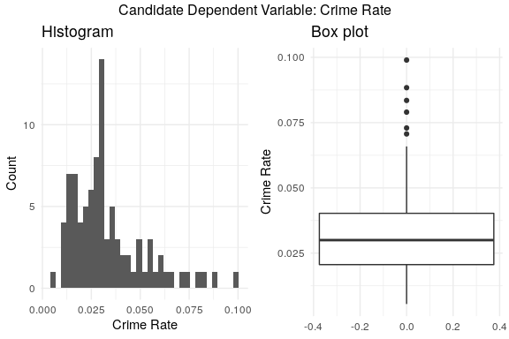

### Independent Variables

#### Actionable Variables

##### Criminal Justice Policy

First, we evaluated the quality the 3 core criminal justice policy variables (prbarr, prbconv, prbpris).

# format data for subplots   
data_cj_long <- data2 %>% select(prbarr, prbconv, prbpris) %>%  
 gather(key = var, value = value)  
  
# convert to factor for subplot labelling   
data_cj_long$var <- factor(data_cj_long$var, labels = c("Prob Arrest", "Prob Convicted", "Prob Sentenced"))

We can see that we have different distributions for these, but that they all could be considered unimodal, with different levels of skew.

# plot hist subplots  
ggplot(data_cj_long, aes(value)) +  
 geom_histogram(bins = 50) +  
 facet_grid(~var) +  
 theme_minimal() +  
 ggtitle("Histogram of Criminal Justice Policy Variables: Assertiveness Variables")

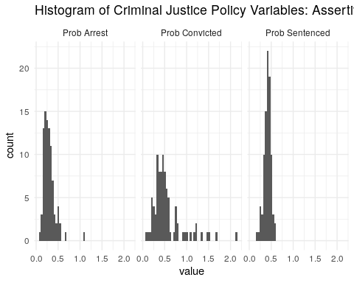

From our boxplots we can see that we have some extreme values for assertiveness of conviction, with multiple counties having a rate above 1. As these are not true probabilities, but rather ratios, these values are not necessarily spurious. However, they imply that for each arrest, there could be multiple convictions - one county has over 2 convictions for every arrest. Only 1 county has more than 1 arrest per crime committed - most counties in fact have a much lower rate (and only put someone under arrest for about one-quarter of crimes). When it comes to setencing, counties show a much lower spread and cluster around 1 conviction resulting in a prison sentence for every 1 conviction that does not.

# plot boxplot subplots   
ggplot(data_cj_long, aes(x = var, y = value)) +  
 geom_boxplot() +  
 theme_minimal() +  
 xlab("") +  
 ylab("Ratio") +   
 ggtitle("Boxplot of Criminal Justice Policy Variables: Assertiveness Variables")

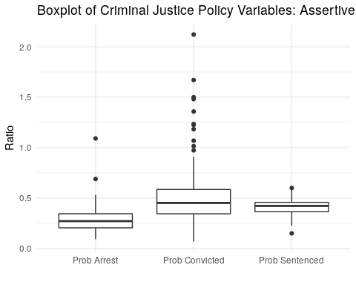

Which county had the highest conviction rate? This is a county in central North Carolina. It has the highest percentage of minorities. It also appears to have the maximum wages in the service industry ($2177 compared to a median of $253).

data2 %>% filter(prbconv == max(prbconv))

## # A tibble: 1 x 23  
## county crmrte prbarr prbconv prbpris avgsen density taxpc west central  
## <dbl> <dbl> <dbl> <dbl> <dbl> <dbl> <dbl> <dbl> <dbl> <dbl>  
## 1 185 0.0109 0.195 2.12 0.443 5.38 0.389 40.8 0 1  
## # … with 13 more variables: urban <dbl>, pctmin80 <dbl>, wcon <dbl>,  
## # wtuc <dbl>, wtrd <dbl>, wfir <dbl>, wser <dbl>, wmfg <dbl>,  
## # wfed <dbl>, wsta <dbl>, wloc <dbl>, mix <dbl>, pctymle <dbl>

The fact that the conviction rate is so high seems odd for county #185. The other measures of assertiveness (for arrest and sentencing) seem close to the mean. That of conviction rate is astronimically high.

data_prb <- data2 %>% as_tibble() %>% select(prbarr, prbconv, prbpris) %>% summarise_all(median) %>%   
 gather(var, value) %>% mutate(Group = "Median")  
  
data_ep_long <- data2 %>%   
 select(wcon, wtuc, wtrd, wfir, wser, wmfg, wfed, wsta, wloc) %>%  
 gather(key = var, value = value)  
  
prb_185 <- data2 %>% as_tibble() %>% filter(county == 185) %>% select(prbarr, prbconv, prbpris) %>%   
 gather(var, value) %>% mutate(Group = "County #185")  
  
prbs <- bind_rows(data_prb, prb_185)  
  
ggplot(data = prbs, aes(x = var, y = value, color = Group)) +   
 geom_point() +  
 xlab('Criminal Justice Assertiveness Category') +  
 ylab('Assertiveness') +  
 theme_minimal() +  
 ggtitle("Comparing Criminal Justice Assertiveness between County 185 and Other Counties")

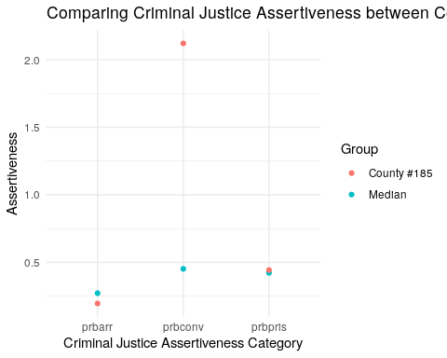

The analysis above suggests that the data for this county #185 may be corrupted - since it has values for wser and prbconv at levels much higher than the median. Assuming that the number in county stands for the FIPS code, #185 stands for Warren County. During the 1980’s, the citizens of Warren County conducted a series of demonstrations against a newly built landfill as per this [document](https://en.wikipedia.org/wiki/Warren_County_PCB_Landfill). These demonstrations led to multiple arrests and convictions that are not associated with crime but disobedience. As this was an extraordinary event that is outside the process that we are interested in studying, this county’s data will be excluded from subsequent modeling.

Our dataset has a second kind of criminal justice system indicator, namely the average sentence of convictions (in days). While the assertiveness indicators relate to the certainty of punishment (the extent to which criminals expect to get caught and face punishment), average sentence relates to the severity of the punishment. We can see that average sentence length follows an approximately normal distribution. We have one value well above the rest (above 20 days; most cluster below 15).

p1 <- ggplot(data2, aes(avgsen)) +  
 geom_histogram(bins = 35) +  
 theme_minimal() +  
 xlab("Days of Imprisonment") +  
 ylab("Count") +  
 ggtitle("Histogram")  
  
p2 <- ggplot(data2, aes(y = avgsen)) +  
 geom_boxplot() +  
 theme_minimal() +  
 ylab("Days of Imprisonment") +  
 ggtitle("Box plot")  
  
grid.arrange(p1, p2, ncol = 2, top = "Criminal Justice Indicator: Average Sentence")

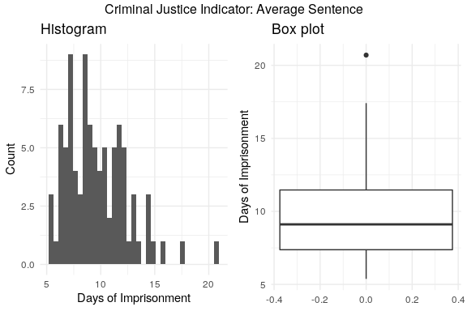

According to the FIPS codes, county #115 - the county with the highest average sentence- is Madison County. This county is in Western North Carolina (in the area commonly known as Appalachia) and is the home to the state’s oldest jail, which was still in operation in 1987 (<https://mountainx.com/news/murky-future-for-madisons-historic-jailhouse/>). The fact that this county is in one of the less prosperous areas of the USA and is also home to a well-known, long lived jail, could perhaps explain its high level of average sentence length. It’s plausible that this is not a data quality issue and so to be conservative, we retain this outlier in the data at this stage but will monitor its effect on model fits.

# show counties with highest average sentence  
data2 %>% arrange(desc(avgsen)) %>% select(county, avgsen) %>% head(5)

## # A tibble: 5 x 2  
## county avgsen  
## <dbl> <dbl>  
## 1 115 20.7  
## 2 41 17.4  
## 3 127 16.0  
## 4 99 14.8  
## 5 149 14.6

##### Economic Policy

One of the things an administrator can affect with economic policy is minimum wage. In North Carolina in 1987, the minimum hourly wage was $3.35. Given that most people work 40 hours per week, the minimum hourly wage would be $134 per week.

In the plots below, we plot weekly wage by sector with a red vertical line indicating this minimum weekly wage. Note that most wages are approximately normally distributed.

We can see that wrtd (Wholesale & Retail Trade) wages are closest to the minimum wage - which would suggest that wages in this sector would be most influenced by changes to the minimum wage. The next sector that would be influenced is wser (Services). Additionally, wser may be a messier measure of income because many in this sector work in restaurants and make additional income through tips - however, some people may not report this income. Meanwhile, those working in Wholesale & Retail Trade may be more likely to work in places like malls, which would not provide additional income as tips and would be a better measure of low-income wages.

Another aspect of wage that is under control of local and state governments are local and state employee wages. Perhaps raising the wages of government employees could be a tactic for reducing crime (although it would also cut into budgets for other crime-cutting efforts and may not be ideal). We will also include these in our models in order to test this policy, keeping in mind that implementation may be challenging.

# format data for subplots   
data_ep_long <- data2 %>%   
 select(wcon, wtuc, wtrd, wfir, wser, wmfg, wfed, wsta, wloc) %>%  
 gather(key = var, value = value)  
# convert to factor for better labeling   
data_ep_long$var <- factor(data_ep_long$var,  
 levels = c("wcon", "wtuc", "wtrd", "wfir",  
 "wser", "wmfg", "wfed", "wsta", "wloc"),  
 labels = c("Construction",   
 "Utilities/Transport",   
 "Wholesale & Retail Trade",  
 "Finance/Insurance/Real Estate",  
 "Services",  
 "Manufacturing",  
 "Federal Emp",  
 "State Emp",  
 "Local/State Emp"))

# plot hist subplots  
ggplot(data_ep_long, aes(value)) +  
 geom_histogram(bins = 50) +  
 facet_wrap(~var) +  
 theme_minimal() +  
 ggtitle("Histogram of Economic Policy Variables: Wages by Sector") +  
 geom_vline(aes(xintercept = 134, color = "red")) +  
 theme(legend.position = "none")

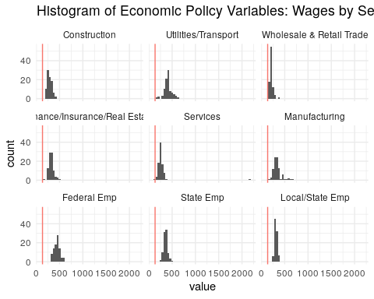

# plot boxplot subplots   
ggplot(data_ep_long, aes(x = var, y = value)) +  
 geom_boxplot() +  
 coord_flip() +   
 theme_minimal() +  
 xlab("") +   
 ylab("Weekly Wage") +  
 ggtitle("Boxplot of Economic Policy Variables: Wages by Sector")+  
 geom_hline(aes(yintercept = 134, color = "red")) +  
 theme(legend.position = "none")

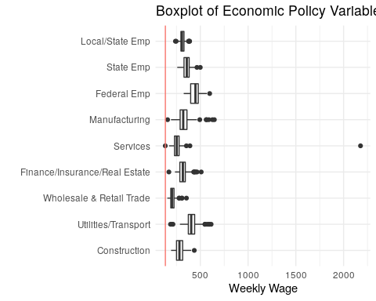

Another variable influenced by economic policy is tax revenue per capita. The distribution of taxpc is skewed. This distribution coupled with the fact that taxpc is measured in dollars makes the variable a top candidate for a log transformation.

# plot histogram & boxplot  
tax1 <- ggplot(data2, aes(taxpc)) +  
 geom_histogram(bins = 25) +  
 theme_minimal() +  
 xlab("Tax Revenue Per Capita") +  
 ylab("Count") +  
 ggtitle("Histogram")  
  
tax2 <- ggplot(data2, aes(y = taxpc)) +  
 geom_boxplot() +  
 theme_minimal() +  
 ylab("Tax Revenue Per Capita") +  
 ggtitle("Boxplot")  
  
grid.arrange(tax1, tax2, ncol = 2, top = "Tax Revenue Per Capita")

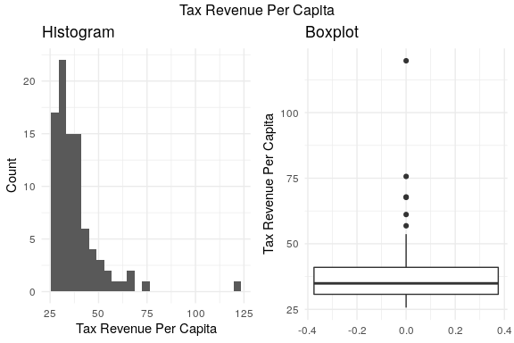

We appear to have an extreme value at $119.76, which is for county #55. This seems to the in the rural, eastern part of the state (as it’s not west, nor central, nor urban). When we cross-check this county with FIPS codes, it appears that this is likely Dare County. Dare County is a small island off the coast of North Carolina that is not an urban center.

# filter for only #55  
data2 %>% filter(taxpc == max(taxpc))

## # A tibble: 1 x 23  
## county crmrte prbarr prbconv prbpris avgsen density taxpc west central  
## <dbl> <dbl> <dbl> <dbl> <dbl> <dbl> <dbl> <dbl> <dbl> <dbl>  
## 1 55 0.0790 0.225 0.208 0.304 13.6 0.512 120. 0 0  
## # … with 13 more variables: urban <dbl>, pctmin80 <dbl>, wcon <dbl>,  
## # wtuc <dbl>, wtrd <dbl>, wfir <dbl>, wser <dbl>, wmfg <dbl>,  
## # wfed <dbl>, wsta <dbl>, wloc <dbl>, mix <dbl>, pctymle <dbl>

With such high tax revenue, one would expect that this county had higher wages. This county appears to have federal employee wages well below the mean for North Carolina. It is also below the median for:

* wfir (financial, insurance & real estate)
* wmfg (manufacturing)
* wser (service industry)
* wtrd (trade)

This seems suspect (combined with the fact that we lack information about its location). However, the location suggests that there is an explanation for such an anamolous pattern. This is a popular vacation spot and could be expected to see high rates of tax revenue of this wealthier populace compared to the rest of the state, as it is mainly wealthier people who would be expected to own vacation homes on such an island.

Given that we do not have much background information on these counties, we will keep county #55 in and monitor its effect on our model fits.

# reformat data for plotting  
data_tax <- data2 %>% as_tibble() %>% select(taxpc, wcon, wtuc, wtrd, wfir, wser, wmfg, wfed, wsta, wloc) %>% summarise_all(median) %>%   
 gather(var, value) %>% mutate(Group = "Median")  
taxes_55 <- data2 %>% as_tibble() %>% filter(county == 55) %>% select(taxpc, wcon, wtuc, wtrd, wfir, wser, wmfg, wfed, wsta, wloc) %>%   
 gather(var, value)%>% mutate(Group = "County #55")  
taxes <- bind_rows(data_tax, taxes_55)  
  
# plot  
ggplot(data = taxes, aes(x = var, y = value, color = Group)) +   
 geom_point() +  
 xlab('Category') +  
 ylab('$') +  
 theme_minimal() +  
 ggtitle("Comparing Tax Revenue and Wages between County 55 and Other Counties")

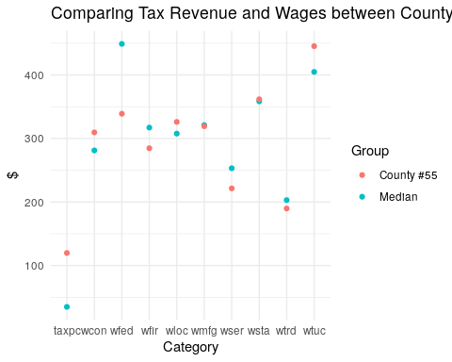

#### Contextual Variables

##### Types of Crime

# plot hist  
p5 <- ggplot(data2, aes(mix)) +  
 geom_histogram(bins = 35) +  
 theme_minimal() +  
 ggtitle("Histogram") +  
 xlab("offense mix: face-to-face/other")  
  
# plot boxplot  
p6 <- ggplot(data2, aes(y = mix)) +  
 geom_boxplot() +  
 theme_minimal() +  
 ggtitle("Boxplot") +  
 ylab("offense mix")  
  
  
  
grid.arrange(p5, p6, ncol = 2, top = "Contextual Variables: Type of Crime")

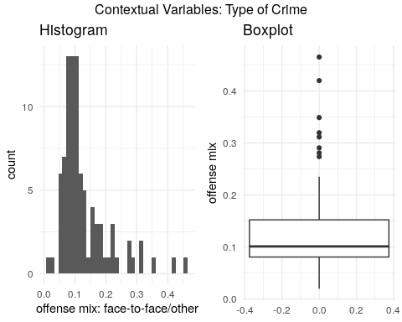

##### Demographics

*Density*

One would expect density to be positively correlated with crime (more people packed together, more crime).

* density: people per square mile

*Minority status*

Minority status is likely positively correlated with crime. Race has a complicated relationship with the criminal justice system and we know that minorities are more likely to be involved.

* pctmin80: percent minority, 1980

*Gender & Age*

Young males are more likely to be involved in the criminal justice system and we would expect this to positively correlate with crime.

* pctymle: percent young male, 1980

The distributions for density and pctymle approximate a normal distribution but the that of pctmin80 approximates a uniform distribution. Minorities seems to be present in most counties on a similar proporties.

# hist  
p7 <- ggplot(data2, aes(density)) +  
 geom_histogram(bins = 35) +  
 theme_minimal() +  
 xlab("Density") +  
 ylab("Count") +  
 ggtitle("Population Density")  
  
# plot boxplot  
p8 <- ggplot(data2, aes(y = density)) +  
 geom_boxplot() +  
 theme_minimal() +  
 ggtitle("Population Density") +  
 ylab("Density")  
  
p9 <- ggplot(data2, aes(pctmin80)) +  
 geom_histogram(bins = 40) +  
 theme_minimal() +  
 xlab("% Minority") +  
 ylab("Count") +  
 ggtitle("Percentage Minority (1980)")  
  
p10 <- ggplot(data2, aes(y = pctmin80)) +  
 geom_boxplot() +  
 theme_minimal() +  
 ylab("% Minority") +  
 ggtitle("Percentage Minority (1980)")  
  
p11 <- ggplot(data2, aes(pctymle)) +  
 geom_histogram(bins = 25) +  
 theme_minimal() +  
 xlab("% Young Males") +  
 ylab("Count") +  
 ggtitle("Percentage Young Male (1980)")  
  
p12 <- ggplot(data2, aes(y = pctymle)) +  
 geom_boxplot() +  
 theme_minimal() +  
 ylab("% Young Males") +  
 ggtitle("Percentage Young Male (1980)")  
  
grid.arrange(p7, p8, p9, p10, p11, p12, ncol = 2, nrow = 3, top = "Contextual Variables: Demographics")

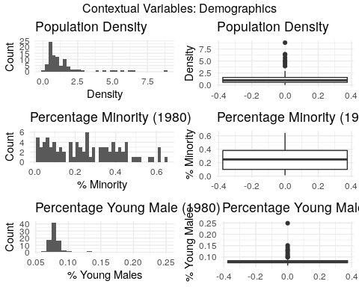

In terms of density outliers, we discovered that the county #119 has the highest density. This county probably is Mecklenburg County, which holds the city of Charlotte (the state capital and one of its most populated cities).

data2 %>% filter(density == max(density))

## # A tibble: 1 x 23  
## county crmrte prbarr prbconv prbpris avgsen density taxpc west central  
## <dbl> <dbl> <dbl> <dbl> <dbl> <dbl> <dbl> <dbl> <dbl> <dbl>  
## 1 119 0.0990 0.149 0.348 0.486 7.13 8.83 75.7 0 1  
## # … with 13 more variables: urban <dbl>, pctmin80 <dbl>, wcon <dbl>,  
## # wtuc <dbl>, wtrd <dbl>, wfir <dbl>, wser <dbl>, wmfg <dbl>,  
## # wfed <dbl>, wsta <dbl>, wloc <dbl>, mix <dbl>, pctymle <dbl>

The smallest county would correspond to Swain County, a very rural county in the Western part of the state. It straddles two national parks/forests (Great Smoky Mountains National Park and Nantahala National Forest), which would explain why it is so low density.

data2 %>% filter(density == min(density))

## # A tibble: 1 x 23  
## county crmrte prbarr prbconv prbpris avgsen density taxpc west central  
## <dbl> <dbl> <dbl> <dbl> <dbl> <dbl> <dbl> <dbl> <dbl> <dbl>  
## 1 173 0.0140 0.530 0.328 0.150 6.64 2.03e-5 37.7 1 0  
## # … with 13 more variables: urban <dbl>, pctmin80 <dbl>, wcon <dbl>,  
## # wtuc <dbl>, wtrd <dbl>, wfir <dbl>, wser <dbl>, wmfg <dbl>,  
## # wfed <dbl>, wsta <dbl>, wloc <dbl>, mix <dbl>, pctymle <dbl>

In terms of “Percetage Young Male”, county #133 (Onslow County based on FIPS code) is the main outlier in this cluster of demographic variables. This deviation in percent of young males could be due to Camp Lejeune, a marine corps base. Most recruits are young males and so this base would impact the percent of young males in the population, epecially because the density of Onslow county is low. Contrary to our expected relationship, the percent of young males would have a negative impact on crime becuase recruits would most likely not commit crimes. However, this is not the only county in North Carolina with a military base, so we will be keeping this observation and monitoring its impact on model results.

data2 %>% filter(pctymle == max(pctymle))

## # A tibble: 1 x 23  
## county crmrte prbarr prbconv prbpris avgsen density taxpc west central  
## <dbl> <dbl> <dbl> <dbl> <dbl> <dbl> <dbl> <dbl> <dbl> <dbl>  
## 1 133 0.0551 0.267 0.272 0.335 8.99 1.65 27.5 0 0  
## # … with 13 more variables: urban <dbl>, pctmin80 <dbl>, wcon <dbl>,  
## # wtuc <dbl>, wtrd <dbl>, wfir <dbl>, wser <dbl>, wmfg <dbl>,  
## # wfed <dbl>, wsta <dbl>, wloc <dbl>, mix <dbl>, pctymle <dbl>

##### Geography

We were given 3 variables to track geography:

* west: =1 if in western N.C.
* central: =1 if in central N.C.
* urban: =1 if in SMSA

Are these mutually exclusive categories? No, these are dummy variables that code for west versus central versus east (with east being the default) and urban versus rural (with rural being the default).

# create new east variable  
geo_supp <- data2 %>% mutate(east = ifelse(west == 0 & central == 0, 1, 0), rural = ifelse(urban == 0, 1, 0))

Eastern counties represent 38.89% of the 89 counties. Central counties represent 37.78%. Western counties represent the rest at 24.44%. These sum to 100% which indicates that this dummy variable has likely been correctly coded.

Urban counties represent 8.89% of the 89 counties. Rural counties represent 91.11%. These also sum to 100%.

# reformat data for plotting  
geo_long <- geo_supp %>%  
 mutate_at(vars(west, central, east, rural, urban), ~ ifelse(. == 0, NA, .)) %>%  
 gather("location", "present1", west, central, east, na.rm = TRUE) %>%  
 gather("type", "present2", rural, urban, na.rm = TRUE) %>%  
 select(-present1, -present2)

We can see that the vast number of counties are rural across central, western, and eastern counties. Central counties have the largest share of urban geographies.

# plot barplots  
ggplot(geo_long, aes(x = location, fill = type)) +  
 geom_bar(position = "fill") +  
 theme_minimal() +  
 ggtitle("Barplot of Contextual Variables: Geography") +  
 xlab("")

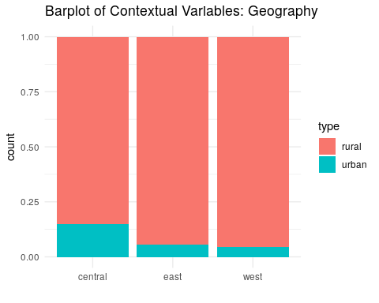

We will prioritize west in our model, as Western North Carolina seems qualitatively different from other regions based on our research (for example, there are less universities in this region). It has the least number of rural counties and represents the least number of counties overall. The other categories may be important, but we expect them to be less influential on crime patterns.

### Relationships between Variables

# remove row with erroneous values (#185) before investigating relationships   
data2 <- data2 %>% filter(county != 185)  
print(paste("Number of records:", dim(data2)[1]))

## [1] "Number of records: 89"

One would expect variables within each of the above groups to be correlated to each other.

This is a correlation matrix of all of our variables, using Spearman’s due to the fact that not all variables follow a normal distribution.

As expected, prbarr and prbconvshow a negative correlation with crmrte. However, prbpris and avgsen do not show a strong correlation with cmrte. For the former, the fact that in general the number of imprisonments is low likely weakens the relationship between prbpris and cmrte. Following the same rationale, given that most crimes committed are petty crimes with relatively low sentence lengths, average sentence length might not be a strong deterrant of crimes. Additionally, mix does not seem to have a strong correlation with cmrte. mix values are very low, indicating that face-to-face crimes are almost non-existant across counties. Thus, the low variability of mix does not allow for a material relationship between type of crime, as currently defined, and crime rate.

Wages appear to all be positively correlated with crime, which is opposite our original conjecture. Rather than seeing that increased wages are related to reduced crime, we are seeing that higher wages is related to higher crime. This unexpected direction could be explained in part by the strong positive relationship between the wage variables and density and between crmrte and density. It could also be due to our points above about inequality - if inequality is strongly correlated both to crime and higher wages, it could be a hidden factor that is driving this relationship. Thus, we will not include the wage variables in early models - and it will be important to include additional variables to control for other influences that could be affecting the direction of this relationship.

Population density has a strong positive relationshiop with crime rate. This relationship is expected as a greater number of poeple living close to each other arguably increase the number of interactions and may lead to higher crime rate. density is also positively correlated with other geographical variables. For example, urban and density are positively correlated because cities will have higher density due to their urban design. We will pay special attention to these strongly correlated variables as they can increase the variance of models’ residuals if they are cast as independent variables in the same equation.

Finally, note that all wages as well as taxpc are positively correlated to each other. This behaviour is expected as wages and taxable income are both determined by economic factors. Similarly as above, we will need to pay close attention as the joint impact of including multiple variables that are highly correlated in models .

data_corr <- data2 %>% select(-county)   
  
matrix_corr <- round(cor(data_corr, method = "spearman"), 1)

corrplot(matrix_corr, type = "lower", method = "ellipse", order = "alphabet")

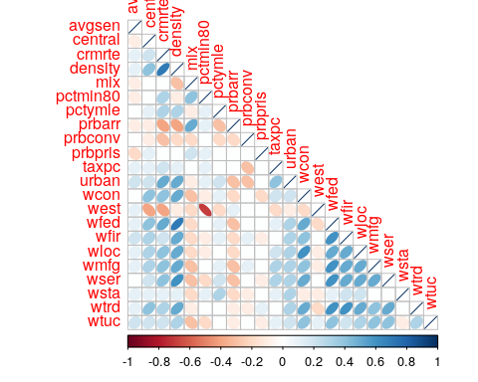

## Results

We will next build a set of models to investigate our research question, documenting our decisions.

In order select the optimal model in a certain range of model specification options, we will rely on information criteria (IC). Two popular IC are AIC (Akaike information criterion) and and BIC (Bayesian information criterion ). AIC and BIC for a model is usually written in the form $−2logL+kp$, where $L$ is the likelihood function, $p$ is the number of parameters in the model, and $k$ is $2$ for AIC and $log(n)$ for BIC ($n$ =number of observations). Despite subtle theoretical differences, their only difference in practice is the size of the penalty: BIC penalizes model complexity more heavily. To maintain parsimony of our models, we opted to use BIC for model selection.

### Model set #1

For our first model, we aimed to evaluate the relationship between crime policy and crime. The null hypothesis in this case is that there is no linear relationship between crime and our main crime policy variables (prbarr and prbconv). The alternative is that there is a negative relationship such that higher probabilities of arrest and conviction are related to lower rates of crime.

We used the following independent variables to predict crime:

*Crime policy*

1. log(prbarr)
2. log(prbconv)
3. log(prbpris)
4. log(avg_sen)

#### Data Transformations

We decided to take the log of the crime policy measures and crmrte to improve our model fit and interpretability. With these variables logged, they can be interpreted as relative increases in crime rate and assertiveness of the criminal justice system (rather than their absolute value).

#### Discussion on results

In the previous section, we found that prbarr and prbconvhave a strong negative correlation with crmrte, but prbpris and avgsen don’t. With that in mind, we found it interesting to compare the output of a model featuring only arrest and conviction rates with the output of a model featuring all the crime policy variables (namely, arrest, conviction and sentencing rates and average sentence).

The results can be found in the table below.

mod1_1 <- lm(log(crmrte) ~ log(prbarr) + log(prbconv) + log(prbpris) + log(avgsen), data = data2)  
mod1_2 <- lm(log(crmrte) ~ log(prbarr) + log(prbconv) + log(prbpris) , data = data2)  
mod1 <- lm(log(crmrte) ~ log(prbarr) + log(prbconv) , data = data2)  
  
# generate robust standard errors  
  
se_mod1_1 <- sqrt(diag(vcovHC(mod1_1)))  
se_mod1_2 <- sqrt(diag(vcovHC(mod1_2)))  
se_mod1 <- sqrt(diag(vcovHC(mod1)))  
  
# produce regression table  
stargazer(  
 mod1_1  
 , mod1_2  
 , mod1  
 , type = "text"  
 , se = list(se_mod1_1, se_mod1_2, se_mod1)  
 , add.lines=list(c("BIC", round(BIC(mod1_1),1), round(BIC(mod1_2),1), round(BIC(mod1),1)))  
 , notes = "Robust SE"  
 , star.cutoffs = c(0.05, 0.01, 0.001)  
)

##   
## ========================================================================================  
## Dependent variable:   
## --------------------------------------------------------------------  
## log(crmrte)   
## (1) (2) (3)   
## ----------------------------------------------------------------------------------------  
## log(prbarr) -0.728*** -0.728*** -0.730***   
## (0.121) (0.118) (0.115)   
##   
## log(prbconv) -0.443** -0.441** -0.442**   
## (0.151) (0.144) (0.140)   
##   
## log(prbpris) 0.164 0.160   
## (0.241) (0.239)   
##   
## log(avgsen) 0.033   
## (0.195)   
##   
## Constant -4.743*** -4.673*** -4.822***   
## (0.525) (0.289) (0.176)   
##   
## ----------------------------------------------------------------------------------------  
## BIC 123.2 118.8 114.9   
## Observations 89 89 89   
## R2 0.405 0.404 0.400   
## Adjusted R2 0.376 0.383 0.386   
## Residual Std. Error 0.428 (df = 84) 0.425 (df = 85) 0.424 (df = 86)   
## F Statistic 14.271*** (df = 4; 84) 19.234*** (df = 3; 85) 28.671*** (df = 2; 86)  
## ========================================================================================  
## Note: *p<0.05; **p<0.01; ***p<0.001  
## Robust SE

The table above shows that approximately 38-40% of the variation in log(crime rate) can be explained by the criminal justice policy variables. Coefficients on log(prbpris) and log(avg_sen) were not statistically significant in equation (1). Also note that excluding criminal justice indicators that are weakly related to crime - log(av_sen) in equation 2 and log(av_sen)/log(prbpris) in equation 3 - did not affect R2 nor changed the estimated coefficients on the criminal justice indicators that are strongly related to crime - log(prbarr) and log(prbconv) - in a material way. Finally - and more importantly - BIC is smaller for the most parsimonious model (equation 3).

Thus simple models featuring only criminal justice policies as independent variables suggest that, ceteris paribus, a 10% increase in prbarr would lead to a ~7% decrease in crime rate, while a 10% increase in prbconv would lead to a ~5% decrease in crime rate. This figures have important practical meaning as well, as a 5-7% change in crime rate may have material impact on people’s lives.

At this point, we believe we have enough information to conclude that log(prbpris) and log(avg_sen) do not have explanatory power over log(crmrte) that goes beyond that of log(prbarr) and log(prbconv). Thus, our preferred specification at this stage is that of equation 3, and log(prbpris) and log(avg_sen) will be removed from future modeling exercises to avoid over fitting. This outcome is not unexpected given our concerns above regarding the dependency between the type of crime someone commits and whether they are imprisoned and for how long.

#### Outliers

One can see that there is one potential outlier that also has leverage, meaning that it is an extreme outlier (observation #6 - which is county #11).

ols_plot_resid_lev(mod1)

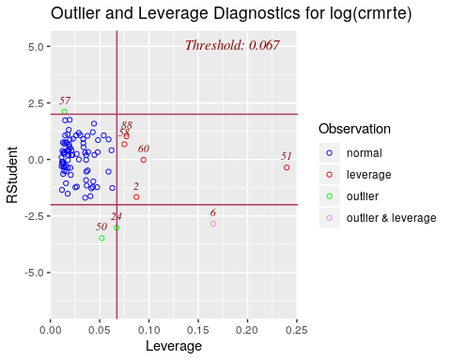

The outlier with leverage was in county #11.

data2 %>% filter(county == 11)

## # A tibble: 1 x 23  
## county crmrte prbarr prbconv prbpris avgsen density taxpc west central  
## <dbl> <dbl> <dbl> <dbl> <dbl> <dbl> <dbl> <dbl> <dbl> <dbl>  
## 1 11 0.0146 0.525 0.0684 0.5 13 0.611 35.2 1 0  
## # … with 13 more variables: urban <dbl>, pctmin80 <dbl>, wcon <dbl>,  
## # wtuc <dbl>, wtrd <dbl>, wfir <dbl>, wser <dbl>, wmfg <dbl>,  
## # wfed <dbl>, wsta <dbl>, wloc <dbl>, mix <dbl>, pctymle <dbl>

Is this outlier influential on our model? We can see that without this observation, we now explain slightly more of log(crmrte) variation (46% compared to 41%). With p-values well under an alpha of .05 for both models, excluding this outlier would not affect our conclusion regarding the relationship between these variables. Either way, we conclude that this relationship is unlikely due to chance alone.

data2_out <- data2 %>% filter(county != 11)  
  
mod1_out <- lm(log(crmrte) ~ log(prbarr) + log(prbconv), data = data2_out)  
se_mod1_out <- sqrt(diag(vcovHC(mod1_out)))  
stargazer(mod1, mod1_out, type = "text" , se = list(se_mod1, se_mod1_out), notes = "Robust SE", column.labels = c("With county #11", "Without county #11") , star.cutoffs = c(0.05, 0.01, 0.001))

##   
## =================================================================  
## Dependent variable:   
## ---------------------------------------------  
## log(crmrte)   
## With county #11 Without county #11   
## (1) (2)   
## -----------------------------------------------------------------  
## log(prbarr) -0.730*** -0.695***   
## (0.115) (0.108)   
##   
## log(prbconv) -0.442** -0.532***   
## (0.140) (0.126)   
##   
## Constant -4.822*** -4.831***   
## (0.176) (0.177)   
##   
## -----------------------------------------------------------------  
## Observations 89 88   
## R2 0.400 0.442   
## Adjusted R2 0.386 0.429   
## Residual Std. Error 0.424 (df = 86) 0.408 (df = 85)   
## F Statistic 28.671*** (df = 2; 86) 33.619*** (df = 2; 85)  
## =================================================================  
## Note: *p<0.05; **p<0.01; ***p<0.001  
## Robust SE

Eliminating the outlier has improved our fit. However, we did not spot any data quality issues in this county during our exploratory data analysis. Furthermore, this leverage issue could also be fixed latter by including covariates. As cannot claim that this record it has a data quality issue, we will continue to monitor it’s leverage as we add more variables to the model.

*Conclusion*

It seems that politicians could leverage criminal justice policies to curb crime rate. In fact, this first model set featuring only criminal justice policies as independent variables suggest that, ceteris paribus, a 10% increase in prbarr would lead to a ~7% decrease in crime rate, while a 10% increase in prbconv would lead to a ~5% decrease in crime rate. These estimated effects are statistically significant and have important practical meaning.

### Model set #2

For our second model, we aimed to evaluate the relationship between crime and economic policies and context. Two important economic variables that politicians control at the state level are minimum wage and fiscal expenditure. As such, only wages of industries whose average wage is close to the minimum wage will be included. Wages of government workers (state and local) will be included as candidates of economic policy variables as well.

We are aware that there are several determinants of wages that go beyond political interference, so wages - even in industries whose average wage is close to the minimum - are only proxies of economic policies. As such, conclusions from these exercises should be taken as hints for future research rather than strong evidence. For example, better research on minimum wage policy, such as [this](https://evans.uw.edu/policy-impact/minimum-wage-study), exists and should also be drawn upon when making decisions on minimum wage policy. We carry out hypothesis testing from these but will interpret the outcomes cautiously.

For reasons discussed at the EDA section of this project, wfed and taxpc will be included as economic context variables as they are a proxy of local wealth and overall economic development. We include wtrd and wser as controls for minimum wage policy (as we noted in our EDA, we expect that these would be closest to the minimum wage and therefore the best measures of it available in the data). We include wloc and wsta as a test of policies related to local and state government employees, with the caveat that implementing this policy in an attempt to reduce crime would be difficult (as mentioned in our EDA).

We used the following independent variables to predict crime:

*Crime policy*

1. log(prbarr)
2. log(prbconv)

*Economic policy*

1. log(wtrd)
2. log(wser)
3. log(wloc)
4. log(wsta)

*Economic context*

1. log(wfed)
2. log(taxpc)

#### Data Transformations

We decided to take the log of our wage variables to show the relationship between relative changes in these to crime (rather than the absolute number). This improves our interpretability since we are making policy recommendations around changing these relative to the existing levels in these counties.

*Economic policy*

We can see that we have a fairly linear relationship between trade industry wages and crime.

ggplot(data = data2, aes(x = log(wtrd), y = log(crmrte))) +  
 geom_point() +  
 theme_minimal() +  
 ggtitle("Relationship between Crime Rate and Wholesale & Retail Trade Wages") +   
 xlab("Average Weekly Wage") + ylab("Log Crime Rate") +  
 geom_smooth(method='lm', formula= y~x)

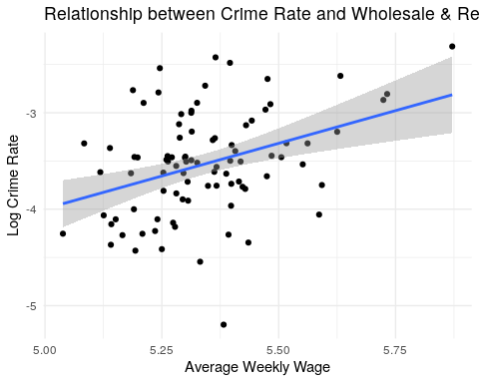

The relationship between the log of Service Wages and Crime Rate seems fairly linear as well, though there are some outliers that seems to have strong leverage on the relationship.

ggplot(data = data2, aes(x = log(wser), log(crmrte))) +  
 geom_point() +  
 theme_minimal() +  
 ggtitle("Relationship between Crime Rate and Log Service Wages") +   
 xlab("Log Average Weekly Wage") + ylab("Log Crime Rate") +  
 geom_smooth(method='lm', formula= y~x)

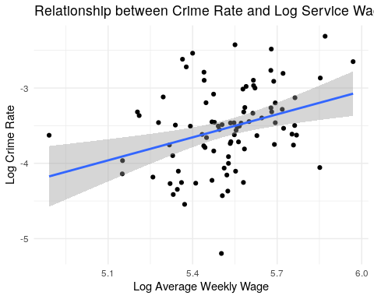

We can see that we have a relatively clear linear relationship between federal wages and crime.

ggplot(data = data2, aes(x = wfed, log(crmrte))) +  
 geom_point() +  
 theme_minimal() +  
 ggtitle("Relationship between Crime Rate and Federal Employee Wages") +   
 xlab("Average Weekly Wage") + ylab("Log Crime Rate") +  
 geom_smooth(method='lm', formula= y~x)

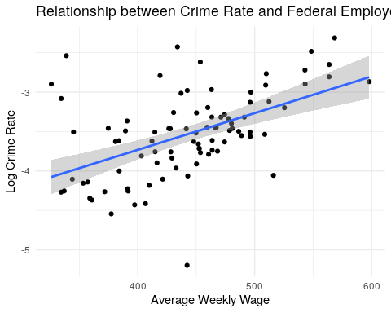

Log transforming wfed does not turn the relationship closer to a linear one. We will model wfed with a log transformation because we are utilizing the variable as a proxy for living expenses. Log transforming would make the interpretation of the variable’s coefficient more intuitive.

ggplot(data = data2, aes(x = log(wfed), log(crmrte))) +  
 geom_point() +  
 theme_minimal() +  
 ggtitle("Relationship between Crime Rate and Federal Employee Wages") +   
 xlab("Log Average Weekly Wage") + ylab("Log Crime Rate") +  
 geom_smooth(method='lm', formula= y~x)

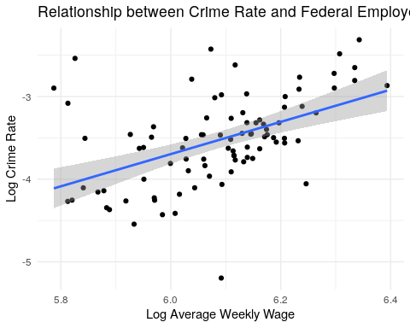

We can see that we do not have a very linear relationship between tax per capita and crime. Many of the points cluster together, leaving little variability with which to predict crime. In order to address this cluster, we also apply a log transformation to the taxpc variable.

ggplot(data = data2, aes(x = taxpc, log(crmrte))) +  
 geom_point() +  
 theme_minimal() +  
 ggtitle("Relationship between Crime Rate and Tax Per Capita") +   
 xlab("Tax Per Capita") + ylab("Log Crime Rate") +  
 geom_smooth(method='lm', formula= y~x)

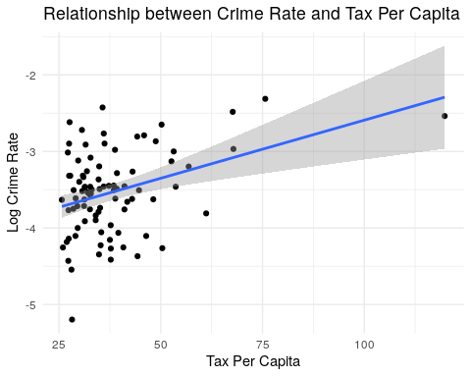

The fit appears slightly improved after logging tax per capita but the data seems to still be clustered. The variable will be log-transformed because we want it to act as a proxy for wealth level in a county and for that purpose the interpretation would be simpler.

ggplot(data = data2, aes(x = log(taxpc), log(crmrte))) +  
 geom_point() +  
 theme_minimal() +  
 ggtitle("Relationship between Crime Rate and Log Tax Per Capita") +   
 xlab("Log Tax Per Capita") + ylab("Log Crime Rate") +  
 geom_smooth(method='lm', formula= y~x)

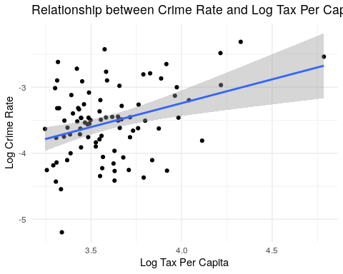

#### Discussion on results

The first iteration of this model includes all crime justice variable as well as all economic policy and wealth variables. In this specification, none of the economic policy variables had statistically significant relationships to crime. The estimated relationship between taxpc and wfed with crmrte was statistically significant and positive. This indicates that crime rate is larger in wealthier counties. At this point, these variables could be capturing part of the crime rate variation that should be captured by demographic variables such as density. We expect the estimated coefficients for these variables to fluctuate as we add more variables.

We also conducted an F-test to determine if the economic policy variables were jointly statistically significant at explaining variation on crime rate. In this test, the null hypothesis was that economic policies, proxied by average wages at lower paying industries and at local administrations, do not have explanatory power over crime rate. The p-value of this test was well over our alpha of .05 and thus we could not reject the hypothesis, which reinforces that the model is not able to capture the impact of economic policy on crime.

The elimination of wage variables from our models is advisable also according to BIC, which is smaller for the most parsimonious model (equation 2). Notice though that we decided to keep one proxy for wage policy, Wholesale & Retail Trade sector wages - as discussed at the EDA section of this project, Wholesale & Retail Trade sector wages are the ones that are closest to the minimum wage and most likely to be affected by a minimum wage policy. Keeping it will give it a chance to be tested with other covariates, such as density and percentage of minority, in the coming model specifications.

It’s interesting to note that when we added economic policy and context to the model, the estimated impact of criminal justice policies gets somewhat smaller. The current set of model specifications suggest that, ceteris paribus, a 10% increase in prbarr would lead to a ~6% decrease in crime rate, while a 10% increase in prbconv would lead to a ~4% decrease in crime rate (vs. an estimated impact of ~7% and ~5% for the first set of models presented in the previous section). Either way, these figures still have important practical meaning, as a 4-6% change in crime rate may have material impact on people’s lives.

mod2_1 <- lm(log(crmrte) ~ log(prbarr) + log(prbconv) + log(wtrd) + log(wser) + log(wloc) + log(wsta) + log(wfed) + log(taxpc), data = data2)  
# fit models  
#mod2_2 <- lm(log(crmrte) ~ log(prbarr) + log(prbconv) + log(wfed) + log(taxpc), data = data2) # no economic policy variables  
#mod2_3 <- lm(log(crmrte) ~ log(prbarr)*log(wfed) + log(prbconv)*log(wfed) + log(wser)*log(wfed) + log(wsta)*log(wfed) + log(taxpc), data = data2) # taxpc interactions  
#mod2_4 <- lm(log(crmrte) ~ log(prbarr)*log(taxpc) + log(prbconv)*log(taxpc) + log(wser)*log(taxpc) + log(wsta)*log(taxpc) + wfed, data = data2) # wfed interactions  
mod2 <- lm(log(crmrte) ~ log(prbarr) + log(prbconv) + log(wtrd) + log(wfed) + log(taxpc), data = data2) # some economic policy variables, no interactions  
  
# generate robust standard errors  
se_mod2_1 <- sqrt(diag(vcovHC(mod2_1)))  
se_mod2 <- sqrt(diag(vcovHC(mod2)))  
  
# produce regression table  
stargazer(  
 mod2_1  
 , mod2  
 , type = "text"  
 , se = list(se_mod2_1, se_mod2)  
 , add.lines=list(c("BIC", round(BIC(mod2_1),1), round(BIC(mod2))))  
 , notes = "Robust SE"  
 , star.cutoffs = c(0.05, 0.01, 0.001)  
 )

##   
## =================================================================  
## Dependent variable:   
## ---------------------------------------------  
## log(crmrte)   
## (1) (2)   
## -----------------------------------------------------------------  
## log(prbarr) -0.615*** -0.567***   
## (0.130) (0.119)   
##   
## log(prbconv) -0.427*** -0.402***   
## (0.123) (0.121)   
##   
## log(wtrd) 0.007 0.074   
## (0.420) (0.417)   
##   
## log(wser) -0.512   
## (0.315)   
##   
## log(wloc) 0.640   
## (0.699)   
##   
## log(wsta) -0.266   
## (0.313)   
##   
## log(wfed) 1.769** 1.559**   
## (0.573) (0.539)   
##   
## log(taxpc) 0.404 0.374   
## (0.207) (0.202)   
##   
## Constant -16.205*** -15.810***   
## (3.414) (2.360)   
##   
## -----------------------------------------------------------------  
## BIC 102.7 93   
## Observations 89 89   
## R2 0.614 0.597   
## Adjusted R2 0.575 0.573   
## Residual Std. Error 0.353 (df = 80) 0.354 (df = 83)   
## F Statistic 15.875*** (df = 8; 80) 24.614*** (df = 5; 83)  
## =================================================================  
## Note: *p<0.05; **p<0.01; ***p<0.001  
## Robust SE

# F-test: joint significance of economic policy variables  
print("F-test results for joint significance of economic policies")

## [1] "F-test results for joint significance of economic policies"

linearHypothesis(mod2_1, c("log(wser)=0", "log(wsta)=0", "log(wtrd)=0", "log(wloc)=0"), vcov=vcovHC)

## Linear hypothesis test  
##   
## Hypothesis:  
## log(wser) = 0  
## log(wsta) = 0  
## log(wtrd) = 0  
## log(wloc) = 0  
##   
## Model 1: restricted model  
## Model 2: log(crmrte) ~ log(prbarr) + log(prbconv) + log(wtrd) + log(wser) +   
## log(wloc) + log(wsta) + log(wfed) + log(taxpc)  
##   
## Note: Coefficient covariance matrix supplied.  
##   
## Res.Df Df F Pr(>F)  
## 1 84   
## 2 80 4 0.7892 0.5356

#### Outliers

Once again, county #11 (observation #6) appears to be an outlier with leverage (it is an extreme value). Note that it’s influence has decreased as we increased the number of variables. We expect the influence of the outlier to decrease as we add more variables that explain the residuals’ variation.

ols_plot_resid_lev(mod2)

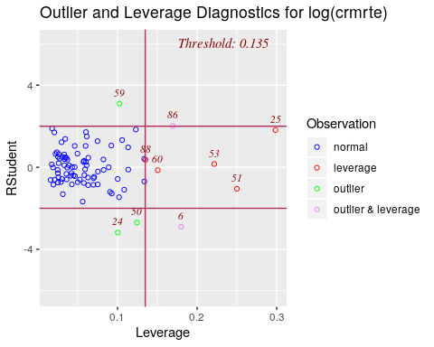

We can see that without this observation, we now explain slightly more of the variation (~57% compared to ~53%).

data2_out <- data2 %>% filter(county != 11)  
  
mod2_out <- lm(log(crmrte) ~ log(prbarr) + log(prbconv) + log(wtrd) + log(wfed) + log(taxpc), data = data2_out)  
se_mod2_out <- sqrt(diag(vcovHC(mod2_out)))  
stargazer(mod2, mod2_out, type = "text", se = list(se_mod2, se_mod2_out) , column.labels = c("With county #11", "Without county #11") , star.cutoffs = c(0.05, 0.01, 0.001))

##   
## =================================================================  
## Dependent variable:   
## ---------------------------------------------  
## log(crmrte)   
## With county #11 Without county #11   
## (1) (2)   
## -----------------------------------------------------------------  
## log(prbarr) -0.567*** -0.542***   
## (0.119) (0.112)   
##   
## log(prbconv) -0.402*** -0.486***   
## (0.121) (0.104)   
##   
## log(wtrd) 0.074 -0.001   
## (0.417) (0.412)   
##   
## log(wfed) 1.559** 1.579**   
## (0.539) (0.534)   
##   
## log(taxpc) 0.374 0.339   
## (0.202) (0.190)   
##   
## Constant -15.810*** -15.424***   
## (2.360) (2.383)   
##   
## -----------------------------------------------------------------  
## Observations 89 88   
## R2 0.597 0.628   
## Adjusted R2 0.573 0.605   
## Residual Std. Error 0.354 (df = 83) 0.339 (df = 82)   
## F Statistic 24.614*** (df = 5; 83) 27.642*** (df = 5; 82)  
## =================================================================  
## Note: *p<0.05; **p<0.01; ***p<0.001

Although eliminating the outlier has improved our fit and this outlier has some influence, we do not have any reason to suspect that it is due to data quality issues. Additionally, we see the same outcome as before when it comes to the inferences we draw with or without this outlier: since our p-value is well under .05 for the model with and without this outlier, our conclusions remain the same.

*Conclusion*

We fail to reject hypothesis that economic policy variables have no impact on crime rate. It seems that politicians might not be able to use economic policy variables to impact crime rate, at least as captured by the available dataset.

The previous section’s finding that that politicians could leverage criminal justice policies to curb crime rate was robust to the inclusion of economic variables to the model. In fact, this second model set featuring criminal justice and economic policies as well as economic context as independent variables suggests that, ceteris paribus, a 10% increase in prbarr would lead to a ~6% decrease in crime rate, while a 10% increase in prbconv would lead to a ~4% decrease in crime rate. These estimated effects are statistically significant and have important practical meaning.

### Model set #3

For our third model, we added demographic control variables to evaluate the robustness of the relationship between crime policy, economic policy, and crime rate when controlling for key demographic factors. We retained the one wage variable we thought was the best proxy for minimum wage (wtrd) so that we can confirm that the lack of relationship was not due to omitted variables biasing our estimates (at least when it comes to those available in the data).

We used the following independent variables to predict crime:

*Crime policy*

1. log(prbarr)
2. log(prbconv)

*Economic policy*

1. log(wtrd)

*Economic context*

1. log(wfed)
2. log(taxpc)

*Demographic*

1. density - higher density means more opportunity for crime to be committed and reported; denser areas also tend to have more economic activity and so this variable could be related to wages
2. pctymle - young males are more likely to commit crimes and thus areas with higher portions of this type of person may see more crime regardless of their policies
3. pctmin80 - minorities are likelier to be arrested and convicted (and from a lot of research we know that this is not always related to their likelihood to commit a crime)

#### Data Transformations

Many of the contextual variables (density, mix, pctymle) showed a pattern in which most counties are clustered closely together. This similar pattern may be due to the fact that North Carolina is a small state that may have limited variation across counties on some elements (like density, crime patterns in terms of their type, and percent young male). Logarithmic transformation is a convenient means of transforming a highly skewed variable into a more normalized dataset. When modeling variables with non-linear relationships, errors may also be skewed negatively. Still, plotting the log of demographic versus the log of crime rate didn’t seem to improve our fitting and we decided not to log-transform these variables.

##### Density

Taking the log of density does not improve its fit to crime rate.

ggplot(data = data2, aes(x = density, log(crmrte))) +  
 geom_point() +  
 theme_minimal() +  
 ggtitle("Relationship between log(Crime Rate) and Density") +   
 ylab("Log Crime Rate") + xlab("People per Sq. Mile") +  
 geom_smooth(method='lm', formula= y~x)

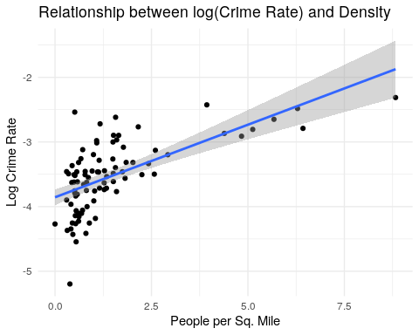

ggplot(data = data2, aes(x = log(density), log(crmrte))) +  
 geom_point() +  
 theme_minimal() +  
 ggtitle("Relationship between log(Crime Rate) and Log (Density)") +   
 ylab("Log Crime Rate") + xlab("Log People per Sq. Mile") +  
 geom_smooth(method='lm', formula= y~x)

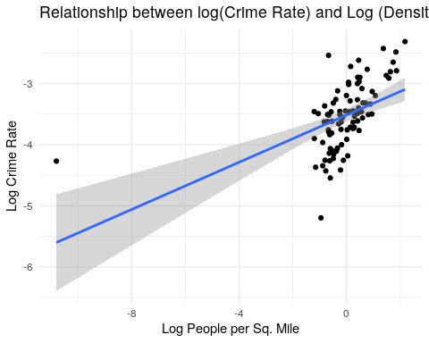

##### Percent Young Male in 1980

Percent Young Male does not seem to have a linear relationship with crime rate. Log-transforming Percent Young Male did not seem to solve the issue.

ggplot(data = data2, aes(x = pctymle, log(crmrte))) +  
 geom_point() +  
 theme_minimal() +  
 ggtitle("Relationship between log(Crime Rate) and Percent Young Male") +   
 ylab("Log Crime Rate") + xlab("% Young Male") +  
 geom_smooth(method='lm', formula= y~x)

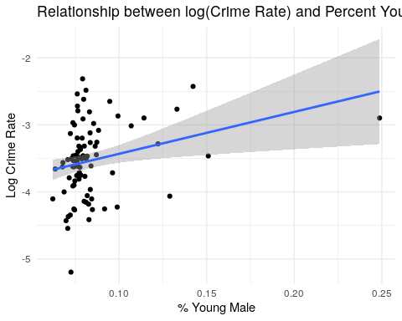

ggplot(data = data2, aes(x = log(pctymle), log(crmrte))) +  
 geom_point() +  
 theme_minimal() +  
 ggtitle("Relationship between log(Crime Rate) and Log Percent Young Male") +   
 ylab("Log Crime Rate") + xlab("Log % Young Male") +  
 geom_smooth(method='lm', formula= y~x)

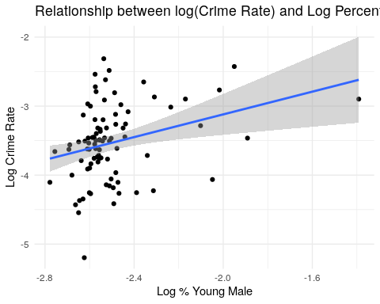

##### Percent Minority

The percent minority in 1980 does not have a strong relationship with crime rate. Counties appear to have a wide range of this variable and there is only a slight positive correlation with crime rate. We noticed a slight concave form on the scatterplot so we tried a quadratic transformation.

ggplot(data = data2, aes(x = pctmin80, log(crmrte))) +  
 geom_point() +  
 theme_minimal() +  
 ggtitle("Relationship between log(Crime Rate) and Percent Minority") +   
 ylab("Log Crime Rate") + xlab("% Minority") +  
 geom_smooth(method='lm', formula= y~x)

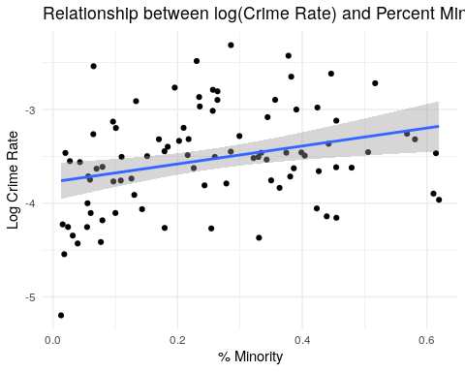

ggplot(data = data2, aes(x = pctmin80*pctmin80, log(crmrte))) +  
 geom_point() +  
 theme_minimal() +  
 ggtitle("Relationship between log(Crime Rate) and Percent Minority^2") +   
 ylab("Log Crime Rate") + xlab("Minority^2") +  
 geom_smooth(method='lm', formula= y ~x + I(x^2))

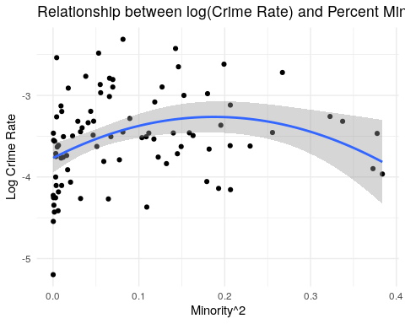

#### Discussion of results

The first iteration (equation 1) of this set of models includes all the variables listed above. The model fit increased dramatically in comparison to model #2. Among all demographic variables included, only pctymle is not individually significant. An F-test was conducted with results leading us to reject the null that the demographic variables are not jointly significant.

In the following iteration (equation 2), we added a quadratic transformation of percent minority, in an attempt to capture the seemingly concave relationship of this variable with log(crmrte) discussed above. Such addition though doesn’t seem to be interesting, as the coefficient on the quadratic transformation of percent minority is not statistically significant and the model’s BIC is slightly larger in equation 1.

In equation 3, we dropped pctymle. Again, such specification doesn’t seem to be interesting, as the model’s BIC is slightly larger than in equation 1. This variable was also not a point of focus as far as contextual variables, although it was not eliminated.

Given the above, our preferred equation in the model set #3 is equation 1.

As in model set #2 discussed in the above section, our economic policy proxy do not seem to be statistically significant in explaining the variation in crime rate. This lack of relationship has not changed with the addition of control variables. We would need to do more external research on the economic policies ran in North Carolina during the time the data collection occurred to determine why these proxies are not significant. As we noted above, there are also issues of omitted variable bias that could be masking this relationship.

Including factors related to the demographics of an area (density; percent young males; and percent minorities) increases our ability to predict crime (lower BIC and larger adjusted R2 vs. model set #2, with only criminal and economic variables). Thus, demographic factors should be part of of our model. Higher rates of any of these are related to higher levels of crime.

Finally, it’s interesting to note that, when we added demographics to the model, the estimated impact of probability of arrest on crime reduces further versus model #2. The current set of model specifications suggest that, ceteris paribus, a 10% increase in prbarr would lead to a ~5% decrease in crime rate, while a 10% increase in prbconv would lead to a ~4% decrease in crime rate (vs. an estimated impact of ~6% and ~4% for the first set of models #2 presented in the previous section). Either way, this figures still have important practical meaning, as a 4-5% change in crime rate may have material impact on people’s lives.

data2$pctmin802 = data2$pctmin80*data2$pctmin80  
  
# fit models  
mod3_1 <- lm(log(crmrte) ~ log(prbarr) + log(prbconv) + log(wtrd) + log(wfed) + log(taxpc) + density + pctmin80 + pctymle, data = data2) # all vars  
mod3_2 <- lm(log(crmrte) ~ log(prbarr) + log(prbconv) + log(wtrd) + log(wfed) + log(taxpc) + density + pctmin80 + pctmin802 + pctymle, data = data2) # pctmin80 quadratic transform  
mod3_3 <- lm(log(crmrte) ~ log(prbarr) + log(prbconv) + log(wtrd) + log(wfed) + log(taxpc) + density + pctmin80 , data = data2) # no pctymle  
#mod3_4 <- lm(log(crmrte) ~ log(prbarr) + log(prbconv) + log(wfed) + log(taxpc) + density + pctmin80 + pctymle, data = data2) # no wages  
  
# generate robust standard errors  
se_mod3_1 <- sqrt(diag(vcovHC(mod3_1)))  
se_mod3_2 <- sqrt(diag(vcovHC(mod3_2)))  
se_mod3_3 <- sqrt(diag(vcovHC(mod3_3)))  
#se_mod3_4 <- sqrt(diag(vcovHC(mod3_4)))  
  
# produce regression table  
stargazer(  
 mod3_1  
 , mod3_2  
 , mod3_3  
 #, mod3_4  
 , type = "text"  
 , se = list(se_mod3_1, se_mod3_2, se_mod3_3)  
 , star.cutoffs = c(0.05, 0.01, 0.001)  
 , notes = c("Robust SE")  
 , add.lines=list(c("BIC", round(BIC(mod3_1),1), round(BIC(mod3_2),1) , round(BIC(mod3_3),1)   
 #, round(BIC(mod3_4),1)  
 )  
 )  
 )

##   
## ========================================================================================  
## Dependent variable:   
## --------------------------------------------------------------------  
## log(crmrte)   
## (1) (2) (3)   
## ----------------------------------------------------------------------------------------  
## log(prbarr) -0.504*** -0.478*** -0.559***   
## (0.110) (0.126) (0.089)   
##   
## log(prbconv) -0.329** -0.326** -0.363***   
## (0.100) (0.101) (0.094)   
##   
## log(wtrd) 0.075 0.032 -0.008   
## (0.373) (0.376) (0.341)   
##   
## log(wfed) 1.072* 1.096* 1.002*   
## (0.427) (0.431) (0.444)   
##   
## log(taxpc) 0.289 0.269 0.230   
## (0.317) (0.362) (0.322)   
##   
## density 0.079 0.077 0.089*   
## (0.043) (0.043) (0.045)   
##   
## pctmin80 1.127*** 1.841 1.153***   
## (0.214) (0.978) (0.210)   
##   
## pctmin802 -1.295   
## (1.551)   
##   
## pctymle 3.087 3.008   
## (3.491) (3.279)   
##   
## Constant -13.064*** -12.921*** -11.835***   
## (2.256) (2.283) (2.650)   
##   
## ----------------------------------------------------------------------------------------  
## BIC 62.6 65.7 63.1   
## Observations 89 89 89   
## R2 0.754 0.758 0.740   
## Adjusted R2 0.729 0.730 0.717   
## Residual Std. Error 0.282 (df = 80) 0.282 (df = 79) 0.288 (df = 81)   
## F Statistic 30.642*** (df = 8; 80) 27.426*** (df = 9; 79) 32.863*** (df = 7; 81)  
## ========================================================================================  
## Note: *p<0.05; **p<0.01; ***p<0.001  
## Robust SE

mod3 <- mod3_1  
se_mod3 <- se_mod3_1

# F-test: joint significance of demographic variables  
print("F-test results for joint significance of demographic variables")

## [1] "F-test results for joint significance of demographic variables"

linearHypothesis(mod3_1, c("density=0", "pctmin80=0", "pctymle=0"), vcov=vcovHC)

## Linear hypothesis test  
##   
## Hypothesis:  
## density = 0  
## pctmin80 = 0  
## pctymle = 0  
##   
## Model 1: restricted model  
## Model 2: log(crmrte) ~ log(prbarr) + log(prbconv) + log(wtrd) + log(wfed) +   
## log(taxpc) + density + pctmin80 + pctymle  
##   
## Note: Coefficient covariance matrix supplied.  
##   
## Res.Df Df F Pr(>F)   
## 1 83   
## 2 80 3 9.6385 1.673e-05 ***  
## ---  
## Signif. codes: 0 '***' 0.001 '**' 0.01 '*' 0.05 '.' 0.1 ' ' 1

#### Outliers

One can see that there are two potential outliers that also have leverage on our model (observations #25). We also have one borderline case. Note that observation #6’s leverage has dropped.

ols_plot_resid_lev(mod3)

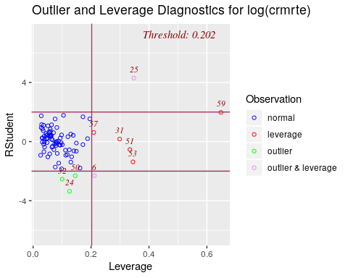

Once again, County #55 appears to be an outlier with leverage. It seemed as though County #55 can be legit extreme case whose pattern might be reasonable (since it could be an odd island off the coast of North Carolina).

data2 %>% filter(county == 55)

## # A tibble: 1 x 24  
## county crmrte prbarr prbconv prbpris avgsen density taxpc west central  
## <dbl> <dbl> <dbl> <dbl> <dbl> <dbl> <dbl> <dbl> <dbl> <dbl>  
## 1 55 0.0790 0.225 0.208 0.304 13.6 0.512 120. 0 0  
## # … with 14 more variables: urban <dbl>, pctmin80 <dbl>, wcon <dbl>,  
## # wtuc <dbl>, wtrd <dbl>, wfir <dbl>, wser <dbl>, wmfg <dbl>,  
## # wfed <dbl>, wsta <dbl>, wloc <dbl>, mix <dbl>, pctymle <dbl>,  
## # pctmin802 <dbl>

Do these influence our model fits? We can see that without these observations, we now explain a some more of the variation (~78% compared to ~73%). Although eliminating the outlier has improved our fit we do not have any reason to suspect that they have data quality issues. However, once again dropping these variables would not change the statistical inference we made from these models as our p-values were well under our alpha of .05 with and without these outliers.

data2_out <- data2 %>% filter(county != 55)  
  
mod3_out <- lm(log(crmrte) ~ log(prbarr) + log(prbconv) + log(wtrd) + log(wfed) + log(taxpc) + density + pctmin80 + pctymle, data = data2_out)   
  
se_mod3_out <- sqrt(diag(vcovHC(mod3_out)))  
  
stargazer(  
 mod3  
 , mod3_out  
 , type = "text"  
 , se = list(se_mod3, se_mod3_out)  
 , star.cutoffs = c(0.05, 0.01, 0.001)  
 , column.labels = c("With county #55", "Without county #55")   
 , notes = c("Robust SE")  
)

##   
## =================================================================  
## Dependent variable:   
## ---------------------------------------------  
## log(crmrte)   
## With county #55 Without county #55   
## (1) (2)   
## -----------------------------------------------------------------  
## log(prbarr) -0.504*** -0.459***   
## (0.110) (0.107)   
##   
## log(prbconv) -0.329** -0.300***   
## (0.100) (0.089)   
##   
## log(wtrd) 0.075 0.021   
## (0.373) (0.344)   
##   
## log(wfed) 1.072* 1.217**   
## (0.427) (0.393)   
##   
## log(taxpc) 0.289 -0.005   
## (0.317) (0.179)   
##   
## density 0.079 0.106**   
## (0.043) (0.034)   
##   
## pctmin80 1.127*** 1.231***   
## (0.214) (0.192)   
##   
## pctymle 3.087 3.146   
## (3.491) (3.152)   
##   
## Constant -13.064*** -12.601***   
## (2.256) (2.243)   
##   
## -----------------------------------------------------------------  
## Observations 89 88   
## R2 0.754 0.793   
## Adjusted R2 0.729 0.772   
## Residual Std. Error 0.282 (df = 80) 0.255 (df = 79)   
## F Statistic 30.642*** (df = 8; 80) 37.737*** (df = 8; 79)  
## =================================================================  
## Note: *p<0.05; **p<0.01; ***p<0.001  
## Robust SE

*Conclusion*

The most important takeaways from model set #3 are (1) the estimated effect of criminal justice policies on crime rate is robust to the inclusion of demographic controls, and (2) even controlling for demographics, the coefficient on our proxy for economic policy (log(wtrd)) remains statistically not significant. Also importantly, we rejected the null hypothesis that demographic covariates are not related to crime rate.

To summarize, this third model set featuring criminal justice, economic policies, economic context as well demographic variables as independent variables suggests that, ceteris paribus, a 10% increase in prbarr would lead to a ~5% decrease in crime rate, while a 10% increase in prbconv would lead to a ~4% decrease in crime rate. These estimated effects are statistically significant and have important practical meaning.

### Model set #4

For our fourth model, we aimed to evaluate the robustness of the relationship between crime policy and crime when controlling for economic, demographic, and geographic context variables. In addition, we will also re-test the impact of economic policy on crime rate. We will also test the hypothesis that geographical characteristics of a county is not related to crime rate.

We used the following independent variables to predict crime:

*Crime policy*

1. log(prbarr)
2. log(prbconv)

*Economic policy*

1. log(wtrd)

*Economic context*

1. log(wfed)
2. log(taxpc)

*Demographic*

1. density
2. pctymle
3. pctmin80

*Geographic*

1. west - Western North Carolina is potentially very different from other regions in North Carolina, as we noted at the beginning of this report. A different culture could relate to different crime patterns and relationships between crime and other factors.

Although west is our main variable of interest and we expect it to drive most of the effect in terms of geography, we will also use the following variables to check that our hunch is correct:

1. central - Central versus eastern North Carolina could be different, and each could vary more widely from Western North Carolina
2. urban - This variable probably has overlap with density and since most urban areas are in central and eastern North Carolina, it is probably not neeeded. However, it is a good confirmation of our prediction to include it in one model.

#### Discussion on results

The crime rate for central and not central counties is fairly similar. Thus, we don’t expect this covariate to be significant. The crime rate has more variance when the counties are grouped by west and non-west. So, we expect the coefficient on west to have higher chances of being statistically significant. The greatest variance on crime rate is observed when the data is grouped by urban and non-urban. However, urban and density are highly correlated as seen early, so adding urban to the model may not improve fits.

Central and eastern counties show similar patterns - they have more urban than rural counties, and rural counties have lower crime. However, as we suspected western counties show a different pattern: they have more rural than urban counties, and those rural counties have a higher crime rate.

# plot barplots  
ggplot(geo_long, aes(x = location, y = crmrte, fill = type)) +  
 geom_bar(position="dodge", stat="identity") +  
 theme_minimal() +  
 ggtitle("Barplot of Contextual Variables: Geography") +  
 xlab("")

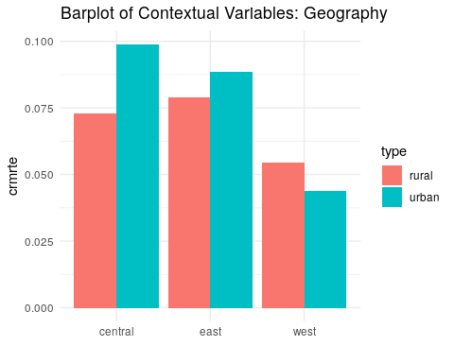

*Statistics Interpretation*

mod4_1 <- lm(log(crmrte) ~ log(prbarr) + log(prbconv) + log(wtrd) + log(wfed) + log(taxpc) + density + pctmin80 + pctymle + west + central + urban, data = data2)  
mod4_2 <- lm(log(crmrte) ~ log(prbarr)*west + log(prbconv)*west + log(prbarr)*central + log(prbconv)*central + log(wtrd) + log(wfed) + log(taxpc) + density + pctmin80 + pctymle, data = data2) # west and central interaction  
mod4_3 <- lm(log(crmrte) ~ log(prbarr)*urban + log(prbconv)*urban + log(`wtrd`) + log(wfed) + log(taxpc) + density + pctmin80 + pctymle, data = data2) # urban interactions  
mod4_4 <- lm(log(crmrte) ~ log(prbarr) + log(prbconv) + log(`wtrd`) + log(wfed) + log(taxpc) + density + pctmin80 + pctymle + west , data = data2) # west only, no interactions  
mod4_5 <- lm(log(crmrte) ~ log(prbarr)*west + log(prbconv)*west + log(`wtrd`) + log(wfed) + log(taxpc) + density + pctmin80 + pctymle, data = data2) # west only, interactions  
  
# generate robust standard errors  
se_mod4_1 <- sqrt(diag(vcovHC(mod4_1)))  
se_mod4_2 <- sqrt(diag(vcovHC(mod4_2)))  
se_mod4_3 <- sqrt(diag(vcovHC(mod4_3)))  
se_mod4_4 <- sqrt(diag(vcovHC(mod4_4)))  
se_mod4_5 <- sqrt(diag(vcovHC(mod4_5)))  
  
# produce regression table  
stargazer(  
 mod4_1  
 , mod4_2  
 , mod4_3  
 , mod4_4  
 , mod4_5  
 , type = "text"  
 , se = list(se_mod4_1, se_mod4_2, se_mod4_3, se_mod4_4, se_mod4_5)  
 , star.cutoffs = c(0.05, 0.01, 0.001)  
 , notes= c("Robust SE")  
 , add.lines=list(c("BIC", round(BIC(mod4_1),1), round(BIC(mod4_2),1) , round(BIC(mod4_3),1) , round(BIC(mod4_4),1) , round(BIC(mod4_5),1)  
 )  
))

##   
## ===========================================================================================================================================  
## Dependent variable:   
## ----------------------------------------------------------------------------------------------------------------------  
## log(crmrte)   
## (1) (2) (3) (4) (5)   
## -------------------------------------------------------------------------------------------------------------------------------------------  
## log(prbarr) -0.473*** -0.661*** -0.510*** -0.482*** -0.508***   
## (0.109) (0.127) (0.103) (0.111) (0.147)   
##   
## log(prbconv) -0.333** -0.354* -0.321** -0.327** -0.408**   
## (0.104) (0.180) (0.099) (0.100) (0.149)   
##   
## log(wtrd) 0.020 -0.043 0.038 0.009 0.008   
## (0.368) (0.381) (0.368) (0.366) (0.362)   
##   
## log(wfed) 1.083** 1.165** 1.013* 1.071* 1.067*   
## (0.407) (0.405) (0.450) (0.421) (0.421)   
##   
## log(taxpc) 0.260 0.183 0.333 0.260 0.260   
## (0.291) (0.334) (0.328) (0.302) (0.298)   
##   
## density 0.136* 0.084 0.135* 0.081* 0.077   
## (0.060) (0.045) (0.066) (0.041) (0.046)   
##   
## pctmin80 0.837* 0.862 1.194*** 0.931** 0.951***   
## (0.398) (0.442) (0.220) (0.306) (0.289)   
##   
## pctymle 2.667 2.738 3.214 2.988 2.790   
## (2.956) (3.152) (3.222) (3.263) (3.230)   
##   
## log(prbarr):west 0.167 0.006   
## (0.219) (0.217)   
##   
## west:log(prbconv) 0.117 0.177   
## (0.238) (0.217)   
##   
## log(prbarr):central 0.317   
## (0.234)   
##   
## log(prbconv):central -0.182   
## (0.214)   
##   
## west -0.175 0.129 -0.113 0.035   
## (0.157) (0.359) (0.107) (0.342)   
##   
## central -0.112 0.196   
## (0.106) (0.443)   
##   
## log(prbarr):urban 0.418   
## (1.055)   
##   
## urban:log(prbconv) -0.105   
## (0.987)   
##   
## urban -0.290 0.231   
## (0.232) (2.432)   
##   
## Constant -12.554*** -12.677*** -12.748*** -12.486*** -12.539***   
## (2.261) (2.320) (2.515) (2.335) (2.350)   
##   
## -------------------------------------------------------------------------------------------------------------------------------------------  
## BIC 70.6 77.9 71.7 65.6 71.9   
## Observations 89 89 89 89 89   
## R2 0.769 0.784 0.765 0.758 0.765   
## Adjusted R2 0.735 0.743 0.732 0.730 0.732   
## Residual Std. Error 0.279 (df = 77) 0.275 (df = 74) 0.280 (df = 77) 0.281 (df = 79) 0.281 (df = 77)   
## F Statistic 23.239*** (df = 11; 77) 19.185*** (df = 14; 74) 22.848*** (df = 11; 77) 27.487*** (df = 9; 79) 22.803*** (df = 11; 77)  
## ===========================================================================================================================================  
## Note: *p<0.05; **p<0.01; ***p<0.001  
## Robust SE

mod4 <- mod4_4  
se_mod4 <- se_mod4_4

We can see that the addition of geographic variables did not reduce BIC nor improve our model fit. Further, we can conclude from the F-test that geographical variables are not jointly significant.

Across equations of this model set, our preferred one is equation 4, which features only west as geographic variables. In fact, equation 4 has the lowest BIC, and our external research suggests that this area of the state is in fact different from the others (it has less cities and universities, for example).

It’s interesting to note that, when we added geographic variables to the model, the point estimates of the impact of probability of arrest and probability of conviction on crime remains virtually unchanged versus model #3. In the current set of model specifications with geographic variables, our preferred equation (number 4) suggests that, ceteris paribus, a 10% increase in prbarr would lead to a ~5% decrease in crime rate, while a 10% increase in prbconv would lead to a ~4% decrease in crime rate - these figures are the same of model set #3 and in fact not much different from model sets #1 (only criminal justice system variables) and #2 (criminal justice system + economic variables). Again, it’s fair to argue that this figures have important practical meaning, as a 4-5% change in crime rate may have material impact on people’s lives.

# F-test: joint significance of geographic characteristics  
print("F-test results for joint significance of geographic characteristics")

## [1] "F-test results for joint significance of geographic characteristics"

linearHypothesis(mod4_1, c("west=0", "central=0", "urban=0"), vcov=vcovHC)

## Linear hypothesis test  
##   
## Hypothesis:  
## west = 0  
## central = 0  
## urban = 0  
##   
## Model 1: restricted model  
## Model 2: log(crmrte) ~ log(prbarr) + log(prbconv) + log(wtrd) + log(wfed) +   
## log(taxpc) + density + pctmin80 + pctymle + west + central +   
## urban  
##   
## Note: Coefficient covariance matrix supplied.  
##   
## Res.Df Df F Pr(>F)  
## 1 80   
## 2 77 3 0.8147 0.4896

*Conclusion*

The most important takeaways from model set #4 are (1) the estimated effect of criminal justice policies on crime rate is robust to the inclusion of geographic controls, and (2) even controlling for demographics, the coefficient on our proxy for economic policy (log(wtrd)) remains statistically not significant. Also importantly, we fail to rejected the null hypothesis that geographic covariates are not related to crime rate.

To summarize, this fourth model set featuring criminal justice, economic policies, economic context, demographic as well geographic variables as independent variables suggests that, ceteris paribus, a 10% increase in prbarr would lead to a ~5% decrease in crime rate, while a 10% increase in prbconv would lead to a ~4% decrease in crime rate. These estimated effects are statistically significant and have important practical meaning.

#### Outliers

One can see that there is one potential outlier that also has leverage.

ols_plot_resid_lev(mod4)

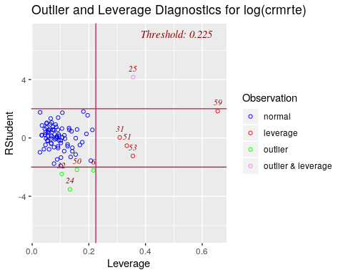

Once again, county #55 appears to be an outlier with leverage.

data2 %>% filter(county == 55)

## # A tibble: 1 x 24  
## county crmrte prbarr prbconv prbpris avgsen density taxpc west central  
## <dbl> <dbl> <dbl> <dbl> <dbl> <dbl> <dbl> <dbl> <dbl> <dbl>  
## 1 55 0.0790 0.225 0.208 0.304 13.6 0.512 120. 0 0  
## # … with 14 more variables: urban <dbl>, pctmin80 <dbl>, wcon <dbl>,  
## # wtuc <dbl>, wtrd <dbl>, wfir <dbl>, wser <dbl>, wmfg <dbl>,  
## # wfed <dbl>, wsta <dbl>, wloc <dbl>, mix <dbl>, pctymle <dbl>,  
## # pctmin802 <dbl>

We can see that without this observation, we now explain slightly more of the variation (~76% compared to ~71%). Although eliminating the outlier has improved our fit, and although this outlier has leverage, we do not have any reason to suspect that our data has quality issues. However, it does not change the statistical significance of any of the observed relationships with alpha of .05 so it would not change our conclusions regarding these inferences.

data2_out <- data2 %>% filter(county != 55)  
  
mod4_out <- lm(log(crmrte) ~ log(prbarr) + log(prbconv) + log(`wtrd`) + log(wfed) + log(taxpc) + density + west + pctmin80 + pctymle, data = data2_out)  
se_mod4_out <- sqrt(diag(vcovHC(mod4_out)))  
  
stargazer(  
 mod4  
 , mod4_out  
 , type = "text"  
 , se = list(se_mod4, se_mod4_out)  
 , star.cutoffs = c(0.05, 0.01, 0.001)  
 , column.labels = c("With county #55", "Without county #55")   
 , notes = (c("Robust SE"))  
)

##   
## =================================================================  
## Dependent variable:   
## ---------------------------------------------  
## log(crmrte)   
## With county #55 Without county #55   
## (1) (2)   
## -----------------------------------------------------------------  
## log(prbarr) -0.482*** -0.446***   
## (0.111) (0.111)   
##   
## log(prbconv) -0.327** -0.299***   
## (0.100) (0.089)   
##   
## log(wtrd) 0.009 -0.019   
## (0.366) (0.342)   
##   
## log(wfed) 1.071* 1.213**   
## (0.421) (0.394)   
##   
## log(taxpc) 0.260 -0.016   
## (0.302) (0.180)   
##   
## density 0.081* 0.107**   
## (0.041) (0.033)   
##   
## pctmin80 0.931** 1.110***   
## (0.306) (0.257)   
##   
## pctymle 2.988 3.085   
## (3.263) (3.033)   
##   
## west -0.113 -0.068   
## (0.107) (0.093)   
##   
## Constant -12.486*** -12.259***   
## (2.335) (2.376)   
##   
## -----------------------------------------------------------------  
## Observations 89 88   
## R2 0.758 0.794   
## Adjusted R2 0.730 0.770   
## Residual Std. Error 0.281 (df = 79) 0.256 (df = 78)   
## F Statistic 27.487*** (df = 9; 79) 33.426*** (df = 9; 78)  
## =================================================================  
## Note: *p<0.05; **p<0.01; ***p<0.001  
## Robust SE

## Regression Table

Across all equations estimated, our preferred one is equation 3 in the table below. It’s from model set #3, which counts on criminal justice, economic policies, economic context and demographic variables (but not geographic variables) to predict crime rate. In fact, equation 3 has the lowest BIC, which justifies our choice.

An important message of this whole exercise of crime rate modeling is that the estimated impact of an increase in the probability of arrest and probability of conviction on crime remains virtually unchanged versus across model specifications. For a 10% rise in each probability individually, the negative impact on crime rate hovers between 5-7% for the probability arrest and between 4-5% for the probability of conviction.

Overall, we could not find a significant impact of economic policies (proxied by wages in lower-paying industries) on crime. The main contextual variables around the economy - wfed and taxpc show different patterns. The latter is not statistically significant across any of the models below. The former is, but its effects are partially absorbed when we add in covariates. This is aligned with our hunch that the relationship between this variable and crime rate would be greatly influenced by other factors and thus we shy away from any causal interpretation here.

We also found that, across demographic determinants, the percentage of minority seems to be the most relevant one in explaining cross-county variation of crime rate, with a positive impact on crime. Finally, it seems that geographic determinants explain only a little of cross-county variation of crime rate in North Carolina, which can be explained by the fact that it’s a small state after all.

stargazer(  
 mod1  
 , mod2  
 , mod3  
 , mod4  
 , type = "text"  
 , se = list(se_mod4, se_mod4, se_mod4, se_mod4)  
 , star.cutoffs = c(0.05, 0.01, 0.001)  
 , notes = c("Robust SE")  
 , add.lines=list(c("BIC", round(BIC(mod1),1), round(BIC(mod2),1) , round(BIC(mod3),1) , round(BIC(mod4),1)  
 )))

##   
## ===============================================================================================================  
## Dependent variable:   
## -------------------------------------------------------------------------------------------  
## log(crmrte)   
## (1) (2) (3) (4)   
## ---------------------------------------------------------------------------------------------------------------  
## log(prbarr) -0.730*** -0.567*** -0.504*** -0.482***   
## (0.111) (0.111) (0.111) (0.111)   
##   
## log(prbconv) -0.442*** -0.402*** -0.329** -0.327**   
## (0.100) (0.100) (0.100) (0.100)   
##   
## log(wtrd) 0.074 0.075 0.009   
## (0.366) (0.366) (0.366)   
##   
## log(wfed) 1.559*** 1.072* 1.071*   
## (0.421) (0.421) (0.421)   
##   
## log(taxpc) 0.374 0.289 0.260   
## (0.302) (0.302) (0.302)   
##   
## density 0.079 0.081*   
## (0.041) (0.041)   
##   
## pctmin80 1.127*** 0.931**   
## (0.306) (0.306)   
##   
## pctymle 3.087 2.988   
## (3.263) (3.263)   
##   
## west -0.113   
## (0.107)   
##   
## Constant -4.822* -15.810*** -13.064*** -12.486***   
## (2.335) (2.335) (2.335) (2.335)   
##   
## ---------------------------------------------------------------------------------------------------------------  
## BIC 114.9 92.9 62.6 65.6   
## Observations 89 89 89 89   
## R2 0.400 0.597 0.754 0.758   
## Adjusted R2 0.386 0.573 0.729 0.730   
## Residual Std. Error 0.424 (df = 86) 0.354 (df = 83) 0.282 (df = 80) 0.281 (df = 79)   
## F Statistic 28.671*** (df = 2; 86) 24.614*** (df = 5; 83) 30.642*** (df = 8; 80) 27.487*** (df = 9; 79)  
## ===============================================================================================================  
## Note: *p<0.05; **p<0.01; ***p<0.001  
## Robust SE

## Checking the 6 Classical Linear Model assumptions for our preferred model (Model #3)

### Linear population model

This assumption is automatically fulfilled because we haven’t constrained the error term, i.e we haven’t required it to be normal. So there’s nothing to check at this point.

## Random Sampling

North Carolina has 100 counties and the supplied dataset has only 91 of them. To check random sampling, we need background knowledge of how why these remaining 9 counties were omitted. Unfortunately, the assignment description does not explain it.

In general, we may be concerned about possible problems with independence. For example, omitted counties are the poorest ones, for which it’s more difficult to gather data. Perhaps, if these counties were in the sample, we could capture better the effect of economic policy variables.

## No perfect collinearity

There is no need to explicitly check for perfect collinearity, because R will alert us if this rare condition happens.

## Zero Conditional Mean

Let’s take a look at the diagnostic plots:

plot(mod3, which = 1)

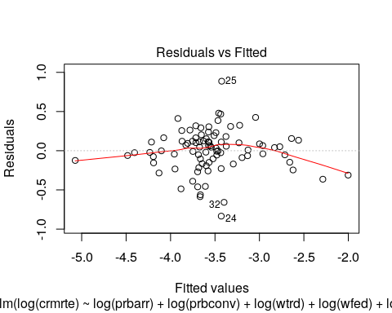

Notice that there is only a slight deviation from zero conditional mean, indicated by a not perfectly flat curve. This means that our coefficients maybe be biased. Next section, we discuss some omitted variables candidates and the bias direction they would imply.

## Homoskedasticity

Our residuals versus fitted values plot seems to indicate heteroskedasticity - thickness for fitted values close to the mean seems to be larger. The scale location plot gives us another way to assess this assumption, and tells a similar story.

plot(mod3, which = 3)

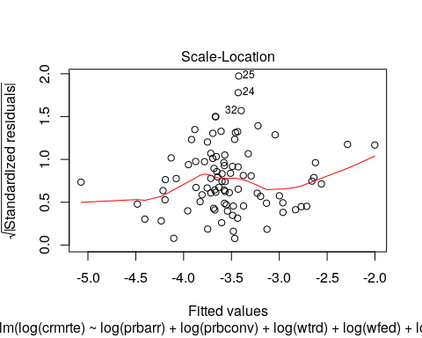

We are not particularly worried about not meeting the homoskedasticity assumption because the output of all our models already featured robust standard errors. We chose to use these throughout as this is a conservative practice that helps us in being more confident around our inferences.

## Normality of Errors

To check normality of errors, we can look at the qqplot that’s part of R’s standard diagnostics.

plot(mod3, which = 2)

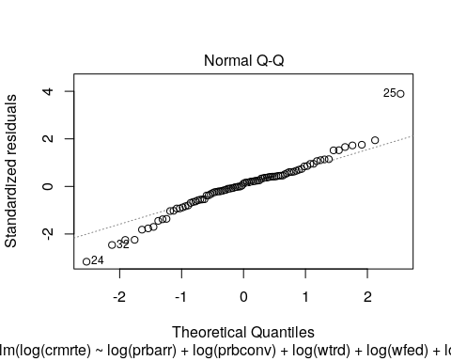

We can also visually look at the residuals directly.

hist(mod3$residuals, breaks = 20, main = "Residuals from Linear Model Predicting log(Crime Rate)")

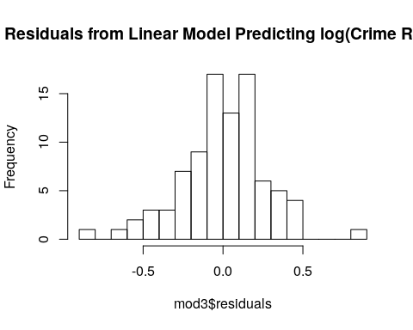

Both methods suggest we have a leftward skew. However, we have a large sample size, so the CLT tells us that our estimators will have a normal sampling distribution. Our look at the histogram confirms that we aren’t in a situation with an extreme skew, so n=90 should be sufficient for the CLT.

# A Discussion of Other Possible Omitted Variables

We lacked many variables related to community-level elements that would be expected to affect crime. Could any of these have affected the quantification of the relationships above?

In order to access the direction of omitted variable bias (OVB) resulting from each of the variables, we analyze the product of two correlations:

* $α$ = correlation between the omitted variable and crmrte
* $β$ = correlation between the omitted variable and prbarr/prbconv

As we assume the true relationship between crmrte and prbarr/prbconv is negative, a positive OVB biases the estimated effect of prbarr/prbconv on crmrte towards zero, while a negative OVB biases the estimated effect away from zero.

plot(mod4, which = 3)

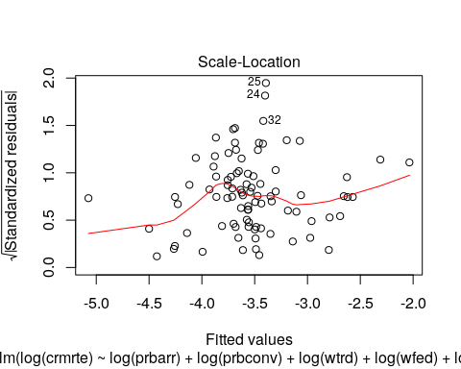

**Unemployment** ( $α>0$ and $β>0$-> away from zero) Unemployment rate is likely positively related to crime rate (so $α>0$), people in need are more prone to commit crimes. Unemployment rate is also arguably positively related to prbarr/prbconv (so $β>0$) due to the negative stigma that unemployment people have in society. Thus this OV should bias the estimated effect of prbarr/prbconv on crmrte away from zero.

**Education levels of the populace** ( $α<0$ and $β<0$-> away from zero)

Although we may be able to proxy education levels by looking at which region a county is in, we would not have a very good measure of overall education levels. A county can have a university, but still have low education levels overall. One would predict that education is negatively related to crime - the more educated, the less crime one would expect to commit (so $α<0$). The relationship between education levels and prbarr/prbconv is arguably negative due to the negative stigma that less educated people have in society (so $β<0$) .

**Public works & investments** ( $α<0$ and $β<0$-> away from zero)

One would predict that, like education, the relationship between and public works and investments with crime would be negative (so $α<0$). More nonprofits and community organizations could strengthen ties in communities, thus lowering crime rates. This factor would probably be inversely related to arrest and conviction rates, since a more punitive society may invest less in rewards to the community.

**Individual Health (mental and physical)** ( $α<0$ and $< 0 $ -> away from zero)

Individual health - both mental and physical - would likely be related to less crime. The healthier you are, the more mental and physical resources you have to solve problems in ways that do not necessitate committing a crime. The direction of the relationship to arrest or conviction rates is fuzzer but one could imagine that communities that have a focus on health may tend to be less punitive.

**Community Health** ( $α<0$ and $< 0 $ -> away from zero)

Community health is about the cohesiveness of a community. If you have good supports in your community, you would be less likely to commit crime. This factor would probably be inversely related to arrest and conviction rates, since a more loving, cohesive community may be less likely to turn to punishment.

**Inequality** ( $α>0$ and $< 0 $ -> towards zero)

We only had measures of average wage by sector in each county. We don’t have information about the distribution within and across these sectors. With more inequality, one would expect to see more crime - more anger & therefore reason to commit crime combined with greater levels of deprivation & need to commit crime would naturally lead to more crime. A more egalitarian society may have less punitive practice, since people would see each other as closer to their own group. This can help humanize other people and make it harder to commit cruelties.

Overall, most of these omitted variables likely inflated our estimate of the relationship between crime rate and these criminal justice policies.

What about our targeted economic policy variables? We were hesitant about making any causal inferences regarding these variables since we identified many variables that could be biasing the effect.

* $α$ = correlation between the omitted variable and crmrte
* $β$ = correlation between the omitted variable and wage variables (e.g., wtrd)

**Unemployment** ( $α>0$ and $β>0$-> away from zero) Unemployment rate is likely positively related to crime rate (so $α>0$), people in need are more prone to commit crimes. There has been mixed evidence around increases in minimum wage and unemployment, however many people believe that unemployment and wage increases are positively correlated so we will make that assumption here (so $β>0$).

**Education levels of the populace** ( $α<0$ and $β>0$-> towards zero)

One would predict that education is negatively related to crime - the more educated, the less crime one would expect to commit (so $α<0$). The relationship between education levels and wages is likely positive, since those who are more educated often make more money and also have the funds to then pay for their own or their children’s education.

**Public works & investments** ( $α<0$ and $β>0$-> towards zero)

One would predict that, like education, the relationship between and public works and investments with crime would be negative (so $α<0$). More nonprofits and community organizations could strengthen ties in communities, thus lowering crime rates. A community with higher wages would have more funds to put towards these, so beta is probably positive.

**Individual Health (mental and physical)** ( $α<0$ and $> 0 $ -> towards zero)

Individual health - both mental and physical - would likely be related to less crime. The healthier you are, the more mental and physical resources you have to solve problems in ways that do not necessitate committing a crime. The direction of the relationship to a community’s wages is probably positive since more money means more funds to invest in health.

**Community Health** ( $α<0$ and $> 0 $ -> towards zero)

Community health is about the cohesiveness of a community. If you have good supports in your community, you would be less likely to commit crime. A community that is cohesive would likely be interested in policies that strengthen others’ status in that community (like increasing the minimum wage), so the relationshp woule likely be positive.

**Inequality** ( $α>0$ and $< 0 $ -> away from zero)

With more inequality, one would expect to see more crime - more anger & therefore reason to commit crime combined with greater levels of deprivation & need to commit crime would naturally lead to more crime. Places with higher minimum wages probably see less inequality, so the relationship is inversed.

Overall, most of these omitted variables likely reduced our estimate of the relationship between crime rate and our wage variables. This was suspected since we were attempting to use these wages a (very) flawed proxy for the economic policies of main interest in this analysis.

# Conclusion

Based on our dataset, our analyses suggest that acting on crime deterrents within the criminal justice system (like arrests and convictions) is important policy efforts to take when it comes to preventing crime. In fact, for a 10% rise in the probability of arrests and convictions individually, the negative impact on crime rate hovers between 5-7% for the arrests and between 4-5% for convictions. Helpful follow-ups in this investigation would be to leverage variation across time and possibly test for large changes in policy that would help for example in designing a regression discontinuity model. However, our findings can be used to hone in on future policy changes that can be evaluated with more rigorous causal analyses.

Even though we could not find much support for the importance of economic policy variables to prevent crimes, measures to improve living conditions locally should not detract from efforts on the criminal justice system front. Targeting economic development policies that can bring higher wages and improve the quality of life in a region is likely important to deter crime. We did find that the wages of federal employees appear positively correlated with crime - one would imagine that counties would not intend to enact policies that depress wages in their region. There are likely hidden or unmeasured factors (such as health, inequality, corruption, or high cost of living without investment back into the community) that could be driving this effect. It would also be helpful to follow-up on this investigation with the addition of the omitted variables listed above. We see that inclusion of these would have reduced our estimates of the effects of crime variables and increased the estimates for wage variables. Other dynamics could also evolve that could be interesting in terms of other factors involved in crime. Overall, omitted variable bias reduced the strength of our claims overall.

It is also clear that real life variations in these counties related to there being many suspected outliers - we did not remove these, as they were likely edge cases rather than erroneous data. We did not wish to fit the data to the model, but rather see what real life events we could capture. Thus, any policies should take the local context into consideration. A stronger follow-up study would include these within-county factors in the model to produce more robust causal findings. The distribution of minorities is a good example of a variable that is not (at least ethically) under the influence of a politician, but must be accepted as a factor inherent to a community. Communities with higher rates of minorities or crime may require additional resources or different types of policies to prevent crime. For example, if the actual number of crimes is different from the number of reported crimes – for example, in a community with a lot of racial conflict where some groups over-report others to the police – we would see elevated measures of crime. If policies aim to reduce actual crime (rather than just reported crime), we would need more nuanced measures to track these and would need to turn towards more nuanced ways to address this (perhaps through strengthening group cohesiveness and hosting workshops to reduce racism). We found that communities with higher density of minorities have higher rates of crime. More follow-up would be needed to investigate mediators of this effect - such as racism, which could lead to higher rates of reported crime (even when holding actual crime constant) - but efforts towards community investments such as those related to the economic development efforts could also be used to fight crime. Perhaps with research using more appropriate economic variables, we could tease out whether providing more assistance in economic development to these regions could help in reducing crime.

It would also be advantageous to have multiple years’ of data so that we could control for the contextual effects of the year and more fully control for within-county factors that are not actionable targets for policy. For example, the year 1987 was unique in that there was a market crash in October of that year. The data are likely biased due to this fact. Policies could also have different effects depending on time elapsed. For example, maybe a change in arrest practice would not affect people’s perception of the likelihood of punishment for some time. It could be that there is a lag in behavior and we would not be able to control for that with only one year of data. Having multiple years could also allow us to more fully include county-specific effects in our model by using dummy variables for each county. More robust regression techniques used to examine causual effects (such as difference-in-differences or regression discontinuity) are not feasible given these data and would be a big improvement on the technique used here.

Based on our findings alone, policy recommendations should be focused on the criminal justice system. Policies could include include improved training and hiring of criminal justice staff, that could improve the ratio of arrest and convictions to crimes. Making sure that those who commit crimes are caught seems to be important in deterring crime - whether by keeping people off the streets, rehabilitating them, or scaring others away from committing crimes

Both of these streams (criminal and economic policies) could be folded under the umbrella of investing more in one’s community. It is not enough to punish and deter - one needs to also get at the root causes of crime and why someone may be compelled to commit a crime in the first place. The fact that crime is higher with high rates of minorities suggests that the picture is more complicated than it may seem when looking at crime policy variables. Are there elements of community cohesion that could be improved to help reduce crime? Or efforts to mitigate the systemic effects of racism? Perhaps more crimes are simply reported in those areas - so the elevate numbers are not truly a reflection of actual crime committed but rather enhanced surveillance.