JPA

1. 新建Maven项目

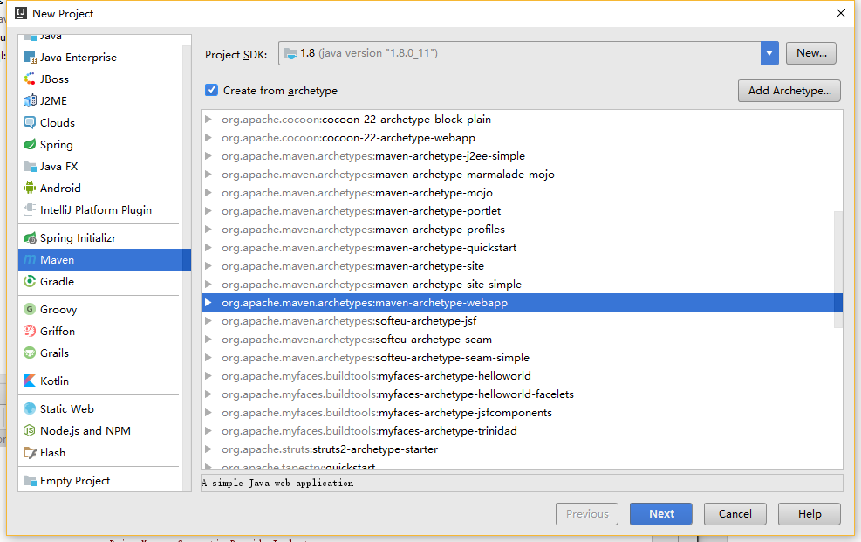

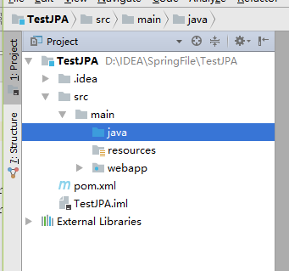

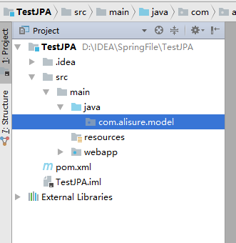

1. 自动生成Entity类

右键项目名：

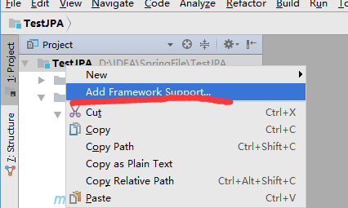

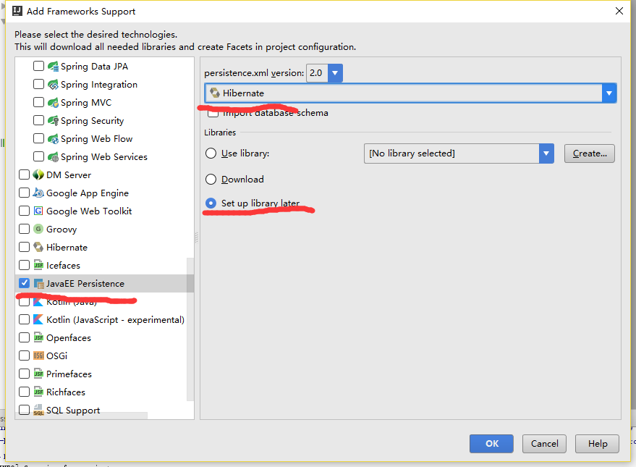

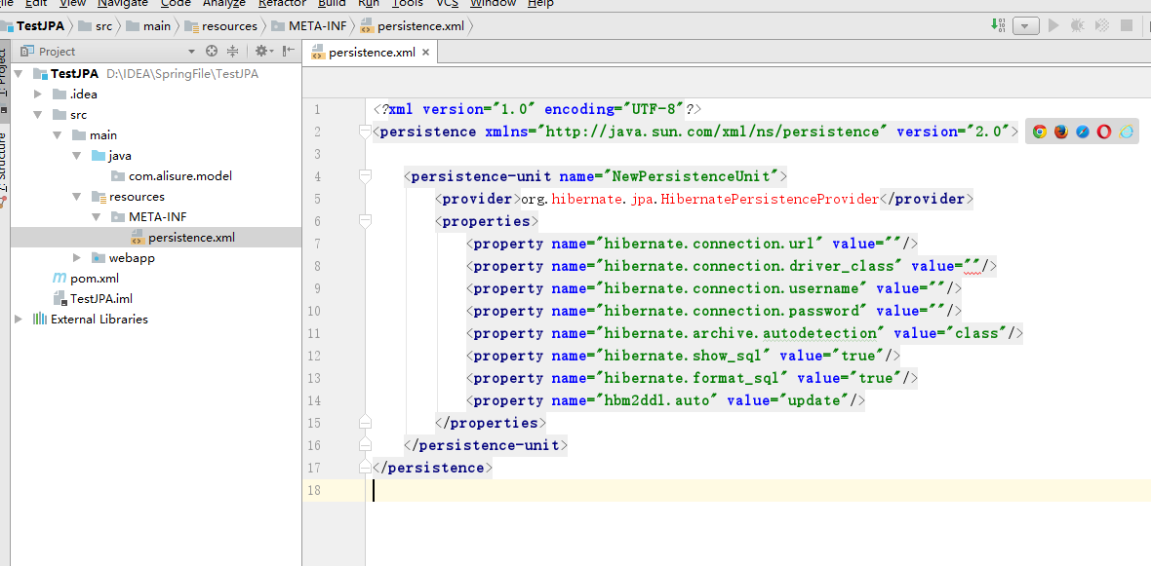

添加jar包

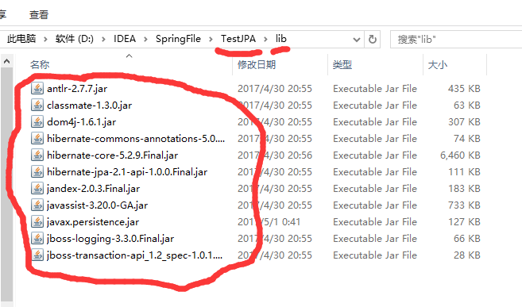

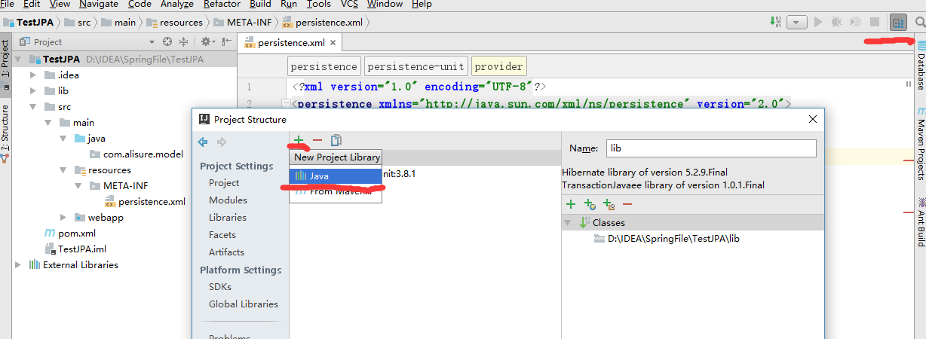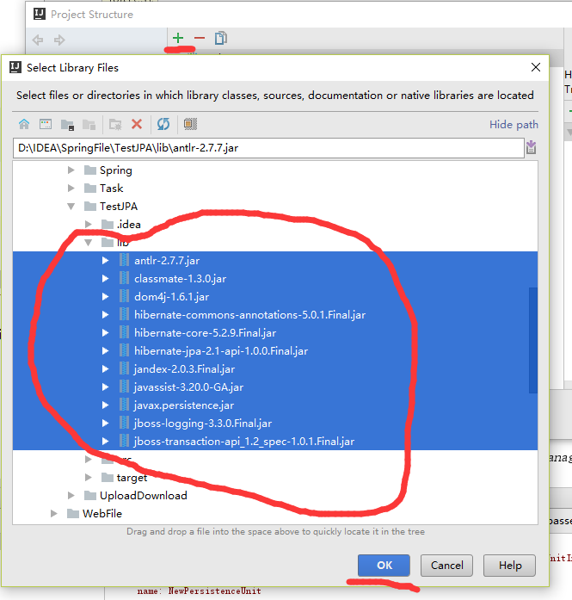

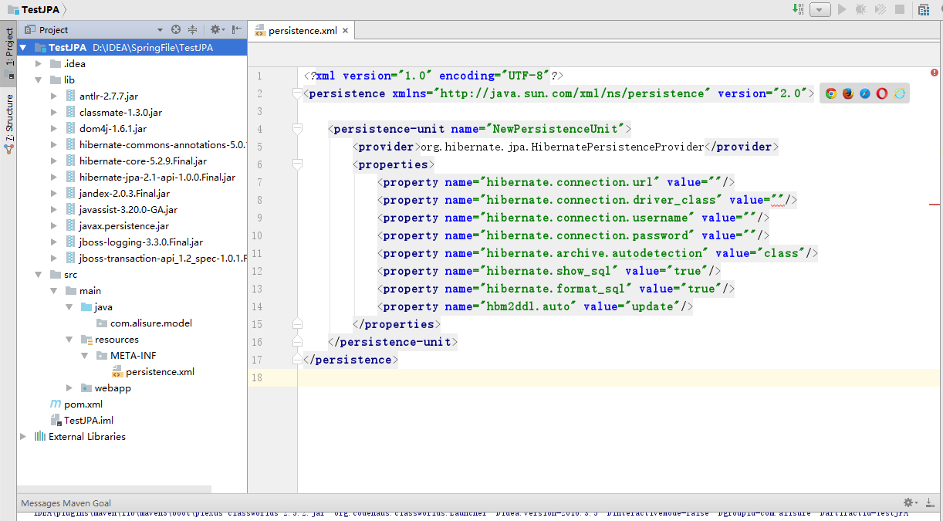

生成Entity

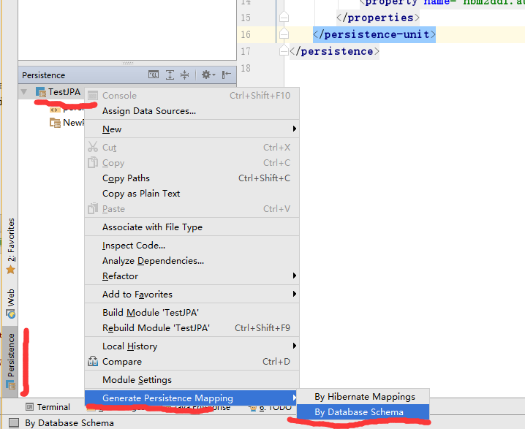

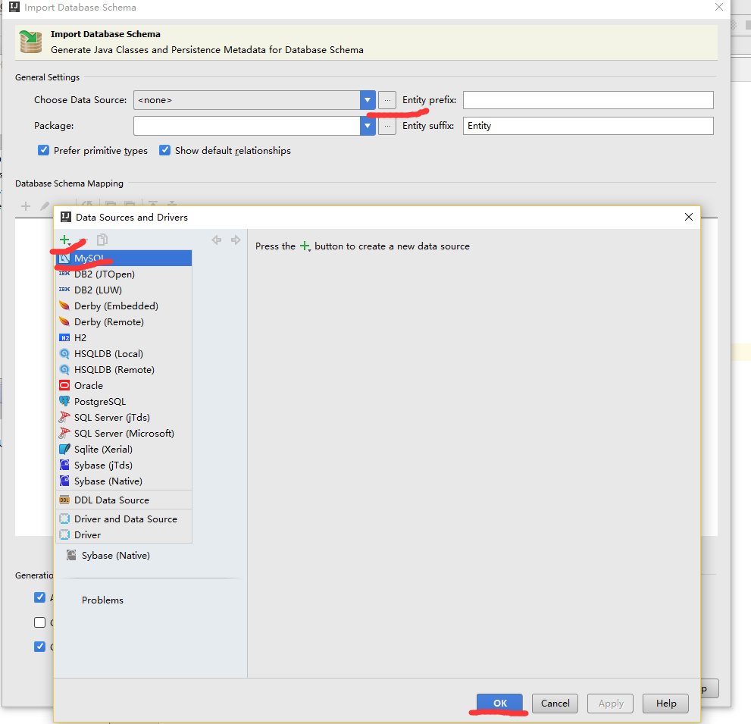

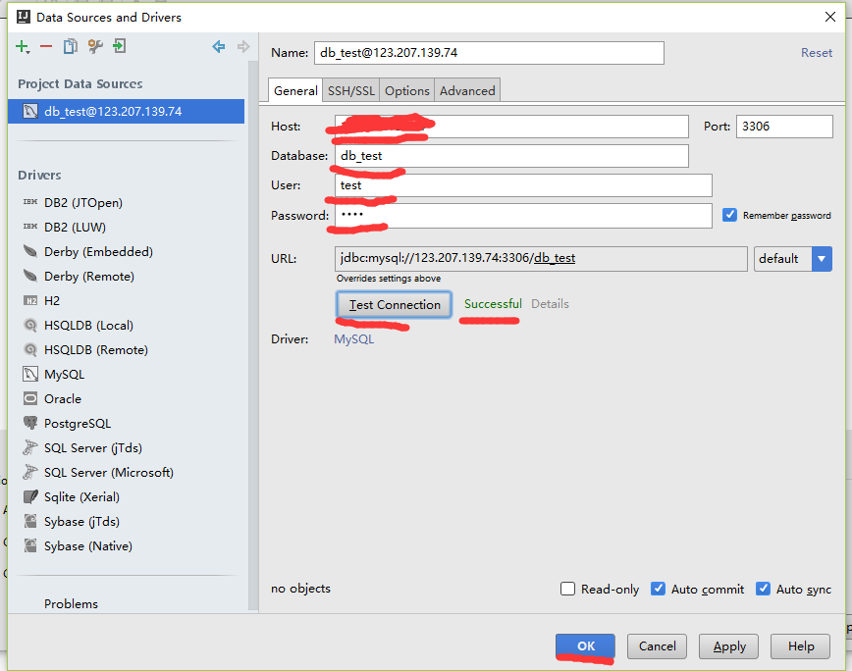

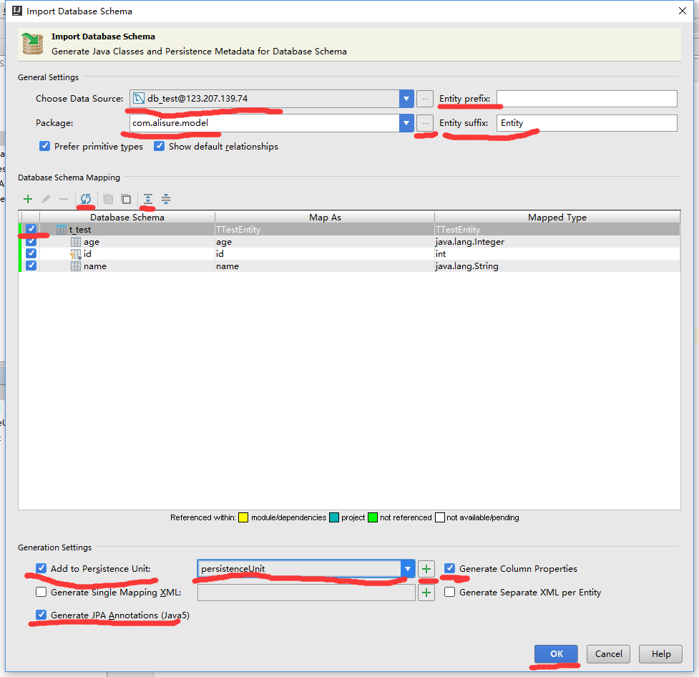

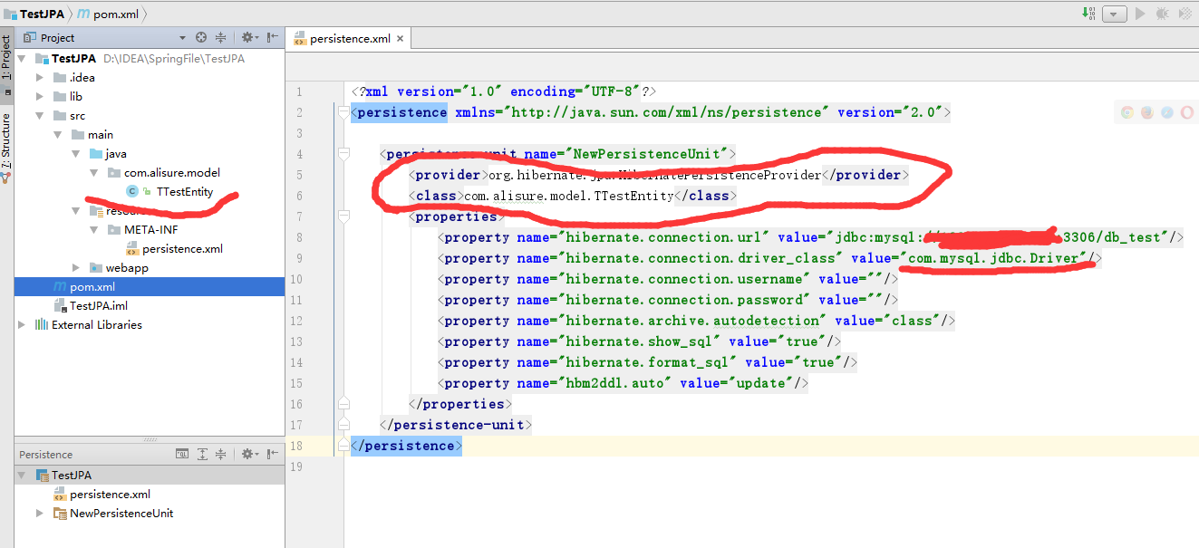

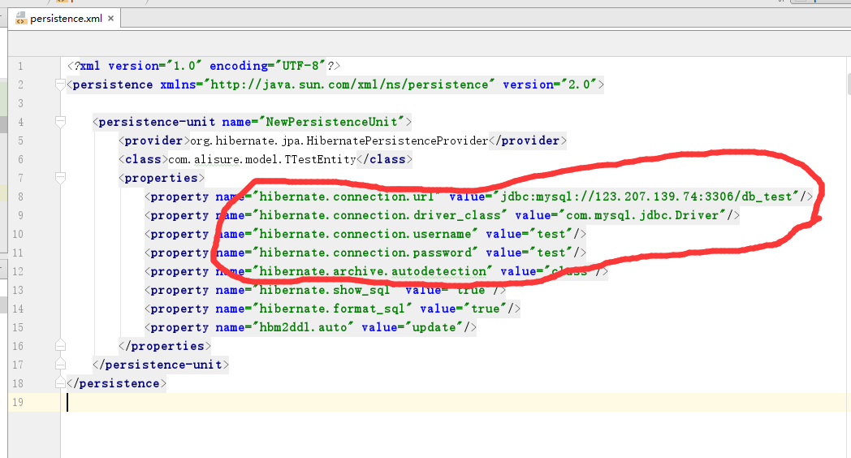

添加数据库驱动：

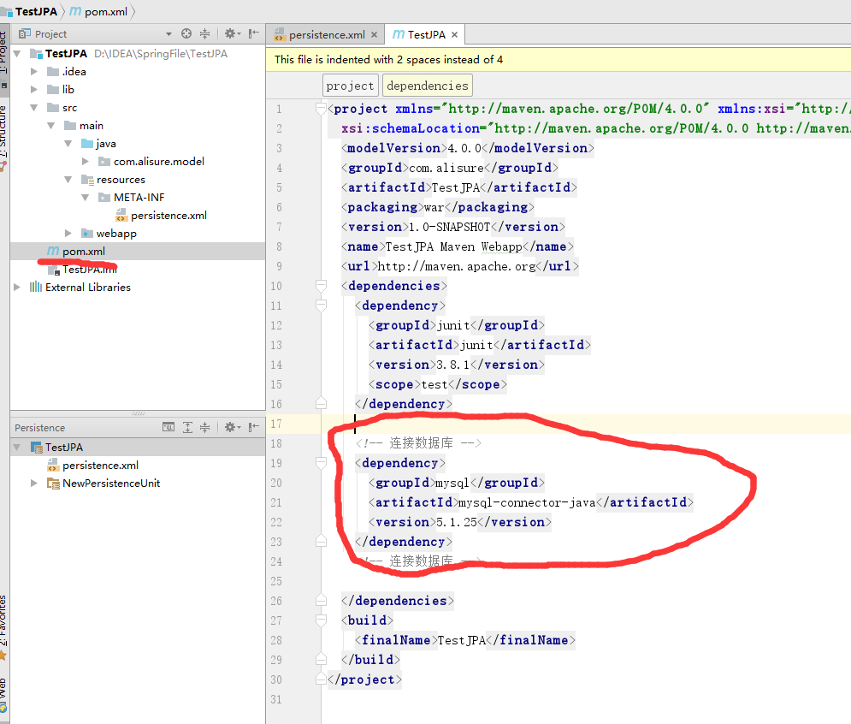

1. 测试

新建测试文件夹：

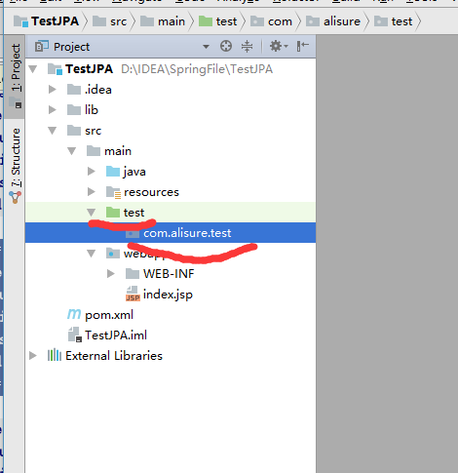

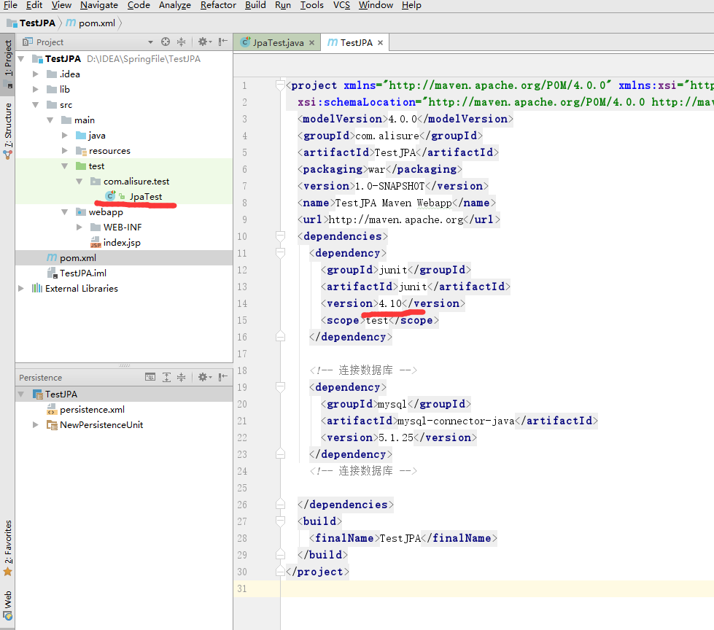

<**dependency**>  
 <**groupId**>junit</**groupId**>  
 <**artifactId**>junit</**artifactId**>  
 <**version**>4.10</**version**>  
 <**scope**>test</**scope**>  
</**dependency**>  
  
*<!-- 连接数据库 -->*<**dependency**>  
 <**groupId**>mysql</**groupId**>  
 <**artifactId**>mysql-connector-java</**artifactId**>  
 <**version**>5.1.25</**version**>  
</**dependency**>  
*<!-- 连接数据库 -->*

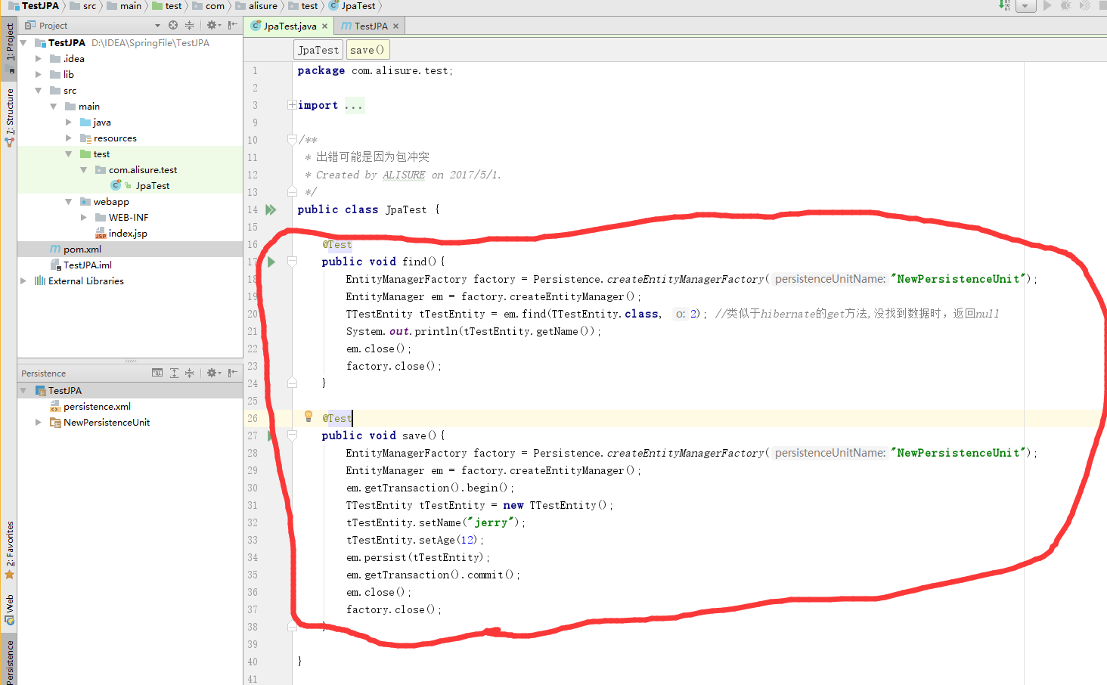

**package** com.alisure.test;  
  
**import** com.alisure.model.TTestEntity;  
**import** org.junit.Test;  
  
**import** javax.persistence.EntityManager;  
**import** javax.persistence.EntityManagerFactory;  
**import** javax.persistence.Persistence;  
  
*/**  
 * 出错可能是因为包冲突  
 * Created by ALISURE on 2017/5/1.  
 */***public class** JpaTest {  
  
 @Test  
 **public void** find(){  
 EntityManagerFactory factory = Persistence.*createEntityManagerFactory*(**"NewPersistenceUnit"**);  
 EntityManager em = factory.createEntityManager();  
 TTestEntity tTestEntity = em.find(TTestEntity.**class**, 2); *//类似于hibernate的get方法,没找到数据时，返回null* System.***out***.println(tTestEntity.getName());  
 em.close();  
 factory.close();  
 }  
  
 @Test  
 **public void** save(){  
 EntityManagerFactory factory = Persistence.*createEntityManagerFactory*(**"NewPersistenceUnit"**);  
 EntityManager em = factory.createEntityManager();  
 em.getTransaction().begin();  
 TTestEntity tTestEntity = **new** TTestEntity();  
 tTestEntity.setName(**"jerry"**);  
 tTestEntity.setAge(12);  
 em.persist(tTestEntity);  
 em.getTransaction().commit();  
 em.close();  
 factory.close();  
 }  
  
}

测试结果：

