# Steps to run Guess Animal Game:

1. **Download file and import into eclipse**.

You will see the error as shown in Figure 1. But don’t worry you are just few steps away from your game.

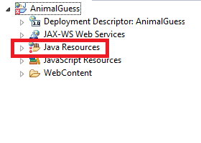

Figure

1. **Right click on Java Resources > New > Add source folder**
2. **Name the folder as shown in Figure 2.**

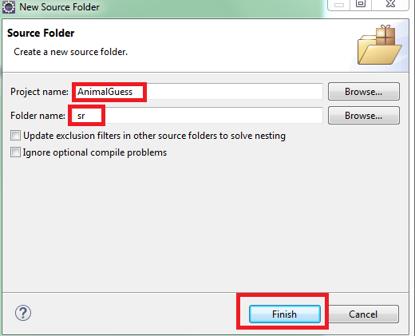

Figure

Application is using apache tomcat 7.0 server. So, you need to configure server before you run application.

1. **Right click on project> Run as > Run on Server.**

You will be displayed with a screen as shown in *Figure 3*.

1. **Select Apache.**

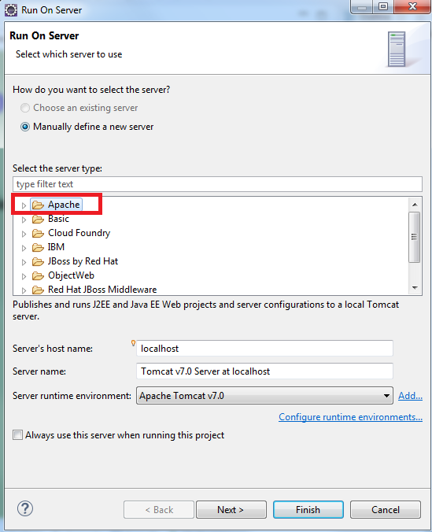

Figure

It will then display a screen as shown in *Figure 4.*

1. **Select Tomcat v7.0 Server and click on next.**

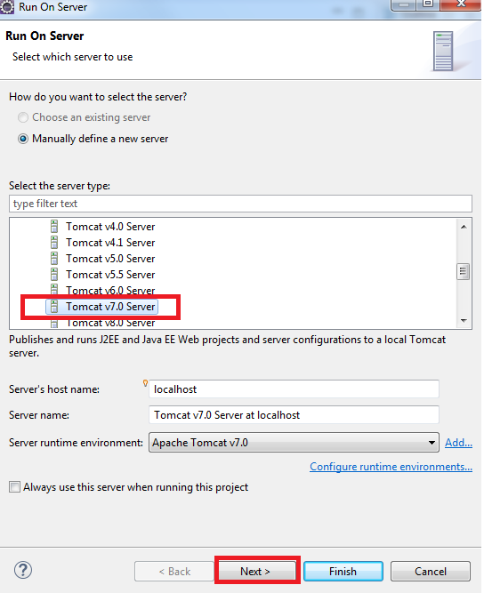

Figure

You will see screen as shown in *Figure 4.*

1. **Make sure AnimalGuess is in configured column.**
2. **Click Finish.**

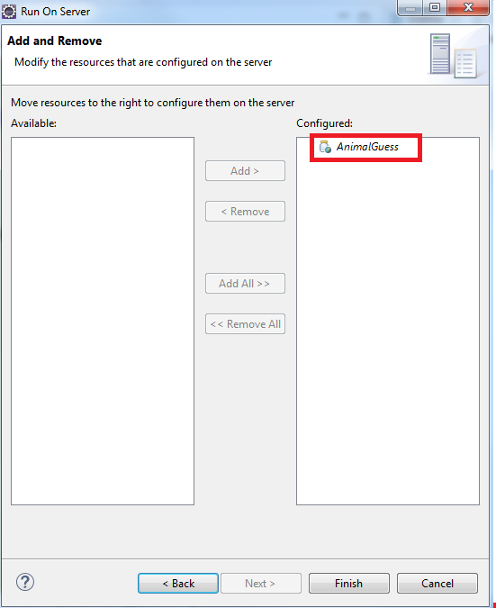

Figure

You will see screen like this as shown in *Figure 6.*

Yay, you have done it…..

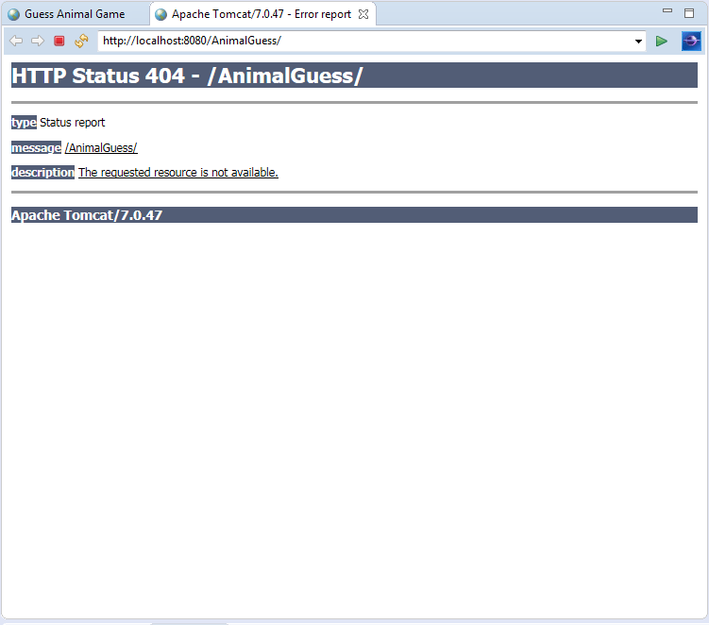

Figure

1. **Just add Game.html at the end of URL as shown in Figure 7.**

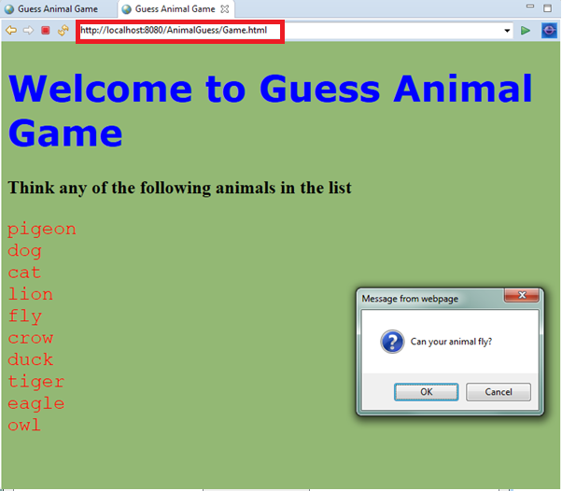

Figure