**Assignment 3**

 **Advance Web Technology**

**Submitted by**

**Ali Tahir 21007105019**

**Submitted to**

**Sir . Safiullah**

**BSIT (Batch 7)**

**Semester: Spring 2024**

**Department of Information Technology**

**University of Management and Technology Lahore,**

**Sialkot Campus**

**React To-Do List Application**

**Objective:**

This project is a single-page to-do list application built using React.js. The objective of this application is to provide users with a simple and effective way to manage their daily tasks. The application offers features such as task management, persistence, and basic styling.

**Project Structure:**

import React, { useState, useEffect } from 'react';

import TodoList from './component/TodoList';

import Footer from './component/Footer';

import './App.css';

const App = () => {

  const [tasks, setTasks] = useState([]);

  useEffect(() => {

    const savedTasks = JSON.parse(localStorage.getItem('tasks')) || [];

    setTasks(savedTasks);

  }, []);

  useEffect(() => {

    localStorage.setItem('tasks', JSON.stringify(tasks));

  }, [tasks]);

  const addTask = (task, priority) => {

    setTasks([...tasks, { text: task, completed: false, priority }]);

  };

  const toggleTask = (index) => {

    const newTasks = [...tasks];

    newTasks[index].completed = !newTasks[index].completed;

    setTasks(newTasks);

  };

  const deleteTask = (index) => {

    const newTasks = [...tasks];

    newTasks.splice(index, 1);

    setTasks(newTasks);

  };

  const clearCompleted = () => {

    setTasks(tasks.filter(task => !task.completed));

  };

  return (

    <div className="app">

      <h1>To-Do List</h1>

      <button onClick={clearCompleted} className='clearbtn'>Clear Completed</button>

      <TodoList tasks={tasks} toggleTask={toggleTask} deleteTask={deleteTask} />

      <Footer />

    </div>

  );

};

export default App;

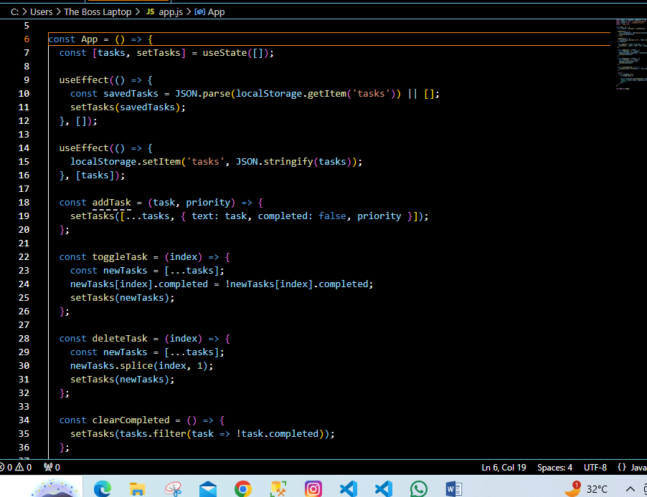

**Usage Instructions:**

**1. Setup:**

* Install the required dependencies using `npm install`.
* Launch the application with `npm start`.

**2. Adding Tasks:**

* Type a task into the input field and hit enter or click the add button.
* The task will be listed below**.**

**3. Managing Tasks:**

* Click the checkbox next to a task to mark it as completed.
* Click the delete button next to a task to remove it.
* Use the "clear completed" button to delete all completed tasks.

**4. Editing Tasks:**

* Double-click on a task or use the edit option to modify an existing task.

**Conclusion:**

This documentation outlines the to-do list application, describing its purpose, features, technical specifications, optional enhancements, implementation specifics, and usage guidelines. This application aims to assist users in organizing their daily tasks effectively with an intuitive and easy-to-use interface.

**Interface:**

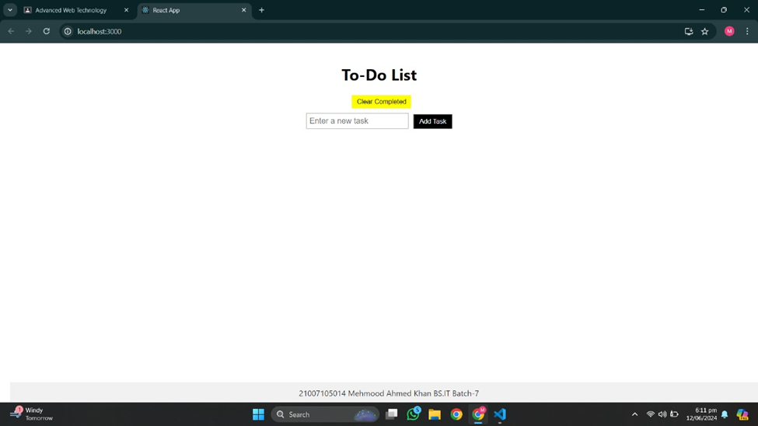

**Adding a new task and mark as completed by clicking on checkbox:**

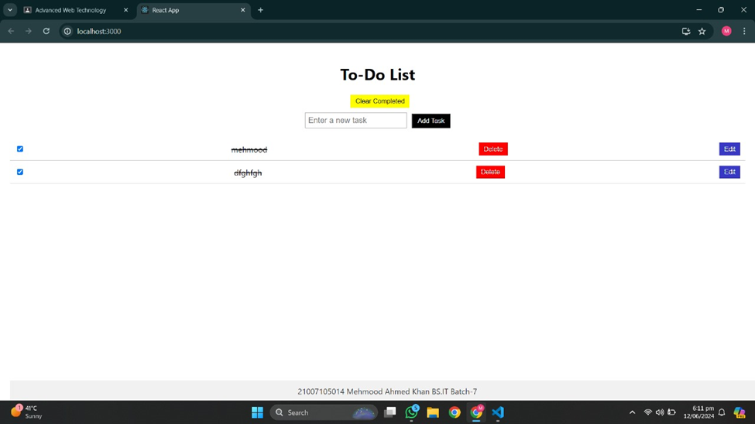

**Editing a task:**

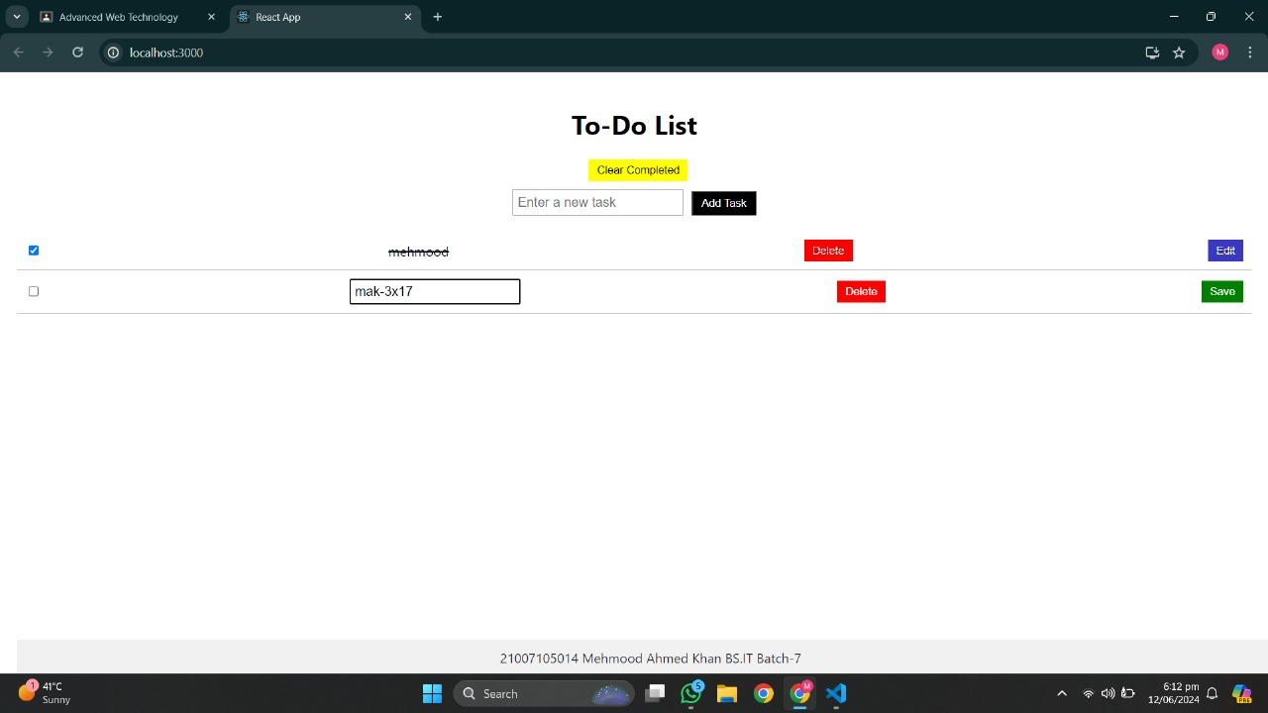

**Save the editing task by clicking save button:**

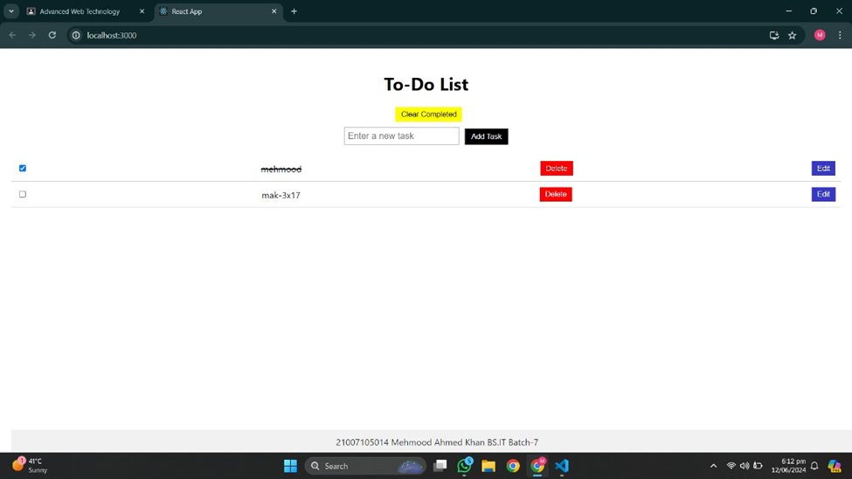

**Deleting the task one by one:**

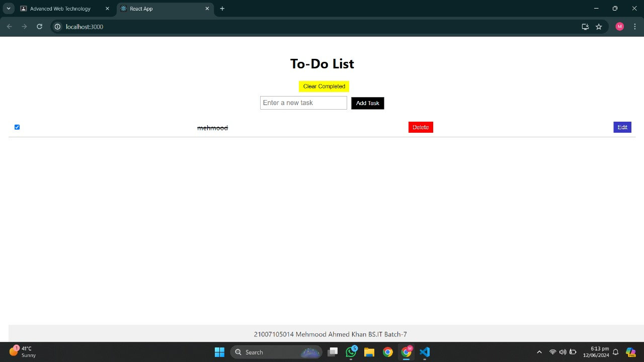

**To Clear all the tasks at once by clicking “Clear Completed” button**

**Before:**

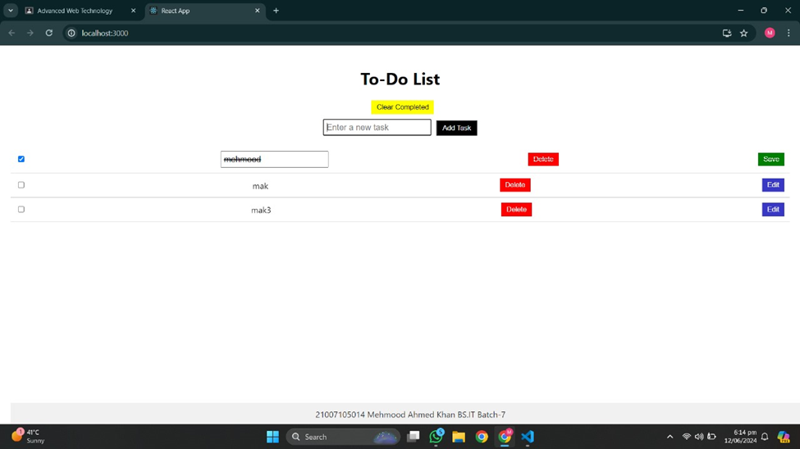

**After:**

