Covariance Proof

Ali Taşbaş

2024-03-28

## Covariance of independent variables is 0

I was asked to prove the above statement. As I’m more into the new tools the world has to offer, I decided to get help from R. Instead of directly proving it, I will prove that the contrary is not possible by constructing a hypothesis test. I hope you will find my first R markdown project entertaining Hocam.

First things first, we will generate 75 observations from a normal and a uniform distribution each and calculate their covariance. We will repeat this process for 500 times. At the end of this process, we will have 500 different covariances for 500 different combinations of two independent variables.

covs <- c() # empty vector to store the sample covariances  
plots <- data.frame(x = c(), y = c(), sample_no = c()) # empty list to store the scatter plots  
  
for (i in 1:500) {  
   
 x <- rnorm(75, 15, 8) # mean is 15, sd is 8  
   
 y <- runif(75, 100, 150) # uniform between 100 and 150  
   
 covs <- c(covs, cov(x, y))  
 plots <- rbind(plots, data.frame(x = x, y = y, sample_no = i))  
}

## A Scatter Plot

Here are 4 examples of the 500 scatter plots representing the combinations of x and y.

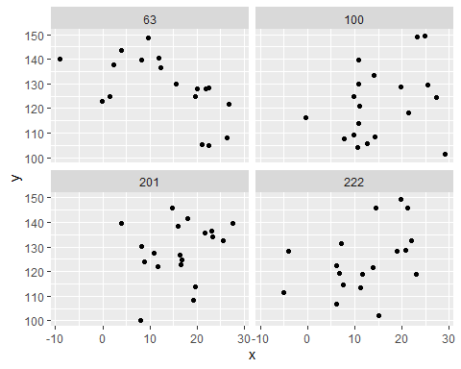

## Distribution of Covariances

Let’s check the distribution of the covariances of the samples

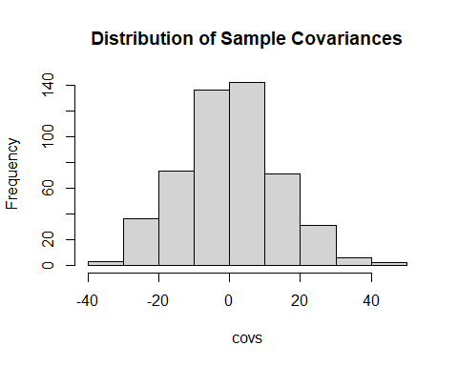

## Hypothesis Test

Now the fun part… We construct our null and alternative hypotheses.

**H0: COV(X,Y)=0**  
**HA: COV(X,Y)≠0**

cov=0.1533444  
**Se**=1.9206048

$$\frac{\overset{‾}{x}−μ}{σ/\sqrt{n}}$$

Pvalue=0.4681816

## Conclusion

We cannot claim that the covariance of 2 independent variables is different from 0 as our p-value is quite big.