sDyna REPORT

This report has been automatically generated by sDyna software.

# Mass Matrix

|  |  |  |  |  |
| --- | --- | --- | --- | --- |
|  | 100.0 | 0.0 | 0.0 | 0.0 |
|  | 0.0 | 100.0 | 0.0 | 0.0 |
| m = | 0.0 | 0.0 | 100.0 | 0.0 |
|  | 0.0 | 0.0 | 0.0 | 100.0 |

# Stiffness Matrix

|  |  |  |  |  |
| --- | --- | --- | --- | --- |
|  | 43140.0 | -30340.0 | 0.0 | 0.0 |
|  | -30340.0 | 60680.0 | -30340.0 | 0.0 |
| k = | 0.0 | -30340.0 | 60680.0 | -30340.0 |
|  | 0.0 | 0.0 | -30340.0 | 30340.0 |

# Damping Matrix

Damping ratio has been taken as 0.05.

|  |  |  |  |  |
| --- | --- | --- | --- | --- |
|  | 200.7 | -153.2 | 0.0 | 0.0 |
|  | -153.2 | 407.0 | -253.8 | 0.0 |
| c = | 0.0 | -253.8 | 577.4 | -323.6 |
|  | 0.0 | 0.0 | -323.6 | 323.6 |

# Natural Frequencies and Periods

ω1 = 4.75 rad/sec ---------------> T1= 1.32 sec

ω2 = 15.32 rad/sec ---------------> T2= 0.41 sec

ω3 = 25.38 rad/sec ---------------> T3= 0.25 sec

ω4 = 32.36 rad/sec ---------------> T4= 0.19 sec

# Modes' Amplitudes

|  |  |  |  |  |
| --- | --- | --- | --- | --- |
| Mode 1 Amplitudes | φ11 = 1.0 | φ12 = 1.35 | φ13 = 1.59 | φ14 = 1.72 |
| Mode 2 Amplitudes | φ21 = 1.0 | φ22 = 0.65 | φ23 = -0.2 | φ24 = -0.9 |
| Mode 3 Amplitudes | φ31 = 1.0 | φ32 = -0.7 | φ33 = -0.91 | φ34 = 0.81 |
| Mode 4 Amplitudes | φ41 = 1.0 | φ42 = -2.03 | φ43 = 1.95 | φ44 = -0.79 |

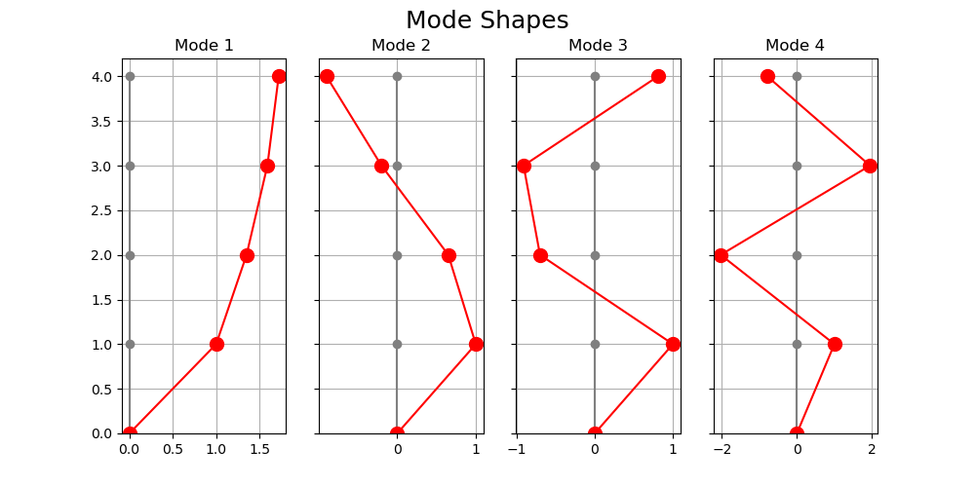

# Generalized Mass Matrix

|  |  |  |  |  |
| --- | --- | --- | --- | --- |
|  | 830.9 | 0.0 | 0.0 | 0.0 |
|  | 0.0 | 227.25 | 0.0 | 0.0 |
| M = | 0.0 | 0.0 | 297.42 | 0.0 |
|  | 0.0 | 0.0 | 0.0 | 954.75 |

# Generalized Stiffness Matrix

|  |  |  |  |  |
| --- | --- | --- | --- | --- |
|  | 18775.26 | 0.0 | 0.0 | 0.0 |
|  | 0.0 | 53303.31 | 0.0 | 0.0 |
| K = | 0.0 | 0.0 | 191578.4 | 0.0 |
|  | 0.0 | 0.0 | 0.0 | 999729.66 |

# Generalized Damping Matrix

|  |  |  |  |  |
| --- | --- | --- | --- | --- |
|  | 86.35 | 0.0 | 0.0 | 0.0 |
|  | 0.0 | 408.2 | 0.0 | 0.0 |
| C = | 0.0 | 0.0 | 1458.78 | 0.0 |
|  | 0.0 | 0.0 | 0.0 | 7903.77 |

# Modal Participating Factors

Γx1 = 0.68

Γx2 = 0.24

Γx3 = 0.07

Γx4 = 0.01

# Effective Participating Mass of Each Mode

Mx1 = 385.55

Mx2 = 13.31

Mx3 = 1.34

Mx4 = 0.18

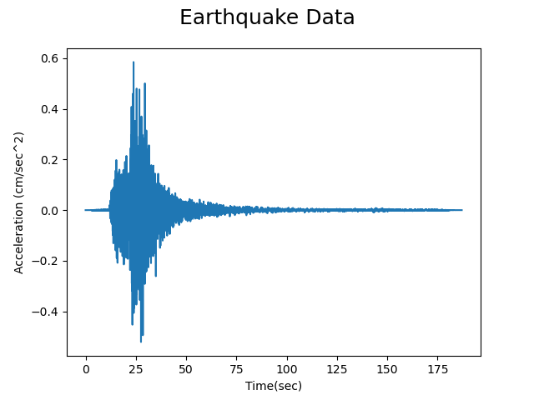

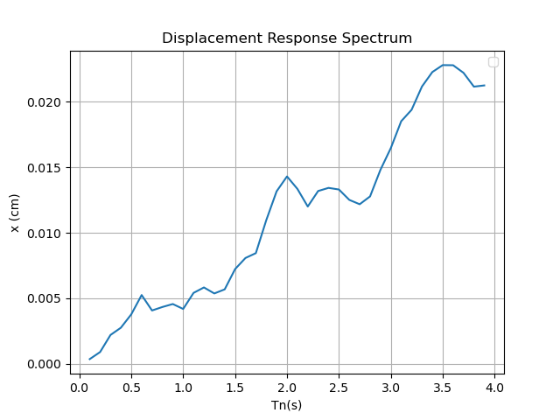

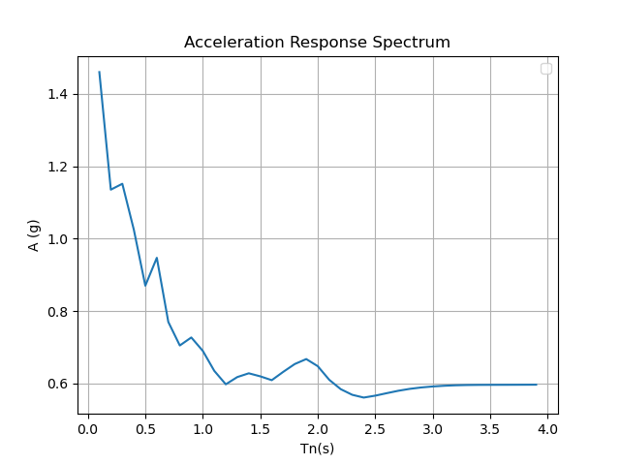

# Psuedo Acceleration Respond Spectrum

Sae1 = 0.12

Sae2 = 0.586

Sae3 = 0.595

Sae4 = 0.921

# Modes' Base Shear Forces

Vx1 = 454.151

Vx2 = 76.473

Vx3 = 7.822

Vx4 = 1.626

# Total Base Shear Force with SRSS method

VT = 460.614