sDyna REPORT

This report has been automatically generated by sDyna software.

# Mass Matrix

|  |  |  |  |
| --- | --- | --- | --- |
|  | 123.0 | 0.0 | 0.0 |
| m = | 0.0 | 123.0 | 0.0 |
|  | 0.0 | 0.0 | 123.0 |

# Stiffness Matrix

|  |  |  |  |
| --- | --- | --- | --- |
|  | 246.0 | -123.0 | 0.0 |
| k = | -123.0 | 246.0 | -123.0 |
|  | 0.0 | -123.0 | 123.0 |

# Damping Matrix

Damping ratio has been taken as 0.05.

|  |  |  |  |
| --- | --- | --- | --- |
|  | 20.91 | -15.38 | 0.0 |
| c = | -15.38 | 37.52 | -22.14 |
|  | 0.0 | -22.14 | 22.14 |

# Natural Frequencies and Periods

ω1 = 0.45 rad/sec ---------------> T1= 14.12 sec

ω2 = 1.25 rad/sec ---------------> T2= 5.04 sec

ω3 = 1.8 rad/sec ---------------> T3= 3.49 sec

# Modes' Amplitudes

|  |  |  |  |
| --- | --- | --- | --- |
| Mode 1 Amplitudes | φ11 = 1.0 | φ12 = 1.8 | φ13 = 2.25 |
| Mode 2 Amplitudes | φ21 = 1.0 | φ22 = 0.45 | φ23 = -0.8 |
| Mode 3 Amplitudes | φ31 = 1.0 | φ32 = -1.25 | φ33 = 0.55 |

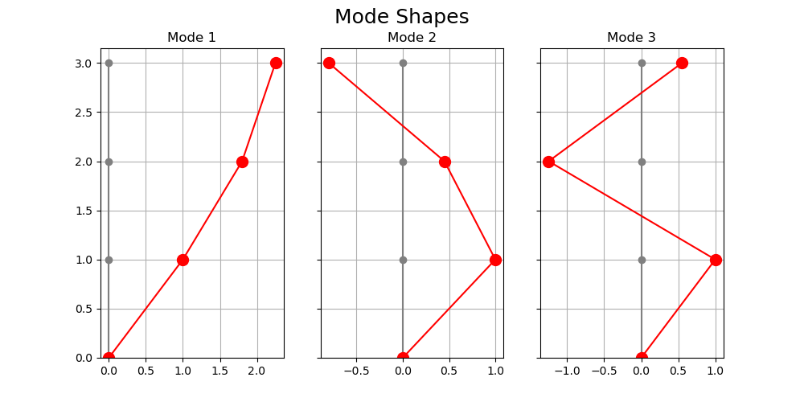

# Generalized Mass Matrix

|  |  |  |  |
| --- | --- | --- | --- |
|  | 1144.21 | 0.0 | 0.0 |
| M = | 0.0 | 226.63 | 0.0 |
|  | 0.0 | 0.0 | 352.4 |

# Generalized Stiffness Matrix

|  |  |  |  |
| --- | --- | --- | --- |
|  | 226.62 | 0.0 | 0.0 |
| K = | 0.0 | 352.4 | 0.0 |
|  | 0.0 | 0.0 | 1144.24 |

# Generalized Damping Matrix

|  |  |  |  |
| --- | --- | --- | --- |
|  | 19.86 | 0.0 | 0.0 |
| C = | 0.0 | 44.78 | 0.0 |
|  | 0.0 | 0.0 | 155.12 |

# Modal Participating Factors

Γx1 = 0.54

Γx2 = 0.35

Γx3 = 0.1

# Effective Participating Mass of Each Mode

Mx1 = 337.2

Mx2 = 28.2

Mx3 = 3.86

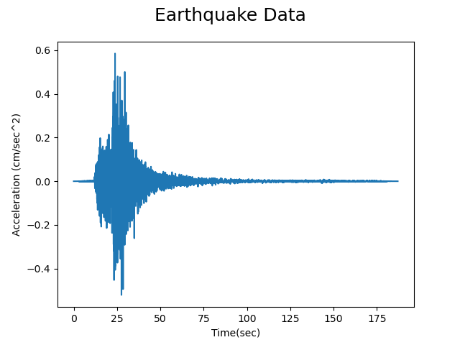

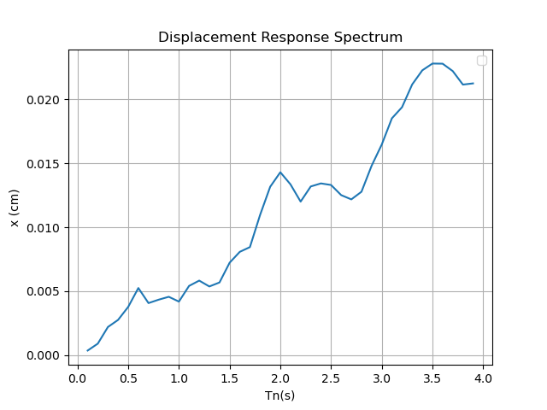

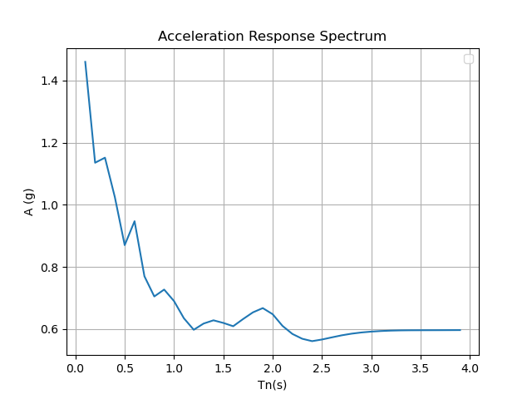

# Psuedo Acceleration Respond Spectrum

Sae1 = 0.004

Sae2 = 0.04

Sae3 = 0.074

# Modes' Base Shear Forces

Vx1 = 12.383

Vx2 = 11.004

Vx3 = 2.791

# Total Base Shear Force with SRSS method

VT = 16.799