sDyna REPORT

This report has been automatically generated by sDyna software.

|  |  |  |  |
| --- | --- | --- | --- |
|  | 227.56 | 0.0 | 0.0 |
| Mass Matrix(t) = | 0.0 | 227.56 | 0.0 |
|  | 0.0 | 0.0 | 227.56 |

|  |  |  |  |
| --- | --- | --- | --- |
|  | 198398.54 | -85910.51 | 0.0 |
| Rigidity Matrix(kN/m) = | -85910.51 | 171821.02 | -85910.51 |
|  | 0.0 | -85910.51 | 85910.51 |

ω1 = 9.251 rad/sec ---------------> T1= 0.679 sec

ω2 = 25.447 rad/sec ---------------> T2= 0.247 sec

ω3 = 35.656 rad/sec ---------------> T3= 0.176 sec

|  |  |  |  |
| --- | --- | --- | --- |
|  | 789.59 | -579.07 | 0.0 |
| Damping Matrix(kN s/m) = | -579.07 | 1390.44 | -811.38 |
|  | 0.0 | -811.38 | 811.38 |

# Mode 1 Amplitude

|  |  |  |
| --- | --- | --- |
| φ11 = 1.0 | φ12 = 2.083 | φ13 = 2.693 |
| φ21 = 1.0 | φ22 = 0.594 | φ23 = -0.831 |
| φ31 = 1.0 | φ32 = -1.058 | φ33 = 0.447 |

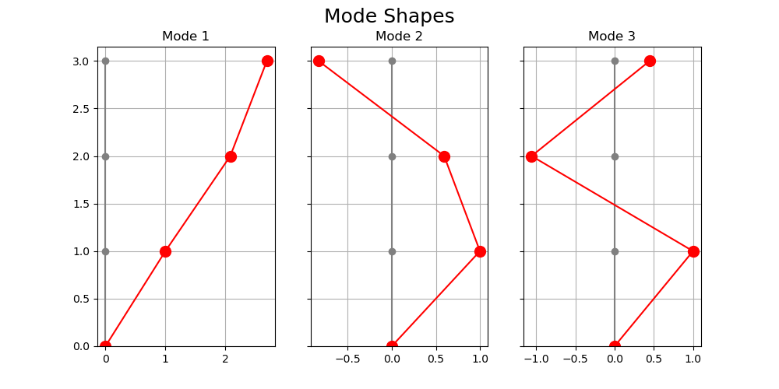

|  |  |  |  |
| --- | --- | --- | --- |
|  | 2865.17 | 0.0 | 0.0 |
| M = | 0.0 | 464.96 | 0.0 |
|  | 0.0 | 0.0 | 527.79 |

|  |  |  |  |
| --- | --- | --- | --- |
|  | 245213.25 | 0.0 | 0.0 |
| K = | 0.0 | 301076.24 | 0.0 |
|  | 0.0 | 0.0 | 670990.62 |

|  |  |  |  |
| --- | --- | --- | --- |
|  | 1191.73 | 0.0 | 0.0 |
| C = | 0.0 | 1953.37 | 0.0 |
|  | 0.0 | 0.0 | 4501.24 |

Γx1 = 0.459

Γx2 = 0.374

Γx3 = 0.168

Mx1 = 602.942

Mx2 = 64.904

Mx3 = 14.833

