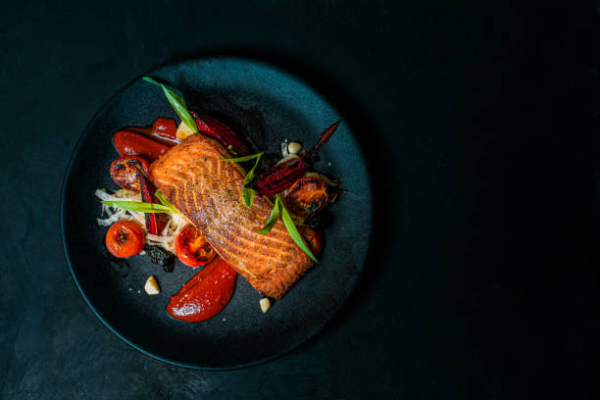

Recipes Favorites Order Now

Food Website

Deep pink (#ff1493)

**Scents Sprinkles Sprays Melts Deals**

**Pink Zebra**

New Scents are Coming!

Fall scents are on the way. Pumpkin, cinnamon, and cranberry – oh my! Join us at next week’s bash to pick your favorites. Door prizes available to the first five to arrive!

