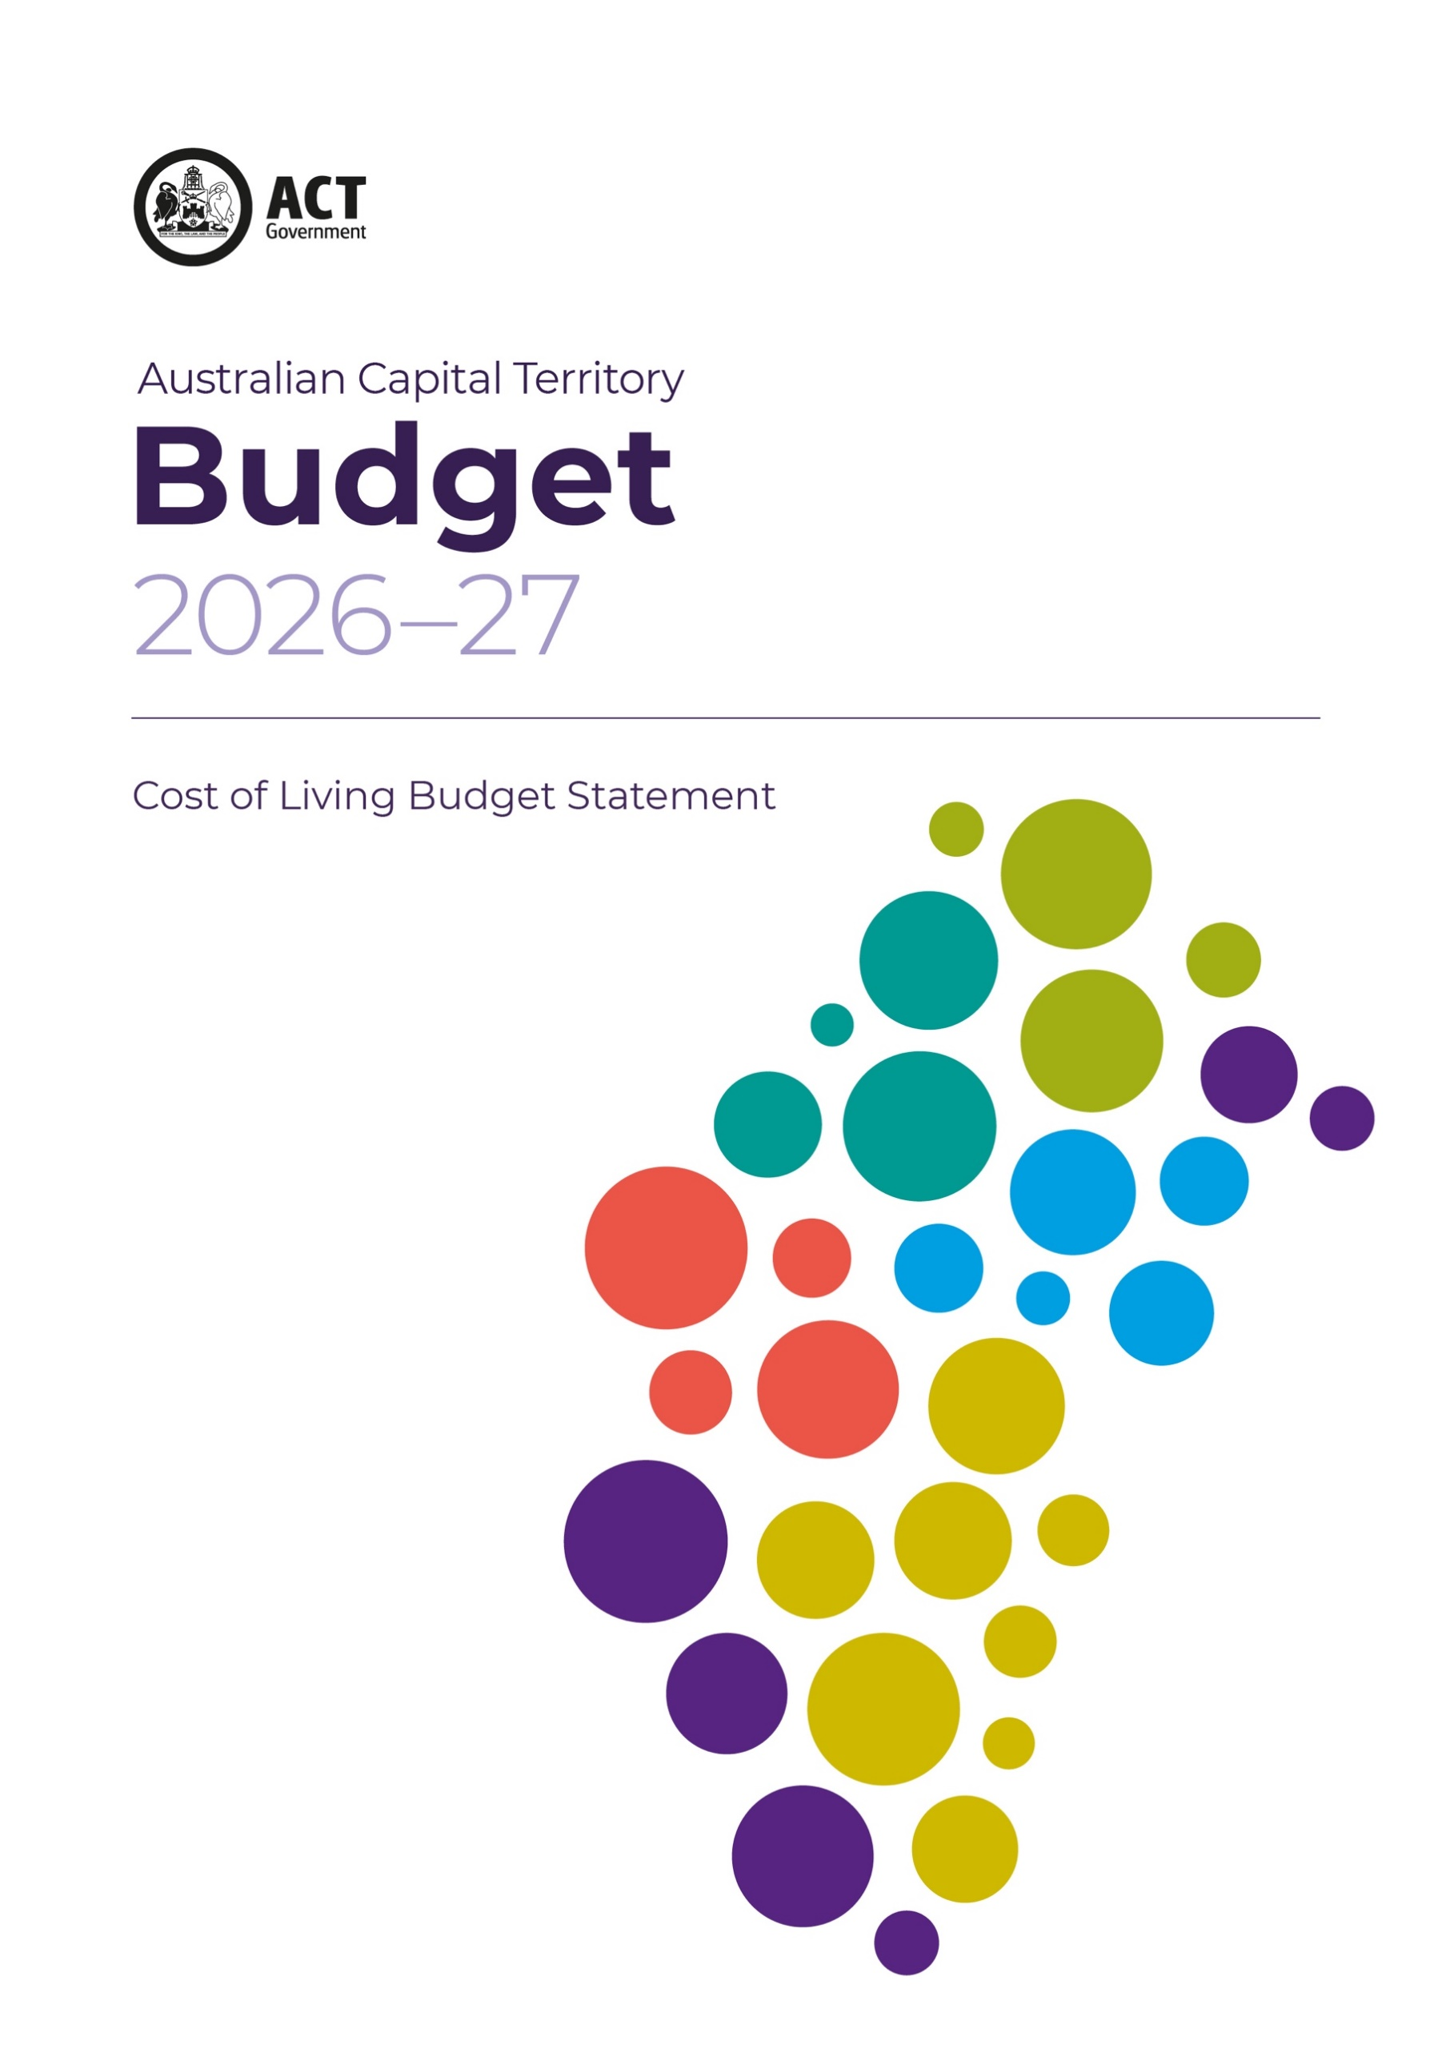



Acknowledgement
We acknowledge the Ngunnawal people as
traditional custodians of the ACT and recognise
any other people or families with connection to
the lands of the ACT and region. We acknowledge
and respect their continuing culture and the
contribution they make to the life of this city
and this region.

ISSN 1327-581X
© Australian Capital Territory, Canberra 2026
Material in this publication may be reproduced
provided due acknowledgement is made.
Produced by the Chief Minister, Treasury and
Economic Development Directorate. Enquiries
about this publication should be directed to the
Chief Minister, Treasury and Economic
Development Directorate.
GPO Box 158, Canberra City 2601
act.gov.au
Telephone: Access Canberra - 13 22 81

Cost of Living Statement

Introduction
Canberra remains a great place to live, work, study and raise a family. Our city continues to benefit from a strong and resilient economy, high employment and a highly skilled population. These strengths support high living standards across the ACT.
The effect of conflict in the Middle East and elevated inflation driven by global energy and supply chain disruptions are having an effect on the cost of living. Lower-income households remain particularly vulnerable to higher housing, energy, food and transport costs. The ACT Government is providing targeted, practical support to households, while investing in the services and infrastructure that sustain our quality of life.
The ACT Government already provides substantial and ongoing cost of living assistance through a broad range of concessions, rebates and targeted support measures. This supports eligible households with major day-to-day costs, including utilities, rates, transport and housing-related expenses.
In the 2026-27 Budget, the ACT Government is introducing new cost of living assistance measures, including:
- financial support to private renters experiencing rental stress or those experiencing financial hardship, through the establishment of the Housing Crisis Support Fund and a Crisis Support Payment;
- reduced monthly public transport fare caps for tertiary students from 40 to 30 paid trips in 2026-27, commencing after the current, halved monthly fare cap initiative ends;
- a community sector grant to establish a transport service for individuals with chronic conditions;
- additional funding for the Future of Education Equity Fund’s 2026 round to support access to education for all students;
- working with the Commonwealth Government to extend fee-free TAFE training to an additional 9,093 training places in healthcare, advanced technology, construction, hospitality and foundation skills;
- additional funding for the Emergency Material and Financial Aid scheme in response to expected increased demand due to the ongoing fuel supply disruptions and associated economic impacts;
- funding to strengthen community services, inclusion and participation;
- further funding for the Home Energy Support Program to support homeowners to cover the costs of rooftop solar and other energy-efficient upgrades including hot water systems, ceiling insulation, and reverse-cycle heating and cooling; and
- additional funding for the Renters’ Home Energy Advice Program will also continue to provide free, tailored advice for renters from an expert energy assessor.

Housing affordability
The ACT is the most affordable jurisdiction to buy or rent a home, with 32.8 per cent of an average family income required to meet home loan repayments and 18.9 per cent to meet rental payments.
Canberra has historically been among the more expensive capital cities to rent but government action and policy settings have helped moderate rental price growth in recent years. Over the year to March 2026, Canberra experienced the lowest median rental growth among capital cities for houses and units.
Canberra’s median established house prices are the third highest among capital cities, at around $1.04 million. The median price for attached dwellings is around $620,000, lower than most other capital cities.
Despite this, many lower income households struggle to access secure and affordable housing. The ACT Government is expanding housing supply, choice and access through a program of land use planning and precinct development to enable 30,000 more homes, including an additional 5,000 affordable and social homes, by the end of 2030.
The 2026-27 Budget includes several new and expanded housing initiatives including:
- from 1 July 2026, no stamp duty will apply for first home buyers, pensioners, or homebuyers purchasing an off-the-plan dwelling or turn-key unit;
- expanding the Pensioner Duty Concession Scheme to include DVA Service Pension recipients with permanent incapacity to work;
- removal of the property price thresholds for the Disability Duty Concession Scheme;
- re-establishment of financial support for private renters through the Housing Crisis Support Fund and establishment of a new Crisis Support Payment;
- continued funding to support the delivery of social housing, including through the Growing and Renewing Public Housing program and the Social Housing Accelerator Program; and
- a new program of works to deliver 450 public housing dwellings and a further 54 social and affordable dwellings to fulfil the housing needs of the most vulnerable community members.
Further information is available in the Housing Budget Statement.

Transport costs
Higher global oil prices have increased fuel costs in Australia, adding to transport costs and broader cost of living pressures. In response, the ACT Government temporarily halved monthly public transport fare caps from 8 April to 30 June 2026. Under the reduced caps, adult passengers will pay no more than $68.20 per month, tertiary students no more than $25.65 per month, and school students less than $20 per month, after which travel is free for the remainder of the month. Higher fuel costs and reduced fare revenue are estimated to increase the cost of providing public transport by around $5.5 million in 2025-26.
The ACT Government is also supporting lower fuel prices by contributing to a temporary reduction in fuel excise. From 1 April to 30 June 2026, fuel excise has been reduced by 32 cents per litre, including 26.3 cents per litre from the Commonwealth and 5.7 cents per litre from the States and Territories.

Utilities
Utilities are a major household cost. ACT households typically use more energy, and face higher energy costs, than households in other states and territories because of the local climate. The ACT Government is continuing to support vulnerable households with the ongoing $800 Electricity, Gas and Water Rebate, which was made permanent in the 2025-26 Budget. The rebate eases the financial burden of essential utility costs for eligible households.
Households can also save hundreds of dollars a year on their electricity bills by switching to the cheapest available offer. The ACT electricity reference price makes comparison across retailers quick and easy.
The Government continues to invest in cleaner, cheaper and more reliable energy. This includes energy efficiency upgrades for public and social housing and low-interest loans through the Sustainable Household Scheme, to help households install batteries, zero-emission vehicles and chargers, ceiling insulation and electric appliances.

Cost of Living in the ACT
The Wellbeing Framework uses CPI and income levels to assess living standards in the ACT, with sustained improvements supported by growth in real wages. While nominal wages growth remains strong, elevated inflation—including from higher global energy prices—has weighed on growth in real wages. Real wages are, however, expected to improve from 2026-27.

Price of Goods and Services
The prices of essential goods and services have continued to increase, driven by upward price pressures from current global energy price shocks.
Canberra’s CPI increased by 4.2 per cent over the year to March 2026, compared to 4.6 per cent nationally. Household spending has decreased by 0.3 per cent over the same period compared to 0.7 per cent nationally, suggesting households are reducing expenditure in response to cost-of-living pressures. Further information on the prices of goods and services in the ACT is in the ACT Economic Overview Chapter 2.2.

Income Levels
Average income levels in the ACT remain the highest of all Australian jurisdictions. In November 2025, Average Weekly Ordinary Time Earnings for full-time employed adults was $2,248 in the ACT, compared with the national average of $2,051 see Figure 3.3.1.
Figure 3.3.1: Average Weekly Ordinary Time-Earnings, by state and territory, November 2025
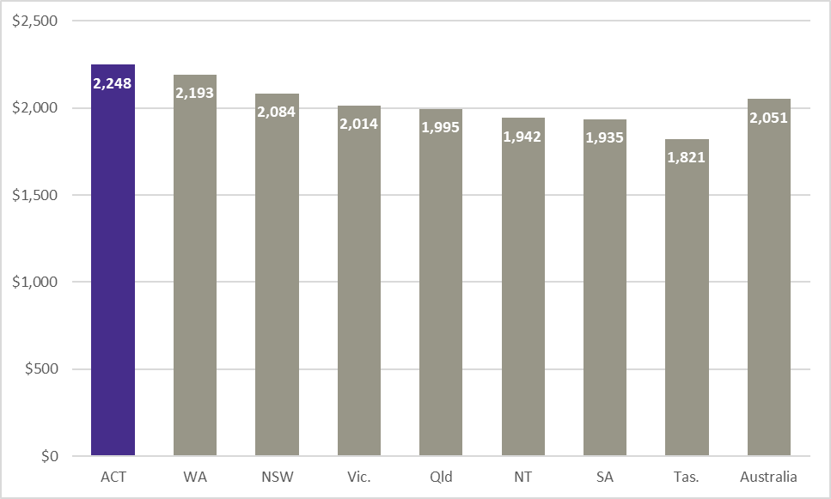

Impact of ACT Government taxes and fees on households
The ACT Government collects revenue from the community and businesses through taxes and fees to fund the high-quality services and infrastructure Canberrans expect. The Government recognises the impact these charges can have on the cost of living and carefully considers their effects across different household groups. In the context of current cost of living pressures, ACT Government tax increases in 2026-27 will be moderate with no significant increase from 2025-26.

ACT Government taxes and fees
Government taxes, fees and charges are a relatively small proportion of household costs in the ACT. Per capita taxation, as a proportion of gross household disposable income in the ACT, was 5.5 per cent in 2024-25, compared with 9.8 per cent in New South Wales and 11.7 per cent in Victoria.
Many government fees and charges are indexed annually in line with the Wage Price Index (WPI). This ensures taxes and fees keep pace with the cost of providing government services, while remaining fair and affordable for the ACT community. Taxes and fees may also be adjusted over time to reflect changes in the costs of government service provision or as economic and fiscal conditions require.

Property related taxes and fees
The 2026-27 Budget continues the Government's long-term tax reform program, supporting a more sustainable and efficient revenue base to fund high-quality public services. The Government will progress this reform by expanding residential conveyance duty concessions and increasing the commercial conveyance duty tax-free threshold, while retaining a portion of general rates increases to support Budget repair.
In 2026-27:
- The average residential general rates bill (inclusive of levies) will increase by 5 per cent.
- The Government is discontinuing the Health Levy.
- Residential and rural Police, Fire and Emergency Services Levy (PFESL) will increase by $32, to $458.
- The pensioner PFESL rebate will increase by $18, to $133.
- The Safer Families Levy (SFL) will increase by $10, to $70.
From 1 July 2026, first home buyers, pensioners buying a home, eligible NDIS recipients buying a home, and homebuyers purchasing an off-the-plan or turn-key unit will pay no duty.

Car related fees
A fee for a full five-year driver licence for a licence period commencing on or after 1 July 2026 will increase from $261.60 to $270.70, in line with WPI.
From 1 July 2024, the ACT vehicle registration system transitioned from a weight-based model to an emissions-based model. The reform means low- and zero- emission vehicles pay lower registration fees, while higher-emissions vehicles pay more. As part of this reform, registration fees for existing vehicles are being adjusted gradually over time.
In response to the significant increase in fuel costs the ACT Government has deferred an increase in registration fees above WPI that was made in the 2025-26 Budget. From 1 July 2026, registration fees will be indexed in line with WPI. This will raise less revenue than under the previous weight-based system, estimated at around $7.5 million in forgone revenue in 2026-27.
For 2026-27, the Lifetime Care and Support Levy is unchanged at $110.40 and the Motor Accident Levy at $14. The Road Safety Contribution Levy will rise from $3.20 to $3.30.

Public transport fares
Public transport fares increased by 2.75 per cent from 10 January 2026. From 8 April until 30 June 2026, the maximum monthly cap for the number of paid trips on public transport has been halved. In 2026-27, the cap for tertiary students will be reduced even further to align with that for primary and secondary school students.

Utility prices
The Government does not set prices for electricity, gas and other utilities. Water and sewerage prices are determined by the independent regulator, while other utility charges are largely market-based, reflecting the costs of generation and distribution as well as the impact of Commonwealth, state and territory energy and environmental policies.
In 2026-27, the Utilities Network Facilities Tax, paid by the owners of network facilities such as power lines, pipes and telecommunications cabling, will increase by an additional 2.5 percentage points above the WPI.

Electricity
From 1 July 2026, the average regulated standing offer tariff is expected to rise by 2.73 per cent. This means an annual bill increase of around $70 for a typical Canberra household consuming 6,500 kilowatts per year.

Natural gas
The ACT does not regulate gas prices and information on retail gas prices in 2026-27 was not available at the time of drafting this statement. An increase in prices in line with CPI is assumed for the household scenarios presented in this chapter.

Water and sewerage
Water and sewerage prices are regulated by the ICRC. For 2026-27, the annual water and sewerage bill for a typical household using 200 kilolitres of water per year will increase by 6.3 per cent, or about $91.

Concessions
The Government provides a wide range of concessions to eligible households and individuals to assist with living expenses such as general rates, conveyance duty, utility bills, driver licence fees, motor vehicle registration fees and public transport fares.
Table 3.3.1: Summary of available assistance and estimated annual take-up and costs
Assistance | Description | Estimated take up 2026-27 | 2025-26  $’000 | 2026-27  $’000
Electricity, Gas and Water Rebate | $800 rebate on utility bills. | 33,200 households | 25,300 | 26,600
Pensioner General Rates Rebate, PFESL Rebate | 50 per cent rates rebate up to $750 per year, $133 PFESL rebate per year. | 15,500 | 11,200 | 11,700
Conveyance duty concessions | Up to 100 per cent discount on conveyance duty payable. | 6,200 | 107,000 | 143,500
Spectacles Subsidy Scheme | Subsidy up to $200 on spectacle purchases once every two years. | 9,200 spectacles | 2,000 | 2,000
Taxi Subsidy Scheme | Assistance for people with disability or significant mobility restriction. | 161,100 trips | 4,900 | 5,000
Motor vehicle registration concessions | Up to 100 per cent discount on motor vehicle registration fees. | 77,900 registrations | 15,400 | 15,700
Driver licence concessions | Up to a 100 per cent discount on driver licence fees. | 6,800 licences | 1,600 | 1,600
Public transport concessions | Reduced or free fares on Transport Canberra bus and light rail services. | Over 3.2 million trips | 6,100 | 6,800
Total |  |  | 173,500 | 212,900

ACT Household Scenarios
Under section 11(1)(f) of the Financial Management Act 1996, the annual Budget must provide a statement on the effect of ACT taxes and fees on households and the concessions that offset them. Examples of how ACT Government taxes and fees, utilities and the offsetting concessions impact ACT households are in Table 3.3.2 below. The Government is mindful that it is not possible to capture the impact of taxes, fees and utility charges on every type of household, as financial circumstances or specific usage patterns of government services will vary. Therefore, eight scenarios are presented as a basis for highlighting the different impacts for various household types and circumstances.
Table 3.3.2: Estimated impact of territory taxes and fees, and utility charges on households in 2026-27
Household | Income | Government taxes and fees |  |  |  |  | Concessions |  |  |  |  | Net Impact
 | Disposable income | Rates, PFESL, SFL, HL | Conveyance Duty | Vehicle Charges | Public Transport Fares | Utilities | Rates and PFESL Concessions | Conveyance Duty Concession | Vehicle Concession | Public Transport Concession | Utilities concession | Net Disposable Income | Change
1. Belconnen - Single, pensioner, in own unit, no car
2025-26 | $29,900 | $1,801 | $0 | $0 | $1,411 | $4,248 | $865 | $0 | $0 | $706 | $800 | $24,811
2026-27 | $31,200 | $1,739 | $0 | $0 | $1,665 | $4,570 | $883 | $0 | $0 | $835 | $800 | $25,744 | $933
2. Braddon - Couple, pensioners, in own house, 2 cars, downsizing to unit in 2026-27
2025-26 | $45,000 | $6,493 | $0 | $1,434 | $0 | $6,125 | $865 | $0 | $1,114 | $0 | $800 | $33,727
2026-27 | $47,100 | $2,208 | $10,568 | $1,540 | $0 | $6,510 | $883 | $10,568 | $1,217 | $0 | $800 | $39,742 | $6,015
3. Banks - Single parent, first income quintile, in own house, 1 car, 1 child who catches the bus to school
2025-26 | $35,800 | $2,953 | $0 | $717 | $937 | $6,125 | $0 | $0 | $505 | $468 | $800 | $26,841
2026-27 | $37,000 | $3,022 | $0 | $770 | $1,084 | $6,510 | $0 | $0 | $555 | $542 | $800 | $27,511 | $670
4. Cook - Single, fixed income retiree, in own house, 1 car
2025-26 | $65,300 | $4,990 | $0 | $717 | $0 | $4,248 | $0 | $0 | $56 | $0 | $0 | $56,300
2026-27 | $68,100 | $4,309 | $0 | $770 | $0 | $4,573 | $0 | $0 | $61 | $0 | $0 | $58,509 | $2,208
5. Kingston - Single, second income quintile, in own unit, no car
2025-26 | $61,200 | $2,643 | $0 | $0 | $1,411 | $4,248 | $0 | $0 | $0 | $0 | $0 | $52,898
2026-27 | $63,200 | $2,758 | $0 | $0 | $1,665 | $4,573 | $0 | $0 | $0 | $0 | $0 | $54,204 | $1,306
6. Turner - Single, third income quintile, 1 car, purchasing first unit in 2026-27
2025-26 | $81,600 | $0 | $0 | $717 | $0 | $4,248 | $0 | $0 | $0 | $0 | $0 | $76,635
2026-27 | $84,200 | $2,559 | $14,456 | $770 | $0 | $4,573 | $0 | $14,456 | $0 | $0 | $0 | $76,298 | -$337
7. Wright - Couple, third income quintile, 2 cars, first time buying house in 2026-27, 1 child who catches bus to school
2025-26 | $163,100 | $0 | $0 | $1,434 | $937 | $6,125 | $0 | $0 | $0 | $468 | $0 | $155,072
2026-27 | $168,400 | $4,061 | $48,358 | $1,540 | $1,084 | $6,510 | $0 | $48,358 | $0 | $542 | $0 | $155,747 | $675
8. Ainslie - Couple, fourth income quintile, in own house, 2 cars, 1 school child and 1 tertiary student who catch the bus
2025-26 | $210,100 | $6,144 | $0 | $1,434 | $2,298 | $7,981 | $0 | $0 | $0 | $1,149 | $0 | $193,392
2026-27 | $217,000 | $6,642 | $0 | $1,540 | $2,337 | $8,429 | $0 | $0 | $0 | $1,168 | $0 | $199,220 | $5,828
9. Forrest - Couple, fifth income quintile, in own house, 2 cars, 2 children who catch the bus to school
2025-26 | $311,900 | $15,789 | $0 | $1,434 | $1,874 | $7,981 | $0 | $0 | $0 | $937 | $0 | $285,759
2026-27 | $322,000 | $17,872 | $0 | $1,540 | $2,168 | $8,429 | $0 | $0 | $0 | $1,084 | $0 | $293,075 | $7,316

Notes:
- Totals may not sum due to rounding.
- Disposable income is gross income minus income tax, the Medicare levy, and the Medicare levy surcharge. Disposable income levels are based on the ABS Survey of Income and Housing2019-20, indexed by WPI.
- Utilities include electricity, water, and gas. Household expenditure on utilities is based on the number of people in a household.
- Income from pension refers to Basic Age Pension only and excludes other benefits. Pension data by suburb is not available.
- Non-pension income data for retirees is unavailable. Non-pension incomes are set at a level above the Age Pension income eligibility thresholds.
- Rates are based on the median values for each suburb.
- Conveyance duty calculations are based on median unit prices in Braddon and Turner, and the median house price in Wright, as of May 2026.
- Vehicle Charges include registration fees, road rescue fee, lifetime care and support levy, and licence fees, but excludes Motor Accident Injuries (MAI) premiums charged by private sector insurers.
- Pensioners are assumed to be eligible for registration concessions. The scenarios assume an emissions category C vehicle, with a tare weight between 1,155kg and 1,505kg.
- Bus fares are calculated on the basis of monthly capped trips. Retirees are assumed to be aged 70+ and qualifying for free travel on Transport Canberra buses.
- While the table shows a decrease in disposable income for household 6, this does not include rental costs that household may have had in the previous year

Real Estate Institute of Australia, Housing Affordability Report, December Quarter 2025: https://reiv.com.au/our-industry/news/reia-s-december-2025-housing-affordability-report-released.
Cotality (previous Corelogic) Quarterly Rental Review, March quarter 2026: https://www.cotality.com/au/resources/downloads/quarterly-rental-review-report.
Australian Bureau of Statistics, Total Value of Dwellings, December Quarter 2025: https://www.abs.gov.au/statistics/economy/price-indexes-and-inflation/total-value-dwellings/latest-release
Consumer Price Index, March 2026 | Australian Bureau of Statistics: Consumer Price Index, Australia, March 2026 | Australian Bureau of Statistics.
Monthly Household Spending Indicator, March 2026 | Australian Bureau of Statistics: Monthly Household Spending Indicator, March 2026 | Australian Bureau of Statistics.
Average Weekly Earnings, Australia, November 2025 | Australian Bureau of Statistics: https://www.abs.gov.au/statistics/labour/earnings-and-working-conditions/average-weekly-earnings-australia/latest-release.

