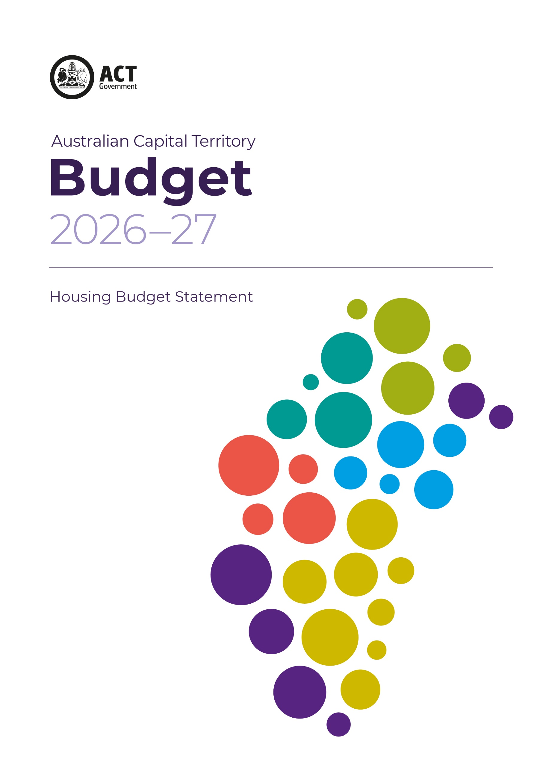



Acknowledgement
We acknowledge the Ngunnawal people as traditional custodians of the ACT and recognise any other people or families with connection to the lands of the ACT and region. We acknowledge and respect their continuing culture and the contribution they make to the life of this city and this region.

© Australian Capital Territory, Canberra 2026
Material in this publication may be reproduced provided due acknowledgement is made.
Produced by the Chief Minister, Treasury and Economic Development Directorate. Enquiries about this publication should be directed to the Chief Minister, Treasury and Economic Development Directorate.
GPO Box 158, Canberra City 2601
act.gov.au
Telephone: Access Canberra - 13 22 81

Investing in housing choice for the Canberra community

Having a home provides a critical foundation for so many aspects of a person’s life – including health, education, work and family. Increasing the supply of housing is a key part of ensuring that all Canberrans can access housing in our city, whether by buying, private-market renting or non-market renting.
The ACT Government continues to build on its range of housing initiatives to meet the needs of a growing city by increasing supply, access and choice for Canberrans

Investment for a growing population
The 2026-27 Budget includes housing initiatives worth more than $700 million over four years, including:
- More than $460 million to build and buy new public housing homes.

- More than $200 million to support public housing repairs, maintenance and operations.

- $13 million in planning and land release initiatives.

- $32 million for specialist, crisis and transitional accommodation and frontline homelessness supports.

These initiatives will help the ACT Government work towards its commitment of enabling 30,000 more homes, including 5,000 additional public, community and affordable rental dwellings in Canberra by the end of 2030.

Enabling 30,000 homes by the end of 2030

Housing Supply and Land Release Program
The 2026-27 Budget features a plan to release land that would enable close to 26,000 new dwellings across Canberra over the next five years. The first year of this plan includes more housing in new suburbs such as Macnamara and Molonglo, as well as urban infill sites in Belconnen and the City.
In 2026-27, 15 per cent of suitable residential land in the Housing Supply and Land Release Program is being released for public, community and affordable housing. These sites are spread across Canberra and will lead to the delivery of around 300 public, community and affordable housing dwellings.

The National Housing Accord
The National Housing Accord (the Accord) was published in October 2022. The Accord sets an aspirational target for Australia of 1.2 million new, well-located homes over five years from mid-2024. The Accord brings together all levels of government, investors, and the residential development, building and construction sectors to play their part in delivering these new homes.
The National Housing Supply and Affordability Council’s State of the Housing System 2026 report notes that the ACT is one of only three jurisdictions on track to meet its National Housing Accord targets.
The ACT is also one of only three jurisdictions to be invited to participate in the New Homes Bonus, which is a payment for meeting or exceeding National Housing Accord targets.
The ACT Government is on track to meet its commitments under the National Housing Accord to directly fund 175 affordable rental homes in the ACT by 2029, supported through the Affordable Housing Project Fund.

Missing Middle Housing
Missing-middle and low-rise housing options in existing suburbs will support an increase of housing supply, provide more housing choice, and support sustainable development by making Canberra more compact and efficient.
Through the 2026-27 Budget, the ACT Government will commission a Canberra House Pattern Book to provide a range of high quality pre-approved ‘missing middle’ housing designs including dual occupancies, tri-occupancies, terraces and townhouses.
The designs will be chosen based on a design competition and will be able to be purchased for $1000.
As the plans are pre-approved, projects will be able to proceed without a development application, providing greater certainty and accelerating project delivery timeframes.

Lease Variation Charge
The Government will provide a temporary 50 per cent remission of the codified Lease Variation Charge (LVC) for developments in Suburban (RZ1) and Suburban Core (RZ2) zones to support the uptake of missing middle housing developments. The remission will apply to eligible developments that:
- receive development approval before 30 June 2029,
- complete construction by 31 December 2030, and
- have not paid or deferred their LVC prior to 10 June 2026.
A framework has also been established to support a reduction in the LVC for social and affordable housing. From 2026, Community Housing Providers and developers with at least 15 per cent social or affordable rental housing in projects of more than 10 dwellings that will be completed by 31 December 2030 may be eligible for a LVC reduction.
The ACT Government will also review the LVC framework to ensure it remains fit for purpose in support of the Government’s housing policy objectives. Opportunities to simplify the framework, reduce the potential for disputes and improve certainty will be explored.

Support for home ownership

The ACT Government is continuing with its nation-leading tax reform program.

Tax Reform and Stamp Duty
In the 2026-27 Budget, the Government will expand stamp duty concessions to help more Canberrans buy a home.
From 1 July 2026 onwards:
- All first home buyers will no longer pay stamp duty.
- Owner-occupier purchasers of turn-key units and off the plan units will not pay any stamp duty.
- Eligible pensioners will no longer pay stamp duty.
- Homebuyers eligible for the Disability Duty Concession Scheme will no longer pay any duty regardless of the price of the property.
- The Pensioner Duty Concession Scheme will be expanded to Service Pension recipients with a permanent incapacity to work, and Department of Veterans’ Affairs Gold Card holders will no longer require a 12-month waiting period.

Supporting Home Ownership
The ACT Government has signed up to the Help to Buy Intergovernmental Agreement that started operating in December 2025. The Help to Buy program complements ACT initiatives by providing shared equity opportunities for low- and middle-income households.
The Commonwealth Government and ACT Government have reached an agreement to unlock around 4,900 homes in the ACT, including over 1,700 exclusively for first home buyers. The Commonwealth Government will provide $200 million in concessional loans and $50 million in grant funding to support infrastructure work for the delivery of these homes throughout the ACT.

Increasing housing choice and affordability and reducing homelessness
Measures in the 2026-27 Budget focus on boosting social housing and working with the community housing sector to increase access to affordable housing.

Delivering 5,000 public, community and affordable rental homes by the end of 2030

Boosting social housing supply
Growing the supply of social housing remains a priority for the ACT Government, with a commitment to grow the Housing ACT property portfolio to 13,200 dwellings by the end of 2030.
By June 2027 the Growing and Renewing Public Housing program will meet the committed target of 1,000 property renewals and 400 net public housing portfolio growth, with funding included in the 2026-27 Budget to achieve this.
The 2026-27 Budget paves the way for further increases to the portfolio by providing $360 million for an additional 450 public housing dwellings, through the launch of the new Public Housing Pipeline.
More than half of these homes are also being put forward for funding by the ACT Government through the Housing Australia Future Fund (HAFF) Round 3.
The ACT Government will also continue to progress delivery of other dwellings supported under Commonwealth Government programs, including construction of 85 social housing dwellings supported under HAFF Round 2 and the 41 remaining Social Housing Accelerator Program dwellings in 2026 to bring the total delivered to 55.

Supporting the delivery of more community and affordable rental homes
Recognising the unprecedented opportunity offered by HAFF Round 3, in the 2026-27 Budget the ACT Government is partnering with the community housing sector to maximise outcomes for the ACT community. This includes launching the Community Housing Loan Guarantee, where the ACT Government will offer financial guarantees for approved projects.
The ACT Government will offer guarantees of up to $650 million to support more than 1,000 social and affordable dwellings.
The ACT Government is also providing financial support for Yerrabi Yurwang to progress its application through the First Nations stream of HAFF Round 3.

Affordable Housing Project Fund
The ACT Government’s $100 million Affordable Housing Project Fund will support over 800 new affordable rental homes.
During 2025-26, significant progress has been made on projects in the Affordable Housing Project Fund pipeline, with 22 dwellings constructed in Strathnairn and a further 464 dwellings under construction across Phillip, Taylor, Turner and Belconnen.
Negotiations have continued with Community Housing Providers on a range of other projects receiving support from the Affordable Housing Project Fund, including:
- 55 homes in the Gungahlin Town Centre through Community Housing Canberra (CHC).
- 29 homes in Moncrieff through Yerrabi Yurwang.
- 27 homes in Lyneham through YWCA Canberra.
- Further homes in Whitlam and Lyneham with Havelock Housing and ECHO.
This is in addition to the following projects announced during 2025-26, including:
- 315 homes in Belconnen delivered by Assemble in partnership with Housing Choices Australia.
- 83 homes in Curtin delivered by Wesley Curtin Limited (co-located with the MyHome project).
- 15 homes in Taylor delivered by Housing Plus.

Build-to-Rent
Build-to-Rent is a housing model that offers housing for long-term rentals under single ownership. The ACT Government is supporting the delivery of Build-to-Rent projects with an affordable rental component by releasing land specifically for this purpose. Sites in the Gungahlin and Molonglo town centres are expected to be released in coming years.
Support for private market renters
The ACT Government will continue to provide financial support to private renters experiencing rental stress or those experiencing financial hardship, through the establishment of the Housing Crisis Support Fund and a Crisis Support Payment. This measure will replace the previous Rent Relief Fund that ceased in July 2025

Affordable Community Housing Land Tax Exemption Scheme
Through the Affordable Community Housing Land Tax Exemption Scheme, the ACT Government provides land tax exemptions to landlords who rent their properties at affordable rates to eligible tenants through a Community Housing Provider. The ACT Government has increased the property cap from 250 to 1,000 and introduced a $500,000 Grant Program in 2026 to support Community Housing Providers in growing and improving the Scheme.

Reducing homelessness
In the 2026-27 Budget, the ACT Government will provide increased funding support, with $16.9 million invested over four years for homelessness and housing support services. Increased funding will be provided for a range of homelessness service providers and advocates including Samaritan House, Roadhouse, Blue Door, Our Place Braddon, Community Housing Canberra, and ACT Shelter, ensuring the ongoing delivery of crucial specialist frontline services and associated advocacy and outreach services for community members experiencing homelessness.
The ACT Government will also provide funding to support the delivery of crisis and transitional housing for vulnerable cohorts at risk of homelessness under the Commonwealth’s National Housing Infrastructure Facility Crisis and Transitional Housing Program.
In the 2026-27 Budget, the ACT Government will provide ongoing funding to continue the Justice Housing Program and the Aboriginal and Torres Strait Islander Transitional Accommodation Program. These programs provide short-term transitional accommodation and wrap-around support to individuals on parole, bail or community correction orders from the Alexander Maconochie Centre (AMC) delivered by the community sector.

More information
For more information, visit https://www.act.gov.au/housing-planning-and-property.

