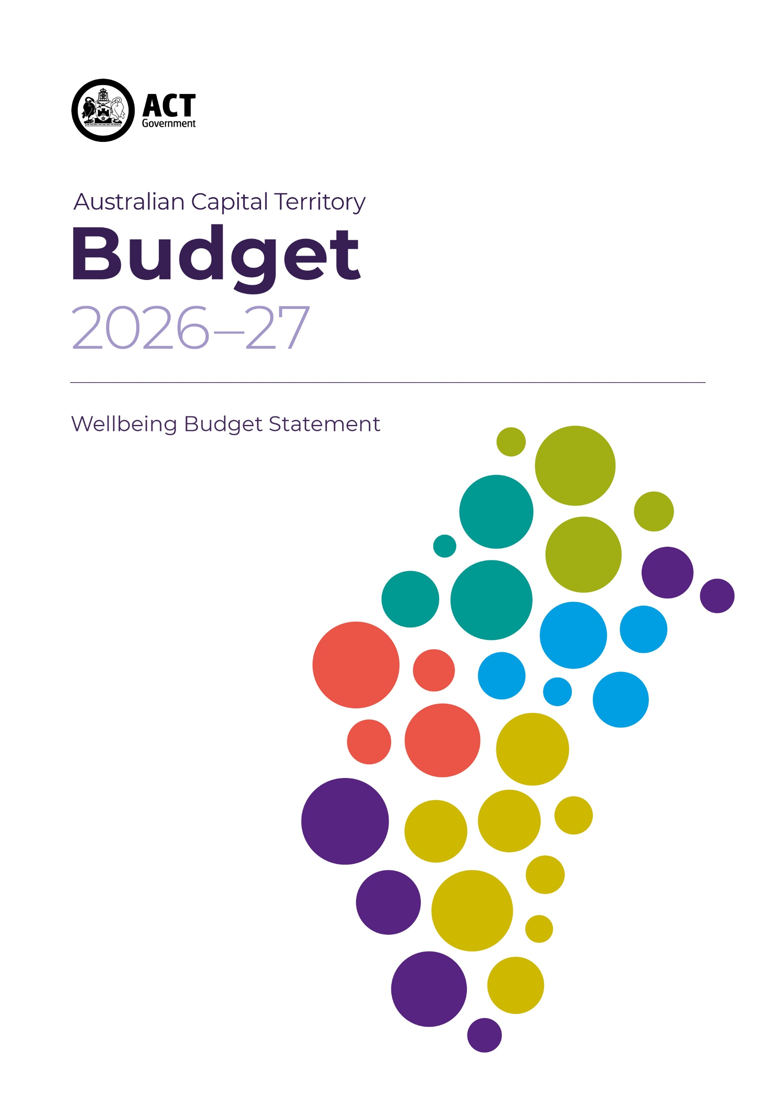



Acknowledgement
We acknowledge the Ngunnawal people as traditional custodians of the ACT and recognise any other people or families with connection to the lands of the ACT and region. We acknowledge and respect their continuing culture and the contribution they make to the life of this city and this region.

© Australian Capital Territory, Canberra 2026
Material in this publication may be reproduced provided due acknowledgement is made.
Produced by the Chief Minister, Treasury and Economic Development Directorate. Enquiries about this publication should be directed to the Chief Minister, Treasury and Economic Development Directorate.
GPO Box 158, Canberra City 2601
act.gov.au
Telephone: Access Canberra - 13 22 81

Chief Minister’s Foreword

Since introducing the ACT Wellbeing Framework in 2020, we have placed wellbeing at the centre of how we develop policy, deliver services and invest in our community, environment and institutions. Each year, we continue to refine and deepen our approach to ensure that decisions reflect what matters most to Canberrans and enhance the quality of life for all who call our city home.
Canberra remains one of the most liveable cities in the world. But we know that persistent pressures exist that have a direct impact on our community.
Our commitment to wellbeing helps us to meet these challenges and target our action and investment towards areas that make a positive difference in the lives of Canberrans, particularly those who are facing disadvantage and marginalisation and those who may be unable to participate in the things that help people feel connected to their city and each other.
Central to a wellbeing informed budget is acting on areas that need immediate attention, while also investing in the areas that are important for life-long wellbeing, and lay the foundations for positive whole of community wellbeing into the future. We have done that in this Budget, with investments in early supports, critical services, and transformational infrastructure and programs.
Through this Budget, we continue our commitment to wellbeing, and to building a stronger, more inclusive and more resilient city that supports Canberrans today and for generations to come.
Andrew Barr, MLA
Chief Minister

Introduction
The ACT Government places the wellbeing of Canberrans at the centre of decision-making. This reflects a commitment to ensuring that our policies, services and investments improve quality of life – not only through economic growth, but across the social, environmental and community factors that shape how we live.
Since the introduction of the ACT Wellbeing Framework in 2020, wellbeing has become an increasingly central part of how Government operates. The Framework was developed in consultation with the Canberra community and reflects what people identified as most important to their lives. It identifies 12 domains of wellbeing, recognising that outcomes are shaped by a broad range of interconnected factors.
Through the 2026-2027 Budget process, we continue our focus on six wellbeing priority areas:
- addressing marginalisation and disadvantage;
- children’s early years;
- cost of living;
- housing;
- mental and physical health; and
- women.
The priorities highlight areas where we can make the most difference for individual and community wellbeing.
These priority areas, and other areas important to wellbeing, are sometimes impacted through factors beyond the control of the ACT Government. We aim to understand, invest and act to improve local experiences where we can and shift outcomes over time.
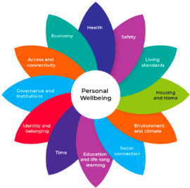

Living well in Canberra
Data from the University of Canberra’s Living Well in the ACT Region survey provides important information about the state of wellbeing in the ACT community and its underlying drivers.
The Personal Wellbeing Index – a measure of how Canberrans perceive their quality of life – indicates a modest improvement in wellbeing between 2024 and 2025. The proportion of residents experiencing low wellbeing declined, returning to levels comparable with mid-2022 and early 2023, reflecting a reduction in levels of economic stress for some households in 2025.
Improvements were observed across the population, with broadly consistent gains across genders. These gains were driven primarily by younger cohorts, particularly those aged under 50, where the proportion reporting low wellbeing declined across both the 18–29 and 30–49 age groups. In contrast, outcomes for those aged over 50 remained relatively stable.
Confidence in the future remained broadly stable, with a modest increase in the proportion of residents expecting to be better off over the next five years and fewer expecting their circumstances to worsen. Improvements in future confidence were most evident among working-age Canberrans.
Canberra continues to demonstrate strong social cohesion and liveability, with more than 90 per cent of residents consistently reporting that Canberra is a good place to live. Community participation has continued its post-pandemic recovery, with fewer residents reporting low participation and more reporting high levels of engagement. While participation has not yet returned to pre-COVID-19 levels, the upward trend indicates sustained re-engagement across the community.
Overall, the findings based on data point to gradual but meaningful improvements in wellbeing across the ACT during 2025 associated with improvement in economic conditions.
The first half of 2026 has been characterised by significant global economic uncertainty, contributing to interest rate increases and heightened cost pressures. These changes are expected to place renewed strain on household finances, particularly for mortgage holders, and may affect confidence in the future and personal wellbeing. These events are a reminder that the wellbeing of the ACT is closely connected to global events and that sustained action on affordability, financial security and social connection is important for building resilience to these global shocks and supporting future wellbeing outcomes.

Wellbeing budgeting in the ACT
A wellbeing approach to budgeting strengthens our ability to address immediate challenges while driving sustained, system-level improvements. It seeks to widen the frame of reference and recognise wellbeing means supporting our community, institutions and environment in the present while promoting intergenerational equity and not compromising the wellbeing of future generations.
The 2026-27 ACT Budget is the seventh budget delivered under the ACT Wellbeing Framework, reflecting a sustained commitment to embedding wellbeing at the centre of government decision-making. This leadership continues to be recognised at both national and international levels.
This approach sharpens our focus on distributional impacts, ensuring policies and services are designed and assessed with a clear understanding of how outcomes differ across population groups, based on their circumstances and lived experiences.
A practical example of this is assessing whether funding proposals invest in upstream or downstream solutions. Upstream investment addresses drivers of the problem and aims to prevent negative outcomes before they occur. Downstream investment focuses on mitigating consequences rather than addressing underlying causes. A balanced approach to investing in wellbeing requires both; long-term investments aimed at prevention alongside immediate responses to shorter term needs.
This assessment informs decision makers, broadens our understanding of the wellbeing impacts of proposals, and provides opportunities to support directorates in early planning of initiatives. When combined with work from our partners, such as the Australian National University’s research on paths into and out of disadvantage, mapping funding flows in this way will help directorates identify where they can strategically invest to improve community wellbeing, particularly for some of the most disadvantaged or at-risk cohorts in Canberra.

Wellbeing Priority Areas for 2026-27
Wellbeing priority areas help to target complex challenges that extend beyond single agencies and budget cycles. This is the third Budget to continue the 6 wellbeing priorities, with an acknowledgement that the delivery of long-lasting and meaningful change requires sustained effort.
The priority areas are interconnected and seek to multiply our efforts. For example, investment in housing not only improves living conditions but also contributes to stronger educational outcomes for children, enhanced social connection, reduced stress, and promotes better health outcomes. This approach enables a single investment to advance multiple priorities, improving overall effectiveness and delivering greater value across the system.

Addressing marginalisation and disadvantage
A fair and inclusive society is fundamental to overall wellbeing for individuals and the community.
People or groups can experience marginalisation and disadvantage for a variety of reasons, limiting full participation in society. Economic, social, cultural or systemic barriers, over time, can lead to entrenched disadvantage and poorer outcomes across multiple areas of life.
Experiences of disadvantage are not evenly distributed with some groups being more likely to face persistent challenges, including those experiencing low income, housing stress, or social exclusion. Without targeted intervention, these challenges can compound across the life course and across generations.
Investments in Budget 2026-27
The Budget provides funding across a range of areas to support those in our community who are marginalised or at greater risk of disadvantage, including supporting children from lower income families to participate more equitably in education, and through investing in the community sector that supports some of the most vulnerable people in our community. Investments detailed across other priority areas, in particular across ‘Housing’ and ‘Cost of living’, will support those in our community facing greater risks of vulnerability, break cycles of disadvantage and improve intergenerational equity.

Cost of living
Cost of living pressures remain a significant challenge for many Canberrans. While the ACT continues to record high average incomes, rising costs for essentials such as housing, energy and food are placing pressure on household budgets, particularly for those on lower incomes or experiencing vulnerability.
These pressures have broad impacts on wellbeing. Financial stress can affect mental and physical health, reduce participation in education and employment, and increase the risk of housing instability. It can also reduce opportunities for social connection and community participation particularly for community members who are disadvantaged, marginalised, living with disability, older, or facing other barriers to participation. These effects are often cumulative, with financial hardship contributing to longer-term disadvantage if not addressed early.
It is important to support individuals and families experiencing challenges with the increasing cost of living for a fairer, more equitable society, where everyone can enjoy the benefits of living in Canberra.
Investments in Budget 2026-27
This budget provides cost of living relief through a variety or measures, including:
- Continuing investment in the Sustainable Household Scheme and increasing the loan cap to $20,000 for all products in the scheme for new participants from 1 July 2026 and also adding electric cargo bikes as eligible for support under the scheme.
- Continuing the Renters’ Home Energy Program and the Home Energy Support program to assist renters and lower income households to manage energy use within their homes.
- Additional funding over two years for a temporary uplift of Emergency Material and Financial Aid to meet expected increased demand due to fuel disruptions and associated impacts.
- Establishing a new Housing Crisis Support Fund and a Crisis Support Payment to provide targeted assistance to low income households experiencing rental stress.
- Providing additional funding for the Student Equity Fund’s 2026 round to support access to education for all students.
The 2026-27 Cost of Living Statement includes more information about cost of living assistance measures.

Housing
Housing is fundamental to our wellbeing and intergenerational equity, and a key priority for government. Access to safe, stable and appropriate housing underpins many facets of wellbeing including our health, education, employment and ability to participate in the community.

Investments in Budget 2026-27
The 2026–27 Budget includes more than $770 million in funding over four years for housing initiatives.
These investments collectively aim to build a more inclusive and responsive housing system in the ACT that increases supply while providing targeted supports to improve stability and wellbeing, particularly for vulnerable people. Further details on these measures are outlined in the Housing Budget Statement and Chapter 3.2 of the Budget Outlook.

Housing spotlight
The ACT, like many jurisdictions nationally and globally, is presented with a significant opportunity to reshape its housing system in response to affordability and supply pressures. These challenges – while acute for low- and moderate-income households and those at risk of homelessness – create a clear impetus to drive targeted, system-wide reform.
Improving housing supply, affordability, access and choice are priorities for government. Targeting our investment and action towards these areas is critical to enhancing wellbeing outcomes across the community. In this Budget, the Government is strengthening its focus on expanding housing supply across the continuum, accelerating the growth of public and community housing, increasing the availability of affordable rental dwellings, and enhancing homelessness and support services.
The Government is delivering on its commitment to support the housing needs of Canberrans now and into the future. This is being delivered through: our land release program; planning reforms; changes to lease variation charges and the expansion of stamp duty concessions; targeted incentives and supports such as the establishment of the Housing Crisis Support Fund for private renters; expanded public, community and affordable housing; and partnerships with the Commonwealth Government and community sector.
Over successive Budget cycles, this government has invested in a range of measures that collectively work towards enabling 30,000 new homes by 2030 while strengthening pathways into home ownership, supporting renters, and reducing homelessness in our growing city. Taken together, these actions position the ACT to build a more inclusive, responsive housing system that not only meets current demand but supports long-term social and economic wellbeing.

Mental and physical health
Good health is central to wellbeing and affects all aspects of our lives. Our physical and mental health influences our ability to work, learn, connect with others and participate in the community.
In recent years, there has been increasing demand for both acute and community-based health services. At the same time, there is growing recognition of the importance of prevention and early intervention for improving long-term outcomes and reducing pressure on the health system.
The government is focused on supporting the life-long health and wellbeing of Canberrans through growing and strengthening our health system, including our hospitals, primary care, and community-based services, alongside expanded prevention and early intervention initiatives.
Investments in Budget 2026-27
The 2026-27 Budget will support the health of Canberrans through the investment of $910 million over four years including:
- Delivering the new Northside Hospital
- Opening the newly constructed South Tuggeranong Health Centre
- Increasing capacity at Canberra Health Services’ Rapid Access Clinic to improve early detection and integrated care for individuals with, or at risk of, lung cancer.
- Operationalising the Acute Palliative Care Unit at Canberra Hospital. The facility will provide specialised medical care that relieves symptoms and improves quality of life.
- Delivery of a suite of initiatives related to medicine management and vaccinations.
- Providing grants to community sector organisations to deliver a perinatal mental health safe space for Aboriginal and Torres Strait Islander women and birthing people.
- Continuing the Indigenous Allied Health Australia ACT Aboriginal and Torres Strait Islander Health Academy.

Children’s early years
The early years of life are critical to long-term wellbeing. Evidence consistently shows that experiences during pregnancy and early childhood have a lasting influence on our health, learning, behaviour and social outcomes.
Investment in the early years delivers significant long-term benefits, including improved educational attainment, better health outcomes, and reduced risk of disadvantage later in life.
Investment in the early years is one of the most effective ways to improve wellbeing, reduce inequality and support intergenerational outcomes.
The 2026–27 Budget continues to prioritise early childhood through investment in education, health, and family support services, ensuring that all children have the opportunity to thrive from the start of life.
Investments in Budget 2026-27
Measures to support the early years in the 2026-27 Budget include:
- Increasing capacity at the Canberra Hospital Paediatric Fracture Clinic, which provides care for children with bone and soft tissue injuries, and establish a dedicated elective paediatric orthopaedic service to provide care for children closer to home.
- Continuing the Children and Young People Equipment Loan Scheme (CAYPELS) as a three day per week service providing free short-term loans of paediatric equipment and assistive technology for children and young people with disabilities and mobility needs.
- Extending Preschool Reform Agreement to continue delivering the free four-year-old preschool program in ACT public schools throughout 2026 and 2027 school years and support the early childhood sector.
- Delivering Stage 2 of the Whitlam Early Childhood Education and Care (ECEC) to Year 6 Primary School project to provide 130 places in an Early Childhood Education and Care Centre and increase the school’s capacity for up to 780 primary school students.

Women
Achieving gender equality is essential to improving wellbeing outcomes across the community. Experiences of safety, economic security, health and participation can differ significantly across gender and these differences influence overall wellbeing outcomes.
While progress has been made, women and girls continue to face disproportionate challenges, including higher rates of domestic, family and sexual violence, lower lifetime earnings, poorer health outcomes and greater housing and financial insecurity.
These inequalities have wide-ranging impacts, affecting not only individual wellbeing but also families, children and communities. Addressing these inequities, and the underlying causes, is a priority for government and requires sustained, collective and targeted action.
Investments in Budget 2026-27
The 2026-27 Budget delivers a range of initiatives to support women and girls, including:
- Supporting local women’s sporting teams – the ACT Meteors, Canberra Heat and Canberra Chill.
- Expanding the High-Risk Breast Cancer Screening Clinic at North Canberra Hospital to increase access to specialised screening, treatment and support services for people at high risk of developing breast cancer.
- Implementing foundational measures under the ACT Domestic, Family and Sexual Violence (DFSV) Strategy First Action Plan aimed at improving the integration, capability and responsiveness of the DFSV system.
- Increasing investment in frontline DFSV services in the ACT and provide funding certainty to the frontline service system. The Canberra Rape Crisis Centre, the Domestic Violence Crisis Service and Everyman will receive additional funding. There will also be funding for Victim Support ACT to continue the Wraparound program.
- Continuing, and funding, our commitment to ensuring period product availability in public schools, sports pavilions, libraries and public health facilities.
- Delivering priority actions under the Maternity in Focus: Second Action Plan 2026-2029, including strengthening midwifery workforce capability and co-designing and implementing a Birthing with Country model.
- Continuing the no cost abortion service.
The 2026-27 Women’s Budget Statement includes more information about how the Government is continuing to invest in the wellbeing of women and girls.

New Support for Community Support, Social Inclusion and Safety
The ACT community sector provides essential frontline services and supports that many Canberrans rely on. During 2026-27 Budget consultations, community sector organisations emphasised the need for continued and increased funding to meet rising demand and support sustainability.
The 2026-27 Budget allocates $182.6million in new funding to support community support, social inclusion and safety, and this includes uplift for the community sector. This investment provides funding certainty and enables our valued community sector partners to have the confidence to plan for the future, grow and retain their hard-working staff, and continue to provide high-quality supports and care to our community.
Key initiatives include:
- $22.7 million to uplift to the community sector, supporting a responsive and evolving service system and focusing on areas of greatest need.
- $16.7 million in ongoing funding for community legal assistance organisations and other justice support.
- $16.9 million in expanded and new funding to support more homelessness services.
- $894,000 in continued and expanded funding to support services and advocacy for LGBTQIA+ Canberrans.
- $100,000 in new funding to support Sexual Health and Family Planning ACT deliver essential sexual and reproductive health services in 2026-27.
This investment demonstrates the government’s commitment to supporting the wellbeing of Canberrans through a strong and sustainable community sector.

Wellbeing Domains
The 2026-27 Budget prioritises investment to meet the immediate needs of our community while supporting the long-term growth of our city. Wellbeing remains a central consideration in policy development, guiding investment toward areas where it can have the greatest impact.
The total figures outlined below for each Budget category have been calculated using the primary wellbeing domains associated with each policy decision. While there will always be a primary domain, most initiatives will have multiple impacts across a broad range of wellbeing domains that will be included in the relevant description in Budget Outlook.
The total investment the Government is committing as part of the 2026-27 Budget is listed below:
- Health care – we are providing $910 million in funding – this category is predominantly aligned to the wellbeing domain of Health and to aspects of the Safety domain.
- Education and training – we are providing nearly $253 million in funding – this category is predominantly aligned to the wellbeing domain of Education and life-long learning and aspects of the Environment and climate, and Health domains.
- Housing and homes – we are providing $770 million in funding – this category is predominantly aligned to the wellbeing domain of Housing and home and aspects of the Governance and institutions, and the Economy domains.
- Community support, social inclusion and safety – we are providing $182.6 million in funding – this category is predominantly aligned to the wellbeing domains of Social connection, Identity and belonging, and Safety.
- Transport, city services, environment and climate – we are providing $343.1 million in funding – this category is predominantly aligned to the wellbeing domains of Environment and climate, Access and connectivity and aspects of the Safety domain.
- Jobs, entertainment, sport and culture – we are providing $143.5 million in funding – this category is aligned to the wellbeing domains of Governance and institutions, Economy, and aspects of Social connection, Identity and belonging and Living standards domains.
- Public administration – we are providing $202 million in funding — this category is aligned to the wellbeing domains of Governance and institutions and the Economy.

What’s next
The ACT Wellbeing Framework already ensures that Government priorities, policies and investment decisions, through Budget and Cabinet processes, are informed by the things that matter most to Canberrans and their quality of life. We are working to embed the Framework more comprehensively to encourage greater consideration of the linkages that contribute to overall wellbeing.
A stronger focus on wellbeing outcomes leads to improved joined-up, and whole of government approaches to developing and delivering solutions to complex and interconnected challenges, including across directorates and agencies with diverse responsibilities. This year, we will be testing what more is possible in this space.
This focus on improving wellbeing and quality of life for all Canberrans, and with a specific focus on those with lower levels of positive wellbeing, helps to build strong, supportive and connected systems, and enhances community resilience to enable us to weather the impacts of disruptive external events.
We will also continue efforts to build and strengthen our evidence base. Building a stronger evidence base is an ongoing effort and is essential to improving wellbeing outcomes. It enables government to better understand the factors that influence quality of life, identify where action is most needed, and assess whether policies and investments are delivering improvements. The ACT Government considers a wide range of data sources – such as administrative data, national datasets, international best practice, feedback from community sector partners, and longitudinal surveys – to provide insight into the experiences of Canberrans and how wellbeing is changing. This approach looks beyond averages to see and respond to those impacts that are not apparent or require longer term responses to needs.
The Government is also strengthening its evidence through partnerships with research institutions and other key partners. Collaborations with the University of Canberra and the Australian National University are supporting data capture and linkage, and deeper analysis of wellbeing drivers, including the pathways into and out of disadvantage. Initiatives such as the Life Course Data Initiative, undertaken in partnership with the Commonwealth Government, are enhancing the ability to link data across systems and over time, providing new insights into how early life experiences and later outcomes are connected.
By continuing to strengthen this foundation, the ACT Government is better positioned to deliver policies and services that improve wellbeing for all Canberrans – now and into the future.
Further information on the ACT’s wellbeing approach can be found here: Embedding wellbeing - ACT Wellbeing Framework.

