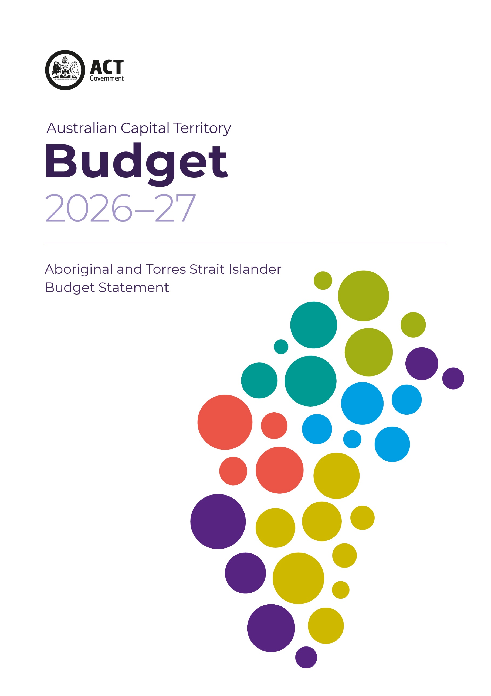



Acknowledgement
We acknowledge the Ngunnawal people as traditional custodians of the ACT and recognise any other people or families with connection to the lands of the ACT and region. We acknowledge and respect their continuing culture and the contribution they make to the life of this city and this region.

© Australian Capital Territory, Canberra 2025
Material in this publication may be reproduced provided due acknowledgement is made.
Produced by the Chief Minister, Treasury and Economic Development Directorate. Enquiries about this publication should be directed to the Chief Minister, Treasury and Economic Development Directorate.
GPO Box 158, Canberra City 2601
act.gov.au
Telephone: Access Canberra - 13 22 81

Aboriginal and Torres Strait Islander Budget Statement

The ACT Government is deeply committed to advancing self‑determination, equity and improved life outcomes for Aboriginal and Torres Strait Islander peoples living in the ACT, guided by genuine partnership, transparency and accountability.

Introduction
Central to this commitment is the ACT Aboriginal and Torres Strait Islander Agreement 2019–2028 (the Agreement), a jointly signed agreement with the Aboriginal and Torres Strait Islander Elected Body (the Elected Body) that places self‑determination at the heart of government decision‑making and service delivery.
The Agreement aligns with the National Agreement on Closing the Gap (the National Agreement) and commits the ACT to structural reform, shared decision‑making and community leadership across government systems.
The ACT Government has strengthened its governance arrangements with Aboriginal and Torres Strait Islander leadership. In November 2025, Cabinet Ministers and the Elected Body members met for the first time as a formal sub‑committee of ACT Cabinet, marking a significant step in shared decision‑making, system reform and whole‑of‑government accountability. Ministers reaffirmed their commitment to regular engagement, transparency in reporting, and coordinated action across portfolios.
In recognition of the need to move beyond intention to action, the ACT has become the first jurisdiction in Australia to legislate public sector accountability for Closing the Gap, embedding these commitments into law and requiring senior public servants to demonstrate measurable progress. This landmark reform, passed by the Legislative Assembly in December 2025, reinforces that Closing the Gap outcomes are core government business, not optional activity.
Our priorities include:
- Delivering on the Priority Reform Areas in the National Agreement
- Strengthening community-controlled organisations
- Improving access to data and transparency
- Ensuring government agencies are accountable for progress
The ACT Government recognises the important role that Aboriginal Community Controlled Organisations (ACCOs) play in supporting greater self-determination for the Aboriginal and Torres Strait islander community. This includes the need for continued investment to sustain and build capacity and ensure greater community control in delivering essential programs under the Closing the Gap agreement. The 2026-27 Budget will also include new initiatives of over $8 million to be delivered by ACCOs, building on the existing pipeline of funding to support programs delivered by the sector.

Uluru Statement from the Heart
The ACT was the only jurisdiction to vote “Yes” in the 2023 referendum and ACT Government is implementing the Uluru Statement from the Heart by:
- Voice: via the Aboriginal and Torres Strait Islander Elected Body, and ensuring they are able to be the voice for Aboriginal and Torres Strait Islander Canberrans
- Treaty: through early-stage discussions and funding. Looking at and drawing from the experiences across the country.
- Truth: through planned healing and truth‑telling processes.

Truth Telling

The Budget provides $754,000 over two years to fund research and cultural history projects into the history, presence and contributions of Aboriginal and Torres Strait Islander peoples in the ACT and surrounding region to advance the Government’s commitment to the Uluru Statement from the Heart. The projects will provide an evidence-based foundation for truth‑telling and cultural recognition, helping to inform and improve government policy and practice.

Supporting the Aboriginal and Torres Strait Islander Elected Body
The ACT Government has responded to the Aboriginal and Torres Strait Islander Elected Body’s 2025 Hearings Report Truth through Transparency, with the ACT Government agreeing to 12 recommendations, agreeing in principle to 37 Recommendations, with one recommendation not agreed to.
The ACT Government acknowledges that more must be done and has committed to accelerated reform against the Agreement’s priority areas.
The ACT Government recognises that meaningful change requires listening, truth‑telling and sustained action. Through partnership with Aboriginal and Torres Strait Islander communities, the Elected Body, and the ACT Public Service, the Government remains committed to delivering tangible, measurable improvements and ensuring Aboriginal and Torres Strait Islander peoples are leaders in shaping their own futures in the ACT.
As the democratically elected representative body for Aboriginal and Torres Strait Islander people living in the ACT, the ACT Government is committed to supporting the Elected Body in fulfilling its role. As the formal “voice” to the ACT Government on issues affecting Aboriginal and Torres Strait Islander people in the ACT, we value their work and are working to enhance their role in line with Priority Reform 1 of the National Agreement.
The Budget will fund $740,000 for the Elected Body to help meet growing community and government engagement expectations, with the Government also working with the Elected Body to consider arrangements for its next term.

Governance for implementation of the review into the over-representation of Aboriginal and Torres Strait Islander people in the ACT criminal justice system.
This governance framework supports the Elected Body in providing independent oversight of the ACT Government’s response to the Jumbunna Institute for Indigenous Education and Research review and to facilitate community interaction with the Elected Body.
The ACT Government is providing $1.06 million to fund two independent justice advisors, one with expertise in child, youth and families and one to focus on adult justice. The Government will support the Elected Body to engage in this work – remunerating relevant portfolio Members for additional time to focus on this work and increasing resourcing for the Elected Body independent secretariat for this work. The Government will also support increased capacity through small grants for community to engage in this important work.

Board of Inquiry into Aboriginal and Torres Strait Islander deaths in the Alexander Maconochie Centre (AMC)
$5.367 million over two years is allocated to conduct a six-month Board of Inquiry into Aboriginal and Torres Strait Islander deaths at the Alexander Maconochie Centre.
$327,000 is specifically set aside to provide legal financial assistance to individuals and organisations, alongside $48,000 for community organisations to deliver counselling and other community-based support services.
Supreme Court Circle Sentencing
Funding of $1.044 million over four years is being provided to continue Circle Sentencing following the successful pilot commenced in 2024. This will deliver up to 10 Aboriginal and Torres Strait Islander Supreme Court Circle Sentencing court matters a year.
The Supreme Court Circle Sentencing enables Aboriginal and Torres Strait Islander community participation in the court process and embedding Aboriginal and Torres Strait Islander voices, perspectives and experiences in the sentencing process. It utilises culturally appropriate programs and supports to address needs, promote rehabilitation and healing and address risk factors that may have an impact on an offender’s continued involvement with the criminal justice system. The Circle Sentencing facilitates court monitoring of culturally appropriate therapeutic programs to address identified needs and risk factors.
Aboriginal and Torres Strait Islander Perinatal Mental Health Safe Space
An Aboriginal and Torres Strait Islander Perinatal Mental Health Safe Space help ensure that Aboriginal and Torres Strait Islander parents and families receive care that is culturally safe, trauma-informed and responsive to their lived experiences during pregnancy and early parenthood.
A Safe Space recognises that perinatal mental health cannot be separated from the broader impacts of intergenerational trauma, colonisation, racism and systemic disadvantage, which continue to affect many Aboriginal and Torres Strait Islander communities. It provides an environment where individuals feel respected, understood and empowered, rather than judged or marginalised.
ACT Government will invest $1.2 million over 4 years from 2026-27 to support grants to community sector organisations to deliver perinatal mental health safe space for Aboriginal and Torres Strait Islander women and birthing people.
This is a significant priority for the Aboriginal and Torres Strait Islander community. Aboriginal and Torres Strait Islander families possess deep cultural strengths – strong kinship networks, cultural identity, and thousands-of-years-old parenting traditions – which mainstream services are not always able to recognise or build upon. This will provide a culturally informed, holistic mental health support including during the perinatal period. This is supported by Priority Reform 2, and outcome 14 of the National Agreement and will support recommendations 9 and 9a from the Our Booris, Our Way report.
By prioritising culturally appropriate care, the Safe Space help to improve mental health outcomes for parents, strengthen family and community wellbeing, and give children the best possible start to life.
Supporting Aboriginal and Torres Strait Islander Housing
The ACT Government is committed to support the development of Aboriginal and Torres Strait Islander housing program. We are providing $500,000 to support Yerrabi Yurwang’s Housing Australia Future Fund application for building costs of a 29-dwelling townhouse development in Moncrieff.
The Government is supporting Yerrabi Yurwang to acquire the Moncrieff site with over $3 million through the Affordable Housing Project Fund.

ACT Domestic, Family and Sexual violence (DFSV) Strategy
The ACT Government is committed to ensuring culturally responsive services are available to support Aboriginal and Torres Strait Islander people impacted by domestic, family and sexual violence. This commitment is reflected in the new Domestic, Family and Sexual violence (DFSV) Strategy 2026-36 which centres the role of Aboriginal and Torres Strait Islander voices in developing and delivering responses for community.
The 2025-26 ACT Budget allocated $6million to Aboriginal Community Controlled Organisations delivering domestic and family violence supports and delivering a community and professional 'Violence Is Not Our Way' education campaign.
There is an additional investment of $2 million in the 2026-27 Budget to establish a grant pool for ACCOs delivering sexual violence responses.
The 2026-27 Budget also includes $124,000 in funding to elevate Aboriginal and Torres Strait Islander voices in DFSV governance arrangements to promote shared decision making and support the participation of ACCOs in broader workforce development and coordination activities.

Aboriginal and Torres Strait Islander Health Academy
The Aboriginal and Torres Strait Islander Health Academy is an important initiative that supports the development of a strong, culturally capable Aboriginal and Torres Strait Islander health workforce and contributes to improved health outcomes for Aboriginal and Torres Strait Islander communities.
The Academy creates pathways into education, training and employment in health and care sectors, enabling Aboriginal and Torres Strait Islander people to build meaningful careers while remaining connected to culture and community. By investing in skills development and leadership, it strengthens self-determination and community control within the health system.
An investment of $1.873 million over four years from 2026–27 (indexed) will sustain the IAHA Health Academy program, supporting 30 places per year for Aboriginal and Torres Strait Islander students and learners. The program provides a structured and supported pathway into the health sector by enabling participants to undertake a Certificate III in Allied Health Assistance at the Canberra Institute of Technology (CIT) alongside an Australian School‑based Apprenticeship (ASbA).
This initiative plays a vital role in building a strong, sustainable Aboriginal and Torres Strait Islander health workforce, which is essential to improving health and wellbeing outcomes for Aboriginal and Torres Strait Islander communities. By creating early and accessible entry points into health careers, the program supports participants to gain practical skills, formal qualifications and meaningful employment opportunities.
Importantly, strengthening pathways for Aboriginal and Torres Strait Islander students to complete vocational education and training during secondary school contributes directly to Closing the Gap Priority Reform 2 —building the community-controlled sector—and aligns with associated sector strengthening plans. Graduates of the program are well positioned to work within, and support the growth of, Aboriginal Community Controlled Health Organisations (ACCHOs) and ACCOs, which deliver culturally safe and community-led health services.

Aboriginal and Torres Strait Islander Cadetship program
Through the City Precinct Renewal Program, the ACT Government is offering an Aboriginal and Torres Strait Islander Cadetship providing $485,000 over four years from 2026-27.
The City Precinct Renewal Program Cadetship will empower Aboriginal and Torres Strait Islander tertiary students by combining academic studies with paid, hands-on work experience. It aims to build professional capabilities, facilitate career pathways into urban planning and public sectors, and foster culturally inclusive city spaces.

Responding to the ACT Public School Resourcing Review
Funding of $2.0 million over four years is provided to establish new Aboriginal and Torres Strait Islander community-led governance within the education system, including funding for secretariat and remuneration for members. The Education Directorate has commenced a community-led consultation and design process to establish the ongoing body.
The ACT Public School System Resourcing Review recommended the Education Directorate work with community to establish an ongoing body to enable Aboriginal and Torres Strait Islander community to advise government on resourcing and policy related matters. The new body will emphasise Aboriginal and Torres Strait Islander voice in decision making.

Head Start Program
The ACT Government's Head Start program is an Australian School-based Apprenticeship (ASbA) initiative that supports public school students to gain hands-on trade and vocational experience while completing their Year 12 certificate.
With $774,000 over two years, Head Start will continue working towards aligning with the Closing the Gap action plans under the National Agreement to strengthen outcomes for Aboriginal and Torres Strait Islander students with a continued annual allocation of five places for Aboriginal and/or Torres Strait Islander students and further collaboration with cultural, educational and community support networks including the Education Directorate’s Aboriginal and Torres Strait Islander Education team and Cultural Integrity Officers across ACT public schools.
Aboriginal and/or Torres Strait Islander students made up 7.66% of all students who applied for a Head Start placement since its inception. The second evaluation report has identified opportunities for inclusive and culturally safe engagement approaches for Aboriginal and Torres Strait Islander students.

Parent Advocacy Service Grant
The ACT Government will commit $550,000 to establish a two-year trial of a parent advocacy service to provide information, tools and support for families to navigate school engagement.
The program will provide grant funding to ACT Parents to deliver the service from the start of the 2027 school year, including advocating for Aboriginal and Torres Strait Islander families and supporting them in a culturally safe and appropriate manner by members of their community.
The grant program development will require service providers to demonstrate how they will support students and families with a range of vulnerabilities, including through connections with specialist community organisations.

CIT Yurauna
An investment of $5.878 million will support the ongoing operational, maintenance, technology and asset management costs associated with the CIT Woden Campus and Youth Foyer. This funding ensures that critical education infrastructure remains modern, accessible and responsive to student needs, while providing a stable foundation for the delivery of high‑quality vocational education and training across the ACT.
As part of this investment, $510,000 supports Yurauna, CIT’s centre for Aboriginal and Torres Strait Islander educational excellence, designed to provide a culturally safe and supportive learning environment for Aboriginal and Torres Strait Islander students. The establishment of Yurauna in its new purpose-built centre on CIT Bruce Campus represents a significant step in strengthening culturally appropriate education pathways and recognising the importance of Aboriginal and Torres Strait Islander-led learning spaces within the tertiary education system.
CIT Yurauna delivers tailored courses, study support and wraparound services that respond to the unique needs and aspirations of Aboriginal and Torres Strait Islander students. Through a combination of skills training, mentoring, academic support and cultural guidance, the centre supports students to build their knowledge, confidence and capabilities. This holistic approach recognises that educational success is closely linked to cultural identity, wellbeing and connection to community.
Importantly, CIT Yurauna plays a key role in supporting students to transition into further education, training and employment, helping to create clear and supported pathways into careers of choice. By empowering students with both qualifications and confidence, the centre contributes to improved education outcomes, increased workforce participation and long-term economic and social wellbeing.
More broadly, this investment strengthens the ACT’s commitment to equity in education and Closing the Gap priorities, by ensuring Aboriginal and Torres Strait Islander learners have access to culturally safe, high-quality learning environments and support systems. It also contributes to building a skilled and diverse workforce, while reinforcing the importance of self-determination and culturally informed approaches within the education sector.

First Nations Justice Initiatives
The Government recognises the urgent need to address the over-representation of Aboriginal and Torres Strait Islander people in the justice system.
We are focused on:
- Improving outcomes for detainees
- Increasing transparency and oversight
- Working with community to design and implement reforms
Justice system reform remains a key priority as part of our broader commitment to equity and human rights.
An investment of $3.267 million over four years will support the continuation and strengthening of Integrated Case Management, with $2.517 million directed to the community sector and $750,000 allocated for a full-time equivalent (FTE) position within the Justice and Community Safety Directorate (JACSD). This funding ensures a coordinated, whole‑of‑system response to meeting the needs of Aboriginal and Torres Strait Islander people in contact with the justice system.
Integrated Case Management provides a holistic, person-centred approach that brings together government agencies and community-controlled organisations to address the complex and often overlapping factors that contribute to justice system involvement. These can include housing instability, health and mental health challenges, substance use, trauma, and socio‑economic disadvantage. By coordinating support across services, the initiative aims to reduce reoffending, improve wellbeing outcomes and support successful reintegration into the community.
A key component of this initiative is the continuation of the Transitional Accommodation Program, including the Justice Housing Program, which provides safe, stable and supported accommodation for individuals exiting custody or at risk of entering the justice system. Access to appropriate housing is recognised as a critical factor in breaking cycles of offending, enabling individuals to focus on rehabilitation, reconnect with family and community, and access employment, education and health services.
Importantly, delivery through the community sector ensures that support is culturally informed, trauma‑aware and grounded in community knowledge and relationships. This enables services to be more responsive and effective, while strengthening the role of Aboriginal and Torres Strait Islander organisations in the justice and social support system.
Overall, this investment reflects a commitment to justice reinvestment principles and Closing the Gap priorities, shifting the focus from reactive responses to early intervention, prevention and community-led solutions. By supporting integrated, culturally appropriate services and stable housing pathways, these initiatives contribute to safer communities, reduced justice system involvement and improved long-term outcomes for Aboriginal and Torres Strait Islander people.

