### Conceptual Data Modeling

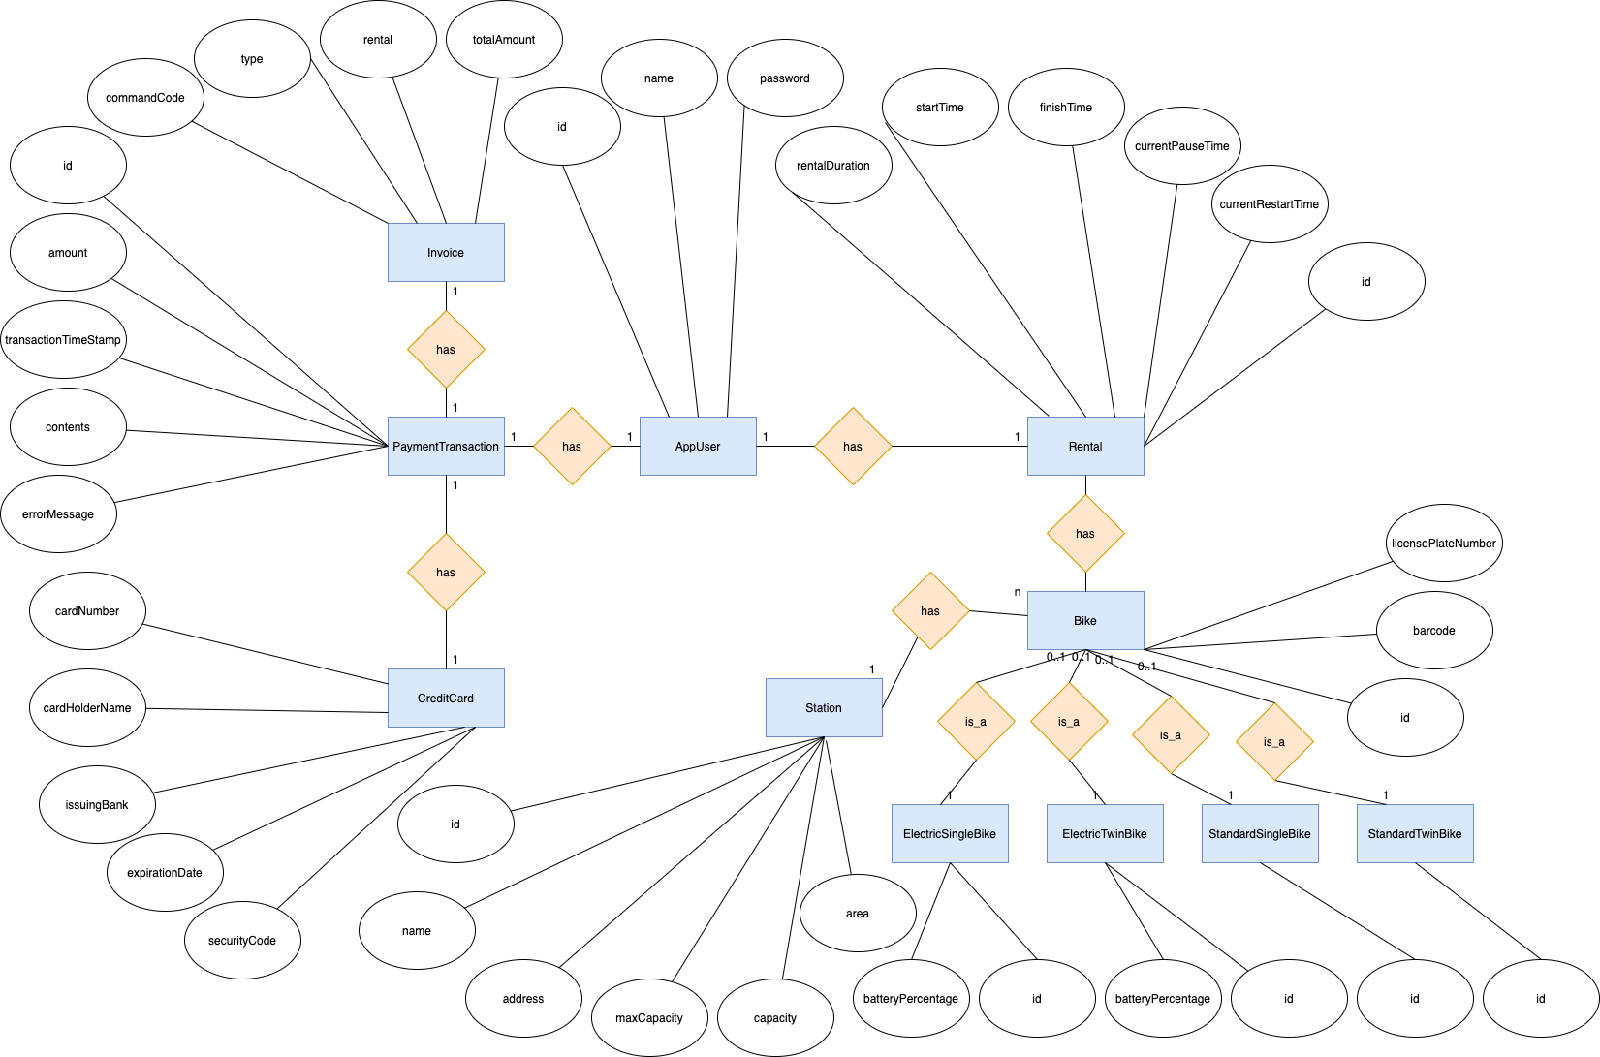

### Database Design

#### Database Management Systems

Database Management System: MySQL

MySQL is an open-source relational database management system.

#### Logical Data Model

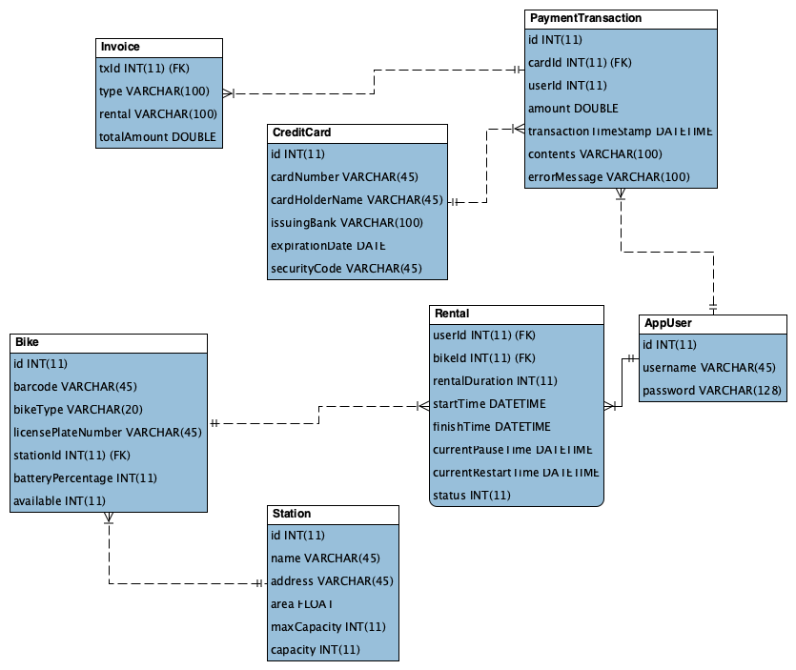

#### Physical Data Model

**AppUser**

|  |  |  |  |  |  |  |
| --- | --- | --- | --- | --- | --- | --- |
| # | PK | FK | Column Name | Data Type | Mandatory | Description |
| 1 | X |  | id | Integer | Yes | Id, auto increment |
| 2 |  |  | username | Varchar(45) | Yes | Name of user |
| 3 |  |  | password | Varchar(128) | Yes | Password of user |

**Rental**

|  |  |  |  |  |  |  |
| --- | --- | --- | --- | --- | --- | --- |
| # | PK | FK | Column Name | Data Type | Mandatory | Description |
| 1 | x | x | userId | Integer | Yes | User’s ID |
| 2 | x | x | bikeID | Integer | Yes | Bike’s ID |
| 3 |  |  | rentalDuration | Integer | Yes | Duration of renting |
| 4 |  |  | startTime | Datetime | Yes | Time start renting |
| 5 |  |  | finishTime | Datetime | Yes | Time finish renting |
| 6 |  |  | currentPauseTime | Datetime | Yes | Current time of pausing |
| 7 |  |  | currentRestartTime | Datetime | Yes | Current time of restarting |
| 8 |  |  | status | Integer | Yes | Status of renting |

**Bike**

|  |  |  |  |  |  |  |
| --- | --- | --- | --- | --- | --- | --- |
| # | PK | FK | Column Name | Data Type | Mandatory | Description |
| 1 | X |  | id | Integer | Yes | Id, auto increment |
| 2 |  |  | barcode | Varchar(45) | Yes | Barcode of bike |
| 3 |  |  | bikeType | Varchar(20) | Yes | The type of the bike |
| 4 |  |  | licensePlateNumber | Varchar(45) | Yes | License plate number of bike |
| 5 |  | X | stationId | Integer | No | station’s ID |
| 6 |  |  | batteryPercentage | Integer | No | The battery percentage of the bike |
| 7 |  |  | available | Integer | Yes | The availability of the bike |

**Station**

|  |  |  |  |  |  |  |
| --- | --- | --- | --- | --- | --- | --- |
| # | PK | FK | Column Name | Data Type | Mandatory | Description |
| 1 | X |  | id | Integer | Yes | Id, auto increment |
| 2 |  |  | name | Varchar(45) | Yes | Name of station |
| 3 |  |  | address | Varchar(45) | Yes | Address of station |
| 4 |  |  | area | Float | Yes | The area of the station |
| 5 |  |  | maxCapacity | Integer | Yes | Max capacity of station |
| 6 |  |  | capacity | Integer | Yes | Current capacity of station |

**PaymentTransaction**

|  |  |  |  |  |  |  |
| --- | --- | --- | --- | --- | --- | --- |
| # | PK | FK | Column Name | Data Type | Mandatory | Description |
| 1 | X |  | id | Integer | Yes | Id, auto increment |
| 2 |  | x | cardId | Integer | Yes | Card’s ID |
| 3 |  | x | userId | Integer | Yes | User’s ID |
| 4 |  |  | amount | Integer | Yes | Amount of transaction |
| 5 |  |  | transactionTimeStamp | Datetime | Yes | Time of transaction |
| 6 |  |  | contents | Varchar(100) | Yes | Contents of transaction |
| 7 |  |  | errorMessage | Varchar(100) | Yes | Error message of transaction |

**Credit Card**

|  |  |  |  |  |  |  |
| --- | --- | --- | --- | --- | --- | --- |
| # | PK | FK | Column Name | Data Type | Mandatory | Description |
| 1 | X |  | id | Integer | Yes | Id, auto increment |
| 2 |  |  | cardNumber | Varchar(45) | Yes | Number of card |
| 3 |  |  | cardHolderName | Varchar(45) | Yes | Holder name of card |
| 4 |  |  | issuingBank | Varchar(100) | Yes | Issuing bank of card |
| 5 |  |  | expirationDate | Date | Yes | Error message of transaction |
| 6 |  |  | securityCode | Varchar(45) | Yes | Expiration Date of card |

**Invoice**

|  |  |  |  |  |  |  |
| --- | --- | --- | --- | --- | --- | --- |
| # | PK | FK | Column Name | Data Type | Mandatory | Description |
| 1 | x |  | txId | Integer | Yes | Id, auto increment |
| 2 |  |  | type | Varchar(100) | Yes | Type of payment: deposit, payment, refund |
| 3 |  |  | rental | Varchar(100) | Yes | Status: pay or refund |
| 4 |  |  | totalAmount | Varchar(100) | Yes | Renting money |

**Database Script:**

*CREATE TABLE AppUser(*

*id INTEGER PRIMARY KEY AUTO_INCREMENT NOT NULL,*

*username VARCHAR(45) NOT NULL,*

*password VARCHAR(128) NOT NULL*

*);*

*CREATE TABLE Station(*

*id INTEGER PRIMARY KEY AUTO_INCREMENT NOT NULL,*

*name VARCHAR(45) NOT NULL,*

*address VARCHAR(45) NOT NULL,*

*area FLOAT NOT NULL,*

*maxCapacity INTEGER NOT NULL,*

*capacity INTEGER NOT NULL*

*);*

*CREATE TABLE Bike(*

*id INTEGER PRIMARY KEY AUTO_INCREMENT NOT NULL,*

*barcode VARCHAR(45) NOT NULL,*

*bikeType VARCHAR(20) NOT NULL,*

*licensePlateNumber VARCHAR(45) NOT NULL,*

*stationId INTEGER,*

*batteryPercentage INTEGER DEFAULT 0,*

*available INTEGER DEFAULT 1,*

*CONSTRAINT fk_Bike_Station1 FOREIGN KEY (stationId) REFERENCES Station(id)*

*);*

*CREATE TABLE Rental(*

*userId INTEGER NOT NULL,*

*bikeId INTEGER NOT NULL,*

*rentalDuration INTEGER DEFAULT 0,*

*startTime DATETIME DEFAULT CURRENT_TIMESTAMP,*

*finishTime DATETIME,*

*currentPauseTime DATETIME,*

*currentRestartTime DATETIME,*

*status INTEGER DEFAULT 0,*

*PRIMARY KEY (userId, startTime),*

*CONSTRAINT fk_Rental_User1 FOREIGN KEY(userId) REFERENCES AppUser(id),*

*CONSTRAINT fk_Rental_Bike1 FOREIGN KEY(bikeId) REFERENCES Bike(id)*

*);*

*CREATE TABLE CreditCard(*

*id INTEGER PRIMARY KEY AUTO_INCREMENT NOT NULL,*

*cardNumber VARCHAR(45) NOT NULL,*

*cardHolderName VARCHAR(45) NOT NULL,*

*issuingBank VARCHAR(100) NOT NULL,*

*expirationDate DATE NOT NULL,*

*securityCode VARCHAR(45) NOT NULL*

*);*

*CREATE TABLE PaymentTransaction(*

*id INTEGER PRIMARY KEY AUTO_INCREMENT NOT NULL,*

*cardId INTEGER NOT NULL,*

*userId INTEGER NOT NULL,*

*amount REAL NOT NULL,*

*transactionTimeStamp DATETIME NOT NULL,*

*contents VARCHAR(100) NOT NULL,*

*errorMessage VARCHAR(100) NOT NULL,*

*CONSTRAINT fk_PaymentTransaction_CreditCard1 FOREIGN KEY(cardId)REFERENCES CreditCard(id),*

*CONSTRAINT fk_PaymentTransaction_User1 FOREIGN KEY(cardId)REFERENCES AppUser(id)*

*);*

*CREATE TABLE Invoice(*

*txId INTEGER DEFAULT NULL,*

*type VARCHAR(100) NOT NULL,*

*rental VARCHAR(100) NOT NULL,*

*totalAmount REAL NOT NULL,*

*PRIMARY KEY(type,rental),*

*CONSTRAINT fk_Invoice_PaymentTransaction1 FOREIGN KEY(txId)REFERENCES PaymentTransaction(id)*

*);*