Small Store (web based)

By: Ali Torabi, Behnaz Akbariafshar

Project description:
Using this system, vendors of different kinds of small stores and owners of small business can save customer and their order records, daily sells, finding best products they sold. They can have different reports such as orders, revenue and so on in a desired period.
This system is divided by two main parts: Administration and Cashier. To buy staffs, user can login, or register, if he has not already registered. Administration role, has five management functionality:
- Category of products: to making categories for products
- Products: to make and assign the products to a category
On the other hand, users can order and change their profiles.
Also, there is the possibility to “Export to pdf or Excel file”.

Technologies used:
In this project, we will use the following technologies:

PHP Slim, Meekrodb, Twig, Monolog, AJAX
Shopping cart
RESTful APIs
Facebook login integration APIs
Google search console APIs
Storing binary files in database
Generating PDF/Excel/Word document on the fly

Challenging items that were not done in class, etc:

Facebook login integration APIs
Google search console APIs
Storing binary files in database
Generating PDF/Excel/Word document

1- Home page: | 2- According to the username, there will be two roles of simple or administrator roles. Obviously, the administrator can manage everything in system like:
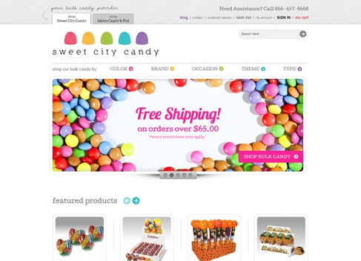 | 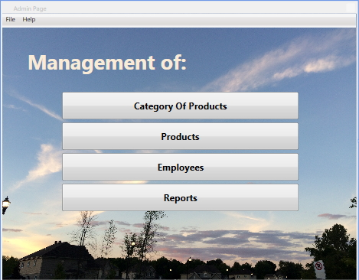
4-By choosing “Group of products”, you can manage this item in the below page: | 5-By choosing “Products”, you can manage this item in the below page:
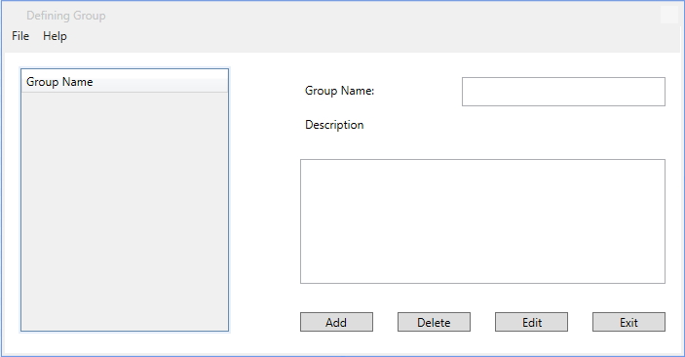 | 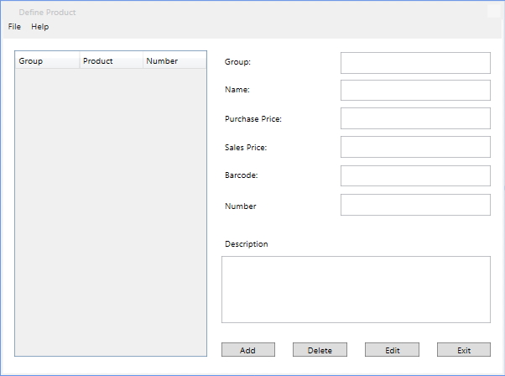
7-By choosing “Reports”, you’ll go to the below page and then you can see your desired report: | 8-By choosing “My profile”, the administrator can edit his information like below page:
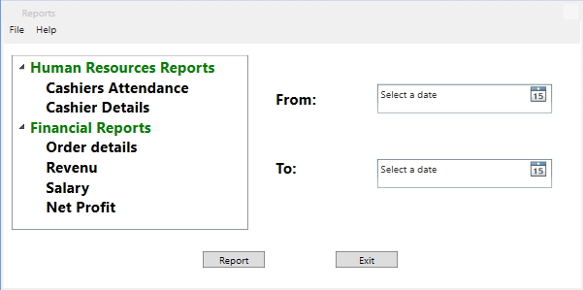 | 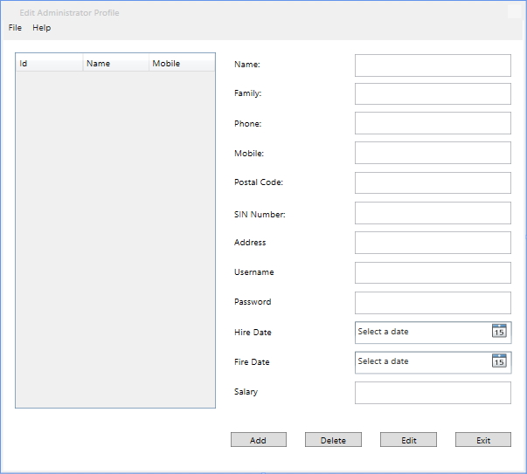

On the other hand, there are different pages for users to manage their orders.

9-By choosing “My orders”, the user can make order | 10-After selecting all products, by clicking on “Pay” button, we’re going to see the confirmation and payment method page and after a successful payment, user will get the green message:
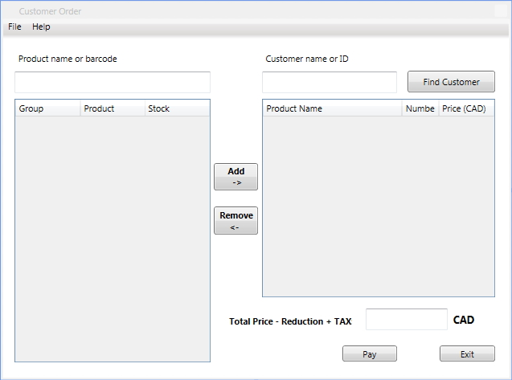 | 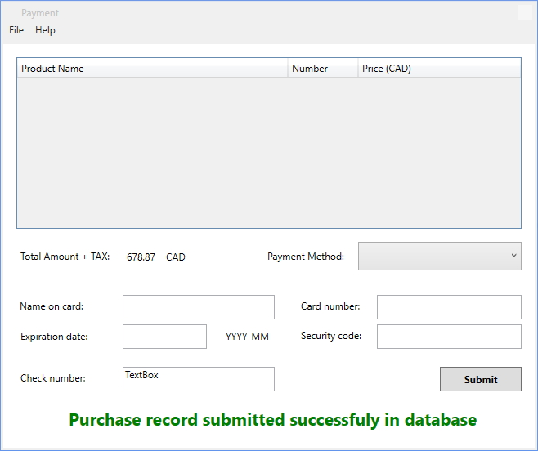

Design of the database:

