Small Store (for small business)

By: Ali Torabi, Behnaz Akbariafshar

Project description:
Using this application, vendors of different kinds of small stores and owners of small business can save customer and their order records, daily sells, finding best products they sold. They can have different reports such as orders, revenue and so on in a desired period. Plus, they can manage their cashier’s attendance to pay their salary.
This system is divided by two main parts: Administration and Cashier. Running the application, we can see the main page (actually the login page in terms of user’s role). Administration role, has five management functionality:
- Category of products: to making categories for products
- Products: to make and assign the products to a category
- Employees: to define employees
- Reports: orders, revenue in a desired period, and so on.
On the other hand, cashiers can define, edit and probably delete customers, to save the customer’s orders and finally to change their password.
Also, in the “File” menu of some pages, there is “Print page” item and “Export to pdf file”.

Technologies used:
In this project, we will use the following technologies:
- WPF, C#
- SQL Database via Azure
- Multiple windows
- Ribbon instead menus
- StackPanel, GridSplitter, TreeView
- PDF-generation and printing

Special features:
Using report viewer (https://msdn.microsoft.com/en-us/library/hh273267.aspx)

Additional libraries:

Extended WPF Toolkit™ (http://wpftoolkit.codeplex.com/) (?)

(http://stackoverflow.com/questions/24500154/wpf-styling-from-external-libraries-and-static-resources)

Challenging items that were not done in class, etc:

(?)

1- After running the application, Login page will appear: | 2-If you do not enter valid Username and/or Password, then you are going to see a message to try again: | 3-By choosing “Administrator”, if you enter valid Username and Password and submit, you’re going to Administration main page:
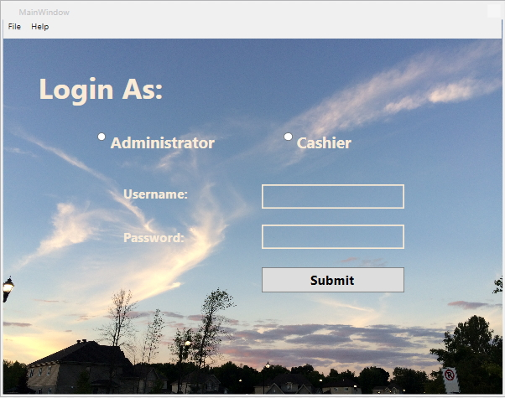 | 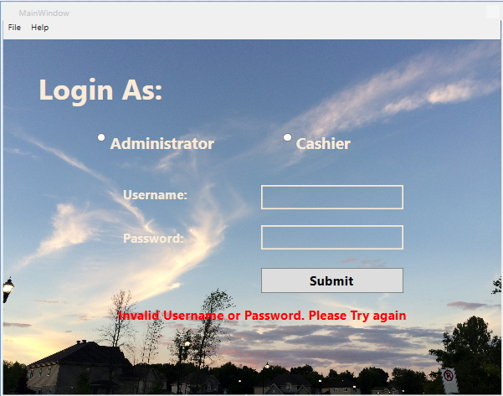 | 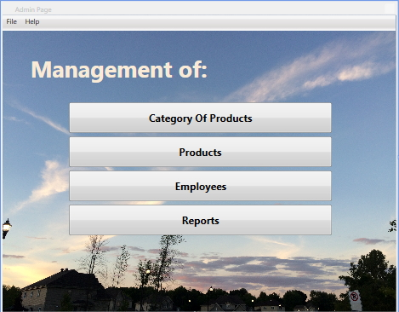
4-By choosing “Group of products”, you can manage this item in the below page: | 5-By choosing “Products”, you can manage this item in the below page: | 6-By choosing “Cashiers”, you can manage this item in the below page:
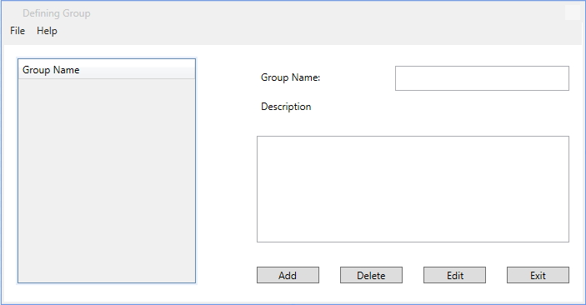 | 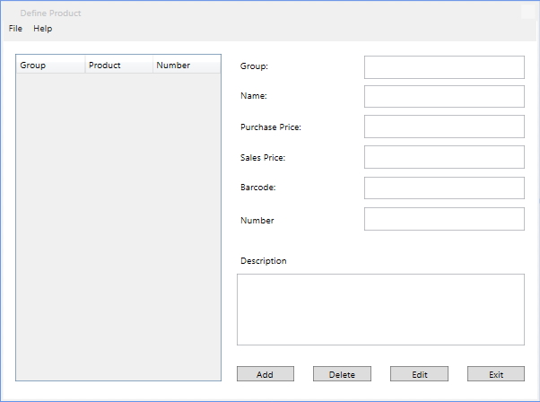 | 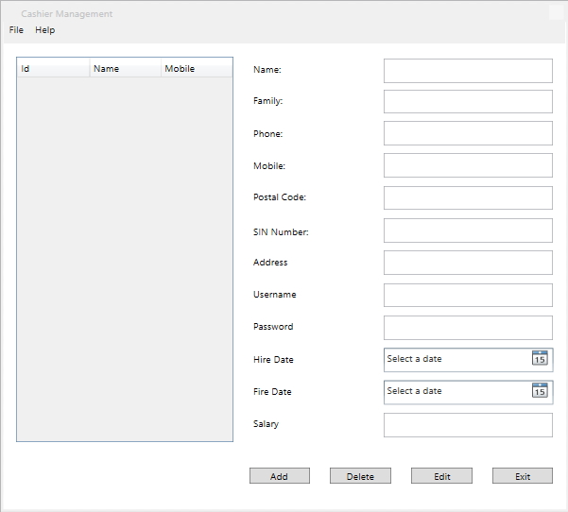
7-By choosing “Reports”, you’ll go to the below page and then you can see your desired report: | 8-By choosing “My profile”, the administrator can edit his information like below page:
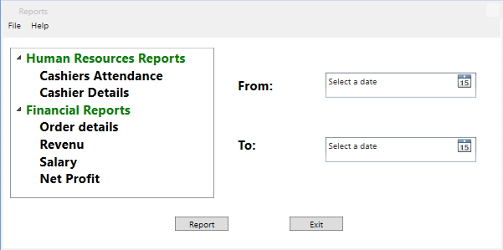 | 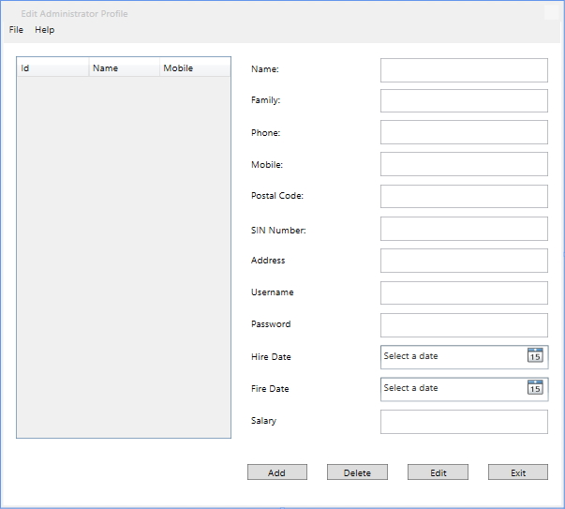

On the other hand, there are different pages to manage customers and orders by a cashier.
Note: An administrator also has access to the related pages like a cashier.

1-By choosing “Cashier”, if you enter valid Username and Password and submit, you’re going to Cashier main page: | 2-By choosing “Customers”, the below page appears and the cashier can add, remove or edit a customer’s record: | 3-By choosing “My Password”, the below page appears to changing his password:
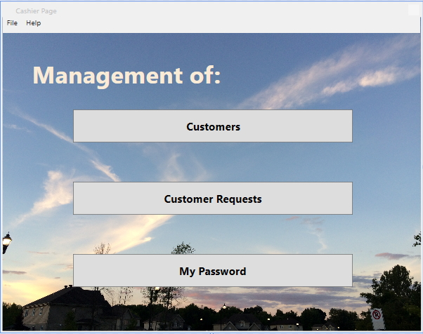 | 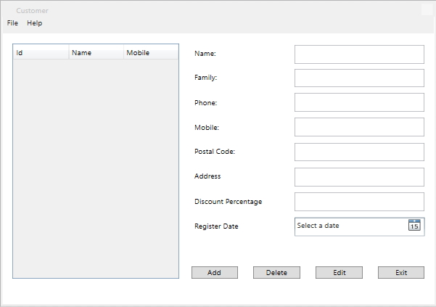 | 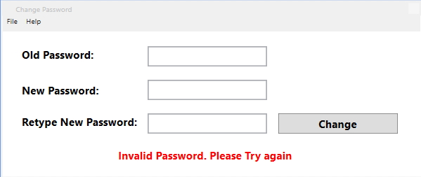
4-By choosing “Customer Requests”, the cashier can make an order for a customer | 5-After selecting all products for the customer, by clicking on “Pay” button, we’re going to see the confirmation and payment method page and after a successful payment, cashier will get the green message:
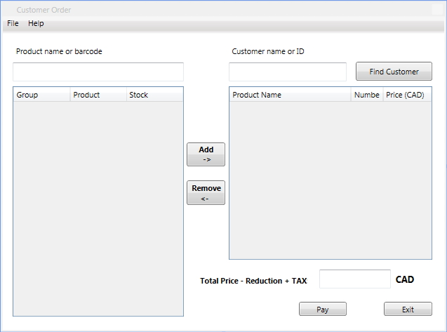 | 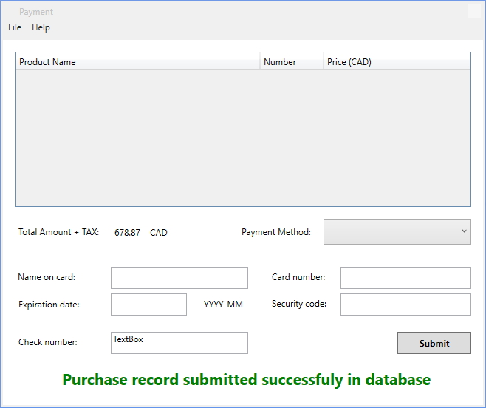

Design of the database:

