e-bay simulation

By: Ali Torabi, Behnaz Akbariafshar

Project description:
An online auction and shopping website to submit goods to sell them with the best price. As well, users can buy and sell a broad variety of goods worldwide. Also a search to find items they need and buy online, as well compare to find the best prices and properties of items.

Technologies used:
In this project, we will use the following technologies:

-PHP Slim, Meekrodb, Twig, Monolog
- AJAX, RESTful API
- Shopping cart
- Facebook login integration
-Storing binary files in database (images)

Additional libraries:

-Facebook API login integration
-Generating PDF(history of payment –history of all purchases or sells)

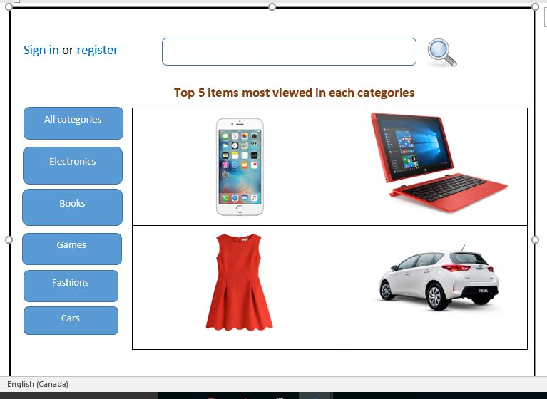
Home Page

User dashboard- user profile
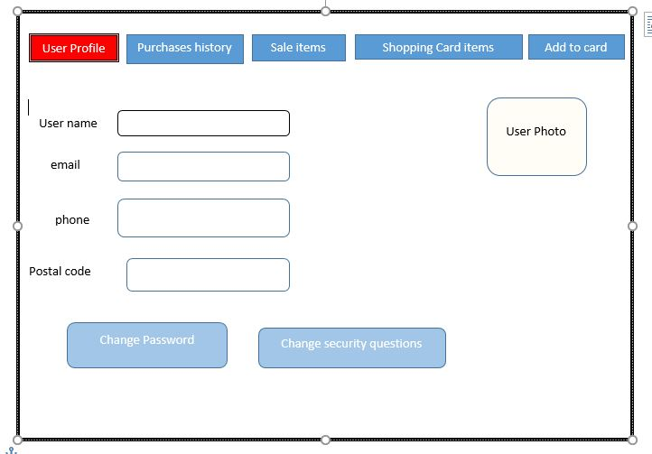

User dashboard- purchases history

