e-bay simulation

By: Ali Torabi, Behnaz Akbariafshar

Project description:
an online auction and shopping website in which people buy and sell a broad variety of goods worldwide
Search for find items that need and buy it in internet compare for good price and also compare properties of items or put an announce for sell something

Technologies used:
In this project, we will use the following technologies:
-PHP Slim, Meekrodb, Twig, Monolog
- AJAX
- Shopping cart
- Facebook login integration
-Storing binary files in database (images)

Additional libraries:

-Facebook API login integration
-Generating PDF(history of payment –history of all purchases or sells)

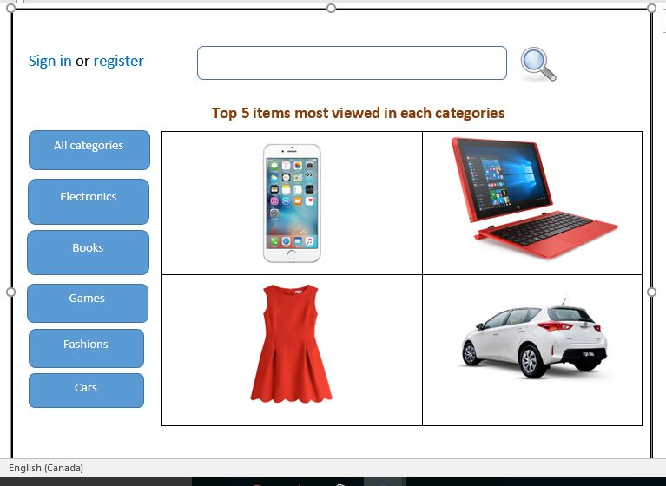
Home Page

User dashboard- user profile
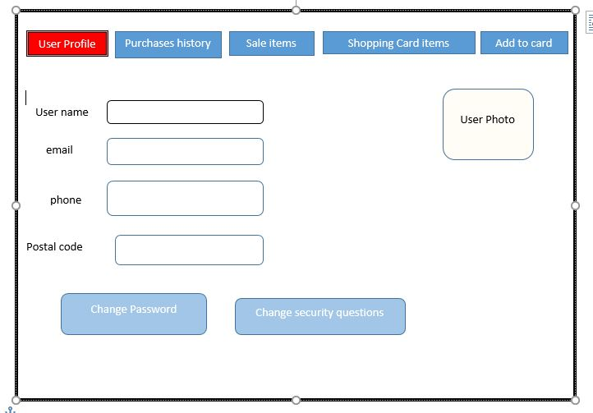

User dashboard- purchases history

