

National University of Computing and

Emerging Sciences (Karachi Campus)

Department Of Computer Sciences

PROJECT

# Title: “EFFECTIVE FLIGHT OPERATION”

***INTRODUCTION:***

***BOOKING A FLIGHT ONLINE:***

Program will introduce “PAKISTAN LOCAL

AIRLINES” (PLA) which operates within Pakistan in the cities like Karachi, Islamabad, Lahore,

Peshawar, Multan, Sialkot, Faisalabad, Quetta, RahimYar- Khan, Turbat, Gwadar and D.G Khan.

Program will ask user if he wants to book flight tickets through website or via agents



# BACKGROUND:

* The project came about existence by observing the situation of PIA. Many people travel using PIA have troubles so our mission is to solve their ambiguity and provide them comfortable journey.
* By this project we are creating a secure and effective program to have an easy booking of flight and mode of transaction.

# PROBLEM ANALYSIS :

* This project was undertaken, so we can make a system in which a customer won’t suffer a fraud by an agent and vice versa.
* People face difficulty when canceling flight tickets, there are policies about it which gave obstacles for e.g.

Asking too much information.

# METHODOLOGY:

## BOOKING FLIGHT TICKETS VIA WEBSITE

If user wants to book his flight through website the program will demand user to enter the desired destination, after this

the user will enter the current date (the date he’s registering his flight) and departure date (the date he wants to departure)

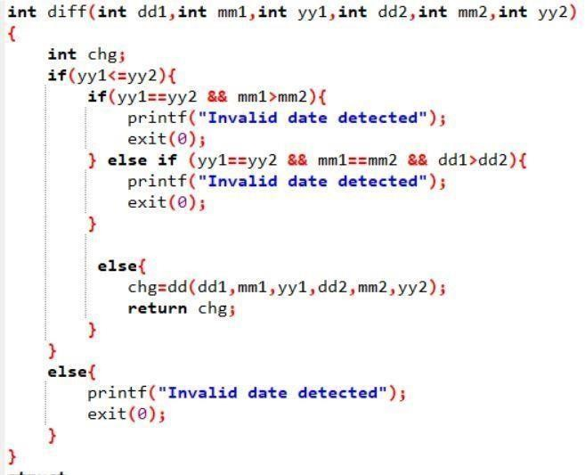





differ•differwday ear( l„y2),

,'

raturn’ differ,

long day ear' ( znt y1, ind y2)

long j , b=8 ;

for ( j z y1 ; j *r* y2 ; j ++ )

b+:365;

b ;

long day_mon€h ( 1n1 d, Snd n , 1n1 y) { long mont h , arr [ 1*•] ;

ar n[ 1 ] -8 ; a nn[ 2] - 31; arr [ 3 ] - 59 ; a op [4] -90 ; arr ( 5 ] - 1 20 ; a rr [ b ] - 15 1 ; ann[7] =18 *L j* apr [ 9 -243 j a nn [ 10] = 273 ; a nn[ 11 ] - 3B4 j a nn[ 12] - 3 34 ; month:arr[m)+d;

return month;

Then the user will be asked how many seats he wants,

If user want seats greater than 10, the program will demand to enter the number of seats again and user want to register again. Moreover, program will ask the user for luggage and the weight for them if the weight of the luggage is greater than 40 kg those bags will be charged R.S 2000 and R.S- 1500 for those bags whose weight is less than 40kg.

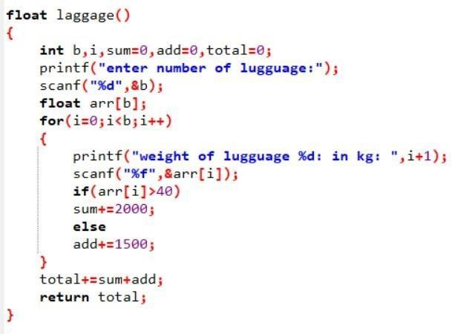

Moreover program will display what PAKISTAN LOCAL AIRLINE (PLA) offers to its

customers, it includes breakfast, lunch, dinner, snacks,

drinks, sweets until the user will press the number by which the asking of meal preferences would be terminated.

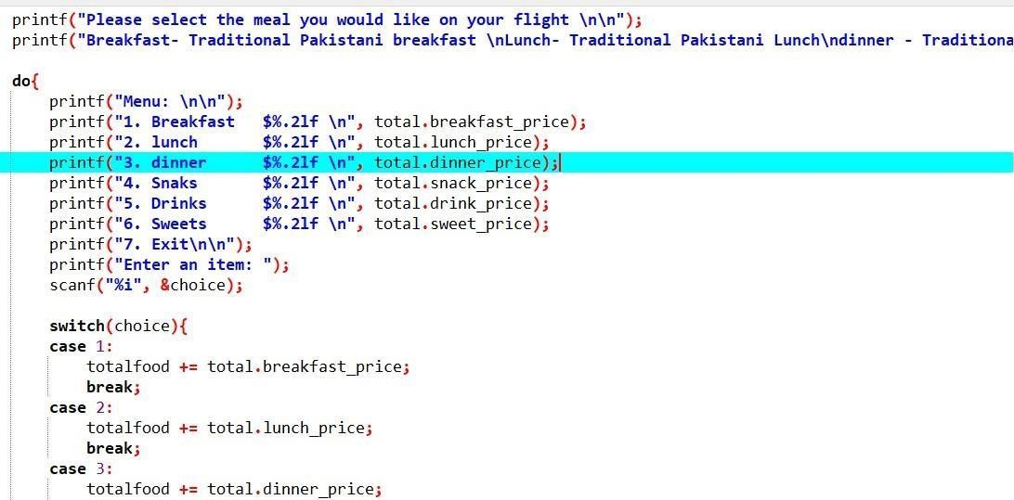

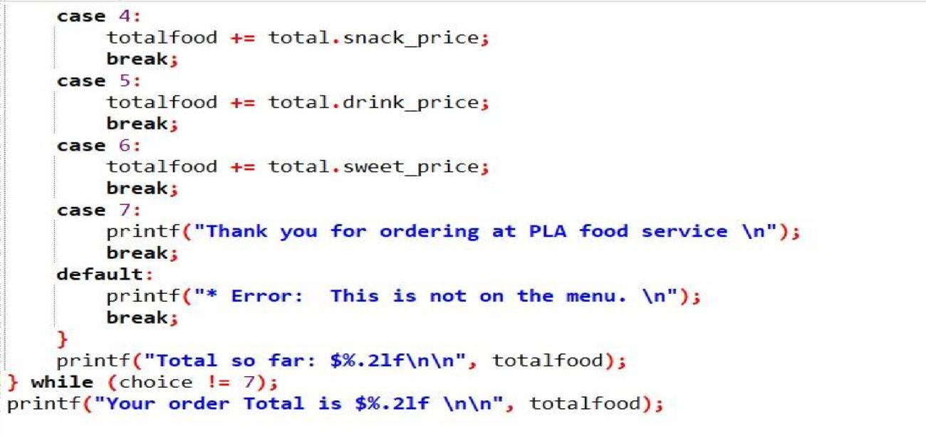

Then the program will proceed to payment of the

ticket and will collect credit card information, after that the program will ask whether user want to cancel the flight or will proceed the booking of the flight tickets, if user want to proceed the process the program would print the information of the ticket in a text file or if the user want to cancel it , the program would ask that how many days before the departure of the flight he’s cancelling it, if user is cancelling the flight before a week he would be charge the 10% of the flight tickets that he registered earlier in the program, if user is cancelling before 2 days so he would be charge 20% of the flight tickets that he registered earlier in the program and if the user is cancelling the flight a days he would be charged 40% of the flight tickets that he registered earlier in the program.

## BOOKING FLIGHT TICKETS VIA AGENTS

### There are three agents with three different

packages.

* + 1st agent will offer 5% discount and 10% discount if user is registering flight before a week or before a month respectively.
  + 2nd agent will offer 10% discount and 20% discount if user is registering before a week or before a month respectively.
  + 3rd agent will offer 10% discount and 20% discount if user is registering flight before a week or before a month respectively + no charge of luggage’s of customer
  + The program will ask the user its destination.
  + Then it will ask the user his agent preference.
  + The program will run when user chooses his or her agent for the booking of a flight with different prices as per each agents offers.
  + After this the user will enter the current date (the date he’s registering his flight) and departure date (the date he wants to departure)
  + Then the user will be asked how many seats he wants, if user want seats greater than 10, the program will demand to enter the number of seats again and user want to register again. Moreover, program will ask the user for luggage and the weight for them if the weight of the luggage is greater than 40 kg those bags will be charged R.S 2000 and R.S 1500 for those bags whose weight is less than 40kg.

Moreover program will display what PAKISTAN LOCAL AIRLINE (PLA) offers to its

customers, it includes breakfast, lunch, dinner, snacks,

drinks, sweets until the user will press the number by which the asking of meal preferences would be terminated.

Then the program will proceed to payment of the ticket and will collect credit card information, after that the program will ask whether user want to cancel the flight or will proceed the booking of the flight tickets, if user want to proceed the process the program would print the information of the ticket in a text file or if the user want to cancel it , the program would ask that how many days before the departure of the flight he’s cancelling it.

If user is cancelling the flight before a week he would be charge the 10% of the flight tickets that he registered earlier in the program, if user is cancelling before 2 days so he would be charge 20% of the flight tickets that he registered earlier in the program and if the user is cancelling the flight a day before so he would be charged 40% of the flight tickets that he registered earlier in the program.

***Implementation :***

We can use this program instead of PIA in real life which will be effective because currently there's no effective system of booking flight tickets in Pakistan.

# RESULTS : THROUGH WEBSITE:

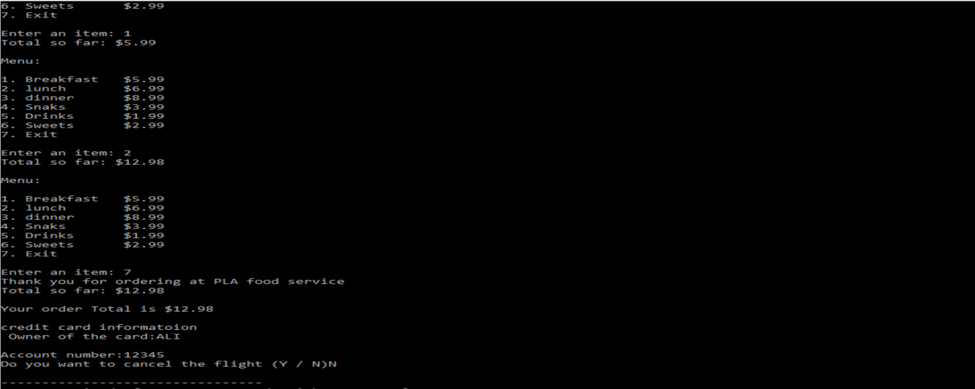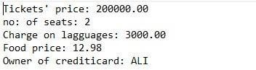

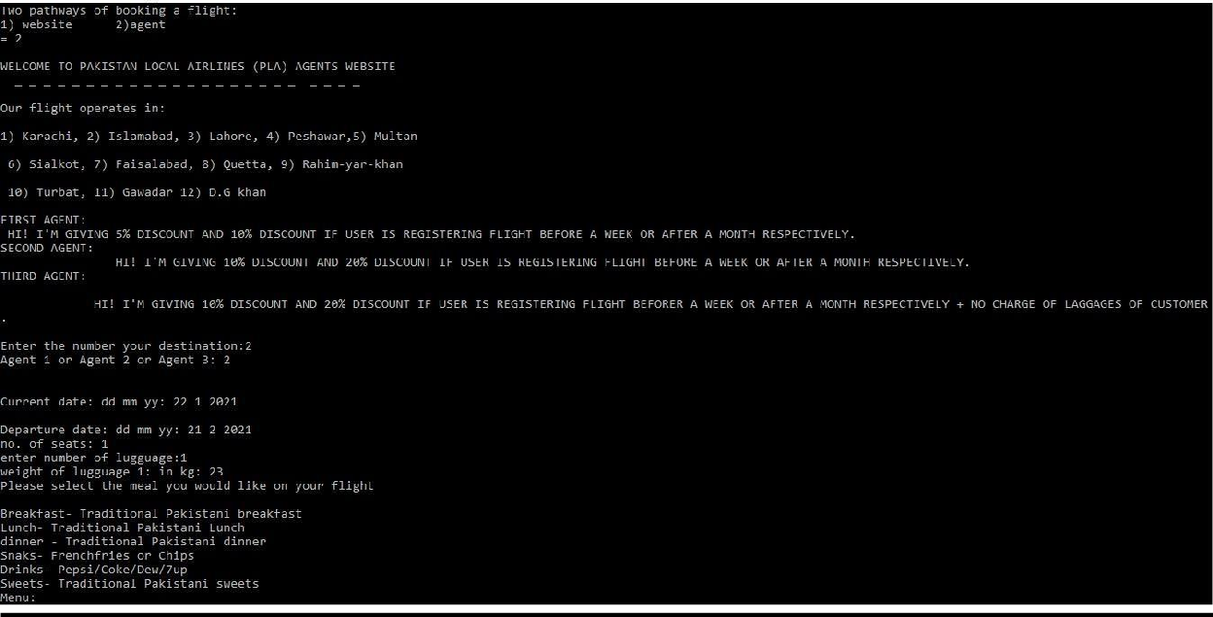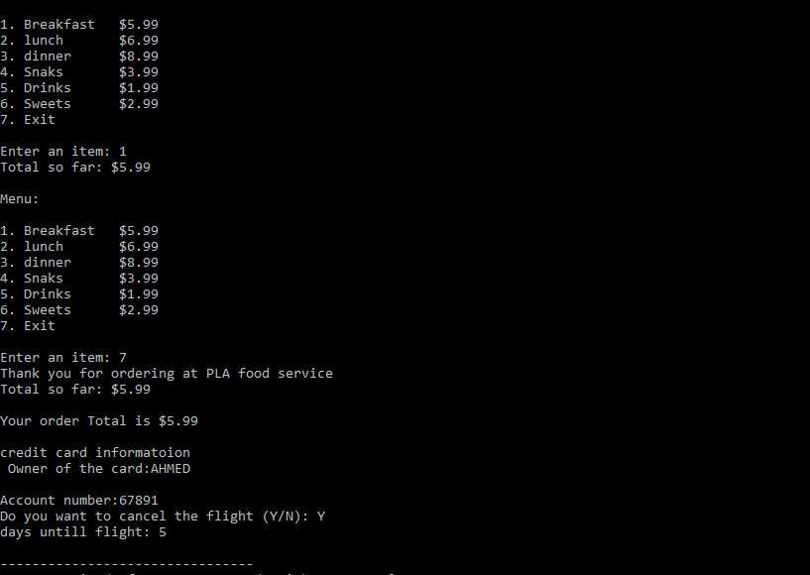***THROUGH AGENT:***

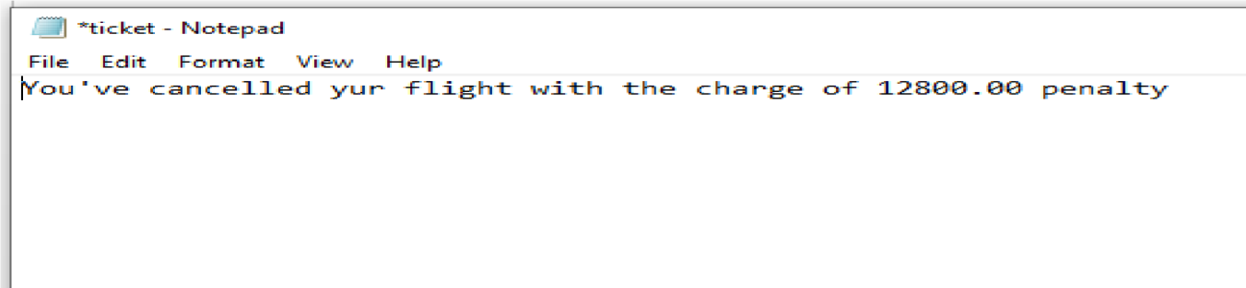

***CONCLUSION :***

This program is one of the finest systems which can work efficiently and can be recognized in local airlines of other countries too.



|  |
| --- |
|  |
|  |