**Punjab University College Of**

**Information and Technology**

MOBILE COMPUTING WORK



Submitted To: **Dr. Haq Nawaz**

Submitted By: **Hafiz Muhammad Ali**

Roll Number: **BSEF18A002**

* Created my first repository on github.com

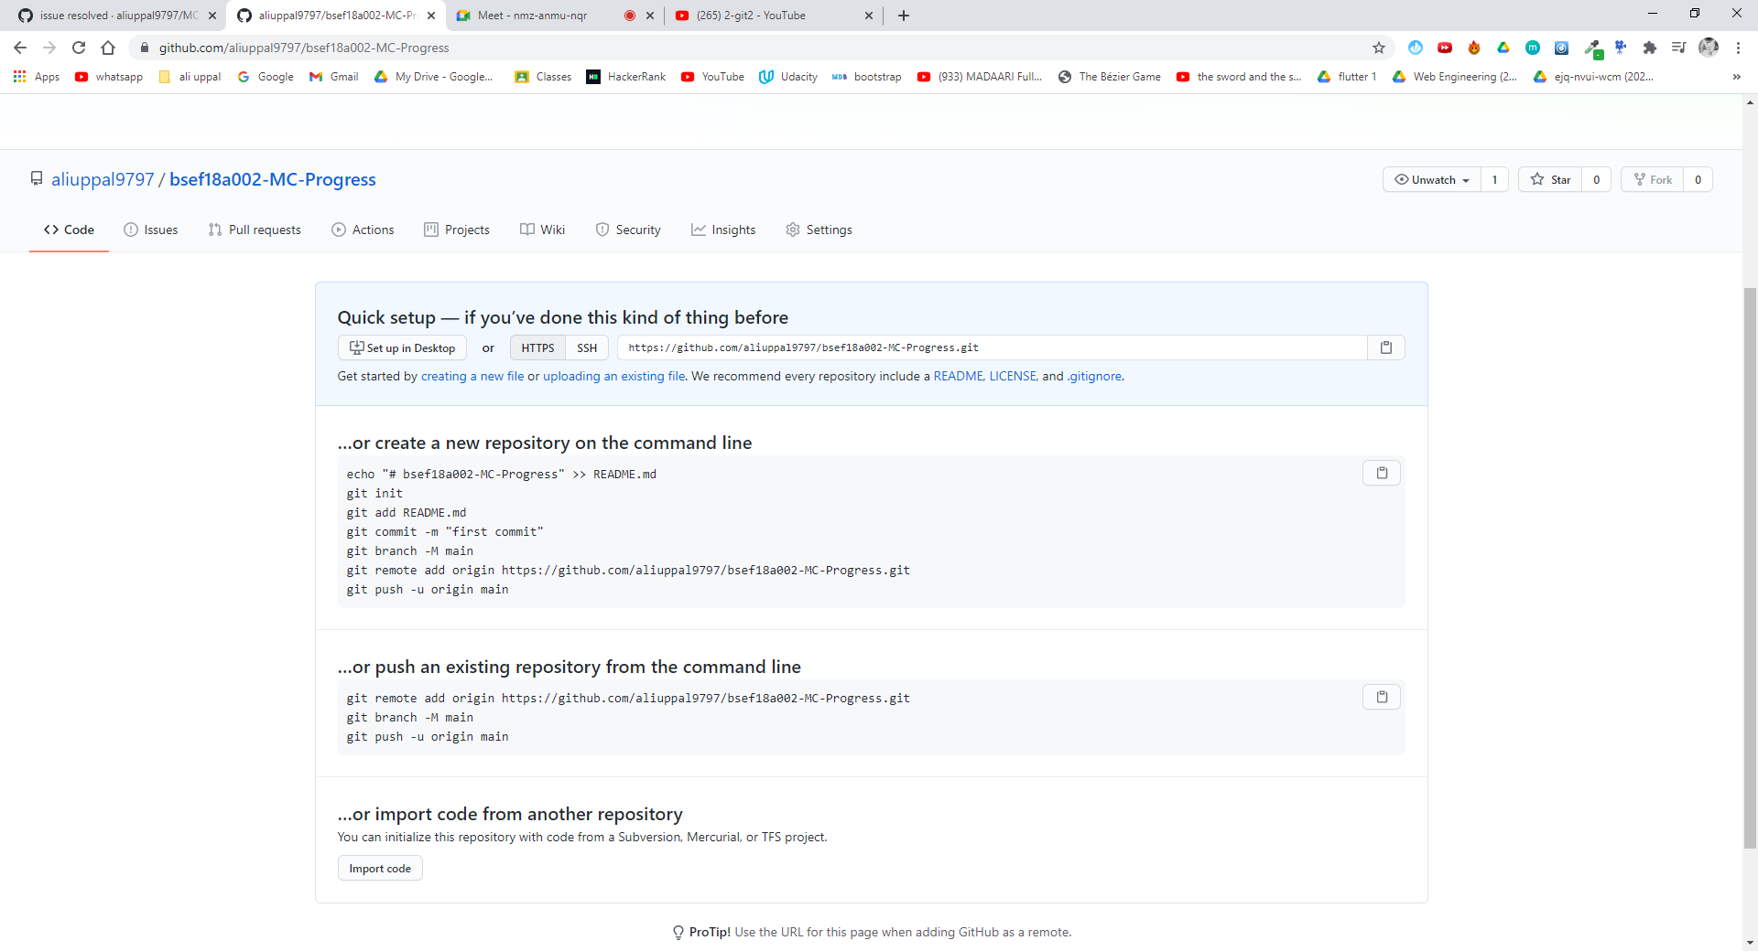

* Cloning of my first repository and added a Word file on local repository

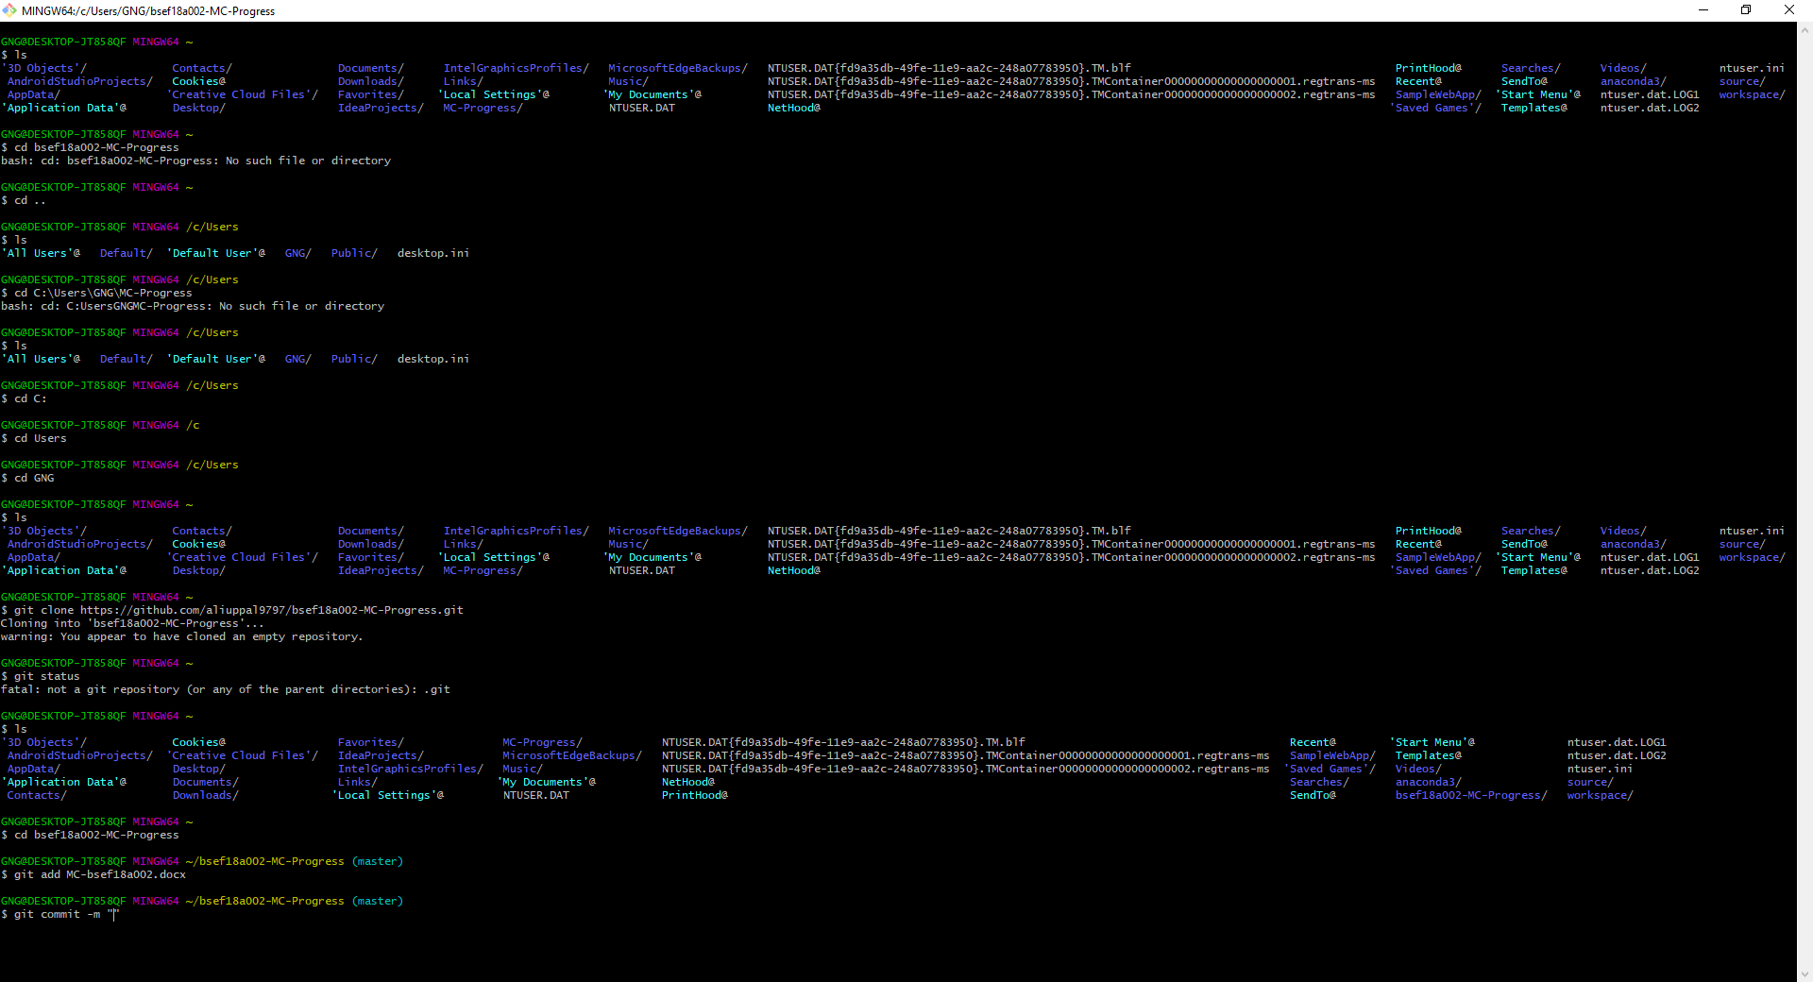

* First commit added

