如何将日常使用的仓库环境构建成dockerfile，并用Trae启动容器？
- 例如用户业务逻辑的环境dockerfile如下：
Dockerfile
FROM node:20-slim
RUN apt-get update && apt-get install -y --no-install-recommends \
git \
gcc \
binutils \
procps \
&& rm -rf /var/lib/apt/lists/*
WORKDIR /app
COPY repo/ .
RUN npm install 2>/dev/null || true
CMD ["sh", "-c", "npm test"]
RUN mkdir -p /installed-agent
RUN command -v patch >/dev/null 2>&1 || ( (apt-get update && apt-get install -y --no-install-recommends patch && rm -rf /var/lib/apt/lists/*) 2>/dev/null || apk add --no-cache patch 2>/dev/null || yum install -y patch 2>/dev/null || true )
- 有可能构建过程 (docker build -t dogfooding .) 中访问外网失败，需要加上proxy。例如在字节内网的话，需要添加如下：
Dockerfile
FROM node:20-slim
ENV http_proxy=http://sys-proxy-rd-relay.byted.org:8118 \
HTTP_PROXY=http://sys-proxy-rd-relay.byted.org:8118 \
https_proxy=http://sys-proxy-rd-relay.byted.org:8118 \
HTTPS_PROXY=http://sys-proxy-rd-relay.byted.org:8118
RUN apt-get update && apt-get install -y --no-install-recommends \
git \
gcc \
binutils \
procps \
&& rm -rf /var/lib/apt/lists/*
WORKDIR /app
COPY repo/ .
RUN npm install 2>/dev/null || true
CMD ["sh", "-c", "npm test"]
RUN mkdir -p /installed-agent
RUN command -v patch >/dev/null 2>&1 || ( (apt-get update && apt-get install -y --no-install-recommends patch && rm -rf /var/lib/apt/lists/*) 2>/dev/null || apk add --no-cache patch 2>/dev/null || yum install -y patch 2>/dev/null || true )
- 为了能让trae连接启动的镜像容器（docker run -d -p2222:22 dogfooding之后的容器），需要给dockerfile中添加并启动SSH服务（标黄部分）；再将environment/ssh_plugin/entrypoint.sh、environment/ssh_plugin/install_ssh.sh内容复制粘贴到对应文件中。

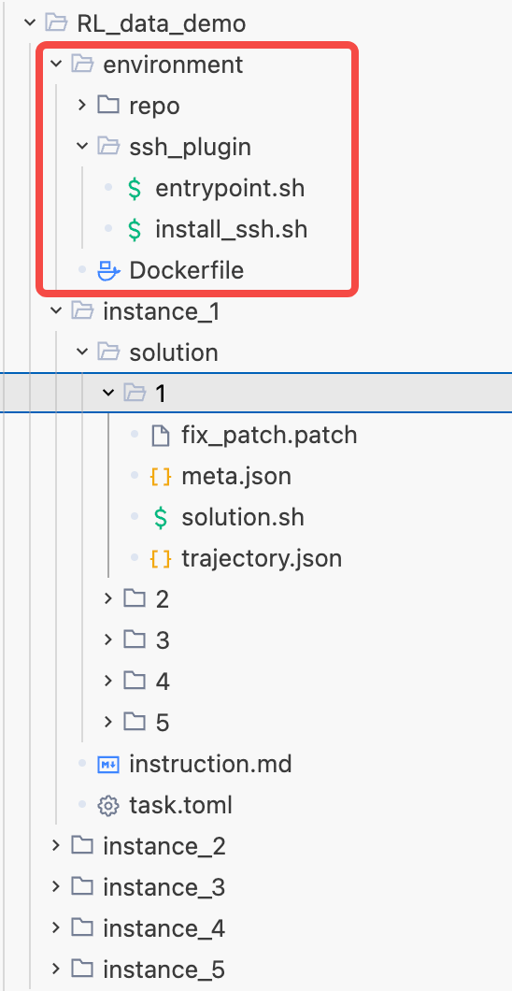
Dockerfile
environment/Dockerfile
FROM node:20-slim
ENV http_proxy=http://sys-proxy-rd-relay.byted.org:8118 \
HTTP_PROXY=http://sys-proxy-rd-relay.byted.org:8118 \
https_proxy=http://sys-proxy-rd-relay.byted.org:8118 \
HTTPS_PROXY=http://sys-proxy-rd-relay.byted.org:8118
RUN apt-get update && apt-get install -y --no-install-recommends \
git \
gcc \
binutils \
procps \
&& rm -rf /var/lib/apt/lists/*
WORKDIR /app
COPY repo/ .
RUN npm install 2>/dev/null || true
CMD ["sh", "-c", "npm test"]
RUN mkdir -p /installed-agent
RUN command -v patch >/dev/null 2>&1 || ( (apt-get update && apt-get install -y --no-install-recommends patch && rm -rf /var/lib/apt/lists/*) 2>/dev/null || apk add --no-cache patch 2>/dev/null || yum install -y patch 2>/dev/null || true )
# ========== SSH plugin (pluggable, for Cursor/Trae vibe coding) ==========
# Drop-in block: copy the same `ssh_plugin/` folder next to this Dockerfile
# and paste this block at the end of any business Dockerfile. Nothing else
# in the business logic needs to change.
#
# Optional customisation (add BEFORE this block if needed):
# ENV SSH_PASSWORD=mysecret # change root password (default: password)
# ENV SSH_PORT=2222 # change sshd port (default: 22)
# ENV ORIG_ENTRYPOINT=/docker-entrypoint.sh # chain base image's ENTRYPOINT
# # (e.g. postgres, mysql, jupyter)
#
# NOTE: this block runs as root (required to install sshd). If the base image
# uses a non-root USER, restore it at the very end, e.g. `USER node`.
USER root
COPY ssh_plugin/ /opt/ssh_plugin/
RUN chmod +x /opt/ssh_plugin/*.sh && /opt/ssh_plugin/install_ssh.sh
EXPOSE 22
ENTRYPOINT ["/opt/ssh_plugin/entrypoint.sh"]
# USER <original-user> # uncomment & set if the base image requires non-root
# ========== end SSH plugin ==========

Bash
environment/ssh_plugin/entrypoint.sh（需要拷贝到对应的environment/下）
#!/bin/sh
# Container entrypoint for vibe-coding-friendly images.
#
# Portability:
# - POSIX sh only (runs in bash / dash / busybox ash).
#
# Flow:
# 1) start sshd in background so Cursor/Trae can always attach
# 2) optionally run the business CMD
# - may be CHAINED through the base image's original ENTRYPOINT
# by setting ORIG_ENTRYPOINT=/path/to/original-entrypoint.sh
# - may be skipped entirely (SKIP_CMD=1) for a pure SSH workbox
# 3) stay alive as PID 1 with signal forwarding and zombie reaping
#
# Runtime tunables (docker run -e ...):
# KEEP_ALIVE=1 (default) keep container alive regardless of CMD exit
# KEEP_ALIVE=0 classic docker semantics (exec CMD as PID 1)
# SKIP_CMD=1 do NOT run the business CMD (SSH-only mode)
# ORIG_ENTRYPOINT=path chain to the base image's original entrypoint
set -u
KEEP_ALIVE="${KEEP_ALIVE:-1}"
SKIP_CMD="${SKIP_CMD:-0}"
ORIG_ENTRYPOINT="${ORIG_ENTRYPOINT:-}"
log() { printf '[ssh_plugin/entrypoint] %s\n' "$*"; }
# --------------------------------------------------------------------------- #
# 1) Start sshd in the background.
# --------------------------------------------------------------------------- #
if [ ! -f /etc/ssh/ssh_host_rsa_key ] && [ ! -f /etc/ssh/ssh_host_ed25519_key ]; then
ssh-keygen -A >/dev/null 2>&1 || true
fi
mkdir -p /var/run/sshd
/usr/sbin/sshd
# Print the actual port (drop-in conf or main config), not a guessed one.
actual_port=$(
{ cat /etc/ssh/sshd_config.d/*.conf 2>/dev/null; cat /etc/ssh/sshd_config 2>/dev/null; } \
| awk 'BEGIN{p=22} /^[[:space:]]*Port[[:space:]]+[0-9]+/ {p=$2} END{print p}'
)
log "sshd started on port ${actual_port}"
# --------------------------------------------------------------------------- #
# 2) Decide whether and how to run the business CMD.
# --------------------------------------------------------------------------- #
have_cmd=0
if [ "$#" -gt 0 ] && [ "$SKIP_CMD" != "1" ]; then
have_cmd=1
fi
# Helper: run the business CMD, optionally chained through ORIG_ENTRYPOINT.
run_business() {
if [ -n "$ORIG_ENTRYPOINT" ] && [ -x "$ORIG_ENTRYPOINT" ]; then
"$ORIG_ENTRYPOINT" "$@"
else
"$@"
fi
}
# --------------------------------------------------------------------------- #
# 2a) Classic docker semantics: exec the CMD as PID 1; container dies with CMD.
# --------------------------------------------------------------------------- #
if [ "$KEEP_ALIVE" = "0" ]; then
if [ "$have_cmd" -eq 0 ]; then
log "KEEP_ALIVE=0 but no CMD given; falling back to idle wait (SSH stays up)"
exec tail -f /dev/null
fi
log "KEEP_ALIVE=0: exec business CMD: $*"
if [ -n "$ORIG_ENTRYPOINT" ] && [ -x "$ORIG_ENTRYPOINT" ]; then
exec "$ORIG_ENTRYPOINT" "$@"
else
exec "$@"
fi
fi
# --------------------------------------------------------------------------- #
# 2b) Default (KEEP_ALIVE=1): business in background, PID 1 stays alive.
# --------------------------------------------------------------------------- #
child_pid=""
cleanup() {
log "received signal, shutting down ..."
if [ -f /var/run/sshd.pid ]; then
kill -TERM "$(cat /var/run/sshd.pid)" 2>/dev/null || true
fi
if [ -n "$child_pid" ]; then
kill -TERM "$child_pid" 2>/dev/null || true
wait "$child_pid" 2>/dev/null || true
fi
exit 0
}
trap cleanup TERM INT HUP
if [ "$have_cmd" -eq 1 ]; then
log "running business CMD in background: $*"
(
run_business "$@"
rc=$?
printf '[ssh_plugin/entrypoint] business CMD exited with code %s; SSH remains available\n' "$rc"
) &
child_pid=$!
else
log "no business CMD (SSH-only mode)"
fi
# --------------------------------------------------------------------------- #
# 3) PID 1 main loop: reap zombies (orphaned grandchildren land on us),
# wake periodically so signals (TERM/INT/HUP) can fire the trap.
# --------------------------------------------------------------------------- #
while :; do
wait 2>/dev/null || true
# `sleep` as a backgrounded job so `wait` is interruptible by signals.
sleep 3600 &
wait "$!" 2>/dev/null || true
done

Bash
environment/ssh_plugin/install_ssh.sh（需要拷贝到对应的environment/下）
#!/bin/sh
# Install & configure OpenSSH server inside a container image.
#
# Portability:
# - POSIX sh only (runs in bash / dash / busybox ash).
# - Package managers: apt-get, apk, dnf, yum, zypper.
# - Tolerates minimal images (busybox passwd fallback when no chpasswd).
# - Idempotent: short-circuits when sshd is already installed.
#
# Env tunables (build-time):
# SSH_PASSWORD root password to set (default: "password")
# SSH_PORT sshd listen port (default: 22)
#
# NOTE: must run as root.
set -eu
SSH_PASSWORD="${SSH_PASSWORD:-password}"
SSH_PORT="${SSH_PORT:-22}"
log() { printf '[ssh_plugin/install] %s\n' "$*"; }
# --------------------------------------------------------------------------- #
# 1) Install openssh-server (and friends) if not already present.
# --------------------------------------------------------------------------- #
if command -v sshd >/dev/null 2>&1; then
log "sshd already present, skipping package installation"
else
if command -v apt-get >/dev/null 2>&1; then
export DEBIAN_FRONTEND=noninteractive
apt-get update
apt-get install -y --no-install-recommends openssh-server ca-certificates wget curl
rm -rf /var/lib/apt/lists/*
elif command -v apk >/dev/null 2>&1; then
# alpine: `shadow` provides chpasswd/usermod; openssh-keygen for ssh-keygen -A
apk add --no-cache openssh openssh-keygen shadow ca-certificates wget curl
elif command -v dnf >/dev/null 2>&1; then
dnf install -y openssh-server openssh-clients wget curl
dnf clean all
elif command -v yum >/dev/null 2>&1; then
yum install -y openssh-server openssh-clients wget curl
yum clean all
elif command -v zypper >/dev/null 2>&1; then
zypper --non-interactive install openssh wget curl
zypper clean -a || true
else
log "ERROR: no supported package manager (apt/apk/dnf/yum/zypper); cannot install sshd" >&2
exit 1
fi
fi
# --------------------------------------------------------------------------- #
# 2) Ensure runtime directories exist.
# --------------------------------------------------------------------------- #
mkdir -p /var/run/sshd /root/.ssh
chmod 700 /root/.ssh
# --------------------------------------------------------------------------- #
# 3) Set root password (with fallback for busybox-only images).
# --------------------------------------------------------------------------- #
if command -v chpasswd >/dev/null 2>&1; then
printf 'root:%s\n' "${SSH_PASSWORD}" | chpasswd
elif command -v passwd >/dev/null 2>&1; then
# busybox passwd reads new password twice from stdin
printf '%s\n%s\n' "${SSH_PASSWORD}" "${SSH_PASSWORD}" | passwd root >/dev/null
else
log "WARNING: neither chpasswd nor passwd available; root password NOT set" >&2
fi
# --------------------------------------------------------------------------- #
# 4) Write a drop-in sshd config.
# More robust than sed-ing /etc/ssh/sshd_config directly:
# - works even if the option isn't present in the main file
# - survives distro upgrades
# - ensures main config loads drop-ins on older distros that don't by default
# --------------------------------------------------------------------------- #
mkdir -p /etc/ssh/sshd_config.d
cat > /etc/ssh/sshd_config.d/99-ssh-plugin.conf <<EOF
# Managed by ssh_plugin/install_ssh.sh -- do not edit by hand.
Port ${SSH_PORT}
PermitRootLogin yes
PasswordAuthentication yes
PubkeyAuthentication yes
UsePAM no
EOF
chmod 644 /etc/ssh/sshd_config.d/99-ssh-plugin.conf
if [ -f /etc/ssh/sshd_config ]; then
if ! grep -qE '^[[:space:]]*Include[[:space:]]+/etc/ssh/sshd_config\.d/' /etc/ssh/sshd_config; then
printf '\n# added by ssh_plugin\nInclude /etc/ssh/sshd_config.d/*.conf\n' >> /etc/ssh/sshd_config
fi
fi
# --------------------------------------------------------------------------- #
# 5) Generate host keys (noop if they already exist).
# --------------------------------------------------------------------------- #
ssh-keygen -A >/dev/null 2>&1 || true
log "done: openssh-server ready; root password set, listening on port ${SSH_PORT}"

具体流程
上面是关键点，下面是一个流程：
- 按照上面流程构建好 environment/ 下的所有内容
- 进入到environment/：cd environment/
- 构建docker image：docker build -t dogfooding .，其中"dogfooding"是镜像名字，可自定义
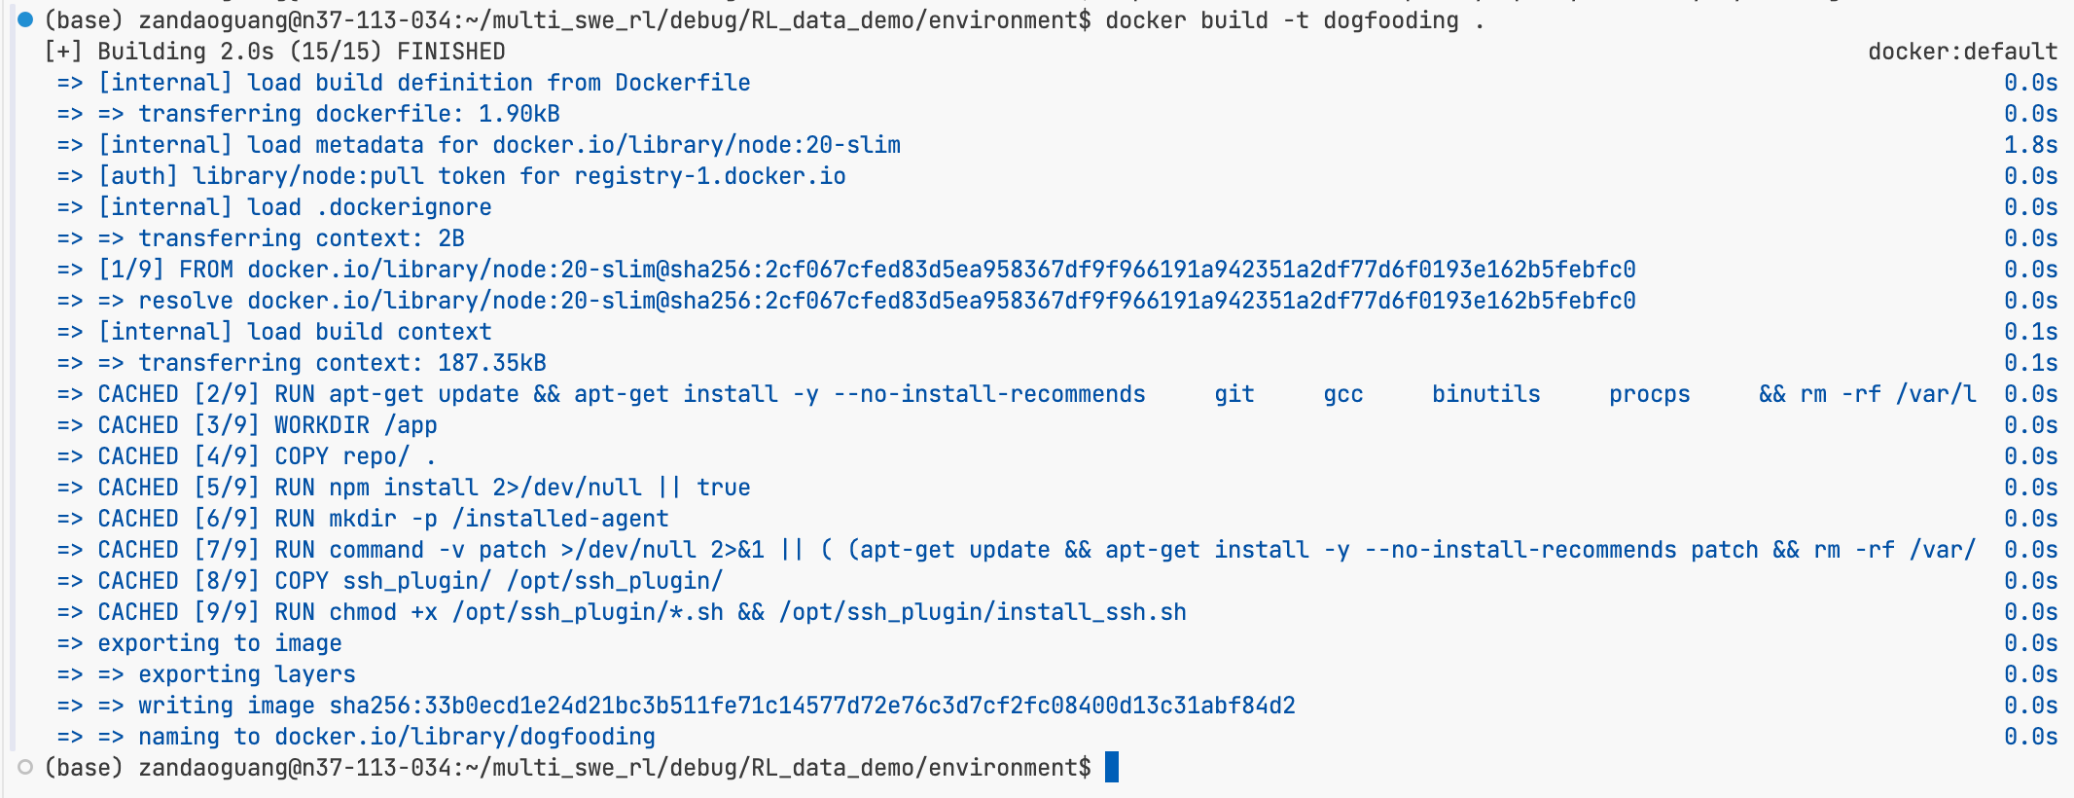
- 启动容器并暴露ssh服务：
Bash
docker run -d -p2222:22 dogfooding
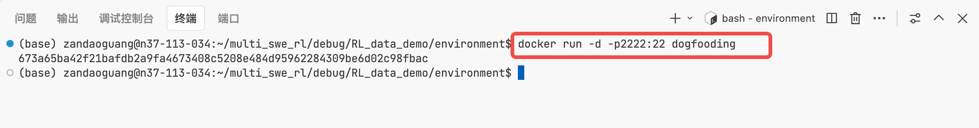
- 配置~/ssh/config（如果是本地就去掉这个proxyjump就行）

Bash
Host devbox
HostName 10.x.x.x
User root
Host docker-container
HostName localhost
User root
Port 2222
ProxyJump devbox
StrictHostKeyChecking no
UserKnownHostsFile /dev/null
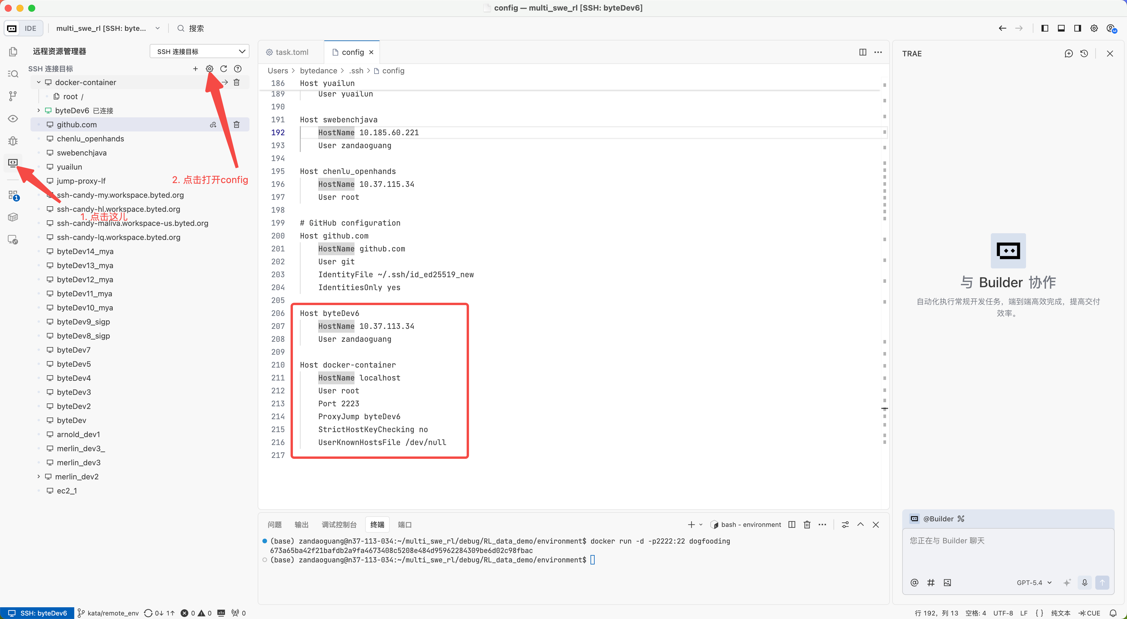
- 通过trae cn连接启动起来的容器 并 vibe coding
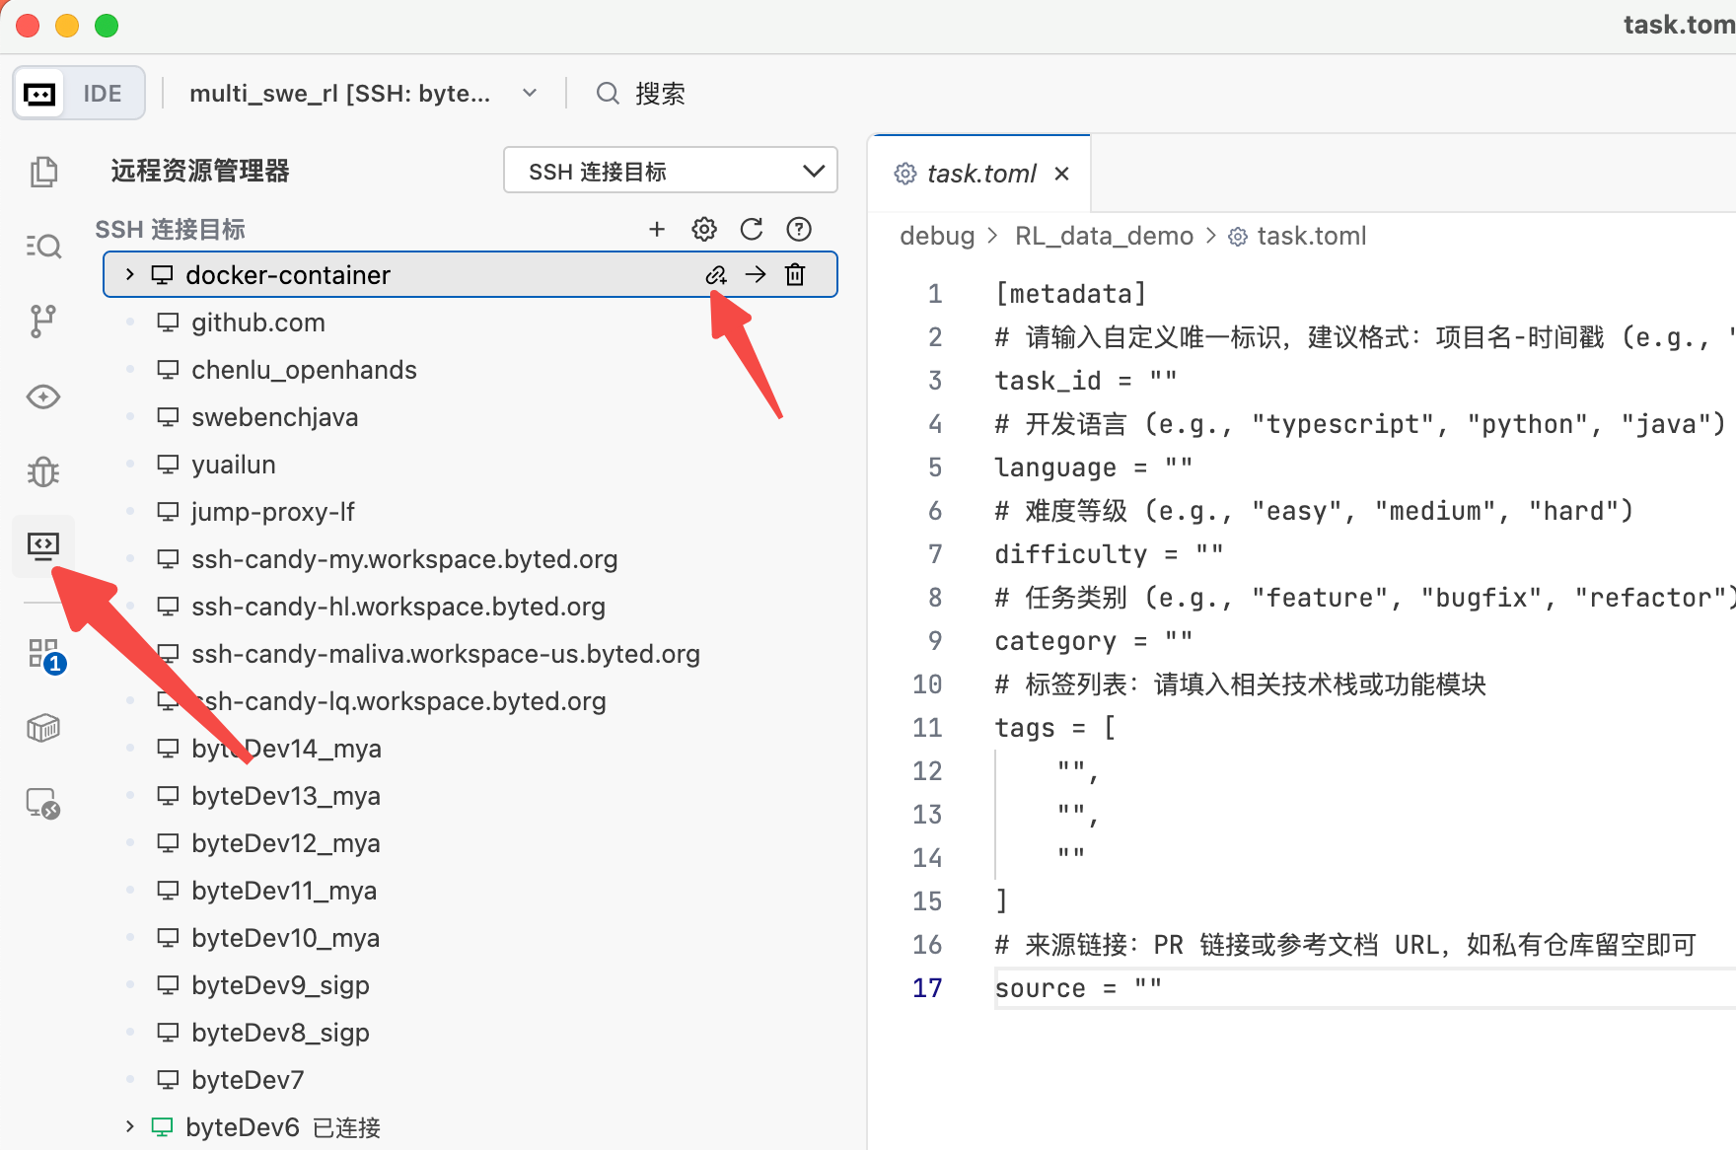
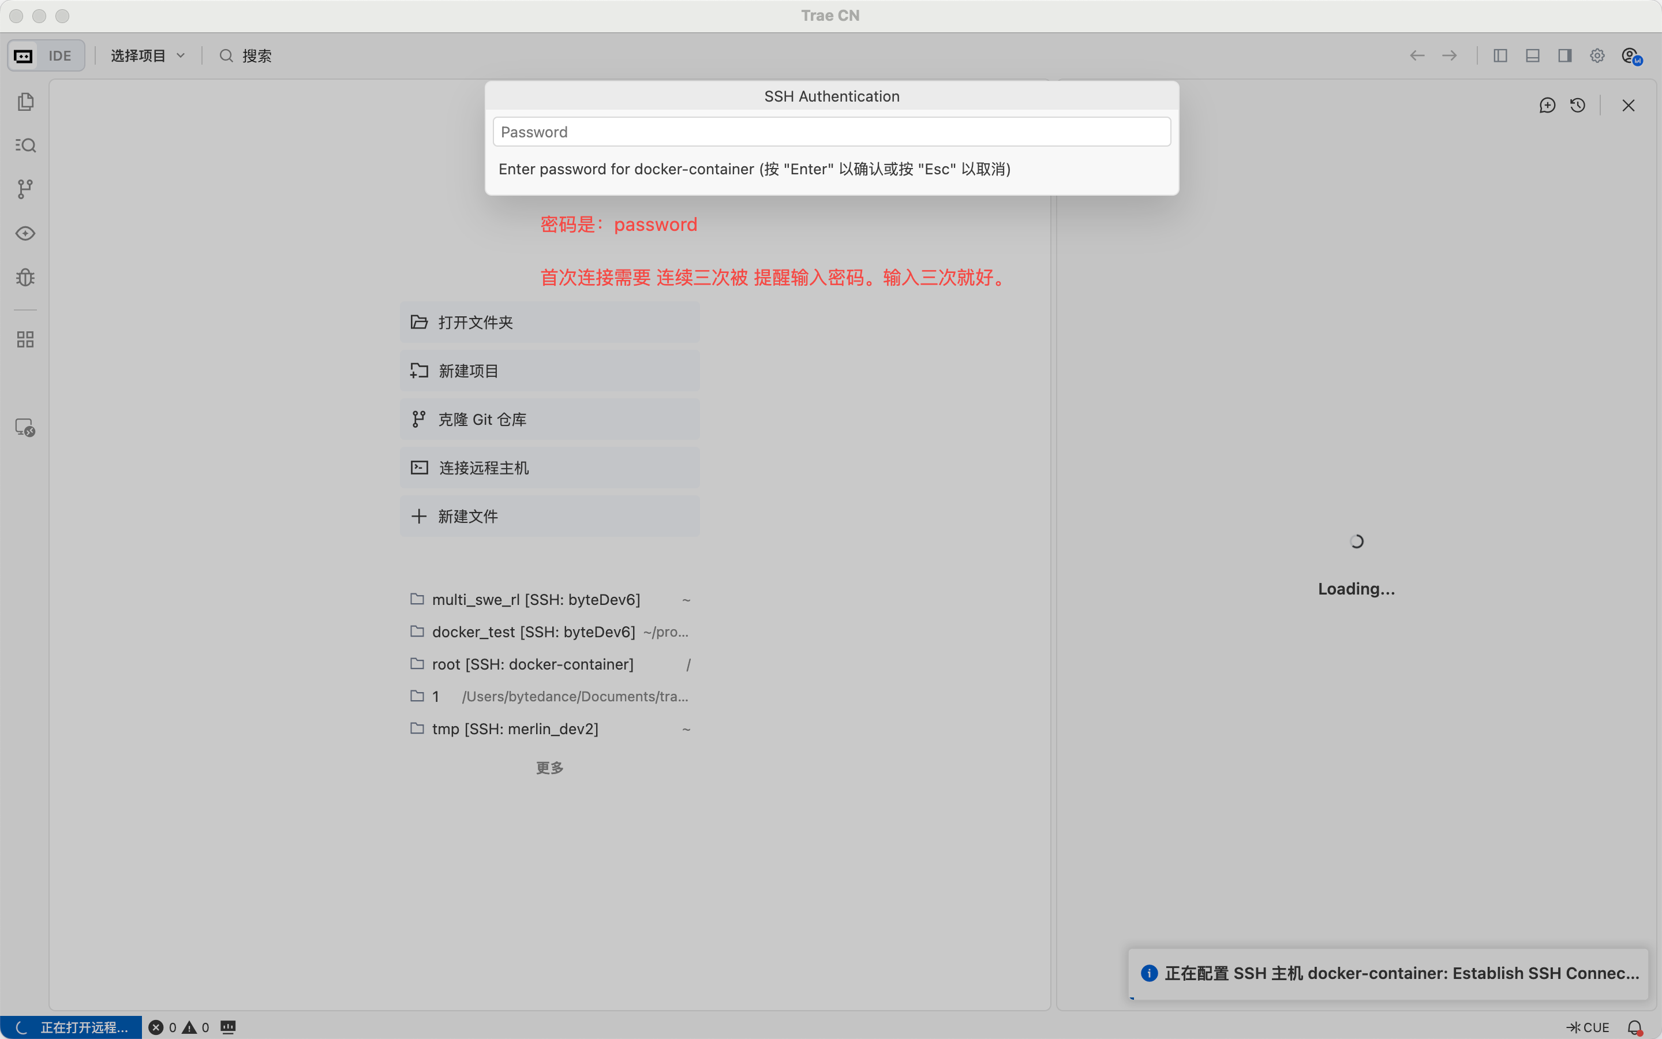
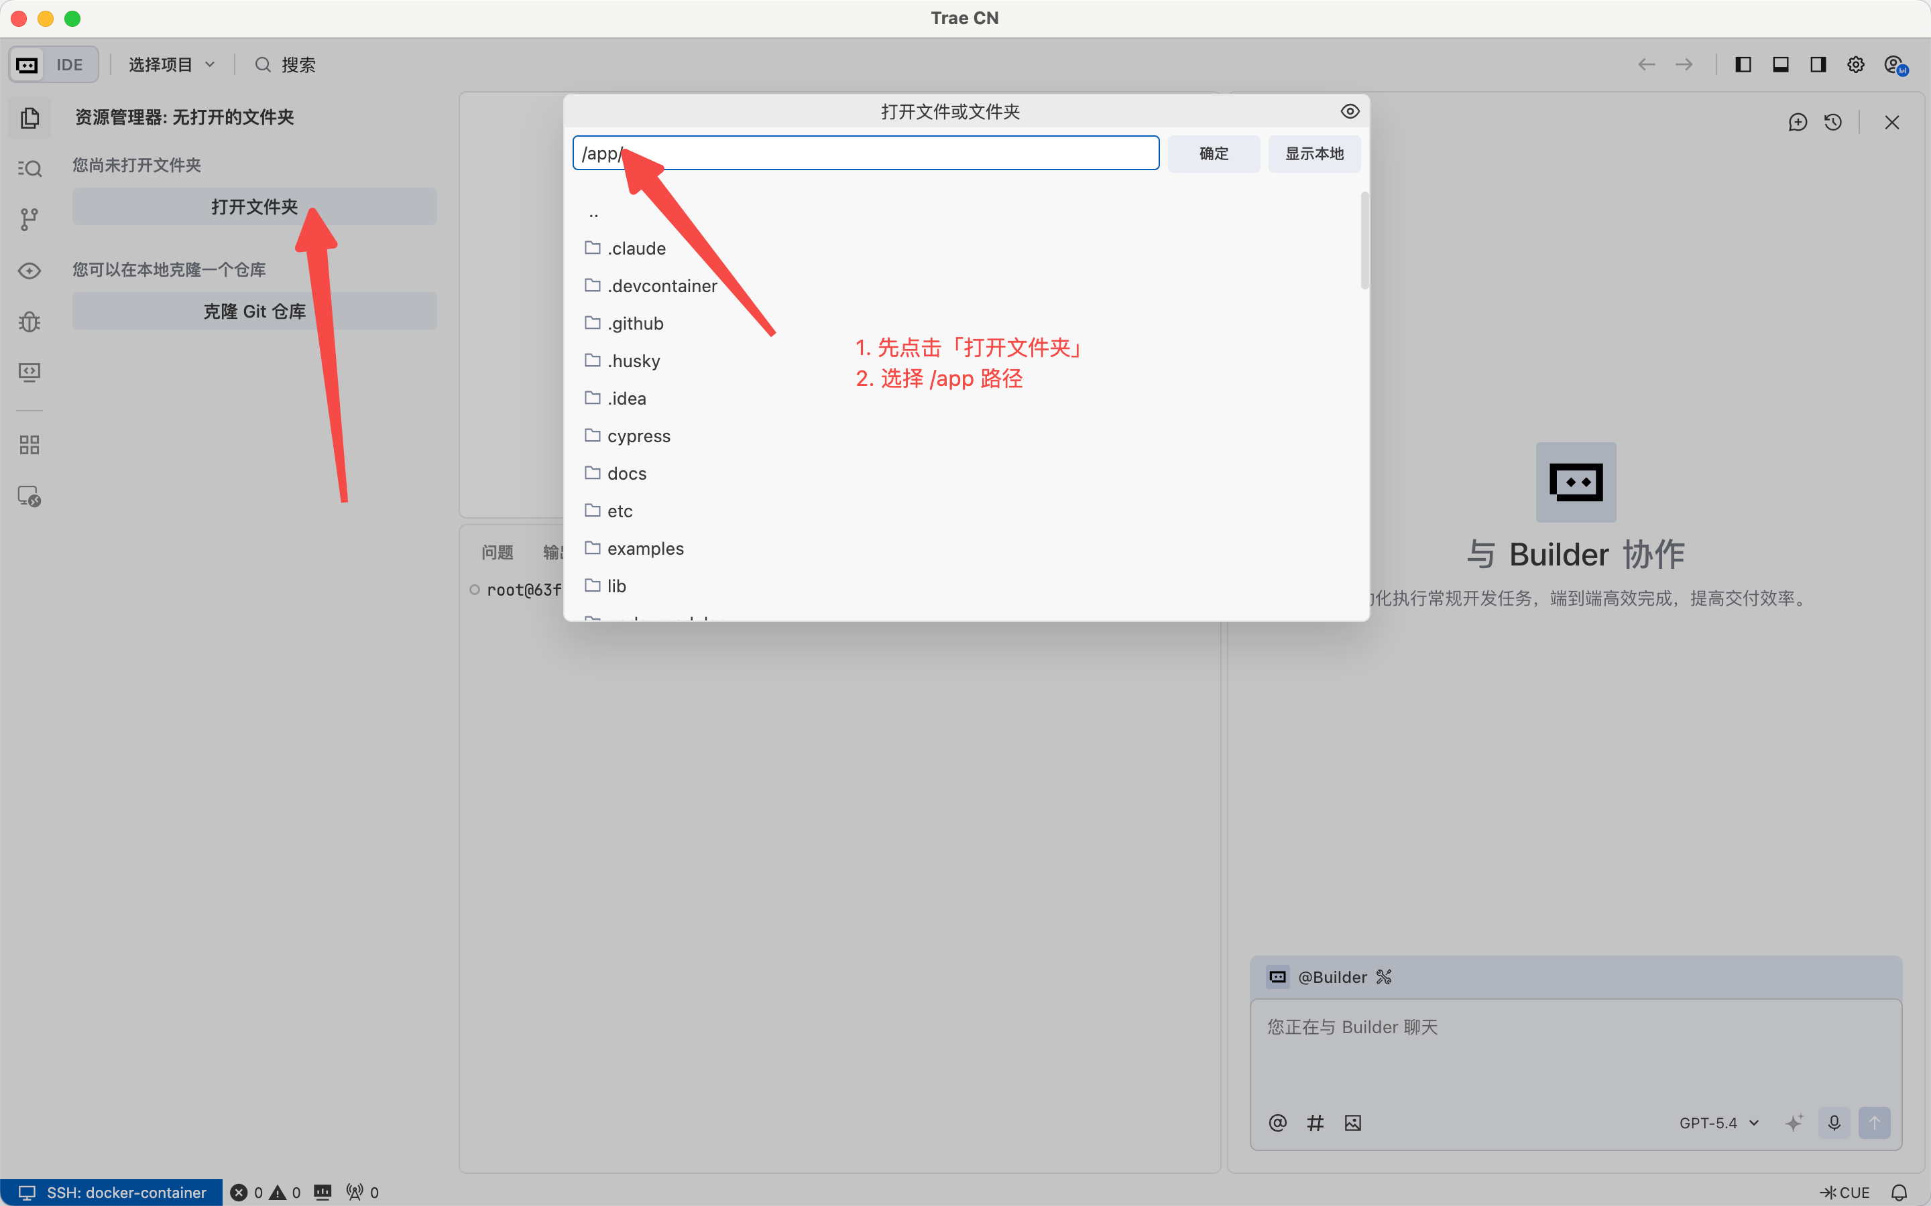
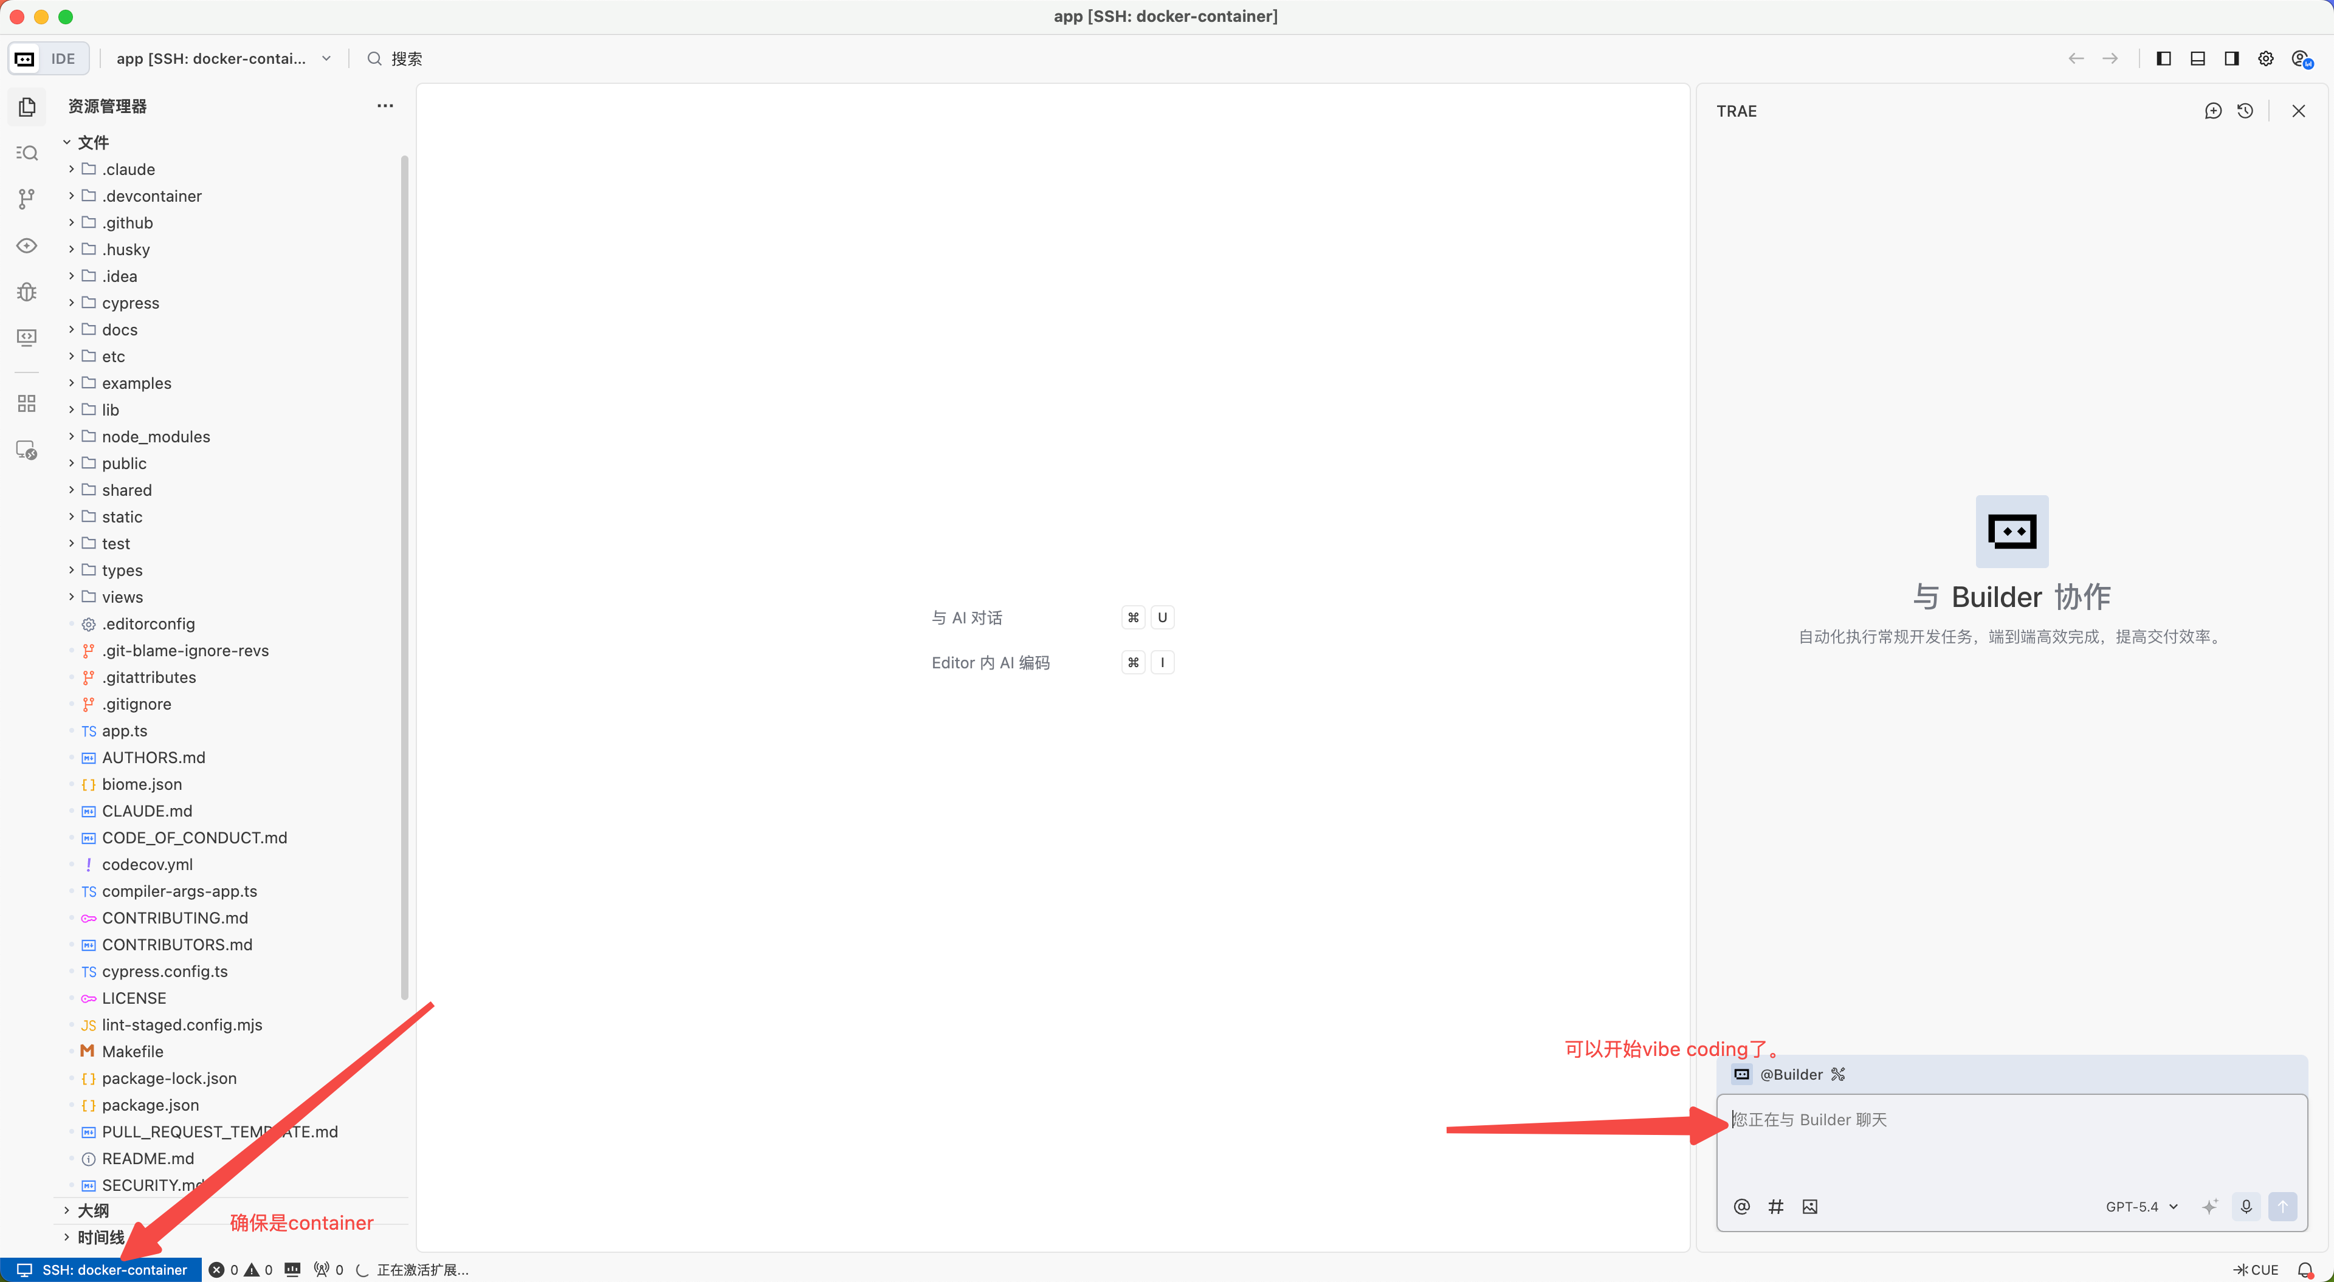
- 在现在这种一个 SSH Host 固定连 localhost:2222 的用法下切换项目时需要注意以下几点：
- docker-container 这个 SSH 配置本质上只认 localhost:2222
- 2222 同一时刻通常只能被一个容器占用，所以你如果想让 docker-container 指到“另一个项目容器”，就得：停掉旧容器，删除或至少停止旧容器，释放 2222；用新项目对应的镜像/挂载重新起一个映射 2222:22 的新容器，然后重新连接 SSH。
- 其他注意事项：
- 部分基础镜像与 TRAE CN 远端服务不兼容
- 典型例子是 Alpine 系镜像：
- node:20-alpine 使用的是 musl
- TRAE CN 下发的远端 server 包依赖 glibc
- 这会导致 SSH 虽然能连上，但远端 server 安装或启动失败，常见表现包括：
- 一直停在 Preparing local cache package...
- Check System Requirements 后续异常
- exit code: 3001
- Server did not start successfully
- 更推荐的基础镜像
- node:20-bookworm
- node:20-bullseye
- 其他 Debian / Ubuntu / glibc 系基础镜像

