App overview

Equipos:
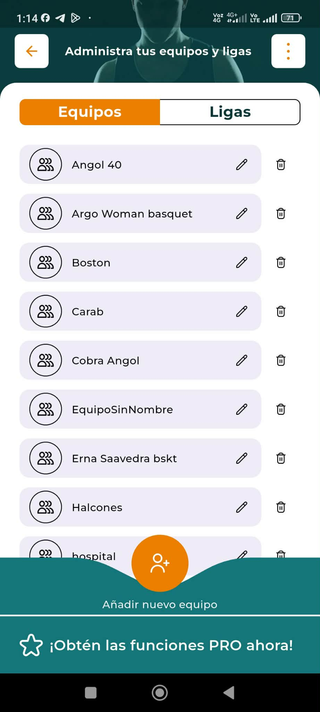
Primer item para ingresar datos de los equipos, al abrir equipos debe verse algo así.
Luego plantilla,
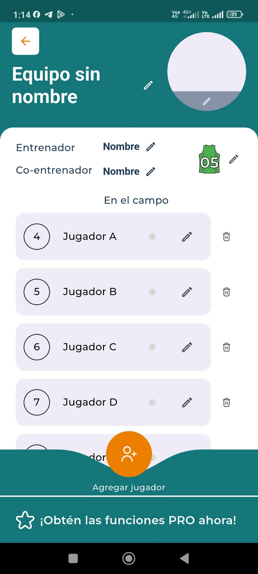
Aquí se puede editar nombre del equipo, subir foto, ediatr nombre del coach, editar colores de camisetas, ingresar datos de jugadores, luego:
Jugadores, aquí se puede editar datos de los jugadores,

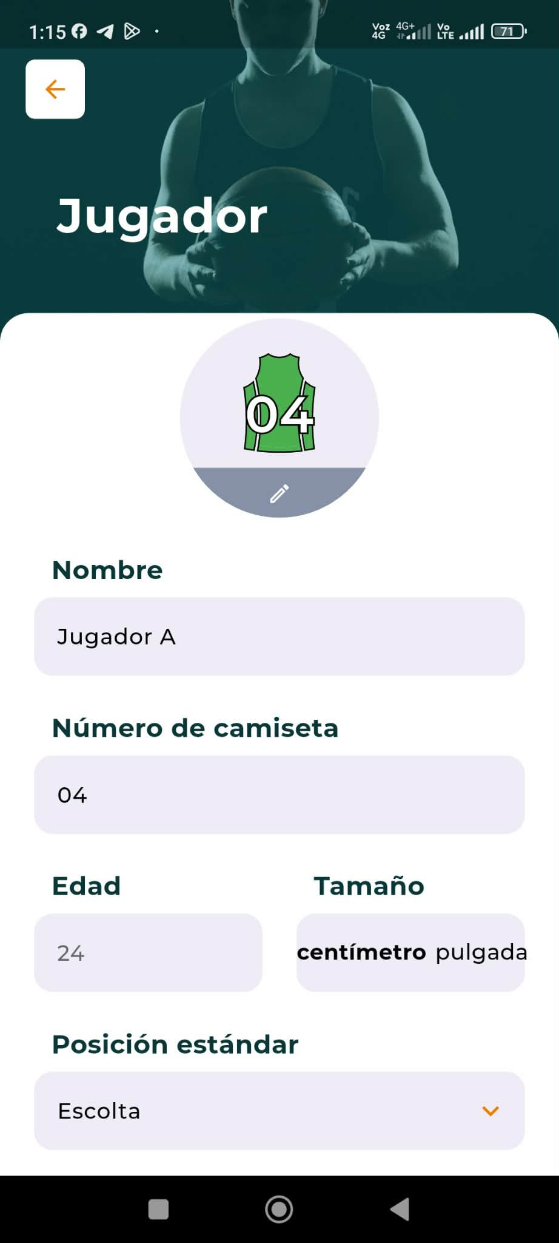

Luego, interfaz de partido, pero antes configuaracion del partido:

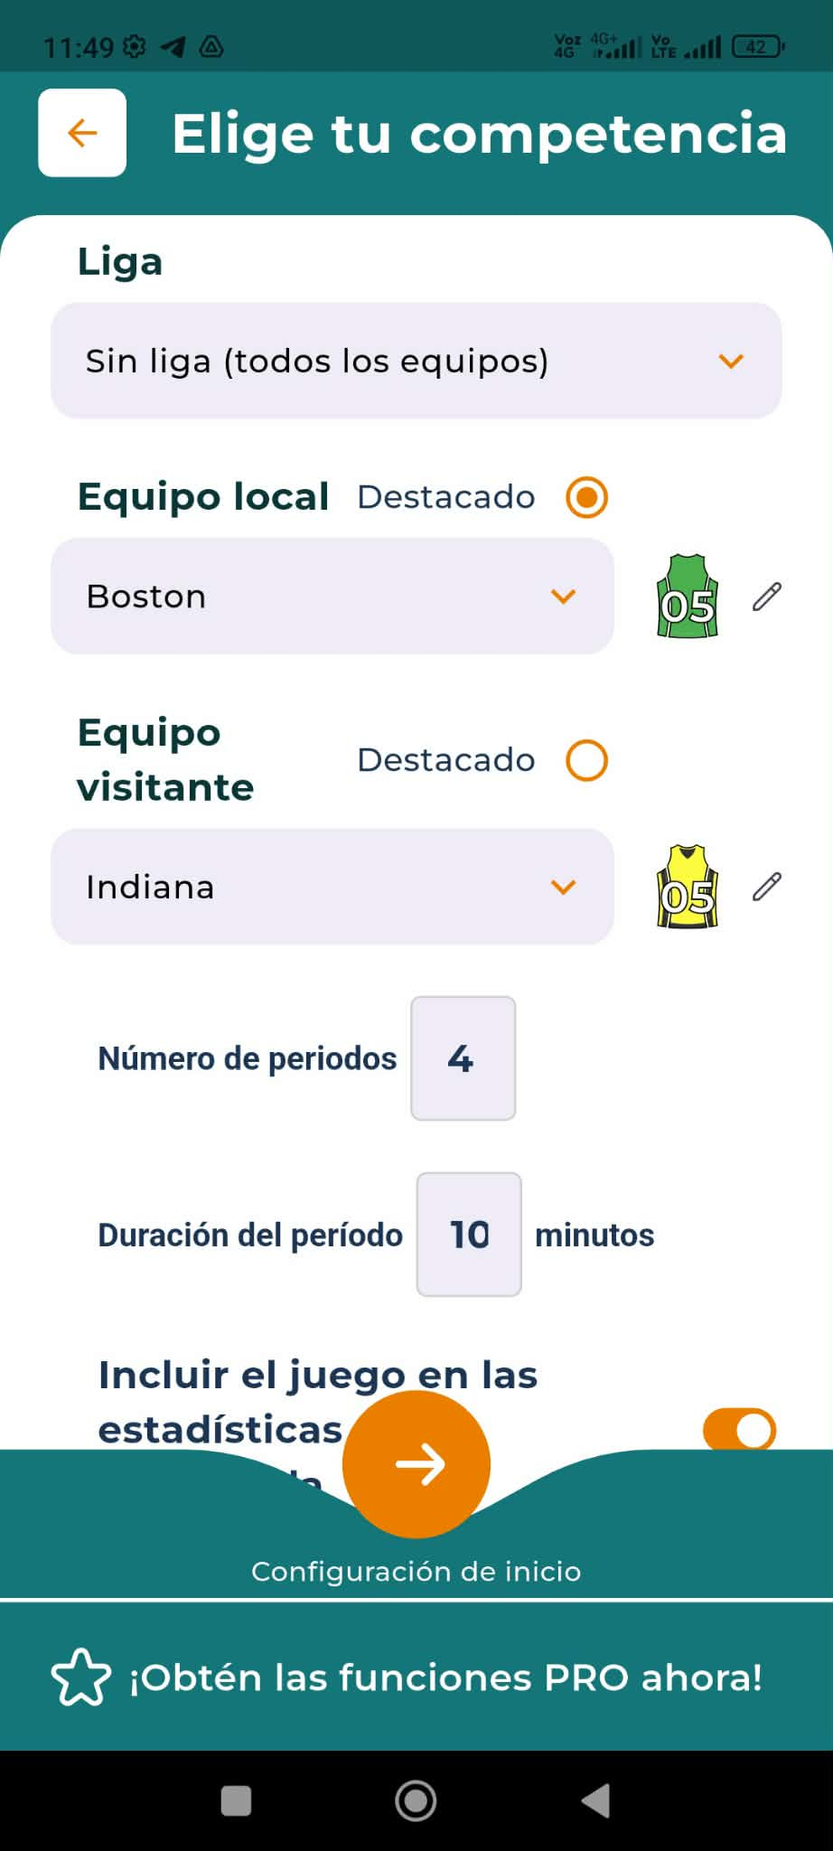

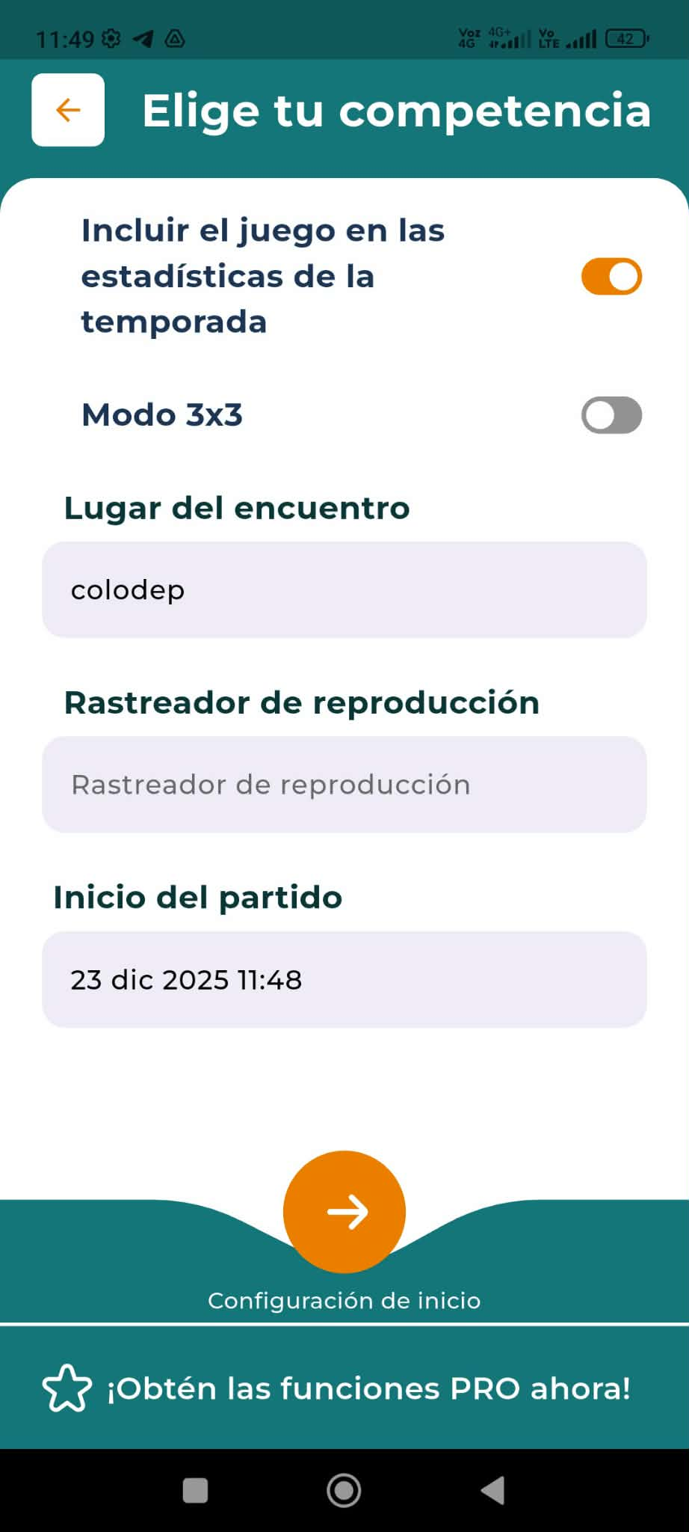
Elección de titulares
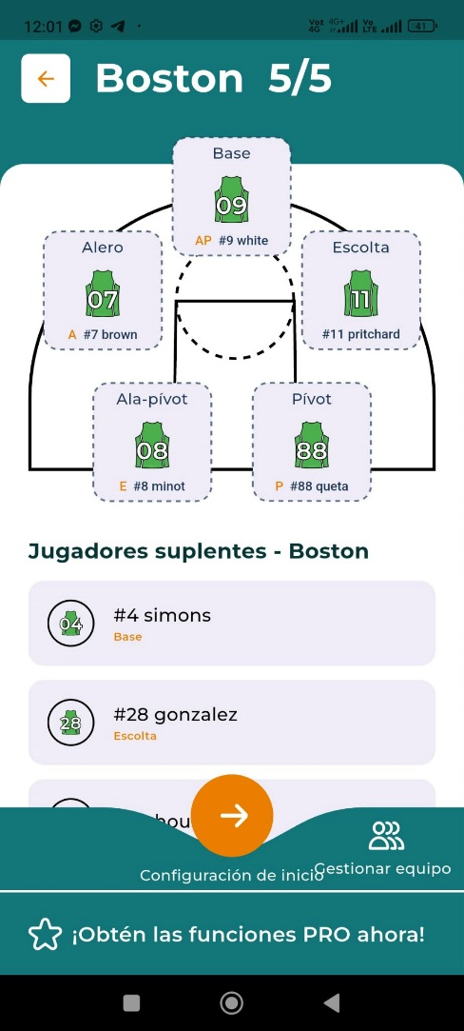

Partido:

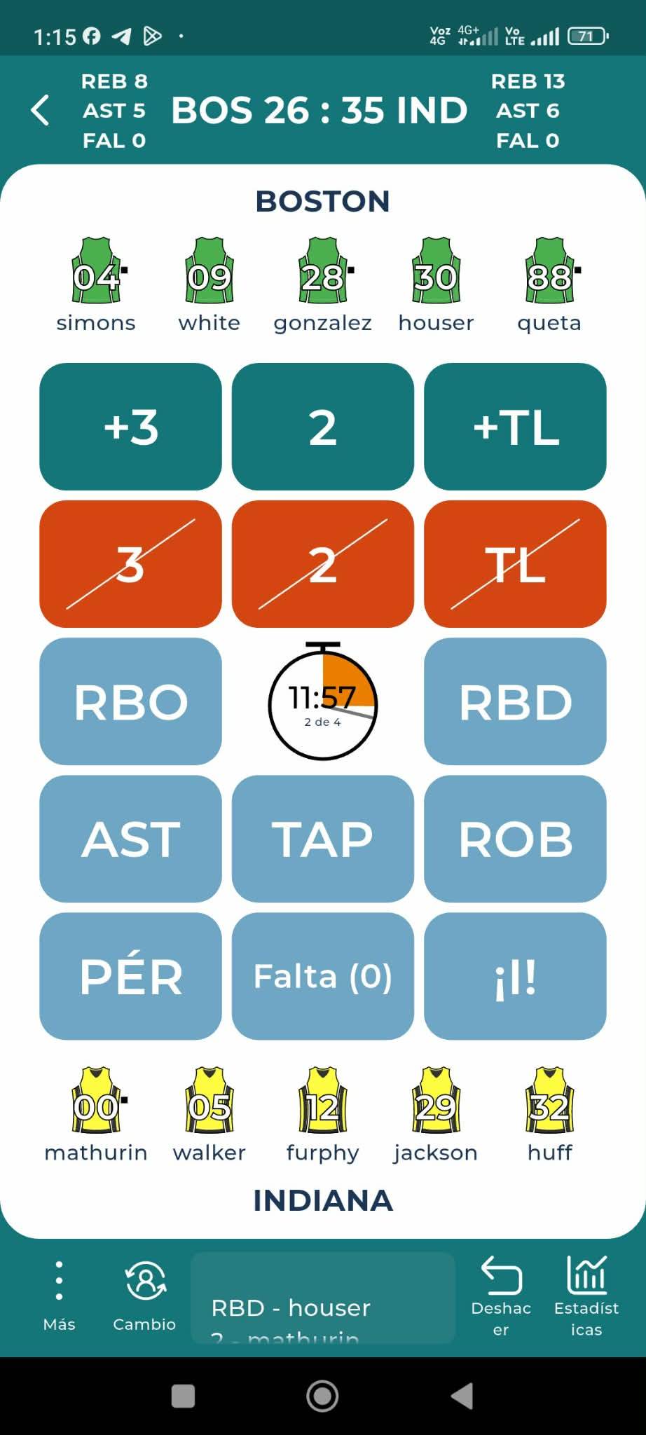

la interfaz del partido se inicia dando click en el reloj que empieza a correr, el reloj se detiene dundo se hace click y cuando se marca falta, la explicación de cada boton esta mas abajo, los botones van marcando lo que va pasando durante el partido son 4 periodos, luego los cambios,
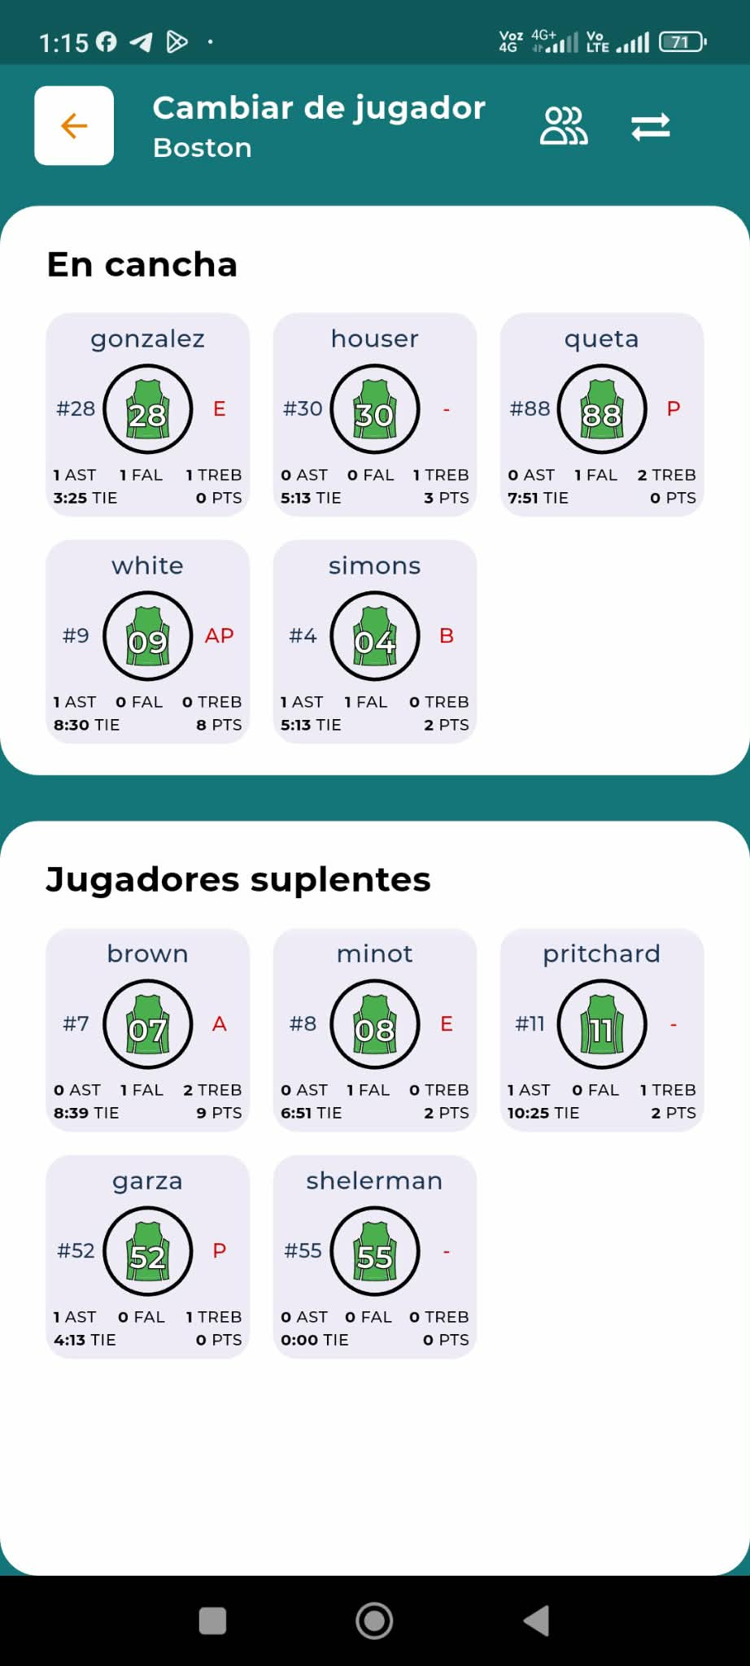

La app debe crear los boxscore de ambos equipos,

Take your game to the next level with Statastic Basketball.
Track every play live – from points and rebounds to assists, steals, and fouls.
Get instant insights with box scores, game flow charts, team and player stats, as well as shot charts and sector analysis.
​
All your basketball data in one app – clear, precise, and ready when you need it.
Available now on the App Store and Google Play.

Game setup & recording
Main screen
The starting point of the app gives you a clear overview of all games. Filter by team, league, or season, start new recordings, and access game settings. From here, you can also navigate directly to your team, league, and season pages.
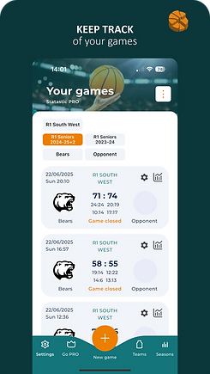

Statistics
Box score
The Box Score gives you a complete overview of the game.
See points, rebounds, assists, fouls, and all key stats for both teams and every player – updated live and always at your fingertips.
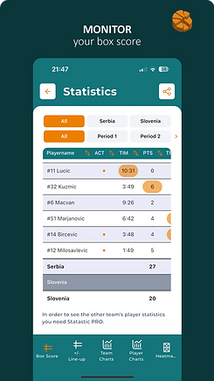
 Offfensive Rebounds

 Three pointer made

 Three pointer attempt

 Defensive Rebounds

 Assists

 Two pointer made

 Two pointer attempt
 Steal

 Free throws made

 Free throws attempt

 Block

 Block received

 Awesome

 Foul

 Turnover

 Travel

 Double Dribbling

 Turnover forced

 Technical Foul

 Unsportsmanlike Foul

 Disqualificational Foul

 Foul received

Analyzable Statistics
2FGA / 2FGM / 2FG%
Two point field goal attempted, made & percentage
3FGA / 3FGM / 3FG%
Three point field goal attempted, made & percentage
FTA / FTM / FT%
Free throws attempted, made & percentage
FGA / FGM / FG%
Field goals attempted, made & percentage
TS%
True shooting percentage
ORB / DRB / TRB
Number of offensive, defensive & total Rebounds
PTS
Number of points
A!
Number of events
AST
Number of Assists
TIM
Time played
TO
Number of Turnovers
STL
Number of Steals
BLK
Number of Blocks
EFF
Efficiency Rating is a composite basketball statistic that is derived from basic individual statistics: points, rebounds, assists, steals, blocks, turnovers and shot attempts. The efficiency stat, in theory, accounts for both a player's offensive contributions (points, assists) and their defensive contributions (steals, blocks), but it is generally thought that efficiency ratings favor offense-oriented players over those who specialize in defense, as defense is difficult to quantify with currently tabulated statistics.
Plus / Minus Index
​+/- or Plus/Minus Index reflects how the team did while that player is on the court. If a player has a +5 PM, it means his team outscored the opponent by 5 points while he was on the court. If he has a -3, then the opposing team outscored his team by 3 points while he was on the court.
PIR
Performance Index Rating is a metric that attempts to give a perspective on a player’s total performance.
The metric is a simple addition and subtraction of positive and negative game factors.
A real-life example as shared directly from our app can be found HERE.
STATASTIC Solutions FlexCo

