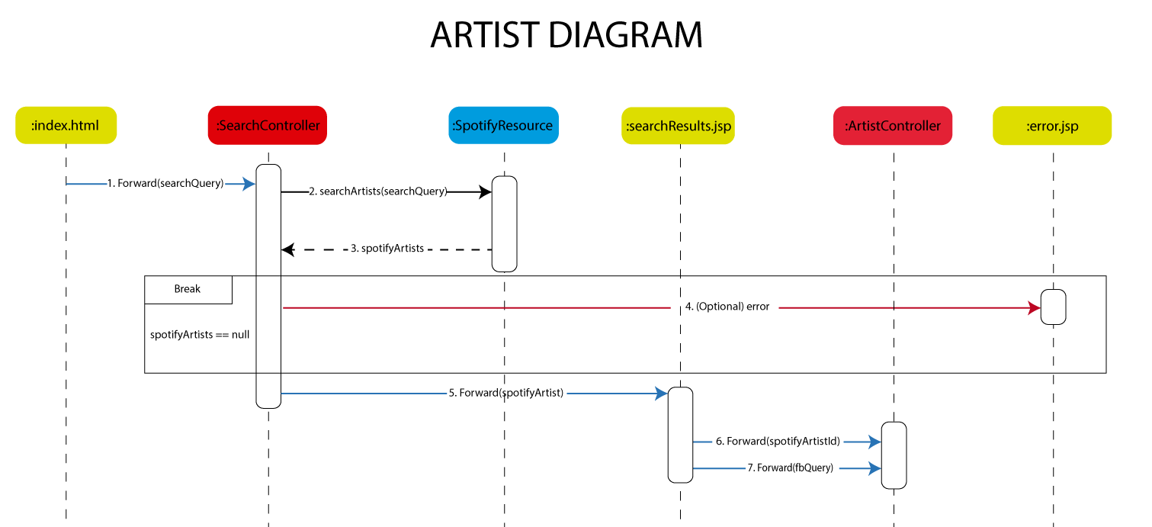

In this flow, the user search for an artist in the main page (index.html). His request is forwarded to SearchController, which tries to get a set of spotifyArtist resources through the SpotifyResource class. If something goes wrong during this procedure, the user is shown the error page. Otherwise, the spotifyArtists is forwarded to the searchResults.jsp page, which presents the results to the user in a user-friendly way. Once there, the user selects one artist from a list of related results and that information is forwarded to the ArtistController servlet to retrieve information about it.

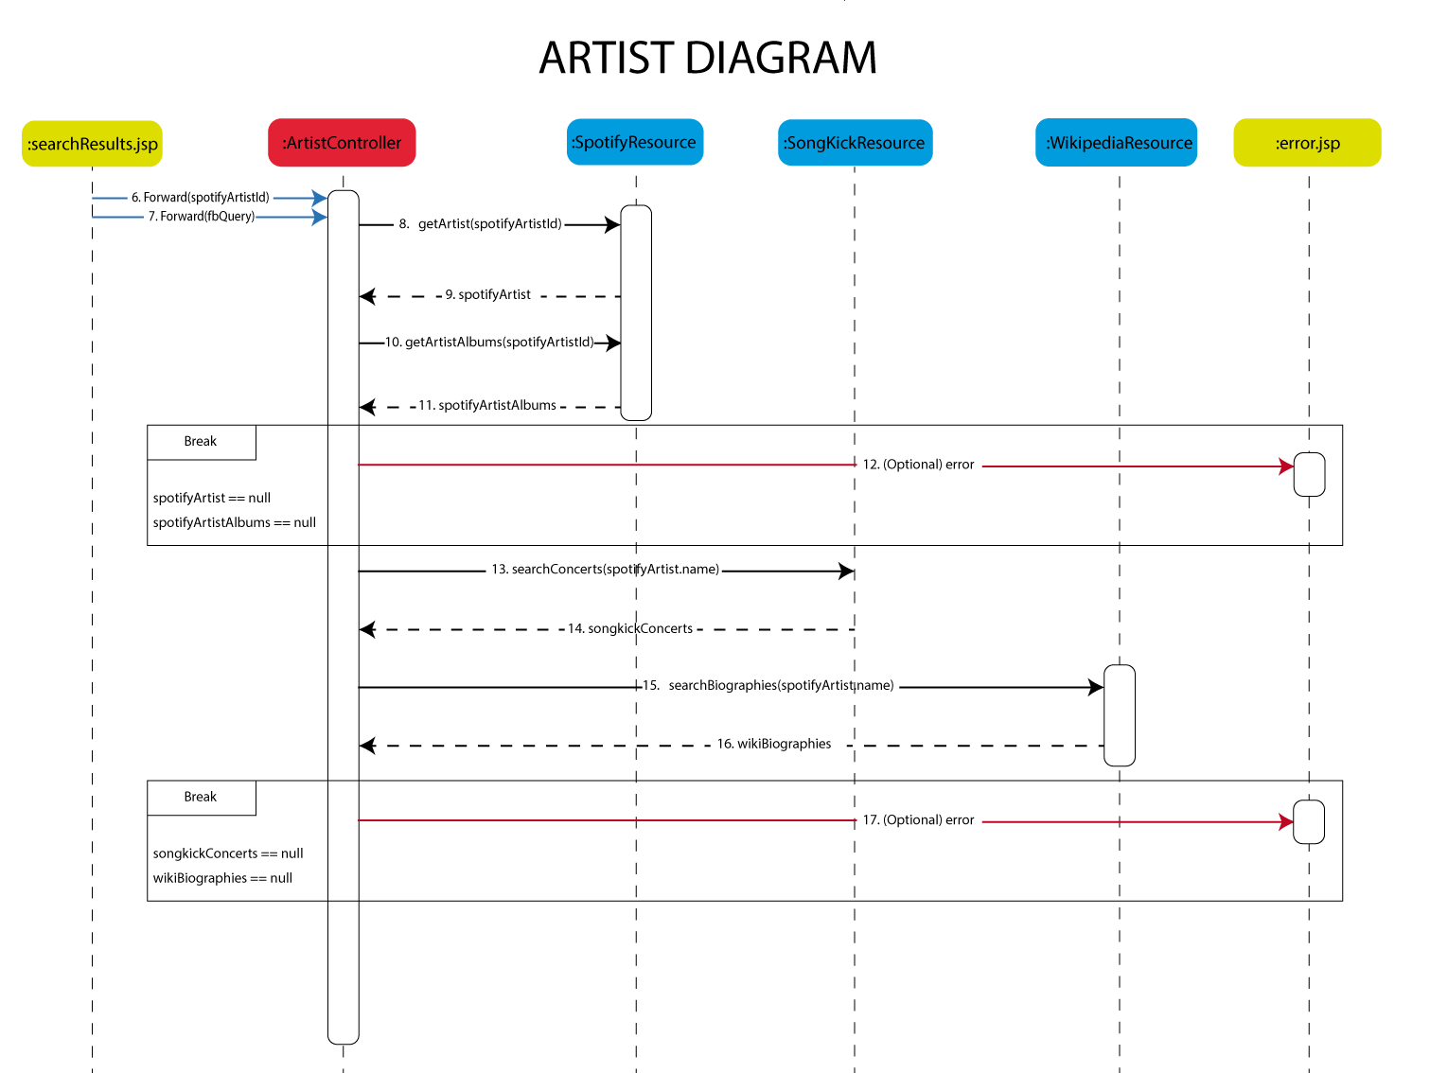

The ArtistController servlet then, with the spotifyArtistId, tries to get the spotifyArtist and spotifyArtistsAlbums resources. If one of them is null or there was an error while trying to obtain any of them, the user will be redirected to the error page. Otherwise the flow will continue with the search of concerts and the biography of the artist. The ArtistController servlet will obtain from SongKickResource a representation of the concerts resource and also a representation of the biography resource from the WikipediaResource class. In the unexpected case of one of them being null, the user will be shown the error page.

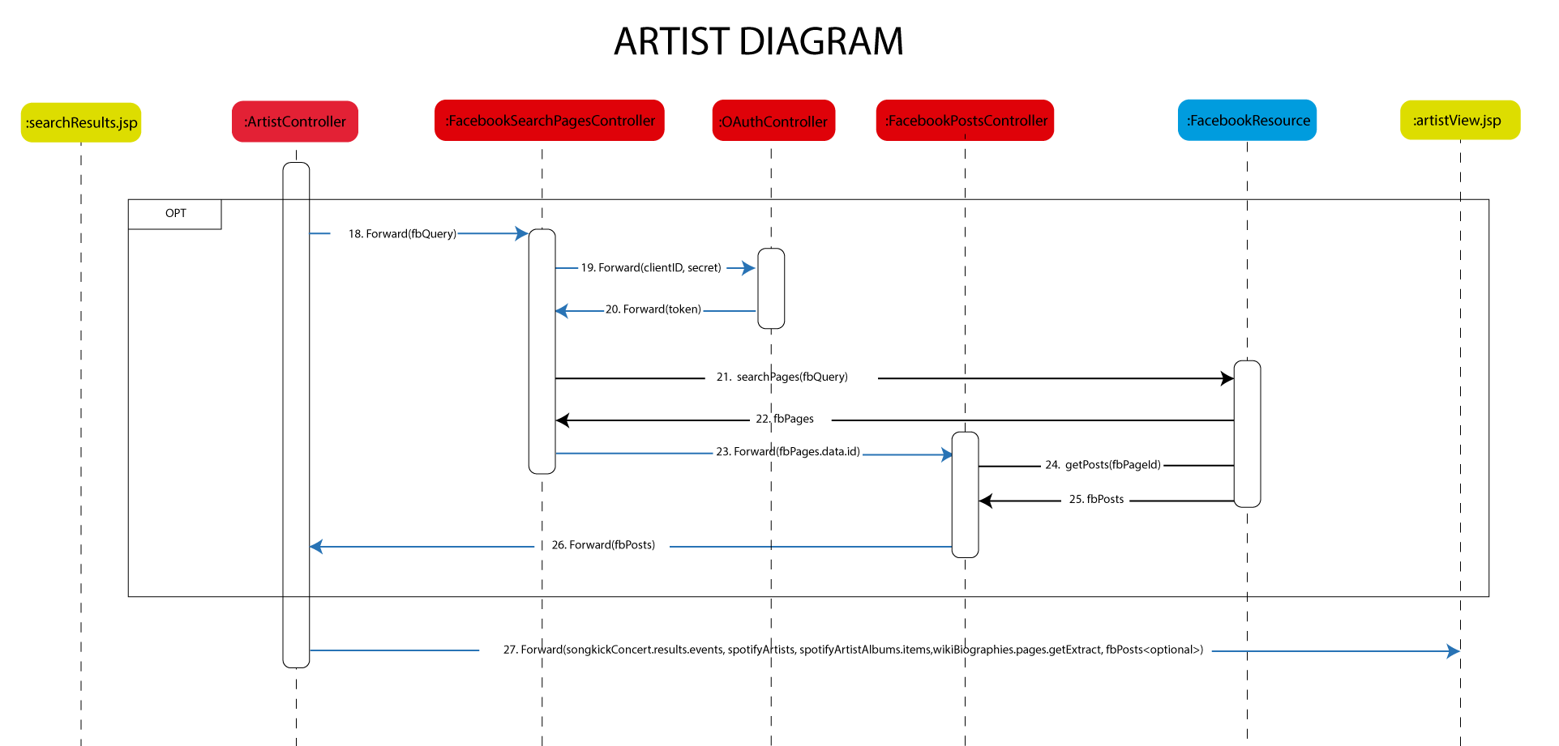

Finally, if there existed a Facebook-token saved in the session, the servlet will proceed by retrieving the artist’s last Facebook post. This will be done by forwarding the fbQuery to the FacebookSearchPagesController, which will obtain the Facebook Pages related to this query. In this case, as we have the Facebook-token in session, we don’t have to obtain it via the OAuthController. Then, the most relevant Facebook page id will be forwarded to the FacebookPostsController in order to retrieve the latest posts. Once there, we will obtain a representation of these posts using via FacebookResource class. Conclusively, all the retrieved resources will be forwarded to artistView.jsp to present the results to the user. One thing to bear in mind is that if we didn’t have a Facebook-token this last flow will not take place, and so the latest posts will not be shown in the artistView.jsp. Alternatively, the user will be presented a button to login on Facebook a get the token, which will lead us to the execution of the flow.