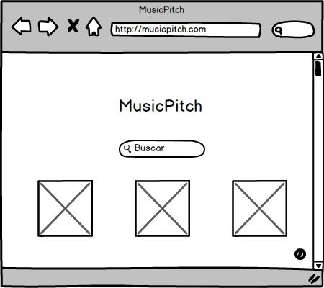

This is the main page of MusicPitch. In this section, you will be able to search for songs, artists and albums in just one click. There are three pictures that represent the songs, the artists and the albums, which will be useful to distinguish the results in the following page.

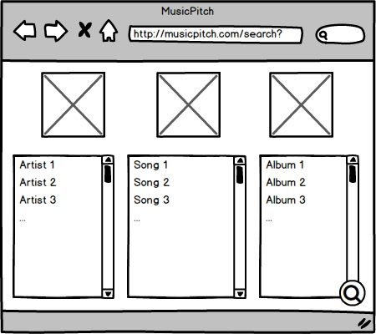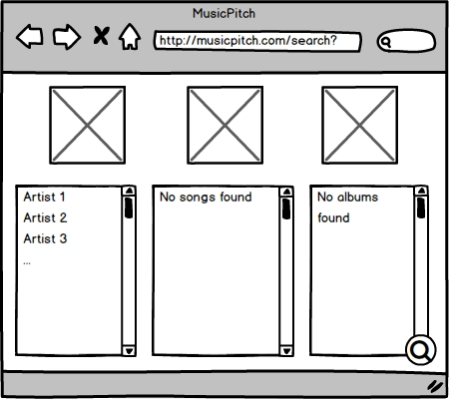

This is the page where the results are shown. In the three columns you will be able to find the artists, songs and albums (in that order) you expected for. Also, in case you need to make a new search, you will find a “Search” button in the bottom right corner, that will direct you to a new results page. This button will appear in every following page in order to make faster searches.

The second mockup represents the sight of the interface in case there weren’t any results of a specific type.

This is the song’s interface. At the top of the page, you will se a widget that includes a player and some information about the song (name, artist and cover). Also, you will be able to add the song to your Spotify account in case you need it. This widget will always appear everywhere in the song’s interface in order to have a better control of the played song.

Right under the widget, you will see the lyrics of the played song and a YouTube videoclip, in case you wanna watch it. Also, you will be able t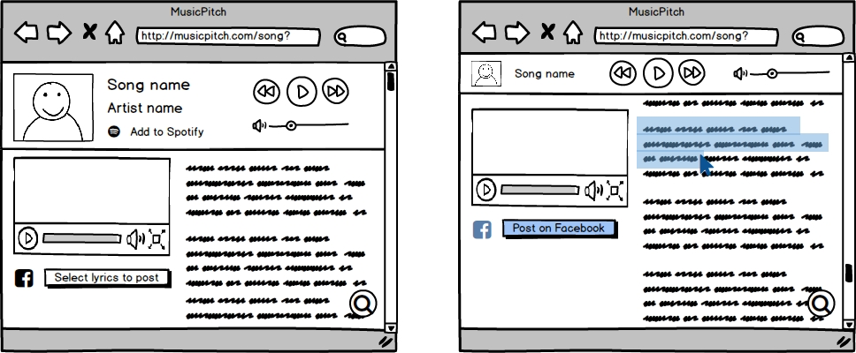o select a fragment of the lyrics and share it on Facebook.

This is the artist’s interface, which is divided in five parts. The first one, is a main picture of the artist, which is displayed at the top of the page. Under the picture, you will see the artist’s recent albums and a shorten biography extracted from Wikipedia.

Below the albums and the biography, you will see the latest posts from the artist on Facebook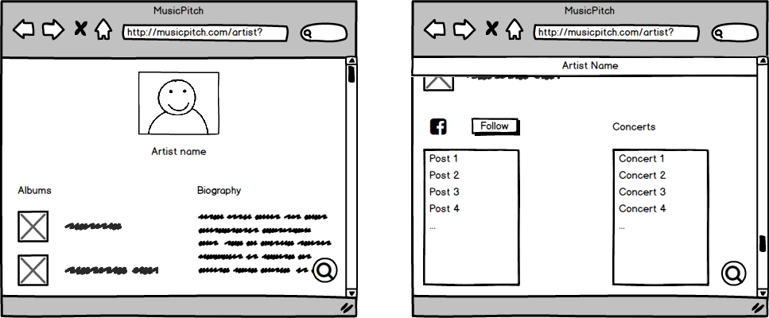 and a small widget where you will be able to see his/her coming concerts from SongKick.

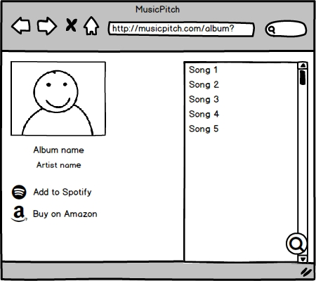

This is the album’s interface. It shows the main information about the album (name, artist and the cover) and the list of the songs included. Also, you will be able to add it in your Spotify account or buy the physical form in Amazon in just one click.

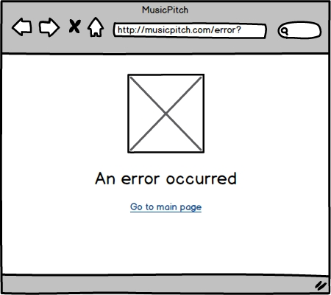

This page will be used in case an error occurred. Below the specification of the error, there will be a link that will access you to the main page in order to make a new search.