OPERATOR MANUAL
SentryLoom Complete User Guide
Install, enroll, operate, update, recover, and troubleshoot the endpoint and HQ
Endpoint Security 0.16.3 | SentryLoom HQ 0.4.2
Windows deployment guide | 2026-07-04

Local protection continues when HQ is unavailable.

How to use this guide
This manual is written for IT administrators, security operators, and endpoint users. HQ and the endpoint may be installed on different computers; that is the normal managed deployment. Follow the installation order and firewall guidance before troubleshooting discovery.
Security boundary: SentryLoom is an actively developed user-mode security project. Keep Microsoft Defender, Windows Firewall, SmartScreen, UAC, Secure Boot, and BitLocker enabled.

Contents
Part | What it covers
1-2 | Solution overview, roles, requirements, ports, and deployment planning
3-4 | HQ installation, client installation, discovery, enrollment, and approval
5-8 | Client use, HQ operations, maintenance authorization, and server policy
9-12 | Updates, state retention, resilience, threat intelligence, tray icon, and notifications
13-16 | Protected disable/uninstall, troubleshooting, hardening, privacy, source use, and CLI
Appendices | Paths, ports, checks, operational test plan, and glossary

Managed deployment quick start
- Install HQ first. Run SentryLoom-HQ-Setup-0.4.2.exe on the server computer and choose the console password.
- Record trust information. Save the HQ URL and certificate SHA-256 fingerprint shown by Setup.
- Verify networking. Allow TCP 8443 and UDP 32110 between the managed endpoint network and HQ.
- Install the endpoint. Run SentryLoom-Setup-0.16.3.exe on each client and select managed mode.
- Approve enrollment. Open the HQ console, inspect the pending device, and approve it.
- Verify recovery. Confirm the tray icon is green, then test network loss and sleep/resume.

1. Understand the solution

1.1 What runs on each computer
Computer | Primary responsibility | Continues without the other?
Windows endpoint | Local scanning, behavioral monitoring, encrypted quarantine, threat intelligence, audit records, and user interface. | Yes. Local protection continues if HQ is offline.
HQ server | Enrollment approval, fleet health, alerts, allowlisted remote actions, maintenance authorization, retention, and signed client updates. | Yes. It retains fleet data while endpoints reconnect.

1.2 What SentryLoom does
- Runs quick, full, custom-path, startup, active-process, and removable-drive scans.
- Combines local SHA-256 signatures, conservative rules, PE checks, optional ClamAV, and community threat intelligence.
- Monitors file changes, processes, persistence, scheduled tasks, services, WMI, ransomware signals, Windows events, DNS, and TCP metadata.
- Encrypts quarantine items with AES-256-GCM and verifies a tamper-evident audit chain.
- Provides optional on-premises management without requiring a public cloud service.

1.3 Deliberate limitations
- SentryLoom is not a certified replacement for Microsoft Defender or a mature commercial EDR.
- Network monitoring uses connection and DNS metadata; it does not decrypt TLS or inspect packet payloads.
- Behavioral signals report by default. Automatic destructive response is intentionally conservative.
- HQ provides no arbitrary shell-command API; remote actions are predefined and allowlisted.

2. Plan the deployment

2.1 Requirements
- Windows 10/11 or Windows Server 2022 or later.
- Administrator access for installation, HQ setup, firewall policy, DNS/USB controls, and system-wide monitoring.
- Node.js 24 or newer and PowerShell 5.1 or 7. Packaged Setup can install supported prerequisites.
- Optional Cisco ClamAV for expanded signature scanning.
- A stable DNS name or computer name for HQ that every managed client can resolve.

2.2 Network ports and scope
Direction | Protocol/port | Purpose | Recommended scope
Client → HQ | TCP 8443 | Pinned HTTPS enrollment, telemetry, commands, approvals, and updates. | Managed LAN/VPN only
Client ↔ HQ | UDP 32110 | Local HQ discovery request and response. | Local subnet or managed routed network
Local browser → client | TCP 3210 | Token-protected endpoint dashboard bound to loopback. | 127.0.0.1 only
HQ browser → HQ | TCP 8443 | Administrator console. | Managed LAN/VPN only

Do not expose HQ: Do not publish TCP 8443 directly to the public internet. Use a managed LAN or VPN and restrict inbound firewall scope.

2.3 Recommended installation order
- Prepare HQ identity. Choose the server DNS/computer name, console owner, backup location, and initial retention policy.
- Install and verify HQ. Confirm the HTTPS listener, console password, certificate fingerprint, scheduled task, and firewall rules.
- Install a pilot endpoint. Use one representative client to verify discovery, enrollment, telemetry, and recovery.
- Expand in groups. Roll out by department or device type after validating alerts, exclusions, and operational ownership.

3. Install and initialize SentryLoom HQ

3.1 Run the packaged HQ installer
- Start Setup as administrator. Run SentryLoom-HQ-Setup-0.4.2.exe on the server computer.
- Enter the public host. Use the DNS name or computer name clients will use, for example security-hq or security-hq.example.local.
- Name the console. Choose an organization-facing name such as Security Operations.
- Set the administrator password. Enter and confirm a 12-128 character password. Setup hashes and verifies the exact password before reporting success.
- Review verbose progress. Setup shows prerequisite, certificate, database, task, firewall, listener, and validation activity without opening command windows.
- Save the result. Record the console URL and certificate SHA-256 fingerprint. Do not store passwords in source control.
Upgrade behavior: Running a newer HQ Setup preserves the database, certificate, configuration, update repository, and operational history. The password entered during an upgrade becomes the new HQ console password.

3.2 Verify HQ after installation
Get-NetTCPConnection -LocalPort 8443 -State Listen
Get-ScheduledTask -TaskName "SentryLoom HQ Server"
Get-NetFirewallRule -Group "SentryLoom HQ"
Get-Content "$env:ProgramData\SentryLoom HQ\Logs\install.log" -Tail 100
- Open https://<hq-host>:8443 and sign in with the password selected during Setup.
- Confirm the left status area says Server online.
- Confirm the HQ data and operations settings panel loads.
- If the browser warns about a self-signed certificate, validate the displayed SHA-256 fingerprint before trusting it.
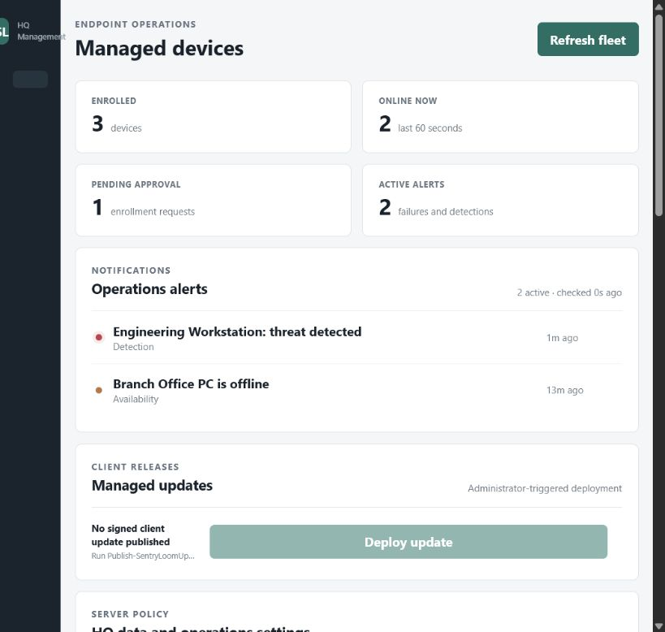
Figure 1. HQ fleet overview with enrollment, online state, approvals, and operations alerts.

4. Install the endpoint and enroll it

4.1 Run endpoint Setup
- Start Setup as administrator. Run SentryLoom-Setup-0.16.3.exe on the client computer.
- Choose deployment mode. Select standalone for local-only use or managed to connect to HQ.
- Provide or discover HQ. Enter https://<hq-host>:8443, or leave the URL blank to use LAN discovery.
- Pin the certificate. Enter the 64-character SHA-256 fingerprint when provided, or let approved trust-on-first-use pin the discovered HQ certificate.
- Finish installation. Setup registers resident protection, scan scheduling, shortcuts, tray behavior, and client firewall rules.
Separate computers: The client must use the HQ computer's resolvable host name or IP—not localhost. localhost always means the client computer itself.

4.2 Approve enrollment in HQ
- Open the HQ approval queue. Locate the pending device by name, hostname, version, and source address.
- Validate the request. Confirm it is the expected physical or virtual endpoint.
- Approve or reject. Approval provisions an independent revocable device token. Rejection leaves local endpoint protection active.
- Confirm managed status. Within seconds, HQ should show the endpoint online and the client tray icon should turn green.

4.3 If automatic discovery does not find HQ
- Confirm both PCs can resolve and reach the HQ host.
- Confirm inbound TCP 8443 and UDP 32110 on HQ, and outbound rules on the client.
- Use the explicit HTTPS URL in client Settings.
- If routed VLANs suppress broadcast discovery, explicit URL configuration is expected.
- Verify the certificate fingerprint rather than disabling TLS validation.

5. Use the endpoint console

5.1 Open the GUI
- Double-click SentryLoom.exe. If the client is already running, the existing GUI is restored.
- Double-click the notification-area icon near the Windows Wi-Fi, speaker, and battery indicators.
- Use the tray menu to open Overview or Activity.
- No command window should appear during normal installed operation.
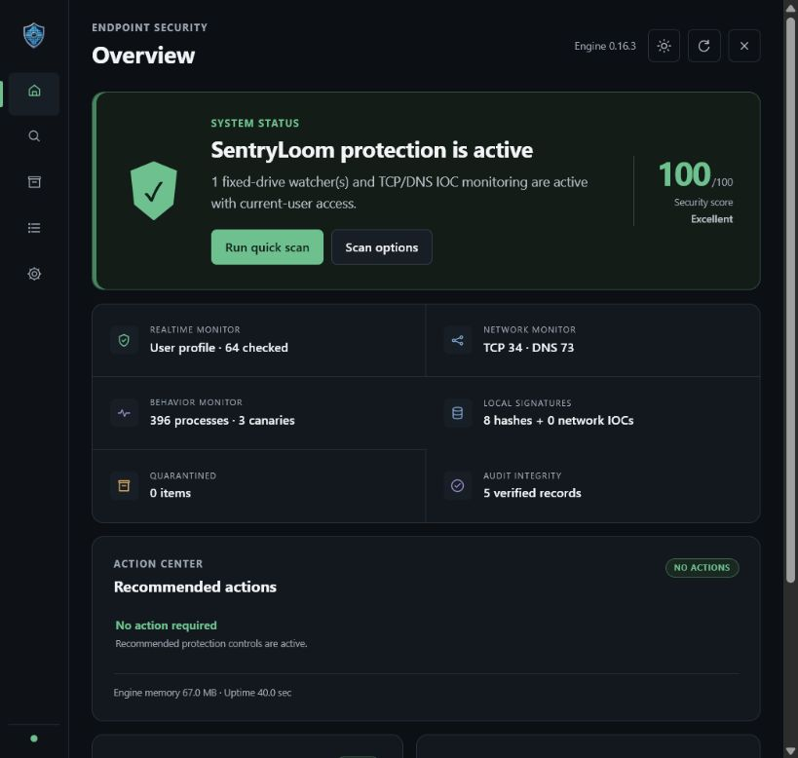
Figure 2. Endpoint Overview consolidates protection health and recommended actions.

5.2 Overview
- Check the security score and protection state.
- Review realtime, network, behavior, signature, quarantine, and audit indicators.
- Use Run quick scan for an immediate low-impact scan.
- Follow Action Center recommendations when a control needs attention.

5.3 Scan
Scan | Use it for
Quick | Common user locations and high-value startup areas.
Full | Broad fixed-drive inspection; schedule for low-use periods.
Custom path | A specific file, folder, share, or mounted target.
Startup | Startup folders, common persistence paths, and launch points.
Processes | Images associated with active processes.
External | Mounted removable drives.

Scan result codes: 0 means clean, 1 means operational error, and 2 means a detection.

5.4 Quarantine
- Inspect the finding, original path, hash, size, and state before acting.
- Restore only after confirming the detection is a false positive and the source is trusted.
- Delete an item when retention is no longer required.
- Quarantine files are authenticated and encrypted; do not manipulate the storage directory manually.

5.5 Activity and background output
- Review scan events, detections, connector state, remote command results, and audit messages.
- Open Resident command output to load bounded stdout/stderr captured from hidden background commands.
- Use this view for diagnosis instead of launching an interactive command window.

6. Understand endpoint settings and authorization
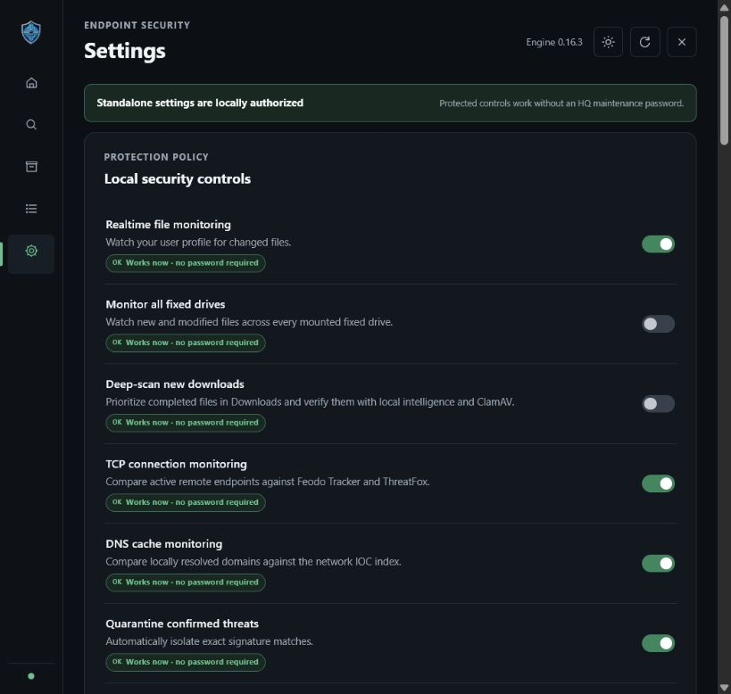
Figure 3. Protected settings display their current authorization state.

6.1 Read the status badge before changing a setting
Badge | Meaning
Works now - no password required | The control is currently authorized, usually because the endpoint is standalone.
Password required | Enter an active HQ maintenance password before applying the change.
HQ offline | The endpoint cannot validate managed authorization. Restore HQ connectivity.
Compatibility checking | Capability metadata is not yet known; SentryLoom verifies support when the action is attempted.
HQ upgrade required | HQ explicitly reports that the required protected-settings API is unavailable.

6.2 Common protected actions
- Changing protection, scan, exclusion, or advanced monitoring policy.
- Disabling realtime or behavioral protection.
- Changing encrypted DNS, USB storage, or SentryLoom firewall policy.
- Disconnecting the endpoint from HQ.
- Continuing through the supported Windows uninstall flow.

7. Operate the HQ console

7.1 Fleet overview and alerts
- Enrolled shows the managed device inventory.
- Online now reflects telemetry received inside the configured offline window.
- Pending approval lists devices waiting for administrator review.
- Active alerts includes stale endpoints, detections, client failures, and failed remote commands.

7.2 Open an endpoint
- Review current posture, protection state, scan progress, recent telemetry trends, quarantine, events, and command history.
- Confirm hostname, platform, client version, remote address, and last-seen time.
- Use remote actions only after identifying the endpoint and expected operational impact.

7.3 Allowlisted remote actions
Action group | Available actions
Scanning | Quick, full, startup, processes, external drives, and cancel scan.
Maintenance | Update threat databases, apply safe Fix All, and restart protection.
Client lifecycle | Queue the latest trusted signed client update.

No remote shell: HQ rejects command types outside the built-in allowlist. It cannot submit arbitrary PowerShell or command-line text.

7.4 Enrollment and revocation
- Approve only devices whose identity and source address are expected.
- Reject unknown requests.
- Revoke an enrolled endpoint when it is retired, lost, rebuilt, or transferred.
- Re-enrollment creates a new device credential relationship.

8. Authorize critical maintenance

8.1 Primary administrator-generated password
- Open Rotating endpoint passwords. Use the HQ maintenance panel.
- Choose lifetime and uses. Select 5, 10, 30, or 60 minutes and one, three, or ten uses.
- Generate the password. HQ shows a long random value once and stores only its hash.
- Enter it on the client. Use it for the intended protected action before expiry or use exhaustion.
- Revoke when finished. Revoke immediately if the value was exposed, copied incorrectly, or no longer needed.
Separate passwords: The HQ console administrator password and endpoint maintenance passwords are different credentials. Never reuse the console password as a maintenance password.

8.2 Client-requested 20-second approval
- Start the protected action. On the endpoint, choose Request administrator approval.
- Watch HQ immediately. A request appears in the maintenance queue for only 20 seconds.
- Approve or reject. Approval creates a device-scoped, one-use password.
- Complete the action. HQ encrypts the value with the endpoint's ephemeral RSA public key; only that endpoint can decrypt it.

8.3 Failure cases
Message | What to do
Invalid, expired, used, or revoked | Generate a new password and verify the target endpoint and current time.
Approval window expired | Start a new request from the endpoint and approve within 20 seconds.
HQ offline | Restore server reachability before attempting managed authorization.
Too many attempts | Stop guessing, wait for the rate-limit window, and generate a fresh value.

9. Configure HQ data and operations policy
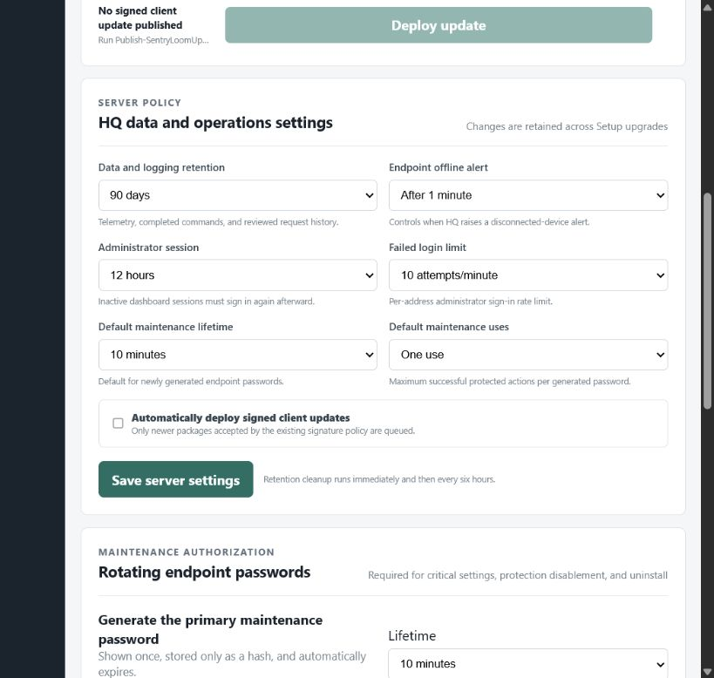
Figure 4. HQ retention, offline alerting, session, login, maintenance, and update controls.

9.1 Data retention
Setting | Recommended use
30 days | Small pilots, privacy-minimized deployments, and constrained storage.
90 days | Balanced operational troubleshooting and recent-history review.
365 days | Longer trend and audit history when policy and storage permit.

The selected period applies to telemetry snapshots, completed command history, reviewed enrollment requests, completed maintenance requests, and expired or revoked maintenance records. Current device status and active security records remain available. Cleanup runs immediately after saving and then every six hours.

9.2 Other discrete settings
Control | Allowed values
Endpoint offline alert | After 1, 5, or 15 minutes
Administrator session | 1, 4, 8, 12, or 24 hours
Failed login limit | 5, 10, or 20 attempts per minute per address
Default maintenance lifetime | 5, 10, 30, or 60 minutes
Default maintenance uses | 1, 3, or 10 uses
Automatic signed update deployment | Off or on

Settings persistence: HQ writes settings atomically into the existing configuration. Setup upgrades retain them unless a versioned schema migration explicitly documents a change.

10. Update safely and retain state

10.1 Endpoint Setup upgrade
Before replacing endpoint files, Setup stops the running version and creates a restricted backup under %ProgramData%\SentryLoom\UpgradeBackups\<timestamp>-<version>.
- Preserved: configuration, migration state, keys, encrypted HQ credentials, quarantine, logs, scan history, signatures, device identity, connector state, DNS backup, device-control state, monitoring state, threat intelligence, and update state.
- A preservation manifest records the source, target version, copied categories, and retain-unless-versioned-migration policy.
- Configuration migration deep-merges new defaults while retaining existing values.
- A failed preservation step blocks the upgrade instead of silently discarding data.

10.2 HQ Setup upgrade
HQ Setup stops the server and creates a restricted copy of the entire HQ data directory under %ProgramData%\SentryLoom HQ\UpgradeBackups\<timestamp>-<version> before modifying installed files.
- Preserved: configuration, TLS certificate, SQLite database, update repository, approvals, telemetry, credentials, and operational history.
- The password entered during Setup becomes the new HQ console password.
- Discrete settings and secret administrator fields are retained when settings are updated.

10.3 Publish a signed client update
Use the HQ publishing script only with an Authenticode-signed endpoint Setup package. Clients verify version, package size, SHA-256, certificate thumbprint, certificate subject, and signature policy before installation.
cd "C:\Program Files\SentryLoom HQ"
.\Publish-SentryLoomUpdate.ps1 -SetupPath "C:\Releases\SentryLoom-Setup-0.16.3.exe"
Unsigned builds: The locally generated development installers are unsigned. Do not label or distribute them as signed production releases.

11. Verify offline, sleep, and recovery behavior
Condition | Expected endpoint behavior | Expected HQ behavior
Wi-Fi/cable/VPN loss | Keeps local protection active; marks HQ reconnecting; retries with bounded backoff. | Marks endpoint offline after the configured delay.
Network returns | Retries within 30 seconds at worst and resumes telemetry. | Clears availability alert when telemetry returns.
Sleep or hibernate | Detects the resume gap, discards stale delay, and sends fresh telemetry. | Receives heartbeat without app restart.
Background client exits | Task Scheduler restarts it within one minute. | Shows offline until the restarted client checks in.
HQ outage | Raises one actionable, deduplicated Windows notification. | Dashboard reports its own API connection loss.

11.1 Operational resilience test
- Confirm baseline. Enroll one client and verify it is online in HQ.
- Disconnect network. Keep it disconnected beyond the offline threshold and confirm both endpoint and HQ indications.
- Reconnect. Confirm telemetry and queued commands recover without restarting either application.
- Sleep and resume. Confirm a resume event and fresh HQ contact.
- End the resident process. Confirm the scheduled task restores it within one minute.
- Queue a scan. After every recovery case, verify that a remote scan completes and reports back.

11.2 Timing defaults
- Normal remote-command polling: 1.5 seconds.
- Normal telemetry submission: every 2 seconds.
- Reconnect backoff: 1.5 seconds up to 30 seconds.
- Default HQ offline state: 60 seconds without telemetry.
- Client outage notification: after two consecutive failures.
- Repeated endpoint notifications: deduplicated for five minutes.

12. Update threat intelligence and ClamAV

12.1 Update from the UI or CLI
sentryloom update all
sentryloom update clamav
sentryloom update malwarebazaar
sentryloom update urlhaus
sentryloom update feodotracker
sentryloom update threatfox
Provider credentials are entered by the operator, encrypted locally, and never stored in source control. Each provider retains its own license and usage terms.

12.2 FreshClam HTTPS error 60
Error 60 means TLS certificate verification failed. The current Windows implementation exports trusted Windows root certificates to a private PEM bundle and passes it to FreshClam through CURL_CA_BUNDLE while keeping verification enabled.
- Check system time. Correct date, time, and timezone before retrying.
- Check TLS inspection. If a proxy or security appliance re-signs traffic, ensure its root certificate is trusted by Windows policy.
- Confirm trusted roots. Run Windows Update or your organization's root-certificate deployment process.
- Retry the update. Use the UI or sentryloom update clamav and review Activity output.
- Do not disable verification. Fix the trust chain rather than bypassing TLS checks.
Expected diagnostic: The Activity output should identify clock, TLS inspection, or trusted-root policy causes instead of showing only a generic update failure.

13. Use the tray icon, notifications, and hidden command output

13.1 Tray icon state
Icon | Meaning | Action
Green | The latest connector heartbeat reports HQ reachable. | No action required.
Red | HQ is unreachable or connector state is stale. | Open the GUI, inspect Settings and Activity, then verify server/network state.

- Double-click the icon to restore the running GUI.
- If the client process is not running, launching SentryLoom starts it.
- The launcher enforces a single GUI instance.
- Background commands run without visible PowerShell, cmd, Node.js, or scheduled-task windows.

13.2 Notifications
- Endpoint notifications report connection loss, recovery, threats, and monitoring failures.
- HQ notifications report new detections, failures, and urgent maintenance requests.
- Repeated outage notifications are deduplicated to reduce noise.
- A recovery notification confirms that telemetry resumed.

13.3 Resident command output
- Open Activity. Use the sidebar or tray menu.
- Open Resident command output. Load the bounded current background log.
- Review both streams. The view includes captured stdout/stderr, scan activity, and remote-command results.
- Use install logs for Setup. Endpoint Setup uses Inno Setup logging; HQ setup writes %ProgramData%\SentryLoom HQ\Logs\install.log.

14. Disable, disconnect, or uninstall safely

14.1 Managed endpoint
- Obtain maintenance authorization. Generate a primary HQ maintenance password or request 20-second approval.
- Start the intended action. Use client Settings for protected policy changes or Windows Apps for uninstall.
- Enter the one-time value. The client validates it with HQ and consumes an allowed use.
- Confirm cleanup. The supported uninstaller removes scheduled tasks, shortcuts, and SentryLoom-owned firewall rules.

14.2 Standalone endpoint
Standalone protected settings are locally authorized. Use the client GUI or Windows Apps to change or uninstall. Administrator permission is still required for system-level cleanup.

14.3 HQ removal
Back up the HQ data directory before removal when records must be retained. The supported HQ uninstaller removes its scheduled task and SentryLoom HQ firewall rules. Do not manually delete the data directory before confirming retention requirements.
Avoid manual deletion: Deleting Program Files does not reliably remove scheduled tasks, firewall rules, or protected data. Use the supported uninstall flow.

15. Troubleshoot common problems
Symptom | Likely cause | Resolution
Client shows the wrong HQ address | Preserved credentials for an older HQ won over a new Setup enrollment request. | Install endpoint 0.16.3 and submit the intended HQ URL again. The new request supersedes the old target.
Client says HQ needs an update | The client contacted an older or unintended HQ, or HQ explicitly lacks the required API. | Confirm the address shown in Settings, then install endpoint 0.16.3 and HQ 0.4.2.
Device API route not found | Client and HQ versions do not share the protected-settings route. | Install the matching current endpoint and HQ builds, then retry.
Request approval button missing | Old client UI or enrollment state was not retryable. | Install endpoint 0.16.3; enter the HQ URL and use Request administrator approval.
HQ password is invalid | Older setup did not transfer the exact selected password, or an upgrade changed it. | Run HQ 0.4.2 Setup and set the intended 12-128 character password.
Client remains offline after sleep | Old connector delay survived resume or the resident task stopped. | Install current client; verify the resident scheduled task and run the resilience test.
HQ cannot be discovered | Broadcast is blocked, routed, or firewall rules are missing. | Use explicit HTTPS URL; verify TCP 8443 and UDP 32110.
Tray icon is red | HQ unreachable, TLS trust failure, connector stale, or client not enrolled. | Open Activity and Settings; verify URL, fingerprint, network, approval, and server listener.
FreshClam update fails with error 60 | Clock, TLS inspection, or Windows trusted-root problem. | Correct trust configuration; do not disable certificate verification.
Setup upgrade stops | Pre-upgrade backup or state validation failed. | Read verbose Setup output and install logs; correct permissions or storage, then retry.

15.1 Minimum diagnostic collection
- Exact endpoint and HQ versions.
- Endpoint Activity output around the failure.
- HQ installation log and server console alert.
- HQ URL, DNS resolution result, and certificate fingerprint—never the password or private key.
- Firewall rule names and listening ports.
- Reproduction steps and whether local protection remained active.

16. Apply security, privacy, and operating controls

16.1 Hardening checklist
- Restrict HQ TCP 8443 and UDP 32110 to managed LAN/VPN ranges.
- Use a unique long HQ administrator password and rotate it through Setup when required.
- Generate short-lived, minimum-use maintenance passwords and revoke them after work.
- Keep Windows security controls enabled and current.
- Back up HQ data and protect backup ACLs.
- Use Authenticode-signed installers for production distribution.
- Review enrollment requests, alerts, revoked devices, and retention policy regularly.
- Never commit PFX files, private keys, certificates with private material, databases, tokens, or environment files.

16.2 Privacy model
- Standalone endpoints do not contact HQ.
- Managed mode is explicit and requires HQ administrator approval.
- HQ stores enrolled-device records, sanitized telemetry, command history, approval history, alerts, and maintenance metadata.
- HQ stores maintenance-password hashes and policy—not plaintext maintenance passwords.
- Threat provider credentials and HQ credentials are encrypted locally.
- The HQ administrator controls retention, host access, firewall scope, and backups.

16.3 Responsible support
Remove secrets, usernames, private hostnames, tokens, full paths containing personal information, and sensitive logs before publishing an issue. Security vulnerabilities should follow the private reporting process in SECURITY.md.

17. Run from source and use the CLI

17.1 Endpoint from source
git clone https://github.com/alivirgo/SentryLoom.git
cd SentryLoom
npm test
node .\src\cli.js dashboard

17.2 HQ from source
cd .\server
.\Initialize-SentryLoomHq.ps1 `
-PublicHost security-hq.example.local `
-HqName "Security Operations" `
-RegisterStartupTask

17.3 CLI reference
sentryloom dashboard [--no-open] [--port 3210]
sentryloom quick|full|startup|processes|external [--json] [--no-quarantine]
sentryloom scan <path> [--json] [--no-quarantine]
sentryloom protect [path ...]
sentryloom status [--json]
sentryloom quarantine list|restore|delete
sentryloom signatures status|trust|import
sentryloom update [all|clamav|malwarebazaar|urlhaus|feodotracker|threatfox]
sentryloom ioc lookup <ip-domain-url>
sentryloom dns status|apply|restore
sentryloom firewall status|clear
sentryloom audit verify
sentryloom hq discover|status|disconnect

17.4 Build and test
npm run check
npm --prefix server test
.\build\Build-Release.ps1 -AllowUnsignedDevelopmentBuild
Signing material: PFX files, private keys, signing passwords, generated installers, databases, and runtime state are ignored by Git. Keep signing material outside the repository.

Appendix A. Installed paths and operational records
Location | Contents
%ProgramFiles%\SentryLoom | Endpoint executable, source runtime, scripts, local documentation, and uninstaller.
%LOCALAPPDATA%\SentryLoom | Endpoint configuration, keys, quarantine, logs, scan history, signatures, identity, connector state, and threat intelligence.
%ProgramData%\SentryLoom\UpgradeBackups | Restricted endpoint pre-Setup backups.
%ProgramFiles%\SentryLoom HQ | HQ runtime, public console, scripts, data directory, shortcut, and uninstaller.
%ProgramData%\SentryLoom HQ\Logs\install.log | Persistent HQ installation and upgrade diagnostic log.
%ProgramData%\SentryLoom HQ\UpgradeBackups | Restricted full HQ data backups created before Setup upgrades.

Appendix B. Firewall rule ownership
Group | Rule purpose
SentryLoom Endpoint | Application-scoped TCP outbound HTTPS and UDP 32110 discovery traffic.
SentryLoom HQ | TCP 8443 inbound, UDP 32110 discovery inbound, and UDP discovery response outbound, scoped to LocalSubnet.

Appendix C. Release verification
Before installing an unsigned development build, compare the SHA-256 value with a trusted release note or separately provided checksum.
Get-FileHash .\SentryLoom-Setup-0.16.3.exe -Algorithm SHA256
Get-FileHash .\SentryLoom-HQ-Setup-0.4.2.exe -Algorithm SHA256
Get-AuthenticodeSignature .\SentryLoom-Setup-0.16.3.exe

Appendix D. Glossary
Term | Meaning
Endpoint | The Windows client computer running local SentryLoom protection.
HQ | The optional on-premises management server and administrator console.
Enrollment | Administrator approval that provisions a revocable device credential.
Certificate pinning | Binding the endpoint to the expected HQ TLS certificate fingerprint.
Maintenance password | A random, expiring, use-limited authorization value for critical managed actions.
Telemetry | Sanitized endpoint posture, health, scan, update, performance, and event information.
Schema migration | A versioned, explicit change that updates stored configuration while preserving existing values by default.

Project documentation: For implementation details, read README.md, server/README.md, SECURITY.md, PRIVACY.md, docs/ARCHITECTURE.md, and docs/CONNECTION-RESILIENCE.md in the repository.

