HW: DevOps Deployment
Repo URL:
git@github.com:momen-qasem/urless.git
1-High-Level Architecture Diagram:
A high-level architecture diagram provides a visual representation of the system's infrastructure. It includes key components such as the backend, frontend, Redis, Nginx, and the hosting environment on AWS or OCI. The diagram also emphasizes security measures, such as firewalls, IAM roles, and data encryption, ensuring the infrastructure aligns with best practices.

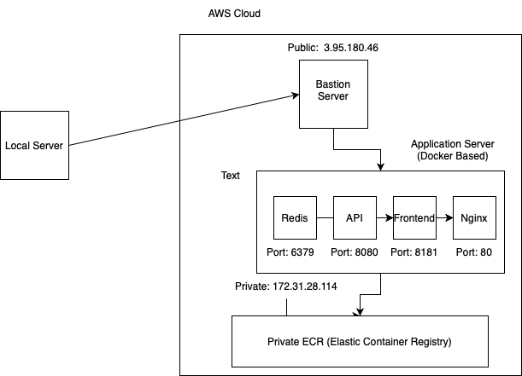

2- Setup Instructions:
Detailed, step-by-step setup instructions guide users through provisioning resources, configuring services, and deploying applications. Specific focus is given to Ansible role descriptions, providing clarity on how automation is achieved for consistent and efficient deployment.

2.1: install ansible on bastion server.
2.2: modify the congiguration vars file inside ansible project.
2.3 we need ssh key (.pem) to connect bastion server with application server.
2.4: create private ECR with needed repositries.
2.5: open needed port from security group.
2.6: create internet gateway and attach to application VPC also, verified the route table.
2.6 run playbook ansible.

Linux Questions:
1. /dev/null: A special file that discards all data written to it.
used to Redirect unwanted output, e.g., command > /dev/null 2>&1.
2. nice/renice:
- nice: Start a process with a specific priority (nice -n 10 command).
- renice: Change the priority of a running process (renice 10 -p PID).
Used for Adjust process priority to optimize resource usage.
3.Troubleshooting Slow Server:
- Check CPU/memory: top/htop.
- Analyze disk I/O: iostat/iotop.
- Network issues: netstat/ss.
- Logs: Review system logs in /var/log.
4. Determine CPU Cores:
- nproc or lscpu.
- View /proc/cpuinfo: grep -c ^processor /proc/cpuinfo.

AWS Questions:

AWS Lambda Cold Start: The delay when a Lambda function initializes due to container provisioning.
Elastic Load Balancer (ELB) High Availability:
- Distributes traffic across multiple instances and Availability Zones.
- Monitors health to reroute traffic from unhealthy targets.
Differences:
- ALB (Application Load Balancer): Layer 7, advanced routing, HTTP/HTTPS support.
- NLB (Network Load Balancer): Layer 4, handles TCP/UDP, low latency.
- CLB (Classic Load Balancer): Legacy, Layer 4/7, limited features.
Securely Store API Keys on EC2:
- Use AWS Systems Manager Parameter Store or AWS Secrets Manager.
- Attach IAM roles with fine-grained permissions to the EC2 instance for secure access.
Troubleshoot EC2 Internet Access:
- Verify route table: Ensure route to an Internet Gateway (IGW).
- Check Security Groups and NACLs: Allow outbound traffic (e.g., port 80/443).
- Confirm Elastic IP/Public IP is assigned and correct.
- Inspect IGW attachment to the VPC.

