Nom : Benrahhou
Prenom : Ali
Lien Github : ali_github

TP1 Java-Bases du langage
Partie1:Condition et Boucles
Exercice1 :
Solution
Solutionffdeed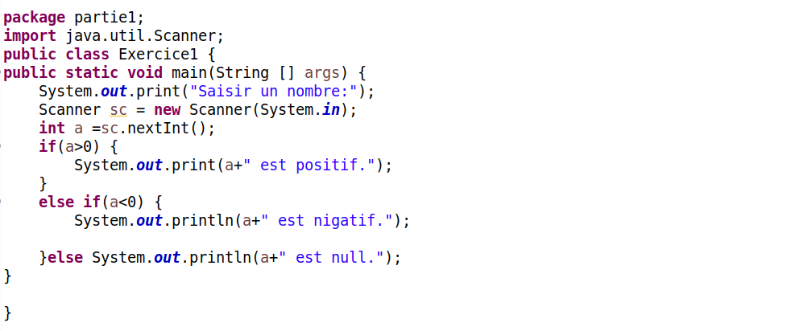
Execution

Exercice2:
Solution

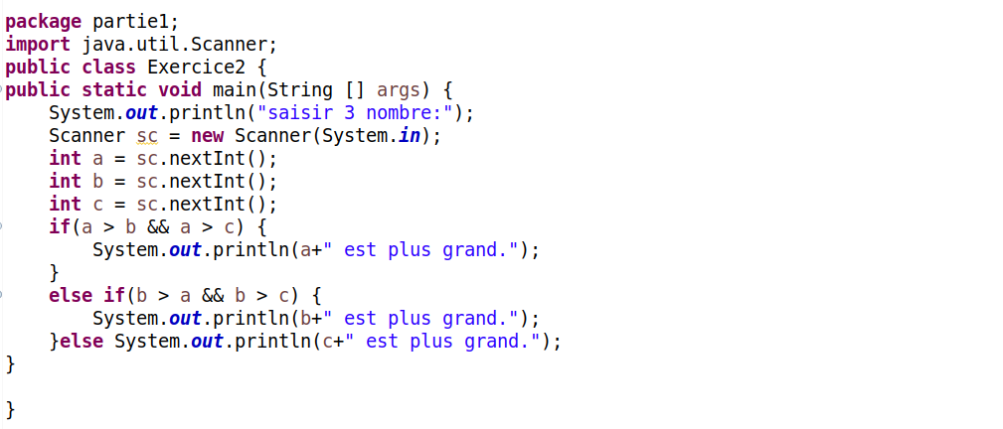
Execution
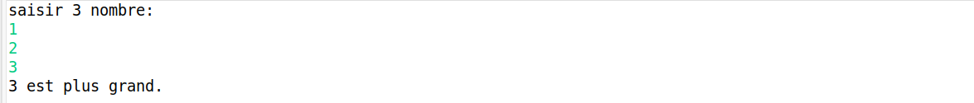
Exercice3:
Solution

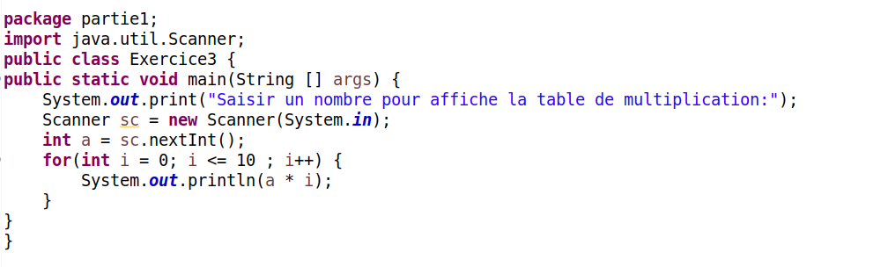
Execution

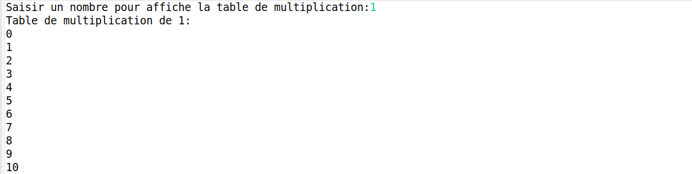
Exercice4:
Solution

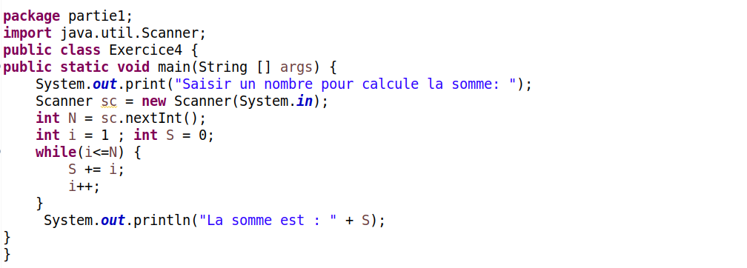

Execution
Partie2:Tableaux
Exercice5:
Solution

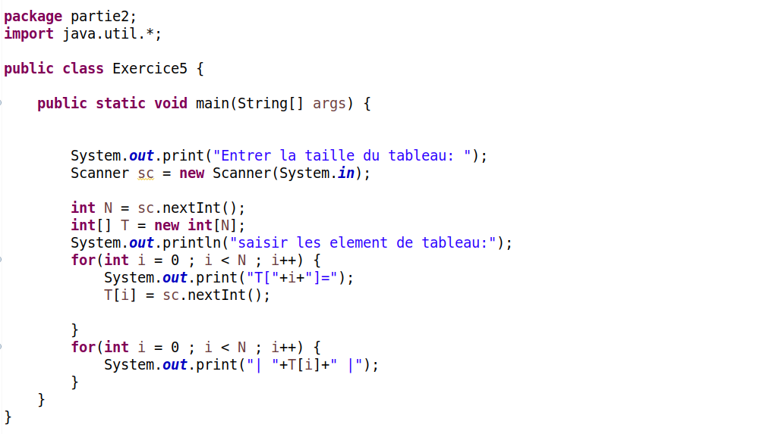
Execution

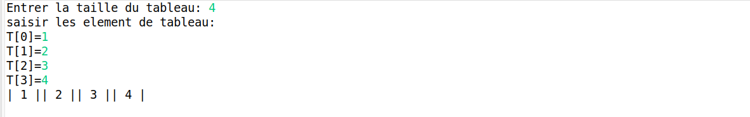
Exercice6:
Solution

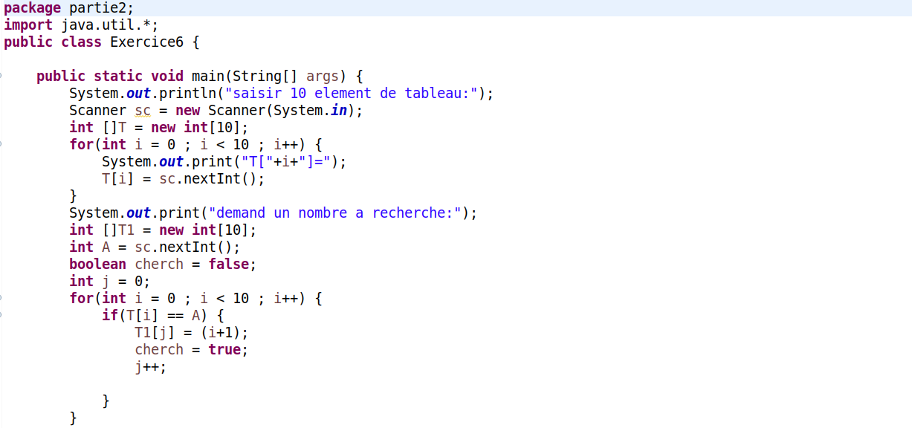
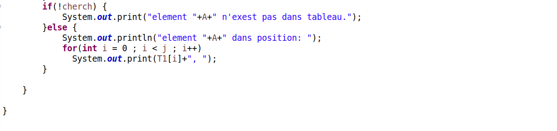
Execution
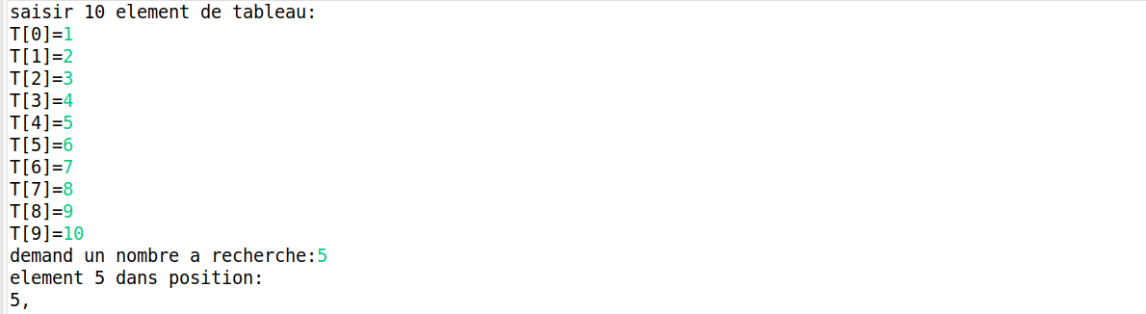
Exercice7:
Solution

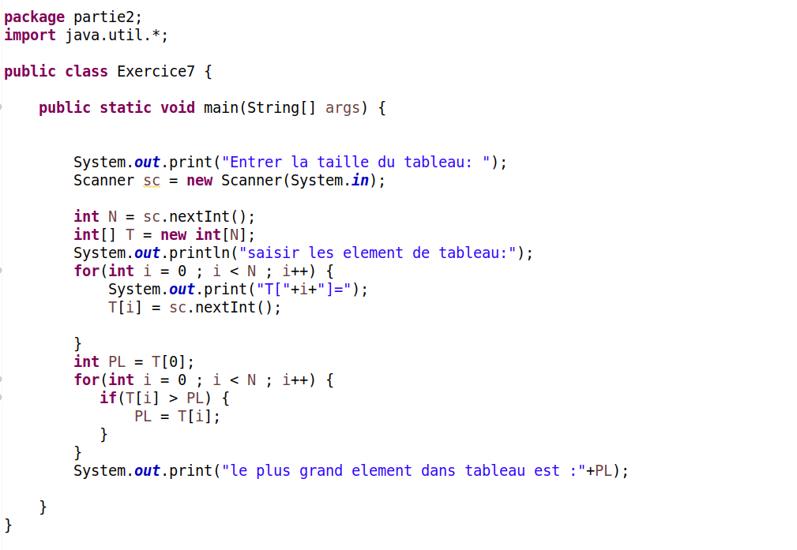

Execution

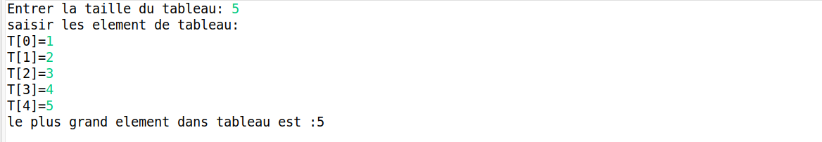
Partie3:Matrices
Exercice8:
Solution

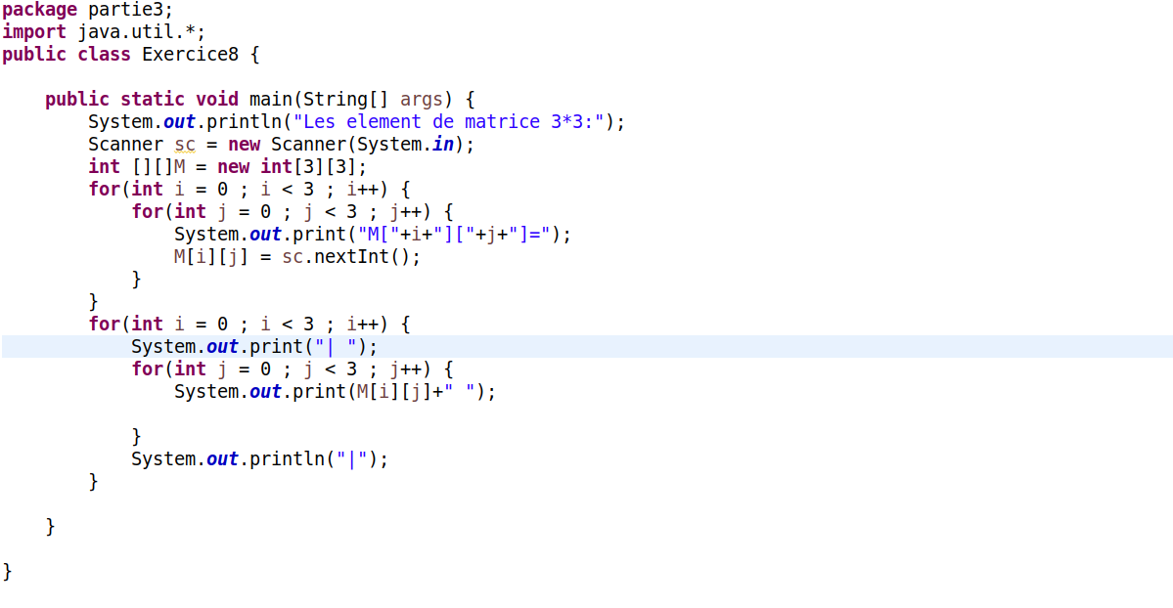
Execution

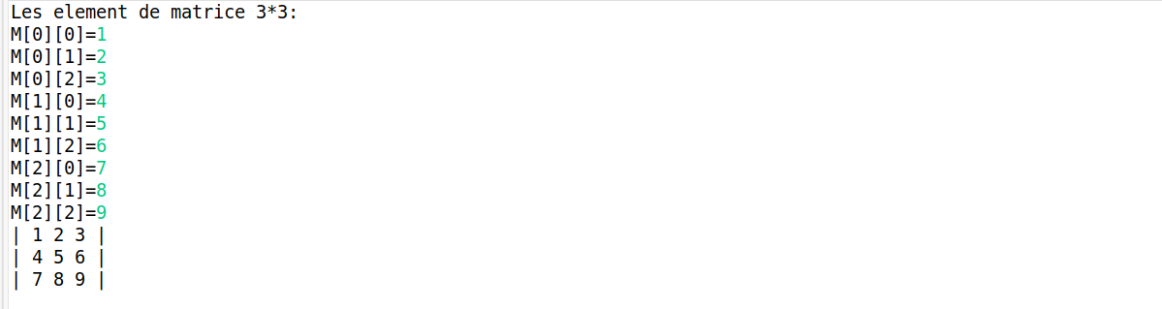

Exercice9:
Solution

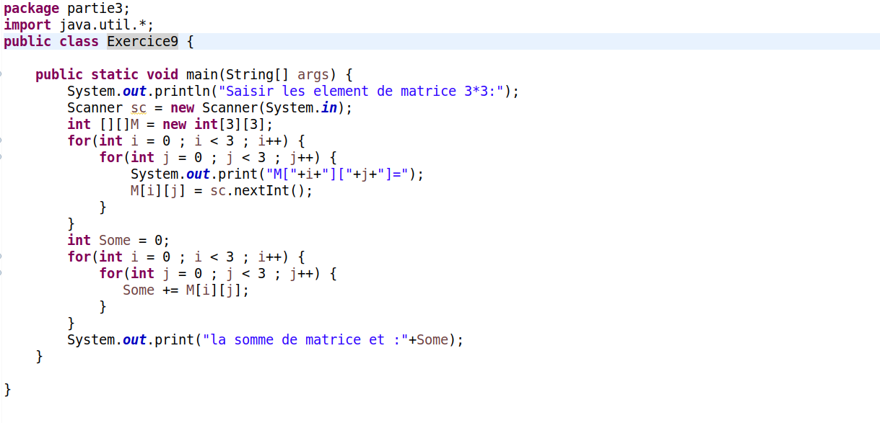
Execution

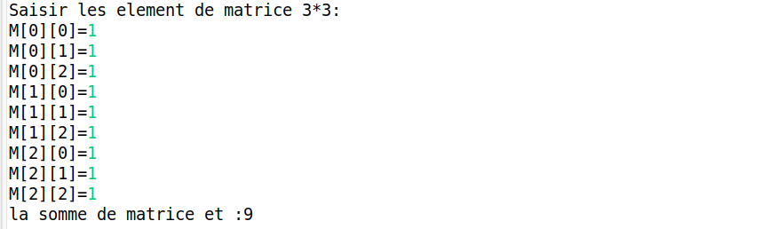
Exercice10:
Solution

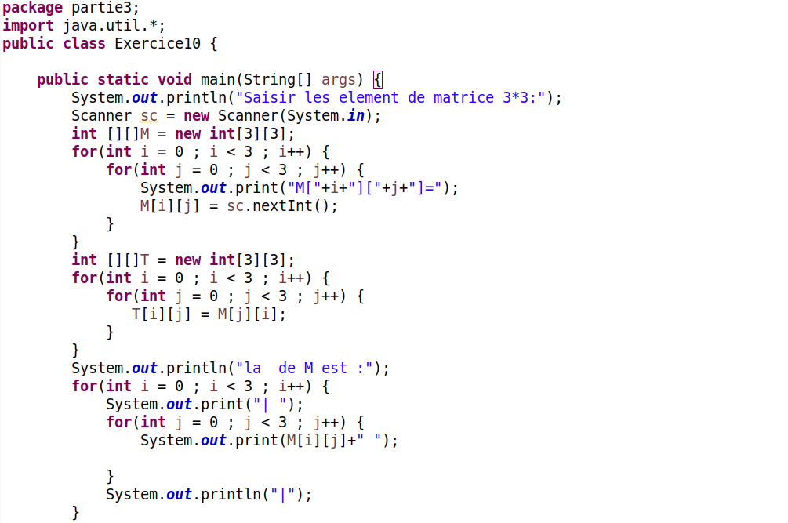
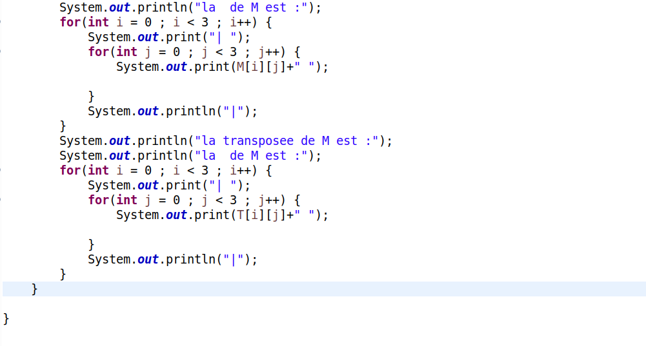
Execution

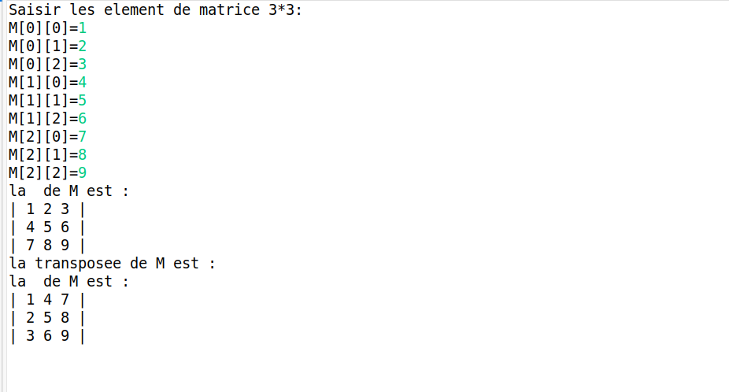
Partie4:Class string
Exercice11:
Solution

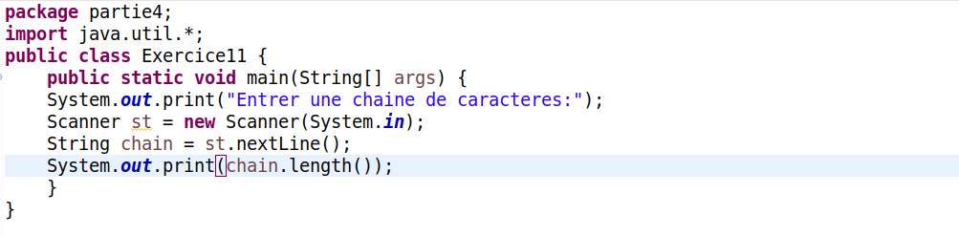
Execution

Exercice12:
Solution

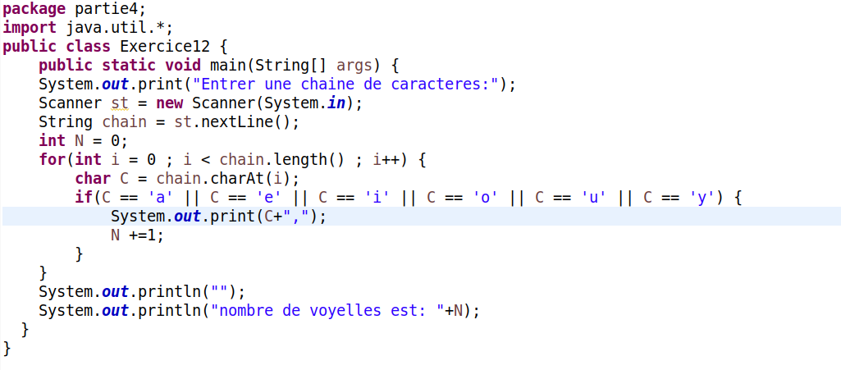
Execution

Exercice13:
Solution

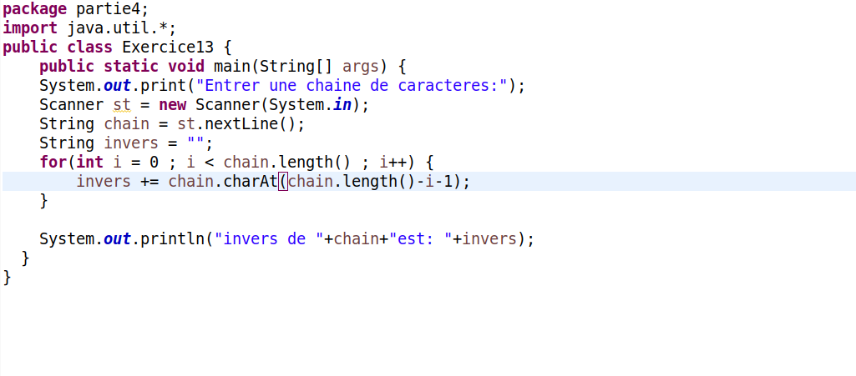
Execution

Exercice14:
Solution

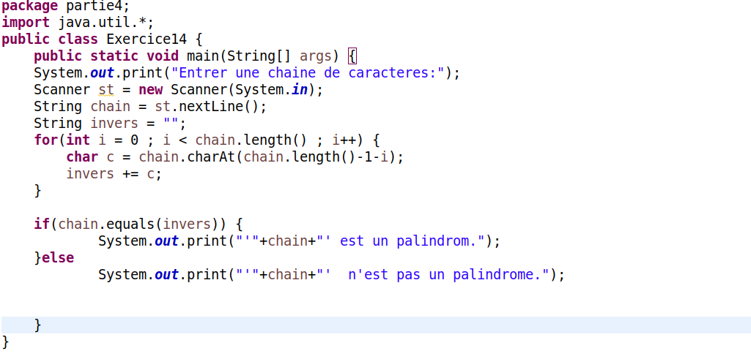
Execution

Fin

