I-JMB charger – Teardown & Circuit reverse engineering

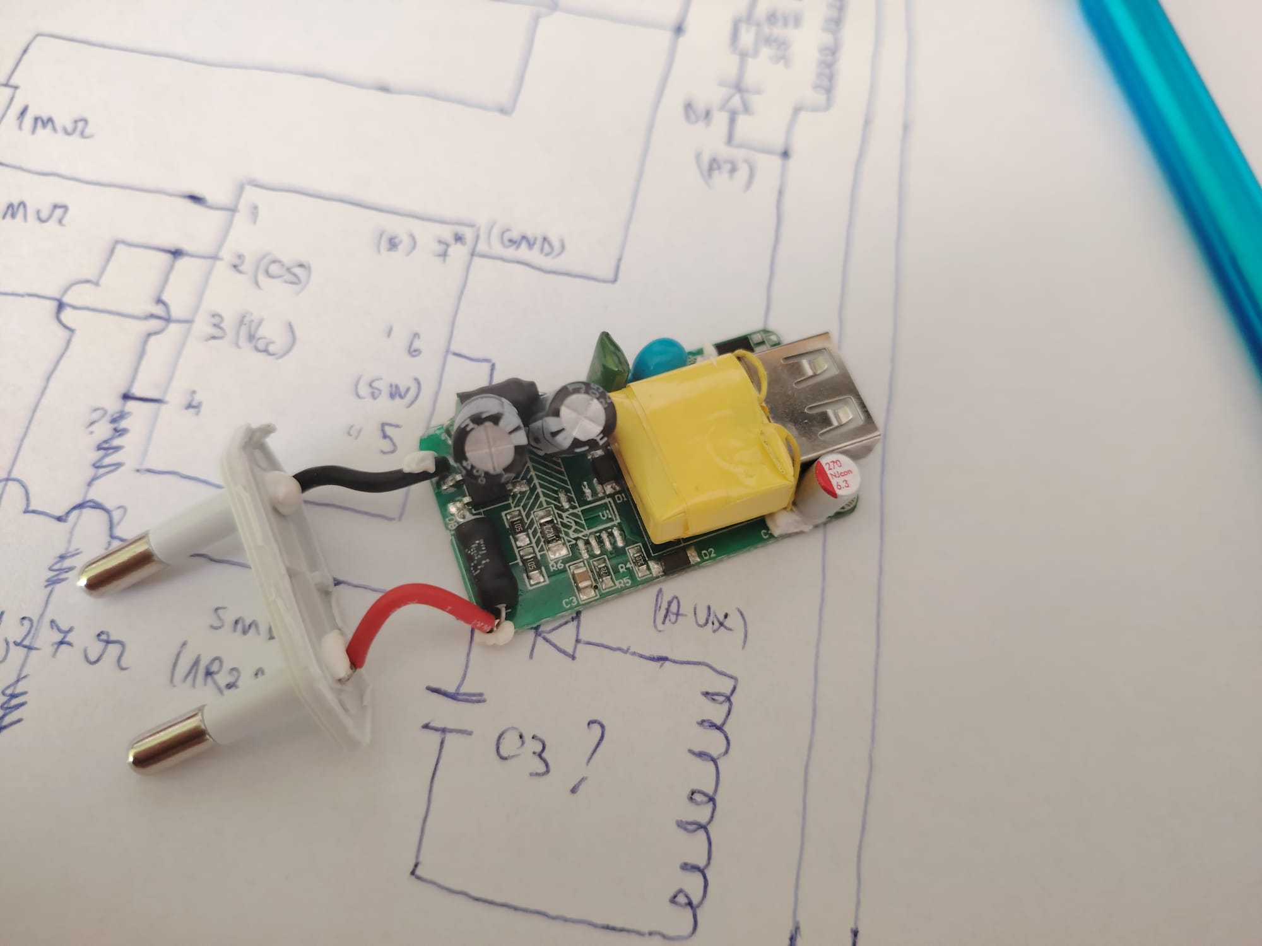
Charger internals - figure.

As shown in the figure, this is the internal parts of a cheap phone charger I bought from one of my local hometown store, which I disassembled and decided to take a look at it.
My main goal is to analyze the overall design, the used parts, how the circuit works, the pcb layout, mechanical enclosure, the user safety measures implied by the manufacturer, and everything related to this product which might impact the performance and its user safety protections.
I don’t recommend opening power-related devices that work with the grid, unless you have experience and the required information about handling it properly. Also, this documentation IS NOT a tutorial as working with main voltages must be done with strict precaution handling and safety measurements.
From my experience, when opening such power adapters, it’s good practice to leave it for some time before tearing it down, so that the main bulk rectification capacitors are getting discharged.

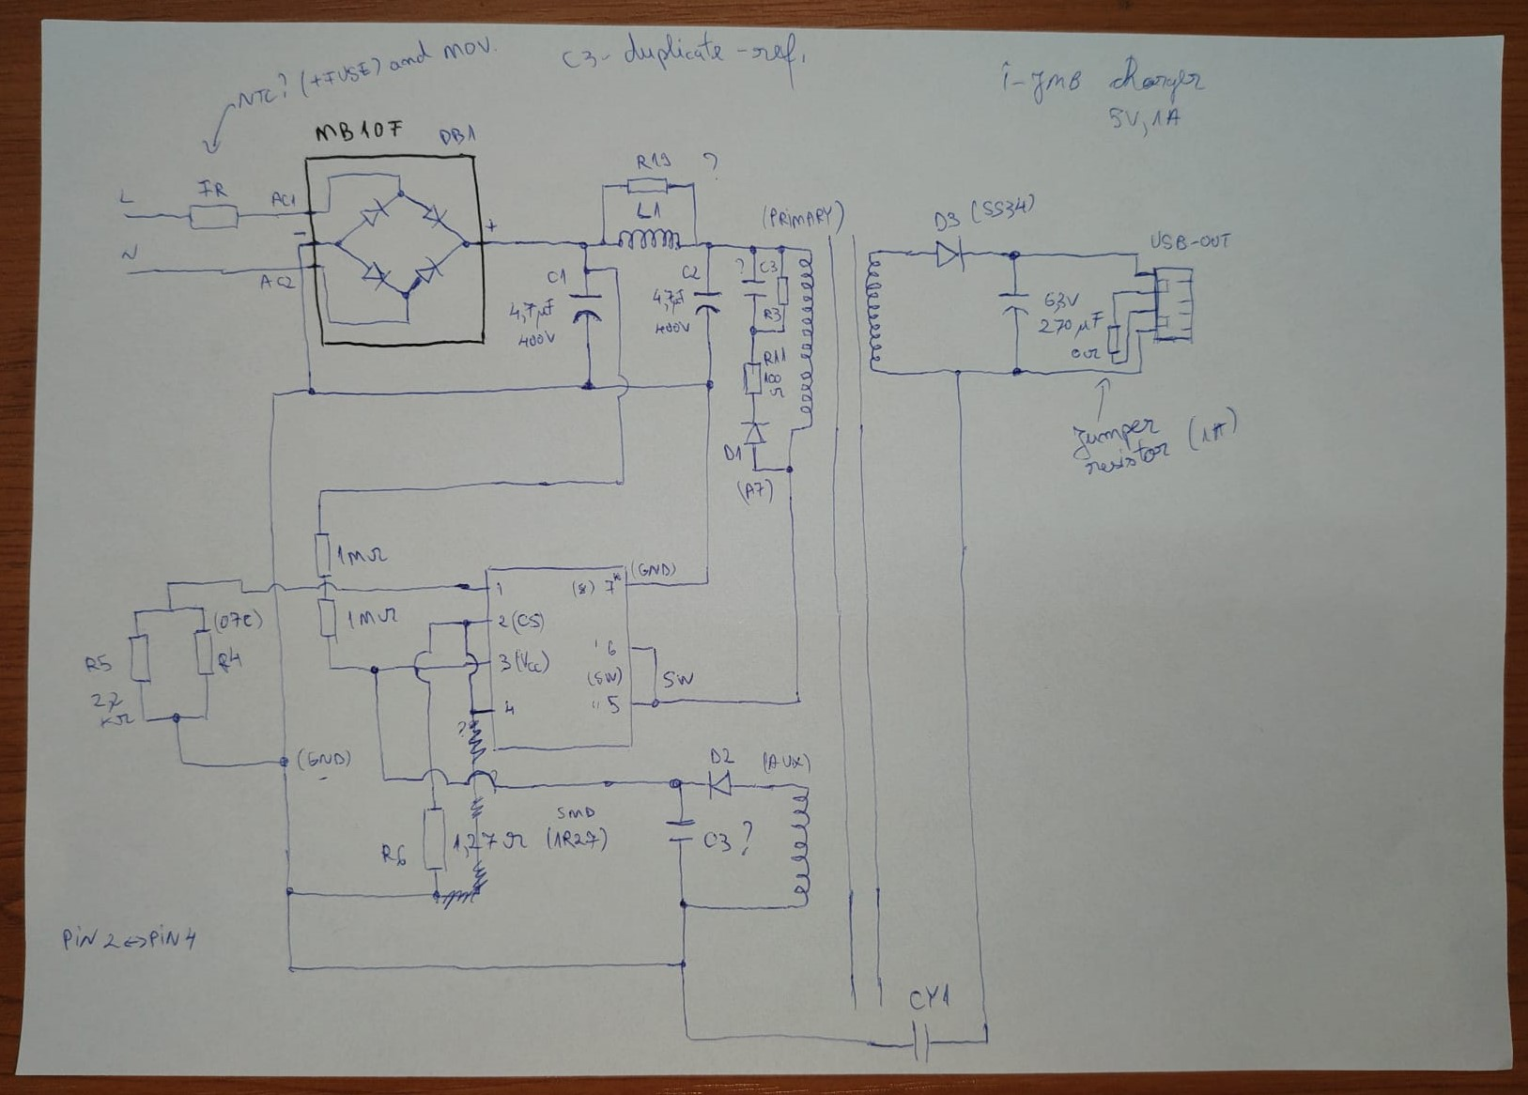
Reversed engineered schematic of the charger.
In order to draw the schematic of the circuit, it’s easier to work with a DMM on continuity mode, which is the easiest way to find where components interconnect. Along side I’ve used to do visual inspections on the board while also interacting with a basic digital microscope to establish the points where measurements should be taken.
Also, if you have experience with common switching power supplies topologies, it’s quite easy to sense where exactly parts tend to connects via traces.

Circuit working principle
The circuit shown in the drawn schematic has a flyback topology regarding the transformer and how the switching is done.
Power comes in from the grid through the AC input terminals, which goes then out of the fusible resistor that’s placed in series to limit the inrush current caused by the charging process of the main filtering capacitor.
The AC is rectified by the bridge rectifier which has all four diodes integrated in the same IC package, labeled as MB10F, a very common bridge rectifier.
The main filtering capacitor is charges up with a peak voltage equal to 230V times the square root of 2, which is going to be around 324 volts. The frequency of the sine wave at the output of the bridge rectifier is doubled, around 100Hz as the negative side of the sine wave is flipped and becomes positive thanks to the diodes conducting inside the bridge rectifier.
I consider mentioning the following fact that most of the basic chargers rated for lower output power, most of them have a single smoothing capacitor rated for around 400V and few uF (like 4.7uF or 10uF).
This charger has a PI filter formed for converting the AC waveform into a quite stable DC. The ripples and the switching noise caused by the main IC is filtered out by this subcircuit.
The transformer has a primary, secondary and auxiliary windings. The IC has an integrated high voltage transistor, which most probably is a MOSFET. The IC has an integrated control circuit for driving the MOSFET which is switching the primary winding, thus a variable magnetic field is generated which is then inducing a stepped-down voltage in the secondary winding. Usually, the primary of the transformer has more turns than the auxiliary winding and the secondary winding.
The primary winding has a snubber network connected in parallel with it consisting of a pair mde of resistors, capacitor and a diode meant to suppress the voltage spikes caused by the back EMF of the primary inductor when the transistor switches off, thus the main switching IC is protected from high negative voltage spikes. The diode conducts when the transistors switches off because of the negative voltage with reversed polarity, which charges the capacitor through a current limiting resistor and after this phase, the voltage built across the capacitor is then dissipated across a discharging resistor meant for the capacitor.
The main IC ‘starts’ up when the adapter is plugged into the grid using the power that comes from the filtering capacitors through the two series resistors of 1Mohm each.
After the circuit starts it’s operation, the IC will be powered by the auxiliary winding, which induces a voltage when the primary winding is switched it will get energized and build up a magnetic field which is conducted through the core of the transformers to the other windings.
The voltage generated by the auxiliary winding get’s rectified by the diode D2 and filtered by the capacitor C3. Resistor R6 is a current sensing resistor used to limit the current through the integrated switching transistor when operating.
There is no output voltage monitoring circuitry available, so there is no feedback for regulating the output voltage when the load current varies. The main reason could be that the power adapter is rated for just one Amp of current, and after surpassing that load current maximum value, the voltage will tend to drop.
CY1 is a interference capacitor between the primary and the secondary of the transformer which is supressing any caused interference by switching. This capacitor must be a safety Class Y legitimate capacitor. Any failure would shock the user in case of a shorted capacitor.
R5, R4 resistors might be used just for setting the output voltage or the output current limit. More information about the main switching IC could be found in it’s datasheet. In this case, the main IC smd marking was hidden by a layer of paint or coating silk. There is also a chance that the manufacturer erased the marking. The only way to find more information about this IC is by searching for common switching IC models and by its pinout, looking at similar parts.
The 5V at the output is created by rectifying and filtering the AC ripples of the secondary circuit via the Schottky diode D3 and by the electrolytic aluminum capacitor. The 0ohm jumper resistor across the USB data lines tells the powered device the USB is only use for drawing current, as much as the load needs.
The operation of this switching power supply is quite complex, same for the circuitry which requires IC drivers, extra components and a different transformer construction.
The PCB has a great isolation gap between the primary and the secondary section’s traces, in order to avoid arcing or any kind of accidental interconnection of parts resembling both circuits while having a better separation for the user safety.
Most probably, the PCB is FR4, double sided, it has a ground plane available in both sections. The dimensions makes the overall charger to be nice and compact.
Traces seem to be well designed, some have greater widths for higher currents.

I think the transformer deserves a separate discussion because it has to meet the safety requirements and must be properly isolated. Because of its form factor, this small transformer will have its windings very close and multiple layers of isolation, paper, plastic foils and isulation dielectric are mandatory for every charger product available for customers, independent of the price and build quality. Some very cheap and fake Chinese chargers avoid taking such steps and the user experiencing shocks are very likely. Also, the electronics being powered by such chargers are going to get fried.
The transformer inside this charger looks well made, the wires coming from the secondary winding have insulation and there you can see in the first picture that the entire transformer is wrapped in a non conductive foil, that’s quite nice. To explore the internals of this transformer, we need to somehow desolder it from the board, and then apply some heat to loosen the components so everything comes apart more easily.

Common failures
Low power adapters don’t really experience any harmful issues compared to high power switch mode power supplies. But, because the design is not perfect, they still produce a lot of heat at high load current, like close to one or few amps, which impacts the performance and affect other nearby parts. Overheating could affect the internal structure of the electrolytic capacitors, they could dry out. High current loads also stress internal parts.
The main IC could short out and that would make other components get shorted or cause any blow ups referring to other parts, like a bridge rectifier, some capacitors dry out, the ESR starts to rise up and the capacity goes down, effectively reducing the ability to get rid of ripples.
Parts that conduct high currents, most of them being semiconductor based components, are prone to failing or getting shorted.

Improvements
After reviewing the charger, in our case, there are a few design changes or added solutions to improve the performance of it, as no electronic product is ever perfect.
Based on my experience, I would add an EMI interference filter at the AC inputs made of Class X capacitors and inductors, for interference surpression. After that I would replace the resistor with a fuse and an NTC thermistor for limiting the inrush current caused by charging the main smoothing capacitor, which is a great practice, but its suitable for applications rated for higher power, with larger capacitors on the primary side.
Separating parts by adding clearance related to the PCB layout might reduce any conducted / radiated heat on adjacent parts. The only downside is the increase in the form factor.
Adding insulation tapes and silicone grease ensures great separation and prevents any conductive ways to form which will damage the entire circuit. The components will start to overheat because of the poor heat conduction of the insulation materials.

Thank you for reviewing this documentation! I hope readers will find it interesting and useful for understanding how such adapters work, devices we often take for granted.

