Data Structure

Data Structure
The data structure name indicates itself that organizing the data in memory. There are many ways of organizing the data in the memory as we have already seen one of the data structures, i.e., array in C language. Array is a collection of memory elements in which data is stored sequentially, i.e., one after another. In other words, we can say that array stores the elements in a continuous manner. This organization of data is done with the help of an array of data structures. There are also other ways to organize the data in memory. Let's see the different types of data structures.
The data structure is not any programming language like C, C++, java, etc. It is a set of algorithms that we can use in any programming language to structure the data in the memory.
To structure the data in memory, 'n' number of algorithms were proposed, and all these algorithms are known as Abstract data types. These abstract data types are the set of rules.
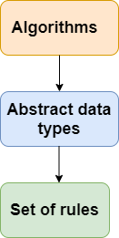

Operations on data structure

1) Traversing: Every data structure contains the set of data elements. Traversing the data structure means visiting each element of the data structure in order to perform some specific operation like searching or sorting.
Example: If we need to calculate the average of the marks obtained by a student in 6 different subject, we need to traverse the complete array of marks and calculate the total sum, then we will devide that sum by the number of subjects i.e. 6, in order to find the average.
2) Insertion: Insertion can be defined as the process of adding the elements to the data structure at any location.
If the size of data structure is n then we can only insert n-1 data elements into it.
3) Deletion:The process of removing an element from the data structure is called Deletion. We can delete an element from the data structure at any random location.
If we try to delete an element from an empty data structure then underflow occurs.
4) Searching: The process of finding the location of an element within the data structure is called Searching. There are two algorithms to perform searching, Linear Search and Binary Search. We will discuss each one of them later in this tutorial.
5) Sorting: The process of arranging the data structure in a specific order is known as Sorting. There are many algorithms that can be used to perform sorting, for example, insertion sort, selection sort, bubble sort, etc.
6) Merging: When two lists List A and List B of size M and N respectively, of similar type of elements, clubbed or joined to produce the third list, List C of size (M+N), then this process is called merging

Advantages of Data Structures
Efficiency: Efficiency of a program depends upon the choice of data structures. For example: suppose, we have some data and we need to perform the search for a perticular record. In that case, if we organize our data in an array, we will have to search sequentially element by element. hence, using array may not be very efficient here. There are better data structures which can make the search process efficient like ordered array, binary search tree or hash tables.
Reusability: Data structures are reusable, i.e. once we have implemented a particular data structure, we can use it at any other place. Implementation of data structures can be compiled into libraries which can be used by different clients.
Abstraction: Data structure is specified by the ADT which provides a level of abstraction. The client program uses the data structure through interface only, without getting into the implementation details.

Data Structures Classification
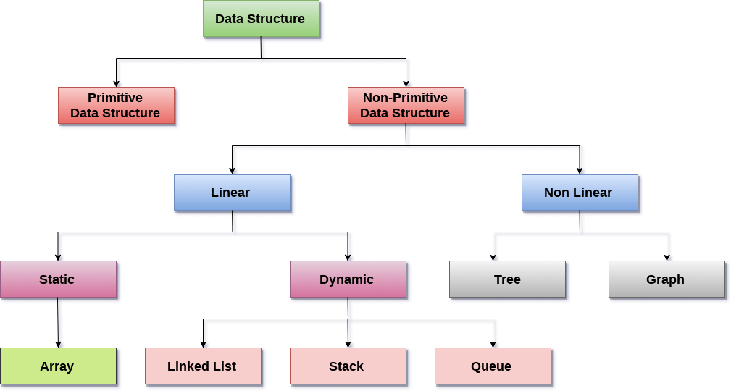
There are two types of data structures:
1. Primitive data structure
2. Non-primitive data structure
1. Primitive Data structure
The primitive data structures are primitive data types. The int, char, float, double, and pointer are the primitive data structures that can hold a single value.
2. Non-Primitive Data structure
The non-primitive data structure is divided into two types:
a. Linear data structure
b. Non-linear data structure
a. Linear Data Structure

The arrangement of data in a sequential manner is known as a linear data structure. The data structures used for this purpose are Arrays, Linked list, Stacks, and Queues. In these data structures, one element is connected to only one another element in a linear form.
When one element is connected to the 'n' number of elements known as a non-linear data structure. The best example is trees and graphs. In this case, the elements are arranged in a random manner.
We will discuss the above data structures in brief in the coming topics. Now, we will see the common operations that we can perform on these data structures
Linear Data structures can also be classified as:
- Static data structure: It is a type of data structure where the size is allocated at the compile time. Therefore, the maximum size is fixed.
- Dynamic data structure: It is a type of data structure where the size is allocated at the run time. Therefore, the maximum size is flexible.

Static data structure

Array

Definition
- Arrays are defined as the collection of similar type of data items stored at contiguous memory locations.
- Arrays are the derived data type in C programming language which can store the primitive type of data such as int, char, double, float, etc.
- Array is the simplest data structure where each data element can be randomly accessed by using its index number.
- For example, if we want to store the marks of a student in 6 subjects, then we don't need to define different variable for the marks in different subject. instead of that, we can define an array which can store the marks in each subject at a the contiguous memory locations.
The array marks[10] defines the marks of the student in 10 different subjects where each subject marks are located at a particular subscript in the array i.e. marks[0] denotes the marks in first subject, marks[1] denotes the marks in 2nd subject and so on.

Properties of the Array
- Each element is of same data type and carries a same size i.e. int = 4 bytes.
- Elements of the array are stored at contiguous memory locations where the first element is stored at the smallest memory location.
- Elements of the array can be randomly accessed since we can calculate the address of each element of the array with the given base address and the size of data element.

