Question 1
- RCode
  - Creating a new variable called wage_band
  - a2wages <- a2wages %>%
  - mutate(wage_band =
  - ifelse(Wage<=40,"Low","High"))
  - Counting how many employees fall into each wage band
  - sum(a2wages$wage_band == "Low")
  - sum(a2wages$wage_band == "High")
  - Computing the percentage distribution across bands
  - paste(((sum(a2wages$wage_band == "Low"))/nrow(a2wages))*100,"%")
  - paste((sum(a2wages$wage_band == "High"))/nrow(a2wages)*100,"%")xc
- RStudio Output
  - 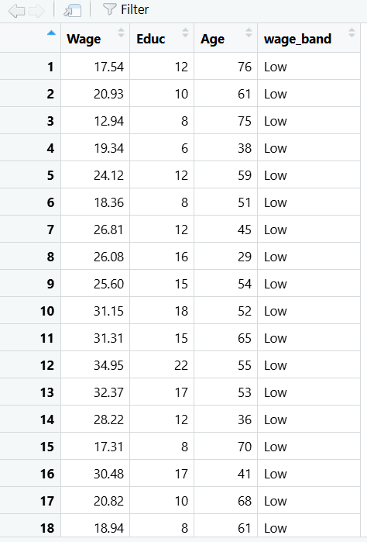
  - 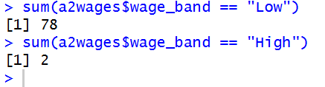
  - 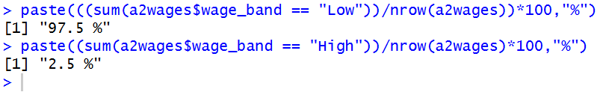
- Business Interpretation
  - # • Discuss whether the wage distribution appears balanced and a business interpretation
  - The wage distribution does not appear balanced at all. The vast majority of employee wages are low. While it makes sense for there to be more low wages than high, perhaps the parameters for defining low and high should be based on the average wages. This would provide more value to quickly and easily see if there is a potential skew in the data and look at patterns among low and high wage employees.

Question 2
- RCode
  - Creating a variable called career_stage
  - for(i in 1:nrow(a2wages))
  - {
  - if(a2wages$Age[i])
  - {
  - if(a2wages$Age[i]<30)
  - {
  - a2wages$career_stages[i]="Early Career"
  - } else {
  - if(a2wages$Age[i]<=50)
  - {
  - a2wages$career_stages[i]="Mid Career"
  - } else {
  - a2wages$career_stages[i]="Late Career"
  - }
  - }
  - }
  - }
  - Displaying the frequency of each stage
  - sum(a2wages$career_stages == "Early Career")
  - sum(a2wages$career_stages == "Mid Career")
  - sum(a2wages$career_stages == "Late Career")
- RStudio Output
  - 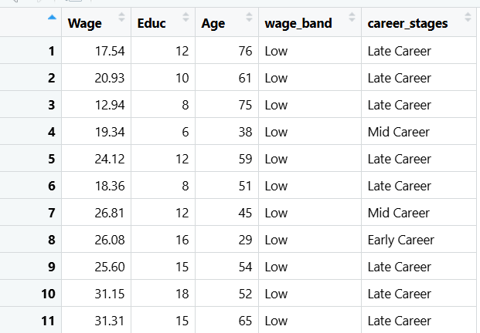
  - 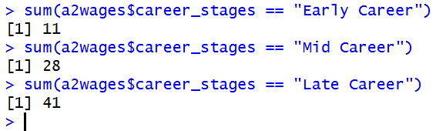
- Business Interpretation
  - By far the “late career” group is the largest, while the “early career” group is the newest. This is concerning because people in late career are more likely to retire, and there are not enough new employees coming in to replace them. More effort and investment should be put into hiring and training new employees to prevent an understaffing issue in the future. Perhaps early career employees should be paired with late career employees in a mentor program.

Question 3
- RCode
  - Fitting a simple linear regression model (lm() function)
  - model1 <- lm(a2wages$Wage ~ a2wages$Age)
  - summary(model1)
- RStudio Output
  - 
  - 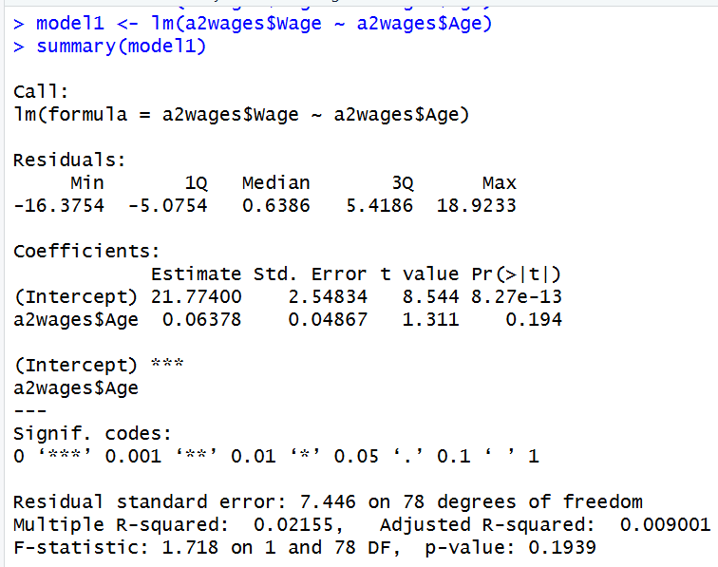
- Business Interpretation
  - The coefficient of age is 0.0678. This means that according to the model, for every 1 year increase in age, there is a 0.0678 increase in wage. This number is relatively small compared to the units of age/wage, which suggests potential low correlation. By looking at R², we can see this is true. R² is only 0.022, which is incredibly low. Age is not a good predictor of wage, and therefore not very useful to the business.

Question 4
- RCode
  - Fitting a multiple linear regression model: Wage ~ Age + Education
  - model2 <- lm(a2wages$Wage ~ a2wages$Age + a2wages$Educ)
  - summary(model2)
- RStudio Output
  - 
  - 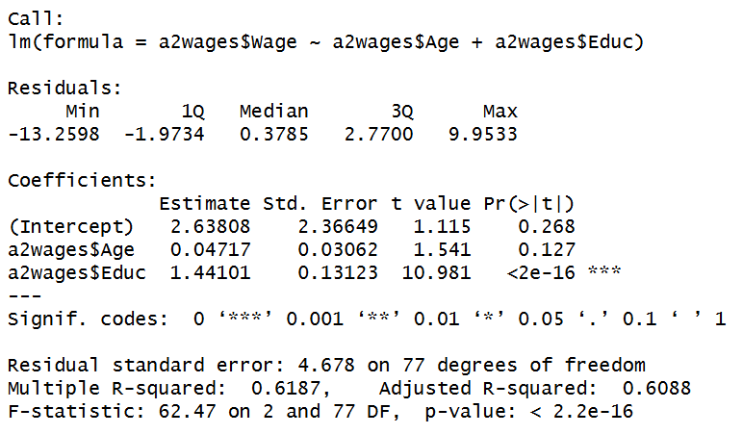
- Business Interpretation
  - The coefficient of age decreased to 0.047 when education was introduced, suggesting an even smaller effect on wage in this model, although significance has increased according to the lower P value. That said, age is still insignificant and not a good predictor. Education has a relatively high coefficient of 1.44, and it is significant. Education greatly improved predictive power, as the adjusted R² has become 0.609. It is better to look at adjusted R² for multiple linear regression models. Education is a much better indicator of wage and should be examined closer by the business.

Question 5
- RCode
  - Splitting the dataset into 70% training and 30% testing
  - a2wages <- a2wages %>%
  - mutate(rowid = row_number())

  - training_ids <- a2wages %>%
  - slice_sample(prop=0.7) %>%
  - pull(rowid)

  - training_wage <- a2wages %>%
  - filter(rowid %in% training_ids)
  - testing_wage <- a2wages %>%
  - filter(!rowid %in% training_ids)
  - Fitting the multiple regression model (Wage ~ Age + Education) on training data
  - tmodel1 <- lm(Wage~Age + Educ, data=training_wage)
  - Generating predictions on test data
  - pred1 <- predict(tmodel1, newdata=testing_wage)
  - Computing RMSE
  - sqrt(mean((testing_wage$Wage - pred1)^2))
- RStudio Output
  - 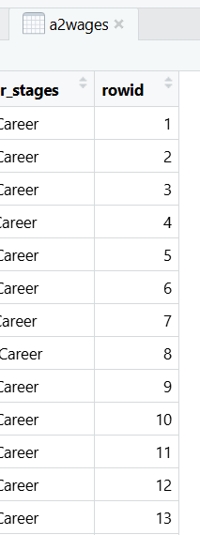
  - 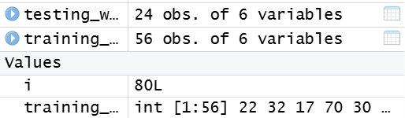
  - 
  - 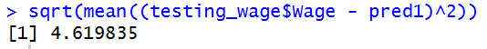
- Business Interpretation
  - Interpret the RMSE – Is the average prediction error acceptable for salary budgeting?
  - The RMSE seems a bit high but not to an abnormal level. The model works fairly well for the test dataset and could be used to predict wage, but the business should consider collecting and using other data to improve on the model, such as experience. This amount of prediction error would be acceptable for salary budgeting, as it is good to stay on the safe side to avoid going over budget.

Question 6
- RCode
  - Predicting wages for specific employees, using best model
  - employees <- tibble(Age=c(28,40,55), Educ=c(16,18,12))
  - predict(tmodel1, newdata=employees)
- RStudio Output
  - 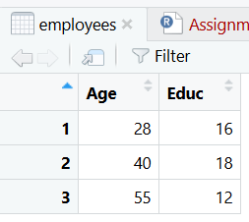
  - 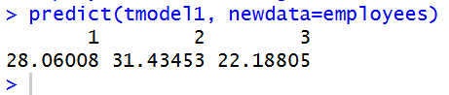
- Business Interpretation
  - The employee with the highest salary is very clearly the one with the highest education, and the employee with the lowest salary has the least education. Age does not seem to have nearly as much of an impact despite employee 1 being significantly younger than the others.

Question 7
- RCode
  - Creating new dataset
  - New_hires <- data.frame(Age = sample(30:40, 25, replace=TRUE),
  - Education = rep(16, 25))
  - New_hires <- New_hires %>%
  - rename(Educ = Education)
  - Making prediction with previous model
  - prednew <- predict(tmodel1, newdata=New_hires)
  - Adding predictions as a column
  - New_hires <- New_hires %>%
  - mutate(prednew=prednew)
  - Estimating average predicted wage
  - mean(prednew)
  - Estimating total annual salary cost (assume 40 hours/week, 52 weeks/year)
  - (sum(New_hires$prednew))*40*52
- RStudio Output
  - 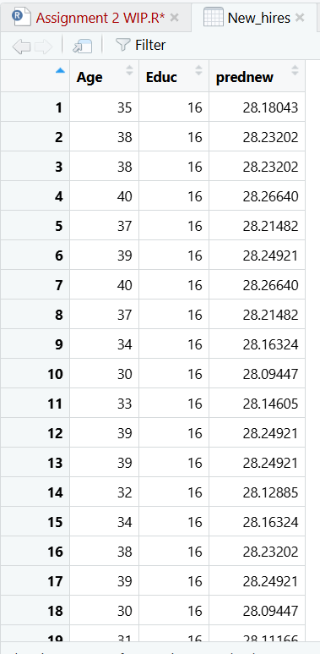
  - 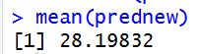
  - 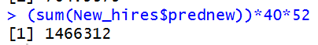
- Business Interpretation
  - Hiring new employees will be extremely costly, as the model predicts most of them will begin with a wage of roughly 28$/hr. However, the company can also rest assured that as the employees increase in age, this will cause only a minimal increase in salary, so cost and budget should stay relatively consistent.

