# CMP3004 PROJECT

## Ali Yağız İlban 1731384 – [REDACTED FOR PRIVACY]

|  |  |  |  |
| --- | --- | --- | --- |
|  | Nearest Neighbor | Divide&Conquer | Greedy |
| Route (km) | 1.716.128 km | 34.778.986 km | 1.830.538 km |
| Compile Time (ms) | 718 ms | 29 ms | 736 ms |

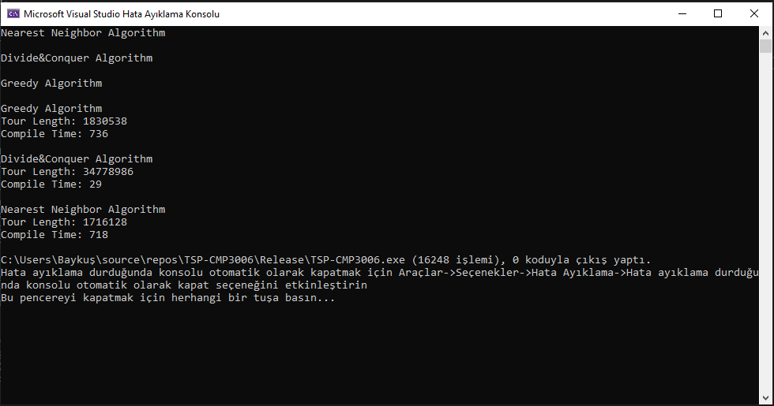

# Output: Nearest Neighbor Algorithm

## Link: https://justpaste.it/5zc7b

# Output: Divide&Conquer Algorithm

## Link: https://justpaste.it/9qxjc

# Output: Greedy Algorithm

## Link: https://justpaste.it/8uyhb