**LAB#06**

**20SW026**

**Task#01**

Basic SQL -Run the following queries:

1.Write a query that returns all the orders where the standard_qty is over 1000, the poster_qty is 0, and the gloss_qty is 0.

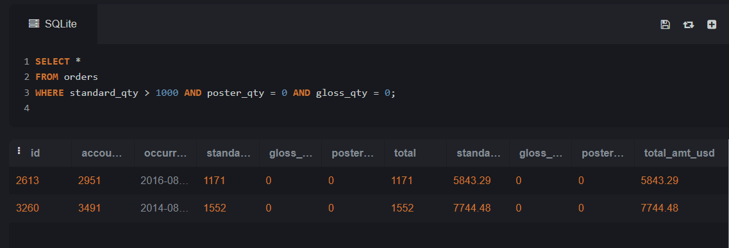

2.Using the accounts table find all the companies whose names do not start with 'C' and end with 's'.

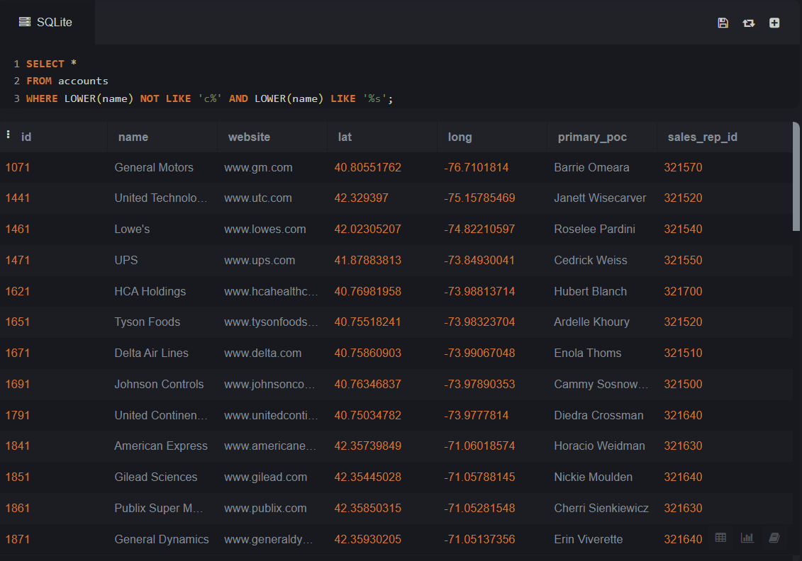

3.Use the web_events table to find all information regarding individuals who were contacted via organic or adwords and started their account at any point in 2016 sorted from newest to oldest.

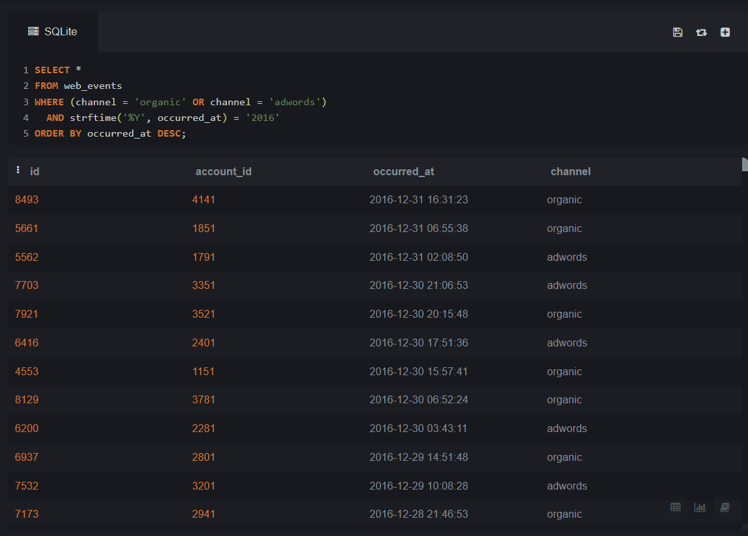

**Task#02**

Joins -Run the following queries:

1.Provide a table that provides theregionfor eachsales_repalong with their associatedaccounts. This time only for theMidwestregion. Your final table should include three columns: the regionname, the sales repname, and the accountname. Sort the accounts alphabetically (A-Z) according to account name.

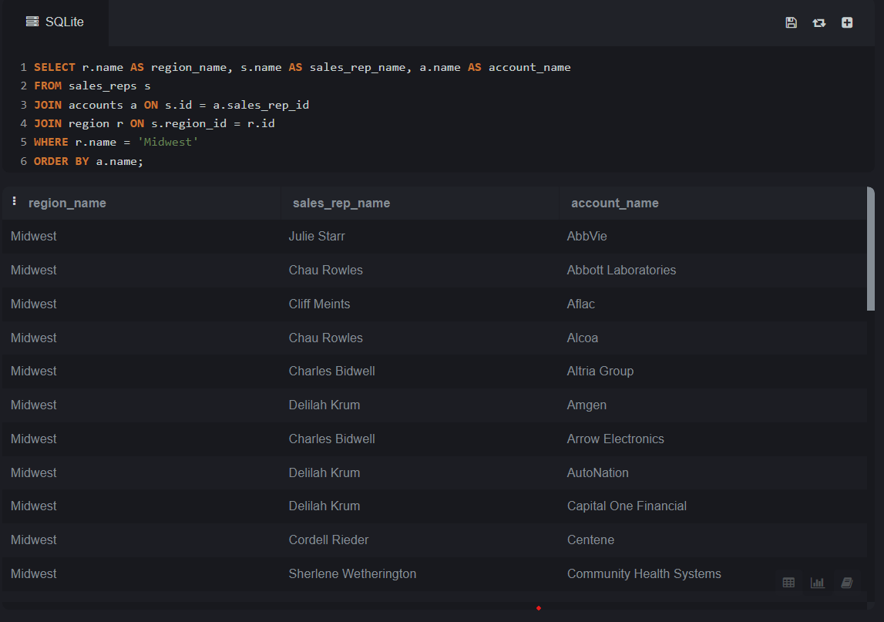

2.Provide a table that provides theregionfor eachsales_repalong with their associatedaccounts. This time only for accounts where the sales rep has a first name starting withSand in theMidwestregion. Your final table should include three columns: the regionname, the sales repname, and the accountname. Sort the accounts alphabetically (A-Z) according to account name.

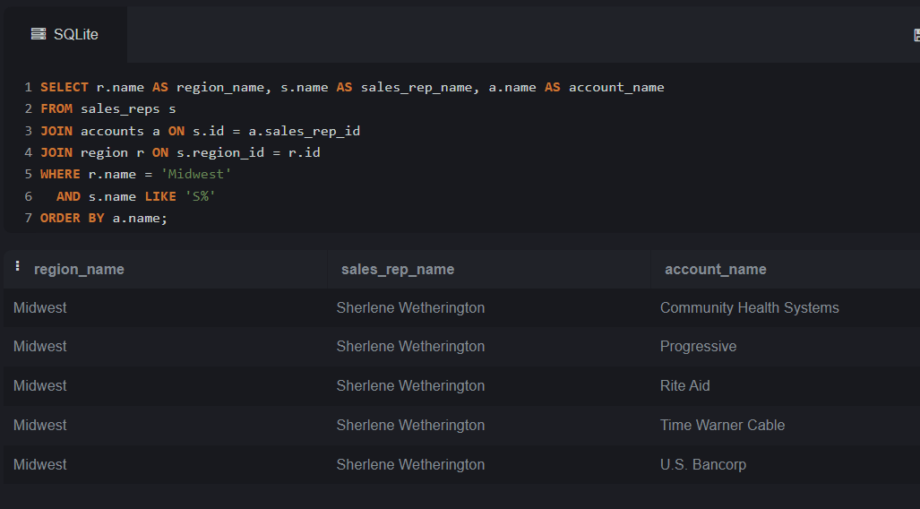

3.Provide a table that provides theregionfor eachsales_repalong with their associatedaccounts. This time only for accounts where the sales rep has alastname starting withKand in theMidwestregion. Your final table should include three columns: the regionname, the sales repname, and the accountname. Sort the accounts alphabetically (A-Z) according to account name.

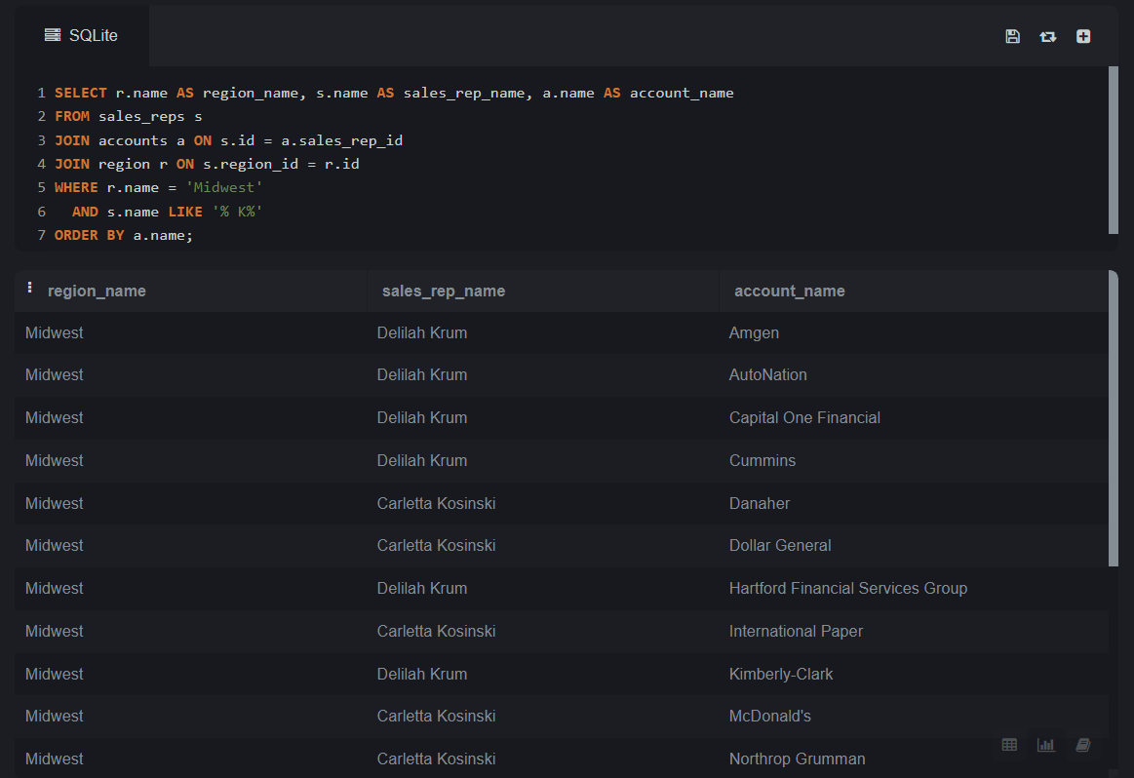

**Task#03**

SQL Aggregations-Run the following queries:

1.Find the total amount spent onstandard_amt_usdandgloss_amt_usdpaper for each order in the orders table. This should give a dollar amount for each order in the table.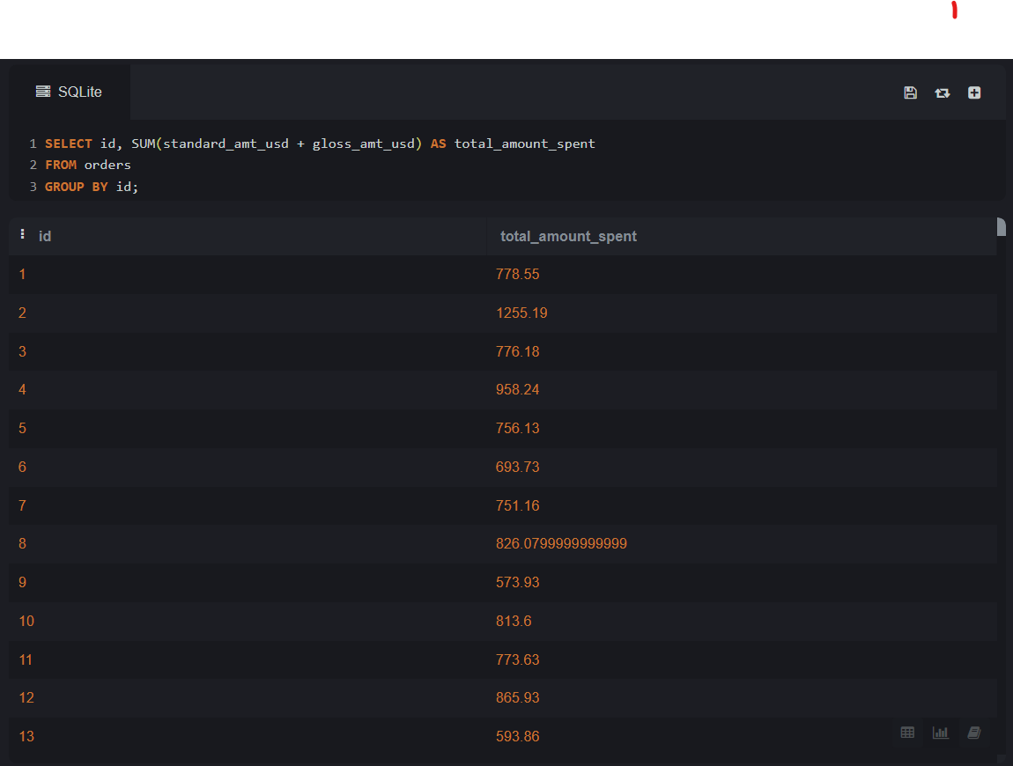

2.Find the mean (AVERAGE) amount spent per order on each paper type, as well as the mean amount of each paper type purchased per order. Your final answer should have 6 values -one for each paper type for the average number of sales, as well as the average amount.

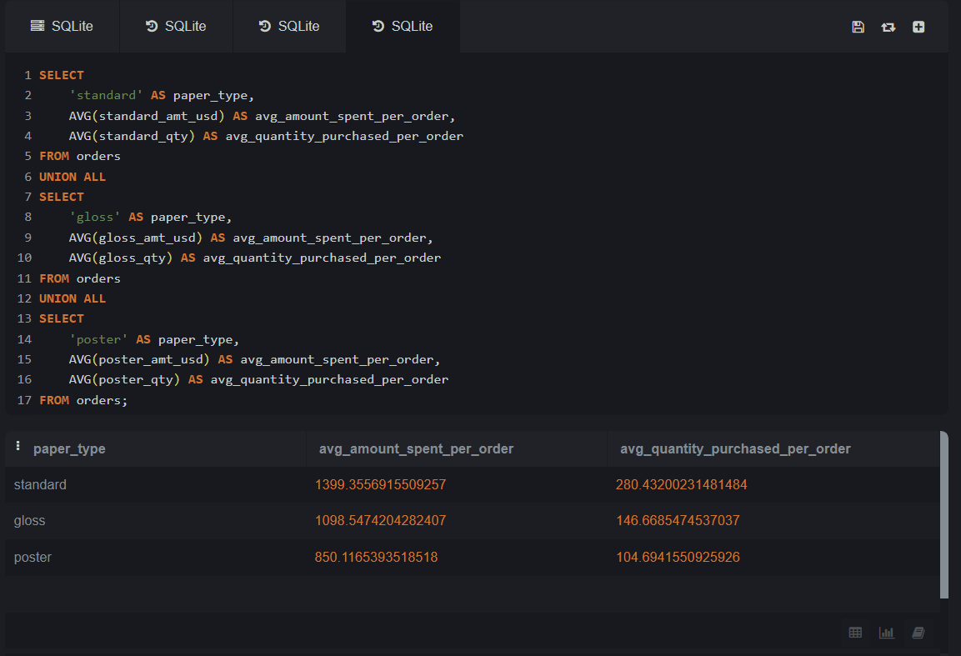

3.Which account usedfacebookmost as achannel?

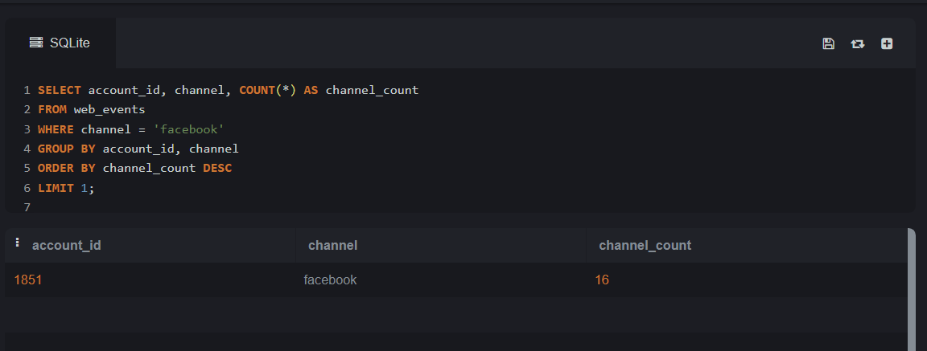

**Task#04**

SQL Subqueries-Run the following queries:1.UseDATE_TRUNC or EXTRACTto pullmonthlevel information about the first order ever placed in theorderstable.

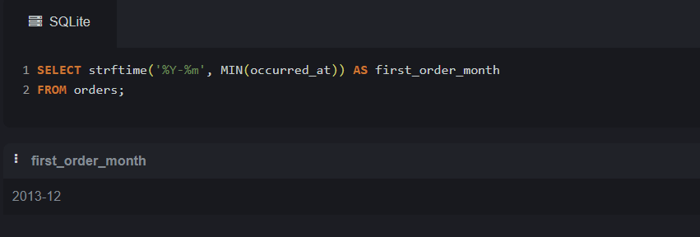

**Task#05**

SQL Data Cleaning -Run the following queries:

1.In theaccountstable, there is a column holding thewebsitefor each company. The last three digits specify what type of web address they are using. A list of extensions (and pricing) is providedhere. Pull these extensions and provide how many of each website type exist in theaccountstable.

