Retail Customer Insights Report
Understanding Shopping Behavior Across 3,900 Transactions

1. Why This Analysis
This report examines 3,900 individual purchase records to understand who our customers are, what they buy, and what keeps them coming back. The workflow behind it follows a typical analytics pipeline: the raw data was cleaned and enriched in Python, business questions were answered with SQL queries against a PostgreSQL database, and the results were assembled into a Power BI dashboard for ongoing tracking. Every screenshot below is taken directly from that workflow, so it reflects real output rather than a mock-up.

2. Getting to Know the Data
Before answering any business question, it helps to see the shape of the raw table. The two panels below come from a standard statistical description of all 18 columns in the dataset — one covering demographic and product fields, the other covering behavioral fields such as discounts, promo codes and payment method.
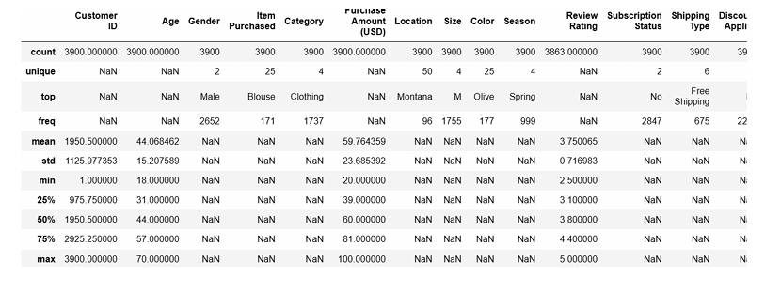
Summary statistics — demographic and product fields (3,900 rows, 25 unique items, 4 categories).
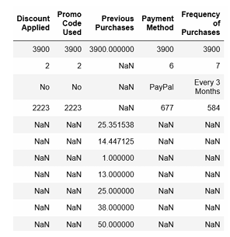
Summary statistics — behavioral fields (discounts, promo codes, payment method, purchase frequency).
A few things stand out immediately: the average purchase is about $59.76, ratings cluster around 3.75 out of 5, and PayPal is the single most common payment method. These numbers become the baseline that every deeper question in this report is measured against.

3. Preparing the Data Before Analysis
Raw retail data is rarely analysis-ready. A short preparation pass was run first so that later SQL queries could be trusted:
- Missing review ratings (37 rows) were filled in using the median rating for that product's category, rather than a single global average, so the imputed values stayed realistic per product type.
- Column names were converted to snake_case so the schema would read cleanly once loaded into PostgreSQL.
- Two new fields were engineered: an age_group bucket (Young Adult, Adult, Middle-aged, Senior) and a purchase_frequency_days field derived from each customer's stated shopping cadence.
- The discount_applied and promo_code_used columns were checked for overlap; because they tracked the same behavior, the redundant promo_code_used column was dropped.
- The cleaned table was then loaded into PostgreSQL so the questions in the next section could be answered with SQL.

4. What the Data Shows: SQL-Driven Findings

4.1 Revenue Split by Gender
Splitting total revenue by gender shows male customers generating roughly double the revenue of female customers across this dataset — a gap worth investigating further to see whether it comes from higher-value baskets, higher purchase frequency, or simply more male customers in the sample.
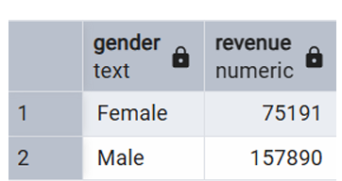
Total revenue (USD) by gender.

4.2 Customers Who Spend Big Even With a Discount
Discounts don't always mean a bargain-hunting customer. This query isolates shoppers who applied a discount but still spent above the $59.76 average purchase amount — 839 customers in total. These are price-sensitive but high-value customers, a segment worth targeting with loyalty perks rather than blanket discounts.
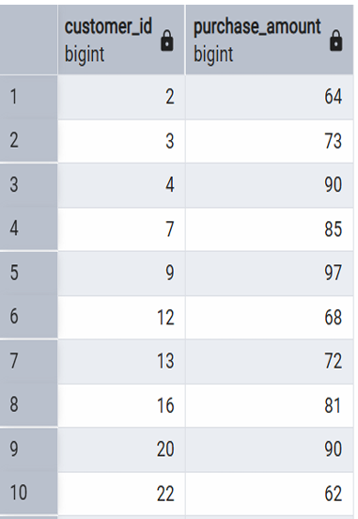
Sample of customers who used a discount yet still spent above average (839 rows total).

4.3 The Five Best-Rated Products
Ranking every item by its average review score surfaces the products customers are happiest with. Gloves, sandals, boots, hats and skirts top the list, all clustered tightly between 3.78 and 3.86 — useful shortlist for 'customer favorites' style marketing.
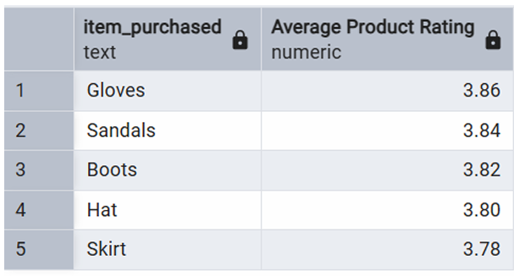
Top 5 products by average review rating.

4.4 Standard vs. Express Shipping
Comparing average order value by shipping method shows Express customers spend slightly more on average ($60.48) than Standard customers ($58.46) — a small but consistent gap suggesting shipping speed correlates loosely with basket size.
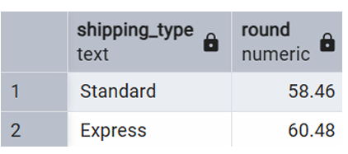
Average purchase amount by shipping type.

4.5 Subscribers vs. Non-Subscribers
Only 1,053 of the 3,900 customers (about 27%) are subscribers, yet their average spend per order ($59.49) is almost identical to non-subscribers ($59.87). The subscription program isn't currently driving bigger baskets — its value has to come from retention and order frequency instead, which is explored further in section 4.9.
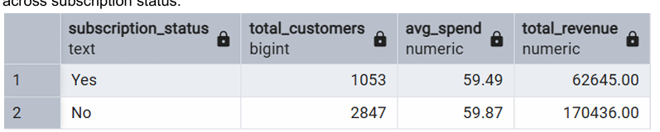
Customer count, average spend and total revenue split by subscription status.

4.6 Products That Rely Most on Discounts
For each product, the share of its purchases that involved a discount was calculated. Hats top the list at a 50% discount rate, followed closely by sneakers, coats, sweaters and pants. These are the items most dependent on markdowns to move — a signal that their full-price appeal may need attention.
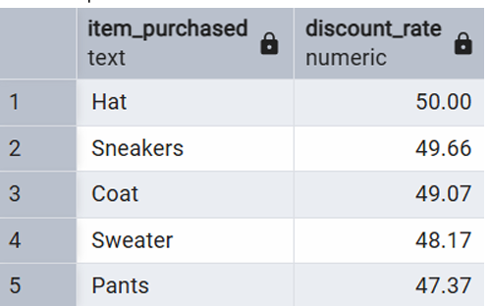
The 5 products with the highest share of discounted purchases.

4.7 Segmenting Customers by Purchase History
Customers were grouped into New, Returning, and Loyal segments based on how many times they've purchased. The base is overwhelmingly Loyal (3,116 customers), with only 83 truly New and 701 in the Returning middle tier — a sign that once someone makes a second or third purchase here, they tend to stick around.
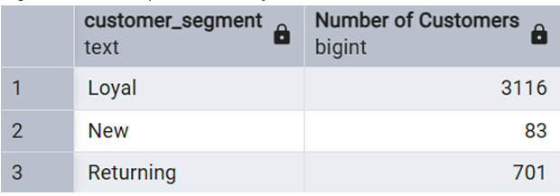
Customer counts by purchase-history segment.

4.8 Best-Sellers Within Each Category
Ranking items by order volume within their own category (Accessories, Clothing, Footwear, Outerwear) shows which specific products carry each department. Jewelry leads Accessories, Blouses lead Clothing, Sandals lead Footwear, and Jackets lead Outerwear — a useful reference for which SKUs deserve prominent shelf or homepage placement.
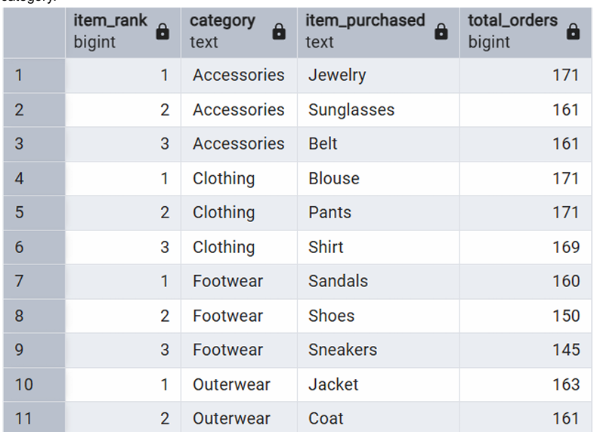
Top 3 best-selling products in each of the four categories.

4.9 Do Repeat Buyers Subscribe More?
Testing whether customers with more than five purchases lean toward subscribing: 958 heavy repeat buyers are subscribers versus 2,518 who are not. In other words, most repeat buyers still aren't on the subscription plan — reinforcing the point from section 4.5 that the subscription offer, as it stands, isn't capturing the loyalty that already exists.
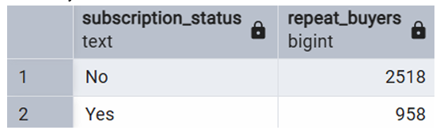
Repeat buyers (>5 purchases) split by subscription status.

4.10 Revenue by Age Group
Total revenue is fairly evenly spread across the four age groups, with Young Adults contributing the most ($62,143) and Seniors the least ($55,763) — a gap of only about 10%. No single age group dominates, which argues for broad rather than narrowly age-targeted campaigns.
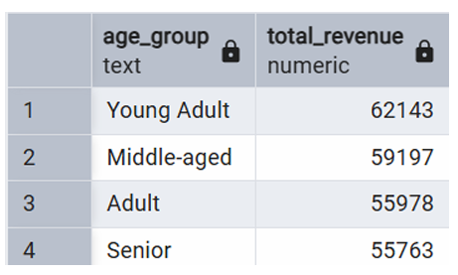
Total revenue contribution by age group.

5. Bringing It Together: The Power BI Dashboard
All of the metrics above were consolidated into a single interactive Power BI dashboard so the business can monitor them on an ongoing basis rather than re-running one-off queries. Filters on the left (subscription status, gender, category, and shipping type) let a user slice the same 3,900-order dataset live.
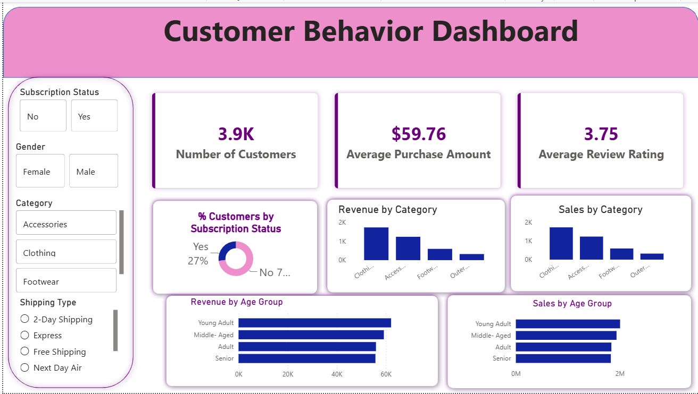
Customer Behavior Dashboard — Power BI.
The headline tiles echo the summary statistics from section 2 (3.9K customers, $59.76 average purchase, 3.75 average rating), while the category and age-group charts let those breakdowns be explored interactively instead of read off static tables.

6. What This Means for the Business
- Redesign the subscription offer — spend and repeat-purchase behavior barely differ between subscribers and non-subscribers today, so the program needs a sharper value proposition to convert the large Loyal segment.
- Lean into express shipping — it correlates with slightly higher basket size, so testing free or discounted express shipping thresholds could lift average order value.
- Re-price discount-dependent items — hats, sneakers, coats, sweaters and pants sell mainly on markdown; consider bundling or repositioning them instead of running further discounts on margin.
- Feature the top-rated products — gloves, sandals, boots, hats and skirts have the strongest customer approval and are natural candidates for homepage or email spotlighting.
- Investigate the gender revenue gap — male customers currently generate close to double the revenue of female customers; understanding whether that's driven by basket size, frequency, or category mix will sharpen future campaigns.
- Keep marketing broad across age groups — since revenue is spread fairly evenly by age (within about 10%), campaigns don't need to over-index on any single age bracket.

7. Closing Note
Taken together, these findings describe a customer base that is loyal and price-aware but not yet well served by the current subscription program. The clearest opportunities are in converting existing repeat buyers into subscribers, tightening the pricing of markdown-dependent products, and using the highest-rated items as the face of upcoming marketing pushes.

