**Asensi, David Joram**

**Caballero, Jian Carlo**

**Toledo, Aliyah Dana**

**Tuason, Diego Miguel**

**4th Hour Project**

For our 4th hour project, we were tasked to raise funds so that we can be able to donate with our partner organization which is a school that specializes in teaching kids with special needs. Our chosen activity in order to raise funds was to sell our preloved clothes on Facebook. Originally, we planned to post on the Facebook group “DLSU Bids to Pick” but we were too shy to do so so, we opted to just post on my Facebook account itself. What we did first was to find clothes and things that we were not using anymore so that we can give them a new home and at the same time, help the kids of Lumina Intervention Center. All of us were able to donate clothes and things that we were able to sell. After I posted on Facebook, there was an overwhelming amount of support from my friends and family that we were able to raise 1,200 pesos from the preloved things that we sold. The process of letting go of our preloved stuff and selling them wasn’t hard for us because we knew that it was all for a good cause. All group members played major roles in this activity because if it wasn’t for the things that everyone was willing to sell, we wouldn’t have been able to raise the said amount.

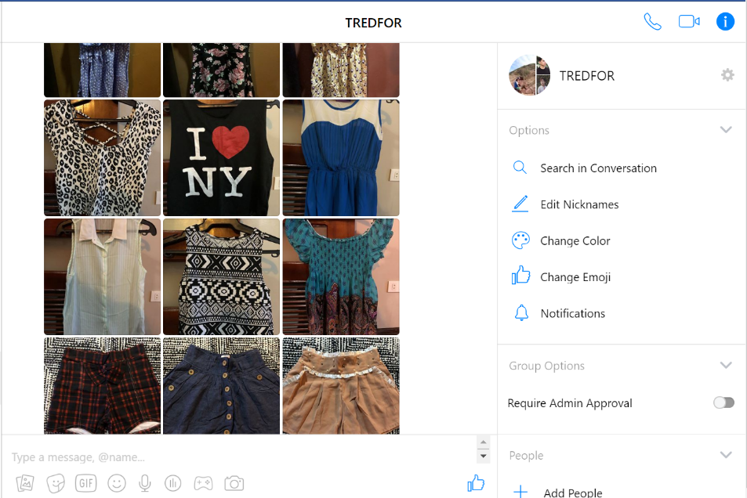

**1.0 Finding clothes and things to sell**

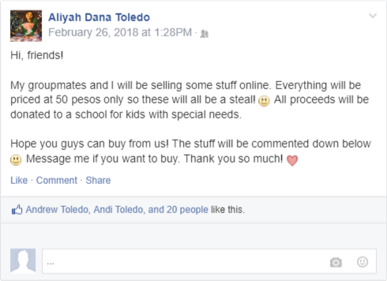

**2.0 Posting on Facebook about our fundraising**

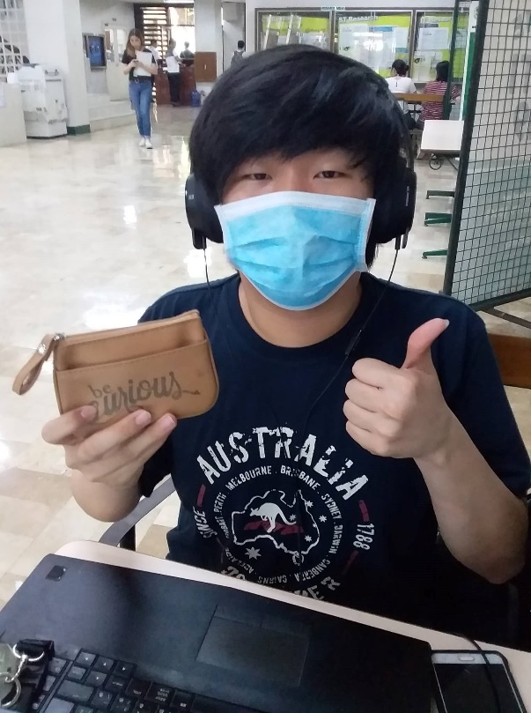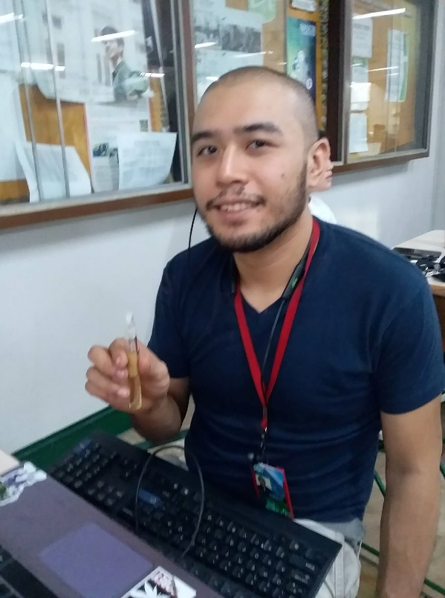

**3.0 Friends who bought from us**