**Research Instrument**

**Filipino Coping Strategies Scale**

This questionnaire was developed by John Robert Rilveria (2018), who is from the University of the Philippines in Diliman, Quezon City. This instrument is written in Tagalog with an English translation under each to provide better perception of the subject of the scale and examine sensitivity to the local Filipino context. It also consists of 37 items which measures nine various kinds of coping styles to stressors, which are: cognitive reappraisal (pagsusuri), social support (paghingi ng tulong), problem-solving (pagtugon), religiosity (pagkarelihiyoso), tolerance (pagtitiis), emotional release (paglabas ng saloobin), overactivity (pagmamalabis), relaxation/recreation (paglilibang), and substance use (pagbibisyo). Cognitive reappraisal indicates to changing one’s view or assumption towards the problem. This involves positive and hopeful thinking, changes of goals and values, and makes another meaning of one thing. A sample item under this domain would be: “Nag-iisip ako ng positive tungkol sa aking problema.” (I think something positive about my problem). While, social support indicates to behaviors which are help-seeking, getting advice or professional care, support from friends and family and sharing of one’s problems. A sample item under this domain would be: “Humihingi ako ng payo mula sa aking mga kaibigan.” (I solicit advice from my friends). Third scale is, problem solving, which includes planning, doing action to handle the source of stress and targets to remove the stressor. A sample item of this domain would be: “Gumagawa ako ng mga hakbang patungo sa pagkaya ng problema.” (I make ways to solve my problem). Fourth scale is, religiosity, which has its different sort because it includes some religious behaviors, in the like of praying, leaving everything to God, believing in destiny, and the will of God. A sample item is “Ipinagdarasal ko sa Diyos ang aking problema.” (I pray my problems to God). Fifth scale is, tolerance, which includes withstanding the struggle and stress without exerting effort in face it. A sample item of this scale is “Tinitiis ko ang stress na aking nararanasan.” (I endure the stress I am experiencing). Sixth scale is, emotional release, which indicates to expressing of emotions through anger, humor, cry, etc. A sample item is “Iniiyakan ko ang aking problema.” (I cry my problems out). Seventh scale is, overactivity, which indicates overextension of work or exerting a tremendous amount of effort in one’s activity to distance oneself from the problem. A sample item is “Pinapagod ko ang sarili sa isang partikular na gawain para mabawasan ang stress na aking dinadala.” (I exhaust myself doing something to lessen the stress I have). Eighth scale is, relaxation/recreation, which includes taking on in activities that would make an individual feel at ease and minimizes the cognitive and emotional burden of stress. A sample item is “Pumupunta ako sa mga lugar kung saan makakapagpahinga ako.” (I go to places where I can rest). Lastly, the ninth scale is, substance use, which involves consuming drugs, drinking alcohol, smoking, or even making use of medicines to alleviate some physical and mental signs of stress. Sample items are “Umiinom ako ng alak para mabawasan ang aking stress.” (I drink alcohol to reduce my stress) and “Naninigarilyo ako upang mawala ang negatibong pakiramdam sa problema.” (I smoke to ease my negative feelings). This test uses a four-point Likert scale. Each item has four responses option scored 1-4 from 1 indicating Never or Hindi to 4 indicating Often or Madalas. Raw score for each domain will be totaled, and derive the composite score. Get the percentile rank in order to know which coping styles are the most and least used.

**Theoretical Framework**

**Repression- Sensitization by Byrne**

Coping means to invest an individual’s conscious effort in order to solve personal and interpersonal problems. To master, [minimize](https://en.wikipedia.org/wiki/Minimisation_(psychology)) or tolerate [stress](https://en.wikipedia.org/wiki/Stress_(psychological)) and [conflict](https://en.wikipedia.org/wiki/Emotional_conflict). Studies on how an individual cope with stressful situations has developed over the decades. One of which is the influence of trait-oriented theories under the macro-analytic approach. Trait-oriented theories are mainly focused on the early understanding of an individual’s resources and tendencies related to coping. Macro-analytic approach concentrates on fundamental and abstract coping methodologies. Bryne’s Repression- Sensitization is under trait-oriented coping that focused more on the macro-analytic approach. Bryne discussed that there is a bipolar dimension in which an individual copes with the stress in only one of two opposite poles – repression or sensitization. Individuals who tend to be repressors cope with the stress by means of denying or minimizing its existence. They use the avoidance coping mechanism in such that they are unable to realize the potential negative outcomes of the stressful experience. In contrast to this, sensitizers tend to react to stress with rumination, excessive worrying and obsessive search for information on stress-related cues.

**Statement of the Problem**

**2. What kind of coping style/s do the respondents mostly use in terms of the following dimensions?**

a. Cognitive Reappraisal

b. Social Support

c. Problem-Solving

d. Religiosity

e. Tolerance

f. Emotional Release

g. Overactivity

h. Relaxation/Recreation

i. Substance Use

**Conceptual Framework**

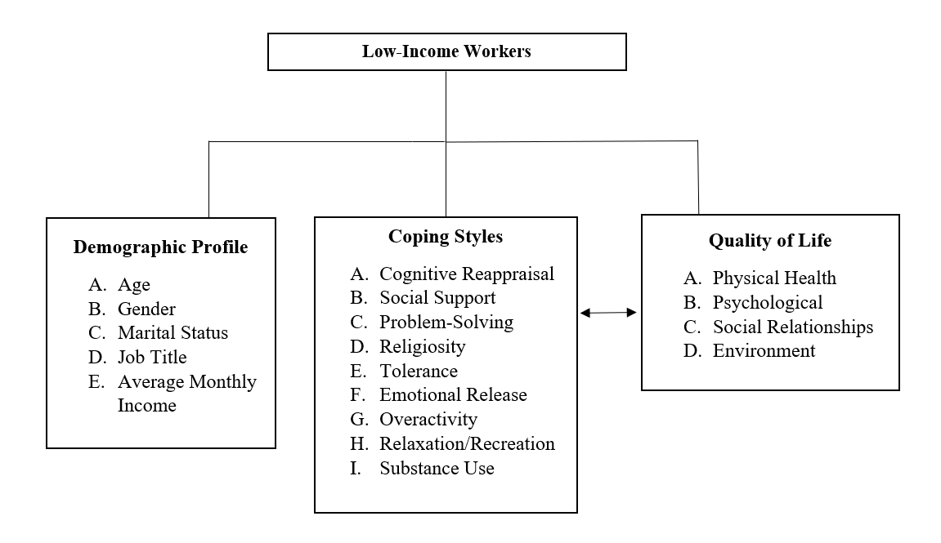

*Figure 1: Conceptual Framework*

With the focus on the low-income workers, the researchers sought to identify the coping style they usually display in terms of how they manage stressful situations they encounter. These coping styles are cognitive reappraisal, social support, problem-solving, religiosity, tolerance, emotional release, overactivity, relaxation/recreation, and substance use. These dimensions are represented in the framework above. The researchers also identified the quality of life of the participants through the four sub-domains of physical health, psychological, social relationships, and environment. The bidirectional line connecting both the coping styles and quality of life to see if the two variables will have a relationship.