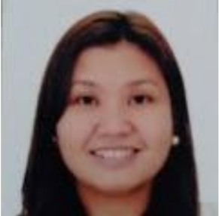**MA. LEWILYNN**  **L. TOLEDO**

Blk. 1 Lot 4 Anthurium St., Sorrento Townhomes, Bacoor, Cavite

Birthdate: June 24, 1971

Mobile No: 0936-045-2789

E-mail: [lewilukman@gmail.com](mailto:lewilukman@gmail.com)

OBJECTIVE

To teach the English language in a reputable educational organization where my extensive teaching and communication skills can help achieve the purpose of foreign students to learn English as their Second Language.

WORK EXPERIENCE

**AGENCY LEADER**

**Allianz PNB (Present)**

* Helping every Filipinos to have knowledge about investing and having life insurance.
* Recruiting people with integrity to join the mission of the company.

**ESL TEACHER**

**51Talk (2017-2018)**

* Taught English to broad age ranges to both Chinese and Korean students.
* Engaged in interactive and specific lessons to accommodate the needs of each students to further their education.
* Knowledgeable in the assessment of English proficiency of Chinese and Korean professionals.
* Handles ESL classes and designed lesson plans based on class strengths and deficiencies.

**MEDICAL CONSULTANT**

**Generika Drugstore (2012-present)**

* Diagnosing patients and providing management according to their complaints.
* Aiding the pharmacy assistants to properly dispose medicines.

**SALES AND TRAINER**

**Royal Prestige (2010-2017)**

* Provided the members with extensive training which includes proper selling techniques and customer service.
* Conducted classroom seminars for existing members to enhance their recruitment skills.

**ANNUAL PHYSICAL EXAMINER**

**Med-Pro Health Systems (2005-2012)**

* Provided standard medical examinations on patients for any possible symptoms of a medical condition.
* Assisted the company in determining the correct diagnosis and devising the treatment plan.

**ASSISTANT RESEARCHER/THESIS**

**International Rice Research Institute (1993)**

* Helped foreign co-researchers fulfill their research papers by assisting them in enhancing their English language through writing.
* Edited and proofread the papers of foreign co-researchers.

EDUCATION

**DOCTOR OF MEDICINE**

**University of the East Ramon Magsaysay Memorial Medical Center**

* Year graduated: 2001

**POST-GRADUATE INTERNSHIP**

**San Juan de Dios Hospital (2000-2003)**

**TERTIARY**

**University of the Philippines – Los Baños campus**

* BS Biology major in Genetics
* Year graduated: 1993

ORGANIZATION

**University of the Philippines – Los Baños**

* UPLB Genetics Society
* UP Sigma Beta Sorority

**University of the East Ramon Magsaysay Memorial Medical Center**

* UERMMMC Sigma Beta Sorority