CS-110: Fundamentals of Computer Programming
Assignment 1: Relief Supply Distribution System
CLO-2: Solve given real-world problem by applying appropriate programming concepts and techniques
Date: 10/ 11 / 2026
Class: BESE-17 A
Submitted By:

Syed Muhammad Aliyan Ali (585981)

Affan Akbar (592135)

Muhammad Yahya Shahzad (604750)
Submitted To:
Dr. Momina Moetesum
School of Electrical Engineering and Computer Science (SEECS)
National University of Sciences & Technology (NUST)

1. About This Project
This program is for a district office after a flood. The office gets requests for help from different areas. The office has only a few trucks and supply packs, so it must choose carefully. The program reads each request, calculates a need score, chooses an action, and then updates the trucks and supply packs that are left. At the end, it prints a summary.
Files in this submission:
- relief_supply.cpp: the C++ source code.
- flowchart.png: the flowchart
How to compile and run:
On Windows, use: g++ relief_supply.cpp -o relief_supply.exe and then relief_supply.exe
The program uses only the iostream library (for cin and cout). We did not use any other library or function.

2. Program Inputs
Input | What to type | Notes
Starting trucks | A whole number, for example 10 | Asked once, at the start
Starting supply packs | A whole number, for example 300 | Asked once, at the start
Damage level | 1 = Low, 2 = Medium, 3 = High | Any other number is rejected
Families affected | A number from 10 to 200 | Any other number is rejected
Access route | 1 = Open, 2 = Damaged | Any other number is rejected
Flood warning | y = Yes, n = No | Capital Y and N also work
Medical need | y = Yes, n = No | Capital Y and N also work
Previous aid received | y = Yes, n = No | Capital Y and N also work
If the user types a wrong value, or letters where a number is needed, the program asks again.

3. Need Score Calculation
Our formula:
Need Score = Damage points + Family points + Route points + Flood points + Medical points - Previous aid penalty
Input | Points we give | Why we gave this weight
Damage level | Low = 5, Medium = 15, High = 25 | Damage shows how much of the area is destroyed. Houses, food and clean water may be lost. High damage is the most urgent, so it gets the most points.
Families affected | Families / 10  (10 families = 1 point, 200 families = 20 points) | More families need more food and packs. We kept this weight small (at most 20), so a large area with little damage does not always win over a smaller area in real danger.
Access route | Damaged = +15  Open = 0 | A damaged road slows the trucks down or can stop them. Help to such places must be planned earlier, so it gets extra points.
Flood warning | Yes = +10  No = 0 | More flooding may come soon. Early help can stop the situation from getting worse.
Medical need | Yes = +30  No = 0 | Sick or injured people need medicine now. This is our biggest single weight, because a life is more important than anything else in this system.
Previous aid received | Yes = -10  No = 0 | The area has already received help. Areas with no help yet come first, so we take points away.
Score range: The lowest possible score is -4 (Low damage, 10 families, previous aid received). The highest possible score is 100 (High damage, 200 families, damaged route, flood warning, medical need, no previous aid).
Worked example, Request R1 (Riverside Village): High damage 25 + 150 families / 10 = 15 + damaged route 15 + flood warning 10 + medical need 30 + previous aid 0 = 95.

4. Decision and Action Rules

4.1 Score to wanted action
First, the score decides which action we want. We call this the "wanted action".
Need score | Wanted action | Trucks needed | Supply packs needed
70 or more | A - Full Relief | 2 | 50
40 to 69 | B - Standard Relief | 1 | 30
20 to 39 | C - Emergency Kit Only | 1 | 10
Below 20 | D - Defer / Monitor | 0 | 0

4.2 Stock check and fallback
Then the program checks if the stock is enough for the wanted action:
- Find the wanted action from the table in 5.1.
- Check the stock. Trucks left must be at least the trucks needed, and packs left must be at least the packs needed.
- If the stock is enough, use this action.
- If it is not enough, try the next smaller action: A, then B, then C, then D.
- If no action fits, the request cannot be served. Action D always fits, because it needs nothing.
- Subtract the trucks and packs that were used. We check the stock before we subtract, so the numbers never go below zero.
Reason messages printed for each request:
- "Enough stock. The wanted action was used."
- "Note: Not enough stock for [action]. A smaller action was used instead."
- "Need score is too low. Request is deferred (monitor)."
- "Not enough trucks or supply packs left. Request NOT served."

4.3 Why we designed the rules this way
- Clear bands. The three limits 70, 40 and 20 split the score into four simple bands. Every score falls into exactly one band, and each band has one action.
- Fallback instead of nothing. When the stock is low, a smaller help is better than no help. Example: if only 1 truck is left, Full Relief needs 2 trucks, so we send Standard Relief (1 truck) instead. The assignment asks us to think about this case.
- Defer low need. A low score means the area is not in urgent danger. It is better to keep the stock for areas in urgent need. The request is marked "monitor", so the office can check it again later.
- Medical need. Medical need adds 30 points, so the lowest score for a medical request is 26. Such a request is never deferred and always gets at least an Emergency Kit.

5. Flowchart
The flowchart shows the same steps as the code. It reads the starting stock, repeats the steps for 5 requests, and then prints the summary.
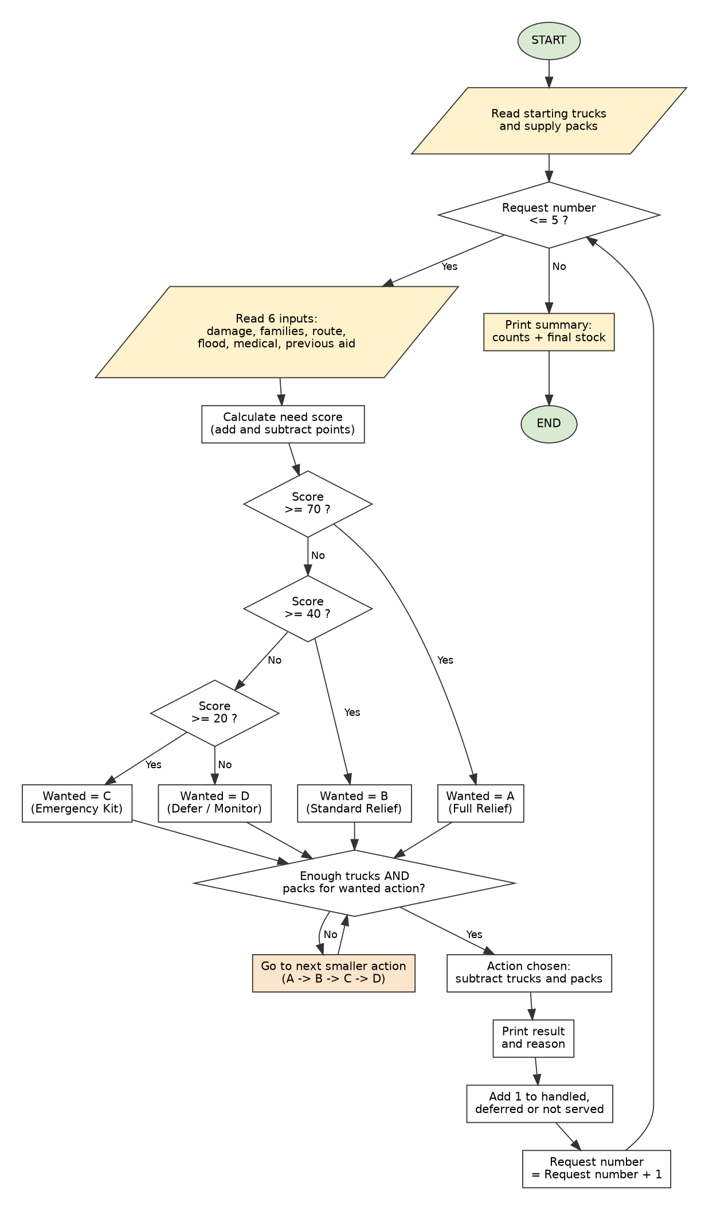

6. Testing and Program Output
We used the same five requests for both test sets. Each request was typed in the order shown below.

6.1 Test Set 1: Sufficient resources
Starting stock: 10 trucks and 300 supply packs.
Request | Damage | Families | Route | Flood | Medical | Previous aid
R1 - Riverside Village | High | 150 | Damaged | Yes | Yes | No
R2 - Hilltop Settlement | Medium | 60 | Open | No | No | Yes
R3 - Lakeside Camp | High | 90 | Open | Yes | Yes | No
R4 - Market Town | Low | 200 | Open | No | No | No
R5 - Bridge Colony | High | 40 | Damaged | Yes | Yes | Yes

Request | Need score | Wanted | Action chosen | Trucks used | Packs used | Trucks left | Packs left
R1 | 95 | A | A - Full Relief | 2 | 50 | 8 | 250
R2 | 11 | D | D - Defer / Monitor | 0 | 0 | 8 | 250
R3 | 74 | A | A - Full Relief | 2 | 50 | 6 | 200
R4 | 25 | C | C - Emergency Kit Only | 1 | 10 | 5 | 190
R5 | 74 | A | A - Full Relief | 2 | 50 | 3 | 140
Full program output, Test Set 1:
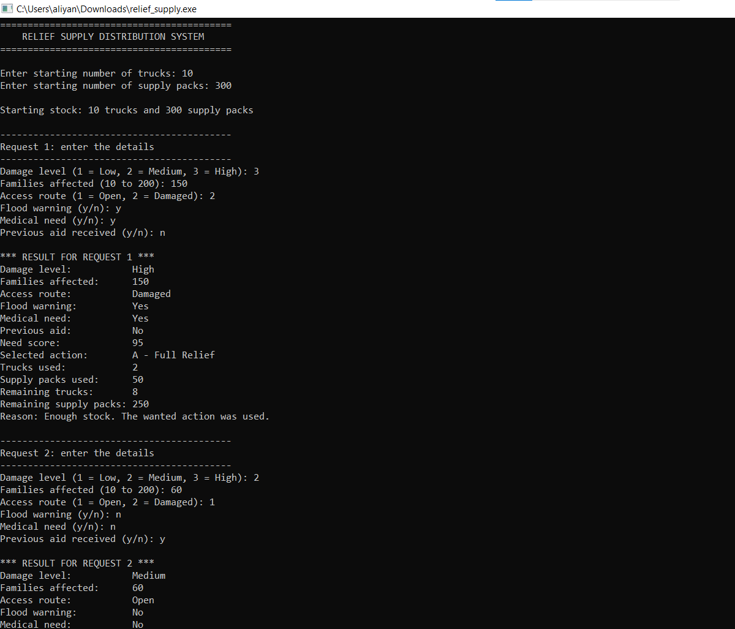

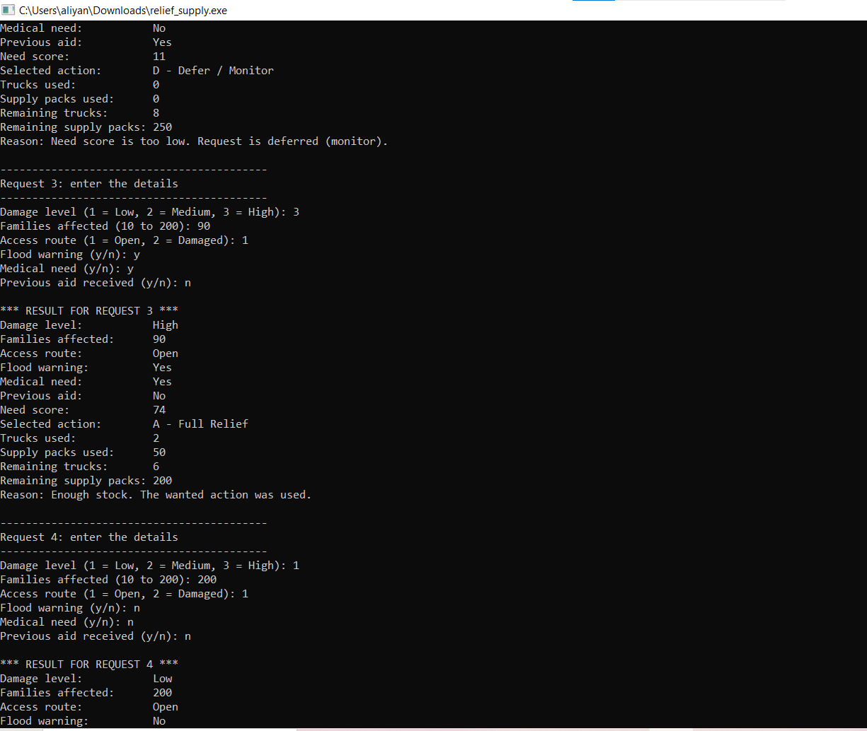
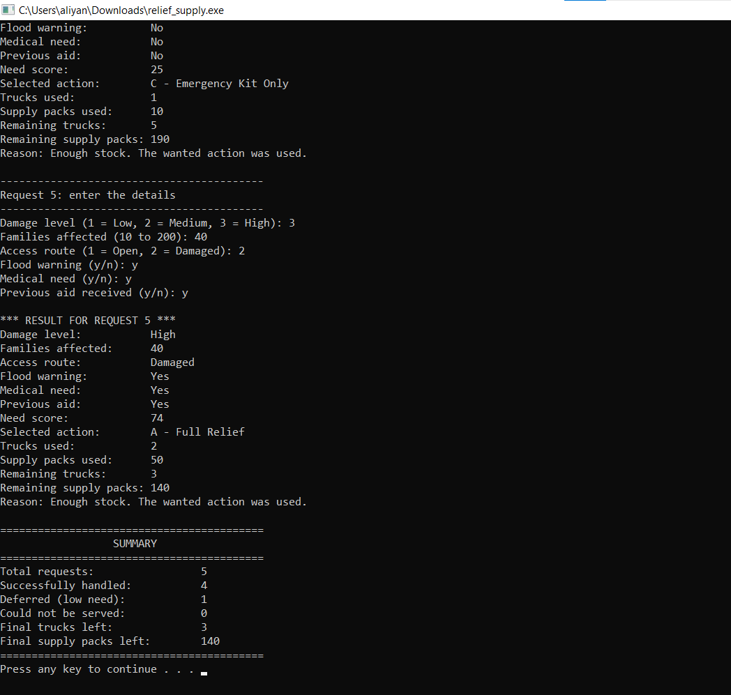
6.2 Test Set 2: Insufficient resources
Starting stock: 3 trucks and 120 supply packs. Trucks run out in this test, so the fallback rule is used.
Request | Damage | Families | Route | Flood | Medical | Previous aid
R1 - Riverside Village | High | 150 | Damaged | Yes | Yes | No
R2 - Hilltop Settlement | Medium | 60 | Open | No | No | Yes
R3 - Lakeside Camp | High | 90 | Open | Yes | Yes | No
R4 - Market Town | Low | 200 | Open | No | No | No
R5 - Bridge Colony | High | 40 | Damaged | Yes | Yes | Yes

Request | Need score | Wanted | Action chosen | Trucks used | Packs used | Trucks left | Packs left
R1 | 95 | A | A - Full Relief | 2 | 50 | 1 | 70
R2 | 11 | D | D - Defer / Monitor | 0 | 0 | 1 | 70
R3 | 74 | A | B - Standard Relief (fallback) | 1 | 30 | 0 | 40
R4 | 25 | C | None - not served | 0 | 0 | 0 | 40
R5 | 74 | A | None - not served | 0 | 0 | 0 | 40
Full program output, Test Set 2:
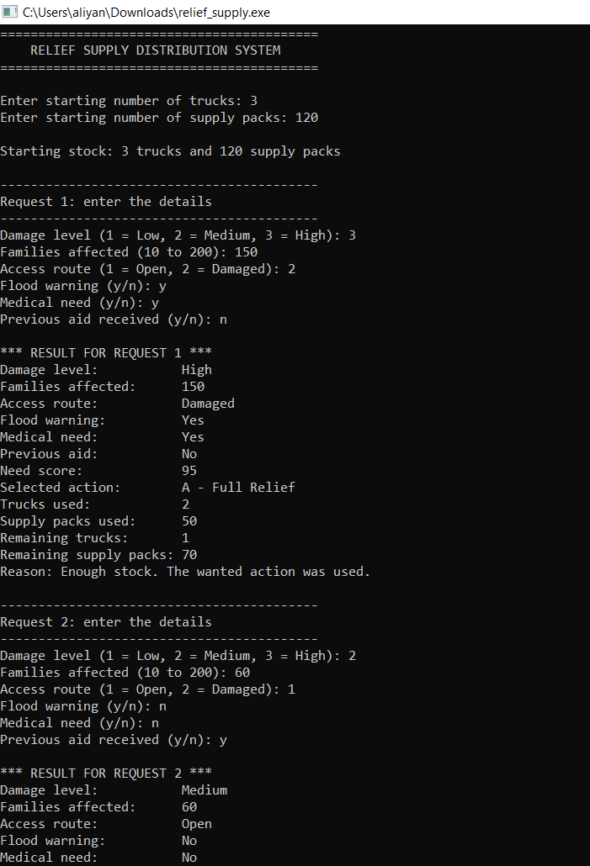

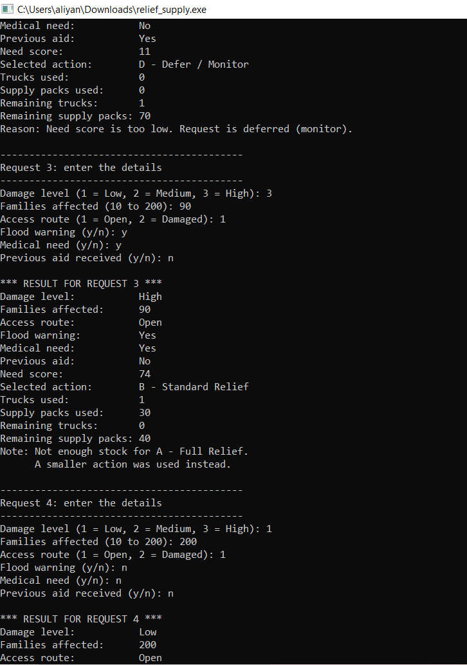

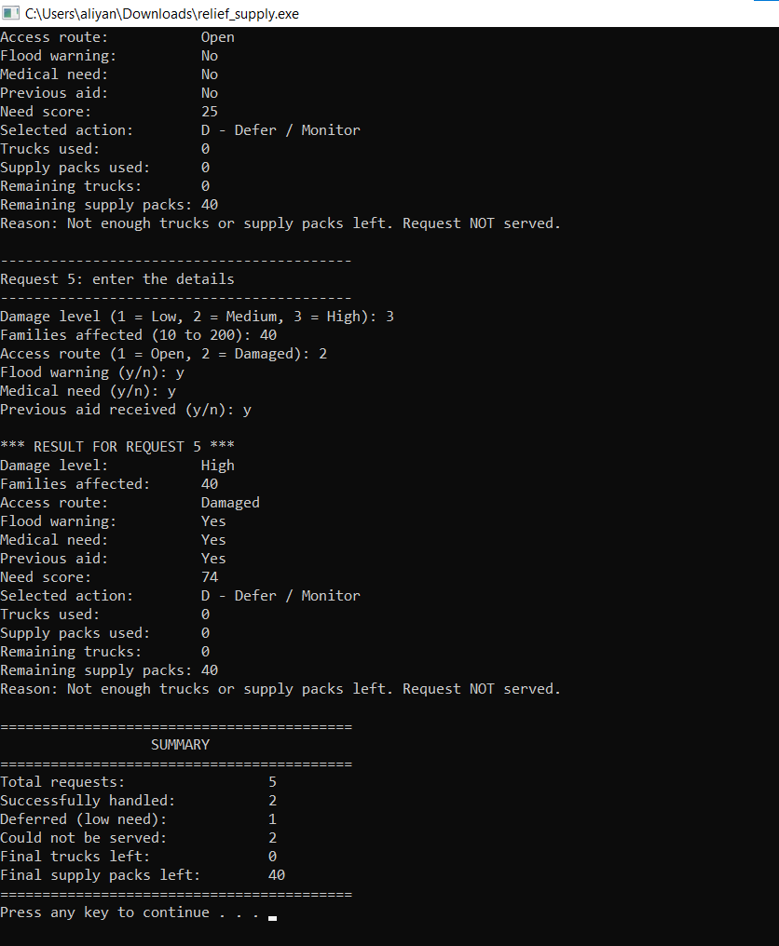

6.3 Extra checks
Start stock: 5 trucks and 120 supply packs. These checks cover cases that the two test sets do not show.
Check | What we typed | Expected | Result
Wrong input | Letters "abc", then 9, then 3 (for damage) | Program asks again and uses 3 | Asked again twice, then used High
Standard Relief from score | High, 150 families, Open, n, n, n (score 40) | B - Standard Relief | B - Standard Relief
Medical need gives at least C | Low, 10 families, Open, n, y, n (score 36) | C - Emergency Kit Only | C - Emergency Kit Only
Low score is deferred | Low, 10 families, Open, n, n, y (score -4) | D - Defer / Monitor | D - Defer / Monitor
Full Relief | High, 200 families, Damaged, y, n, n (score 70) | A - Full Relief | A - Full Relief
Fallback with only 1 truck left | Same as the Full Relief row, with 1 truck left | B - Standard Relief | B - Standard Relief, 0 trucks left

7. Test Results Check
Before we ran the program, we worked out the score and the remaining stock for each request by hand. The program output matched our hand results in both test sets and in the extra checks.
- Test Set 1: all requests except R2 were served. R2 was deferred because its score was low (11).
- Test Set 2: the stock ran out. R3 used the fallback. R4 and R5 could not be served.
- The summary counts are correct in every test: handled + deferred + not served = 5 requests.
- Trucks and supply packs never went below zero in any test.

8. Known Limits and Possible Improvements
- The number of requests is fixed at 5 .
- The results are shown on the screen only. They are not saved to a file.
- The points and limits are fixed numbers in the functions. If they are changed, the report and the test results must be updated too.

9. Group Members and Contributions
Name | Student ID | Main work
Syed Muhammad Aliyan Ali | 585981 | Need score formula and reasons (Section 4)
Affan Akbar | 592135 | Decision rules, stock check and fallback (Section 5), flowchart (Section 6)
Muhammad Yahya Shahzad | 604750 | Test sets and transcripts (Section 7), README, Git commits

10. GitHub Repository
[https://github.com/aliyan2525/Relief-Distribution-System-Assignment01]

11. Use of AI Tools
We used an AI tool to help us understand the assignment. We then write the code, compiled it, ran both test sets, and made changes ourselves.

Appendix A: C++ Source Code (relief_supply.cpp)
// =====================================================
// Relief Supply Distribution System
// CS-110 Fundamentals of Computer Programming - Assignment 1
// Class: BESE-17 A
//
// What this program does:
// 1. Asks for the starting trucks and supply packs.
// 2. Reads 5 relief requests from the user.
// 3. Calculates a need score for each request.
// 4. Chooses an action (A, B, C or D).
// 5. Updates the trucks and supply packs.
// 6. Prints a summary at the end.
// =====================================================

#include <iostream>
using namespace std;

const int TOTAL_REQUESTS = 5;

// ---------- Input functions ----------

// Reads one whole number from the user.
// If the user types letters, the program clears the error and asks again.
int readNumber()
{
int number = 0;

cin >> number;
while (cin.fail())
{
cin.clear(); // clear the error flag
cin.ignore(1000, '\n'); // throw away the wrong text
cout << "Please type a whole number: ";
cin >> number;
}

return number;
}

// Asks for the damage level. 1 = Low, 2 = Medium, 3 = High
int askDamageLevel()
{
int level = 0;

cout << "Damage level (1 = Low, 2 = Medium, 3 = High): ";
level = readNumber();

// Keep asking until the value is 1, 2 or 3
while (level < 1 || level > 3)
{
cout << "Wrong value. Please type 1, 2 or 3: ";
level = readNumber();
}

return level;
}

// Asks for the number of families. Allowed: 10 to 200
int askFamilies()
{
int families = 0;

cout << "Families affected (10 to 200): ";
families = readNumber();

while (families < 10 || families > 200)
{
cout << "Wrong value. Please type a number from 10 to 200: ";
families = readNumber();
}

return families;
}

// Asks for the access route. 1 = Open, 2 = Damaged
int askRouteStatus()
{
int route = 0;

cout << "Access route (1 = Open, 2 = Damaged): ";
route = readNumber();

while (route != 1 && route != 2)
{
cout << "Wrong value. Please type 1 or 2: ";
route = readNumber();
}

return route;
}

// Asks a yes or no question. Returns 'y' or 'n'.
char askYesNo(const char question[])
{
char answer = 'n';

cout << question;
cin >> answer;

while (answer != 'y' && answer != 'n' && answer != 'Y' && answer != 'N')
{
cout << "Please type y or n: ";
cin >> answer;
}

// Change a capital letter to a small letter
if (answer == 'Y')
{
answer = 'y';
}
if (answer == 'N')
{
answer = 'n';
}

return answer;
}

// ---------- Need score ----------

// Adds points for each input. A higher score means more urgent.
int calculateNeedScore(int damageLevel, int families, int routeStatus,
char floodWarning, char medicalNeed, char previousAid)
{
int score = 0;

// Damage points: Low = 5, Medium = 15, High = 25
if (damageLevel == 1)
{
score = score + 5;
}
else if (damageLevel == 2)
{
score = score + 15;
}
else
{
score = score + 25;
}

// Family points: 1 point for every 10 families
score = score + families / 10;

// Route points
if (routeStatus == 2)
{
score = score + 15;
}

// Flood points
if (floodWarning == 'y')
{
score = score + 10;
}

// Medical points: people who need medicine come first
if (medicalNeed == 'y')
{
score = score + 30;
}

// Previous aid penalty: they already got help before
if (previousAid == 'y')
{
score = score - 10;
}

return score;
}

// ---------- Decision rules ----------

// Picks the action we WANT, using only the score.
// score 70 or more -> A (Full Relief)
// score 40 to 69 -> B (Standard Relief)
// score 20 to 39 -> C (Emergency Kit Only)
// score below 20 -> D (Defer / Monitor)
// Note: a medical request gets at least 26 points, so it never falls to D.
char chooseWantedAction(int score)
{
char action = 'D';

if (score >= 70)
{
action = 'A';
}
else if (score >= 40)
{
action = 'B';
}
else if (score >= 20)
{
action = 'C';
}

return action;
}
// How many trucks does each action need?
int trucksNeeded(char action)
{
switch (action)
{
case 'A':
return 2;
case 'B':
return 1;
case 'C':
return 1;
default:
return 0;
}
}
// How many supply packs does each action need?
int packsNeeded(char action)
{
switch (action)
{
case 'A':
return 50;
case 'B':
return 30;
case 'C':
return 10;
default:
return 0;
}
}
// If the wanted action does not fit the stock, try the next smaller action.
// Order: A -> B -> C -> D.
char findActionThatFits(char wantedAction, int trucksLeft, int packsLeft)
{
char action = wantedAction;

while (action != 'D')
{
if (trucksNeeded(action) <= trucksLeft && packsNeeded(action) <= packsLeft)
{
return action;
}

// Not enough stock, so go to the next smaller action
if (action == 'A')
{
action = 'B';
}
else if (action == 'B')
{
action = 'C';
}
else
{
action = 'D';
}
}

return 'D';
}

// ---------- Text helpers (only used for printing) ----------

const char* damageName(int level)
{
if (level == 1)
{
return "Low";
}
if (level == 2)
{
return "Medium";
}
return "High";
}

const char* routeName(int route)
{
if (route == 1)
{
return "Open";
}
return "Damaged";
}

const char* yesNoName(char answer)
{
if (answer == 'y')
{
return "Yes";
}
return "No";
}

const char* actionName(char action)
{
switch (action)
{
case 'A':
return "A - Full Relief";
case 'B':
return "B - Standard Relief";
case 'C':
return "C - Emergency Kit Only";
default:
return "D - Defer / Monitor";
}
}

// ---------- Main program ----------

int main()
{
int trucks = 0;
int packs = 0;

int handledCount = 0;
int deferredCount = 0;
int notServedCount = 0;

cout << "==========================================\n";
cout << " RELIEF SUPPLY DISTRIBUTION SYSTEM\n";
cout << "==========================================\n\n";

// Ask for the starting stock
cout << "Enter starting number of trucks: ";
trucks = readNumber();
cout << "Enter starting number of supply packs: ";
packs = readNumber();

cout << "\nStarting stock: " << trucks << " trucks and "
<< packs << " supply packs\n";

// Repeat for every request
for (int requestNumber = 1; requestNumber <= TOTAL_REQUESTS; requestNumber++)
{
cout << "\n------------------------------------------\n";
cout << "Request " << requestNumber << ": enter the details\n";
cout << "------------------------------------------\n";

// Step 1: read the inputs
int damage = askDamageLevel();
int families = askFamilies();
int route = askRouteStatus();
char flood = askYesNo("Flood warning (y/n): ");
char medical = askYesNo("Medical need (y/n): ");
char previousAid = askYesNo("Previous aid received (y/n): ");

// Step 2: calculate the need score
int score = calculateNeedScore(damage, families, route, flood, medical, previousAid);

// Step 3: choose the action we want
char wanted = chooseWantedAction(score);

// Step 4: check the stock and choose the action that really fits
char action = findActionThatFits(wanted, trucks, packs);

// Step 5: update the trucks and supply packs
int trucksUsed = trucksNeeded(action);
int packsUsed = packsNeeded(action);
trucks = trucks - trucksUsed;
packs = packs - packsUsed;

// Step 6: print the result
cout << "\n*** RESULT FOR REQUEST " << requestNumber << " ***\n";
cout << "Damage level:\t\t" << damageName(damage) << "\n";
cout << "Families affected:\t" << families << "\n";
cout << "Access route:\t\t" << routeName(route) << "\n";
cout << "Flood warning:\t\t" << yesNoName(flood) << "\n";
cout << "Medical need:\t\t" << yesNoName(medical) << "\n";
cout << "Previous aid:\t\t" << yesNoName(previousAid) << "\n";
cout << "Need score:\t\t" << score << "\n";
cout << "Selected action:\t" << actionName(action) << "\n";
cout << "Trucks used:\t\t" << trucksUsed << "\n";
cout << "Supply packs used:\t" << packsUsed << "\n";
cout << "Remaining trucks:\t" << trucks << "\n";
cout << "Remaining supply packs:\t" << packs << "\n";

// Step 7: explain the decision and count it
if (action == 'D' && wanted == 'D')
{
cout << "Reason: Need score is too low. Request is deferred (monitor).\n";
deferredCount++;
}
else if (action == 'D')
{
cout << "Reason: Not enough trucks or supply packs left. Request NOT served.\n";
notServedCount++;
}
else if (action != wanted)
{
cout << "Note: Not enough stock for " << actionName(wanted) << ".\n";
cout << " A smaller action was used instead.\n";
handledCount++;
}
else
{
cout << "Reason: Enough stock. The wanted action was used.\n";
handledCount++;
}
}

// Summary at the end
cout << "\n==========================================\n";
cout << " SUMMARY\n";
cout << "==========================================\n";
cout << "Total requests:\t\t\t" << TOTAL_REQUESTS << "\n";
cout << "Successfully handled:\t\t" << handledCount << "\n";
cout << "Deferred (low need):\t\t" << deferredCount << "\n";
cout << "Could not be served:\t\t" << notServedCount << "\n";
cout << "Final trucks left:\t\t" << trucks << "\n";
cout << "Final supply packs left:\t" << packs << "\n";
cout << "==========================================\n";
system(“pause”);

return 0;
}

