Semester Project: Smart Parking Platform
Aliyan Adnan
University of Houston
Course Number: CIS 4374
Instructor Otto Dobretsberger
10/15/2026

Existing Software
Instead of focusing just on international examples, I concentrated on apps that individuals in Texas interact on a day-to-day basis. Drivers in Houston can utilize ParkHouston/ParkMobile, SpotHero, or ParkWhiz. Austin also offers Park ATX, which provides municipal parking. These applications demonstrate that users expect to pay, extend time, and book parking on their phones. The issue is that drivers may still be unsure whether a spot is available or whether they must pay to park, which entry to use, or what the approximate price will be, as some are also using prepaid features. The most crucial aspect of this project, in my opinion, is providing drivers with clear and real-time information.
- ParkHouston / ParkMobile (Houston)
- Advantages:
They provide a service through which one can pay for on-street and off-street parking by phone by entering a zone number, extending a session remotely, receiving expiration alerts, and reserving parking in some locations. It is already linked to City of Houston parking and is recognizable to those who park downtown.
- Disadvantages:
It is mostly designed around zone payments; the driver still has to know the proper zone and may not get a clear live image of all garage spaces, which can be confusing.
- Opportunities for improvement:
Showing a single map that incorporates street, lot, and garage space options, with clear availability status and access directions.
- SpotHero
- Advantages:
It can search the city’s locations, compare prices, reserve ahead of time, manage reservations, and book parking near airports, stadiums, and other attractions. Useful for events and travel since it allows drivers to assess choices before departing and save a lot of time.
- Disadvantages:
It primarily focuses on reservation marketplace; thus it does not focus on city meter payments or live empty space information.
- Opportunities for improvement:
Add verified live occupancy and make the app explain whether a space is reserved, when it will be available, or currently open.
- ParkWhiz
- Advantages:
It can search by city’s address, place, or event; compare location and price; reserve and prepay; use a mobile parking pass. It is very easy and simple layout for the bookings.
- Disadvantages:
It mainly focuses more on booking garages and lots rather than on managing city street parking or operator issues in real time, as it does not provide much useful data.
- Opportunities for improvement:
It can be vastly improved by connecting booking to operator updates, closures, and alternate options if the desired spot is occupied or unavailable.
- Park ATX
- Advantages:
It allows you to pay for eligible city parking, start or stop a session, extend time, receive expiration alerts, and view receipts and parking history. It uses a commonly used simple payment method that also supports pay by phone.
- Disadvantages:
This is exclusively designed for Austin city parking sessions rather than for a full multi-city reservation and operator platform, so it limits its own market.
- Opportunity for improvement:
This can be expanded a lot by building a platform that can support Texas cities while still letting each city keep its own rules, zones, rates, and notices so the drivers don’t have to rely on other services.

What Makes My application Unique
There is nothing more frustrating than reserving a parking spot only to pull up to the garage and find that floor blocked off and you miss an event or get late for your meeting. This platform fixes disconnect by keeping drivers and operators on the same page. Drivers can see right away whether an open space is physically verified, an estimate based on recent trends, or still unconfirmed. Total pricing and cancellation rules are laid out clearly before checkout, so there are no surprises at the gate. And if something does go wrong at the facility, the app doesn't leave people stranded immediately points them to an open nearby garage or processes a quick refund on the spot.

Vision and Scope
Project Vision:
Everyone knows the quiet panic of watching the time go by while circling the same packed parking lot in hope of finding space. Whether you are running late for an exam, rushing toward an airport terminal, or trying to catch a football match, the last thing you depend on is that parking spot that you can't seem to find, and it is now a guessing game. This platform cuts through that mess by keeping drivers and lot operators entirely in sync. Drivers can quickly pinpoint verified spots, pay clear upfront rates, and pull straight into an open space with confidence. Behind the scenes, garage managers get clean, practical insights to open or close levels, update pricing for busy hours, and track their occupancy without the usual operational headaches. Instead of drivers gambling in empty spaces and managers flying blind, it turns parking into an easy, reliable part of the day.
The Deliverable
Drivers get an option to track down spots, clear directions to their preferred map, and filter by essentials like EV chargers, vehicle height clearance, and accessible parking, while also showing whether a space is sensor-verified or time-estimated. On the other side, operators receive a clean dashboard that allows them to adjust surge rates, review occupancy, and shut down blocked ramps the second an accident or an issue arises.
Ground Realities
Development runs on a strict single-semester clock, requiring disciplined trade-offs and heavy reliance on proven third-party APIs for card transactions, merchants, mapping tiles, and access-control systems. Because spot projections are only as dependable as the garage's own incoming feeds, every release must carefully account for data gaps while meeting strict payment security, accessibility, and local consumer refund rules before launch.
Company and Project Overview
Company Background
WE ARE $oftware ¢orp. It is a student company formed to design and launch the Smart Parking Platform, as we were routinely penalized for showing up late to our 8:00 AM class not because we overslept, but because the campus parking structure was a daily nightmare. After missing a midterm while trapped in a stagnant line outside a garage that was secretly at capacity, our group spent a long weekend doing our research on the parking companies. That scrappy prototype eventually evolved into WE ARE $oftware ¢orp, a full-spectrum student development studio committed to killing urban gridlock through smart software. For this coursework scenario, we operate with zero financial or staffing limitations, focusing our energy on integrating external APIs smoothly.
How We Got the Job
We shaped our project around a public-private challenge: our city's transit authority needed a way to coordinate both municipal garages and commercial decks under a unified system. Rather than having drivers download three different tools and lot supervisors use four separate dashboards, our team stepped in to build a single system that connects drivers, garage staff, and municipal oversight.
The Core Concept
The project is straightforward, as it solves a real-life problem with no more guessing games at the barrier gate. Drivers choose their destination, lock in a verified spot, pay the exact fee upfront, and pull directly to the designated lane without circling. On the other side of the screen, lot owners get quick analytics view to adjust hourly fees, block off flooded ramps, and see real occupancy without checking stalls by hand, making the process smooth.
Software Requirements Specification (SRS)
System Overview & Operational Context
This SRS defines the functional and quality requirements for the Smart Parking Platform. I updated it after the risk, cost and resource work so it matches the decisions we made there. The product is a cloud-hosted system with mobile and responsive web clients, an operator dashboard, an administrative console, and APIs that connect mapping, payment, notification, sensor, and facility access services.
User Role | Primary Function & System Needs
Driver | finds parking spaces, completes pre-arrival transactions, accesses entry gates, and manages digital receipts.
Parking operator | Responsible for operational capacity, overrides bay allocations, tracks traffic, and manages lane shutdowns.
Finance user | Manages merchant payouts, monitors processing fees, reviews payment reversals.
System administrator | Control’s role permissions, manages API keys, sets monitoring alerts, and audits system access logs.
City transportation analyst | Reviews recurring parking trends, duration metrics, and peak curbside pressure points for transit optimization.
Merchants | Provides payments, maps, notifications, availability, or access-control events.

- Functional Requirements: The specific features and actions the system must support. These define what users can do (search, reserve, pay, navigate, cancel) and what administrative or automated systems handle (lock spots, dispatch alerts, sync rates, handle gate failures). The spot lock lasts 5 minutes, drivers can filter by EV charging, ADA access and height clearance, and operators can close a floor with one tap.
- Non-Functional Requirements: The system's quality standards and constraints. Rather than features, these specify operational criteria such as surge time, speed/latency, data encryption, privacy, accessibility compliance, and traffic scaling. Occupancy has to update within 60 seconds, a garage is marked Estimated / Stale after 5 minutes without sensor data, card numbers are never stored (a tokenized gateway keeps us in line with PCI-DSS), and cloud spending alerts warn us before busy event days.
- External System Integrations: The outside third-party services and hardware the platform relies on to function, such as mapping services, credit card gateways, barrier gate equipment, and push notification networks. Each one sits behind an adapter layer and payments have a backup option, so one outage does not stop checkout.
Use Cases
Driver Discovery & Booking
- Set Up Car & Profile
Actor: Driver
Flow: Driver saves vehicle height and license plate info once; system pre-configures automatic gate detection and vehicle clearance warnings for future trips.
Fallback: Plate conflict alerts driver to confirm registration before booking.
- Search for Parking
Actor: Driver
Flow: Driver inputs destination and arrival window; platform maps nearby garages, clearly tagging each lot as sensor-verified, trend-estimated, or offline.
Fallback: If zero spots match, system expands the search radius by 0.5 miles.
- Need-Specific Filtering
Actor: Driver
Flow: Driver filters for rapid EV charging, ADA access, or covered decks; map updates instantly to show only matching stalls.
Fallback: If no exact match exists, the system surfaces the closest partial alternative with clearly missing tags highlighted.
- Reservation Hold
Actor: Driver
Flow: Driver picks an open spot; system places a strict 5-minute database lock on that stall while displaying upfront costs and cancellation terms.
Fallback: If the checkout timer expires, the spot quietly returns to the open public pool.
- Pay for Parking
Actor: Driver, Payment Gateway
Flow: Driver approves itemized costs via Apple Pay, Google Pay, or saved card; gateway confirms payment and drops a digital receipt into the driver’s profile.
Fallback: Card decline alerts the driver immediately without dropping their 5-minute stall hold.
Arrival & Gate Entry
- Route to the Entrance
Actor: Driver, Navigation API
Flow: App transfers exact garage driveway coordinates not building into Apple or Google Maps for zero-confusion arrival.
Fallback: Road closures trigger an alternative alleyway or side-street entrance pin.
- Scan in at the Gate
Actor: Driver, Gate Controller
Flow: Garage camera reads the driver's license plate on approach and lifts the barrier automatically.
Fallback: If camera fails or plate is obscured, driver scans an offline-ready in-app QR code at the pedestal scanner.
- Get Gate Help
Actor: Driver, Support Agent
Flow: Barrier refuses to lift; driver taps "Help" in-app to generate a dynamic 4-digit keypad pin or trigger a remote buzzer override from the operator.
Fallback: Complete gate outage prompts the driver to proceed to an overflow lane with manual attendant check-in.
Session Management & Exceptions
- Add More Time
Actor: Driver
Flow: Driver receives a 15-minute expiration alert, taps "Extend 1 Hour," and the system charges the difference while extending gate privileges.
Fallback: If the facility is fully reserved for an upcoming event, the app warns the driver to vacate to avoid overstay fees.
- Cancel for a Refund
Actor: Driver, Payment Gateway
Flow: Driver cancels booking prior to the garage grace period; system unlocks the space for resale and queues an instant, full refund.
Fallback: Late cancellations calculate and display a partial cancellation fee before the user confirms.
- Emergency Rerouting on Deck Closure
Actor: Driver, Platform Engine
Flow: An operator closes a flooded deck containing booked spaces; app pings approaching drivers with a one-tap reroute to an adjacent affiliated lot at no extra charge.
Fallback: If nearby garages are full, platform issues an immediate full refund plus a capped courtesy travel credit.
- Pay Late Fees
Actor: Driver, Payment Gateway
Flow: Driver exits 45 minutes past booking window; exit gate captures departure timestamp and automatically bills the prorated overstay fee to the saved card.
Fallback: Expired payment card prompts an in-app payment request before digital receipt generation.
Operator Control & Telemetry
- Track Open Spots
Actor: Sensor Network / Garage Gate
Flow: Ground loops and stall cameras transmit vehicle entries and exits; backend updates available stall counts within 60 seconds.
Fallback: If sensor pings stop for more than 5 minutes, the app automatically flags the garage inventory as "Estimated / Stale."
- Change Prices
Actor: Parking Operator
Flow: Operator raises event rates or lowers slow-day pricing from a simple browser dashboard; updated fees reflect instantly on the public map.
Fallback: Existing active reservations retain their locked-in booking price.
- Block Off Rows or Floors
Actor: Parking Operator
Flow: Operator taps "Maintenance Mode" once on Floor 3; platform instantly freezes bookings for those specific stalls while keeping other levels active.
Fallback: System flags any driver currently end route to that deck for reassignment.
Auditing & Analytics
- Download Daily Reports
Actor: Parking Operator, City Analyst
Flow: Manager selects a date range and exports clean CSV/PDF reports covering fill rates, peak arrival hours, and gross earnings; no technical help needed.
Fallback: Huge annual queries run asynchronously in the background and deliver a download link to email.
- End-of-Day Payments
Actor: Finance Specialist
Flow: System matches in-platform booking IDs against processor settlement payouts, automatically flagging unpaid dues or chargeback disputes.
Fallback: Mismatches generate an exception ticket with links to the corresponding transaction logs.

Work Breakdown Structure
To keep our development strategy grounded and practical, I based the Work Breakdown Structure (WBS) on how drivers and lot managers will engage with the platform daily, rather than a high-level list of features. The project spans the whole operational experience, from first user login and profile creation to real-time garage monitoring, payment processing, and administrative statistics. By moving every main element down at least three tiers, I've broken down the whole scope into bite-sized, manageable tasks. This level of specificity eliminates uncertainty, clarifies work items, and guarantees that each deliverable is modest enough for a single developer to manage and complete within our time.

Instead of a standard feature list, this Work Breakdown Structure organizes the Smart Parking Platform across four core operational areas. Each area is broken down into specific sub-tasks to ensure clear ownership and straightforward execution during development.
Driver-Facing Applications: Covers everything the driver interacts with, beginning with user onboarding, profile setup, and digital payment options. It controls lot discoveries using interactive maps and feature filters, reservation holds through upfront checkout, and active parking sessions such as time extensions or overstay charges. UX wireframes (1.1.0) come first so the screens are designed before anyone codes them.
Operator & Admin Portal: Concentrates on back-office controls for facilities managers. It has live telemetry dashboards for tracking real-time lot occupancy, dynamic price toggles for peak hours, maintenance overrides to block individual stalls or decks, and financial export capabilities for daily revenue audits.
Hardware & Gate Access Integrations: Connects software logic to actual garage hardware. This includes synchronizing License Plate Recognition (LPR) cameras for barrier entrance, installing offline QR scanners, enabling backup PIN access, and receiving live telemetry feeds from in-ground loop sensors and above stall cameras. I added a pilot hardware order and a gate simulator (1.3.0) so we can keep testing if the real equipment shows up late.
Engineering Management & Launch: This describes the technological underpinning and deployment processes. It includes early integration of core mapping and payment APIs, PCI-DSS compliance and security audits, comprehensive end-to-end integration testing, and the final cloud infrastructure deployment. I also added team training (1.4.3) and a practice PCI check in Week 9 (1.4.2.1).

Project Timeline
WBS ID | Task / Phase Name | Duration | Start Week | End Week | Dependencies
1.0 | Requirements & Architecture Phase | 2 Weeks | W1 | W2 | X
1.4.1 | System Architecture & Third-Party API Setup | 2 Weeks | W1 | W2 | None
1.1.0 | UX Wireframes & Accessibility Checks | 2 Weeks | W1 | W2 | None
1.4.3 | Team Training (LPR & Payment APIs) | 2 Weeks | W1 | W2 | None
2.0 | Core Development Phase | 6 Weeks | W3 | W8 | X
1.1.1 | Driver Setup, Profile & Payment Method Setup | 2 Weeks | W3 | W4 | 1.4.1
1.1.2 | Search, Map Filtering & Occupancy system | 3 Weeks | W4 | W6 | 1.1.1
1.1.3 | Reservation Hold & Payment Engine | 2 Weeks | W6 | W7 | 1.1.2
1.2.1 | Operator Telemetry & Rate Controls | 3 Weeks | W5 | W7 | 1.4.1
1.3.0 | Pilot Hardware Order & Gate Simulator | 2 Weeks | W3 | W4 | 1.4.1
1.3.1 | Gate Access Integration (LPR, QR, PIN) | 3 Weeks | W6 | W8 | 1.1.3, 1.2.1, 1.3.0
3.0 | Advanced Features & Edge Cases | 3 Weeks | W8 | W10 | X
1.1.4 | Extensions, Overstays & Rerouting | 2 Weeks | W8 | W9 | 1.1.3
1.2.2 | Analytics, Reports & Payout system | 2 Weeks | W9 | W10 | 1.2.1
1.4.2.1 | Pre-Audit PCI Practice Check | 1 Week | W9 | W9 | 1.1.3
4.0 | Testing, Compliance & Rollout | 4 Weeks | W11 | W14 | X
1.4.2 | System Security, PCI Audits & Testing | 2 Weeks | W11 | W12 | 1.3.1, 1.1.4
1.4.2.2 | Launch & Final Presentation | 2 Weeks | W13 | W14 | 1.4.2
GANTT CHART
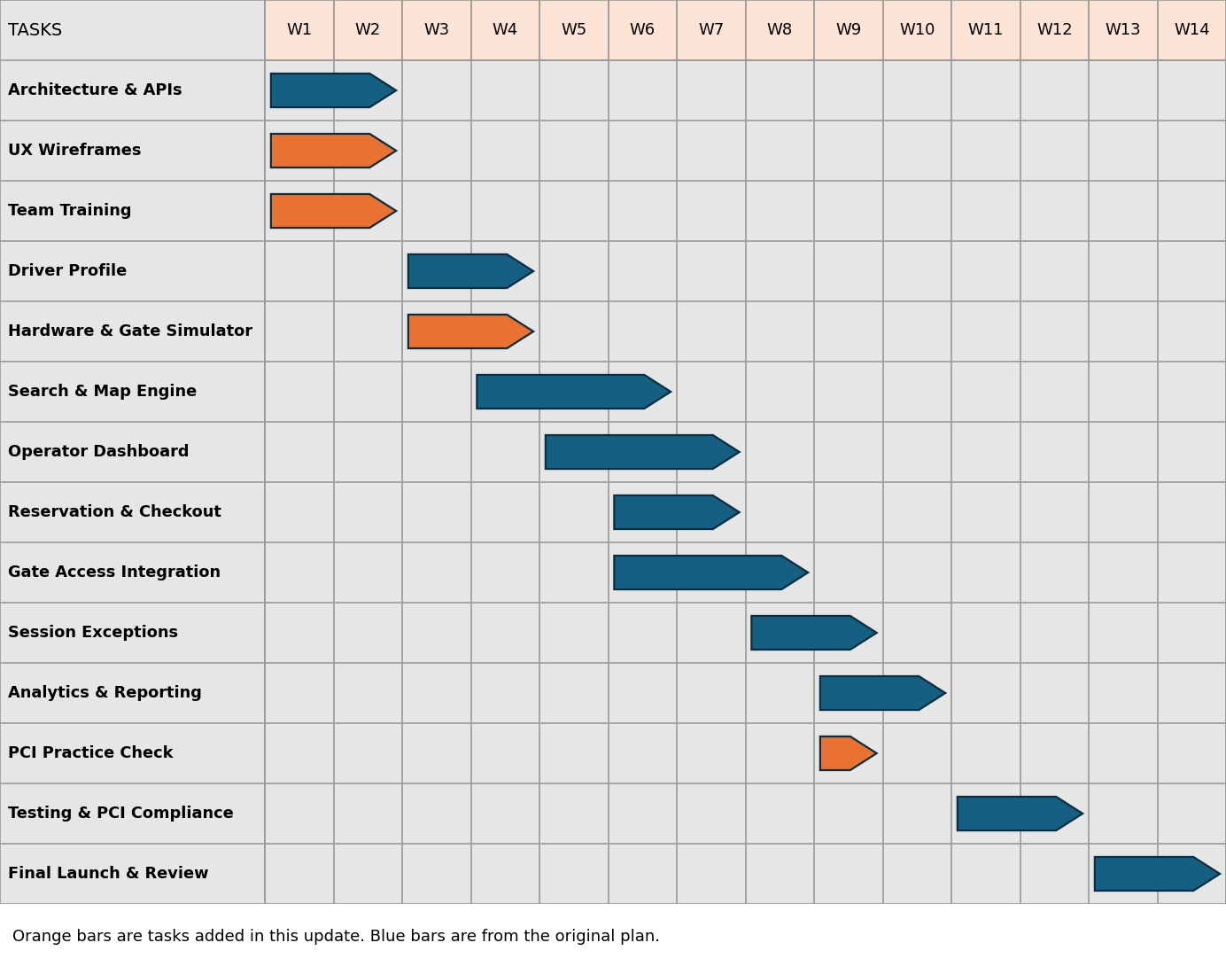
I updated the timeline and this Gantt chart after finishing the risk and cost work. Four tasks are new (the orange bars): UX wireframes (1.1.0), team training (1.4.3), the pilot hardware order and gate simulator (1.3.0), and a practice PCI check in Week 9 (1.4.2.1). Three of them came from risk plans (R14, R5 and R7), and the wireframes task came from adding a UX designer in the Roles section. I also fixed the old chart, where the Reservation and Operator bars did not match the timeline table.

Agile Task Management & Product Backlog (Trello)
https://trello.com/invite/b/6ab5a5f48c0beec860958379/ATTIb5c08fc72042298c91128aa436c4254eBD8C9930/smart-parking-platform
Implementation Strategy & Architecture
To connect high-level system design to everyday engineering execution, the Smart Parking Platform's Work Breakdown Structure (WBS) was converted into an organized Agile Scrum backlog using Trello. The platform's functional scope is divided into four key operating streams: authentication, user interfaces, core microservices, and analytical reporting. This is supported by an active Sprint 1 Backlog, which is aimed to deliver our first architectural baseline.
Each card includes thorough user stories, system dependencies, and technical details in order to uphold stringent project control and go beyond baseline criteria. In order to cover edge scenarios, hardware integration failovers, and compliance standards required for a production-grade platform launch, the backlog purposefully grows above baseline item needs.
Backlog Verification & Category Breakdown
- Category A: Login & Authentication (7): Establishes identity management, biometric authentication, role-based access control, and automated session timeouts.
- Category B: Operator & User UI (17): Encompasses responsive interfaces for driver discovery, live sensor status indicators, interactive level selectors, and operator override controls.
- Category C: Backend Processes (17): Houses core system engines, including dynamic pricing synchronization, automated stall reservation timers, LPR gate validation, and PCI-DSS payment tokenization.
- Category D: Reporting & Analytics (12): Delivers operational intelligence, including daily occupancy heatmaps, automated settlement logs, audit trails, and city-wide transit analytics.
- Sprint 1 Backlog (10): Prioritizes foundational deliverables for Weeks 1–2, focusing on cloud infrastructure setup, payment gateway integration, and primary authentication workflows. Team training (1.4.3) and the UX wireframes (1.1.0) also happen in these two weeks.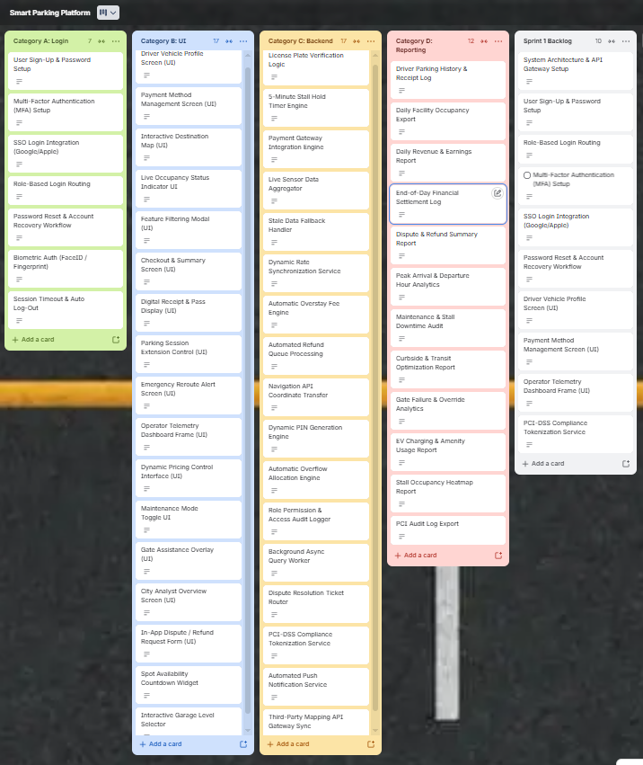
Sprint plan: Our sprints are 2 weeks each, so the 14-week timeline gives us 7 sprints. Tasks that run longer than two weeks carry over into the next sprint.
Sprint | Weeks | Goal | Main WBS tasks
Sprint 1 | W1-2 | Architecture, API setup, wireframes and training | 1.4.1, 1.1.0, 1.4.3
Sprint 2 | W3-4 | Driver accounts, hardware ordered, gate simulator | 1.1.1, 1.3.0, start 1.1.2
Sprint 3 | W5-6 | Search and map, operator dashboard | 1.1.2, 1.2.1
Sprint 4 | W7-8 | Reservation hold, payments and gate access | 1.1.3, 1.3.1
Sprint 5 | W9-10 | Extensions and rerouting, reports, PCI practice check | 1.1.4, 1.2.2, 1.4.2.1
Sprint 6 | W11-12 | Security audit and testing | 1.4.2
Sprint 7 | W13-14 | Launch and final presentation | 1.4.2.2

Risk Management
The missed midterm is still the reason this project exists. We sat outside a garage that was secretly full and nobody told us. So when I made the risk list, the ones that worried me most were the ones that would hand drivers wrong information again. Below I list the risks, score them, and plan how our team talks to each other. I matched every risk to a WBS task or use case so it fits the plan we already built.
Risks by Category
There are four risks for each category: technical, schedule, financial and people. One thing to remember is that our scenario has no financial limits, so the money risks are really about what the platform would cost once it’s live.
Category | Risk | What could happen | Links to
Technical | Sensors or cameras stop sending data | A garage could show open spots when it is really full, which is the same problem that made us miss our midterm. | Use Case 13, WBS 1.2.1
Technical | The plate reader (LPR) fails in heavy rain, glare or dark decks | The gate will not lift, so the driver has to use the QR code or PIN. | Use Cases 7 and 8, WBS 1.3.1
Technical | Everyone tries to book at once before a big event | Football games and airport rushes could break the 5-minute spot hold and double book a stall. | Use Case 4, WBS 1.1.3
Technical | Payment, map or notification services go down or change | Our plan depends on outside APIs, so drivers could not pay or get directions. | Ground Realities, WBS 1.4.1
Schedule | Gate access work (1.3.1) starts late | It waits on 1.1.3 and 1.2.1, so any delay there moves it back. | WBS 1.3.1
Schedule | Search, map filtering and occupancy (1.1.2) takes longer than 3 weeks | Reservations (1.1.3) cannot start until it is done. | WBS 1.1.2
Schedule | The PCI-DSS audit finds problems | Fixing them could eat into the launch weeks (13-14). | WBS 1.4.2
Schedule | The Trello backlog keeps growing | It already has more than 50 cards, and we only have one semester. | Trello Categories A-D
Financial | Card fees and chargebacks are higher than expected | Operators would get less money in their payouts. | Use Case 17, WBS 1.2.2
Financial | Sensors, cameras and gate equipment cost too much | Hardware prices are hard to guess, and every garage needs it. | Hardware and Gate Access area
Financial | Event days bring huge traffic and a bigger cloud and map bill | Football matches and airport trips are the exact moments the app is used most. | Use Case 14, WBS 1.4.2.2
Financial | Refunds and travel credits add up when a deck closes | A flooded Houston garage could mean many full refunds in one day. | Use Cases 10 and 11, WBS 1.1.4
People | Teammates get busy with exams or 8:00 AM classes | Each WBS task is meant for one developer, so work could stop. | Whole timeline
People | Nobody on the team has used plate readers or payment APIs before | We would need extra time to learn them. | WBS 1.3.1 and 1.1.3
People | It is unclear who owns what across the four WBS areas | Tasks could get missed or done twice. | All four WBS areas
People | Garage staff do not know how to use the operator dashboard | A flooded floor might stay open to drivers because nobody closed it. | Use Cases 14 and 15, WBS 1.2.1

Risk Register
Here are all 16 risks in one table. For the score I multiplied Probability as (P) times Impact as (I), each from 1 to 5. Fifteen or higher is high, 8 to 14 is medium, and under 8 is low. The Status column is how we’ll keep track: open, being watched, or accepted. We’ll update it every week.
ID | Risk | Category | P | I | Score | Response | What we will do | Owner | Status
R1 | Sensors or cameras stop sending data (Use Case 13) | Technical | 4 | 4 | 16 | Reduce | Mark the garage "Estimated / Stale" after 5 minutes with no data, and always show if a spot is sensor-verified or only an estimate | Hardware lead | Open
R2 | Plate reader fails in rain, glare or dark decks (Use Case 7) | Technical | 3 | 4 | 12 | Reduce | Test in low light; keep the QR code and 4-digit PIN backups (Use Case 8) | Hardware lead | Open
R3 | Everyone books at once before big events (Use Case 4) | Technical | 3 | 4 | 12 | Reduce | Lock the spot in the database for 5 minutes and load test with a fake event rush | Backend lead | Open
R4 | Payment, map or notification service goes down | Technical | 3 | 5 | 15 | Reduce | Test the APIs in Weeks 1-2 (WBS 1.4.1) and keep a backup payment option | Tech lead | Open
R5 | Gate access (1.3.1) starts late | Schedule | 4 | 4 | 16 | Reduce | Start hardware setup early and use a fake gate to test in the meantime (WBS 1.3.0) | Project manager | Open
R6 | Search and map filtering (1.1.2) runs over 3 weeks | Schedule | 3 | 4 | 12 | Reduce | Build the basic map first and add EV, height and ADA filters after | Driver app lead | Open
R7 | PCI-DSS audit finds problems (1.4.2) | Schedule | 3 | 5 | 15 | Reduce | Use a payment gateway so we never store card numbers; do a practice check in Week 9 (WBS 1.4.2.1) | QA lead | Open
R8 | Trello backlog keeps growing | Schedule | 4 | 3 | 12 | Avoid | Stop adding cards after Sprint 1; the project manager approves any new one | Project manager | Open
R9 | Card fees and chargebacks are too high (Use Case 17) | Financial | 3 | 3 | 9 | Accept | Show the full price before checkout and match payments to payouts every day | Finance lead | Monitoring
R10 | Hardware costs too much | Financial | 3 | 4 | 12 | Transfer | Get fixed quotes from vendors and start with one pilot garage | Project manager | Open
R11 | Event-day traffic raises cloud and map costs | Financial | 2 | 3 | 6 | Accept | Set usage alerts and a spending limit before the busy days | Tech lead | Accepted
R12 | Refunds and travel credits add up after a deck closes (Use Case 11) | Financial | 2 | 4 | 8 | Accept | Cap the travel credit and try rerouting to a nearby garage first | Finance lead | Accepted
R13 | Teammates busy with exams or 8:00 AM classes | People | 4 | 3 | 12 | Reduce | Have two people know each task and leave extra time in Weeks 13-14 | Project manager | Open
R14 | Team has not used plate readers or payment APIs | People | 3 | 3 | 9 | Reduce | Spend Weeks 1-2 on tutorials and sample projects and work in pairs (WBS 1.4.3, $440 training) | Tech lead | Open
R15 | Unclear who owns what in the four WBS areas | People | 3 | 3 | 9 | Avoid | Give every WBS item one owner and go over them in the weekly meeting | Project manager | Open
R16 | Garage staff cannot use the dashboard (Use Case 15) | People | 3 | 4 | 12 | Reduce | Make Maintenance Mode one tap, write a one-page guide and test it with a real operator | Operator portal lead | Open
Red = high (15+), yellow = medium (8-14), green = low (under 8).
Communication Plan
Each of our four WBS areas gets its own meeting rhythm. We’re students with classes and exams, so I kept it light on purpose. Most days it’s a quick message in the group chat instead of a call, and meetings happen right after class so nobody needs an extra trip. In exam weeks we only chat, except for the weekly status meeting.
Team | Meeting | How often | Who joins | Why
Whole project | Sprint planning and review | Every 2 weeks | Everyone and the instructor | Plan the next sprint, show what is finished, review the top risks
Project management | Status meeting | Once a week (30 min, after class) | Project manager and team leads | Check the timeline, update the Risk Register, fix blockers
Driver-Facing Applications | Daily update in group chat | Daily (5 min) | Driver app developers | Profile, search, reservation hold and payments: done, next, stuck
Operator & Admin Portal | Daily update in group chat | Daily (5 min) | Dashboard developers | Occupancy dashboard, price changes, floor closures and reports
Hardware & Gate Access | Check-in call | Twice a week (20 min) | Hardware lead and backend developers | Plate reader, QR, PIN and sensor progress and test results
Engineering Management & Launch | Security and testing review | Once a week | QA lead and tech lead | Testing, PCI checklist and launch readiness
Transit authority and garage operators | Feedback meeting | Every 2 weeks | Project manager and their reps | Show a demo and get feedback and approval
Exam weeks | Chat updates only | Daily | Everyone | Keep work moving without extra meetings

Reporting Methods
My goal here was simple: catch small problems early and get big ones to the project manager fast. Daily messages show who’s stuck, the Trello board shows where each task really is, and anything urgent goes straight to the PM instead of sitting until the weekly meeting.
Method | How often | Who gets it | Tool / format
Daily update | Daily | Own team | Short message in the group chat: done, next, stuck
Trello board | Always up to date | Whole team | Cards move from backlog to done
Weekly status report | Weekly | Project manager and instructor | One page: progress vs. timeline, budget (burn rate), top 3 risks, next steps
Risk Register update | Weekly | Team leads | Shared copy of the register with new scores and statuses
Sprint demo | Every 2 weeks | Transit authority and operators | Live demo with short slides
Urgent issue | Within 24 hours | Project manager | Direct message for any high risk or a delay of 2+ days
Meeting notes | After each meeting | Everyone | Notes saved in one shared folder

Resource and Cost Management
This section is about who’s on the team, how much time each person gives, and what the project would cost. Our scenario says we have no money or staffing limits, but a plan with no numbers felt fake to me, so I priced it the way a real small team would. The names are made up, like the homework asked.
1. Roles and Resources
I matched each role to one of our four WBS areas and to the owners in the Risk Register, so the same people show up everywhere in this document. For skill levels, I used three: Junior (knows the basics, needs help with new tools, $30/hr), Mid (handles most tasks alone, $40/hr) and Senior (designs the system and reviews everyone else’s work, $55/hr).
Role | Name (fictional) | Skill level | Main work (WBS) | FTE % | Hours | Rate | Cost
Project Manager | Maya Torres | Mid | Planning, status reports, Risk Register, budget tracking, stakeholder demos | 25% | 140 | $40/hr | $5,600
Tech Lead (architecture and cloud) | Ethan Park | Senior | 1.4.1 Architecture and API setup, 1.4.3 Team training, cloud deployment, 1.4.2.2 Launch | 40% | 224 | $55/hr | $12,320
Backend Lead | Priya Nair | Mid | 1.1.3 Reservation hold and payment engine, 1.1.4 Extensions, overstays and rerouting | 50% | 280 | $40/hr | $11,200
Driver App Lead | Jordan Lee | Mid | 1.1.1 Driver setup and profile, 1.1.2 Search, map filtering and occupancy | 50% | 280 | $40/hr | $11,200
Operator Portal Lead | Sofia Ramirez | Mid | 1.2.1 Telemetry and rate controls, 1.2.2 Analytics, reports and payouts | 50% | 280 | $40/hr | $11,200
Hardware and Gate Lead | Marcus Johnson | Junior | 1.3.0 Pilot kit and gate simulator, 1.3.1 Gate access (LPR, QR, PIN) and sensor feeds | 40% | 224 | $30/hr | $6,720
QA and Security Lead | Aisha Khan | Mid | 1.4.2 Testing, 1.4.2.1 PCI practice check, PCI-DSS audit prep, test cases for every WBS area | 40% | 224 | $40/hr | $8,960
UX Designer | Lena Cho | Junior | 1.1.0 Wireframes for the driver app and dashboard, accessibility (ADA) checks | 20% | 112 | $30/hr | $3,360
Finance Lead | Daniel Brooks | Mid | Payouts, card fees, chargebacks, cost tracking (Use Case 17) | 15% | 84 | $40/hr | $3,360
TOTAL |  |  |  |  | 1,848 |  | $73,920

Hours = FTE % x 40 hours x 14 weeks, since the timeline is 14 weeks. I kept each person’s time flat every week so the math stays easy. In real life the hardware lead would be slammed in Weeks 6-8 and QA in Weeks 11-12. I made Marcus Junior because nobody on the team has touched a plate reader (Risk R14), so he gets some training money.
2. Resource and Cost Plan
I went bottom-up. We already have a WBS and a week-by-week timeline, so adding up real work felt smarter than guessing one big number and slicing it up. Labor comes from the table above. The other lines are things we’d have to pay for to build and launch.
Item | Category | Basis | Unit cost | Total | Notes
Team labor (9 roles) | Labor | 1,848 hours | $40/hr average | $73,920 | From the resource table above
Cloud hosting | Infrastructure | 4 months | $300/month | $1,200 | Dev, test and staging; sensor feed testing
Maps and notification APIs | Third-party APIs | 4 months | $260/month | $1,040 | Map tiles, push and SMS; payment gateway stays in free test mode
Developer and design tools | Licenses and tools | One time | $400 | $400 | IDE tools, design tool, test accounts
Pilot hardware kit | Hardware (CAPEX) | 1 kit | $1,500 | $1,500 | LPR camera $800, QR pedestal scanner $300, sensor kit $400
Training | Training | 2 courses | $220 | $440 | LPR and payment API courses (Risk R14)
Security scan and pen test | Compliance | 1 | $2,000 | $2,000 | Needed for the PCI-DSS audit in WBS 1.4.2
Accessibility and refund-rule review | Legal | 1 | $1,000 | $1,000 | ADA and Texas consumer refund rules (Ground Realities)
Subtotal |  |  |  | $81,500
Contingency | Reserve | 15% of subtotal |  | $12,225 | Only for risks in the Risk Register
Grand total |  |  |  | $93,725

Labor comes out to about 79% of the total. The top-down example in class used 80% for labor, so my numbers seem to be in a believable range. On CAPEX vs OPEX: only the pilot hardware kit ($1,500) is CAPEX. Salaries, cloud, APIs, training, and audits are all OPEX.
I picked 15% contingency instead of the 10% in the class indie example. My two scariest risks, R1 (sensors) and R5 (gate access), both scored 16, and two more scored 15. This money is only for risks already in the Risk Register, and the project manager has to approve any of it.
A few costs aren’t in this budget on purpose: card fees per transaction after launch (we stay in free test mode while building, see R9), bigger cloud and map bills on event days (R11), refunds and travel credits when a deck closes (R12), and tech debt from the quick fixes we’d make to hit the 14-week deadline.
Budgeted Cashflow
Month 1 is Weeks 1-4, Month 2 is Weeks 5-8, Month 3 is Weeks 9-12, and Month 4 is just Weeks 13-14, so labor is half as big at the end. Hardware and training get bought in Month 1 because we need them early (R5 and R14). The security scan and legal review land in Month 3, right before the PCI audit in Weeks 11-12.
Month | Labor | Cloud and APIs | Tools and training | Hardware | Security and legal | Contingency (15%) | Total
Month 1 (Weeks 1-4) | $21,120 | $560 | $840 | $1,500 | $0 | $3,603 | $27,623
Month 2 (Weeks 5-8) | $21,120 | $560 | $0 | $0 | $0 | $3,252 | $24,932
Month 3 (Weeks 9-12) | $21,120 | $560 | $0 | $0 | $3,000 | $3,702 | $28,382
Month 4 (Weeks 13-14) | $10,560 | $560 | $0 | $0 | $0 | $1,668 | $12,788
TOTAL | $73,920 | $2,240 | $840 | $1,500 | $3,000 | $12,225 | $93,725

Month 3 is the expensive one ($28,382) because of the audit and legal costs. To keep an eye on the budget, the project manager and finance lead will compare planned spending to real spending every week (the weekly burn rate). If we get more than 10% over plan, it goes in the weekly status report.
3. RACI Matrix
Each row is a deliverable from the WBS (now including the four tasks I added), plus a few team jobs, and each column is a role. R is Responsible (does the work), A is Accountable (signs off), C is Consulted and I is Informed. Every row has exactly one A. When you see A/R, one person does the work and also answers for it.
Deliverable (WBS ID) | PM | Tech | Backend | App | Ops | HW | QA | UX | Fin
Architecture and API setup (1.4.1) | C | A/R | R | I | I | C | C | I | I
Team training: LPR and payment APIs (1.4.3) | I | A/R | R | I | I | R | I | I | I
Wireframes and accessibility checks (1.1.0) | I | C | I | C | C | I | C | A/R | I
Driver setup, profile and payment method (1.1.1) | I | C | C | A/R | I | I | C | C | I
Search, map filtering and occupancy (1.1.2) | I | C | C | A/R | I | C | C | C | I
Pilot hardware order and gate simulator (1.3.0) | I | C | C | I | I | A/R | I | I | C
Reservation hold and payment engine (1.1.3) | I | C | A/R | R | I | I | C | I | C
Operator telemetry and rate controls (1.2.1) | I | C | C | I | A/R | C | C | C | I
Gate access: LPR, QR, PIN (1.3.1) | I | C | C | I | C | A/R | C | I | I
Extensions, overstays and rerouting (1.1.4) | I | C | A/R | R | C | I | C | I | C
Analytics, reports and payouts (1.2.2) | I | C | C | I | A/R | I | C | I | R
Pre-audit PCI practice check (1.4.2.1) | I | C | R | I | I | I | A/R | I | I
Security, PCI audit and testing (1.4.2) | I | C | R | C | C | C | A/R | I | C
Launch and final presentation (1.4.2.2) | A/R | R | C | C | C | C | C | R | I
Budget tracking and cost reports | A | C | I | I | I | I | I | I | R
Risk Register and weekly status report | A/R | C | C | C | C | C | C | I | C

PM = Project Manager, Tech = Tech Lead, Backend = Backend Lead, App = Driver App Lead, Ops = Operator Portal Lead, HW = Hardware and Gate Lead, QA = QA and Security Lead, UX = UX Designer, Fin = Finance Lead. The transit authority and garage operators aren’t in the matrix because they give feedback at the sprint demos every two weeks.

References
- ParkHouston and ParkMobile Houston. https://park.parkmobile.io/tx/houston/parkhouston Accessed September 10, 2026.
- SpotHero Houston. https://spothero.com/city/houston-parking Accessed September 10, 2026.
- ParkWhiz Houston. https://www.parkwhiz.com/p/houston-parking/ Accessed September 10, 2026.
- Park ATX. https://play.google.com/store/apps/details?id=com.parkgenius.ParkGenius Accessed September 10, 2026

