INTERNSHIP PROJECT REPORT
EMPLOYEE ATTRITION PREDICTION
Data Analysis and Machine Learning

Submitted by
ALIYA SHAIKH
Data Science Intern

Naviotech Solution Pvt. Ltd.
October 2026

A project report documenting data preparation, exploratory analysis, statistical validation and predictive modelling.

Executive Summary
This project analyses employee attrition using a dataset of 1,500 employee records and 26 columns. The workflow covers data understanding, cleaning, exploratory data analysis (EDA), diagnostic comparisons, statistical tests, feature preparation, model comparison, evaluation and interpretation.
The dataset contains 297 employees marked as having left and 1,203 employees marked as having stayed, giving an overall attrition rate of 19.8%. The Random Forest classifier was selected as the strongest model in the notebook's cross-validation comparison. On the held-out test set, it achieved 89.0% accuracy, 100.0% precision, 44.1% recall, an F1-score of 0.612 and ROC-AUC of 0.799.
The model's high precision and comparatively low recall mean that its positive attrition predictions were correct in this test set, but it identified fewer than half of the employees who actually left. The results are therefore useful as an analytical starting point, not as a stand-alone employee decision tool.

Contents
- 1. Introduction
- 2. Problem Statement and Objectives
- 3. Dataset Description
- 4. Data Preparation and Cleaning
- 5. Exploratory and Diagnostic Analysis
- 6. Statistical Validation
- 7. Feature Preparation and Modelling
- 8. Model Evaluation
- 9. Model Interpretability
- 10. Business Recommendations
- 11. Limitations and Future Scope
- 12. Conclusion
- 13. Tools and References

1. Introduction
Employee attrition refers to employees leaving an organisation. High employee turnover can affect continuity, recruitment effort, training costs and team productivity. Analysing employee information can help an organisation understand how attrition is distributed across employee groups and explore whether available workforce attributes can support early risk identification.
This project applies a structured data science workflow to an employee attrition dataset. It combines descriptive analysis with supervised machine learning to estimate whether an employee record is labelled as attrition or no attrition.

2. Problem Statement and Objectives
Problem statement: analyse employee-related attributes and build a classification model that predicts the Attrition label, while identifying patterns that may help inform employee-retention discussions.

Project objectives
- Understand the dataset structure, data types and quality.
- Check missing values, duplicate records and basic consistency.
- Explore attrition patterns across demographic, role and workplace variables.
- Use statistical tests to examine selected relationships and account for multiple comparisons.
- Prepare numerical and categorical features for machine learning.
- Compare a baseline with Logistic Regression, Decision Tree and Random Forest.
- Evaluate the selected model on a held-out test set and interpret important features.
- Translate observed patterns into cautious, practical recommendations.

3. Dataset Description
The notebook loads employee_attrition_analysis_dataset.csv. The dataset contains 1,500 rows and 26 columns. It includes an employee identifier, demographic information, job details, compensation, tenure, satisfaction and workplace measures, and the target variable Attrition.
Dataset property | Notebook result
Records | 1,500
Columns | 26
Numerical columns | 20
Categorical columns | 6
Target variable | Attrition (Yes / No)
Employees who stayed | 1,203 (80.2%)
Employees who left | 297 (19.8%)
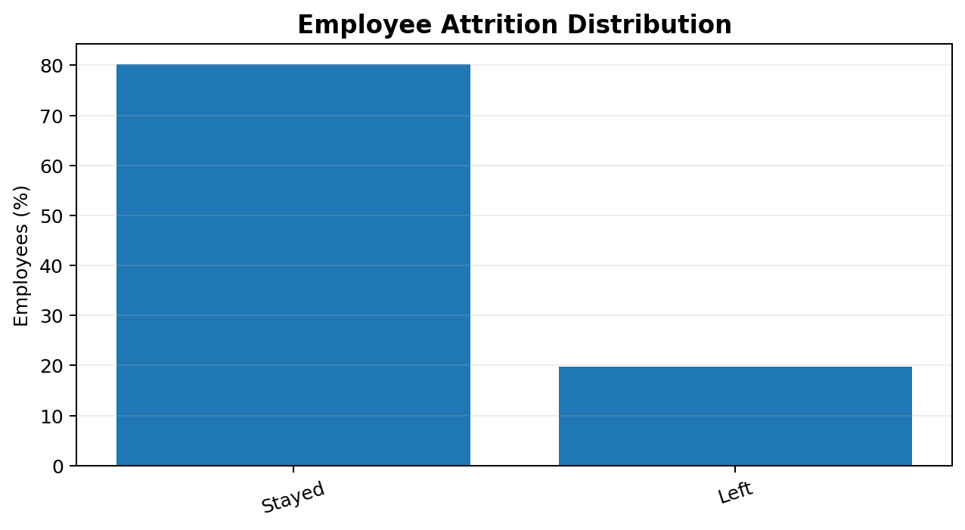
Figure 1. Overall distribution of employees who stayed and left.
The target classes are imbalanced: the no-attrition group represents 80.2% of records. This is why accuracy alone is not sufficient to judge model performance; precision, recall, F1-score and ROC-AUC are also considered.

4. Data Preparation and Cleaning
The notebook checks dataset information, column names, data types, descriptive statistics, missing values and duplicates. The saved outputs show zero missing values before and after treatment, zero duplicate rows and zero duplicate Employee_ID values. The cleaned dataset retains 1,500 rows and 26 columns after duplicate handling.
The workflow also trims whitespace from text fields and includes checks for basic value validity. The notebook does not report removing records as outliers; unusual values should be investigated using domain context rather than automatically deleted.
Quality check | Result
Missing values before treatment | 0
Missing values after treatment | 0
Duplicate rows | 0
Duplicate Employee_ID values | 0
Rows after duplicate handling | 1,500

5. Exploratory and Diagnostic Analysis
EDA examines the distribution of the target and selected demographic, role and workplace variables. Diagnostic analysis compares the observed attrition rates between groups. These comparisons describe patterns in this dataset and do not establish that a feature causes employees to leave.
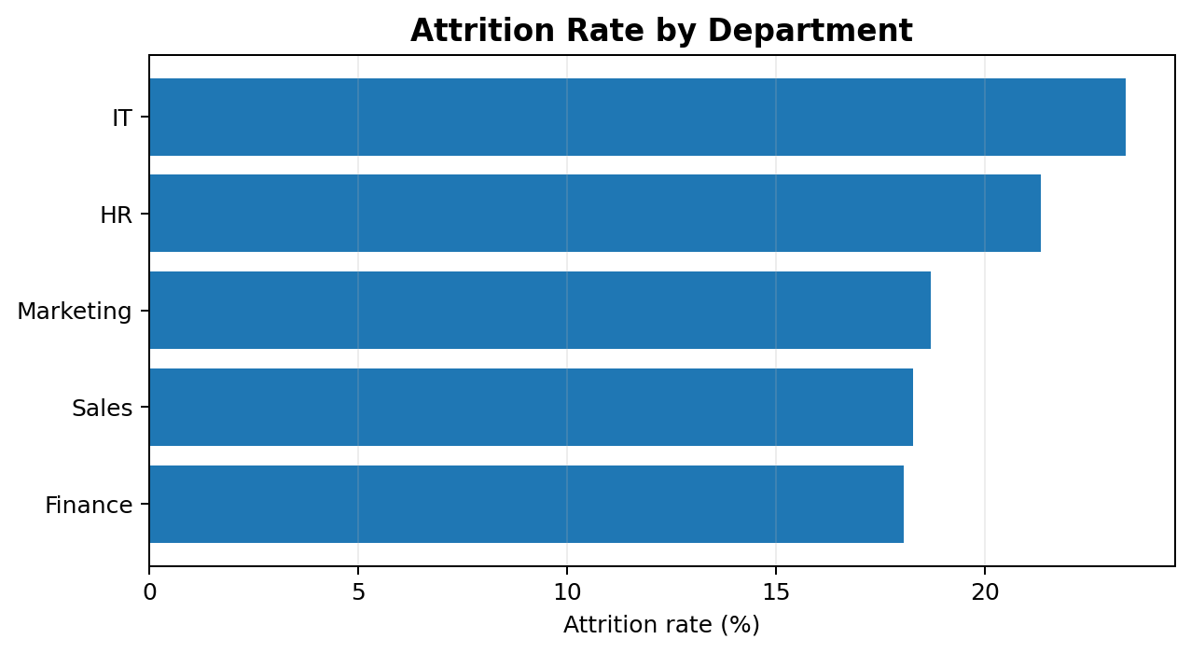
Figure 2. Department-wise attrition rates.
Department | Employees | Employees left | Attrition rate
IT | 261 | 61 | 23.37%
HR | 300 | 64 | 21.33%
Marketing | 289 | 54 | 18.69%
Sales | 312 | 57 | 18.27%
Finance | 338 | 61 | 18.05%
IT has the highest observed department attrition rate (23.37%), followed by HR (21.33%). Finance has the lowest rate among the listed departments (18.05%).
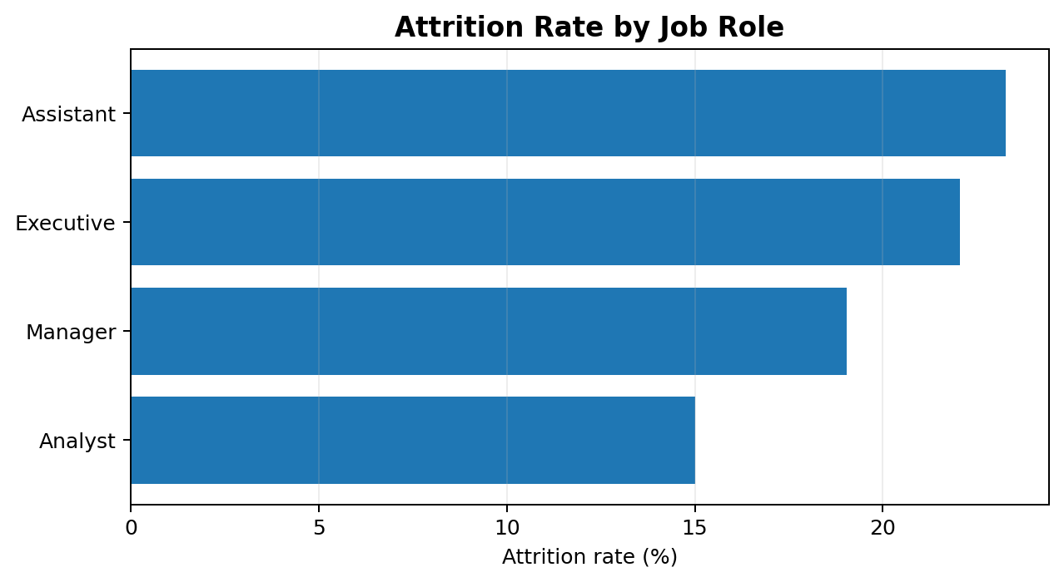
Figure 3. Job-role-wise attrition rates.
Job role | Employees | Employees left | Attrition rate
Assistant | 344 | 80 | 23.26%
Executive | 381 | 84 | 22.05%
Manager | 415 | 79 | 19.04%
Analyst | 360 | 54 | 15.00%
Assistant and Executive roles have the highest observed attrition rates in the role comparison. Analyst roles have the lowest rate.
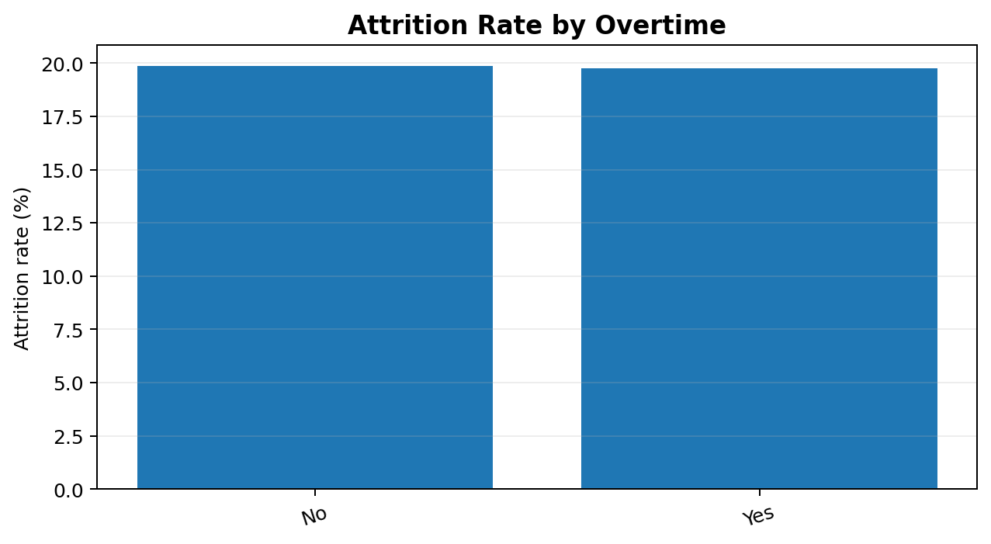
Figure 4. Attrition rates by overtime status.
The overtime groups have nearly identical attrition rates: 19.85% for employees recorded as not working overtime and 19.75% for employees recorded as working overtime. In this dataset, overtime status alone does not separate the two groups meaningfully.
The notebook's group summaries show median/mean patterns including average weekly hours (median 46 for attrition = Yes and 44 for No) and absenteeism (median 10 for Yes and 9 for No). These small differences should be interpreted alongside the statistical validation results.

6. Statistical Validation
The notebook applies chi-square tests to selected categorical features and Mann–Whitney U tests to selected numerical features. Benjamini–Hochberg adjusted p-values are used to account for multiple comparisons. Cramér's V is included as an effect-size measure for categorical comparisons.
Although some unadjusted p-values are below 0.05 (for example, Job Role in the chi-square analysis and Average Hours Worked Per Week and Absenteeism in the Mann–Whitney analysis), their adjusted p-values are above 0.05. None of the reported adjusted p-values is below the 0.05 threshold. Therefore, the notebook does not provide statistically significant evidence after multiple-testing adjustment for the tested features.

Tested feature | Adjusted p-value
Job Role | 0.1353
Gender | 0.1831
Marital Status | 0.3875
Department | 0.5279
Overtime | 1.0000
Numerical feature | Adjusted p-value
Average Hours Worked/Week | 0.1124
Absenteeism | 0.1124
Years Since Last Promotion | 0.1542
Years at Company | 0.1542
Distance From Home | 0.1542
Job Satisfaction | 0.3498
Age | 0.7054
Years in Current Role | 0.7054
Work-Life Balance | 0.7054
Monthly Income | 0.9905
Statistical tests assess association or distributional differences; they do not prove causation. The results should be read as exploratory evidence within this dataset.

7. Feature Preparation and Modelling
The target variable Attrition is encoded as 0 for No and 1 for Yes. Employee_ID is excluded from the model inputs because it is an identifier rather than a meaningful employee attribute. The notebook uses 24 predictor features.
The data is divided into training and testing subsets using an 80:20 stratified split with random_state=42. This produces 1,200 training records and 300 test records. Numerical variables are imputed using the median and standardised. Categorical variables are imputed using the most frequent category and one-hot encoded. Preprocessing is placed inside a scikit-learn pipeline so it is fitted within the training folds during cross-validation.

Models compared
Model | Accuracy | Precision | Recall | F1-score | ROC-AUC
Baseline | 0.802 | 0.000 | 0.000 | 0.000 | 0.500
Logistic Regression | 0.558 | 0.222 | 0.491 | 0.306 | 0.552
Decision Tree | 0.685 | 0.335 | 0.592 | 0.427 | 0.682
Random Forest | 0.893 | 1.000 | 0.458 | 0.627 | 0.790
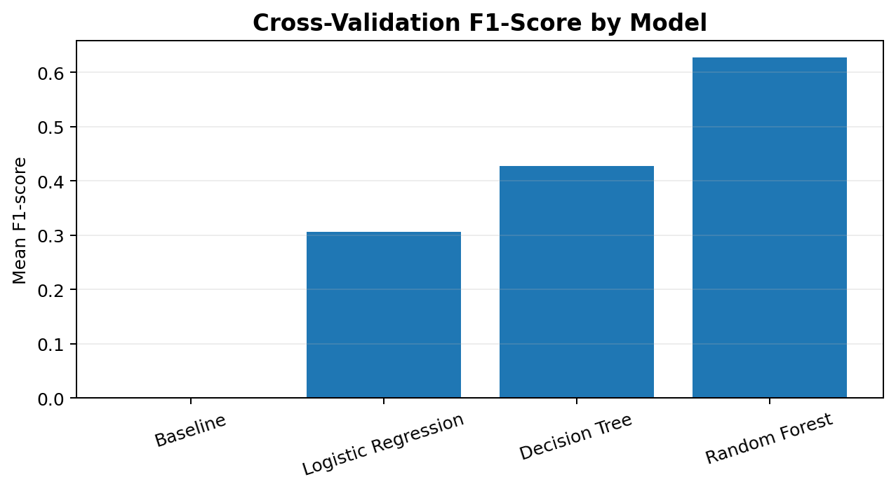
Figure 5. Cross-validation model comparison using F1-score.
The Random Forest model achieved the highest F1-score in the notebook's model comparison (0.627), followed by Decision Tree (0.427), Logistic Regression (0.306) and the baseline (0.000). The baseline accuracy of 0.802 reflects the majority class and demonstrates why accuracy alone can be misleading for an imbalanced target.

8. Model Evaluation
Random Forest was selected and evaluated on the 300-record held-out test set. The test-set results are shown below. The F1-score differs slightly from the cross-validation mean because the two values come from different evaluation procedures.
Metric | Held-out test result
Accuracy | 0.890 (89.0%)
Precision | 1.000 (100.0%)
Recall | 0.441 (44.1%)
F1-score | 0.612 (61.2%)
ROC-AUC | 0.799 (79.9%)
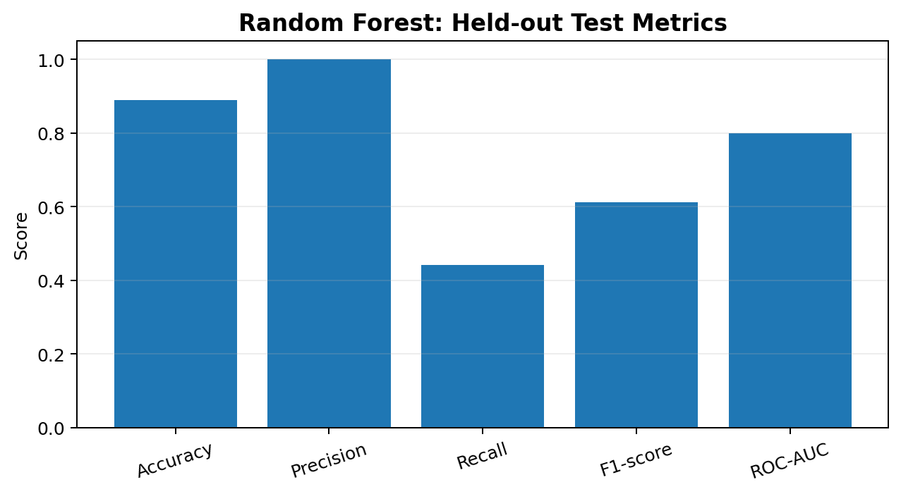
Figure 6. Random Forest performance on the held-out test set.
Actual class | Predicted class | Count
No Attrition | No Attrition | 241
No Attrition | Attrition | 0
Attrition | No Attrition | 33
Attrition | Attrition | 26
The classification report shows 241 no-attrition records and 59 attrition records in the test set. The model correctly identifies 26 of the 59 attrition cases and misses 33. It produces no false-positive attrition predictions in this particular test set. Thus, the model is conservative when predicting attrition: its positive predictions are precise, but its recall is limited.

9. Model Interpretability
Permutation importance estimates how much the model's ROC-AUC score changes when one input feature is shuffled. It provides a model-specific indication of which features the fitted model relies on; it is not a causal explanation.
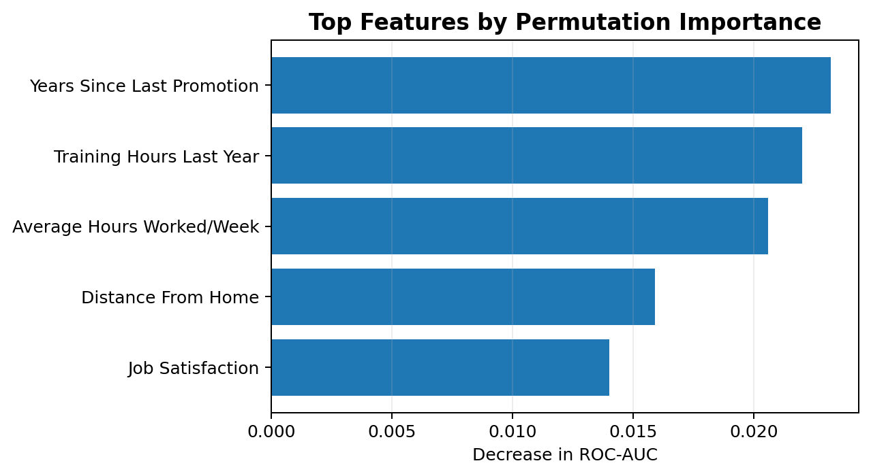
Figure 7. Five leading features by permutation importance.
The highest listed importance values are Years Since Last Promotion (0.0232), Training Hours Last Year (0.0220), Average Hours Worked Per Week (0.0206), Distance From Home (0.0159) and Job Satisfaction (0.0140). These are modest changes in ROC-AUC and should not be interpreted as strong standalone predictors.

10. Business Recommendations
- Review employee experience in IT and HR departments, where the observed attrition rates are relatively higher; conduct team-level discussions before assuming a cause.
- Explore role-specific feedback for Assistant and Executive positions, which show higher observed attrition rates than Analyst roles.
- Review career progression and promotion pathways, as Years Since Last Promotion appears among the leading permutation-importance features.
- Evaluate whether training opportunities are accessible and relevant across roles, given the importance ranking of Training Hours Last Year.
- Use working-hours, absenteeism and satisfaction measures as prompts for supportive conversations, not as grounds for individual employment decisions.
- Monitor the model's recall and test alternative decision thresholds or class-sensitive approaches if the business priority is to identify more potential attrition cases.
Recommendations are hypotheses for HR teams to investigate. The notebook's adjusted statistical tests do not establish significant associations after correction, and the model should not be used to make automated decisions about employees.

11. Limitations and Future Scope
- The dataset contains no date or timestamp field, so temporal validation and time-based attrition forecasting could not be performed.
- The dataset is limited to 1,500 records; performance may change on a larger or different workforce sample.
- The target is imbalanced, and the selected model's test recall is 44.1%, meaning many attrition cases are missed.
- The notebook uses a single stratified train-test split for final testing; additional external validation would provide stronger evidence of generalisation.
- Permutation importance and group-level rates describe patterns, not causes; unmeasured factors may influence attrition.
- Future work could include threshold tuning on validation data, calibrated probabilities, class-weighted models, additional validation samples and fairness checks across employee groups.

12. Conclusion
The project completed an end-to-end employee attrition analysis and developed a Random Forest classification pipeline. The dataset contained 1,500 records, with an overall attrition rate of 19.8%. The model achieved 89.0% test accuracy and 0.799 ROC-AUC, but its 44.1% recall indicates that it missed a substantial share of employees who left. Department, job-role and feature-importance analyses provide areas for further investigation, while adjusted statistical tests caution against treating observed group differences as confirmed relationships. The project demonstrates how data analysis and machine learning can support, but should not replace, informed HR judgement.

13. Tools and References
- Python 3
- Jupyter Notebook
- Pandas and NumPy
- Matplotlib and Seaborn
- SciPy
- Scikit-learn
- Joblib
Primary project source: Employee_Attrition_Prediction.ipynb and the employee_attrition_analysis_dataset.csv file used by the notebook. All numerical findings in this report are transcribed from the saved notebook outputs.

