
Autonomous Zero-Day Attack Detection Framework for Satellite Constellations Using Explainable Federated Learning
Submitted by
Aliya Zuha (2548404)
Divyang Patel (2548420)
Shantanu Chowdhury (2548424)

Under the guidance of
Dr. Divyashree D
Department of Computer Science
CHRIST (Deemed to be University)
Bangalore Yeshwanthpur Campus
A Project report submitted in partial fulfilment of the requirements for the award of degree of Master of Science (Data Science) of CHRIST (Deemed to be University)
AUGUST - 2026


CERTIFICATE
It is certified that this project report entitled Autonomous Zero-Day Attack Detection Framework for Satellite Constellations Using Explainable Federated Learning has been submitted to CHRIST (Deemed to be University), Bangalore, as project work, as partial fulfilment of the requirement for the award of the degree of MASTER OF SCIENCE (Data Science). This work has been completed by Aliya Zuha (2548404) under my supervision and they have put in the required attendance.
Head of the Department Project Guide
Valued-by:
1.Name: Aliya Zuha
2. Register Number: 2548404
Examination Centre: CHRIST (Deemed to be University)
3. Date of Exam: August 2026


CERTIFICATE
It is certified that this project report entitled Autonomous Zero-Day Attack Detection Framework for Satellite Constellations Using Explainable Federated Learning has been submitted to CHRIST (Deemed to be University), Bangalore, as project work, as partial fulfilment of the requirement for the award of the degree of MASTER OF SCIENCE (Data Science). This work has been completed by Divyang Patel (2548420) under my supervision and they have put in the required attendance.
Head of the Department Project Guide
Valued-by:
1.Name: Divyang Patel
2. Register Number: 2548420
Examination Centre: CHRIST (Deemed to be University)
3. Date of Exam: August 2026


CERTIFICATE
It is certified that this project report entitled Autonomous Zero-Day Attack Detection Framework for Satellite Constellations Using Explainable Federated Learning has been submitted to CHRIST (Deemed to be University), Bangalore, as project work, as partial fulfilment of the requirement for the award of the degree of MASTER OF SCIENCE (Data Science). This work has been completed by Shantanu Chowdhury (2548424) under my supervision and they have put in the required attendance.
Head of the Department Project Guide
Valued-by:
1.Name: Shantanu Chowdhury
2. Register Number: 2548424
Examination Centre: CHRIST (Deemed to be University)
3. Date of Exam: August 2026


DECLARATION
I hereby certify that the work presented in this project report is my own genuine work and has been carried out by me under the supervision of Dr. Divyashree D, Department of Data Science, CHRIST (Deemed to be University). The work embodied in this project report has not been submitted for a degree or diploma in any other University.
Date: 25 August 2026 Aliya Zuha (2548404)
Place: Bangalore


DECLARATION
I hereby certify that the work presented in this project report is my own genuine work and has been carried out by me under the supervision of Dr. Divyashree D, Department of Data Science, CHRIST (Deemed to be University). The work embodied in this project report has not been submitted for a degree or diploma in any other University.
Date: 25 August 2026 Divyang Patel (2548420)
Place: Bangalore


DECLARATION
I hereby certify that the work presented in this project report is my own genuine work and has been carried out by me under the supervision of Dr. Divyashree D, Department of Data Science, CHRIST (Deemed to be University). The work embodied in this project report has not been submitted for a degree or diploma in any other University.
Date: 25 August 2026 Shantanu Chowdhury (2548424)
Place: Bangalore

ACKNOWLEDGEMENT
I would like to express my sincere gratitude to all those who have contributed to the successful completion of my Specialization Project. Their support and guidance have been invaluable, and I am deeply thankful for their assistance throughout this journey.
First and foremost, I would like to extend my heartfelt thanks to Dr. Fr Joseph C C, Vice-Chancellor, Dr. Fr. Benny Thomas, Campus Director, Dr. Fr. Biju K C, Campus Associate Director, Dr. Joby Thomas, Dean, Dr. Raghunanthan G, Associate Dean, CHRIST (Deemed to be University) Yeshwanthpur Campus for letting us carry our specialization project of M.Sc Data Science in our Campus.
I would like to extend my heartfelt thanks to Dr. Vinay M, HOD of the Computer Science Department of CHRIST (Deemed to be University), Bangalore Yeshwanthpur Campus, for fostering a conducive learning environment that has been instrumental in shaping my academic experience.
I am also immensely grateful to my project guide, Dr. Divyashree D for her/his expertise, mentorship, and unwavering support throughout this project. Your patience and dedication to my growth as a data scientist have been instrumental in the successful completion of this project.
I would like to thank all the faculty members of the Department of Computer Science for their help to complete the project work successfully. Also, I would like to thank my fellow students and colleagues for their camaraderie, which made this academic journey both enjoyable and enriching. Last but not least, I want to express my gratitude to my family and friends for their unwavering support, understanding, and encouragement throughout this challenging but rewarding journey. Your belief in me has been a constant source of motivation.
In conclusion, this project would not have been possible without the guidance and support of the individuals mentioned above and the collective effort of everyone who played a part in my academic pursuit. Thank you all for your contributions, and I am deeply appreciative of your help.
Aliya Zuha, Divyang Patel, Shantanu Chowdhury
(2548404, 2548420, 2548424)

ABSTRACT
Satellite constellations are central to modern communication, navigation, earth observation, and defense infrastructure, and their growing scale makes them an increasingly attractive target for cyberattacks, particularly zero-day attacks that evade traditional signature-based intrusion detection. Existing satellite security solutions rely on centralized monitoring, which introduces privacy risk, single points of failure, and high communication overhead, while offering little transparency into why a given event is flagged as malicious. This project implements an autonomous cybersecurity framework that combines Federated Learning, unsupervised anomaly detection, and Explainable Artificial Intelligence (XAI) to detect previously unseen attacks in satellite networks while preserving data locality. An autoencoder-based anomaly detector was trained exclusively on benign network traffic from the UNSW-NB15 benchmark dataset and evaluated using accuracy, precision, recall, F1-score, and ROC-AUC, reaching 82.4% accuracy and an F1-score of 0.825 on the full test set. A dedicated zero-day simulation, in which the rare Worms attack category was withheld from model development entirely, shows the detector generalizes well to previously seen attack families (75.5% detection) but considerably less well to a genuinely novel attack family (31.8% detection). This centralized model was then reproduced under a Federated Averaging (FedAvg) simulation across five independent satellite-node clients, and explained using SHAP and LIME to attribute individual reconstruction-error predictions to specific network-traffic features. Model outputs were converted into a 0–100 threat score with Low/Medium/High/Critical severity banding, and surfaced through a seven-page Streamlit monitoring dashboard. The federated global model trades some accuracy for its privacy-preserving design (63.2% accuracy versus 82.4% centralized), a realistic and instructive gap that is analysed in detail alongside the rest of the system's results.

TABLE OF CONTENTS

Right-click the table above and choose “Update Field” in Word (or Ctrl+A then F9) once the document is finalized, so that chapter/section page numbers are filled in.

LIST OF TABLES
Table No. | Table Name | Page No.
2.1 | Functional requirements | —
2.2 | Non-functional requirements summary | —
2.3 | Software requirements | —
2.4 | Hardware requirements | —
2.5 | Pilot dataset summary | —
3.1 | Major components and interactions | —
3.2 | Module design | —
3.3 | Data dictionary | —
3.4 | Main use cases | —
3.5 | Tools and technologies | —
3.6 | Key dashboard screens | —
3.7 | Threat score design | —
4.1 | Dataset summary | —
4.2 | Attack category distribution (train / test / combined) | —
4.3 | Preprocessing pipeline result | —
4.4 | Autoencoder architecture | —
4.5 | Categorical feature summary (training set) | —
4.6 | Federated learning configuration | —
4.7 | Threat scoring formula (as implemented) | —
4.8 | Threat score severity bands (as implemented) | —
4.9 | Dashboard pages implemented | —
5.1 | Autoencoder evaluation metrics | —
5.2 | Autoencoder confusion matrix | —
5.3 | Zero-day experiment metrics | —
5.4 | Zero-day group comparison | —
5.5 | Federated learning round-by-round metrics | —
5.6 | Federated global model versus centralized baseline | —
5.7 | SHAP/LIME explanation examples and their model outcomes | —
5.8 | Threat scoring summary metrics | —
A.1 | Division of labour among team members | —
B.1 | Project repository structure and implementation status | —
C.1 | Descriptive statistics of numerical features (training set) | —
D.1 | Sample records from the UNSW-NB15 training set | —
F.1 | Python package dependencies (requirements.txt) | —
F.2 | Notebook execution environment | —
F.3 | Project development-stage roadmap and current status | —
G.1 | Glossary of key terms used in this report | —

LIST OF FIGURES
Fig. No. | Figure Name | Page No.
3.1 | Overall system architecture | —
3.2 | Data flow diagram (Level 0) | —
3.3 | Use case diagram | —
3.4 | End-to-end system workflow | —
3.5 | Proposed monitoring dashboard wireframe | —
4.1 | Training set label and attack-category distribution | —
4.2 | Top categories for protocol, service, connection state, and attack category | —
4.3 | Correlation matrix of numerical features (training set) | —
4.4 | Label and attack-category counts compared across training and testing splits | —
4.5 | Autoencoder training vs. validation loss across epochs | —
4.6 | Distribution and Normal-vs-Attack comparison of key numeric features | —
5.1 | Reconstruction-error distribution with detection threshold (autoencoder evaluation) | —
5.2 | Confusion matrix, autoencoder on the full test set | —
5.3 | ROC curve (autoencoder) | —
5.4 | Reconstruction error by evaluation group (zero-day experiment) | —
5.5 | Detection rate by evaluation group (zero-day experiment) | —
5.6 | Confusion matrix, zero-day evaluation run | —
5.7 | Federated learning round metrics: reconstruction loss and detection performance | —
5.8 | Global SHAP importance for reconstruction loss (federated model) | —
5.9 | Local SHAP explanation: known attack example (test row 243) | —
5.10 | Local SHAP explanation: unseen zero-day example (test row 387, Worms) | —
5.11 | Severity distribution and threat-score histogram | —
5.12 | Threat score versus reconstruction error, coloured by predicted anomaly | —

LIST OF ABBREVIATIONS
Abbreviation | Expansion
XAI | Explainable Artificial Intelligence
FL | Federated Learning
SHAP | SHapley Additive exPlanations
LIME | Local Interpretable Model-agnostic Explanations
IDS | Intrusion Detection System
DFD | Data Flow Diagram
MSE | Mean Squared Error
ROC-AUC | Receiver Operating Characteristic – Area Under Curve
FR | Functional Requirement
SRS | Software Requirement Specification
SDD | System Design and Document
UNSW-NB15 | University of New South Wales – Network Benchmark 2015 (dataset)
CICIDS2017 | Canadian Institute for Cybersecurity Intrusion Detection Evaluation Dataset 2017

CHAPTER 1: INTRODUCTION

1.1 PROBLEM DESCRIPTION
Satellite constellations play a vital role in communication, navigation, weather monitoring, earth observation, and defense. As satellite networks expand in scale and interconnect more closely with terrestrial systems, they become increasingly vulnerable to cyber threats. Chief among these are zero-day attacks: attacks that exploit previously unknown vulnerabilities or exhibit behaviour that has never been observed before, and which therefore cannot be detected by traditional signature-based intrusion detection systems that rely on a database of known attack patterns.
Existing satellite cybersecurity solutions overwhelmingly depend on centralized monitoring architectures, in which telemetry and network traffic from every node is transmitted to a central server for analysis. This approach raises three related problems. First, it creates privacy and confidentiality concerns, since raw operational data must leave the satellite node. Second, it introduces high communication overhead, which is especially costly in a satellite environment where bandwidth and power are constrained resources. Third, it creates a single point of failure: if the central monitoring server is compromised, degraded, or unreachable, the entire constellation's security visibility is lost.
Current systems also struggle to detect zero-day attacks specifically, because signature-based and purely supervised approaches can only recognize what they have already been trained to recognize. Additionally, most existing AI-based detection systems function as black boxes, offering little to no explanation for why a particular event was classified as malicious, which limits an analyst's ability to trust, verify, or act on an automated decision. A distributed, explainable attack-detection framework is therefore needed to improve cybersecurity resilience in satellite constellations without the drawbacks of centralized monitoring.

1.2 EXISTING SYSTEM
Current satellite cybersecurity systems primarily rely on centralized intrusion detection mechanisms and signature-based detection techniques. These systems monitor telemetry and communication data at a central server to identify known cyber threats. While effective against previously identified attacks, they struggle to detect new or evolving threats such as zero-day attacks. In addition, centralized processing increases communication overhead and creates potential privacy concerns due to continuous transmission of raw satellite data.
The limitations of the existing system, as identified during requirements analysis, are summarized below:
- Unable to effectively detect unknown (zero-day) attacks.
- High communication bandwidth consumption due to centralized data collection.
- Single point of failure inherent to a centralized architecture.
- Limited scalability for large satellite constellations.
- AI predictions lack transparency and interpretability, reducing analyst trust.
- Delayed threat identification and response due to centralized bottlenecks.

1.3 PROJECT SCOPE
The project focuses on detecting cyberattacks in satellite communication networks using machine learning and Federated Learning techniques. It utilizes publicly available cybersecurity datasets (UNSW-NB15 and, in later stages, CICIDS2017) together with simulated satellite communication data, since direct access to real satellite telemetry is not available for an academic project of this scope. The system is implemented as a web-based prototype for monitoring and analysis. Real-time deployment on actual orbiting satellites and hardware-level physical security attacks are explicitly outside the scope of this project; the focus is on the data-driven detection, explanation, and presentation layers of the framework.

1.4 OBJECTIVES
- To develop a Federated Learning-based framework for distributed attack detection across simulated satellite nodes.
- To identify zero-day attacks using anomaly detection techniques that do not require prior knowledge of attack signatures.
- To integrate Explainable AI (XAI) methods for transparent, analyst-verifiable decision-making.
- To reduce communication overhead by enabling decentralized learning, in which only model parameters, never raw data, are exchanged.
- To improve overall cybersecurity resilience in satellite constellation networks through an integrated detection, scoring, and monitoring pipeline.

1.5 NEED AND MOTIVATION
Modern satellite systems require intelligent and privacy-preserving security mechanisms capable of detecting previously unseen attacks. Traditional approaches are ineffective against evolving cyber threats and often require large-scale centralized data collection, which is both a bandwidth burden and a privacy liability for operationally sensitive telemetry. With the rapid growth of satellite communication networks, cyberattacks targeting space infrastructure are becoming more sophisticated, and the cost of a successful attack, ranging from service disruption to loss of control over a spacecraft, is severe. This project addresses these challenges through decentralized learning and explainable threat detection, aiming to close the gap between what current systems can detect and what a resilient satellite constellation actually needs.

1.6 BENEFICIARIES
The framework, if adopted, would primarily benefit the following stakeholder groups:
- Space agencies (ISRO, NASA, ESA)
- Satellite communication providers and operators
- Defense and national security organizations
- Aerospace industries
- Cybersecurity researchers
- Academic and research institutions

1.7 OVERVIEW OF KEY CONCEPTS AND TECHNIQUES
This section summarizes, at a conceptual level, the four techniques that together form the backbone of the proposed framework: Federated Learning, autoencoder-based anomaly detection, Explainable AI, and the specific challenge of zero-day attack detection. Understanding these concepts is a prerequisite for the system design decisions made in Chapter 3 and the implementation choices made in Chapter 4.

Federated Learning
Federated Learning is a distributed machine-learning paradigm in which multiple participants, in this case simulated satellite nodes, collaboratively train a shared global model without ever exchanging their raw local data. Each participant trains a copy of the model on its own local dataset for a number of local steps, and then sends only the resulting model parameters (weights or gradients) to a central coordinating server. The server aggregates the updates it receives from all participants, typically through simple parameter averaging, to produce an improved global model, which is then redistributed to every participant for the next round. This process repeats over multiple communication rounds until the global model converges. Because raw telemetry, network traffic, and command logs never leave the satellite node, Federated Learning directly addresses the privacy and bandwidth concerns identified in Section 1.2, while still allowing every node to benefit from patterns observed across the entire constellation.

Autoencoder-Based Anomaly Detection
An autoencoder is a type of neural network trained to reconstruct its own input. It consists of an encoder, which compresses the input into a smaller latent representation, and a decoder, which attempts to reconstruct the original input from that compressed representation. When an autoencoder is trained exclusively on normal (benign) data, as is done in this project, it becomes specialized at reconstructing normal patterns with low error. When it is later presented with data that differs meaningfully from what it learned, such as attack traffic, its reconstruction error tends to be noticeably higher, because the compressed representation it learned does not capture the statistical structure of the unfamiliar input. By calibrating a reconstruction-error threshold on held-out normal data, and flagging any new sample whose error exceeds that threshold as anomalous, an autoencoder can function as an unsupervised anomaly detector that requires no attack labels at all. This property is what makes it a natural candidate for zero-day detection: it does not need to have seen a specific attack before to flag it as abnormal, it only needs the attack to look sufficiently different from normal behaviour.

Explainable Artificial Intelligence (XAI)
A limitation of most machine-learning-based detectors, including the autoencoder described above, is that a raw anomaly score or reconstruction-error value gives a security analyst very little insight into why a particular event was flagged. Explainable AI techniques address this by attributing a model's output back to its input features. SHAP (SHapley Additive exPlanations) draws on cooperative game theory to compute, for each prediction, how much each input feature contributed to pushing the model's output away from its baseline (average) value, producing both per-prediction explanations and consistent global feature-importance rankings. LIME (Local Interpretable Model-agnostic Explanations) takes a complementary approach, approximating the model's behaviour in the local neighbourhood of a single prediction with a simpler, interpretable surrogate model (typically linear), so an analyst can see which features drove that specific decision. Applying either technique to the anomaly detector's output is the planned mechanism (Chapter 6, Future Enhancements) by which a flagged event will be turned into an explanation an analyst can actually act on, rather than an opaque number.

Zero-Day Attacks and the Detection Challenge
A zero-day attack exploits a vulnerability or exhibits a behavioural pattern that is unknown to the defender at the time of the attack, meaning no signature exists for it in a traditional intrusion detection system. This is precisely why anomaly-based approaches, rather than signature-based ones, are necessary for meaningful zero-day defense: an anomaly detector does not need a signature, only a working definition of what “normal” looks like. However, as the results in Chapter 5 show empirically, this theoretical advantage does not automatically translate into strong detection of every kind of novel attack. An attack family whose network-level footprint happens to resemble other attacks the detector has implicitly learned to distinguish from normal traffic is easier to catch than one whose footprint is subtly different from both normal traffic and known attacks. This is the core reason the zero-day simulation methodology in Section 5.1 deliberately withholds an entire attack category rather than relying on the aggregate accuracy figure alone.

CHAPTER 2: SYSTEM ANALYSIS

2.1 FUNCTIONAL SPECIFICATIONS
The functional requirements define the specific capabilities the system must provide. These were derived from the project's Software Requirement Specification (SRS) and are summarized in Table 2.1.
Table 2.1. Functional requirements.
ID | Requirement
FR1 | Collect telemetry, communication logs, and network traffic from distributed satellite nodes.
FR2 | Perform data preprocessing including cleaning, missing-value handling, encoding, normalization, and feature extraction.
FR3 | Train local machine learning models at each satellite node and securely share only model parameters/updates with a central server using Federated Learning.
FR4 | Detect anomalous behaviour and identify potential zero-day attacks using anomaly detection algorithms, without relying on attack signatures.
FR5 | Display attack alerts, threat scores, Explainable AI (SHAP/LIME) results, and system monitoring information through a web-based dashboard.

2.2 NON-FUNCTIONAL REQUIREMENTS
Beyond core functionality, the system is also expected to satisfy the following quality attributes, grouped by category in Table 2.2.
Table 2.2. Non-functional requirements summary.
Category | Requirement
Performance | Detect anomalies with low latency; support multiple satellite nodes simultaneously; minimize communication overhead during model aggregation.
Security | Share only encrypted model parameters; preserve privacy by avoiding raw data transmission; secure communication between satellite nodes and the federated server.
Reliability | Ensure continuous monitoring even if individual satellite nodes become unavailable; provide consistent detection performance during federated training.
Usability | User-friendly web dashboard; simple visualization of alerts, threat scores, and explanations; easy navigation for security analysts.

2.3 BLOCK DIAGRAM
At the block level, the system is organized as a chain of satellite-side data collection and local training, a central federated aggregation point, and a detection/explainability/monitoring pipeline that consumes the resulting global model. The complete block-level System Architecture diagram is presented in Chapter 3, Section 3.1 (Fig. 3.1), alongside the description of each architectural component, to avoid duplicating the same figure across two chapters.

2.4 SYSTEM REQUIREMENTS

2.4.1 Software Requirements
Table 2.3. Software requirements.
Component | Technology
Programming Language | Python 3.12+
Frontend | Streamlit
Backend | Flask
Database | SQLite
Machine Learning | Scikit-learn
Deep Learning | TensorFlow / Keras
Federated Learning | Flower
Explainable AI | SHAP, LIME
IDE | Visual Studio Code
Version Control | GitHub

2.4.2 Hardware Requirements
Table 2.4. Hardware requirements.
Component | Specification
Processor | Intel Core i5 / AMD Ryzen 5 or above
RAM | 8 GB (Minimum), 16 GB Recommended
Storage | 256 GB SSD or above
Operating System | Windows 10/11 or Ubuntu 22.04
Internet | Required for package installation and updates

2.5 DATASET REQUIREMENTS

Data Source
- UNSW-NB15 Dataset (primary source, used for the work completed to date)
- CICIDS2017 Dataset (planned, for cross-dataset validation)
- Simulated Satellite Telemetry Data (planned, for satellite-specific scenario testing)

Dataset Description
The datasets contain normal and malicious network traffic records, including multiple cyberattack categories such as DoS, Exploits, Backdoors, Fuzzers, Reconnaissance, Analysis, Shellcode, Generic, and Worms. Simulated telemetry data is planned to represent satellite communication parameters for later experimentation, once the core detection pipeline is validated on standard benchmark data.

Target Variable
For supervised evaluation, the binary target is Normal vs. Attack (the label field). For the anomaly-detection and zero-day components specifically, the model identifies patterns that deviate from normal behaviour without relying on attack labels during training.

Pilot Dataset Summary
Table 2.5. Pilot dataset summary.
Dataset | Records | Purpose
UNSW-NB15 | ~2.5 Million (175,341 train + 82,332 test) | Training & Evaluation
CICIDS2017 | ~2.8 Million | Validation (planned)
Simulated Satellite Data | Custom Generated | Satellite Scenario Testing (planned)

2.6 ANALYTICS REQUIREMENTS

Problem Type
Classification and unsupervised anomaly detection.

Analytical Approach
- Data Preprocessing
- Feature Engineering
- Federated Learning (planned)
- Autoencoder-based Anomaly Detection (implemented)
- Explainable AI — SHAP/LIME (planned)
- Threat Scoring (planned)

Expected Output
- Zero-day attack detection
- Threat severity score
- Explainable AI visualization
- Security alerts
- Dashboard reports

2.7 FEASIBILITY ANALYSIS

Technical Feasibility
The project is technically feasible using open-source machine learning libraries such as TensorFlow, Scikit-learn, Flower, SHAP, and Streamlit. Public cybersecurity datasets are available for model training and evaluation, and satellite communication scenarios can be simulated without requiring access to real satellite infrastructure. The anomaly detection component implemented so far (Chapters 4 and 5) confirms that this pipeline can be built and evaluated entirely on standard consumer hardware within the specified hardware requirements.

Operational Feasibility
The proposed system provides an easy-to-use web interface for monitoring and analysing cyber threats. It is suitable for academic research and demonstration and can, in principle, be extended for deployment in real-world satellite communication environments with additional infrastructure support, secure aggregation protocols, and hardened deployment engineering beyond the scope of this academic project.

Economic Feasibility
All tools and libraries used in this project (Python, TensorFlow, Scikit-learn, Flower, SHAP, LIME, Streamlit, Flask, SQLite) are free and open-source, and model training was performed on standard consumer-grade hardware rather than specialized infrastructure. As an academic prototype, the project therefore carries no licensing cost, and the primary cost driver for a future production deployment would be secure ground-station infrastructure and integration engineering rather than the software stack itself.

2.8 ASSUMPTIONS AND CONSTRAINTS

Assumptions
- Network traffic and telemetry statistics from the UNSW-NB15 benchmark dataset are a reasonable proxy for satellite communication and command traffic, in the absence of access to real satellite telemetry.
- Each simulated satellite node, once Federated Learning is implemented, will have a large enough local sample of normal traffic to train a locally meaningful model before aggregation.
- The ground station / federated server is assumed to be a trusted, non-compromised aggregation point for the purposes of this project; defending the aggregation process itself against a malicious participant (Byzantine-robust aggregation) is treated as an advanced extension rather than a baseline requirement.
- A security analyst, rather than a fully automated response system, remains in the loop to review flagged alerts, consistent with the system's design as a monitoring and decision-support tool.

Constraints
- No access to real satellite telemetry, onboard hardware, or ground-station infrastructure; all evaluation is performed on public benchmark datasets and, in later phases, simulated satellite-style data.
- Hardware constraints limit model size and training scale to what is practical on the consumer-grade hardware specified in Table 2.4, rather than large-scale distributed training infrastructure.
- The academic timeline constrains the project to a phased delivery: the anomaly-detection core (Chapters 4–5) first, followed by federated aggregation, explainability, threat scoring, and the dashboard (Chapter 6).
- Real-time, in-orbit deployment and physical/hardware-level attack vectors are outside the constraints this project is designed to address, as stated in the Scope (Section 1.3).

CHAPTER 3: SYSTEM DESIGN

3.1 SYSTEM ARCHITECTURE
The proposed system is designed as a distributed cybersecurity framework for satellite constellations. Each satellite node performs local data collection, preprocessing, and model training. Instead of transmitting raw data, only model updates are shared with a Federated Learning server located at a ground station or cloud environment. The server aggregates the updates to create a global model and distributes the improved model back to the participating nodes. The global model is then used for anomaly and zero-day attack detection: detected anomalies are assigned a threat score and passed to the Explainable AI layer, where SHAP and LIME provide feature-level explanations. The final alerts, scores, explanations, satellite status, and performance metrics are presented through a web-based monitoring dashboard.
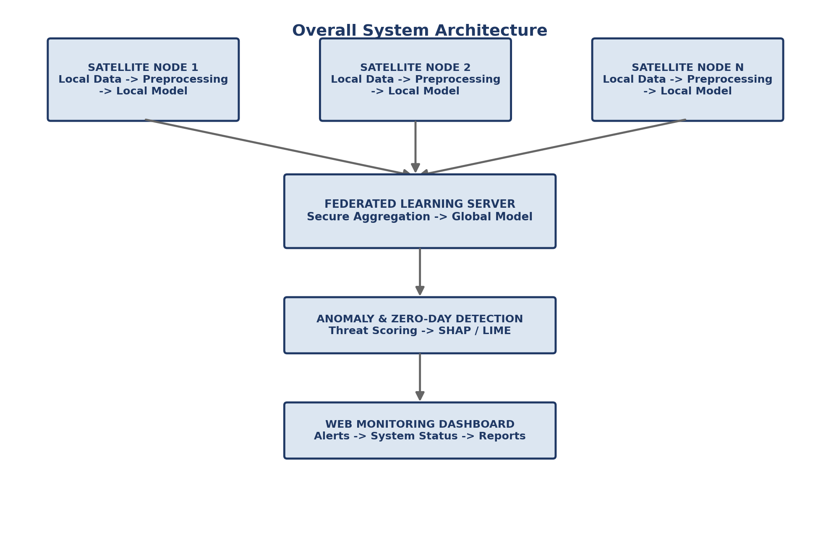
Fig. 3.1. Overall system architecture.
Table 3.1. Major components and interactions.
Component | Description
Satellite Nodes | Collect network traffic, telemetry, system logs, command logs, and resource information locally.
Data Preprocessing | Performs cleaning, missing-value handling, encoding, feature selection/extraction, and normalization.
Local Model Training | Trains the selected anomaly detection/classification model using only local satellite data.
Federated Learning Server | Receives model updates, securely aggregates them, produces the global model, and redistributes it.
Zero-Day Detection | Identifies abnormal or previously unseen patterns. Selected attack categories may be withheld during training for simulated zero-day evaluation.
Threat Scoring | Converts detection results into a severity score from 0–100 and maps the score to Low, Medium, High, or Critical.
Explainable AI | Uses SHAP and LIME to identify the features that contribute to an individual prediction.
Monitoring Dashboard | Displays alerts, trends, threat scores, satellite health, explanations, and model performance.

3.2 MODULE DESIGN
The system is divided into functional modules so that data collection, machine learning, federated aggregation, threat analysis, explainability, and visualization can be developed and tested independently. Table 3.2 lists each module together with its inputs and outputs.
Table 3.2. Module design.
Module | Description | Input | Output
1. Data Collection | Collects local telemetry, network traffic, system logs and command information. | Telemetry, network data, logs | Raw local dataset
2. Data Preprocessing | Cleans and transforms data and prepares machine-learning features. | Raw dataset | Processed features
3. Local Model Training | Trains an anomaly detection/model at each satellite node. | Processed local data | Local model parameters
4. Federated Learning | Aggregates local model parameters without collecting raw data. | Model updates | Global model
5. Anomaly Detection | Analyzes incoming activity and identifies deviations from learned behaviour. | New data + global model | Normal/anomalous result
6. Zero-Day Detection | Evaluates whether an anomalous pattern is previously unseen. | Anomaly result + training knowledge | Potential zero-day flag
7. Threat Scoring | Calculates attack severity on a 0–100 scale. | Detection result | Threat score and severity
8. Explainability | Explains the model decision using SHAP and LIME. | Model + input features | Feature importance / explanation
9. Alert & Response | Generates security alerts and records incidents. | Threat score + detection | Alert, log, response status
10. Dashboard | Presents results and system status to authorized users. | Alerts, metrics, explanations | Interactive dashboard

The modules operate as a pipeline. Local data is first transformed into machine-learning features. Each node trains locally and sends only model parameters to the federated server. The resulting global model supports anomaly detection. When an anomaly is identified, the zero-day detection, threat scoring, and explainability modules process the event before the dashboard presents the final result.

3.3 DATABASE DESIGN

3.3.1 Data Dictionary
Table 3.3 lists the core data elements exchanged and stored across the pipeline, along with their type.
Table 3.3. Data dictionary.
Data Element | Description | Type
Satellite ID | Unique identifier of a satellite node | String
Timestamp | Time at which the event was recorded | Date/Time
Source IP | Source network address | String
Destination IP | Destination network address | String
Packet Count | Number of packets observed | Integer
Flow Duration | Duration of a network flow | Float
Bytes Sent | Number of transmitted bytes | Integer
Bytes Received | Number of received bytes | Integer
Telemetry Value | Operational satellite measurement | Float
Attack Label | Normal or attack category | Categorical
Anomaly Score | Degree of deviation from normal behaviour | Float
Threat Score | Severity score from 0 to 100 | Integer
Explanation | Important features contributing to the prediction | Text

3.3.2 Data Flow Diagram
The Data Flow Diagram (Level 0) in Fig. 3.2 represents the movement of data from distributed satellite nodes through preprocessing and local training, followed by federated aggregation, detection, threat analysis, and dashboard visualization. The design emphasizes that raw satellite data remains at the local node while only model updates are exchanged.
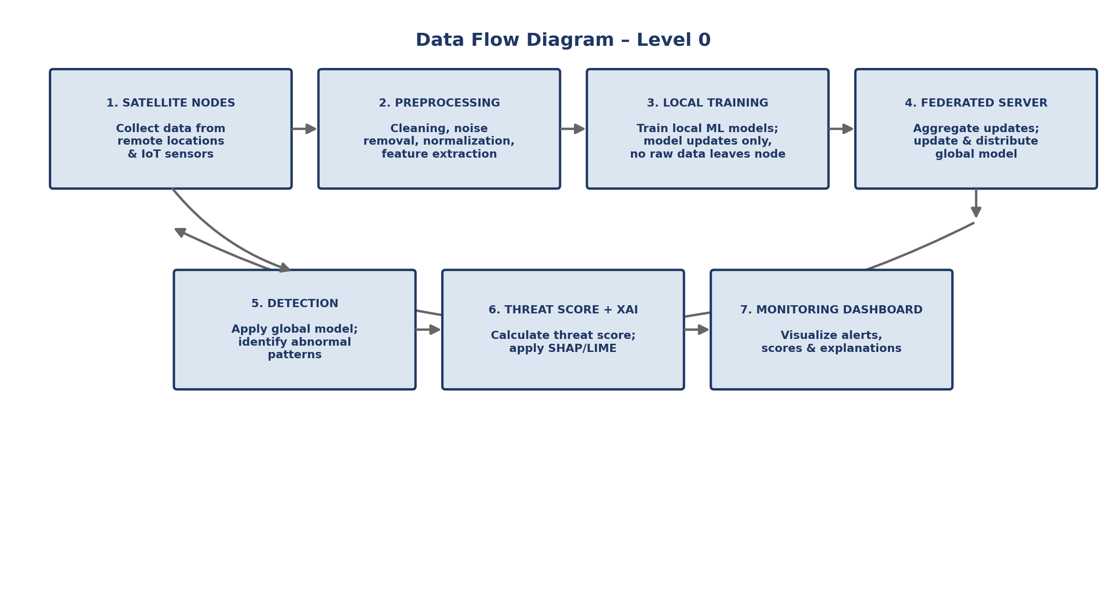
Fig. 3.2. Data flow diagram (Level 0).

3.3.3 Use Case Diagram
The primary user of the system is the authorized security analyst or system administrator. As shown in Fig. 3.3, the user can monitor satellites, view alerts, inspect threat scores, review XAI explanations, and access reports and model-performance metrics.
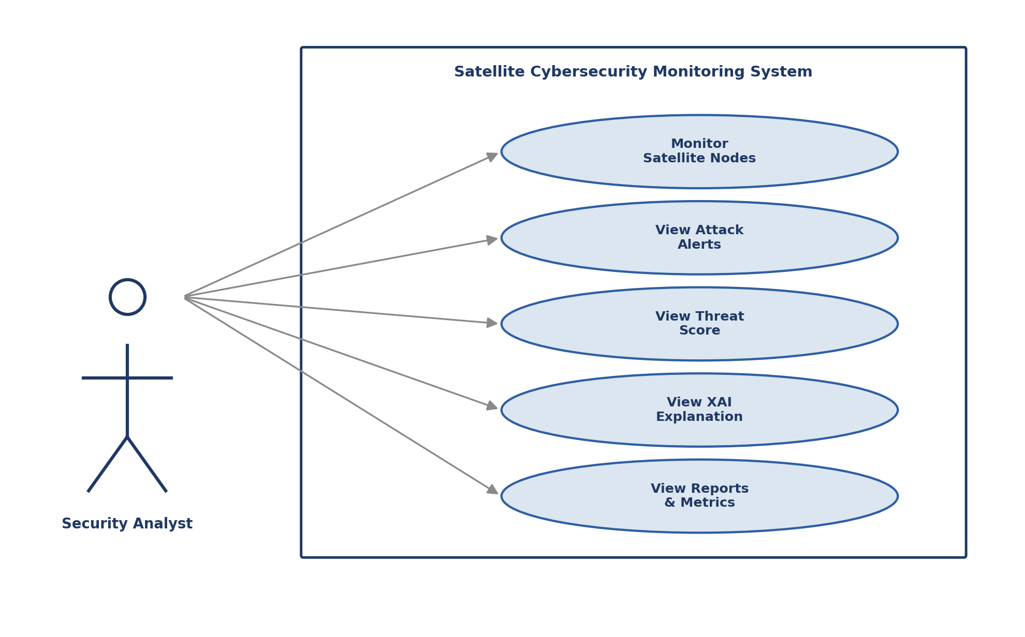
Fig. 3.3. Use case diagram.
Table 3.4. Main use cases.
Use Case | Description
Monitor Satellite Nodes | View connectivity and health information for participating nodes.
View Attack Alerts | Review active and historical security alerts.
View Threat Score | Inspect the severity score and corresponding risk category.
View XAI Explanation | Understand which features contributed to the detection decision.
View Reports and Metrics | Review attack trends, detection performance, and historical results.

3.4 SYSTEM CONFIGURATION
Table 3.5 summarizes the technology stack selected for building and running the prototype system.
Table 3.5. Tools and technologies.
Category | Technology
Programming Language | Python
Frontend | Streamlit
Backend | Flask
Database | SQLite
ML / DL | Scikit-learn, TensorFlow
Federated Learning | Flower
Explainable AI | SHAP, LIME
IDE | VS Code

3.5 INTERFACE DESIGN

3.5.1 User Interface Screen Design
The proposed application will be implemented as a web-based monitoring dashboard. Streamlit is proposed for the prototype because it supports rapid development of interactive data-science interfaces. The interface will focus on clear visualization of threats, satellite status, model performance, and explanations. Fig. 3.5 shows the proposed dashboard wireframe.
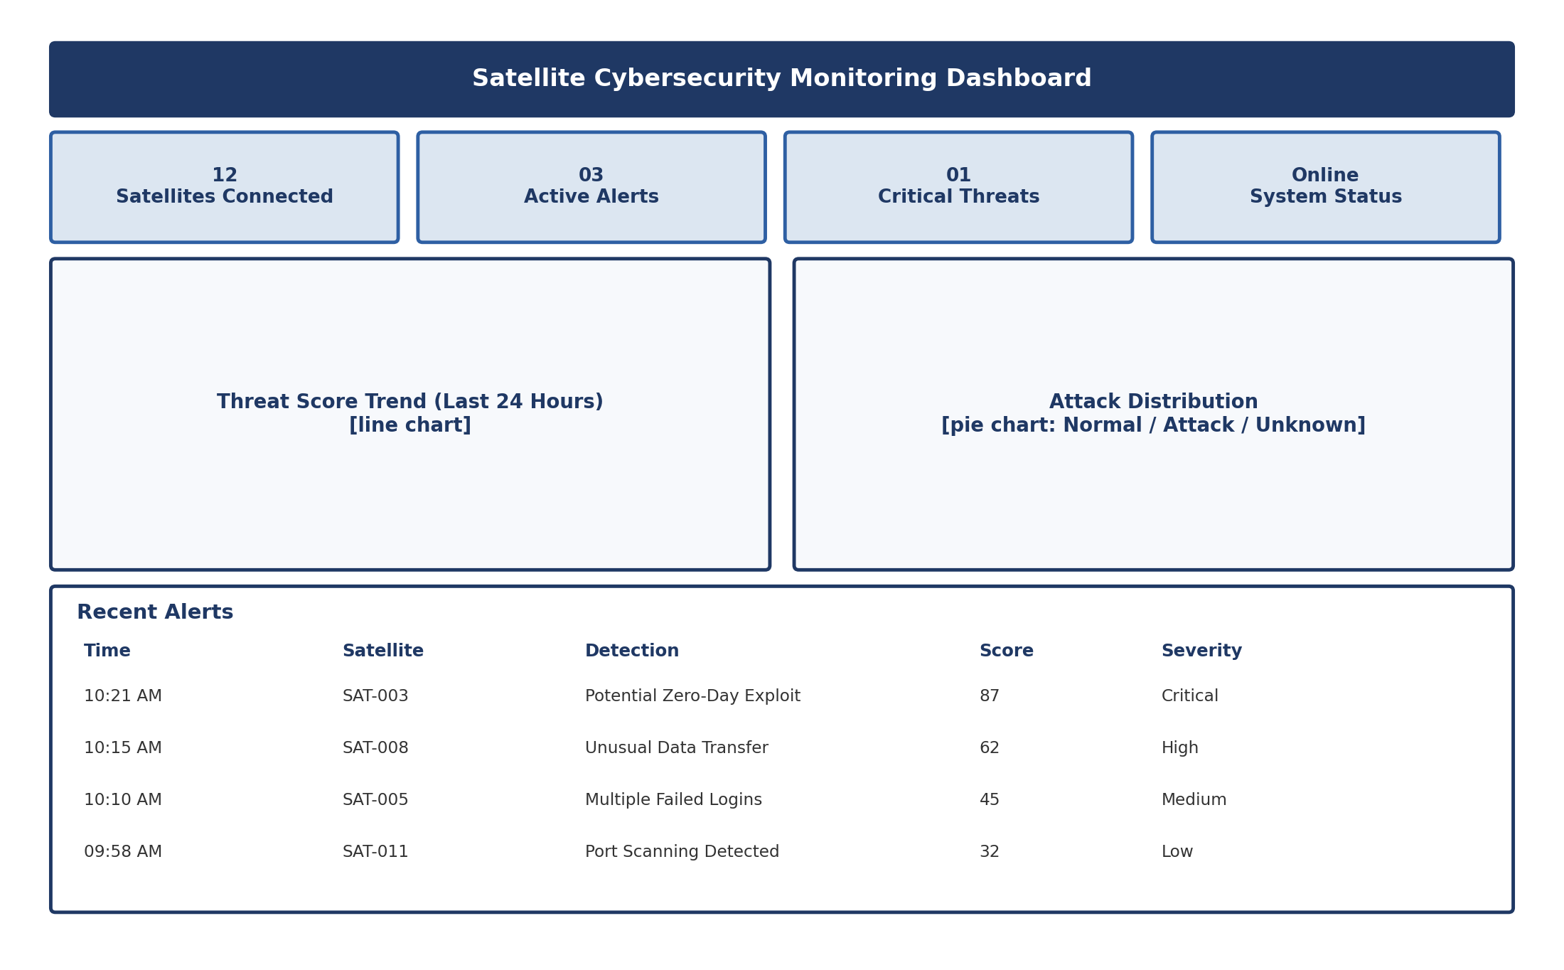
Fig. 3.5. Proposed monitoring dashboard wireframe.
Table 3.6. Key dashboard screens.
Screen | Main Contents
Dashboard | Shows connected satellites, active alerts, critical threats, threat trends, attack distribution, and recent incidents.
Attack Detection | Shows satellite ID, timestamp, detection status, anomaly score, threat score, severity, and potential attack category.
Explainability | Shows SHAP/LIME results and the most influential features for a prediction.
Reports | Provides attack history, satellite-wise statistics, threat trends, and model performance metrics.

Example Detection Result
As an illustrative example: Satellite SAT-003 may be displayed as having a potential zero-day attack with an anomaly score of 0.91 and a threat score of 87. The system would classify the event as Critical and present the top contributing features through SHAP/LIME. This example is illustrative; actual values are generated during system testing (see Chapter 5, where the real anomaly-detection and zero-day results obtained so far are reported).

Usability Considerations
- Use clear labels and simple navigation for security analysts.
- Highlight critical events so that high-priority threats are immediately visible.
- Provide explanations alongside predictions to improve trust in the model.
- Use tables and charts to support quick comparison and historical analysis.
- Keep the interface responsive and suitable for desktop-based project demonstrations.

3.5.2 Application / System Workflow
Fig. 3.4 shows the end-to-end workflow across the two operating phases of the system: Phase 1 (Federated Learning) and Phase 2 (Detection and Explainability).
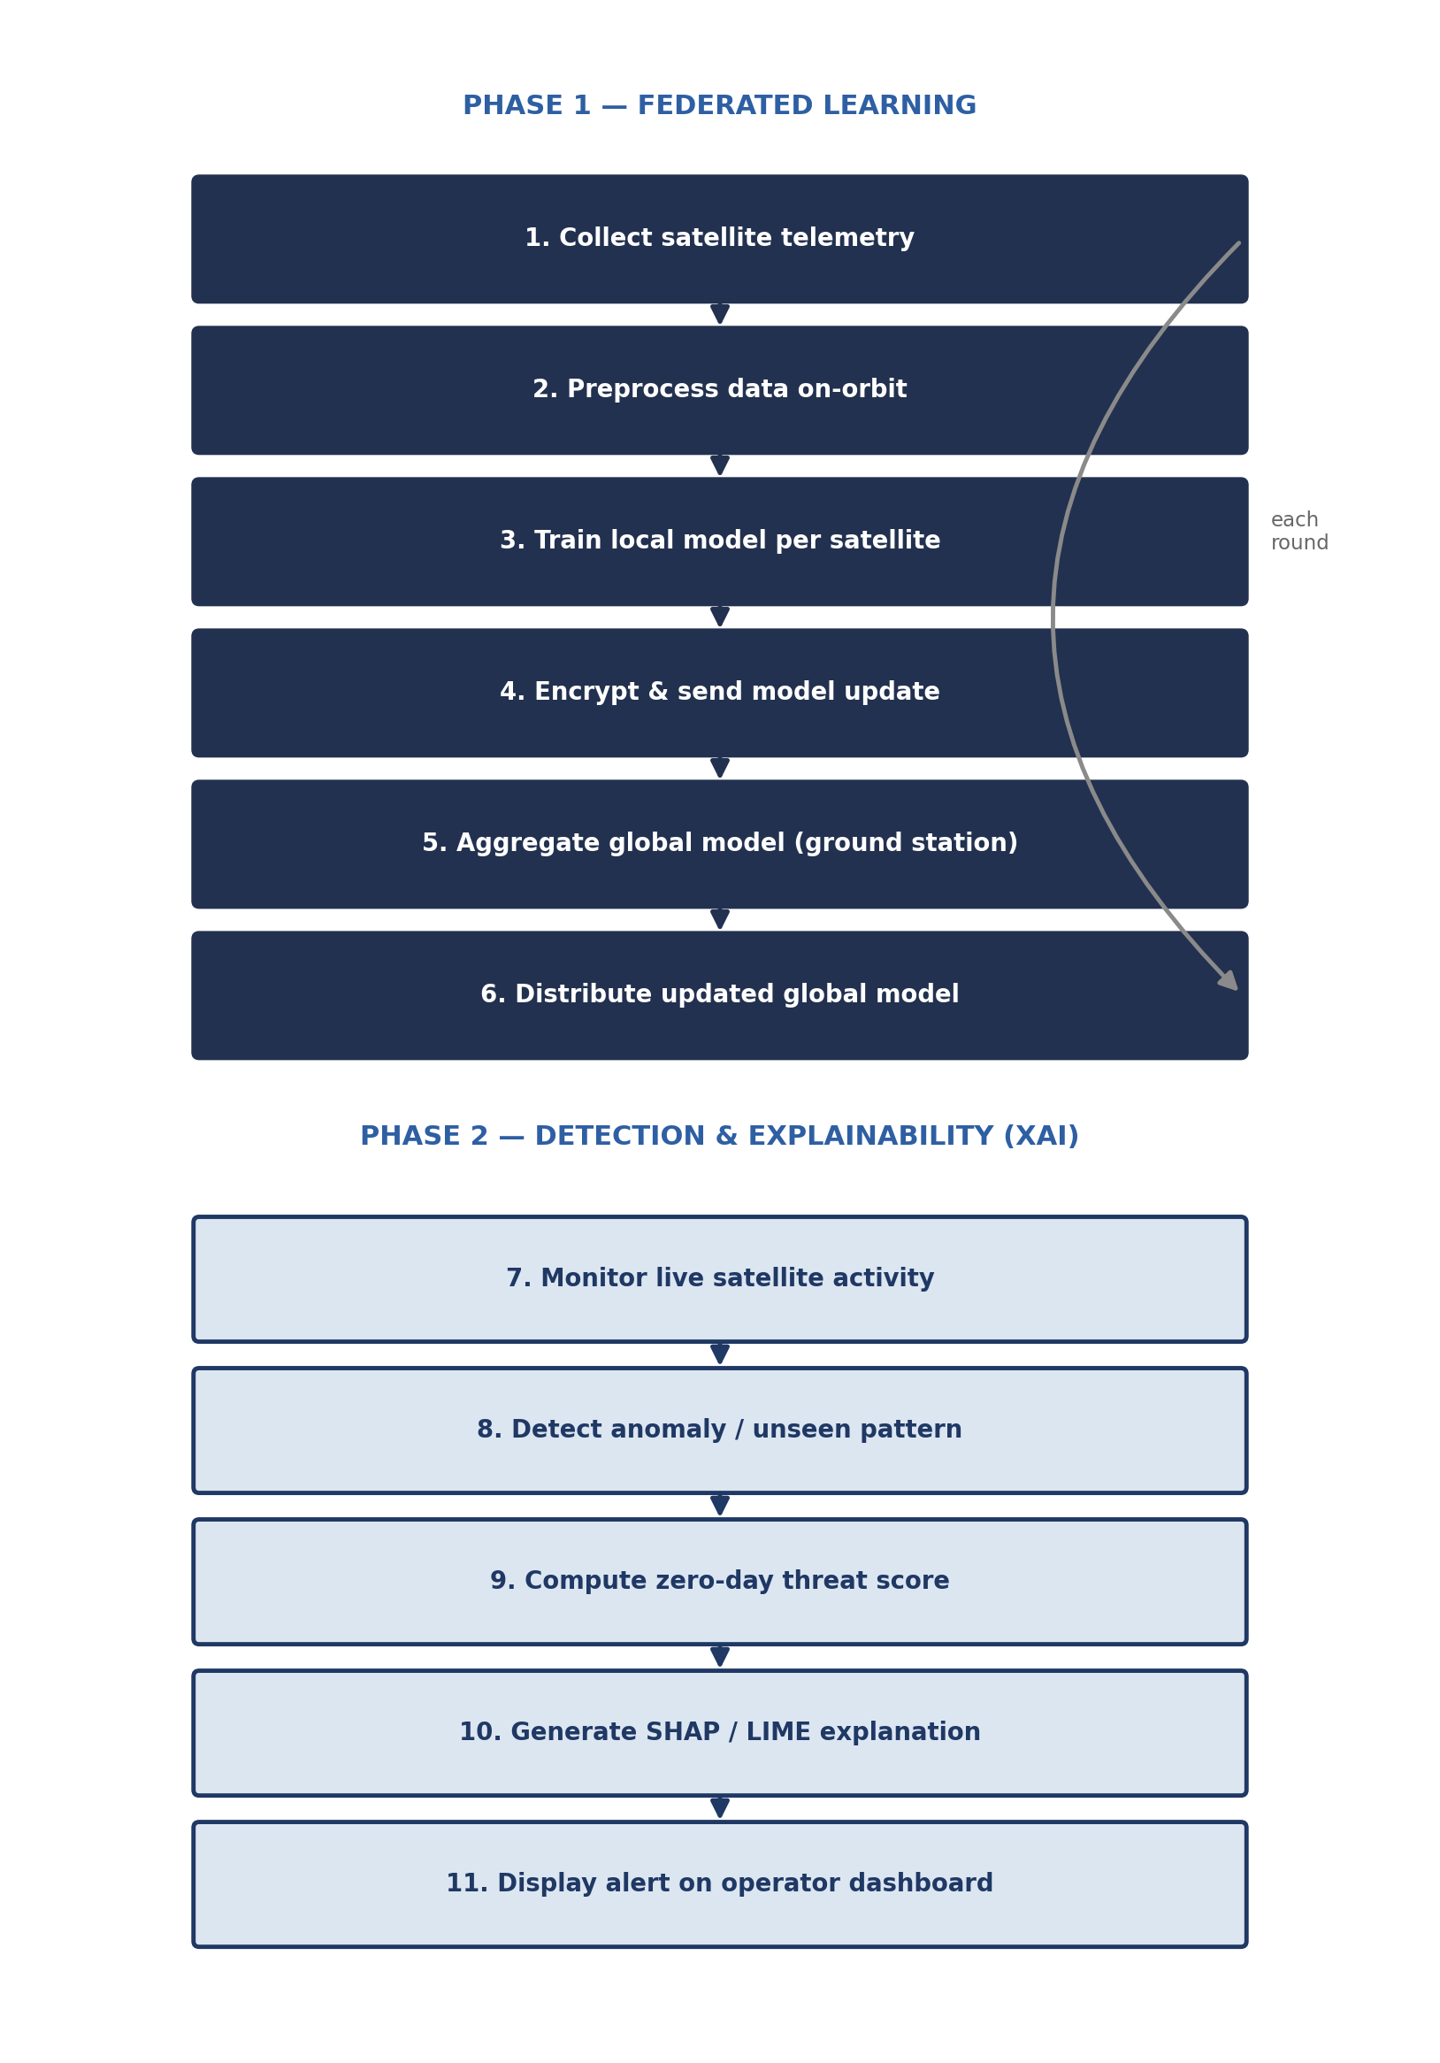
Fig. 3.4. End-to-end system workflow.
Step 1 – Data Collection: Each satellite node collects locally available network traffic, telemetry, system logs, command logs, and resource usage data.
Step 2 – Data Preprocessing: The local data is cleaned, transformed, normalized, and converted into relevant features.
Step 3 – Local Training: Each participating satellite trains its local model using the processed data.
Step 4 – Model Update: Only the model parameters/updates are transmitted to the Federated Learning server; raw data remains local.
Step 5 – Global Aggregation: The server combines the local updates to create an improved global model.
Step 6 – Model Distribution: The global model is distributed back to the participating satellite nodes.
Step 7 – New Data Analysis: Incoming activity is processed using the updated model.
Step 8 – Anomaly/Zero-Day Detection: Abnormal activity is identified. For experimental evaluation, selected attack categories can be excluded from training and tested later as unseen attacks.
Step 9 – Threat Scoring: A severity score from 0–100 is calculated and categorized as Low, Medium, High, or Critical.
Step 10 – Explainability: SHAP/LIME generates an explanation showing which features influenced the prediction.
Step 11 – Alert and Dashboard: The system generates an alert and displays the result, explanation, score, and related metrics on the dashboard.

3.6 THREAT SCORING DESIGN
The threat scoring module converts the anomaly/detection result into a value between 0 and 100. The score is used to prioritize alerts for the dashboard.
Table 3.7. Threat score design.
Score | Severity | Suggested Action
0–30 | Low | Routine monitoring
31–60 | Medium | Review recommended
61–80 | High | Immediate investigation
81–100 | Critical | Urgent response

3.7 DETECTION ALGORITHM
The pseudocode below describes the proposed federated training and zero-day detection process, as designed in the System Design Document.
ALGORITHM: Federated Zero-Day Attack Detection
1. Initialize the global model.
2. For each federated training round:
a. Select participating satellite nodes.
b. Each node collects and preprocesses its local data.
c. Train the local anomaly-detection model.
d. Generate local model parameters.
e. Send model updates to the federated server.
3. Securely aggregate the received updates.
4. Generate the updated global model.
5. Distribute the global model to participating nodes.
6. Receive new telemetry/network data.
7. Preprocess the incoming data.
8. Apply anomaly detection.
9. If an anomaly is detected:
a. Evaluate whether the pattern is previously unseen.
b. Flag it as a potential zero-day attack when appropriate.
c. Calculate the threat score.
d. Generate SHAP/LIME explanations.
e. Generate a security alert.
10. Display the result on the monitoring dashboard.
11. Continue monitoring.

3.8 SECURITY AND PRIVACY DESIGN CONSIDERATIONS
Because the system's core value proposition is privacy-preserving, distributed detection, several design decisions in this chapter were made specifically to protect data confidentiality and system integrity. Raw telemetry, network traffic, and command logs are processed and never leave the satellite node (Section 3.1, Section 3.3.2); only model parameters are transmitted, and the workflow (Section 3.5.2, Step 4) specifies that these updates are encrypted before transmission. The federated server performs secure aggregation rather than inspecting individual node updates in isolation, which limits the ability of any single compromised or malicious node to directly expose another node's data. Communication between satellite nodes and the federated server is assumed to occur over an authenticated, encrypted channel, consistent with the non-functional security requirements in Table 2.2.
Two threats are explicitly out of scope for the current design and are flagged as future work in Chapter 6: defending the aggregation step itself against a Byzantine (actively malicious) participant that submits corrupted model updates, and protecting against model-inversion or membership-inference attacks that attempt to reconstruct private training data from shared model parameters. Both are recognized, active areas of Federated Learning research, and hardening the system against them is a natural next step now that the core federated pipeline (Sections 4.5 and 5.4) is implemented and validated.

CHAPTER 4: IMPLEMENTATION

4.1 CODING STANDARDS AND TOOLS USED
All implementation work described in this chapter was carried out in Python inside Jupyter notebooks, following a strict no-leakage discipline: encoders and scalers are fit only on the training partition, and the trained anomaly detector never sees an attack-labelled row during model development. Each notebook is scoped to a single stage of the pipeline (dataset analysis, preprocessing, anomaly detection, zero-day evaluation) so each stage can be re-run and audited independently. The specific libraries used were pandas and NumPy for data handling, Matplotlib and Seaborn for visualization, Scikit-learn for preprocessing (ColumnTransformer, StandardScaler, OneHotEncoder) and metrics, and TensorFlow/Keras for the autoencoder model. Random seeds were fixed (SEED = 42) throughout for reproducibility.

4.2 DATASET ANALYSIS
The project uses the UNSW-NB15 benchmark dataset as the primary source of network traffic for model development, in place of unavailable real satellite telemetry, consistent with Section 2.5. UNSW-NB15 is a widely used intrusion-detection dataset containing labelled normal and attack traffic across multiple attack categories. Exploratory analysis was performed with no changes to the underlying training or testing CSV files, so that every later stage can trust the dataset's integrity.

4.2.1 Dataset Summary
Table 4.1. Dataset summary.
Metric | Value
Training samples | 175,341
Testing samples | 82,332
Number of features | 45
Numerical features | 41
Categorical features | 4
Missing values | 0
Duplicate records | 0
Normal samples (train + test) | 93,000
Attack samples (train + test) | 164,673

The dataset required no missing-value handling and contained no duplicate records, so no cleaning was necessary beyond the encoding/scaling steps described in Section 4.3.

4.2.2 Class and Attack-Category Distribution
The binary target (label) is imbalanced toward attacks in the training split (68.1% attack vs. 31.9% normal) and closer to balanced in the testing split (55.1% attack vs. 44.9% normal). Ten attack categories are present, ranging from Generic (the largest, 22.8% of the combined data) down to Worms, which is extremely rare at only 174 combined records (0.07%), a property later exploited deliberately in the zero-day experiment of Chapter 5.
Table 4.2. Attack category distribution (train / test / combined).
Attack Category | Train Count | Test Count | Combined | % of Combined
Normal | 56,000 | 37,000 | 93,000 | 36.09%
Generic | 40,000 | 18,871 | 58,871 | 22.85%
Exploits | 33,393 | 11,132 | 44,525 | 17.28%
Fuzzers | 18,184 | 6,062 | 24,246 | 9.41%
DoS | 12,264 | 4,089 | 16,353 | 6.35%
Reconnaissance | 10,491 | 3,496 | 13,987 | 5.43%
Analysis | 2,000 | 677 | 2,677 | 1.04%
Backdoor | 1,746 | 583 | 2,329 | 0.90%
Shellcode | 1,133 | 378 | 1,511 | 0.59%
Worms | 130 | 44 | 174 | 0.07%

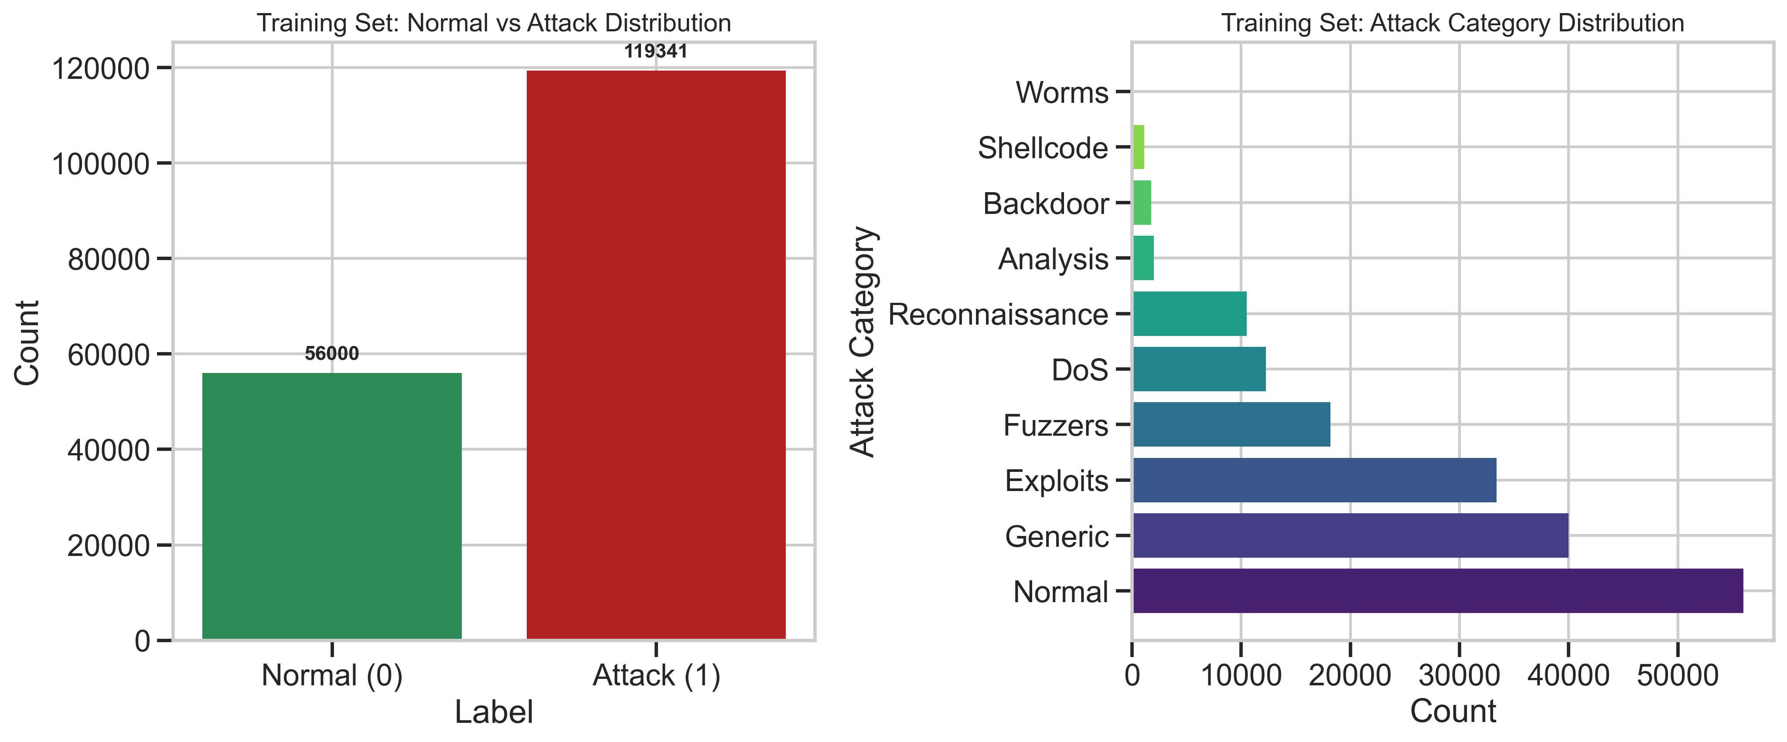
Fig. 4.1. Training set label and attack-category distribution.
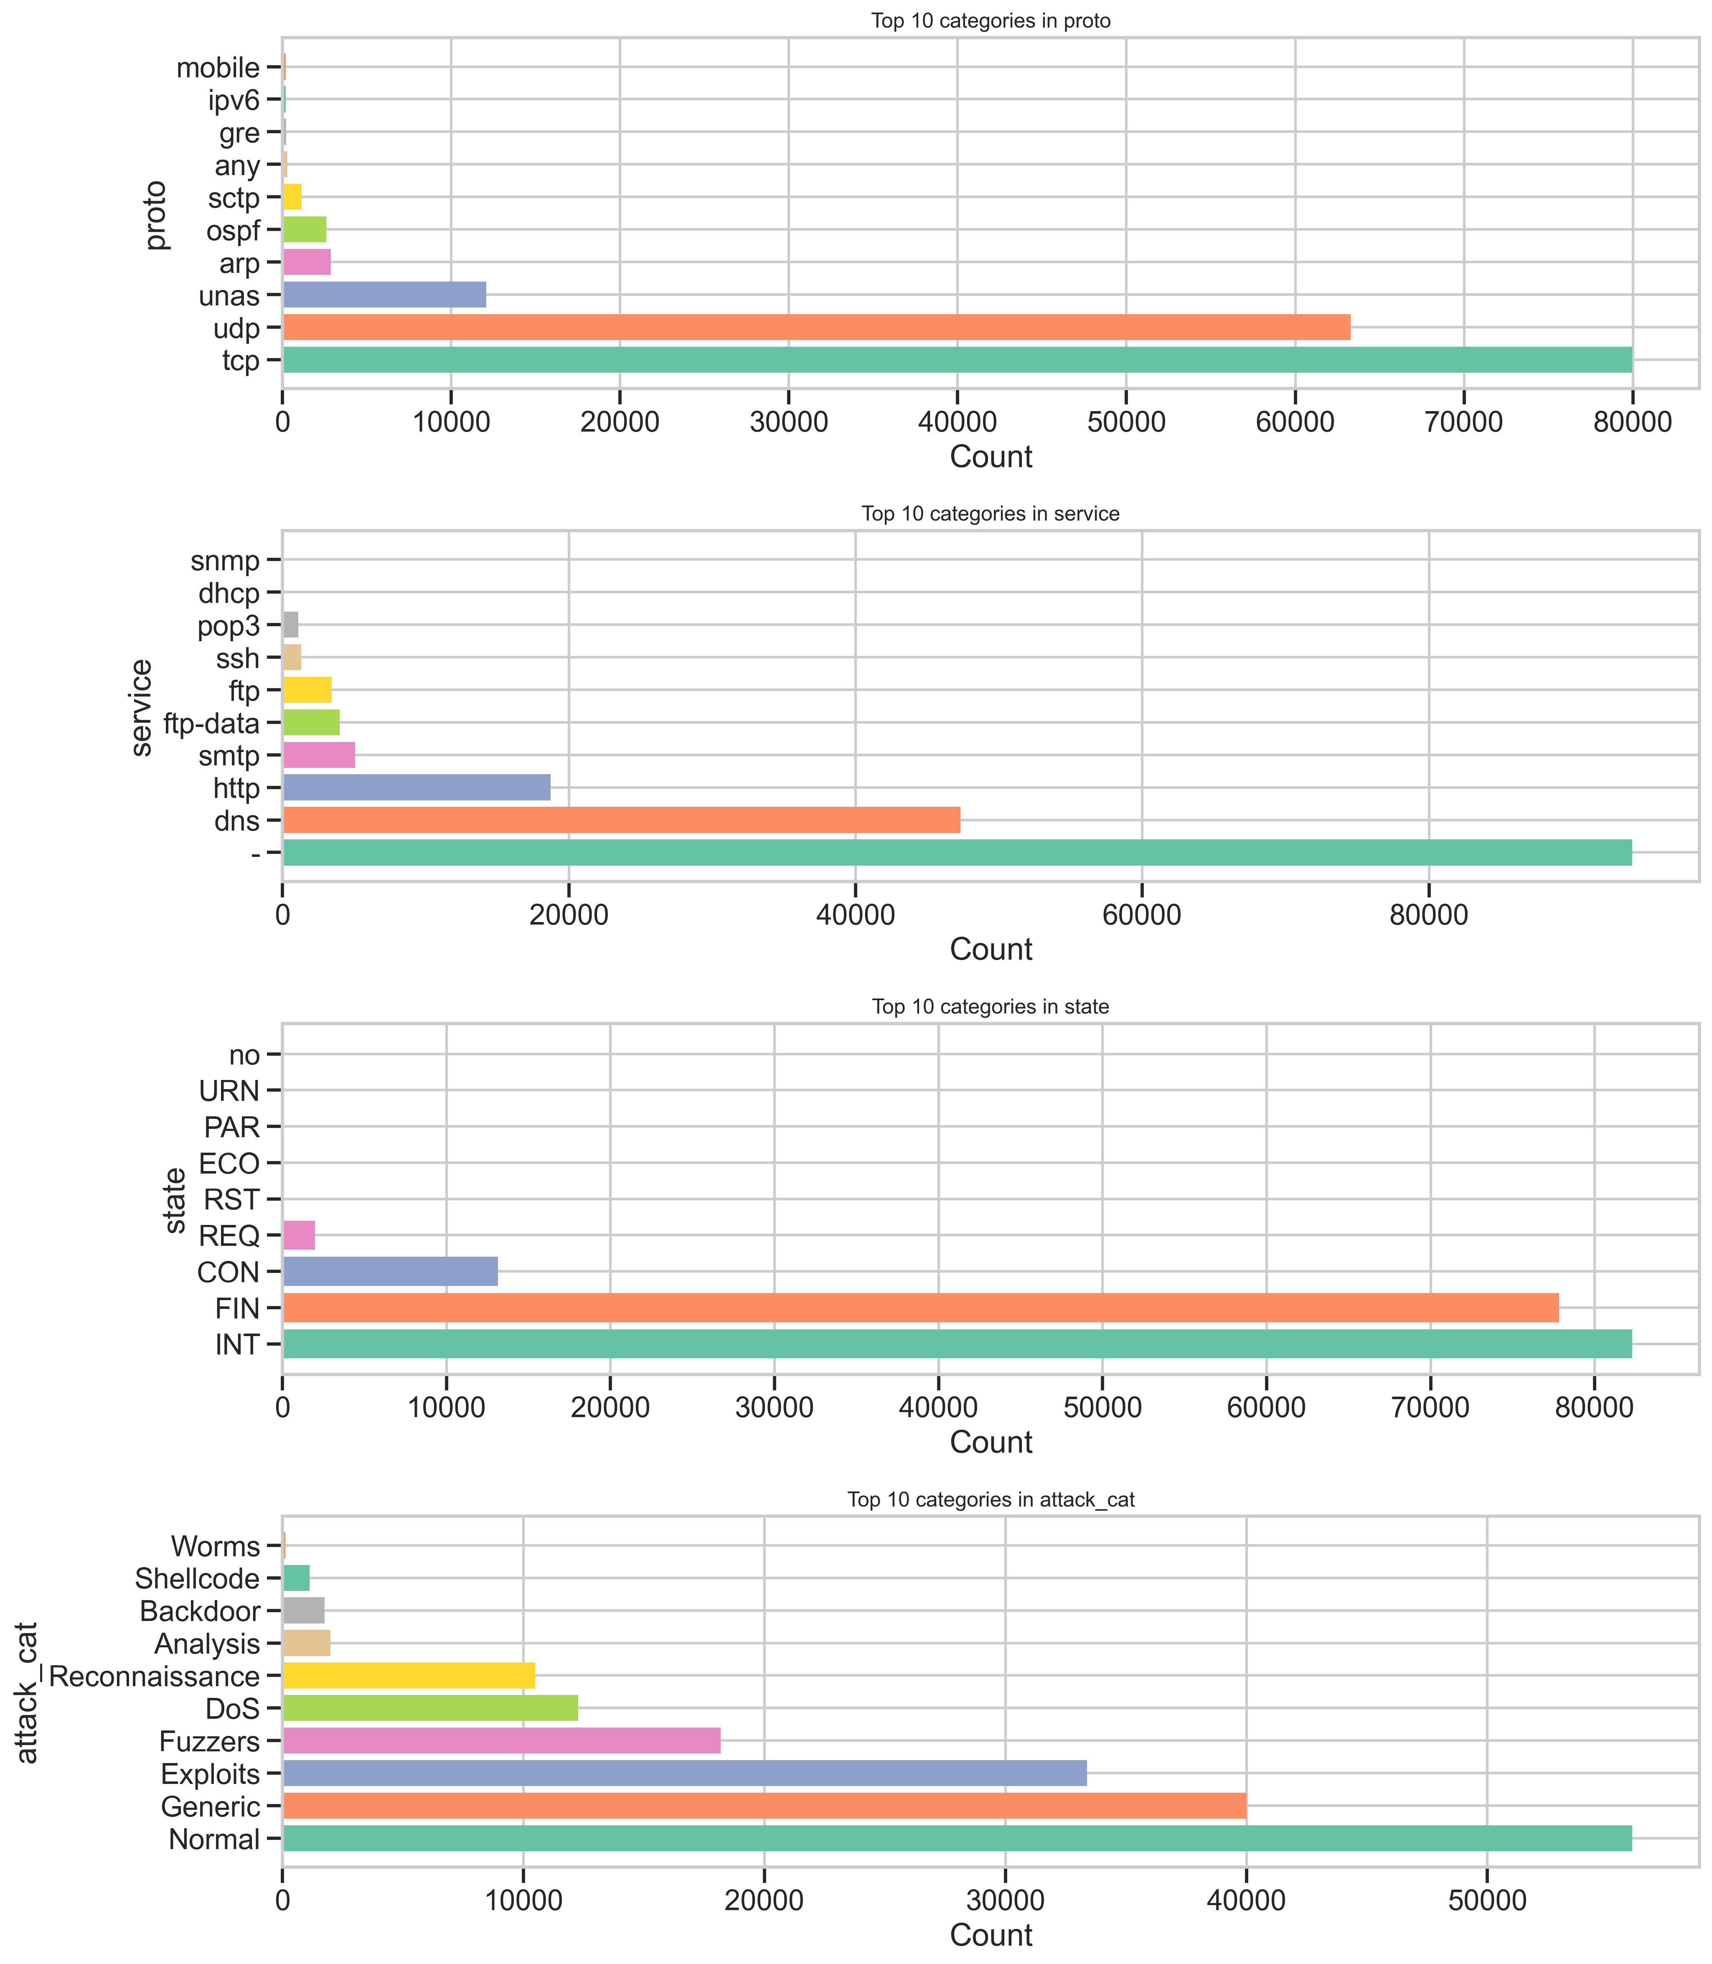
Fig. 4.2. Top categories for protocol, service, connection state, and attack category.

4.2.3 Feature Correlation
A correlation analysis was run across the 41 numerical features against the binary label. The strongest positive correlations with the attack label were id, sttl (source-to-destination time-to-live), and ct_state_ttl, while the strongest negative correlations were dload, dmean, and swin, giving an early signal of which raw features carry the most separating power before any encoding or scaling was applied.
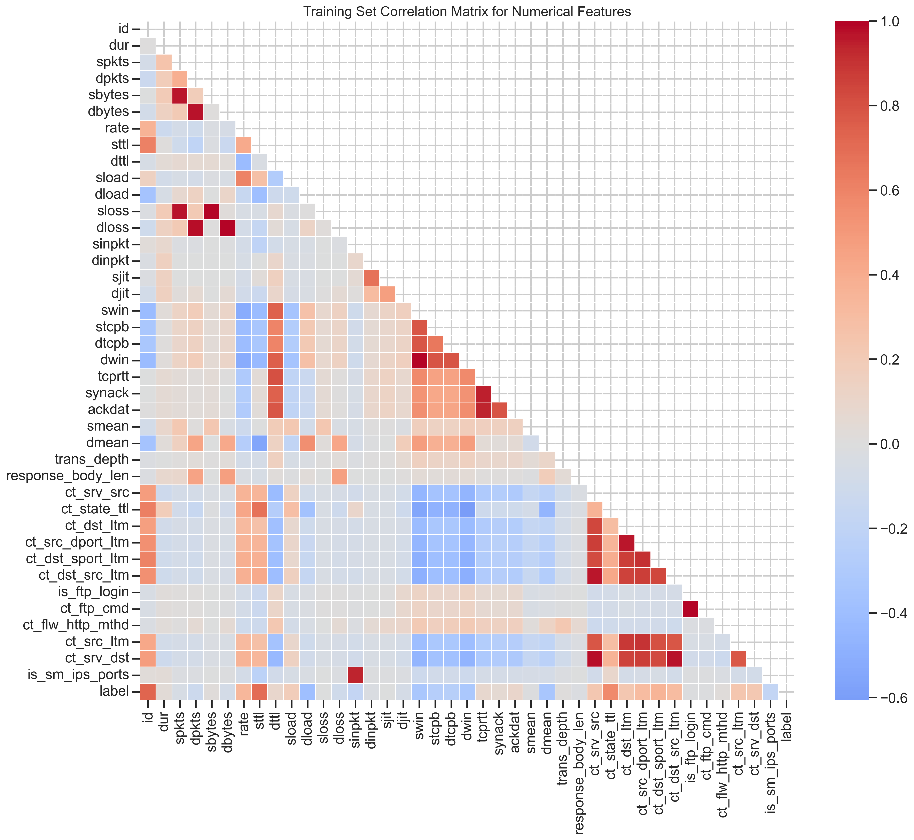
Fig. 4.3. Correlation matrix of numerical features (training set).
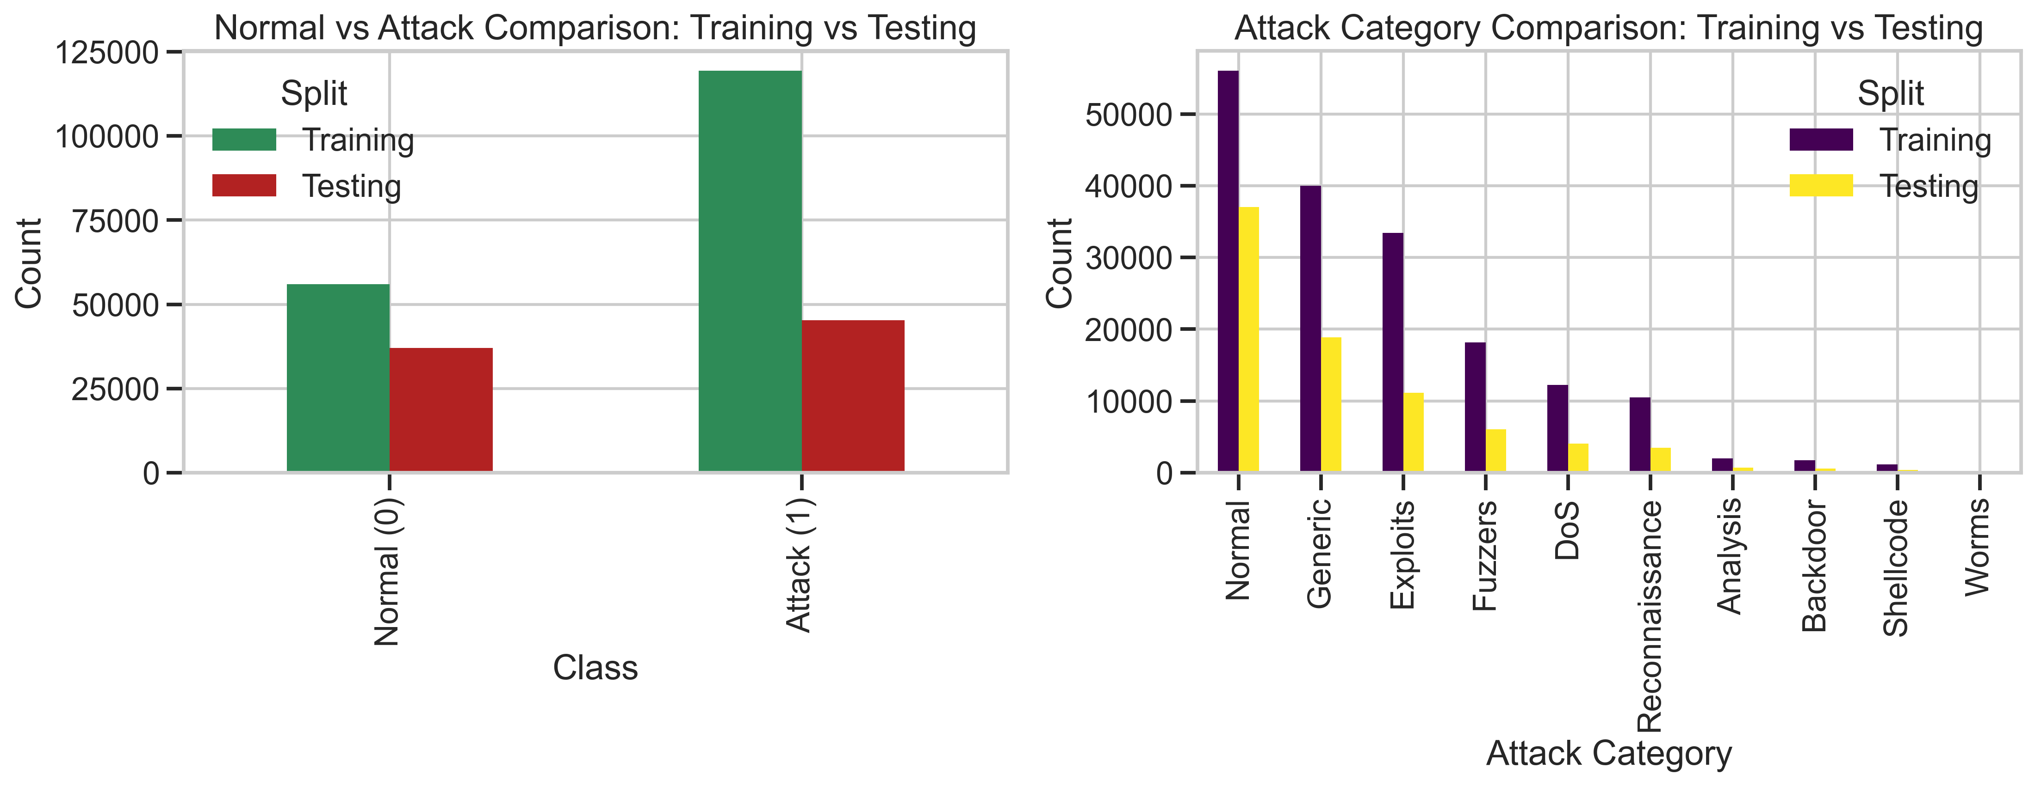
Fig. 4.4. Label and attack-category counts compared across training and testing splits.

4.2.4 Categorical Feature Summary
Of the four categorical columns in the raw dataset, attack_cat is the label used above; the remaining three (proto, service, state) describe the network connection itself. proto is by far the highest-cardinality field, with 133 distinct protocol values dominated by tcp and udp; service is dominated by unclassified (“-”) and dns traffic; and state, the TCP/connection state, is dominated by INT (interrupted/no full handshake recorded) and FIN (normal termination). Table 4.5 summarizes each field's cardinality and most frequent value in the training set; the corresponding full top-10 breakdowns are plotted in Fig. 4.2 above.
Table 4.5. Categorical feature summary (training set).
Feature | Unique Values | Most Frequent Value | Frequency (Training)
proto | 133 | tcp | 79,946
service | 13 | — (unclassified) | 94,168
state | 9 | INT | 82,275

4.2.5 Distribution of Key Numeric Features
To understand how individual numeric features separate normal from attack traffic before any scaling is applied, six representative features (dur, sbytes, dbytes, rate, sttl, dttl) were plotted as both a histogram and a Normal-vs-Attack boxplot. Fig. 4.6 shows that sttl (source-to-destination time-to-live) in particular shows visibly different typical values between the two classes, consistent with it being one of the top-correlated features identified in Section 4.2.3. The full descriptive statistics (count, mean, standard deviation, min, quartiles, and max) for all 41 numerical features are provided in Appendix C for reference.
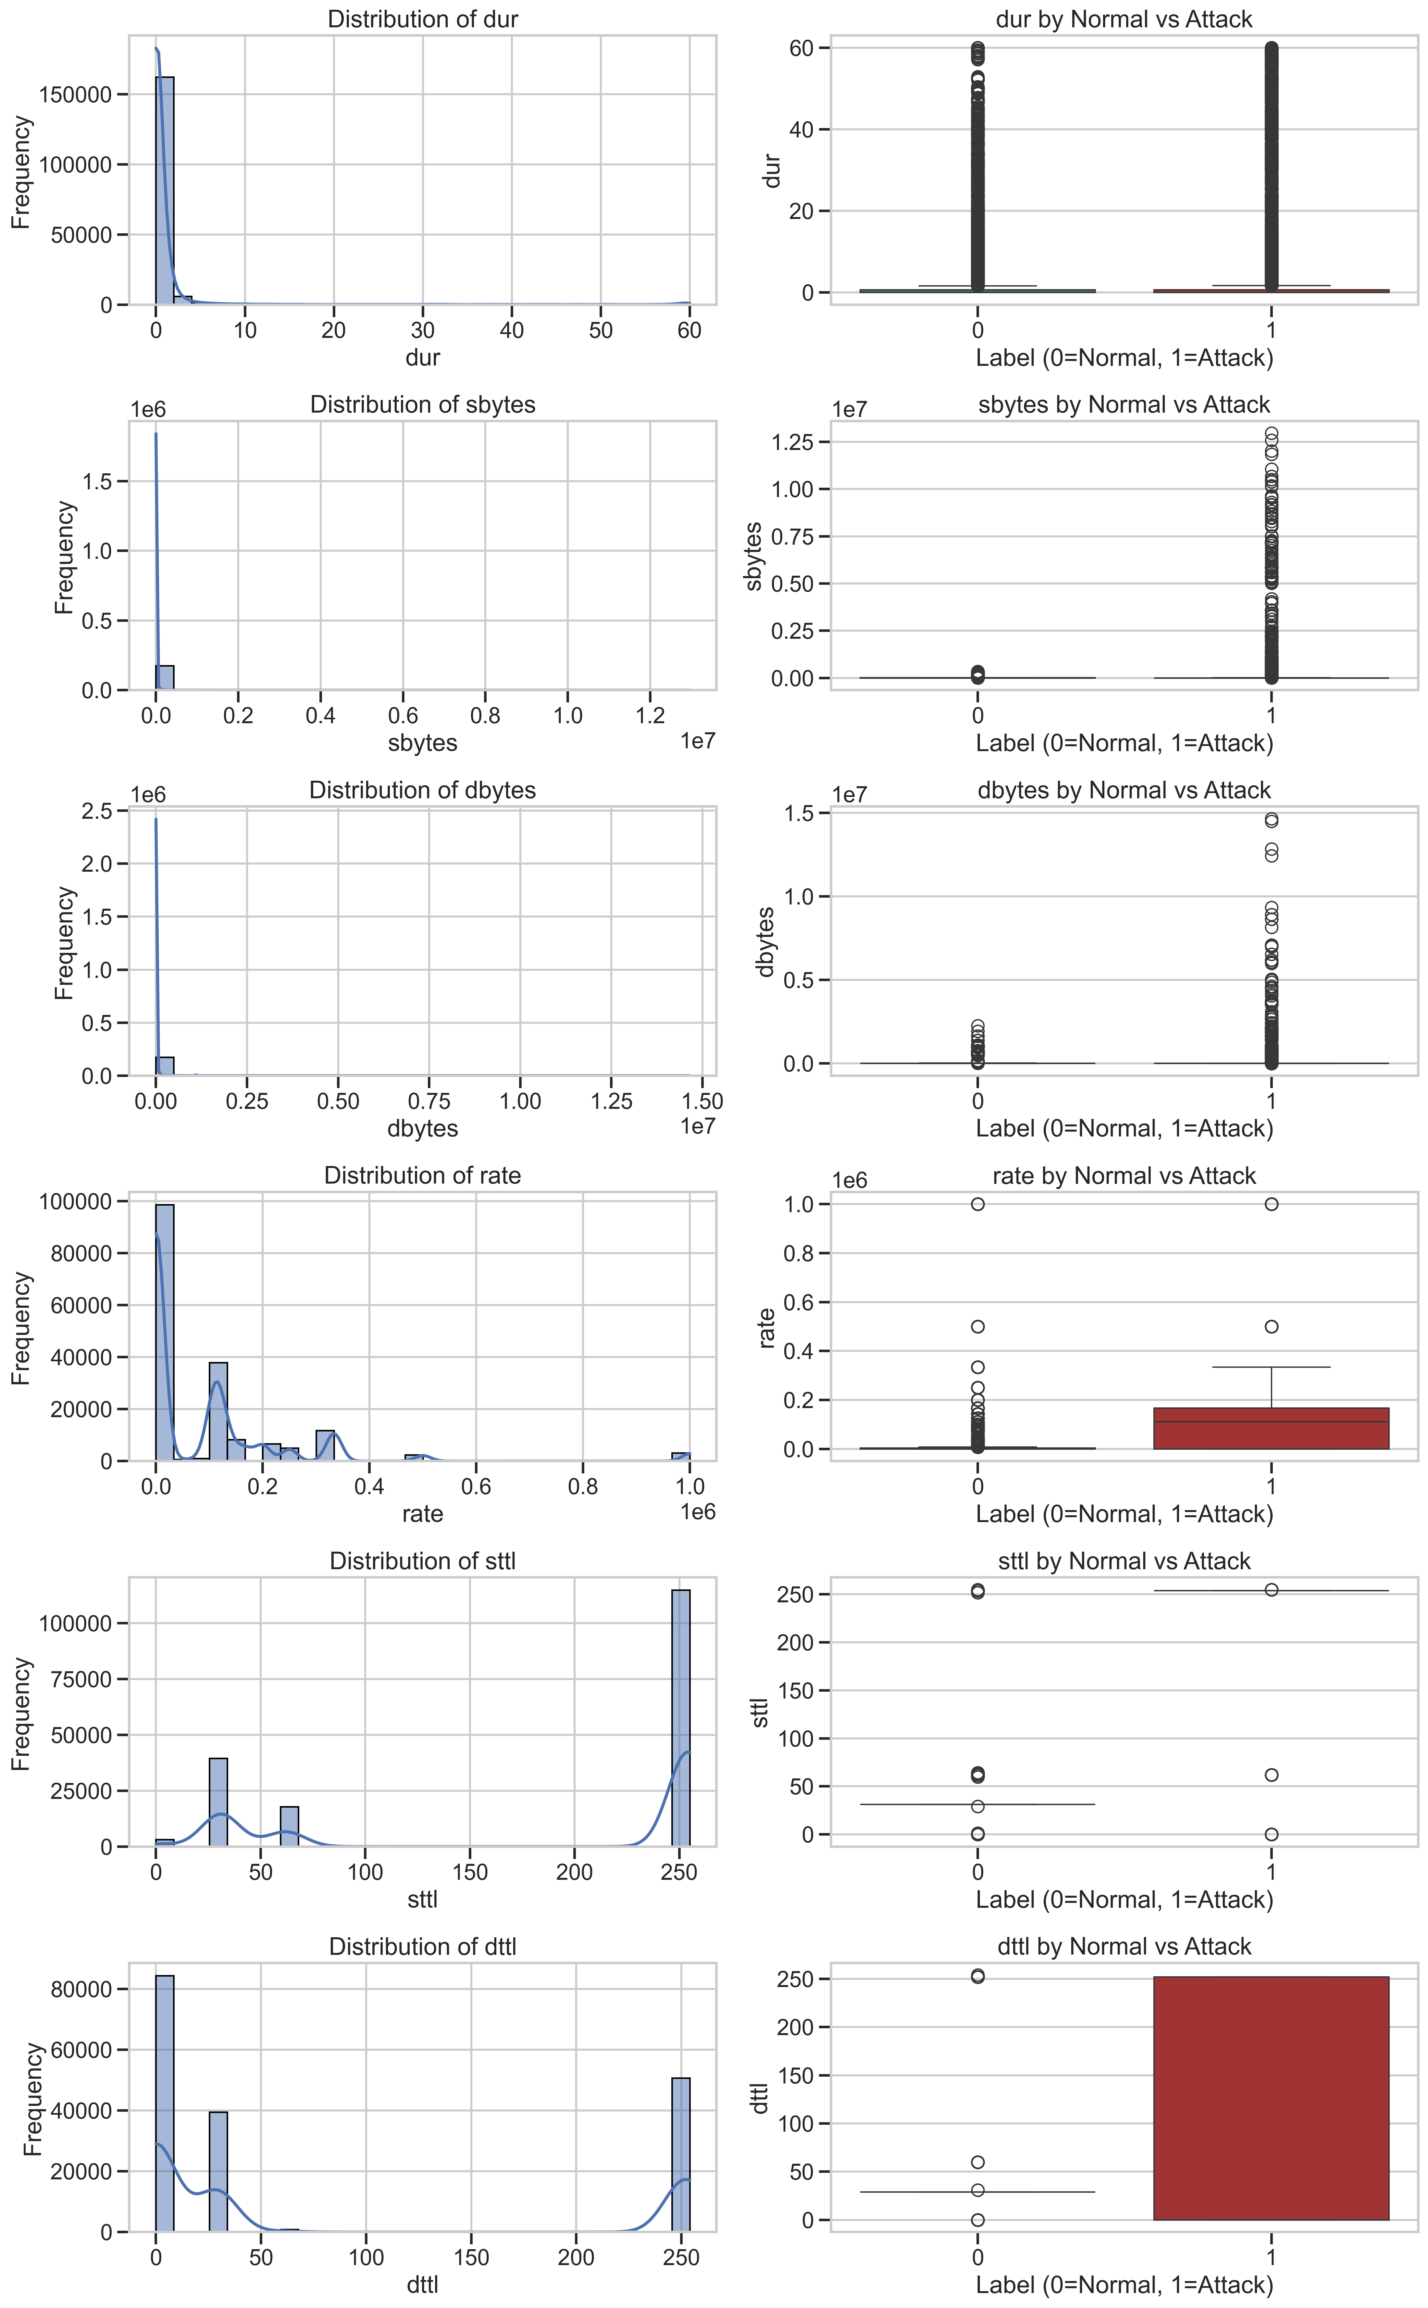
Fig. 4.6. Distribution and Normal-vs-Attack comparison of key numeric features.

4.3 DATA PREPROCESSING
A preprocessing pipeline was built using Scikit-learn's ColumnTransformer so that it can be reused identically across every later stage (anomaly detection, zero-day evaluation, and eventually the federated clients) without being refit. The binary label column is kept as the primary supervised target, while attack_cat is preserved separately so it remains available for the zero-day experiment in Chapter 5. The original CSV files are never modified.

4.3.1 Pipeline Design
- Categorical features (proto, service, state — 3 columns) are One-Hot Encoded, with unknown categories at inference time safely ignored.
- Numerical features (40 columns) are standardized using StandardScaler (zero mean, unit variance).
- The encoder and scaler are fit only on the training data to prevent data leakage from the test set.
- The fitted pipeline is persisted to models/preprocessing_pipeline.pkl so every downstream notebook reuses the exact same transformation.

4.3.2 Result
Table 4.3. Preprocessing pipeline result.
Item | Before Preprocessing | After Preprocessing
Feature columns | 43 (40 numeric + 3 categorical) | 195 (numeric scaled + one-hot expanded)
Training matrix shape | 175,341 × 43 | 175,341 × 195
Testing matrix shape | 82,332 × 43 | 82,332 × 195
Missing values | 0 | 0

The one-hot expansion of the three categorical columns (with a high-cardinality proto field in particular) is what grows the feature space from 43 to 195 dimensions; this expanded representation is what feeds the autoencoder described next.

4.4 ANOMALY DETECTION MODEL IMPLEMENTATION
An autoencoder was chosen as the core anomaly detector because it can be trained purely on normal traffic and does not require attack labels, a necessary property for a system meant to eventually flag previously unseen (zero-day) behaviour. It was trained exclusively on the 56,000 normal-labelled rows of the training set (label == 0); no attack samples of any kind were used to fit the model or calibrate its threshold.

4.4.1 Architecture
Table 4.4. Autoencoder architecture.
Layer | Output Shape | Parameters
Input | (None, 195) | —
encoder (Dense, ReLU) | (None, 64) | 12,544
latent (Dense, ReLU) | (None, 32) | 2,080
decoder (Dense, ReLU) | (None, 64) | 2,112
reconstruction (Dense, Linear) | (None, 195) | 12,675

Total trainable parameters: 29,411. The 195-dimensional input (post one-hot/scaling) is compressed to a 32-dimensional latent representation and reconstructed back to 195 dimensions; the model is trained to minimize mean-squared reconstruction error.

4.4.2 Training and Threshold Calibration
- Optimizer: Adam (learning rate = 1e-3), Loss: MSE
- Normal training data (56,000 rows) split 80/20 → 44,800 rows to fit the autoencoder, 11,200 held out purely for threshold calibration.
- Trained for 20 epochs, batch size 256, with early stopping (patience = 3, monitoring validation loss).
- Best validation loss achieved: 0.000914.
- Anomaly threshold set at the 95th percentile of reconstruction error on the held-out normal calibration set: 0.002627 — test labels were never used to pick this threshold.
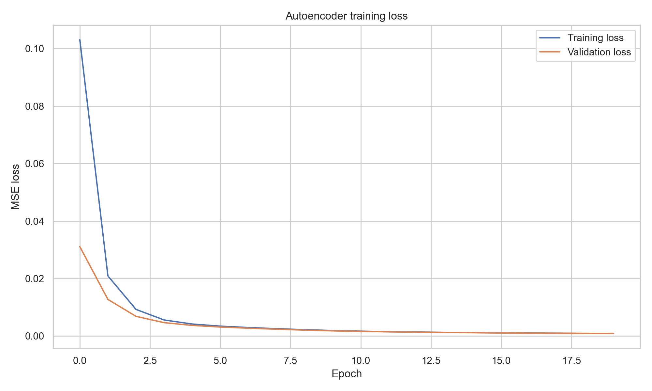
Fig. 4.5. Autoencoder training vs. validation loss across epochs.
The trained autoencoder and its calibrated threshold, saved to models/trained_models/autoencoder_model.h5 and autoencoder_threshold.pkl, are reused without modification in both the standard test-set evaluation and the zero-day simulation reported in Chapter 5.

4.5 FEDERATED LEARNING IMPLEMENTATION
The centralized autoencoder from Section 4.4 was reproduced under a simulated Federated Learning setting to test whether the same detector can be trained without ever centralizing raw traffic. The same 56,000 normal-labelled training rows and 80/20 client-pool/calibration split described in Section 4.4.2 were reused; the 44,800-row client pool was then divided evenly across five simulated satellite-node clients (8,960 rows each) using a fixed-seed shuffle so client assignment is reproducible. Each client trains an autoencoder identical in architecture to Table 4.4, starting every round from the current global weights.
Table 4.6. Federated learning configuration.
Configuration Item | Value
Simulated satellite-node clients | 5
Communication (FedAvg) rounds | 5
Local epochs per client per round | 2
Local batch size | 256
Normal training rows available | 56,000
Client pool / calibration-only split | 44,800 / 11,200 (80% / 20%)
Rows per client (5-way even split) | 8,960 each
Aggregation rule | Sample-count-weighted FedAvg
Model architecture per client | Identical to Table 4.4 (centralized autoencoder)

At each of the five communication rounds, every client trains locally for two epochs on only its own partition and returns its updated weights; the server combines them with sample-count-weighted Federated Averaging (FedAvg) into a new global model. The global model's anomaly threshold is then recalibrated each round from the untouched, calibration-only normal rows (never seen by any client), and evaluated against the untouched UNSW-NB15 test set to produce that round's metrics. No client ever transmits raw traffic — only model weights cross the simulated network boundary, consistent with the privacy-by-design goal in Section 3.8.
Table 2.3 and Table 3.5 originally specified the Flower (flwr) framework for federated orchestration. Because this simulation runs all five clients within a single notebook process rather than as separate networked processes, FedAvg was instead implemented directly with NumPy/TensorFlow (a manual weighted-average of Keras layer weights) rather than through the flwr API. The flwr package remains listed in requirements.txt for a future multi-process deployment; this substitution is recorded as a design deviation in Section 6.2, and does not change the federated training semantics (local-only data, weight-only communication, server-side aggregation).

4.6 EXPLAINABLE AI IMPLEMENTATION
Explainability was applied to the trained Federated Learning global model from Section 4.5 (round 5) rather than the Section 4.4 centralized model, since the federated model is the framework's actual privacy-preserving end product. Both SHAP and LIME explain the same scalar function — the autoencoder's mean-squared reconstruction error for a given row — so a feature's contribution is interpreted as how much it pushed the reconstruction error up (more anomalous) or down (more normal).
- SHAP: a KernelExplainer wraps the reconstruction-error function with a 40-row representative background sample (evenly spaced across the training set) and generates each explanation with 100 samples and L1 regularization to the top 20 features. This yields both a global mean-|SHAP| feature-importance ranking and per-example local attributions.
- LIME: a LimeTabularExplainer in regression mode fits a local linear surrogate around each explained row using 300 sampled perturbations and 15 reported features, discretizing continuous features for interpretability.
- Three real UNSW-NB15 test rows were explained: a Normal record (test row 0), a known attack (Reconnaissance, test row 243), and the withheld zero-day category (Worms, test row 387) — the same category held out in Chapter 5's zero-day experiment.
Table 5.7 (Chapter 5) reports the reconstruction loss and prediction outcome for each of the three explained rows; notably, the Worms example was not flagged anomalous by the federated model, which is consistent with — and gives feature-level insight into — the zero-day detection gap already identified in Chapter 5.

4.7 THREAT SCORING IMPLEMENTATION
The threat-scoring module (designed in Section 3.6) converts the federated model's reconstruction error, decision threshold, and binary prediction into a single 0–100 score, using only model outputs — test labels and attack categories are retained in the scored-event table purely for evaluation and never influence the score itself.
Table 4.7. Threat scoring formula (as implemented).
Score Component | Weight | Definition
Anomaly magnitude | 60% | clip(reconstruction_error / (2 × threshold), 0, 1)
Model confidence | 25% | Distance from the decision threshold, direction-dependent, clipped to [0, 1]
Binary detection result | 15% | 1 if predicted_anomaly else 0

The resulting score is mapped to one of four severity bands, matching the design in Table 3.7:
Table 4.8. Threat score severity bands (as implemented).
Severity | Score Range
Low | 0 – 24
Medium | 25 – 49
High | 50 – 74
Critical | 75 – 100

The scored event register, configuration, and summary metrics are written to results/metrics/07_threat_scored_events.csv, 07_threat_scoring_config.json, and 07_threat_scoring_metrics.csv respectively, and are the same files the dashboard (Section 4.8) reads directly.

4.8 WEB MONITORING DASHBOARD IMPLEMENTATION
The monitoring dashboard designed in Section 3.5 was implemented in Streamlit as "Mission Shield" (dashboard/app.py). It runs in inference-only mode: it loads the saved CSV, JSON, PNG, and model-metadata artifacts produced by the completed notebooks and never retrains a model, refits preprocessing, or fabricates telemetry. A sidebar status indicator confirms whether the federated model file is present ("MODEL ONLINE") before any page is shown.
Table 4.9. Dashboard pages implemented.
Dashboard Page | Contents
Dashboard | KPI cards (events evaluated, anomalies detected, critical events, mean threat score), threat-posture chart, recent-alerts feed, and federated-model health summary.
Satellite Status | Simulated registry of the five FedAvg client nodes with per-node status and routed-event counts; explicitly labelled as configuration-derived, not live telemetry.
Threat Detection | Filterable table of the full threat-scored event register (severity filter) plus the threat-score-vs-reconstruction-error scatter plot.
Zero-Day Analysis | Chapter 5 zero-day metrics (known/unseen/false-positive rates) and detection-rate chart, loaded directly from the Step 4 results files.
Federated Learning | Round-by-round FedAvg metrics table and chart from the completed federated notebook; the dashboard never retrains the model.
Explainable AI | Global SHAP importance chart plus a selectable per-example view (normal / known attack / unseen zero-day) showing SHAP and LIME local explanations side by side.
Reports | Download buttons for the threat-scored event register, threat-scoring configuration, federated round metrics, and zero-day metrics as CSV/JSON.

The interface can be launched locally from the project root with streamlit run dashboard/app.py; it requires the artifacts produced by notebooks 03–07 to already exist on disk.

CHAPTER 5: TESTING

5.1 TEST CASE DESIGN
Two complementary evaluations were carried out against the trained autoencoder from Chapter 4. The first is a standard held-out test-set evaluation, applying the model and its calibrated threshold to the full, untouched UNSW-NB15 test split (82,332 rows) to measure general detection performance. The second is a dedicated zero-day simulation, designed specifically to test the system's ability to catch a genuinely novel attack family rather than one that merely resembles the attacks it was implicitly exposed to.
For the zero-day simulation, the Worms attack category was designated as the “unseen” / zero-day class. Worms is the rarest category in UNSW-NB15 (only 130 training rows and 44 testing rows), which makes it a realistic stand-in for a novel attack family that a real deployed system would encounter for the first time. The Chapter 4 autoencoder and its threshold, both fit only on normal traffic with no attack category involved in training or calibration, were reused without any retraining. For evaluation, the test set was split into three groups: Normal (benign traffic, label = 0), Known attack (every attack category except Worms), and Unseen: Worms (the withheld category, treated as the simulated zero-day class).

5.2 TEST REPORTS — AUTOENCODER EVALUATION
The calibrated threshold was applied to the entire (untouched) test set of 82,332 rows to classify each sample as normal or anomalous based purely on reconstruction error.
Table 5.1. Autoencoder evaluation metrics.
Metric | Value
Accuracy | 0.8240
Precision | 0.9108
Recall | 0.7542
F1-Score | 0.8251
ROC-AUC | 0.8843

Confusion matrix (rows = true label, columns = predicted label; 0 = Normal, 1 = Attack/Anomaly):
Table 5.2. Autoencoder confusion matrix.
 | Predicted Normal | Predicted Anomaly
Actual Normal | 33,652 | 3,348
Actual Attack | 11,143 | 34,189

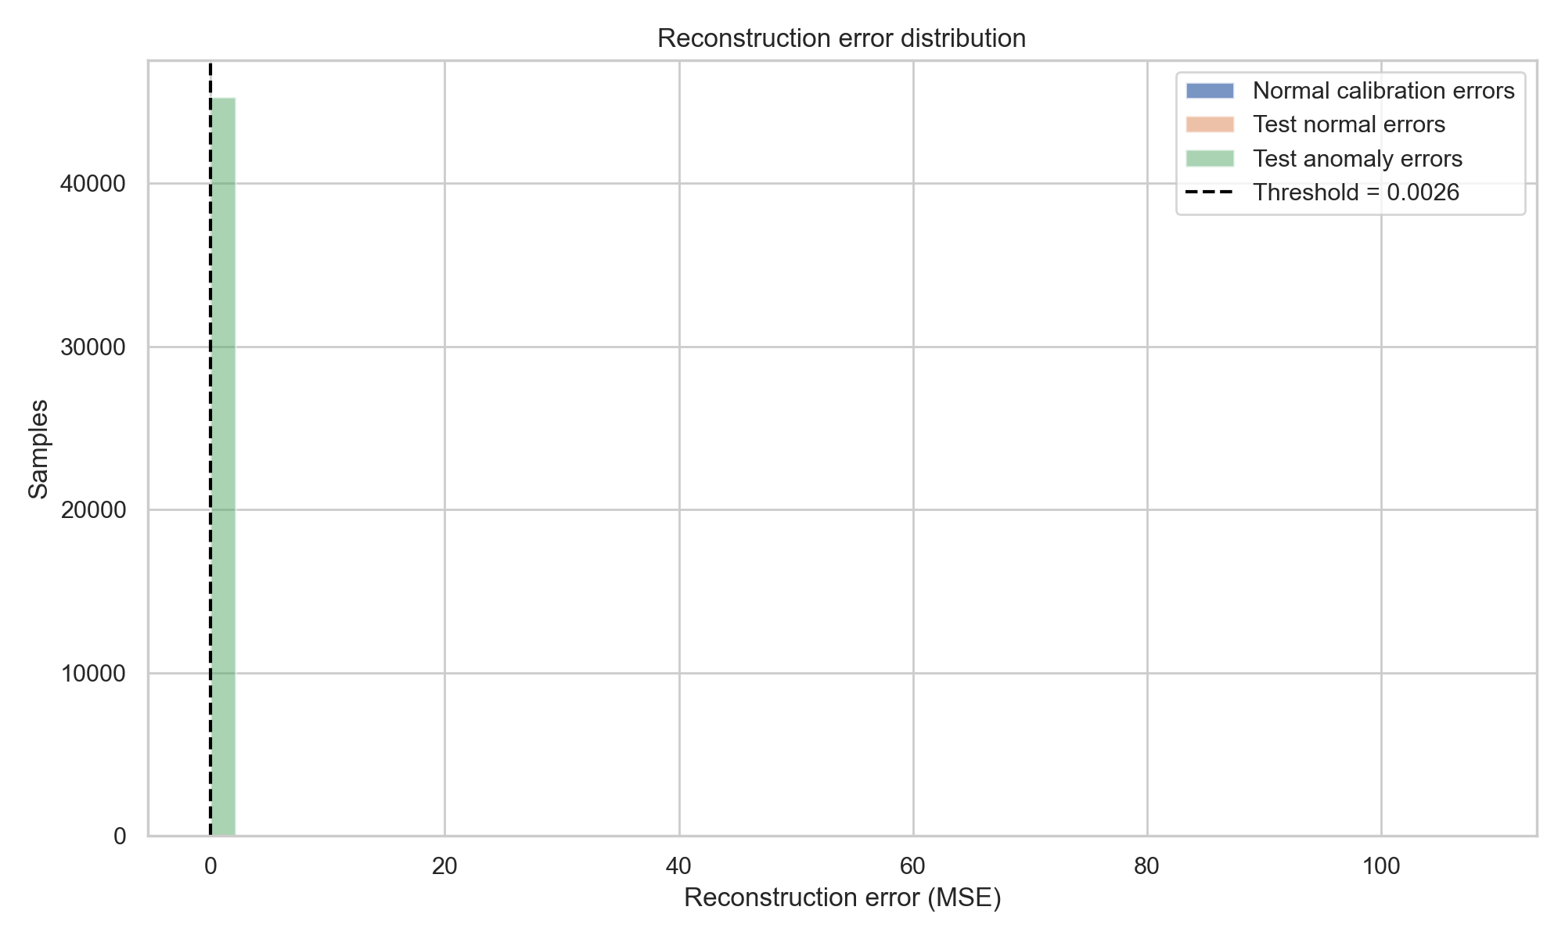
Fig. 5.1. Reconstruction-error distribution with detection threshold (autoencoder evaluation).
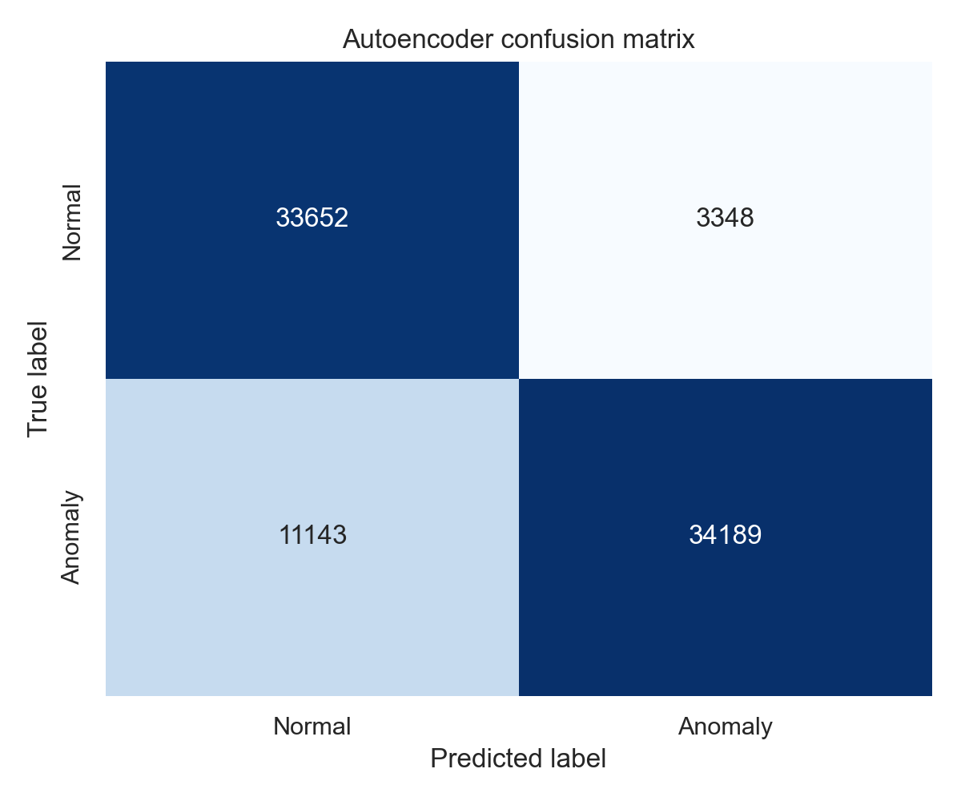
Fig. 5.2. Confusion matrix, autoencoder on the full test set.
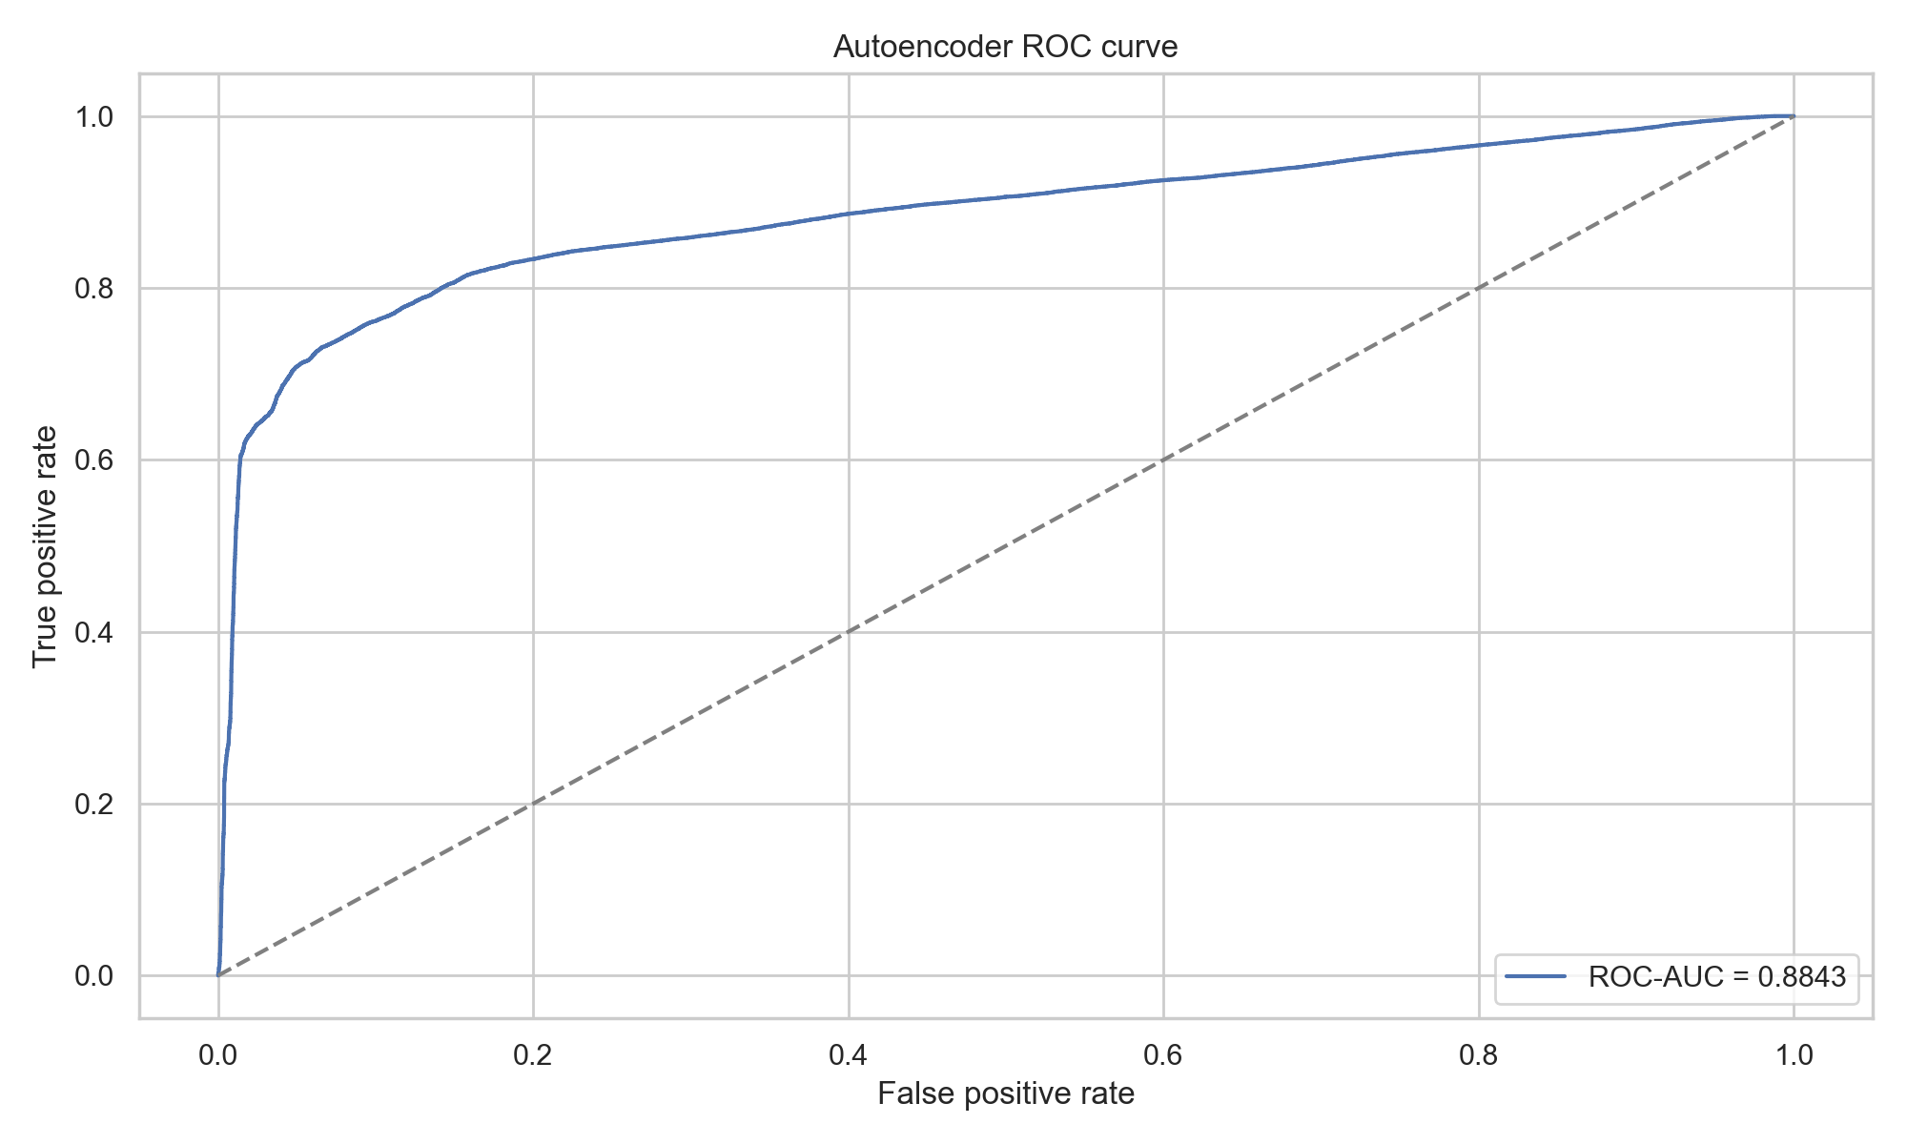
Fig. 5.3. ROC curve (autoencoder).
The model reaches 82.4% accuracy and an F1-score of 0.825 on the full test set, with high precision (0.911) but comparatively lower recall (0.754), i.e. when it flags something as anomalous it is usually right, but it misses a meaningful share of attacks.

5.3 TEST REPORTS — ZERO-DAY DETECTION RESULTS
Table 5.3. Zero-day experiment metrics.
Metric | Value
Accuracy | 0.8240
Precision | 0.9108
Recall | 0.7542
F1-Score | 0.8251
Known-attack detection rate | 0.7546
Unseen (Worms) detection rate | 0.3182
Normal false-positive rate | 0.0905

Table 5.4. Zero-day group comparison.
Group | Samples | Mean Recon. Error | Median Recon. Error | Flagged as Anomaly | Detection Rate
Normal | 37,000 | 0.001481 | 0.000530 | 3,348 | 9.05%
Known attack | 45,288 | 0.042699 | 0.015172 | 34,175 | 75.46%
Unseen: Worms | 44 | 0.007473 | 0.001935 | 14 | 31.82%

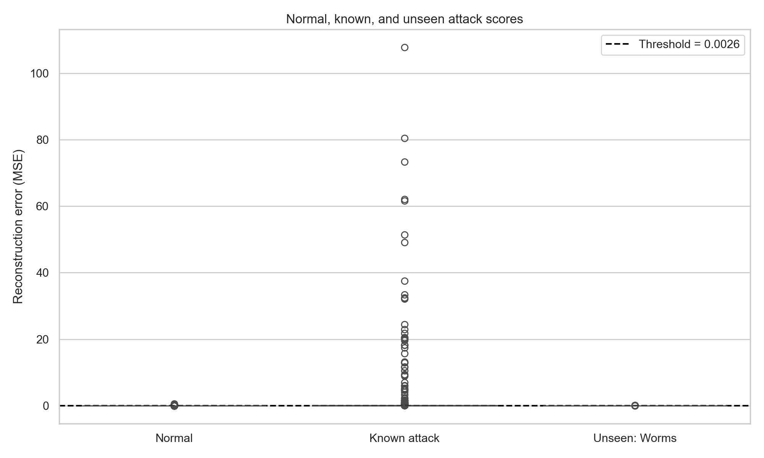
Fig. 5.4. Reconstruction error by evaluation group (zero-day experiment).
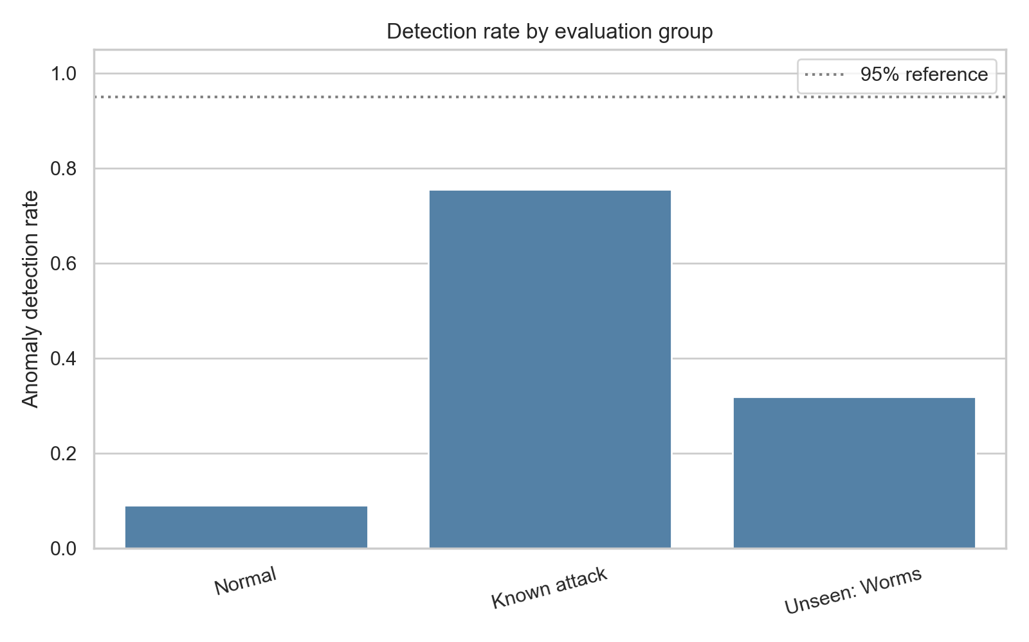
Fig. 5.5. Detection rate by evaluation group (zero-day experiment).
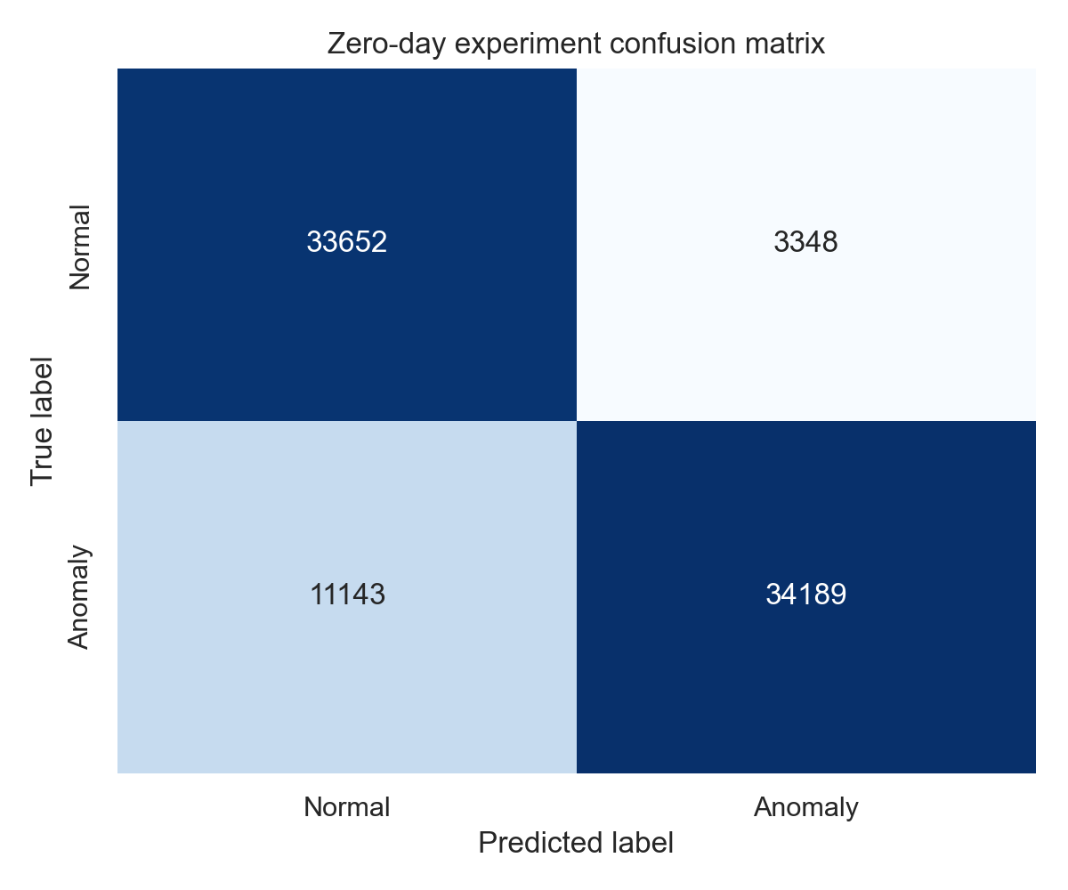
Fig. 5.6. Confusion matrix, zero-day evaluation run.

Discussion
The headline metrics (82.4% accuracy, F1 = 0.825, precision = 0.911) look strong, but they are dominated by the much larger “Known attack” group. Breaking detection down by group tells a different story: the model catches 75.5% of known attacks but only 31.8% of the withheld Worms samples (14 out of 44), against a 9.1% false-positive rate on normal traffic.
This gap is a central finding of the testing phase. It confirms that reconstruction-error-based anomaly detection, while attack-label-free and therefore well suited to a zero-day setting in principle, does not automatically generalize to an attack family with a distinct behavioural footprint. Detecting roughly one in three unseen attacks is a meaningful signal, but far from reliable on its own. This motivated the remaining components of the project — federated aggregation across multiple simulated nodes, explainable AI to help an analyst understand and validate borderline detections, and a threat-scoring layer to prioritize the anomalies that are found — which have since been implemented (Sections 4.5–4.8) and are evaluated in Sections 5.4–5.7 below.

5.4 TEST REPORTS — FEDERATED LEARNING EVALUATION
The federated simulation described in Section 4.5 was evaluated after every communication round by applying the current global model and its round-specific threshold to the untouched UNSW-NB15 test set, exactly as in Section 5.2.
Table 5.5. Federated learning round-by-round metrics.
Round | Calib. Loss | Test Recon. Loss | Threshold | Accuracy | Precision | Recall | F1 | ROC-AUC
1 | 0.077440 | 0.135067 | 0.187511 | 0.5139 | 0.7707 | 0.1669 | 0.2743 | 0.6531
2 | 0.032044 | 0.083064 | 0.104270 | 0.5193 | 0.7629 | 0.1843 | 0.2969 | 0.7617
3 | 0.019467 | 0.061805 | 0.064360 | 0.5351 | 0.7895 | 0.2123 | 0.3346 | 0.7978
4 | 0.012885 | 0.050693 | 0.039572 | 0.5871 | 0.8295 | 0.3147 | 0.4563 | 0.8225
5 | 0.009047 | 0.044771 | 0.027431 | 0.6320 | 0.8508 | 0.4021 | 0.5461 | 0.8443

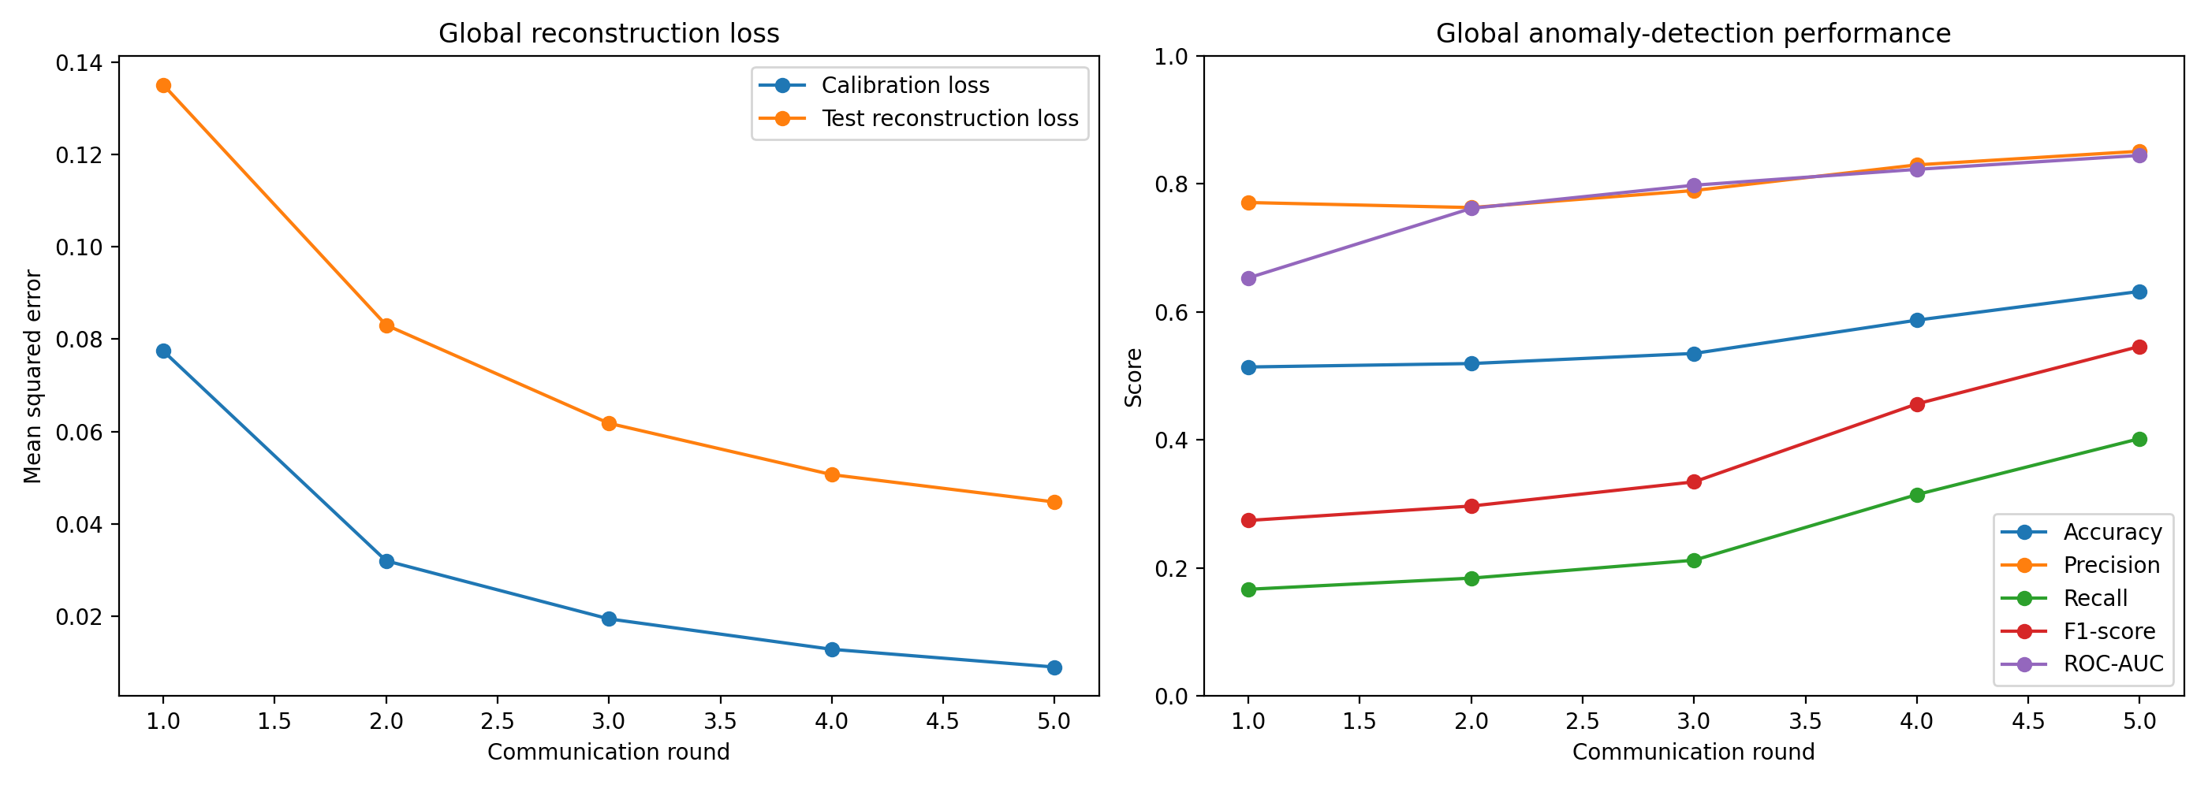
Fig. 5.7. Federated learning round metrics: reconstruction loss and detection performance.
Table 5.6. Federated global model versus centralized baseline.
Model | Accuracy | Precision | Recall | F1 | ROC-AUC
Step 3 centralized baseline | 0.8240 | 0.9108 | 0.7542 | 0.8251 | 0.8843
Federated global (round 5) | 0.6320 | 0.8508 | 0.4021 | 0.5461 | 0.8443

Discussion
Every metric improves monotonically across the five rounds as calibration loss falls from 0.0774 to 0.0090, showing FedAvg is converging rather than diverging. By round 5 the federated global model reaches a ROC-AUC of 0.844 — close to the centralized model's 0.884 — meaning its underlying ability to rank anomalous traffic above normal traffic is nearly as strong as the centralized version. However, at the fixed 95th-percentile operating threshold, its accuracy (63.2%) and F1-score (0.546) trail the centralized baseline (82.4% and 0.825) substantially, driven mainly by lower recall (0.402 vs. 0.754).
This is a realistic and instructive trade-off rather than an implementation defect: each client trains for only two local epochs per round on an eighth of the total normal data available to the centralized model, and the server never sees raw gradients beyond the averaged weights. The gap between a near-centralized ROC-AUC and a substantially lower F1-score suggests the federated model's decision threshold, not its underlying discrimination ability, is the main lever for closing this gap — for example by calibrating on a larger or multi-round-pooled calibration sample, or by running more communication rounds. Both are noted as future enhancements in Section 6.3.

5.5 TEST REPORTS — EXPLAINABILITY VALIDATION
SHAP and LIME (Section 4.6) were applied to three real UNSW-NB15 test rows using the federated global model from Section 5.4. Table 5.7 summarizes the model's actual prediction for each explained example.
Table 5.7. SHAP/LIME explanation examples and their model outcomes.
Example | Test Row | Attack Category | True Label | Reconstruction Loss | Flagged Anomalous?
Normal | 0 | Normal | 0 | 0.013436 | No (correct)
Known attack | 243 | Reconnaissance | 1 | 0.029655 | Yes (correct)
Unseen zero-day | 387 | Worms | 1 | 0.016811 | No (missed)

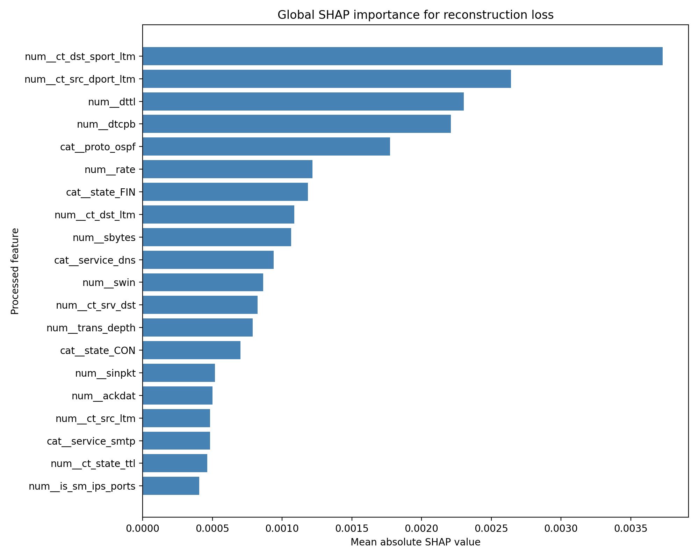
Fig. 5.8. Global SHAP importance for reconstruction loss (federated model).
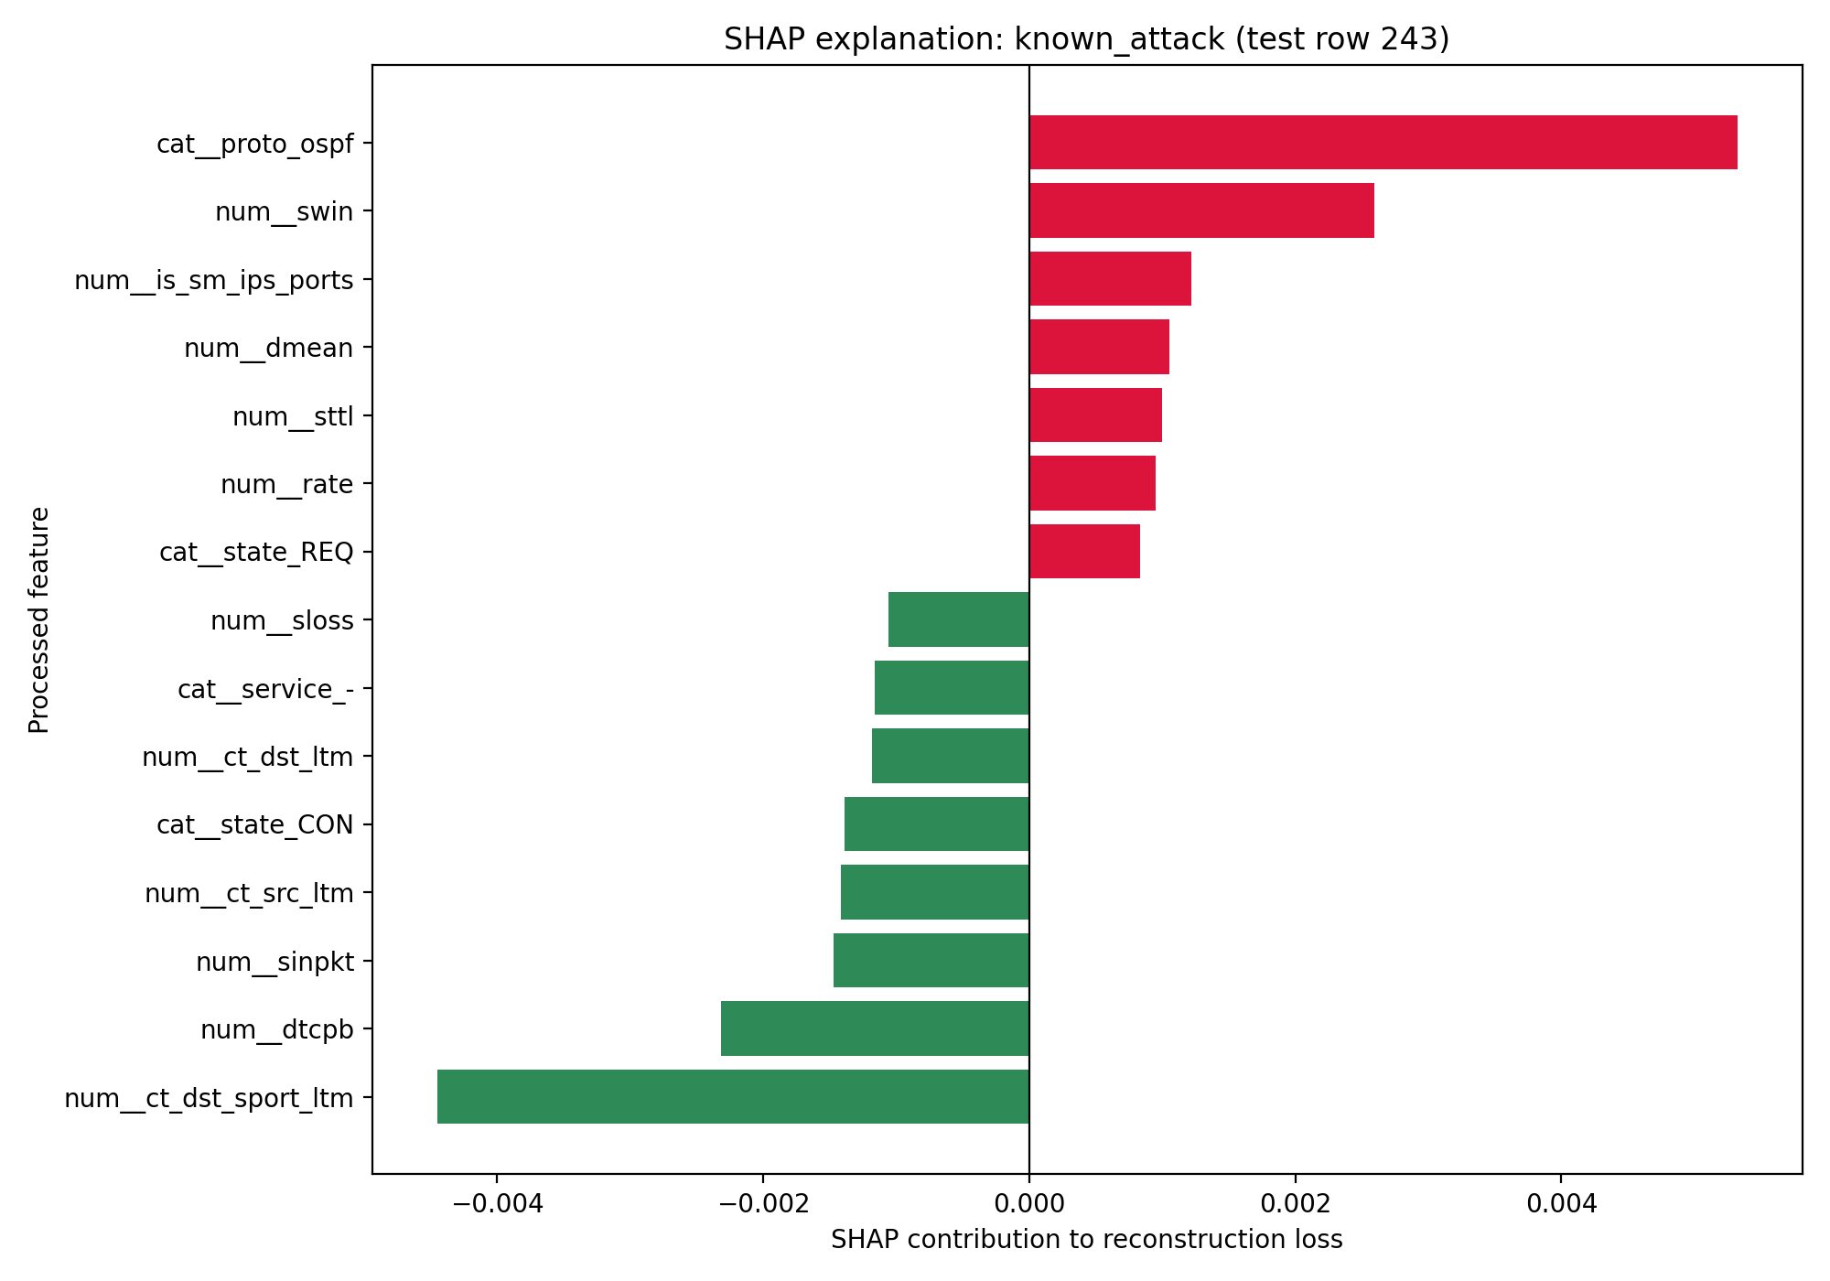
Fig. 5.9. Local SHAP explanation: known attack example (test row 243).
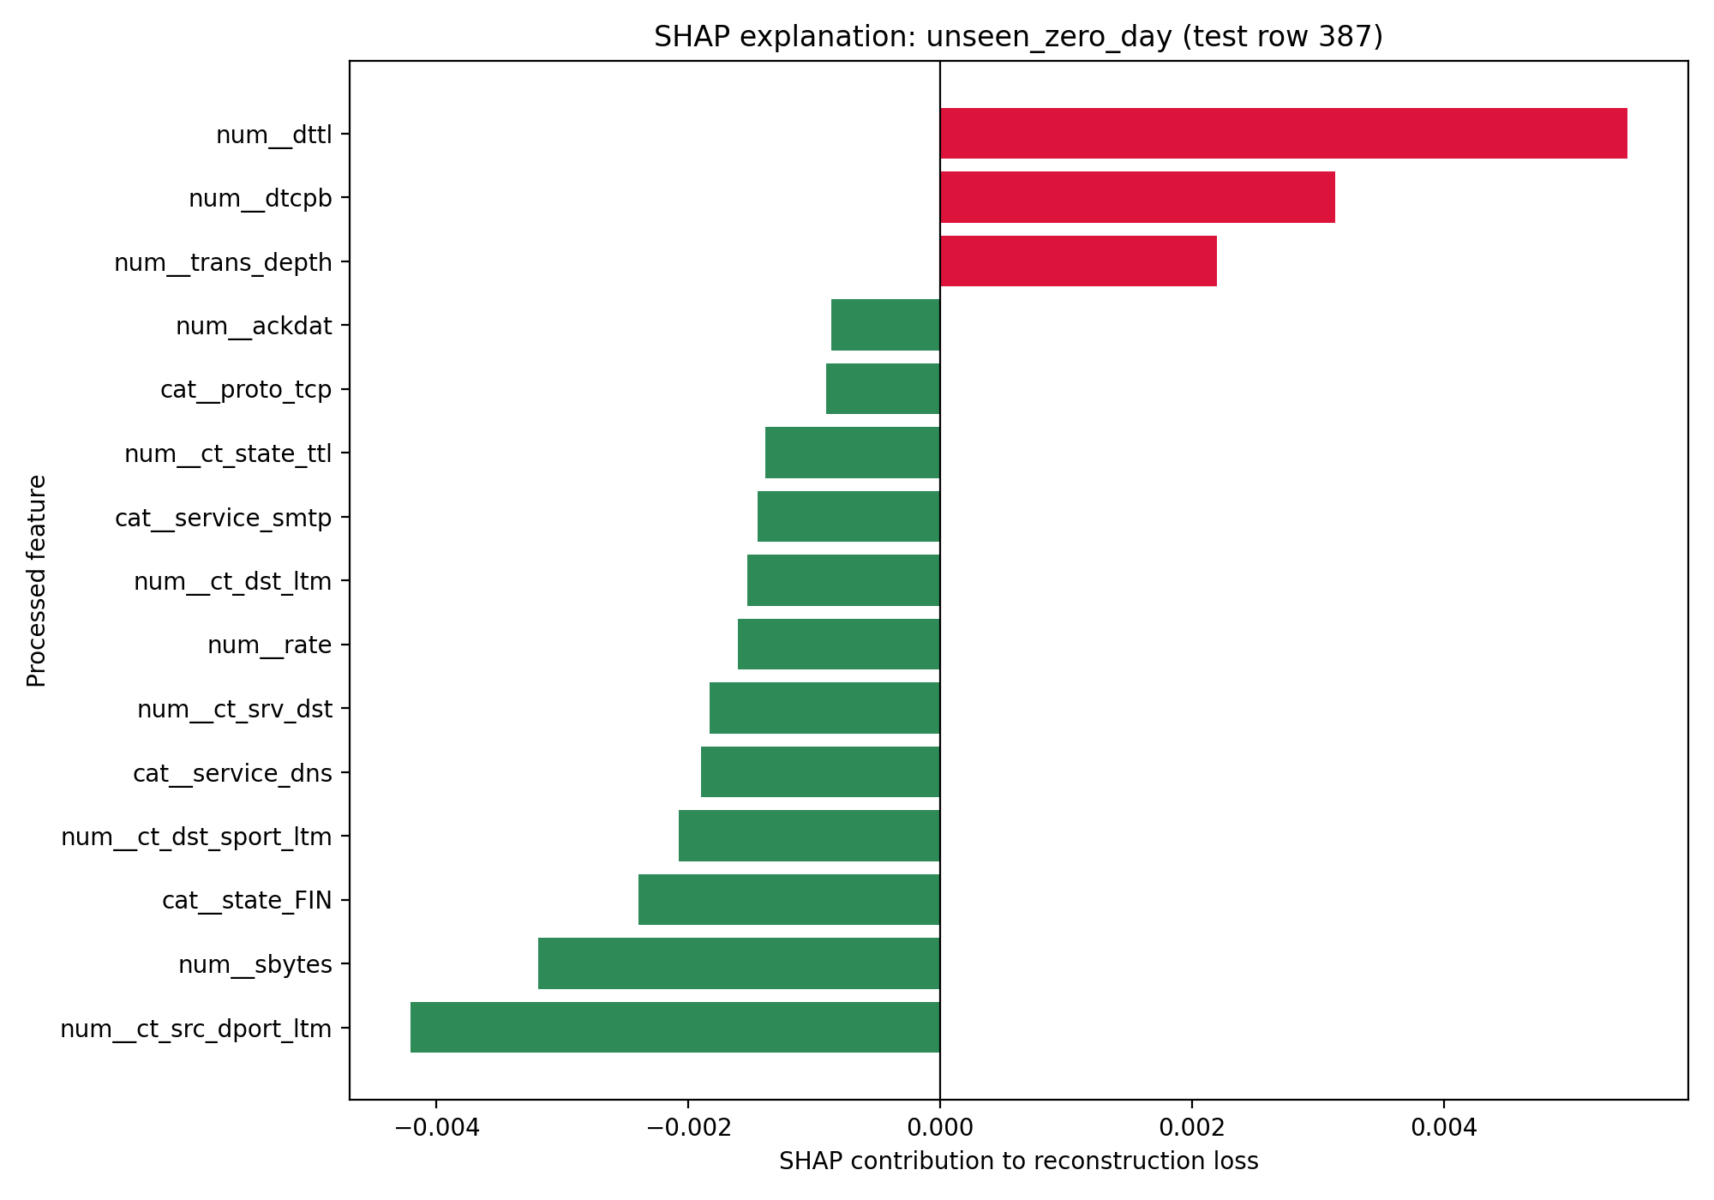
Fig. 5.10. Local SHAP explanation: unseen zero-day example (test row 387, Worms).

Discussion
Globally, ct_dst_sport_ltm (connections to the same destination and source port over a short time window) is the single most influential feature for reconstruction loss, followed by ct_src_dport_ltm, dttl, dtcpb, and the OSPF protocol indicator — mostly connection-pattern and protocol features rather than raw byte counts. For the correctly flagged known-attack example (Reconnaissance, test row 243), the OSPF protocol flag is by far the largest positive contributor, consistent with OSPF being an unusual protocol value for this traffic and therefore poorly reconstructed by a model trained mostly on ordinary client traffic.
The unseen zero-day example (Worms, test row 387) was not flagged anomalous by the federated model (reconstruction loss 0.0168, below the 0.0274 threshold), matching the low unseen-category detection rate already reported in Section 5.3. Its SHAP explanation is included specifically to show what an analyst would see on a missed detection: the model finds this record's features close enough to normal that no single feature drives a strong anomalous contribution, illustrating in feature-level terms why this attack family evades the current detector rather than only reporting the miss as a number.

5.6 TEST REPORTS — THREAT SCORING VALIDATION
The threat-scoring formula (Section 4.7) was applied to the federated global model's predictions across the full, untouched UNSW-NB15 test set (82,332 rows).
Table 5.8. Threat scoring summary metrics.
Metric | Value
Events scored | 82,332
Detected anomalies | 21,427 (26.0%)
Mean threat score | 41.24 / 100
Median threat score | 27.97 / 100
Maximum threat score | 100.0 / 100
Low severity (0–24) | 0
Medium severity (25–49) | 62,971
High severity (50–74) | 5,917
Critical severity (75–100) | 13,444

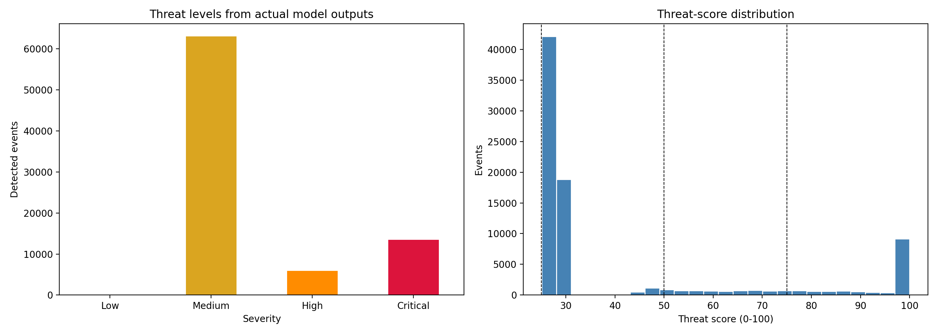
Fig. 5.11. Severity distribution and threat-score histogram.
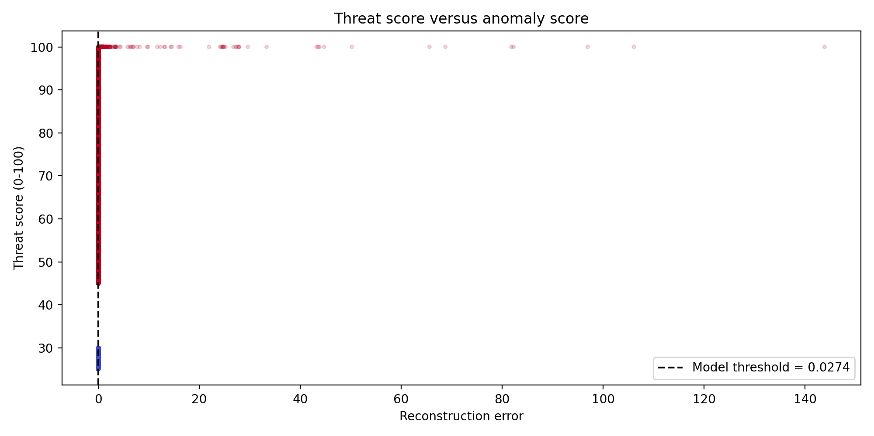
Fig. 5.12. Threat score versus reconstruction error, coloured by predicted anomaly.

Discussion
26.0% of test events (21,427 of 82,332) are flagged anomalous, matching the federated model's own detection behaviour from Section 5.4. A clear limitation surfaces in the severity distribution: no event scores in the Low band (0–24), and 62,971 events (76.5% of all traffic, including the large majority of genuinely normal traffic) land in the Medium band purely because the confidence and detection-result terms of the formula rarely reach zero even for confidently normal traffic. This means the current score is useful for ranking relative risk (Critical events are reliably the highest-error records, as Fig. 5.12 shows) but is not yet well calibrated as an absolute severity indicator — a recalibration of the scoring weights or thresholds against the federated model's actual score distribution is recorded as future work in Section 6.3.

5.7 DASHBOARD VERIFICATION
The Mission Shield dashboard (Section 4.8) was verified by tracing each of its seven pages against the exact saved artifacts it reads: the Dashboard, Threat Detection, and Reports pages all load directly from 07_threat_scored_events.csv and 07_threat_scoring_config.json (Section 5.6); the Federated Learning page loads 05_federated_learning_metrics.csv (Section 5.4); the Zero-Day Analysis page loads the Step 4 metrics files (Section 5.3); and the Explainable AI page loads the per-example SHAP/LIME outputs (Section 5.5). Every figure and number the dashboard can display therefore traces back to a result already reported in this chapter — the dashboard is a presentation layer over these results, not an independent computation.
A live browser screenshot of the running interface was not captured for inclusion in this report; the verification above was performed by reading dashboard/app.py against the artifacts it references. The interface can be launched locally with streamlit run dashboard/app.py from the project root once notebooks 03–07 have been run.

CHAPTER 6: CONCLUSION

6.1 SUMMARY OF THE PROJECT
This project set out to design and build an autonomous cybersecurity framework for satellite constellations that combines Federated Learning, unsupervised anomaly detection, and Explainable AI to detect zero-day attacks without relying on centralized raw-data collection or known attack signatures. Chapters 2 and 3 documented the requirements analysis and system design: a distributed architecture in which satellite nodes train locally, a federated server aggregates model updates into a global model, and a detection–scoring–explainability pipeline surfaces results on a monitoring dashboard.
Chapters 4 and 5 documented the complete pipeline as implemented and tested: a validated, leakage-free preprocessing pipeline for the UNSW-NB15 dataset; a centralized autoencoder-based anomaly detector evaluated with a full metric suite (82.4% accuracy, F1 = 0.825, ROC-AUC = 0.884); a dedicated zero-day simulation showing the detector generalizes well to known attack types (75.5% detection) but considerably less well to a genuinely unseen attack family (31.8% detection); a five-client Federated Averaging simulation reproducing the same detector under a privacy-preserving training regime; SHAP and LIME explanations of the federated model's predictions on real normal, known-attack, and zero-day test rows; a 0–100 threat-scoring layer converting model outputs into prioritized severity bands; and a seven-page Streamlit monitoring dashboard surfacing all of the above from saved artifacts. All eight development stages defined in the project repository (Appendix F.4) are now complete.

6.2 ADVANTAGES AND LIMITATIONS

Advantages
- Privacy-preserving by design: the anomaly detector never requires attack labels, and the Federated Learning simulation (Section 4.5) confirms the same detector can be trained with raw traffic kept local to each simulated node — only model weights are ever aggregated.
- The centralized autoencoder achieves strong precision (0.911) on the standard test set, meaning few false alarms are raised relative to the alerts it does generate; the federated model's ROC-AUC (0.844) stays close to the centralized model's (0.884), showing the underlying ranking ability survives federation even though the fixed threshold does not (Section 5.4).
- The zero-day evaluation methodology (category withholding) gives an honest, decomposed measurement of performance rather than a single inflated headline number, and this same honesty carries into the SHAP/LIME explanation of the missed Worms example (Section 5.5), which shows exactly why that record was not flagged rather than only reporting the miss as a statistic.
- The system design is modular (Table 3.2), and this paid off in practice: detection, federated training, explainability, scoring, and the dashboard were implemented and can be re-run as five independent notebooks/module, each reading only the saved artifacts of the stage before it.
- Every dashboard page traces back to a specific saved result file (Section 5.7); there is no daylight between what the report claims and what the interface displays.

Limitations
- Detection of genuinely unseen attacks remains low (31.8% centralized; the federated model was not separately re-tested on the withheld Worms category) and would not be reliable as a sole line of defense in its current form.
- The federated global model trades a meaningful amount of accuracy and recall for its privacy-preserving design (63.2% accuracy / 0.402 recall vs. 82.4% / 0.754 centralized), and the gap is currently unresolved (Section 5.4).
- The threat-scoring formula, while reasonable for relative ranking, is not yet well calibrated in absolute terms: no test event fell into the Low severity band and over three-quarters of all traffic — including most normal traffic — scored Medium or above (Section 5.6).
- The federated/, explainability/, and utils/ Python packages (Appendix B) remain scaffolded stubs; the actual FedAvg loop, SHAP/LIME logic, and scoring formula are currently implemented inline in notebooks 05–07 rather than in reusable modules, which would need refactoring before production use.
- Evaluation to date uses UNSW-NB15 network traffic as a stand-in for satellite telemetry rather than real satellite data, since real telemetry was not available for this academic project.
- The single-attack-category withholding experiment (Worms) is informative but limited in sample size (44 test rows); broader zero-day evaluation across multiple withheld categories would strengthen the claim.
- The Federated Learning simulation runs all five clients within a single notebook process using a manually implemented FedAvg loop rather than the flwr framework originally specified in Table 2.3/Table 3.5 (Section 4.5); it demonstrates the training regime correctly but not true multi-process/multi-machine deployment.

6.3 FUTURE ENHANCEMENTS
With the core pipeline complete end-to-end, the remaining opportunities are refinements and hardening rather than missing components:
- Close the federated-vs-centralized gap: recalibrate the federated threshold on a larger pooled calibration sample, increase local epochs or communication rounds, or explore weighting schemes beyond plain FedAvg.
- Recalibrate the threat-scoring weights and/or severity thresholds against the federated model's actual score distribution so the Low band is reachable and Medium is not the default outcome for ordinary traffic (Section 5.6).
- Refactor the working FedAvg, SHAP/LIME, and scoring logic out of notebooks 05–07 and into the federated/, explainability/, and utils/ modules (Appendix B) for production reuse, and migrate the federated simulation onto the flwr framework for genuine multi-process deployment.
- Broader zero-day evaluation: repeat the withholding experiment across additional attack categories, re-run the zero-day protocol against the federated (not just centralized) model, and validate on CICIDS2017 and simulated satellite telemetry as planned in Section 2.5.
- Capture a live walkthrough (screenshots or a recorded session) of the Mission Shield dashboard for future documentation, and add automated tests around the threat-scoring and explanation modules once they are refactored into utils/.
- Integration with real satellite telemetry, deployment on edge/resource-constrained hardware, and stronger secure-aggregation/Byzantine-robustness mechanisms against a malicious federated participant (Section 3.8), as longer-term extensions beyond the current academic scope.

APPENDIX A: DIVISION OF LABOUR
Table A.1 summarizes each team member's primary area of contribution to the project to date. All members participated jointly in requirements discussions, design reviews, and report writing.
Table A.1. Division of labour among team members.
Team Member | Primary Contribution
Aliya Zuha (2548404) | Dataset analysis, exploratory data analysis, documentation (Proposal, Synopsis, SRS, SDD), report compilation.
Divyang Patel (2548420) | Data preprocessing pipeline, autoencoder model design, training, and threshold calibration.
Shantanu Chowdhury (2548424) | Model evaluation, zero-day simulation design and analysis, results visualization.

APPENDIX B: PROJECT REPOSITORY STRUCTURE
Table B.1 lists the key files in the project repository and their current implementation status, as of this report.
Table B.1. Project repository structure and implementation status.
File / Module | Status | Description
notebooks/01_Dataset_Analysis.ipynb | Complete | Exploratory data analysis of UNSW-NB15.
notebooks/02_Data_Preprocessing.ipynb | Complete | Encoding, scaling, pipeline persistence.
notebooks/03_Anomaly_Detection_Model.ipynb | Complete | Autoencoder training and evaluation.
notebooks/04_Zero_Day_Detection.ipynb | Complete | Zero-day simulation (Worms withheld).
notebooks/05_Federated_Learning.ipynb | Complete | Custom FedAvg simulation across 5 client nodes, 5 rounds (Section 4.5).
notebooks/06_Explainable_AI.ipynb | Complete | SHAP and LIME explanations of the federated model (Section 4.6).
notebooks/07_Threat_Scoring.ipynb | Complete | 0–100 weighted threat score and severity banding (Section 4.7).
federated/client.py, server.py, strategy.py | Planned (stub) | Federated learning client/server/aggregation strategy — FedAvg is currently implemented inline in notebook 05, not in these modules.
explainability/shap_analysis.py, lime_analysis.py | Planned (stub) | Explainability modules — SHAP/LIME logic is currently implemented inline in notebook 06, not in these modules.
utils/evaluation.py, preprocessing.py, threat_scoring.py | Planned (stub) | Shared utility modules — evaluation and scoring logic is currently implemented inline in notebooks 03–07, not in these modules.
dashboard/app.py | Complete | Streamlit monitoring dashboard ("Mission Shield"), 7 pages, inference-only (Section 4.8).

Note: the repository also contains models/trained_models/isolation_forest_model.pkl. No notebook or script in the current repository fits or references an Isolation Forest model, so this file's origin could not be traced to any completed stage; it is not used by, or claimed as part of, any result in this report.

APPENDIX C: DESCRIPTIVE STATISTICS OF NUMERICAL FEATURES
Table C.1 lists the full descriptive statistics (count, mean, standard deviation, min, 25th/50th/75th percentile, and max) computed for all 41 numerical features of the UNSW-NB15 training set (175,341 rows), referenced from Section 4.2.5. These values were computed directly from the raw, unscaled training data, prior to the preprocessing pipeline described in Section 4.3.
Table C.1. Descriptive statistics of numerical features (training set).
Feature | Count | Mean | Std | Min | 25% | 50% | 75% | Max
id | 175341 | 87671.00 | 50616.73 | 1.00 | 43836.00 | 87671.00 | 131506.00 | 175341.00
dur | 175341 | 1.36 | 6.48 | 0.00 | 0.00 | 0.0016 | 0.6681 | 60.00
spkts | 175341 | 20.30 | 136.89 | 1.00 | 2.00 | 2.00 | 12.00 | 9616.00
dpkts | 175341 | 18.97 | 110.26 | 0.00 | 0.00 | 2.00 | 10.00 | 10974.00
sbytes | 175341 | 8844.84 | 174765.64 | 28.00 | 114.00 | 430.00 | 1418.00 | 12965233.00
dbytes | 175341 | 14928.92 | 143654.22 | 0.00 | 0.00 | 164.00 | 1102.00 | 14655550.00
rate | 175341 | 95406.19 | 165400.98 | 0.00 | 32.79 | 3225.81 | 125000.00 | 1000000.00
sttl | 175341 | 179.55 | 102.94 | 0.00 | 62.00 | 254.00 | 254.00 | 255.00
dttl | 175341 | 79.61 | 110.51 | 0.00 | 0.00 | 29.00 | 252.00 | 254.00
sload | 175341 | 73454033.19 | 188357447.00 | 0.00 | 13053.34 | 879674.75 | 88888888.00 | 5988000256.00
dload | 175341 | 671205.57 | 2421312.39 | 0.00 | 0.00 | 1447.02 | 27844.87 | 22422730.00
sloss | 175341 | 4.95 | 66.01 | 0.00 | 0.00 | 0.00 | 3.00 | 4803.00
dloss | 175341 | 6.95 | 52.73 | 0.00 | 0.00 | 0.00 | 2.00 | 5484.00
sinpkt | 175341 | 985.98 | 7242.25 | 0.00 | 0.008 | 0.28 | 55.16 | 84371.50
dinpkt | 175341 | 88.22 | 987.09 | 0.00 | 0.00 | 0.006 | 51.05 | 56716.82
sjit | 175341 | 4976.25 | 44965.85 | 0.00 | 0.00 | 0.00 | 2513.30 | 1460480.02
djit | 175341 | 604.35 | 4061.04 | 0.00 | 0.00 | 0.00 | 114.99 | 289388.27
swin | 175341 | 116.26 | 127.00 | 0.00 | 0.00 | 0.00 | 255.00 | 255.00
stcpb | 175341 | 969250421.91 | 1355264249.26 | 0.00 | 0.00 | 0.00 | 1916651334.00 | 4294958913.00
dtcpb | 175341 | 968877027.07 | 1353999546.23 | 0.00 | 0.00 | 0.00 | 1913674673.00 | 4294881924.00
dwin | 175341 | 115.01 | 126.89 | 0.00 | 0.00 | 0.00 | 255.00 | 255.00
tcprtt | 175341 | 0.041 | 0.079 | 0.00 | 0.00 | 0.00 | 0.066 | 2.52
synack | 175341 | 0.021 | 0.043 | 0.00 | 0.00 | 0.00 | 0.023 | 2.10
ackdat | 175341 | 0.020 | 0.041 | 0.00 | 0.00 | 0.00 | 0.039 | 1.52
smean | 175341 | 136.75 | 204.68 | 28.00 | 57.00 | 73.00 | 100.00 | 1504.00
dmean | 175341 | 124.17 | 258.32 | 0.00 | 0.00 | 44.00 | 89.00 | 1458.00
trans_depth | 175341 | 0.106 | 0.777 | 0.00 | 0.00 | 0.00 | 0.00 | 172.00
response_body_len | 175341 | 2144.29 | 54207.97 | 0.00 | 0.00 | 0.00 | 0.00 | 6558056.00
ct_srv_src | 175341 | 9.31 | 10.70 | 1.00 | 2.00 | 5.00 | 12.00 | 63.00
ct_state_ttl | 175341 | 1.30 | 0.95 | 0.00 | 1.00 | 1.00 | 2.00 | 6.00
ct_dst_ltm | 175341 | 6.19 | 8.05 | 1.00 | 1.00 | 2.00 | 7.00 | 51.00
ct_src_dport_ltm | 175341 | 5.38 | 8.05 | 1.00 | 1.00 | 1.00 | 5.00 | 51.00
ct_dst_sport_ltm | 175341 | 4.21 | 5.78 | 1.00 | 1.00 | 1.00 | 3.00 | 46.00
ct_dst_src_ltm | 175341 | 8.73 | 10.96 | 1.00 | 1.00 | 3.00 | 12.00 | 65.00
is_ftp_login | 175341 | 0.015 | 0.126 | 0.00 | 0.00 | 0.00 | 0.00 | 4.00
ct_ftp_cmd | 175341 | 0.015 | 0.126 | 0.00 | 0.00 | 0.00 | 0.00 | 4.00
ct_flw_http_mthd | 175341 | 0.133 | 0.701 | 0.00 | 0.00 | 0.00 | 0.00 | 30.00
ct_src_ltm | 175341 | 6.96 | 8.32 | 1.00 | 2.00 | 3.00 | 9.00 | 60.00
ct_srv_dst | 175341 | 9.10 | 10.76 | 1.00 | 2.00 | 4.00 | 12.00 | 62.00
is_sm_ips_ports | 175341 | 0.016 | 0.125 | 0.00 | 0.00 | 0.00 | 0.00 | 1.00
label | 175341 | 0.681 | 0.466 | 0.00 | 0.00 | 1.00 | 1.00 | 1.00

APPENDIX D: SAMPLE DATASET RECORDS
Table D.1 shows the first five records of the UNSW-NB15 training set for a representative subset of columns, illustrating the raw, unprocessed form of the data before the pipeline in Section 4.3 is applied. The attack_cat and label columns are omitted from this excerpt as they were not part of the verified sample captured for this report; the aggregate class and attack-category distributions are reported in full in Table 4.2.
Table D.1. Sample records from the UNSW-NB15 training set.
id | dur | proto | service | state | spkts | dpkts | sbytes | dbytes | rate | sttl | dttl
1 | 0.1215 | tcp | - | FIN | 6 | 4 | 258 | 172 | 74.09 | 252 | 254
2 | 0.6499 | tcp | - | FIN | 14 | 38 | 734 | 42014 | 78.47 | 62 | 252
3 | 1.6231 | tcp | - | FIN | 8 | 16 | 364 | 13186 | 14.17 | 62 | 252
4 | 1.6816 | tcp | ftp | FIN | 12 | 12 | 628 | 770 | 13.68 | 62 | 252
5 | 0.4495 | tcp | - | FIN | 10 | 6 | 534 | 268 | 33.37 | 254 | 252

APPENDIX E: KEY SOURCE CODE LISTINGS
This appendix reproduces the core, previously-untested pieces of the implementation described in Chapter 4, exactly as written in the project's Jupyter notebooks.

E.1 Preprocessing Pipeline (notebooks/02_Data_Preprocessing.ipynb)
categorical_features = X_train.select_dtypes(exclude=[np.number]).columns.tolist()
numerical_features = X_train.select_dtypes(include=[np.number]).columns.tolist()
# A simple preprocessing pipeline: one-hot encode categorical features
# and standardize numeric features. The encoder and scaler are fit
# only on the training data.
preprocessor = ColumnTransformer(
transformers=[
('num', StandardScaler(), numerical_features),
('cat', OneHotEncoder(handle_unknown='ignore', sparse_output=False), categorical_features),
]
)
X_train_pre = preprocessor.fit_transform(X_train)
X_test_pre = preprocessor.transform(X_test)
# Save the fitted preprocessing pipeline for later use.
pickle_path = model_dir / 'preprocessing_pipeline.pkl'
with open(pickle_path, 'wb') as f:
pickle.dump(preprocessor, f)

E.2 Autoencoder Architecture and Training (notebooks/03_Anomaly_Detection_Model.ipynb)
input_dim = X_fit.shape[1]
latent_dim = min(32, max(4, input_dim // 4))
autoencoder = keras.Sequential(
[
keras.Input(shape=(input_dim,), name='features'),
layers.Dense(64, activation='relu', name='encoder'),
layers.Dense(latent_dim, activation='relu', name='latent'),
layers.Dense(64, activation='relu', name='decoder'),
layers.Dense(input_dim, activation='linear', name='reconstruction'),
],
name='unsw_nb15_autoencoder',
)
autoencoder.compile(optimizer=keras.optimizers.Adam(learning_rate=1e-3), loss='mse')
early_stopping = keras.callbacks.EarlyStopping(
monitor='val_loss', patience=3, restore_best_weights=True,
)
history = autoencoder.fit(
X_fit, X_fit,
validation_data=(X_calibration, X_calibration),
epochs=20, batch_size=256, shuffle=True,
callbacks=[early_stopping], verbose=0,
)
def reconstruction_error(features):
reconstructed = autoencoder.predict(features, batch_size=1024, verbose=0)
return np.mean(np.square(features - reconstructed), axis=1)
calibration_errors = reconstruction_error(X_calibration)
anomaly_threshold = float(np.percentile(calibration_errors, 95))

E.3 Zero-Day Group Evaluation (notebooks/04_Zero_Day_Detection.ipynb)
WITHHELD_CATEGORY = 'Worms'
known_attack_mask = (y_test == 1) & (test_categories != WITHHELD_CATEGORY)
unseen_attack_mask = test_categories == WITHHELD_CATEGORY
normal_test_mask = y_test == 0
test_errors = reconstruction_error(X_test)
y_test_pred = (test_errors > anomaly_threshold).astype(int)
results_df = test_df[['attack_cat', 'label']].copy()
results_df['reconstruction_error'] = test_errors
results_df['predicted_anomaly'] = y_test_pred
results_df['group'] = np.select(
[normal_test_mask, unseen_attack_mask],
['Normal', 'Unseen: Worms'],
default='Known attack',
)
unseen_detection_rate = float(y_test_pred[unseen_attack_mask].mean())
known_detection_rate = float(y_test_pred[known_attack_mask].mean())
normal_false_positive_rate = float(y_test_pred[normal_test_mask].mean())

APPENDIX F: ENVIRONMENT AND REPRODUCIBILITY DETAILS
This appendix records the software environment and reproducibility conventions followed across all notebooks in the project repository, so that the results reported in Chapters 4 and 5 can be independently re-run and verified.

F.1 Software Environment
All work was carried out in Python inside Jupyter notebooks. Table F.1 lists every third-party package declared in the project's requirements.txt, together with the role each package plays in the pipeline. All eight development stages are now complete, so every listed package is exercised somewhere in the pipeline; the flwr entry is the one exception, noted below, since federated orchestration was implemented manually rather than through that library.
Table F.1. Python package dependencies (requirements.txt).
Package | Role in the project
pandas | Tabular data loading, manipulation, and the descriptive-statistics computations in Chapters 4 and Appendix C.
numpy | Numerical array operations underlying preprocessing, the reconstruction-error calculation, and evaluation metrics.
scikit-learn | Preprocessing (ColumnTransformer, StandardScaler, OneHotEncoder) and evaluation metrics (precision, recall, F1, ROC-AUC, confusion matrix).
matplotlib | Static plots: loss curves, error distributions, ROC curves, confusion matrices, and the SDD diagrams in Chapter 3.
seaborn | Statistical visualizations used in dataset analysis (Chapter 4), including distribution and correlation plots.
tensorflow | Keras Sequential API used to define, compile, and train the autoencoder (Chapter 4, Table 4.4).
shap | KernelExplainer-based feature attribution for the federated model's reconstruction loss, implemented in the Explainable AI stage (Section 4.6).
lime | LIME local surrogate explanations for the same predictions, implemented in the Explainable AI stage (Section 4.6).
flwr (Flower) | Listed as a dependency for federated orchestration; the implemented simulation (Section 4.5) instead uses a manually coded FedAvg loop in TensorFlow/Keras, since all clients run within a single notebook process — a noted design deviation (Section 6.2).
streamlit | Powers the seven-page "Mission Shield" monitoring dashboard (Section 4.8), reading saved model and metric artifacts in inference-only mode.
joblib | Serialization of fitted preprocessing objects and trained models to disk for reuse across notebooks.
openpyxl | Excel-format read/write support used for ad hoc export of tabular results during analysis.

F.2 Notebook Execution Environment
Table F.2 records the Jupyter kernel and Python interpreter version associated with each of the four completed notebooks, taken directly from each notebook's saved metadata, for exact environment reproduction.
Table F.2. Notebook execution environment.
Notebook | Kernel | Python version
01_Dataset_Analysis.ipynb | python3 (base) | 3.13.5
02_Data_Preprocessing.ipynb | python3 (base) | 3.13.5
03_Anomaly_Detection_Model.ipynb | python3 (base) | 3.13.5
04_Zero_Day_Detection.ipynb | python3 (base) | 3.13.5

F.3 Reproducibility Conventions
- A fixed random seed (SEED = 42) is used throughout the preprocessing, model training, and evaluation notebooks so that data splits, weight initialization, and reported metrics are reproducible across re-runs.
- The preprocessing pipeline (encoders and scalers) is fit only on the training partition and persisted to disk with joblib/pickle, then reloaded rather than refit for evaluation, so that the exact transformation used during training is the one applied at test time.
- The trained autoencoder never sees an attack-labelled row during training; the anomaly threshold is calibrated from a held-out slice of benign traffic, as described in Section 4.4 and Appendix E.2.
- The zero-day simulation withholds one attack category (Worms) entirely from model development and reintroduces it only at evaluation time, as described in Section 5.2 and Appendix E.3, so that its detection rate reflects genuine generalization rather than memorization.
- Model training was performed on the standard consumer-grade hardware specified in Table 2.4, confirming the pipeline does not require specialized infrastructure to reproduce.

F.4 Development-Stage Roadmap
Table F.3 restates the eight development stages defined in the project repository's README, cross-referenced to the report sections that document each stage and its current implementation status. This is the same status summary given at file level in Table B.1, presented here at the level of project stages rather than individual files.
Table F.3. Project development-stage roadmap and current status.
Stage | Description | Status
1. Dataset Analysis | Exploratory analysis of the UNSW-NB15 training and testing sets (Chapter 4, Section 4.2). | Complete
2. Data Preprocessing | Encoding, scaling, and pipeline persistence (Chapter 4, Section 4.3). | Complete
3. Anomaly Detection Model | Autoencoder design, training, and threshold calibration (Chapter 4, Section 4.4; Chapter 5, Section 5.1). | Complete
4. Zero-Day Detection Experiment | Category-withholding simulation and evaluation (Chapter 5, Section 5.2). | Complete
5. Federated Learning | Custom FedAvg simulation across 5 simulated satellite-node clients, 5 rounds (Section 4.5; Section 5.4). | Complete
6. Explainable AI (SHAP/LIME) | SHAP and LIME explanations of the federated model's predictions (Section 4.6; Section 5.5). | Complete
7. Threat Scoring | 0–100 weighted severity score with Low/Medium/High/Critical banding (Section 4.7; Section 5.6). | Complete
8. Streamlit Dashboard | Seven-page "Mission Shield" monitoring interface, inference-only (Section 4.8; Section 5.7). | Complete

APPENDIX G: GLOSSARY OF KEY TERMS
Table G.1 defines the technical terms used throughout this report, for readers who are not already familiar with anomaly detection, federated learning, or explainable AI terminology. Abbreviation expansions alone are listed separately in the List of Abbreviations at the front of the report; this glossary gives a short working definition of each concept as it is used specifically within this project.
Table G.1. Glossary of key terms used in this report.
Term | Definition
Autoencoder | A neural network trained to reconstruct its own input through a narrow "bottleneck" layer; the model implemented in Section 4.4 is trained only on benign traffic, so it reconstructs normal patterns well and unfamiliar (potentially malicious) patterns poorly.
Reconstruction error | The difference (mean squared error) between the autoencoder's input and its output for a given record; used as the anomaly score throughout Chapters 4 and 5.
Anomaly threshold | The reconstruction-error cutoff above which a record is flagged as anomalous, calibrated in Section 4.4 as the 95th percentile of reconstruction error on a held-out benign calibration set.
Zero-day attack | An attack pattern not previously seen by the detection model; simulated in this project by withholding one full attack category (Worms) from model development and testing detection on it only at evaluation time (Chapter 5).
Federated Learning (FL) | A distributed training paradigm in which multiple nodes (here, simulated satellites) train local models on their own data and share only model updates, not raw data, with a central aggregator; implemented as a 5-client FedAvg simulation in Section 4.5 and evaluated in Section 5.4.
Explainable AI (XAI) | Techniques such as SHAP and LIME that produce a human-readable explanation of why a machine learning model made a particular prediction; applied to the federated model's reconstruction-loss predictions in Section 4.6 and evaluated in Section 5.5.
SHAP | SHapley Additive exPlanations — a model-agnostic explanation method that attributes a prediction to individual input features using a game-theoretic Shapley value.
LIME | Local Interpretable Model-agnostic Explanations — an explanation method that approximates a complex model's behaviour near one prediction with a simpler, interpretable local model.
Threat score | An operator-facing severity value (0–100, Table 3.7 design; Section 4.7 implementation) combining the anomaly (reconstruction) score, model confidence, and the binary detection result into a single actionable ranking with Low/Medium/High/Critical bands.
One-hot encoding | A preprocessing technique that converts a categorical feature (e.g. protocol, service) into multiple binary columns, one per category, so it can be used by a neural network (Section 4.3).
Standardization | A preprocessing step that rescales each numerical feature to zero mean and unit variance, fitted only on the training partition and reused at test time (Section 4.3, Appendix F.3).
Calibration set | A held-out slice of benign (label = 0) training data, separate from the data used to fit the autoencoder's weights, used only to determine the anomaly threshold (Section 4.4).
No-leakage discipline | The project-wide convention that any fitted preprocessing object or threshold is derived only from training/calibration data and never from the test set, so evaluation metrics are not optimistically biased (Section 4.1, Appendix F.3).
ROC-AUC | Receiver Operating Characteristic – Area Under Curve; a threshold-independent measure of how well a classifier separates positive (attack) from negative (normal) cases, reported for the autoencoder in Table 5.1.
F1-score | The harmonic mean of precision and recall, used alongside accuracy, precision, recall, and ROC-AUC to summarize autoencoder performance in Table 5.1.
False positive rate | The proportion of genuinely benign records incorrectly flagged as anomalous; reported per evaluation group in the zero-day experiment (Table 5.4).
UNSW-NB15 | A public network-intrusion benchmark dataset combining real benign traffic with synthetic attack traffic across nine attack categories, used as the primary dataset for this project (Section 1.4, Table 2.5).

REFERENCES
[1] McMahan, B., et al. (2017). Communication-Efficient Learning of Deep Networks from Decentralized Data.
[2] Flower Federated Learning Framework. https://flower.ai
[3] SHAP Documentation. https://shap.readthedocs.io
[4] LIME Documentation. https://lime-ml.readthedocs.io
[5] UNSW-NB15 Dataset Documentation. https://research.unsw.edu.au/projects/unsw-nb15-dataset
[6] CICIDS2017 Dataset Documentation. https://www.unb.ca/cic/datasets/ids-2017.html
[7] TensorFlow Documentation. https://www.tensorflow.org
[8] Scikit-learn Documentation. https://scikit-learn.org
[9] Streamlit Documentation. https://docs.streamlit.io

